Supplementary Information

HPLC-MS/MS method applied to an untargeted metabolomics approach for the diagnosis of “Olive Quick Decline Syndrome”
Sabrina Di Masi¹, Giuseppe E. De Benedetto^{2,} , Cosimino Malitesta¹*, Maria Saponari³, Cinzia Citti^{4,5}, Giuseppe Cannazza^{4,5}, Giuseppe Ciccarella^{5,6,}*
¹Laboratorio di Chimica Analitica, Dipartimento di Scienze e Tecnologie Biologiche ed Ambientali, Università del Salento, Via Monteroni, 73100 Lecce, Italy
²Laboratorio di Spettrometria di Massa Analitica e Isotopica, Dipartimento di Beni Culturali, Università del Salento, Via Monteroni, 73100 Lecce, Italy
³Istituto per la Protezione Sostenibile delle Piante, CNR – IPSP, Consiglio Nazionale delle Ricerche, Via Amendola 165/A, 70126 Bari, Italy
⁴Dipartimento di Scienze della Vita, Università di Modena e Reggio Emilia, Via Campi 103, 41125 Modena, Italy
⁵Istituto di Nanotecnologia − CNR NANOTEC, Consiglio Nazionale delle Ricerche, Via Monteroni, 73100 Lecce, Italy
⁶Dipartimento di Scienze e Tecnologie Biologiche ed Ambientali Università del Salento, Via Monteroni, 73100 Lecce, Italy & UdR INSTM Salento,
*Corresponding authors: cosimino.malitesta@unisalento.it, giuseppe.ciccarella@unisalento.it

Contents of supporting information
No. | Contents | Pages
Figure S1 | High resolution MS/MS spectrum for significant metabolites identified by comparison of experimental MS/MS spectra and in-silico MS/MS spectra computer generated by MS-FINDER. | 2
Figure S2 | OPLS-DA predicted score plots obtained for (a) ESI/MS (+ ion mode) and (b) ESI/MS (– ion mode). | 1
Figure S3 | OPLS-DA Classification lists obtained for (a) ESI/MS (+ ion mode) and (b) ESI/MS (– ion mode). | 1
Table S1 | Sample classification against different cultivars and geolocalised information | 1
Table S2 | Additional samples classification | 1
Table S3 | PLS-DA Classification lists and confusion matrix obtained for ESI-MS data, positive ion mode on all samples belonging to training (Ctrl 1-14 and Xf 1-8), test (Ctrl 15-17 and Xf 9-10) and new (Ctrl 18-22) sets. | 1
Table S4 | PLS-DA Classification lists and confusion matrix obtained for ESI-MS data, negative ion mode on all samples belonging to training (Ctrl 1-14 and Xf 1-8), test (Ctrl 15-17 and Xf 9-10) and new (Ctrl 18-22) sets. | 1
Table S5 | OPLS-DA Classification lists and confusion matrix obtained for ESI-MS data, positive ion mode on all samples belonging to training (Ctrl 1-14 and Xf 1-8), test (Ctrl 15-17 and Xf 9-10) and new (Ctrl 18-22) sets. | 1
Table S6 | OPLS-DA Classification lists and confusion matrix obtained for ESI-MS data, negative ion mode on all samples belonging to training (Ctrl 1-14 and Xf 1-8), test (Ctrl 15-17 and Xf 9-10) and new (Ctrl 18-22) sets. | 1

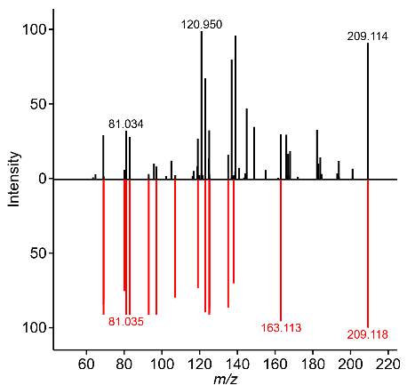 | 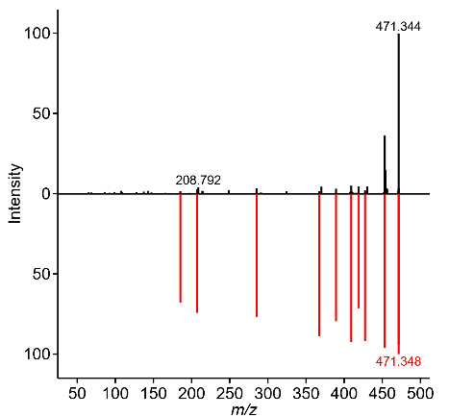
Jasmonic acid  m/z: 209.1180 | Maslinic acid  m/z: 471.3472

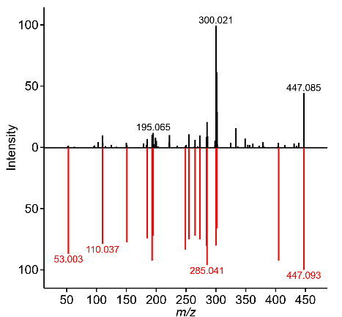 |  | 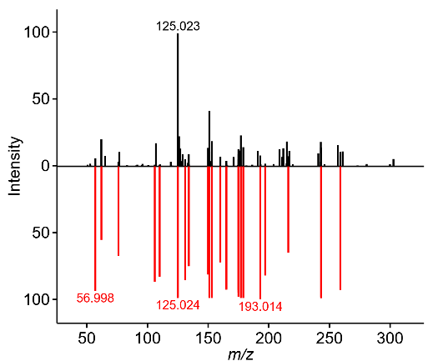
Diosmin  m/z: 607.1614 |  | Taxifolin  m/z: 303.0485

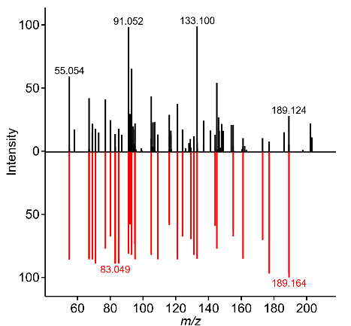 | 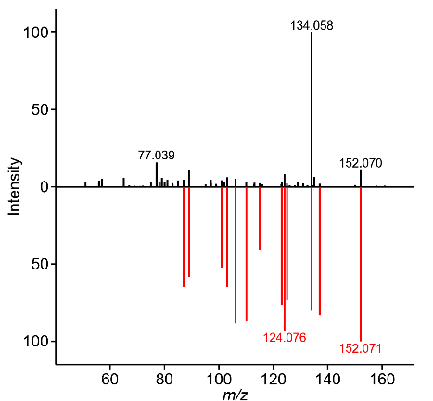 | 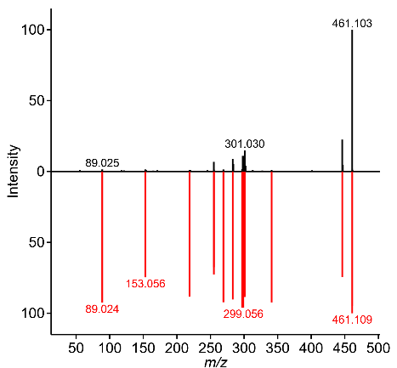
Solavetivone  m/z: 219.1663 | Pyridoxine (Vitamin B6)  m/z: 170.0804 | Diosmetin 7-O-beta-D-glucopyranoside  m/z: 461.0673

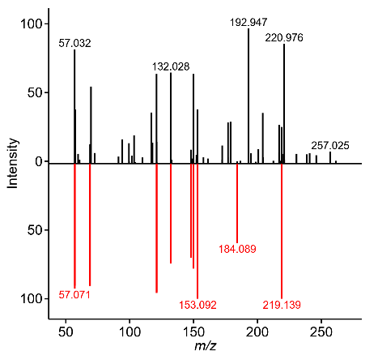 | 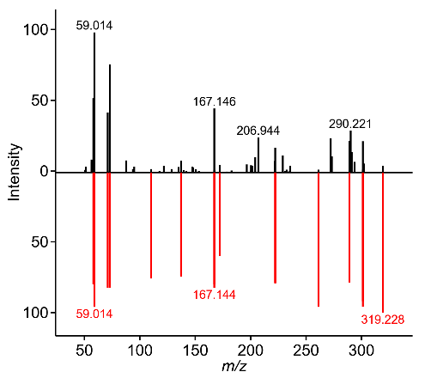
(S)-Abscisic acid  m/z: 263.1264 | 12-HETE  m/z: 319.2298

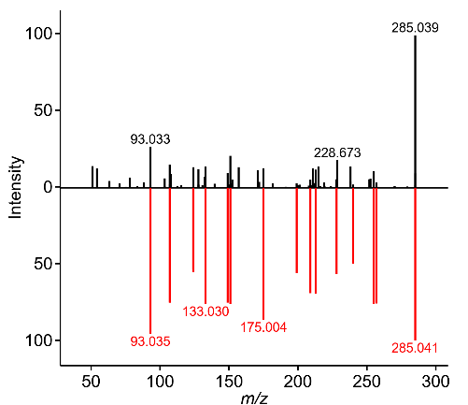 | 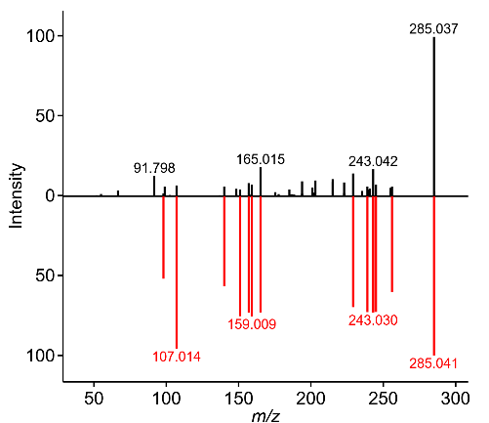 | 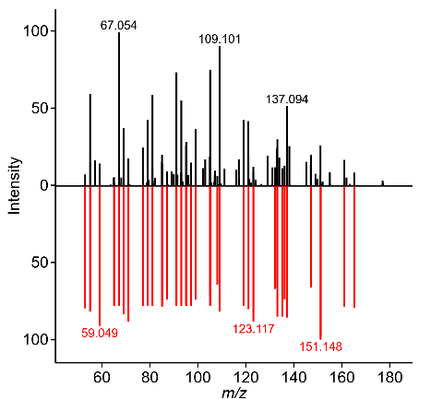
Kaempferol  m/z: 285.0376 | Luteolin  m/z: 285.0376 | β-Ionone  m/z: 193.1577

Figure S1. High resolution MS/MS spectrum for significant metabolites identified by comparison of experimental MS/MS spectra and in-silico MS/MS spectra computer generated by MS-FINDER.

Table S1. Sample classification
Sample no.¹ | Cultivar | Label
1 | Ogliarola | Ctrl1
2 | Ogliarola | Ctrl2
3 | Cellina | Ctrl3
4 | Cellina | Ctrl4
5 | Cellina | Ctrl5
6 | Cellina | Ctrl6
7 | Ogliarola | Ctrl7
8 | Ogliarola | Ctrl8
9 | Ogliarola | Ctrl9
10 | Cellina | Ctrl10
11 | Cellina | Ctrl11
12 | Cellina | Ctrl12
13 | Cellina | Ctrl13
14 | Cellina | Ctrl14
15 | Ogliarola | Ctrl15
16 | Ogliarola | Ctrl16
17 | Ogliarola | Ctrl17
18 | Ogliarola | Xf1
19 | Cellina | Xf2
20 | Ogliarola | Xf3
21 | Cellina | Xf4
22 | Ogliarola | Xf5
23 | Ogliarola | Xf6
24 | Ogliarola | Xf7
25 | Cellina | Xf8
26 | Ogliarola | Xf9
27 | Cellina | Xf10
¹ Samples 1-27 were collected from “Tremolizzo” field
Geolocation: 40°12'56"N 18°20'42"E.
Samples 18-27 were collected from “Uccio” field
Geolocation: 40°01'13"N 18°04'14"E.

Table S2. Additional samples classification
Sample no¹ | Cultivar | Label
28 | Barone di Monteprofico | Ctrl18
29 | Ornella | Ctrl19
30 | Usciana | Ctrl20
31 | Cornola | Ctrl21
32 | Colozzese | Ctrl22

¹ Samples 28-32 were collected from “Tremolizzo” field
Geolocation: 40°12'56"N 18°20'42"E.

a | b
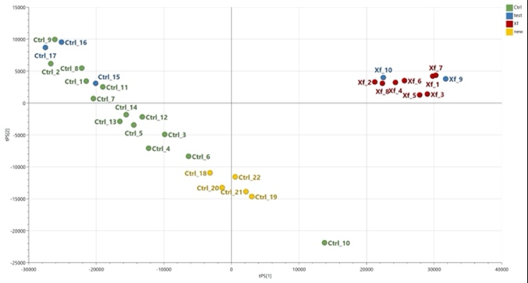 | 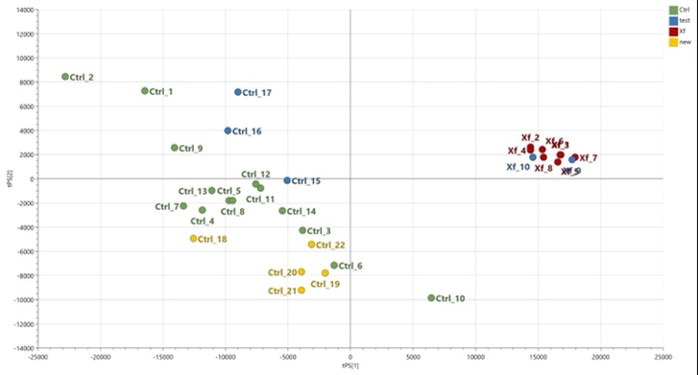
c | d
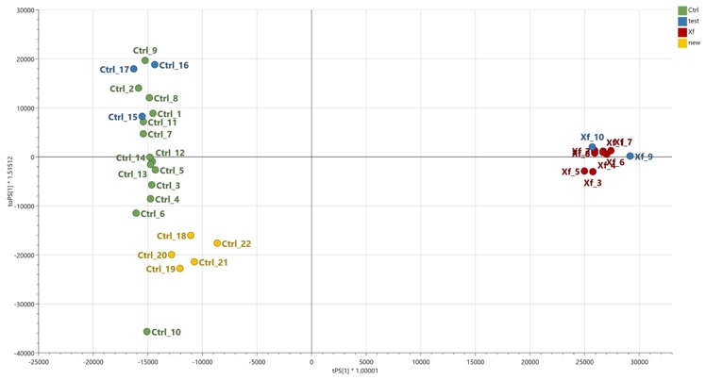 | 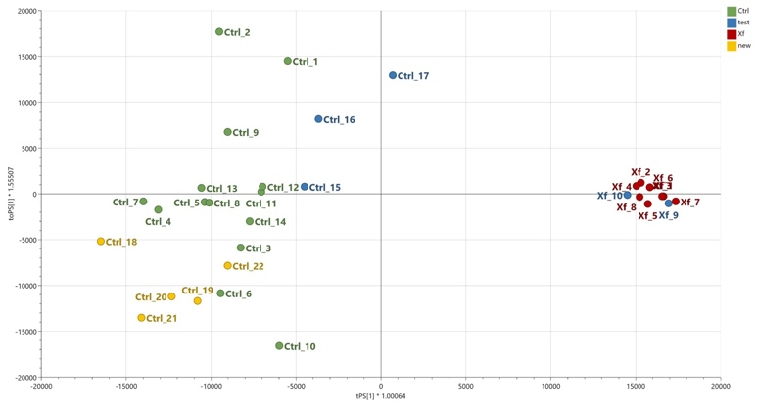

Figure S2. Scatter plots for the predicted scores of the two components retained in the PLS-DA and OPLS-DA models calculated for both ESI-MS ion modes: (a) PLS-DA, ESI-MS, + ion mode; (b) PLS-DA, ESI-MS, - ion mode; (c) OPLS-DA, ESI-MS, + ion mode; and (d) OPLS-DA, ESI-MS, - ion mode. Healthy (Ctrl) and Xf infected samples (Xf) belonging to the training set are coloured in green and in red, respectively, whereas all the test samples are in blue. The new samples listes in table S2 are in yellow. Variables were filtered according to p-value <0.01 and fold change >1.5 for both ESI modes.

Table S3. PLS-DA Classification lists and confusion matrix obtained for ESI-MS data, positive ion mode on all samples belonging to training (Ctrl 1-14 and Xf 1-8), test (Ctrl 15-17 and Xf 9-10) and new (Ctrl 18-22) sets.
Primary ID | $ClassID | M1.YVarPS($M1.DA(Ctrl)) | M1.YPredPS[2]($M1.DA(Ctrl)) | M1.YVarPS($M1.DA(Xf)) | M1.YPredPS[2]($M1.DA(Xf))
Ctrl_1 | Ctrl | 1 | 0.992078 | 0 | 0.00792176
Ctrl_2 | Ctrl | 1 | 1.02918 | 0 | -0.0291808
Ctrl_3 | Ctrl | 1 | 0.97235 | 0 | 0.0276497
Ctrl_4 | Ctrl | 1 | 1.07739 | 0 | -0.0773942
Ctrl_5 | Ctrl | 1 | 1.02722 | 0 | -0.0272187
Ctrl_6 | Ctrl | 1 | 0.988976 | 0 | 0.0110238
Ctrl_7 | Ctrl | 1 | 1.04172 | 0 | -0.04172
Ctrl_8 | Ctrl | 1 | 0.953016 | 0 | 0.0469845
Ctrl_9 | Ctrl | 1 | 0.916862 | 0 | 0.083138
Ctrl_10 | Ctrl | 1 | 0.930223 | 0 | 0.0697767
Ctrl_11 | Ctrl | 1 | 0.964792 | 0 | 0.0352083
Ctrl_12 | Ctrl | 1 | 0.967998 | 0 | 0.0320025
Ctrl_13 | Ctrl | 1 | 1.05616 | 0 | -0.0561625
Ctrl_14 | Ctrl | 1 | 1.00932 | 0 | -0.00932
Ctrl_15 | test | 0 | 0.971351 | 0 | 0.0286492
Ctrl_16 | test | 0 | 0.905124 | 0 | 0.0948758
Ctrl_17 | test | 0 | 0.979076 | 0 | 0.0209236
Xf_1 | Xf | 0 | -0.0938312 | 1 | 1.09383
Xf_2 | Xf | 0 | 0.107478 | 1 | 0.892522
Xf_3 | Xf | 0 | -0.0028577 | 1 | 1.00286
Xf_4 | Xf | 0 | 0.0467572 | 1 | 0.953243
Xf_5 | Xf | 0 | 0.0237636 | 1 | 0.976236
Xf_6 | Xf | 0 | 0.0102778 | 1 | 0.989722
Xf_7 | Xf | 0 | -0.108296 | 1 | 1.1083
Xf_8 | Xf | 0 | 0.0894172 | 1 | 0.910583
Xf_9 | test | 0 | -0.123369 | 0 | 1.12337
Xf_10 | test | 0 | 0.06371 | 0 | 0.93629
Ctrl_18 | new | 0 | 0.992576 | 0 | 0.00742432
Ctrl_19 | new | 0 | 0.962259 | 0 | 0.0377412
Ctrl_20 | new | 0 | 1.01631 | 0 | -0.0163111
Ctrl_21 | new | 0 | 0.958631 | 0 | 0.0413686
Ctrl_22 | new | 0 | 0.932155 | 0 | 0.0678448
 | Members | Correct | Ctrl | Xf | No class (YPred <= 0)
Ctrl | 14 | 100% | 14 | 0 | 0
Xf | 8 | 100% | 0 | 8 | 0
No class | 10 |  | 8 | 2 | 0
Total | 32 | 100% | 22 | 10 | 0

Table S4. PLS-DA Classification lists and confusion matrix obtained for ESI-MS data, negative ion mode on all samples belonging to training (Ctrl 1-14 and Xf 1-8), test (Ctrl 15-17 and Xf 9-10) and new (Ctrl 18-22) sets.
Primary ID | $ClassID | M2.YVarPS($M2.DA(Ctrl)) | M2.YPredPS[2]($M2.DA(Ctrl)) | M2.YVarPS($M2.DA(Xf)) | M2.YPredPS[2]($M2.DA(Xf))
Ctrl_1 | Ctrl | 1 | 0.85052 | 0 | 0.14948
Ctrl_2 | Ctrl | 1 | 1.00641 | 0 | -0.0064102
Ctrl_3 | Ctrl | 1 | 0.9578 | 0 | 0.0421996
Ctrl_4 | Ctrl | 1 | 1.14632 | 0 | -0.146322
Ctrl_5 | Ctrl | 1 | 1.03985 | 0 | -0.0398515
Ctrl_6 | Ctrl | 1 | 1.00307 | 0 | -0.0030694
Ctrl_7 | Ctrl | 1 | 1.17939 | 0 | -0.179388
Ctrl_8 | Ctrl | 1 | 1.02984 | 0 | -0.0298429
Ctrl_9 | Ctrl | 1 | 0.986542 | 0 | 0.0134578
Ctrl_10 | Ctrl | 1 | 0.869316 | 0 | 0.130684
Ctrl_11 | Ctrl | 1 | 0.910215 | 0 | 0.0897855
Ctrl_12 | Ctrl | 1 | 0.90703 | 0 | 0.0929702
Ctrl_13 | Ctrl | 1 | 1.04787 | 0 | -0.0478666
Ctrl_14 | Ctrl | 1 | 0.936176 | 0 | 0.0638244
Ctrl_15 | test | 0 | 0.811275 | 0 | 0.188725
Ctrl_16 | test | 0 | 0.778613 | 0 | 0.221387
Ctrl_17 | test | 0 | 0.609077 | 0 | 0.390923
Xf_1 | Xf | 0 | -0.0102178 | 1 | 1.01022
Xf_2 | Xf | 0 | 0.0416574 | 1 | 0.958343
Xf_3 | Xf | 0 | -0.0069686 | 1 | 1.00697
Xf_4 | Xf | 0 | 0.0514091 | 1 | 0.948591
Xf_5 | Xf | 0 | 0.0257626 | 1 | 0.974237
Xf_6 | Xf | 0 | 0.020685 | 1 | 0.979315
Xf_7 | Xf | 0 | -0.0377318 | 1 | 1.03773
Xf_8 | Xf | 0 | 0.0450537 | 1 | 0.954946
Xf_9 | test | 0 | -0.0210642 | 0 | 1.02106
Xf_10 | test | 0 | 0.0734985 | 0 | 0.926501
Ctrl_18 | new | 0 | 1.27708 | 0 | -0.27708
Ctrl_19 | new | 0 | 1.05601 | 0 | -0.0560133
Ctrl_20 | new | 0 | 1.11515 | 0 | -0.115153
Ctrl_21 | new | 0 | 1.18487 | 0 | -0.184868
Ctrl_22 | new | 0 | 0.986662 | 0 | 0.0133381
 | Members | Correct | Ctrl | Xf | No class (YPred <= 0)
Ctrl | 14 | 100% | 14 | 0 | 0
Xf | 8 | 100% | 0 | 8 | 0
No class | 10 |  | 8 | 2 | 0
Total | 32 | 100% | 22 | 10 | 0

Table S5. OPLS-DA Classification lists and confusion matrix obtained for ESI-MS data, positive ion mode on all samples belonging to training (Ctrl 1-14 and Xf 1-8), test (Ctrl 15-17 and Xf 9-10) and new (Ctrl 18-22) sets.
Primary ID | $ClassID | M2.YVarPS($M2.DA(Ctrl)) | M2.YPredPS[1]($M2.DA(Ctrl)) | M2.YVarPS($M2.DA(Xf)) | M2.YPredPS[1]($M2.DA(Xf))
Ctrl_1 | Ctrl | 1 | 0.992078 | 0 | 0.0079217
Ctrl_2 | Ctrl | 1 | 1.02918 | 0 | -0.0291808
Ctrl_3 | Ctrl | 1 | 0.97235 | 0 | 0.0276496
Ctrl_4 | Ctrl | 1 | 1.07739 | 0 | -0.0773942
Ctrl_5 | Ctrl | 1 | 1.02722 | 0 | -0.0272188
Ctrl_6 | Ctrl | 1 | 0.988976 | 0 | 0.0110238
Ctrl_7 | Ctrl | 1 | 1.04172 | 0 | -0.0417201
Ctrl_8 | Ctrl | 1 | 0.953016 | 0 | 0.0469844
Ctrl_9 | Ctrl | 1 | 0.916862 | 0 | 0.083138
Ctrl_10 | Ctrl | 1 | 0.930223 | 0 | 0.0697768
Ctrl_11 | Ctrl | 1 | 0.964792 | 0 | 0.0352083
Ctrl_12 | Ctrl | 1 | 0.967998 | 0 | 0.0320025
Ctrl_13 | Ctrl | 1 | 1.05616 | 0 | -0.0561625
Ctrl_14 | Ctrl | 1 | 1.00932 | 0 | -0.0093201
Ctrl_15 | test | 0 | 0.971351 | 0 | 0.0286492
Ctrl_16 | test | 0 | 0.905124 | 0 | 0.0948758
Ctrl_17 | test | 0 | 0.979077 | 0 | 0.0209235
Xf_1 | Xf | 0 | -0.0938313 | 1 | 1.09383
Xf_2 | Xf | 0 | 0.107478 | 1 | 0.892522
Xf_3 | Xf | 0 | -0.0028578 | 1 | 1.00286
Xf_4 | Xf | 0 | 0.046757 | 1 | 0.953243
Xf_5 | Xf | 0 | 0.0237635 | 1 | 0.976237
Xf_6 | Xf | 0 | 0.0102777 | 1 | 0.989722
Xf_7 | Xf | 0 | -0.108296 | 1 | 1.1083
Xf_8 | Xf | 0 | 0.0894172 | 1 | 0.910583
Xf_9 | test | 0 | -0.12337 | 0 | 1.12337
Xf_10 | test | 0 | 0.06371 | 0 | 0.93629
Ctrl_18 | new | 0 | 0.992576 | 0 | 0.00742435
Ctrl_19 | new | 0 | 0.962259 | 0 | 0.0377412
Ctrl_20 | new | 0 | 1.01631 | 0 | -0.0163112
Ctrl_21 | new | 0 | 0.958631 | 0 | 0.0413686
Ctrl_22 | new | 0 | 0.932155 | 0 | 0.0678448
 | Members | Correct | Ctrl | Xf | No class (YPred <= 0)
Ctrl | 14 | 100% | 14 | 0 | 0
Xf | 8 | 100% | 0 | 8 | 0
No class | 10 |  | 8 | 2 | 0
Total | 32 | 100% | 22 | 10 | 0

Table S6. OPLS-DA Classification lists and confusion matrix obtained for ESI-MS data, negative ion mode on all samples belonging to training (Ctrl 1-14 and Xf 1-8), test (Ctrl 15-17 and Xf 9-10) and new (Ctrl 18-22) sets.
Primary ID | $ClassID | M1.YVarPS($M1.DA(Ctrl)) | M1.YPredPS[1]($M1.DA(Ctrl)) | M1.YVarPS($M1.DA(Xf)) | M1.YPredPS[1]($M1.DA(Xf))
Ctrl_1 | Ctrl | 1 | 0.85052 | 0 | 0.14948
Ctrl_2 | Ctrl | 1 | 1.00641 | 0 | -0.0064102
Ctrl_3 | Ctrl | 1 | 0.9578 | 0 | 0.0421996
Ctrl_4 | Ctrl | 1 | 1.14632 | 0 | -0.146322
Ctrl_5 | Ctrl | 1 | 1.03985 | 0 | -0.0398514
Ctrl_6 | Ctrl | 1 | 1.00307 | 0 | -0.0030694
Ctrl_7 | Ctrl | 1 | 1.17939 | 0 | -0.179388
Ctrl_8 | Ctrl | 1 | 1.02984 | 0 | -0.0298429
Ctrl_9 | Ctrl | 1 | 0.986542 | 0 | 0.0134578
Ctrl_10 | Ctrl | 1 | 0.869316 | 0 | 0.130684
Ctrl_11 | Ctrl | 1 | 0.910215 | 0 | 0.0897855
Ctrl_12 | Ctrl | 1 | 0.90703 | 0 | 0.0929702
Ctrl_13 | Ctrl | 1 | 1.04787 | 0 | -0.0478666
Ctrl_14 | Ctrl | 1 | 0.936176 | 0 | 0.0638244
Ctrl_15 | test | 0 | 0.811275 | 0 | 0.188725
Ctrl_16 | test | 0 | 0.778613 | 0 | 0.221387
Ctrl_17 | test | 0 | 0.609077 | 0 | 0.390923
Xf_1 | Xf | 0 | -0.0102177 | 1 | 1.01022
Xf_2 | Xf | 0 | 0.0416575 | 1 | 0.958342
Xf_3 | Xf | 0 | -0.0069686 | 1 | 1.00697
Xf_4 | Xf | 0 | 0.0514091 | 1 | 0.948591
Xf_5 | Xf | 0 | 0.0257626 | 1 | 0.974237
Xf_6 | Xf | 0 | 0.020685 | 1 | 0.979315
Xf_7 | Xf | 0 | -0.0377317 | 1 | 1.03773
Xf_8 | Xf | 0 | 0.0450537 | 1 | 0.954946
Xf_9 | test | 0 | -0.0210642 | 0 | 1.02106
Xf_10 | test | 0 | 0.0734985 | 0 | 0.926501
Ctrl_18 | new | 0 | 1.27708 | 0 | -0.27708
Ctrl_19 | new | 0 | 1.05601 | 0 | -0.0560133
Ctrl_20 | new | 0 | 1.11515 | 0 | -0.115153
Ctrl_21 | new | 0 | 1.18487 | 0 | -0.184868
Ctrl_22 | new | 0 | 0.986662 | 0 | 0.0133381
 | Members | Correct | Ctrl | Xf | No class (YPred <= 0)
Ctrl | 14 | 100% | 14 | 0 | 0
Xf | 8 | 100% | 0 | 8 | 0
No class | 10 |  | 8 | 2 | 0
Total | 32 | 100% | 22 | 10 | 0

