Multiresidue antibiotic-metabolite quantification method using ultra-performance liquid chromatography coupled with tandem mass spectrometry for environmental and public exposure estimation

Analytical and Bioanalytical Chemistry

Elizabeth Holton, Barbara Kasprzyk-Hordern
Department of Chemistry, University of Bath, Bath, BA2 7AY, UK

2.4.1. Liquid chromatography (supplementary information)
Table S1 Chemical information, ordered by class
Table S2 Chromatographic and validation parameters for solids analyses in mobile phase, ordered by retention time (in full)
Table S3 Liquid chromatography and mass spectrometry setup
Table S4a Chromatographic and validation parameters: Matrix retention times for aqueous analyses, ordered by retention time
Table S4b Chromatographic and validation parameters: Matrix retention times for solids analyses, ordered by retention time
Table S5a Chromatographic and validation parameters: Matrix ion ratios for aqueous analyses, ordered by retention time
Table S5b Chromatographic and validation parameters: Matrix ion ratios for solids analyses, ordered by retention time
Table S6 Mass spectrometry parameters, ordered by retention time
Table S7 Equations for calculating concentration, instrument performance, and method performance
Table S8 Method recovery from urban matrices, ordered by drug class
Table S9 Method detection and quantification limits per matrix, ordered by retention time
Table S10 Compound structural information, grouped by drug class and corresponding drug metabolites (9 pages)

Figure S1 Weighting schemes
Figure S2 Split calibration ranges
Figure S3 Overlaid chromatograms, scaled by relative intensity, highlighting regions by chemical class
Figure S4 Overlaid chromatograms, scaled by relative intensity

2.4.1. Liquid chromatography (supplementary information)
The chromatography was optimised in terms of mobile phase composition, needle washes, sample composition, flow rate, and inlet gradient (Online resource T2).
A starting mobile phase of water/methanol with 0.1% formic acid produced the strongest ionisation across the range of analytes in positive ESI mode. Outperforming other buffers such as ammonium acetate (5mM NH₄OAc) with 0.3 % acetic acid, and ammonium fluoride (1mM NH₄F). The preparation of water and methanol was also tested at several ratios for the aqueous (A) line, such as 80:20 and 60:40 H₂O:MeOH. The best separation and organic purge was achieved using 95:5 H₂O:MeOH with 0.1 % formic acid (mobile phase A) and 100 % MeOH (mobile phase B).
Strong and weak needle washes were selected to compliment the system. The strong wash used was 1:1:1:1 MeOH:ACN:IPA:H₂O + 0.1 % formic acid and the weak wash was prepared to mimic the starting mobile phase (95:5 H₂O:MeOH). The injection volume was 20 µL, via a partial loop injection.
Five ratios were assessed for the sample make-up (0:100, 20:80, 40:60, 60:40, and 80:20 H₂O:MeOH). At high concentrations of organic modifier, the effects of longitudinal diffusion were reduced, which increased analyte velocity and sharpened peaks. But as analyte retention decreased, peak splitting occurred upon solvent mixing. Sample composition performed best at 60:40 but was prepared at 80:20 H₂O:MeOH to enable samples to be co-analysed with pre-established methods.
The method flow rate was tested across the range of 0.04 - 0.3 mL min⁻¹. The best results, in terms of system pressure, peak separation, and peak shape; were determined at 0.2 mL min⁻¹.
Numerous elution profiles were tested to maximise overall peak separation whilst retaining Gaussian shape. Starting conditions were: 0 % B, held for 1 min; followed by an 8.5 min gradient to 40 % B; 3.5 min gradient to 100 % B; 3 min hold; finally returning to 0 % B (0.5 min) to re-equilibrate for 2.5 min. Two gradients were utilised; operating at a gradual rate during aqueous-based elution (0-40 % B), followed by a much steeper gradient towards the high-organic hold (40-100 % B). The former enhanced the initial peak separation, and the latter vastly shortened the overall chromatographic period. The re-equilibration hold (2.5 min), plus LC pre-injection liquid handling (needle wash cycles, sample aspiration, etc. approx. 0.5 min), was optimised as the minimum acceptable duration: equivalent to >5 column volumes. System pressures consistently reached equilibrium over this duration and analyte carryover was negligible. The total run time was 19 min. Figure 2 shows the distribution of peaks relative to the inlet gradient and internal standard retention times (top); as well as the example chromatographs, organised by drug class (bottom).

Table S1 Chemical information, ordered by class groupings
Grouping |  | Chemical | Abbrev | Class A |  | Class B |  | CAS No. |  | Salt form θ |  | Molec. Formula |  | M.I. mass |  | Supplier
Sulfonamide & |  | Sulfadiazine | SDZ | Sulfonamide |  | Parent |  | 68-35-9 |  |  |  | C10H10N4O2S |  | 250.05 |  | Sigma-Aldrich
Trimethoprim |  | Sulfapyridine | SPY | Sulfonamide |  | Parent |  | 144-83-2 |  |  |  | C11H11N3O2S |  | 249.06 |  | Sigma-Aldrich
 |  | Sulfamethoxazole | SMX | Sulfonamide |  | Parent |  | 723-46-6 |  |  |  | C10H11N3O3S |  | 253.05 |  | Sigma-Aldrich
 |  | Sulfasalazine | SLZ | Sulfonamides |  | Parent |  | 599-79-1 |  |  |  | C18H14N4O5S |  | 398.07 |  | Sigma-Aldrich
 |  | Trimethoprim | TMP | Trimethoprim |  | Parent |  | 738-70-5 |  |  |  | C14H18N4O3 |  | 290.14 |  | Sigma-Aldrich
 |  | N-acetyl sulfadiazine | aSDZ | Sulfonamide |  | Metabolite |  | 127-74-2 |  |  |  | C12H12N4O3S |  | 292.06 |  | TRC
 |  | N-acetyl sulfapyridine | aSPY | Sulfonamide |  | Metabolite |  | 19077-98-6 |  |  |  | C13H13N3O3S |  | 291.07 |  | TRC
 |  | N-acetyl sulfamethoxazole | aSMX | Sulfonamide |  | Metabolite |  | 21312-10-7 |  |  |  | C12H13N3O4S |  | 295.06 |  | TRC
 |  | 4-hydroxy-trimethoprim | hTMP | Trimethoprim |  | Metabolite |  | 112678-48-5 |  |  |  | C14H18N4O4 |  | 306.13 |  | TRC
Macrolide |  | Azithromycin | AZM | Macrolide |  | Parent |  | 83905-01-5 |  |  |  | C38H72N2O12 |  | 748.51 |  | LCG
& Lincomycin |  | Erythromycin | ERY | Macrolide |  | Parent |  | 114-07-8 |  |  |  | C37H67NO13 |  | 733.46 |  | Sigma-Aldrich
 |  | Clarithromycin | CLR | Macrolide |  | Parent |  | 81103-11-9 |  |  |  | C38H69NO13 |  | 747.48 |  | Sigma-Aldrich
 |  | Clindamycin | CLI | Lincomycin |  | Parent |  | 18323-44-9 |  | Hydrochloride |  | C18H33ClN2O5S |  | 424.18 |  | Sigma-Aldrich
 |  | N-desmethyl azithromycin | dmAZM | Macrolide |  | Metabolite |  | 172617-84-4 |  |  |  | C37H70N2O12 |  | 734.49 |  | TRC
 |  | N-desmethyl erythromycin A | dmERY | Macrolide |  | Metabolite |  | 992-62-1 |  |  |  | ‎C36H65NO13 |  | 719.45 |  | TRC
 |  | N-desmethyl clarithromycin | dmCLR | Macrolide |  | Metabolite |  | 101666-68-6 |  |  |  | C37H67NO13 |  | 733.46 |  | TRC
 |  | N-desmethyl clindamycin | dmCLI | Lincomycin |  | Metabolite |  | 22431-45-4 |  |  |  | C17H31ClN2O5S |  | 410.16 |  | TRC
β-LACTAMS
Penicillin |  | Amoxicillin | AMX | Penicillin |  | Parent |  | 26787-78-0 |  |  |  | C16H19N3O5S |  | 365.10 |  | Fluka
 |  | Ampicillin | AMP | Penicillin |  | Parent |  | 69-53-4 |  | Trihydrate |  | C16H19N3O4S |  | 349.11 |  | Fluka
 |  | Flucloxacillin | FLX | Penicillin |  | Parent |  | 5250-39-5 |  | Sodium |  | C19H17ClFN3O5S |  | 453.06 |  | Fluka
 |  | Penicillin G | PenG | Penicillin |  | Parent |  | 113-98-4 |  | Sodium |  | C16H18N2O4S |  | 334.10 |  | Fluka
 |  | Penicillin V | PenV | Penicillin |  | Parent |  | 132-98-9 |  | Potassium |  | C16H18N2O5S |  | 350.09 |  | Sigma-Aldrich
 |  | Amoxicilloic acid | AMXa | Penicillin |  | Metabolite |  | 42947-63-7 ¥ |  | Trisodium salt |  | C16H21N3O6S |  | 383.12 |  | TRC
 |  | Ampicilloic acid | AMPa | Penicillin |  | Metabolite |  | 32746-94-4 |  |  |  | C16H21N3O5S |  | 367.12 |  | TRC
 |  | Penicilloic G acid | PenGa | Penicillin |  | Metabolite |  | 11039-68-2 |  |  |  | C9H14N2O5S |  | 262.06 |  | TRC
Cefalosporin |  | Cefalexin | LEX | Cefalosporin |  | Parent |  | 23325-78-2 |  | Monohydrate |  | C16H17N3O4S |  | 347.09 |  | Fluka
 |  | Cefixime | CFM | Cefalosporin |  | Parent |  | 79350-37-1 |  | Trihydrate |  | C16H15N5O7S2 |  | 453.04 |  | Fluka
 |  | Ceftiofur | CTF | Cefalosporin |  | Parent |  | 104010-37-9 |  |  |  | ‎C19H17N5O7S3 |  | 523.03 |  | Fluka
 |  | Ceftriaxone | CRO | Cefalosporin |  | Parent |  | 104376-79-6 |  | Disodium hemi(heptahydrate) |  | C18H18N8O7S3 |  | 554.05 |  | Sigma-Aldrich
Monobactam |  | Aztreonam | ATM | Monobactam |  | Parent |  | 78110-38-0 |  |  |  | C13H17N5O8S2 |  | 435.05 |  | TRC
Carbapenem |  | Imipenem | IPM | Carbapenem |  | Parent |  | 64221-86-9 |  |  |  | C12H17N3O4S |  | 299.09 |  | Sigma-Aldrich
 |  | Meropenem | MEM | Carbapenem |  | Parent |  | 119478-56-7 |  | Trihydrate |  | C17H25N3O5S |  | 383.15 |  | Sigma-Aldrich
Quinolone |  | Besifloxacin | BSF | Quinolone |  | Parent |  | 405165-61-9 |  | Hydrochloride |  | C19H21ClFN3O3 |  | 393.13 |  | MCE
 |  | Ciprofloxacin | CIP | Quinolone |  | Parent/Metab. |  | 85721-33-1 |  |  |  | C17H18FN3O3 |  | 331.13 |  | Fluka
 |  | Danofloxacin | DFX | Quinolone |  | Parent |  | 119478-55-6 |  | Mesylate |  | C19H20FN3O3 |  | 357.15 |  | LCG
 |  | Enrofloxacin | ENR | Quinolone |  | Parent |  | 93106-60-6 |  |  |  | C19H22FN3O3 |  | 359.16 |  | Sigma-Aldrich
 |  | Flumequine | FLU | Quinolone |  | Parent |  | 42835-25-6 |  |  |  | C14H12FNO3 |  | 261.08 |  | Fluka
 |  | Gatifloxacin | GAT | Quinolone |  | Parent |  | 112811-59-3 |  |  |  | C19H22FN3O4 |  | 375.16 |  | TRC
 |  | Lomefloxacin | LOM | Quinolone |  | Parent |  | 98079-52-8 |  | Hydrochloride |  | C17H19F2N3O3 |  | 351.14 |  | Sigma-Aldrich
 |  | Moxifloxacin | MXF | Quinolone |  | Parent |  | 268545-13-7 |  | Hydrochloride |  | C21H24FN3O4 |  | 401.18 |  | MCE
 |  | Nadifloxacin | NAD | Quinolone |  | Parent |  | 124858-35-1 |  |  |  | C19H21FN2O4 |  | 360.15 |  | MCE
 |  | Nalidixic acid | NAL | Quinolone |  | Parent |  | 389-08-2 |  | Sodium |  | C12H12N2O3 |  | 232.08 |  | Sigma-Aldrich
 |  | Norfloxacin | NOR | Quinolone |  | Parent |  | 70458-96-7 |  |  |  | C16H18FN3O3 |  | 319.13 |  | Sigma-Aldrich
 |  | Ofloxacin (Levofloxacin) * | OFX | Quinolone |  | Parent |  | 82419-36-1 |  |  |  | C18H20FN3O4 |  | 361.14 |  | Sigma-Aldrich
 |  | Prulifloxacin | PFLX | Quinolone |  | Parent (prodrug) |  | 123447-62-1 |  |  |  | C21H20FN3O6S |  | 461.11 |  | Sigma-Aldrich
Grouping |  | Chemical | Abbrev | Class A |  | Class B |  | CAS No. |  | Salt form θ |  | Molec. Formula |  | M.I. mass |  | Supplier
 |  | Sarafloxacin | SRF | Quinolone |  | Parent |  | 91296-87-6 |  | Hydrochloride |  | C20H17F2N3O3 |  | 385.12 |  | Sigma-Aldrich
 |  | Desethylene ciprofloxacin | deCIP | Quinolone |  | Metabolite |  | 528851-31-2 |  | Hydrochloride |  | C15H16FN3O3 |  | 305.12 |  | TRC
 |  | Hydroxy-norfloxacin | hNOR | Quinolone |  | Metabolite |  | 109142-49-6 |  |  |  | C16H18FN3O4 |  | 335.13 |  | TRC
 |  | Ofloxacin N-oxide | OFXo | Quinolone |  | Metabolite |  | 104721-52-0 |  | Acetic acid salt |  | C18H20FN3O5 |  | 377.14 |  | TRC
 |  | Desmethyl-ofloxacin | dmOFX | Quinolone |  | Metabolite |  | 82419-52-1 |  |  |  | C17H18FN3O4 |  | 347.13 |  | TRC
 |  | Ulifloxacin | UFX | Quinolone |  | Metabolite |  | 112984-60-8 |  |  |  | C16H16FN3O3S |  | 349.09 |  | TRC
TB (1st line) |  | Isoniazid | INH | Isoniazid |  | Parent |  | 54-85-3 |  |  |  | C6H7N3O |  | 137.06 |  | Sigma-Aldrich
 |  | Pyrazinamide | PZA | Pyrazinamide |  | Parent |  | 98-96-4 |  |  |  | C5H5N3O |  | 123.04 |  | Sigma-Aldrich
 |  | Ethambutol | EMB | Ethambutol |  | Parent |  | 74-55-5 |  | Dihydrochloride |  | C10H24N2O2 |  | 204.18 |  | Sigma-Aldrich
 |  | Rifampicin | RMP | Rifamycin |  | Parent |  | 13292-46-1 |  |  |  | C43H58N4O12 |  | 822.41 |  | Sigma-Aldrich
 |  | Rifabutin | RFB | Rifamycin |  | Parent |  | 72559-06-9 |  |  |  | C46H62N4O11 |  | 846.44 |  | Sigma-Aldrich
 |  | Isonicotinic acid | INa | Isoniazid |  | Metabolite |  | 55-22-1 |  |  |  | C6H5NO2 |  | 123.03 |  | Sigma-Aldrich
 |  | Acetyl-isoniazid | aINH | Isoniazid |  | Metabolite |  | 1078-38-2 |  |  |  | C8H9N3O2 |  | 179.07 |  | Sigma-Aldrich
 |  | 5-Hydroxy-pyrazinoic acid | hPZA | Pyrazinamide |  | Metabolite |  | 34604-60-9 |  |  |  | C5H4N2O3 |  | 140.02 |  | Sigma-Aldrich
 |  | 25-desacetyl rifampicin | daRMP | Rifamycin |  | Metabolite |  | 16783-99-6 |  |  |  | C41H56N4O11 |  | 780.39 |  | Sigma-Aldrich
 |  | 25-O-desacetyl rifabutin | daRFB | Rifamycin |  | Metabolite |  | 100324-63-8 |  |  |  | C44H60N4O10 |  | 804.43 |  | TRC
TB (MDR) |  | Capreomycin IA ≠ | CAPIa | Aminoglycoside |  | Parent |  | 1405-37-4 |  | Sulfate |  | C25H44N14O8 |  | 668.35 |  | TRC
 |  | Capreomycin IB ≠ | CAPIb | Aminoglycoside |  | Parent |  | 1405-37-4 |  | Sulfate |  | C25H44N14O7 |  | 652.35 |  | TRC
 |  | Gentamycin C1 ≠ | GEN1 | Aminoglycoside |  | Parent |  | 1405-41-0 |  | Sulfate salt hydrate |  | C21H43N5O7 |  | 477.32 |  | Fluka
 |  | Gentamycin C1a ≠ | GEN1a | Aminoglycoside |  | Parent |  | 1405-41-0 |  | Sulfate salt hydrate |  | C19H39N5O7 |  | 449.28 |  | Fluka
 |  | Gentamycin C2 C2a C2b ≠ | GEN2 | Aminoglycoside |  | Parent |  | 1405-41-0 |  | Sulfate salt hydrate |  | C20H43N5O7 |  | 465.32 |  | Fluka
 |  | Kanamycin A ≠ | KAN | Aminoglycoside |  | Parent |  | 25389-94-0 |  | Sulfate |  | C18H36N4O11 |  | 484.24 |  | Sigma-Aldrich
 |  | Streptomycin A ≠ | STR | Aminoglycoside |  | Parent |  | 3810-74-0 |  | Sulfate |  | C21H39N7O12 |  | 581.27 |  | Sigma-Aldrich
 |  | D-cycloserine | DCS | Isoxazole |  | Parent/Metab. |  | 68-41-7 |  |  |  | C3H6N2O2 |  | 102.04 |  | TRC
TB (other) |  | Delamanid | DMD | Nitroimidazole |  | Parent |  | 681492-22-8 |  |  |  | C25H25F3N4O6 |  | 534.17 |  | Sigma-Aldrich
 |  | Bedaquiline | BDQ | Diarylquinoline |  | Parent |  | 843663-66-1 |  |  |  | C32H31BrN2O2 |  | 554.16 |  | Sigma-Aldrich
 |  | Linezolid | LZD | Oxazolidinone |  | Parent |  | 165800-03-3 |  |  |  | C16H20FN3O4 |  | 337.14 |  | Sigma-Aldrich
 |  | Thalidomide | THAL | Thalidomide |  | Parent |  | 50-35-1 |  |  |  | C13H10N2O4 |  | 258.06 |  | Sigma-Aldrich
OTHER
Amphenicol |  | Chloramphenicol | CHL | Amphenicol |  | Parent |  | 56-75-7 |  |  |  | C11H12Cl2N2O5 |  | 322.01 |  | Sigma-Aldrich
 |  | Florfenicol | FLO | Amphenicol |  | Parent |  | 73231-34-2 |  |  |  | C12H14Cl2FNO4S |  | 357.00 |  | MCE
 |  | 2-Amino-1-(4-nitrophenyl)-1,3-propanediol | ANP | Amphenicol |  | Metabolite |  | 2964-48-9 |  |  |  | C9H12N2O4 |  | 212.08 |  | Sigma-Aldrich
Cycline |  | Doxycycline | DOX | Cycline |  | Parent |  | 24390-14-5 |  | Hyclate |  | C22H24N2O8 |  | 444.15 |  | Sigma-Aldrich
 |  | Oxytetracycline | OTC | Cycline |  | Parent |  | 2058-46-0 |  | Hydrochloride |  | C22H24N2O9 |  | 460.15 |  | TRC
 |  | Tetracycline | TET | Cycline |  | Parent |  | 64-75-5 |  | Hydrochloride |  | C22H24N2O8 |  | 444.15 |  | Sigma-Aldrich
Nitrofuran |  | Nitrofurantoin | NIT | Nitrofuran |  | Parent |  | 67-20-9 |  |  |  | C8H6N4O5 |  | 238.03 |  | Sigma-Aldrich
 |  | 1-(2-nitrobenzylidenamino)-2,4-imidazolidinedione | NPAHD | Nitrofuran |  | Metabolite |  | 623145-57-3 |  |  |  | C10H8N4O4 |  | 248.05 |  | TRC
Azole |  | Metronidazole | MTZ | Azole |  | Parent |  | 443-48-1 |  |  |  | C6H9N3O3 |  | 171.06 |  | Sigma-Aldrich
 |  | Ketoconazole | KTC | Azole |  | Parent |  | 65277-42-1 |  |  |  | C26H28Cl2N4O4 |  | 530.15 |  | Sigma-Aldrich
 |  | Hydroxy-metronidazole | hMTZ | Azole |  | Metabolite |  | 1215071-08-1 |  |  |  | C6H9N3O4 |  | 187.06 |  | TRC
 |  | Deacetyl-ketoconazole | daKTC | Azole |  | Metabolite |  | 67914-61-8 |  |  |  | C24H26Cl2N4O3 |  | 488.14 |  | TRC
Antiretroviral |  | Emtricitabine | FTC | ARV |  | Parent |  | 143491-57-0 |  |  |  | C8H10FN3O3S |  | 247.04 |  | TRC
 |  | Lamivudine | 3TC | ARV |  | Parent |  | 134678-17-4 |  |  |  | C8H11N3O3S |  | 229.05 |  | TRC
Monoisotopic mass (M.I. mass), multi-drug resistant (MDR), tuberculosis (TB), nucleoside reverse transcriptase inhibitor (NRTI)
LC-MS method is not chiral (*); one standard used for all forms within the drug complex (≠); CAS for chiral free acid (¥); salt corrections considered in all calculations, i.e., analysis of the free base (θ)

Table S2 Chromatographic and validation parameters for solids analyses in mobile phase, ordered by retention time (grey text: parameters are equivalent for aqueous and solid analyses)
 |  |  | Weighted linear calibration curves (µg L⁻¹) and associated r² value |  |  |  |  |  |  |  |  |  |  |  | Absolute and relative retention times (min) ≠ |  |  |  |  |  |  |  | Ion Ratio (by range, µg L⁻¹)
# | Chemical | Abbrev | Range 1 | r² | Range 2 | r² | Range 3 | r² |  |  |  |  | STD t_{R(abs)} |  |  | STD t_{R(rel)} |  | Corresponding ISTD |  | ISTD t_{R(abs)} |  |  | 0-100 | 100-1000
1 | Gentamycin C1 | GEN1 | 9.400-150 | 0.807 | 150-375 | 0.975 | - | - |  |  |  |  | 0.52±0.1 |  |  | 6.30±0.6 |  | Metronidazole D4 |  | 3.25±0.3 |  |  | #N/A | #N/A
2 | Gentamycin C1a | GEN1a | 6.900-55 | 0.964 | 55-275 | 0.955 | - | - |  |  |  |  | 0.54±0.1 |  |  | 6.05±0.6 |  | Metronidazole D4 |  | 3.25±0.3 |  |  | #N/A | #N/A
3 | Gentamycin C2 C2a C2b | GEN2 | 17.500-140 | 0.920 | 140-350 | 0.986 | - | - |  |  |  |  | 0.54±0.1 |  |  | 6.08±0.9 |  | Metronidazole D4 |  | 3.25±0.3 |  |  | #N/A | #N/A
4 | Kanamycin A | KAN | 11.875-95 | 0.927 | 95-950 | 0.992 | - | - |  |  |  |  | 0.54±0.1 |  |  | 6.02±0.6 |  | Metronidazole D4 |  | 3.25±0.3 |  |  | #N/A | #N/A
5 | Capreomycin IA | CAPIa | 22.071-441 | 0.964 | - | - | - | - |  |  |  |  | 0.55±0.1 |  |  | 5.97±0.6 |  | Metronidazole D4 |  | 3.25±0.3 |  |  | #N/A | #N/A
6 | Capreomycin IB | CAPIb | 22.071-441 | 0.965 | - | - | - | - |  |  |  |  | 0.56±0.1 |  |  | 5.86±0.6 |  | Metronidazole D4 |  | 3.25±0.3 |  |  | #N/A | #N/A
7 | Streptomycin A | STR | 40.000-800 | 0.979 | - | - | - | - |  |  |  |  | 0.57±0.1 |  |  | 5.69±0.6 |  | Metronidazole D4 |  | 3.25±0.3 |  |  | #N/A | #N/A
8 | Ethambutol | EMB | 0.010-100 | 0.999 | 100-200 | 0.996 | 200-1000 | 0.994 |  |  |  |  | 0.65±0.1 |  |  | 5.02±0.5 |  | Metronidazole D4 |  | 3.25±0.3 |  |  | #N/A | #N/A
9 | D-cycloserine | DCS | 1.000-750 | 0.997 | - | - | - | - |  |  |  |  | 0.66±0.1 |  |  | 4.94±0.5 |  | Metronidazole D4 |  | 3.25±0.3 |  |  | 0.3±0.05 | 0.3±0.04
10 | Imipenem | IPM | 5.000-500 | 0.993 | - | - | - | - |  |  |  |  | 0.72±0.1 |  |  | 4.57±0.5 |  | Metronidazole D4 |  | 3.25±0.3 |  |  | 1.2±0.2 | 1.0±0.1
11 | Isoniazid | INH | 0.500-200 | 0.997 | 200-1800 | 0.995 | - | - |  |  |  |  | 0.74±0.1 |  |  | 4.33±0.4 |  | Metronidazole D4 |  | 3.25±0.3 |  |  | 7.9±0.8 | 8.8±0.9
12 | Isonicotinic acid | INa | 0.500-200 | 0.999 | 200-3000 | 0.995 | - | - |  |  |  |  | 0.75±0.1 |  |  | 4.48±0.4 |  | Metronidazole D4 |  | 3.25±0.3 |  |  | 3.9±0.6 | 3.8±0.4
13 | Acetyl-isoniazid | aINH | 0.500-100 | 0.992 | 100-1000 | 0.996 | - | - |  |  |  |  | 0.79±0.1 |  |  | 4.12±0.4 |  | Metronidazole D4 |  | 3.25±0.3 |  |  | 0.5±0.1 | 0.5±0.1
14 | 5-Hydroxy-pyrazinoic acid | hPZA | 1.000-750 | 0.998 | - | - | - | - |  |  |  |  | 0.84±0.2 |  |  | 3.98±0.8 |  | Metronidazole D4 |  | 3.25±0.3 |  |  | 4.5±1.8 | 14.2±1.4
15 | Pyrazinamide | PZA | 1.250-1000 | 0.998 | - | - | - | - |  |  |  |  | 1.47±0.4 |  |  | 2.47±1.0 |  | Metronidazole D4 |  | 3.25±0.3 |  |  | 1.0±0.1 | 1.3±0.1
16 | 2-Amino-1-(4-nitrophenyl)-1,3-propanediol | ANP | 5.000-25 | 0.997 | 25-100 | 0.996 | 100-1000 | 0.997 |  |  |  |  | 2.05±0.2 |  |  | 1.59±0.2 |  | Metronidazole D4 |  | 3.25±0.3 |  |  | 2.4±0.4 | 2.4±0.2
17 | Lamivudine | 3TC | 1.000-1000 | 0.995 | - | - | - | - |  |  |  |  | 2.30±0.6 |  |  | 1.66±0.3 |  | Metronidazole D4 |  | 3.25±0.3 |  |  | 6.3±0.9 | 7.4±0.7
18 | Hydroxy-metronidazole | hMTZ | 0.100-100 | 0.995 | 100-750 | 0.998 | - | - |  |  |  |  | 2.32±0.2 |  |  | 1.40±0.1 |  | Metronidazole D4 |  | 3.25±0.3 |  |  | 1.4±0.2 | 1.3±0.1
19 | Metronidazole | MTZ | 0.100-500 | 0.997 | 500-1000 | 0.997 | - | - |  |  |  |  | 3.30±0.3 |  |  | 0.99±0.1 |  | Metronidazole D4 |  | 3.25±0.3 |  |  | 1.8±0.3 | 1.8±0.2
20 | Amoxicilloic acid | AMXa | 1.000-1000 | 0.998 | - | - | - | - |  |  |  |  | 3.50±0.3 |  |  | 2.00±0.2 |  | Sulfamethoxazole D4 |  | 6.97±0.7 |  |  | 1.3±0.3 | 1.3±0.1
21 | Emtricitabine | FTC | 0.500-200 | 0.996 | 50-1000 | 0.998 | 1000-3000 | 0.985 |  |  |  |  | 3.63±0.4 |  |  | 0.90±0.1 |  | Metronidazole D4 |  | 3.25±0.3 |  |  | 12.4±2.5 | 13.2±1.3
22 | Sulfadiazine | SDZ | 0.050-1000 | 0.999 | - | - | - | - |  |  |  |  | 3.70±0.4 |  |  | 1.74±0.2 |  | Sulfamethoxazole D4 |  | 6.97±0.7 |  |  | 0.9±0.1 | 0.9±0.1
23 | Amoxicillin | AMX | 5.000-100 | 0.995 | 100-1000 | 0.997 | - | - |  |  |  |  | 3.85±0.4 |  |  | 1.81±0.2 |  | Sulfamethoxazole D4 |  | 6.97±0.7 |  |  | 3.3±0.7 | 2.9±0.3
24 | Sulfapyridine | SPY | 0.010-1000 | 0.999 | - | - | - | - |  |  |  |  | 4.50±0.5 |  |  | 1.47±0.1 |  | Sulfamethoxazole D4 |  | 6.97±0.7 |  |  | 1.2±0.1 | 1.2±0.1
25 | Meropenem | MEM | 5.000-500 | 0.992 | - | - | - | - |  |  |  |  | 5.24±0.5 |  |  | 1.13±0.1 |  | Trimethoprim D9 |  | 5.91±0.6 |  |  | 6.3±0.9 | 6.2±0.6
26 | N-acetyl sulfadiazine | aSDZ | 0.070-25 | 0.996 | 25-750 | 0.998 | - | - |  |  |  |  | 5.54±0.6 |  |  | 1.26±0.1 |  | Sulfamethoxazole D4 |  | 6.97±0.7 |  |  | 1.5±0.3 | 1.5±0.2
27 | Nitrofurantoin | NIT | 5.000-1000 | 0.998 | - | - | - | - |  |  |  |  | 5.54±0.6 |  |  | 1.00±0.1 |  | Nitrofurantoin 13C3 |  | 5.54±0.6 |  |  | 1.8±0.3 | 1.9±0.2
28 | Aztreonam | ATM | 1.000-750 | 0.996 | - | - | - | - |  |  |  |  | 5.85±0.6 |  |  | 1.01±0.1 |  | Trimethoprim D9 |  | 5.91±0.6 |  |  | 0.9±0.2 | 0.8±0.1
29 | Ampicilloic acid | AMPa | 0.500-750 | 0.997 | - | - | - | - |  |  |  |  | 6.01±0.6 |  |  | 1.16±0.1 |  | Sulfamethoxazole D4 |  | 6.97±0.7 |  |  | 2.0±0.4 | 1.8±0.2
30 | Trimethoprim | TMP | 0.500-500 | 0.996 | - | - | - | - |  |  |  |  | 6.01±0.6 |  |  | 0.98±0.1 |  | Trimethoprim D9 |  | 5.91±0.6 |  |  | 0.9±0.1 | 0.9±0.1
31 | 4-hydroxy-trimethoprim | hTMP | 0.013-63 | 0.996 | 63-95 | 0.994 | - | - |  |  |  |  | 6.15±0.6 |  |  | 0.96±0.1 |  | Trimethoprim D9 |  | 5.91±0.6 |  |  | 3.9±0.4 | 3.9±0.4
32 | N-acetyl sulfapyridine | aSPY | 0.500-25 | 0.996 | 25-750 | 0.997 | - | - |  |  |  |  | 6.19±0.6 |  |  | 1.13±0.1 |  | Sulfamethoxazole D4 |  | 6.97±0.7 |  |  | 0.9±0.1 | 0.9±0.1
33 | Tetracycline | TET | 0.500-200 | 0.996 | 200-500 | 0.995 | - | - |  |  |  |  | 6.55±0.7 |  |  | 1.03±0.1 |  | Desmethyl-ofloxacin D8 |  | 6.76±0.7 |  |  | 2.3±0.5 | 2.1±0.2
34 | Ofloxacin (Levofloxacin) | OFX | 0.100-750 | 0.995 | - | - | - | - |  |  |  |  | 6.59±0.7 |  |  | 1.00±0.1 |  | Ofloxacin D3 |  | 6.58±0.7 |  |  | 1.1±0.2 | 1.0±0.1
35 | Desethylene ciprofloxacin | deCIP | 0.500-100 | 0.998 | 100-500 | 0.999 | - | - |  |  |  |  | 6.71±0.7 |  |  | 1.01±0.1 |  | Desmethyl-ofloxacin D8 |  | 6.76±0.7 |  |  | 2.6±0.5 | 2.4±0.2
36 | Oxytetracycline | OTC | 1.000-200 | 0.998 | 200-500 | 0.994 | - | - |  |  |  |  | 6.77±0.7 |  |  | 1.00±0.1 |  | Desmethyl-ofloxacin D8 |  | 6.76±0.7 |  |  | 3.9±0.8 | 3.8±0.4
37 | Desmethyl-ofloxacin | dmOFX | 0.500-50 | 0.994 | 50-750 | 0.994 | - | - |  |  |  |  | 6.82±0.7 |  |  | 0.99±0.1 |  | Desmethyl-ofloxacin D8 |  | 6.76±0.7 |  |  | 1.2±0.2 | 1.1±0.1
38 | Ceftriaxone | CRO | 25.000-1000 | 0.994 | - | - | - | - |  |  |  |  | 6.82±0.7 |  |  | 0.86±0.1 |  | Trimethoprim D9 |  | 5.91±0.6 |  |  | 0.8±0.2 | 0.8±0.2
39 | Cefalexin | LEX | 1.250-100 | 0.994 | 100-750 | 0.997 | - | - |  |  |  |  | 6.92±0.7 |  |  | 0.85±0.1 |  | Trimethoprim D9 |  | 5.91±0.6 |  |  | 0.9±0.2 | 0.9±0.1
40 | Florfenicol | FLO | 10.000-200 | 0.988 | 200-750 | 0.996 | - | - |  |  |  |  | 6.92±0.7 |  |  | 1.24±0.1 |  | Chloramphenicol D5 |  | 8.60±0.9 |  |  | 4.9±1.0 | 5.5±0.8
41 | Norfloxacin | NOR | 0.010-200 | 0.992 | 200-500 | 0.993 | 500-1000 | 0.983 |  |  |  |  | 7.00±0.7 |  |  | 0.97±0.1 |  | Desmethyl-ofloxacin D8 |  | 6.76±0.7 |  |  | 1.4±0.3 | 1.3±0.1
42 | Sulfamethoxazole | SMX | 0.010-200 | 0.995 | 200-1000 | 0.997 | - | - |  |  |  |  | 7.02±0.7 |  |  | 0.99±0.1 |  | Sulfamethoxazole D4 |  | 6.97±0.7 |  |  | 1.3±0.3 | 1.2±0.1
43 | Ciprofloxacin | CIP | 0.500-400 | 0.996 | - | - | - | - |  |  |  |  | 7.14±0.7 |  |  | 0.95±0.1 |  | Desmethyl-ofloxacin D8 |  | 6.76±0.7 |  |  | 4.0±0.6 | 5.1±0.8
Table S2 continued
# | Chemical | Abbrev | Range 1 | r² | Range 2 | r² | Range 3 |  | r² |  |  |  |  | STD t_{R(abs)} |  |  | STD t_{R(rel)} |  | Corresponding ISTD |  | ISTD t_{R(abs)} |  | 0-100 | 100-1000
44 | Enrofloxacin | ENR | 0.100-100 | 0.992 | 100-750 | 0.992 | - |  | - |  |  |  |  | 7.20±0.7 |  |  | 0.94±0.1 |  | Desmethyl-ofloxacin D8 |  | 6.76±0.7 |  | 2.4±0.5 | 2.5±0.2
45 | Danofloxacin | DFX | 5.000-750 | 0.997 | - | - | - |  | - |  |  |  |  | 7.34±0.7 |  |  | 0.92±0.1 |  | Desmethyl-ofloxacin D8 |  | 6.76±0.7 |  | 3.1±1.6 | 11.4±3.4
46 | Lomefloxacin | LOM | 0.100-500 | 0.997 | - | - | - |  | - |  |  |  |  | 7.44±0.7 |  |  | 0.91±0.1 |  | Desmethyl-ofloxacin D8 |  | 6.76±0.7 |  | 2.2±0.4 | 2.2±0.2
47 | Ampicillin | AMP | 5.000-1000 | 0.998 | - | - | - |  | - |  |  |  |  | 7.49±0.7 |  |  | 0.93±0.1 |  | Sulfamethoxazole D4 |  | 6.97±0.7 |  | 0.2±0.03 | 0.2±0.02
48 | Thalidomide | THAL | 1.000-100 | 0.998 | 100-750 | 0.998 | - |  | - |  |  |  |  | 7.87±0.8 |  |  | 0.75±0.1 |  | Trimethoprim D9 |  | 5.91±0.6 |  | 2.4±0.2 | 2.3±0.2
49 | Ulifloxacin | UFX | 5.000-500 | 0.986 | - | - | - |  | - |  |  |  |  | 7.90±0.8 |  |  | 0.86±0.1 |  | Desmethyl-ofloxacin D8 |  | 6.76±0.7 |  | 1.0±0.2 | 1.1±0.1
50 | Sarafloxacin | SRF | 0.500-1000 | 0.998 | - | - | - |  | - |  |  |  |  | 7.92±0.8 |  |  | 0.85±0.1 |  | Desmethyl-ofloxacin D8 |  | 6.76±0.7 |  | 0.6±0.1 | 0.4±0.1
51 | Ofloxacin N-oxide | OFXo | 12.000-75 | 0.995 | 75-1000 | 0.995 | - |  | - |  |  |  |  | 8.07±0.8 |  |  | 0.84±0.1 |  | Desmethyl-ofloxacin D8 |  | 6.76±0.7 |  | 0.9±0.2 | 0.9±0.1
52 | 1-(2-nitrobenzylidenamino)-2,4-imidazolidinedione | NPAHD | 0.100-200 | 0.994 | 200-1000 | 0.997 | - |  | - |  |  |  |  | 8.11±0.8 |  |  | 1.06±0.1 |  | Chloramphenicol D5 |  | 8.60±0.9 |  | 1.9±0.4 | 1.8±0.2
53 | Cefixime | CFM | 5.000-750 | 0.996 | - | - | - |  | - |  |  |  |  | 8.20±0.8 |  |  | 0.72±0.1 |  | Trimethoprim D9 |  | 5.91±0.6 |  | 2.7±0.4 | 2.2±0.3
54 | Gatifloxacin | GAT | 0.010-500 | 0.996 | - | - | - |  | - |  |  |  |  | 8.32±0.8 |  |  | 0.81±0.1 |  | Desmethyl-ofloxacin D8 |  | 6.76±0.7 |  | 1.5±0.3 | 1.6±0.2
55 | Chloramphenicol | CHL | 0.500-200 | 0.997 | 200-1000 | 0.998 | - |  | - |  |  |  |  | 8.69±0.9 |  |  | 0.99±0.1 |  | Chloramphenicol D5 |  | 8.60±0.9 |  | 0.5±0.1 | 0.6±0.1
56 | N-acetyl sulfamethoxazole | aSMX | 0.063-475 | 0.997 | 475-1500 | 0.997 | - |  | - |  |  |  |  | 8.90±0.9 |  |  | 0.78±0.1 |  | Sulfamethoxazole D4 |  | 6.97±0.7 |  | 0.8±0.2 | 0.8±0.1
57 | Linezolid | LZD | 0.100-1000 | 0.994 | - | - | - |  | - |  |  |  |  | 8.93±0.9 |  |  | 0.96±0.1 |  | Chloramphenicol D5 |  | 8.60±0.9 |  | 1.4±0.3 | 1.4±0.1
58 | Moxifloxacin | MXF | 1.250-500 | 0.997 | - | - | - |  | - |  |  |  |  | 9.14±0.9 |  |  | 0.74±0.1 |  | Desmethyl-ofloxacin D8 |  | 6.76±0.7 |  | 2.1±0.4 | 1.8±0.3
59 | Hydroxy-norfloxacin | hNOR | 1.000-750 | 0.987 | - | - | - |  | - |  |  |  |  | 9.82±1.0 |  |  | 0.69±0.1 |  | Desmethyl-ofloxacin D8 |  | 6.76±0.7 |  | 0.9±0.2 | 0.9±0.1
60 | Penicilloic G acid | PenGa | 0.500-750 | 0.997 | - | - | - |  | - |  |  |  |  | 9.94±1.0 |  |  | 0.70±0.1 |  | Sulfamethoxazole D4 |  | 6.97±0.7 |  | 1.0±0.2 | 1.0±0.1
61 | Prulifloxacin | PFLX | 1.000-400 | 0.997 | - | - | - |  | - |  |  |  |  | 10.18±1.0 |  |  | 0.66±0.1 |  | Desmethyl-ofloxacin D8 |  | 6.76±0.7 |  | 1.2±0.2 | 1.1±0.1
62 | Azithromycin | AZM | 0.050-1000 | 0.999 | - | - | - |  | - |  |  |  |  | 10.22±1.0 |  |  | 1.19±0.1 |  | Clarithromycin D3 |  | 12.15±1.2 |  | 1.4±0.3 | 1.1±0.1
63 | N-desmethyl azithromycin | dmAZM | 1.250-400 | 0.991 | - | - | - |  | - |  |  |  |  | 10.29±1.0 |  |  | 1.18±0.1 |  | Clarithromycin D3 |  | 12.15±1.2 |  | 1.1±0.3 | 1.1±0.1
64 | Ceftiofur | CTF | 0.500-200 | 0.997 | - | - | - |  | - |  |  |  |  | 10.45±1.0 |  |  | 1.16±0.1 |  | Clarithromycin D3 |  | 12.15±1.2 |  | 1.9±0.4 | 1.8±0.2
65 | Deacetyl-ketoconazole | daKTC | 1.250-200 | 0.993 | 200-500 | 0.995 | - |  | - |  |  |  |  | 10.49±1.0 |  |  | 1.09±0.1 |  | Flumequine 13C3 |  | 11.42±1.1 |  | 1.7±0.5 | 1.7±0.2
66 | Doxycycline | DOX | 1.250-1000 | 0.991 | - | - | - |  | - |  |  |  |  | 10.77±1.1 |  |  | 1.15±0.1 |  | Rifabutin D7 |  | 12.48±1.2 |  | 0.8±0.2 | 0.8±0.1
67 | Clindamycin | CLI | 0.500-1000 | 0.993 | - | - | - |  | - |  |  |  |  | 11.09±1.1 |  |  | 1.03±0.1 |  | Flumequine 13C3 |  | 11.42±1.1 |  | 63.8±12.8 | 74.5±7.4
68 | Nalidixic acid | NAL | 0.010-500 | 0.998 | - | - | - |  | - |  |  |  |  | 11.14±1.1 |  |  | 1.03±0.1 |  | Flumequine 13C3 |  | 11.42±1.1 |  | 1.7±0.2 | 1.7±0.2
69 | Besifloxacin | BSF | 1.250-750 | 0.988 | - | - | - |  | - |  |  |  |  | 11.18±1.1 |  |  | 1.02±0.1 |  | Flumequine 13C3 |  | 11.42±1.1 |  | 2.5±0.4 | 2.0±0.3
70 | N-desmethyl clindamycin | dmCLI | 0.005-200 | 0.994 | - | - | - |  | - |  |  |  |  | 11.26±1.1 |  |  | 1.01±0.1 |  | Flumequine 13C3 |  | 11.42±1.1 |  | 12.7±1.9 | 11.6±2.3
71 | Penicillin G | PenG | 0.500-500 | 0.994 | - | - | - |  | - |  |  |  |  | 11.32±1.1 |  |  | 0.61±0.1 |  | Sulfamethoxazole D4 |  | 6.97±0.7 |  | 1.3±0.5 | 0.9±0.5
72 | Flumequine | FLU | 0.010-200 | 0.996 | 200-1000 | 0.997 | - |  | - |  |  |  |  | 11.45±1.1 |  |  | 1.00±0.1 |  | Flumequine 13C3 |  | 11.42±1.1 |  | 2.9±0.4 | 2.8±0.3
73 | Penicillin V | PenV | 10.00-1000 | 0.992 | - | - | - |  | - |  |  |  |  | 11.72±1.2 |  |  | 0.59±0.1 |  | Sulfamethoxazole D4 |  | 6.97±0.7 |  | 4.4±0.9 | 4.4±0.7
74 | Erythromycin | ERY | 0.005-200 | 0.997 | - | - | - |  | - |  |  |  |  | 11.74±1.2 |  |  | 1.03±0.1 |  | Clarithromycin D3 |  | 12.15±1.2 |  | 3.7±0.6 | 3.8±0.4
75 | N-demethyl erythromycin | dmERY | 0.034-136 | 0.999 | - | - | - |  | - |  |  |  |  | 11.74±1.2 |  |  | 1.03±0.1 |  | Clarithromycin D3 |  | 12.15±1.2 |  | 3.6±1.3 | 15.7±3.9
76 | Ketoconazole | KTC | 0.500-200 | 0.997 | - | - | - |  | - |  |  |  |  | 11.81±1.2 |  |  | 1.00±0.1 |  | Ketoconazole D3 |  | 12.31±1.2 |  | 5.8±1.2 | 5.8±1.2
77 | Nadifloxacin | NAD | 1.000-400 | 0.969 | - | - | - |  | - |  |  |  |  | 11.86±1.2 |  |  | 0.96±0.1 |  | Flumequine 13C3 |  | 11.42±1.1 |  | 1.0±0.1 | 1.0±0.1
78 | Flucloxacillin | FLX | 0.500-1000 | 0.992 | - | - | - |  | - |  |  |  |  | 12.09±1.2 |  |  | 0.95±0.1 |  | Flumequine 13C3 |  | 11.42±1.1 |  | 3.5±0.9 | 3.7±0.6
79 | N-desmethyl clarithromycin | dmCLR | 0.017-1250 | 0.998 | 1250-2000 | 0.981 | - |  | - |  |  |  |  | 12.15±1.2 |  |  | 1.00±0.1 |  | Clarithromycin D3 |  | 12.15±1.2 |  | 4.4±0.9 | 4.1±0.4
80 | Clarithromycin | CLR | 0.005-200 | 0.997 | 200-3000 | 0.998 | - |  | - |  |  |  |  | 12.15±1.2 |  |  | 1.00±0.1 |  | Clarithromycin D3 |  | 12.15±1.2 |  | 8.2±1.6 | 8.1±0.8
81 | Sulfasalazine | SLZ | 5.000-1000 | 0.997 | - | - | - |  | - |  |  |  |  | 12.19±1.2 |  |  | 0.57±0.1 |  | Sulfamethoxazole D4 |  | 6.97±0.7 |  | 1.4±0.3 | 1.2±0.1
82 | Delamanid | DMD | 25.000-750 | 0.997 | - | - | - |  | - |  |  |  |  | 12.31±1.2 |  |  | 0.90±0.1 |  | Clarithromycin D3 |  | 12.15±1.2 |  | 39.4±11.8 | 38.2±5.7
83 | 25-O-desacetyl rifabutin | daRFB | 0.100-100 | 0.996 | 100-750 | 0.980 | - |  | - |  |  |  |  | 12.34±1.2 |  |  | 1.01±0.1 |  | Rifabutin D7 |  | 12.48±1.2 |  | 2.2±0.6 | 2.2±0.3
84 | 25-desacetyl rifampicin | daRMP | 5.000-500 | 0.937 | - | - | - |  | - |  |  |  |  | 12.43±1.2 |  |  | 1.00±0.1 |  | Rifabutin D7 |  | 12.48±1.2 |  | 2.0±0.4 | 1.8±0.2
85 | Rifabutin | RFB | 0.500-400 | 0.996 | - | - | - |  | - |  |  |  |  | 12.49±1.2 |  |  | 1.00±0.1 |  | Rifabutin D7 |  | 12.48±1.2 |  | 1.4±0.3 | 1.5±0.2
86 | Rifampicin | RMP | 1.250-1000 | 0.989 | - | - | - |  | - |  |  |  |  | 12.57±1.3 |  |  | 0.99±0.1 |  | Rifabutin D7 |  | 12.48±1.2 |  | 1.7±0.5 | 1.7±0.3
87 | Bedaquiline | BDQ | 5.000-400 | 0.778 | - | - | - |  | - |  |  |  |  | 13.07±1.3 |  |  | 0.95±0.1 |  | Rifabutin D7 |  | 12.48±1.2 |  | #N/A | #N/A

Table S3 Liquid chromatography and mass spectrometry instrumentation setup
Instrumentation
Liquid chromatography | Waters, ACQUITY UPLC ™ system (Waters, UK)
Column | Waters, ACQUITY UPLC BEH C18 (50 × 2.1mm, 1.7μm)
Mass spectrometry | Xevo TQD (Waters, UK)
Source | Electrospray ionisation (ESI)
Coordinating LC-MS system | MassLynx (Waters, UK)
Liquid chromatography
Needle wash (strong) | 1:1:1:1 MeOH:ACN:IPA:H2O + 0.1 % formic acid
Needle wash (weak) | 95:5 H₂O:MeOH
Mobile phase A | 95:5 H₂O:MeOH with 0.1% formic acid
Mobile phase B | MeOH (100%)
Injection | 20 µL, 80:20 H₂O:MeOH, partial-loop
Inlet gradient elution | 19 min method:  0-1min (0% B), 1-9.5min (0-40% B), 9.5-13min (40-100% B), 13-16min (100% B), 16-16.5min (100-0% B), 16.5-19min (0% B)
Flow rate | 0.2 mL min⁻¹
Column temperature | 25°C
Mass spectrometry
Nebulizing gas | Nitrogen
Desolvation gas | N₂ (1000 L/hr; 400°C)
Collision gas | Argon (99.999%)
Capillary voltage | 3.8 kV
Analyses mode | Positive
Acquisition mode | Multiple reaction monitoring (MRM)
Acquisition rate | 10 scans sec⁻¹
Mass resolution * | 0.75 Da
Data processing
Processing software | TargetLynx V4.1 (Waters Lab Informatics, UK)
Triple quadrupole detector (TQD); bridged ethylene hybrid (BEH); ultrahigh performance liquid chromatography (UPLC)
(*) Resolution value approximated based on an analyte m/z of 200

Table S4a Chromatographic and validation parameters: Matrix retention times for aqueous analyses, ordered by retention time
 |  |  | Absolute and relative t_{R}  in mobile phase (min) ≠ |  | Absolute and relative t_{R}  in clean aqueous samples (min) ≠ |  | Absolute and relative t_{R}  in dirty aqueous samples (min) ≠
# | Chemical | Abbrev | t_{R(abs)} | t_{R(rel)} | t_{R(abs)} | t_{R(rel)} | t_{R(abs)} | t_{R(rel)}
1 | Gentamycin C1 | GEN1 | 0.52±0.1 | 6.30±0.6 | 0.76±0.1 | 4.63±0.5 | 0.68±0.1 | 5.35±1.3
2 | Gentamycin C1a | GEN1a | 0.54±0.1 | 6.05±0.6 | 0.74±0.1 | 4.75±0.5 | 0.75±0.1 | 4.78±0.7
3 | Gentamycin C2 C2a C2b | GEN2 | 0.54±0.1 | 6.08±0.9 | 0.75±0.1 | 4.67±0.5 | 0.76±0.1 | 4.68±0.5
4 | Kanamycin A | KAN | 0.54±0.1 | 6.02±0.6 | 0.72±0.1 | 4.85±0.5 | 0.81±0.1 | 4.33±0.4
5 | Capreomycin IA | CAPIa | 0.55±0.1 | 5.97±0.6 | 0.76±0.1 | 4.60±0.5 | 0.82±0.2 | 4.36±0.7
6 | Capreomycin IB | CAPIb | 0.56±0.1 | 5.86±0.6 | 0.78±0.1 | 4.54±0.5 | 0.83±0.1 | 4.27±0.6
7 | Streptomycin A | STR | 0.57±0.1 | 5.69±0.6 | 0.67±0.1 | 5.25±0.5 | 0.72±0.1 | 4.89±0.5
8 | Ethambutol | EMB | 0.65±0.1 | 5.02±0.5 | 0.69±0.1 | 5.07±0.5 | 0.74±0.1 | 4.77±0.5
9 | D-cycloserine | DCS | 0.66±0.1 | 4.94±0.5 | 0.68±0.1 | 5.14±0.5 | 0.70±0.1 | 5.02±0.5
10 | Imipenem | IPM | 0.72±0.1 | 4.57±0.5 | 0.74±0.1 | 4.75±0.5 | 0.77±0.1 | 4.55±0.5
11 | Isoniazid | INH | 0.74±0.1 | 0.98±0.1 | 0.85±0.1 | 1.01±0.1 | 1.53±0.2 | 0.56±0.1
12 | Isonicotinic acid | INa | 0.75±0.1 | 0.96±0.1 | 0.82±0.1 | 0.99±0.1 | 0.85±0.1 | 1.01±0.2
13 | Acetyl-isoniazid | aINH | 0.79±0.1 | 0.94±0.1 | 0.84±0.1 | 0.97±0.2 | 0.83±0.1 | 1.02±0.2
14 | 5-Hydroxy-pyrazinoic acid | hPZA | 0.84±0.2 | 3.98±0.8 | 0.86±0.2 | 4.20±0.6 | 0.81±0.2 | 4.40±0.7
15 | Pyrazinamide | PZA | 1.47±0.4 | 2.47±1.0 | 2.05±0.3 | 1.84±0.6 | 1.70±0.2 | 2.05±0.2
16 | 2-Amino-1-(4-nitrophenyl)-1,3-propanediol | ANP | 2.05±0.2 | 1.59±0.2 | 2.32±0.2 | 1.51±0.2 | 2.31±0.2 | 1.52±0.2
17 | Lamivudine | 3TC | 2.30±0.6 | 1.66±0.3 | 1.95±0.2 | 1.85±0.2 | 1.93±0.2 | 1.80±0.2
18 | Hydroxy-metronidazole | hMTZ | 2.32±0.2 | 1.40±0.1 | 2.64±0.3 | 1.33±0.1 | 2.63±0.3 | 1.33±0.1
19 | Metronidazole | MTZ | 3.30±0.3 | 0.99±0.1 | 3.55±0.4 | 0.98±0.1 | 3.56±0.4 | 0.98±0.1
20 | Amoxicilloic acid | AMXa | 3.50±0.3 | 1.10±0.1 | 3.71±0.4 | 1.11±0.1 | 3.68±0.4 | 1.13±0.1
21 | Emtricitabine | FTC | 3.63±0.4 | 0.90±0.1 | 3.84±0.4 | 0.91±0.1 | 3.87±0.4 | 0.91±0.1
22 | Sulfadiazine | SDZ | 3.70±0.4 | 1.74±0.2 | 4.03±0.4 | 1.81±0.2 | 4.05±0.4 | 1.79±0.2
23 | Amoxicillin | AMX | 3.85±0.4 | 0.99±0.1 | 4.39±0.4 | 1.00±0.1 | 4.11±0.4 | 1.00±0.1
24 | Sulfapyridine | SPY | 4.50±0.5 | 1.47±0.1 | 4.75±0.5 | 1.52±0.2 | 4.75±0.5 | 1.52±0.2
25 | Meropenem | MEM | 5.24±0.5 | 1.13±0.1 | 5.41±0.5 | 1.13±0.1 | 5.54±0.6 | 1.12±0.1
26 | N-acetyl sulfadiazine | aSDZ | 5.54±0.6 | 1.26±0.1 | 5.86±0.6 | 1.24±0.1 | 5.89±0.6 | 1.23±0.1
27 | Nitrofurantoin | NIT | 5.54±0.6 | 1.00±0.1 | 5.96±0.6 | 1.00±0.1 | 5.70±0.6 | 1.01±0.1
28 | Aztreonam | ATM | 5.85±0.6 | 1.01±0.1 | 6.03±0.6 | 1.01±0.1 | 6.00±0.6 | 1.02±0.1
29 | Ampicilloic acid | AMPa | 6.01±0.6 | 1.24±0.1 | 6.30±0.6 | 1.20±0.1 | 6.28±0.6 | 1.20±0.1
30 | Trimethoprim | TMP | 6.01±0.6 | 0.98±0.1 | 6.24±0.6 | 0.98±0.1 | 6.23±0.6 | 0.75±0.1
31 | 4-hydroxy-trimethoprim | hTMP | 6.15±0.6 | 0.96±0.1 | 6.39±0.6 | 0.96±0.1 | 6.37±0.6 | 0.96±0.1
32 | N-acetyl sulfapyridine | aSPY | 6.19±0.6 | 1.13±0.1 | 6.40±0.6 | 1.13±0.1 | 6.38±0.6 | 1.13±0.1
33 | Tetracycline | TET | 6.55±0.7 | 1.64±0.3 | 6.79±0.7 | 1.62±0.2 | 6.79±0.7 | 1.62±0.2
34 | Ofloxacin (Levofloxacin) | OFX | 6.59±0.7 | 1.00±0.1 | 6.79±0.7 | 1.00±0.1 | 6.79±0.7 | 1.00±0.1
35 | Desethylene ciprofloxacin | deCIP | 6.71±0.7 | 1.01±0.1 | 6.93±0.7 | 1.03±0.1 | 6.93±0.7 | 1.03±0.1
36 | Oxytetracycline | OTC | 6.77±0.7 | 1.02±0.1 | 7.03±0.7 | 1.02±0.1 | 7.10±0.7 | 1.01±0.1
37 | Desmethyl-ofloxacin | dmOFX | 6.82±0.7 | 0.99±0.1 | 7.02±0.7 | 0.99±0.1 | 7.02±0.7 | 0.99±0.1
38 | Ceftriaxone | CRO | 6.82±0.7 | 1.01±0.1 | 6.83±0.7 | 1.04±0.1 | 6.80±0.7 | 1.04±0.1
39 | Cefalexin | LEX | 6.92±0.7 | 0.99±0.1 | 7.15±0.7 | 0.99±0.1 | 7.14±0.7 | 0.99±0.1
40 | Florfenicol | FLO | 6.92±0.7 | 1.24±0.1 | 7.20±0.7 | 1.24±0.1 | 7.18±0.7 | 1.24±0.1
41 | Norfloxacin | NOR | 7.00±0.7 | 0.97±0.1 | 7.11±0.7 | 0.98±0.1 | 7.11±0.7 | 0.98±0.1
42 | Sulfamethoxazole | SMX | 7.02±0.7 | 0.99±0.1 | 7.26±0.7 | 0.99±0.1 | 7.24±0.7 | 0.99±0.1
43 | Ciprofloxacin | CIP | 7.14±0.7 | 0.95±0.1 | 7.31±0.7 | 0.98±0.1 | 7.32±0.7 | 0.98±0.1
44 | Enrofloxacin | ENR | 7.20±0.7 | 0.94±0.1 | 7.42±0.7 | 0.96±0.1 | 7.42±0.7 | 0.96±0.1
45 | Danofloxacin | DFX | 7.34±0.7 | 0.92±0.1 | 7.65±0.8 | 0.93±0.1 | 7.55±0.8 | 0.92±0.1
46 | Lomefloxacin | LOM | 7.44±0.7 | 0.91±0.1 | 7.61±0.8 | 0.94±0.1 | 7.60±0.8 | 0.94±0.1
47 | Ampicillin | AMP | 7.49±0.7 | 0.99±0.1 | 7.76±0.8 | 0.98±0.1 | 7.75±0.8 | 0.97±0.1
48 | Thalidomide | THAL | 7.87±0.8 | 0.75±0.1 | 8.11±0.8 | 0.75±0.1 | 8.07±0.8 | 0.88±0.1
49 | Ulifloxacin | UFX | 7.90±0.8 | 0.86±0.1 | 8.13±0.8 | 0.88±0.1 | 8.18±0.8 | 0.87±0.1
50 | Sarafloxacin | SRF | 7.92±0.8 | 0.85±0.1 | 8.11±0.8 | 0.88±0.1 | 8.14±0.8 | 0.88±0.1
51 | Ofloxacin N-oxide | OFXo | 8.07±0.8 | 0.84±0.1 | 8.27±0.8 | 0.84±0.1 | 8.27±0.8 | 0.84±0.1
52 | 1-(2-nitrobenzylidenamino)-2,4-imidazolidinedione | NPAHD | 8.11±0.8 | 1.06±0.1 | 8.38±0.8 | 1.07±0.1 | 8.51±0.9 | 1.05±0.1
53 | Cefixime | CFM | 8.20±0.8 | 0.72±0.1 | 8.36±0.8 | 0.73±0.1 | 8.28±0.8 | 0.80±0.1
54 | Gatifloxacin | GAT | 8.32±0.8 | 0.81±0.1 | 8.49±0.8 | 0.84±0.1 | 8.51±0.9 | 0.84±0.1
55 | Chloramphenicol | CHL | 8.69±0.9 | 0.99±0.1 | 9.04±0.9 | 0.99±0.1 | 9.03±0.9 | 0.99±0.1
56 | N-acetyl sulfamethoxazole | aSMX | 8.90±0.9 | 0.78±0.1 | 9.13±0.9 | 0.79±0.1 | 9.09±0.9 | 0.79±0.1
57 | Linezolid | LZD | 8.93±0.9 | 0.96±0.1 | 9.19±0.9 | 0.97±0.1 | 9.14±0.9 | 0.98±0.1
58 | Moxifloxacin | MXF | 9.14±0.9 | 0.74±0.1 | 9.36±0.9 | 0.76±0.1 | 9.41±0.9 | 0.74±0.1
59 | Hydroxy-norfloxacin | hNOR | 9.82±1.0 | 0.69±0.1 | 10.07±1.0 | 0.71±0.1 | 10.05±1.0 | 0.71±0.1
60 | Penicilloic G acid | PenGa | 9.94±1.0 | 1.14±0.1 | 10.15±1.0 | 1.13±0.1 | 10.07±1.0 | 1.13±0.1
61 | Prulifloxacin | PFLX | 10.18±1.0 | 0.66±0.1 | 10.58±1.1 | 0.67±0.1 | 10.49±1.0 | 0.67±0.1
62 | Azithromycin | AZM | 10.22±1.0 | 1.15±0.1 | 10.51±1.1 | 1.06±0.1 | 10.58±1.1 | 1.07±0.1
63 | N-desmethyl azithromycin | dmAZM | 10.29±1.0 | 1.14±0.1 | 10.57±1.1 | 1.05±0.1 | 10.65±1.1 | 1.10±0.1
64 | Ceftiofur | CTF | 10.45±1.0 | 0.93±0.1 | 10.64±1.1 | 1.07±0.1 | 10.62±1.1 | 1.09±0.1
65 | Deacetyl-ketoconazole | daKTC | 10.49±1.0 | 1.12±0.1 | 10.91±1.1 | 1.06±0.1 | 10.88±1.1 | 1.06±0.1
66 | Doxycycline | DOX | 10.77±1.1 | 1.00±0.1 | 10.98±1.1 | 1.00±0.1 | 11.06±1.1 | 1.00±0.1
67 | Clindamycin | CLI | 11.09±1.1 | 1.06±0.1 | 11.32±1.1 | 1.05±0.1 | 11.33±1.1 | 1.06±0.1
68 | Nalidixic acid | NAL | 11.14±1.1 | 1.03±0.1 | 11.27±1.1 | 1.03±0.1 | 11.24±1.1 | 1.03±0.1
69 | Besifloxacin | BSF | 11.18±1.1 | 1.02±0.1 | 11.32±1.1 | 1.02±0.1 | 11.43±1.1 | 1.01±0.1
70 | N-desmethyl clindamycin | dmCLI | 11.26±1.1 | 1.04±0.1 | 11.41±1.1 | 1.04±0.1 | 11.50±1.1 | 1.04±0.1
71 | Penicillin G | PenG | 11.32±1.1 | 1.00±0.1 | 11.47±1.1 | 1.00±0.1 | 11.44±1.1 | 1.00±0.1
Table S4a continued
# | Chemical | Abbrev | mP tR(abs) | mP tR(rel) | Clean tR(abs) | Clean tR(rel) | Dirty tR(abs) | Dirty tR(rel)
72 | Flumequine | FLU | 11.45±1.1 | 1.00±0.1 | 11.55±1.2 | 1.00±0.1 | 11.55±1.2 | 1.00±0.1
73 | Penicillin V | PenV | 11.72±1.2 | 0.96±0.1 | 11.88±1.2 | 0.97±0.1 | 11.86±1.2 | 0.97±0.1
74 | Erythromycin | ERY | 11.74±1.2 | 1.00±0.1 | 11.87±1.2 | 1.00±0.1 | 12.01±1.2 | 1.00±0.1
75 | N-demethyl erythromycin | dmERY | 11.74±1.2 | 1.00±0.1 | 11.86±1.2 | 1.00±0.1 | 12.02±1.2 | 1.00±0.1
76 | Ketoconazole | KTC | 11.81±1.2 | 1.00±0.1 | 11.94±1.2 | 0.97±0.2 | 12.11±1.2 | 1.00±0.1
77 | Nadifloxacin | NAD | 11.86±1.2 | 0.96±0.1 | 11.99±1.2 | 0.96±0.1 | 11.95±1.2 | 0.97±0.1
78 | Flucloxacillin | FLX | 12.09±1.2 | 0.95±0.1 | 12.18±1.2 | 0.95±0.1 | 11.98±1.2 | 0.96±0.1
79 | N-desmethyl clarithromycin | dmCLR | 12.15±1.2 | 1.00±0.1 | 12.27±1.2 | 1.00±0.1 | 12.50±1.3 | 1.00±0.1
80 | Clarithromycin | CLR | 12.15±1.2 | 1.00±0.1 | 12.27±1.2 | 1.00±0.1 | 12.50±1.2 | 1.00±0.1
81 | Sulfasalazine | SLZ | 12.19±1.2 | 1.00±0.1 | 12.30±1.2 | 1.00±0.1 | 12.27±1.2 | 1.00±0.1
82 | Delamanid | DMD | 12.31±1.2 | 1.01±0.1 | 12.44±1.2 | 1.02±0.1 | 12.52±1.3 | 1.03±0.1
83 | 25-O-desacetyl rifabutin | daRFB | 12.34±1.2 | 1.01±0.1 | 12.47±1.2 | 1.01±0.1 | 12.72±1.3 | 1.01±0.1
84 | 25-desacetyl rifampicin | daRMP | 12.43±1.2 | 1.00±0.1 | 12.67±1.3 | 1.00±0.1 | 12.86±1.3 | 1.00±0.1
85 | Rifabutin | RFB | 12.49±1.2 | 1.00±0.1 | 12.62±1.3 | 1.00±0.1 | 12.87±1.3 | 1.00±0.1
86 | Rifampicin | RMP | 12.57±1.3 | 0.99±0.1 | 12.72±1.3 | 0.99±0.1 | 12.93±1.3 | 1.00±0.1
87 | Bedaquiline | BDQ | 13.07±1.3 | 0.95±0.1 | 13.18±1.3 | 0.96±0.1 | 13.65±1.4 | 0.97±0.1

Table S4b Chromatographic and validation parameters: Matrix retention times for solids analyses, ordered by retention time
 |  |  | Absolute and relative t_{R}  in mobile phase (min) ≠ |  | Absolute and relative t_{R}  in influent SPM (min) ≠ |  | Absolute and relative t_{R}  in river sediment samples (min) ≠
# | Chemical | Abbrev | t_{R(abs)} | t_{R(rel)} | t_{R(abs)} | t_{R(rel)} | t_{R(abs)} | t_{R(rel)}
1 | Gentamycin C1 | GEN1 | 0.52±0.1 | 6.30±0.6 | 0.89±0.1 | 3.74±0.4 | 0.89±0.1 | 3.74±0.4
2 | Gentamycin C1a | GEN1a | 0.54±0.1 | 6.05±0.6 | 0.77±0.2 | 4.17±1.0 | 0.77±0.2 | 4.17±1.0
3 | Gentamycin C2 C2a C2b | GEN2 | 0.54±0.1 | 6.08±0.9 | 0.77±0.2 | 4.52±1.1 | 0.77±0.2 | 4.52±1.1
4 | Kanamycin A | KAN | 0.54±0.1 | 6.02±0.6 | 0.85±0.1 | 3.93±0.6 | 0.85±0.1 | 3.93±0.6
5 | Capreomycin IA | CAPIa | 0.55±0.1 | 5.97±0.6 | 0.81±0.1 | 4.07±0.4 | 0.81±0.1 | 4.07±0.4
6 | Capreomycin IB | CAPIb | 0.56±0.1 | 5.86±0.6 | 0.80±0.1 | 4.14±0.4 | 0.80±0.1 | 4.14±0.4
7 | Streptomycin A | STR | 0.57±0.1 | 5.69±0.6 | 0.77±0.1 | 4.32±0.4 | 0.77±0.1 | 4.32±0.4
8 | Ethambutol | EMB | 0.65±0.1 | 5.02±0.5 | 0.78±0.1 | 4.22±0.4 | 0.78±0.2 | 4.31±1.3
9 | D-cycloserine | DCS | 0.66±0.1 | 4.94±0.5 | 0.74±0.1 | 4.44±0.4 | 0.74±0.1 | 4.44±0.4
10 | Imipenem | IPM | 0.72±0.1 | 4.57±0.5 | 2.04±0.2 | 1.62±0.2 | 2.04±0.2 | 1.62±0.2
11 | Isoniazid | INH | 0.74±0.1 | 4.33±0.4 | 1.32±0.1 | 2.49±0.2 | 1.32±0.1 | 2.49±0.2
12 | Isonicotinic acid | INa | 0.75±0.1 | 4.48±0.4 | 0.97±0.1 | 3.35±0.3 | 0.97±0.1 | 3.35±0.3
13 | Acetyl-isoniazid | aINH | 0.79±0.1 | 4.12±0.4 | 0.88±0.1 | 3.75±0.4 | 0.88±0.1 | 3.75±0.4
14 | 5-Hydroxy-pyrazinoic acid | hPZA | 0.84±0.2 | 3.98±0.8 | 0.92±0.2 | 3.68±0.7 | 1.38±0.1 | 2.34±0.2
15 | Pyrazinamide | PZA | 1.47±0.4 | 2.47±1.0 | 1.12±0.2 | 3.02±0.5 | 1.21±0.4 | 2.81±0.7
16 | 2-Amino-1-(4-nitrophenyl)-1,3-propanediol | ANP | 2.05±0.2 | 1.59±0.2 | 2.00±0.2 | 1.64±0.2 | 2.00±0.2 | 1.64±0.2
17 | Lamivudine | 3TC | 2.30±0.6 | 1.66±0.3 | 1.55±0.2 | 2.08±0.2 | 1.55±0.2 | 2.08±0.2
18 | Hydroxy-metronidazole | hMTZ | 2.32±0.2 | 1.40±0.1 | 2.22±0.2 | 1.47±0.1 | 2.22±0.2 | 1.47±0.1
19 | Metronidazole | MTZ | 3.30±0.3 | 0.99±0.1 | 3.32±0.3 | 0.98±0.1 | 3.32±0.3 | 0.98±0.1
20 | Amoxicilloic acid | AMXa | 3.50±0.3 | 2.00±0.2 | #N/A | #N/A | #N/A | #N/A
21 | Emtricitabine | FTC | 3.63±0.4 | 0.90±0.1 | 3.61±0.4 | 0.90±0.1 | 3.61±0.4 | 0.90±0.1
22 | Sulfadiazine | SDZ | 3.70±0.4 | 1.74±0.2 | 3.99±0.6 | 1.77±0.2 | 3.85±0.4 | 1.80±0.2
23 | Amoxicillin | AMX | 3.85±0.4 | 1.81±0.2 | 6.44±0.6 | #N/A | 6.44±0.6 | #N/A
24 | Sulfapyridine | SPY | 4.50±0.5 | 1.47±0.1 | 4.53±0.5 | 1.53±0.2 | 4.53±0.5 | 1.53±0.2
25 | Meropenem | MEM | 5.24±0.5 | 1.13±0.1 | 5.79±0.6 | 1.01±0.1 | 5.79±0.6 | 1.01±0.1
26 | N-acetyl sulfadiazine | aSDZ | 5.54±0.6 | 1.26±0.1 | 5.49±0.5 | 1.26±0.1 | 5.49±0.5 | 1.26±0.1
27 | Nitrofurantoin | NIT | 5.54±0.6 | 1.00±0.1 | 5.47±0.5 | 1.00±0.1 | 5.47±0.5 | 1.00±0.1
28 | Aztreonam | ATM | 5.85±0.6 | 1.01±0.1 | 6.61±0.7 | 0.88±0.1 | 6.61±0.7 | 0.88±0.1
29 | Ampicilloic acid | AMPa | 6.01±0.6 | 1.16±0.1 | 7.27±0.7 | 1.02±0.1 | 7.27±0.7 | 1.02±0.1
30 | Trimethoprim | TMP | 6.01±0.6 | 0.98±0.1 | 5.94±0.6 | 0.98±0.1 | 5.94±0.6 | 0.98±0.1
31 | 4-hydroxy-trimethoprim | hTMP | 6.15±0.6 | 0.96±0.1 | 6.12±0.6 | 0.95±0.1 | 6.12±0.6 | 0.95±0.1
32 | N-acetyl sulfapyridine | aSPY | 6.19±0.6 | 1.13±0.1 | 6.17±0.6 | 1.13±0.1 | 6.17±0.6 | 1.13±0.1
33 | Tetracycline | TET | 6.55±0.7 | 1.03±0.1 | 6.61±0.7 | 1.01±0.1 | 6.61±0.7 | 1.01±0.1
34 | Ofloxacin (Levofloxacin) | OFX | 6.59±0.7 | 1.00±0.1 | 6.46±0.6 | 1.00±0.1 | 6.46±0.6 | 1.00±0.1
35 | Desethylene ciprofloxacin | deCIP | 6.71±0.7 | 1.01±0.1 | 6.57±0.7 | 1.01±0.1 | 6.57±0.7 | 1.01±0.1
36 | Oxytetracycline | OTC | 6.77±0.7 | 1.00±0.1 | 6.89±0.7 | 0.97±0.1 | 6.89±0.7 | 0.97±0.1
37 | Desmethyl-ofloxacin | dmOFX | 6.82±0.7 | 0.99±0.1 | 6.68±0.7 | 0.99±0.1 | 6.68±0.7 | 0.99±0.1
38 | Ceftriaxone | CRO | 6.82±0.7 | 0.86±0.1 | #N/A | #N/A | #N/A | #N/A
39 | Cefalexin | LEX | 6.92±0.7 | 0.85±0.1 | #N/A | #N/A | #N/A | #N/A
40 | Florfenicol | FLO | 6.92±0.7 | 1.24±0.1 | 6.94±0.7 | 1.26±0.1 | 6.94±0.7 | 1.26±0.1
41 | Norfloxacin | NOR | 7.00±0.7 | 0.97±0.1 | 6.76±0.7 | 0.98±0.1 | 6.76±0.7 | 0.98±0.1
42 | Sulfamethoxazole | SMX | 7.02±0.7 | 0.99±0.1 | 6.98±0.7 | 0.99±0.1 | 6.98±0.7 | 0.99±0.1
43 | Ciprofloxacin | CIP | 7.14±0.7 | 0.95±0.1 | 6.97±0.7 | 0.95±0.1 | 6.97±0.7 | 0.95±0.1
44 | Enrofloxacin | ENR | 7.20±0.7 | 0.94±0.1 | 7.07±0.7 | 0.94±0.1 | 7.07±0.7 | 0.94±0.1
45 | Danofloxacin | DFX | 7.34±0.7 | 0.92±0.1 | 7.19±0.7 | 0.92±0.1 | 7.19±0.7 | 0.92±0.1
46 | Lomefloxacin | LOM | 7.44±0.7 | 0.91±0.1 | 7.28±0.7 | 0.91±0.1 | 7.28±0.7 | 0.91±0.1
47 | Ampicillin | AMP | 7.49±0.7 | 0.93±0.1 | 7.45±0.7 | 0.93±0.1 | 7.45±0.7 | 0.93±0.1
48 | Thalidomide | THAL | 7.87±0.8 | 0.75±0.1 | 7.81±0.8 | 0.75±0.1 | 7.81±0.8 | 0.75±0.1
49 | Ulifloxacin | UFX | 7.90±0.8 | 0.86±0.1 | 7.76±0.8 | 0.86±0.1 | 7.76±0.8 | 0.86±0.1
50 | Sarafloxacin | SRF | 7.92±0.8 | 0.85±0.1 | 7.78±0.8 | 0.85±0.1 | 7.78±0.8 | 0.85±0.1
51 | Ofloxacin N-oxide | OFXo | 8.07±0.8 | 0.84±0.1 | 7.92±0.8 | 0.84±0.1 | 7.92±0.8 | 0.84±0.1
52 | 1-(2-nitrobenzylidenamino)-2,4-imidazolidinedione | NPAHD | 8.11±0.8 | 1.06±0.1 | 8.05±0.8 | 1.09±0.1 | 8.05±0.8 | 1.09±0.1
53 | Cefixime | CFM | 8.20±0.8 | 0.72±0.1 | 8.07±0.8 | 0.72±0.1 | 8.07±0.8 | 0.72±0.1
54 | Gatifloxacin | GAT | 8.32±0.8 | 0.81±0.1 | 8.16±0.8 | 0.82±0.1 | 8.16±0.8 | 0.82±0.1
55 | Chloramphenicol | CHL | 8.69±0.9 | 0.99±0.1 | 8.74±0.9 | 1.00±0.1 | 8.74±0.9 | 1.00±0.1
56 | N-acetyl sulfamethoxazole | aSMX | 8.90±0.9 | 0.78±0.1 | 8.85±0.9 | 0.78±0.1 | 8.85±0.9 | 0.78±0.1
57 | Linezolid | LZD | 8.93±0.9 | 0.96±0.1 | 8.90±0.9 | 0.98±0.1 | 8.90±0.9 | 0.98±0.1
58 | Moxifloxacin | MXF | 9.14±0.9 | 0.74±0.1 | 9.00±0.9 | 0.74±0.1 | 9.00±0.9 | 0.74±0.1
59 | Hydroxy-norfloxacin | hNOR | 9.82±1.0 | 0.69±0.1 | 9.71±1.0 | 0.70±0.1 | 9.71±1.0 | 0.70±0.1
60 | Penicilloic G acid | PenGa | 9.94±1.0 | 0.70±0.1 | 10.36±1.0 | 1.08±0.1 | 10.36±1.0 | 1.08±0.1
61 | Prulifloxacin | PFLX | 10.18±1.0 | 0.66±0.1 | 10.45±1.0 | 0.67±0.1 | 10.45±1.0 | 0.67±0.1
62 | Azithromycin | AZM | 10.22±1.0 | 1.19±0.1 | 10.18±1.0 | 1.20±0.1 | 10.18±1.0 | 1.20±0.1
63 | N-desmethyl azithromycin | dmAZM | 10.29±1.0 | 1.18±0.1 | 10.80±1.1 | 1.13±0.1 | 10.80±1.1 | 1.13±0.1
64 | Ceftiofur | CTF | 10.45±1.0 | 1.16±0.1 | 10.21±1.0 | 1.20±0.1 | 10.21±1.0 | 1.20±0.1
65 | Deacetyl-ketoconazole | daKTC | 10.49±1.0 | 1.09±0.1 | 10.70±1.1 | 1.07±0.1 | 10.70±1.1 | 1.07±0.1
66 | Doxycycline | DOX | 10.77±1.1 | 1.15±0.1 | 11.11±1.1 | 1.13±0.1 | 11.11±1.1 | 1.13±0.1
67 | Clindamycin | CLI | 11.09±1.1 | 1.03±0.1 | 11.07±1.1 | 1.03±0.1 | 11.07±1.1 | 1.03±0.1
68 | Nalidixic acid | NAL | 11.14±1.1 | 1.03±0.1 | 11.08±1.1 | 1.03±0.1 | 11.08±1.1 | 1.03±0.1
69 | Besifloxacin | BSF | 11.18±1.1 | 1.02±0.1 | 11.43±1.1 | 1.00±0.1 | 11.43±1.1 | 1.00±0.1
70 | N-desmethyl clindamycin | dmCLI | 11.26±1.1 | 1.01±0.1 | 11.27±1.1 | 1.01±0.1 | 11.27±1.1 | 1.01±0.1
71 | Penicillin G | PenG | 11.32±1.1 | 0.61±0.1 | 11.44±1.1 | 0.61±0.1 | 11.44±1.1 | 0.61±0.1
Table S4b continued
# | Chemical | Abbrev | mP tR(abs) | mP tR(rel) | Clean tR(abs) | Clean tR(rel) | Dirty tR(abs) | Dirty tR(rel)
72 | Flumequine | FLU | 11.45±1.1 | 1.00±0.1 | 11.41±1.1 | 1.00±0.1 | 11.41±1.1 | 1.00±0.1
73 | Penicillin V | PenV | 11.72±1.2 | 0.59±0.1 | 12.03±1.2 | 0.57±0.1 | 12.03±1.2 | 0.57±0.1
74 | Erythromycin | ERY | 11.74±1.2 | 1.03±0.1 | 11.67±1.2 | 1.05±0.1 | 11.67±1.2 | 1.05±0.1
75 | N-demethyl erythromycin | dmERY | 11.74±1.2 | 1.03±0.1 | 11.78±1.2 | 1.04±0.1 | 11.78±1.2 | 1.04±0.1
76 | Ketoconazole | KTC | 11.81±1.2 | 1.00±0.1 | 11.85±1.2 | 1.00±0.1 | 11.85±1.2 | 1.00±0.1
77 | Nadifloxacin | NAD | 11.86±1.2 | 0.96±0.1 | 11.90±1.2 | 0.96±0.1 | 11.90±1.2 | 0.96±0.1
78 | Flucloxacillin | FLX | 12.09±1.2 | 0.95±0.1 | 12.15±1.2 | 0.94±0.1 | 12.15±1.2 | 0.94±0.1
79 | N-desmethyl clarithromycin | dmCLR | 12.15±1.2 | 1.00±0.1 | 12.23±1.2 | 1.00±0.1 | 12.23±1.2 | 1.00±0.1
80 | Clarithromycin | CLR | 12.15±1.2 | 1.00±0.1 | 12.23±1.2 | 1.00±0.1 | 12.23±1.2 | 1.00±0.1
81 | Sulfasalazine | SLZ | 12.19±1.2 | 0.57±0.1 | 12.23±1.2 | 0.57±0.1 | 12.23±1.2 | 0.57±0.1
82 | Delamanid | DMD | 12.31±1.2 | 0.90±0.1 | 12.47±1.2 | 0.98±0.1 | 12.47±1.2 | 0.98±0.1
83 | 25-O-desacetyl rifabutin | daRFB | 12.34±1.2 | 1.01±0.1 | 12.42±1.2 | 1.01±0.1 | 12.42±1.2 | 1.01±0.1
84 | 25-desacetyl rifampicin | daRMP | 12.43±1.2 | 1.00±0.1 | 12.63±1.3 | 1.00±0.1 | 12.63±1.3 | 1.00±0.1
85 | Rifabutin | RFB | 12.49±1.2 | 1.00±0.1 | 12.57±1.3 | 1.00±0.1 | 12.57±1.3 | 1.00±0.1
86 | Rifampicin | RMP | 12.57±1.3 | 0.99±0.1 | 12.62±1.3 | 1.00±0.1 | 12.62±1.3 | 1.00±0.1
87 | Bedaquiline | BDQ | 13.07±1.3 | 0.95±0.1 | 13.21±1.3 | 0.95±0.1 | 13.21±1.3 | 0.95±0.1

Table S5a Chromatographic and validation parameters: Ion ratios for aqueous analyses, ordered by retention time
 |  |  | Ion Ratio (PI₁/PI₂) in mobile phase |  | Ion Ratio (PI₁/PI₂) in clean samples |  | Ion Ratio (PI₁/PI₂) in dirty samples
# | Chemical | Abbrev | 0-100 µg L⁻¹ | 100-1000 µg L⁻¹ | 0-100 µg L⁻¹ | 100-1000 µg L⁻¹ | 0-100 µg L⁻¹ | 100-1000 µg L⁻¹
1 | Gentamycin C1 | GEN1 | #N/A | #N/A | #N/A | #N/A | #N/A | #N/A
2 | Gentamycin C1a | GEN1a | #N/A | #N/A | #N/A | #N/A | #N/A | #N/A
3 | Gentamycin C2 C2a C2b | GEN2 | #N/A | #N/A | #N/A | #N/A | #N/A | #N/A
4 | Kanamycin A | KAN | #N/A | #N/A | #N/A | #N/A | #N/A | #N/A
5 | Capreomycin IA | CAPIa | #N/A | #N/A | #N/A | #N/A | #N/A | #N/A
6 | Capreomycin IB | CAPIb | #N/A | #N/A | #N/A | #N/A | #N/A | #N/A
7 | Streptomycin A | STR | #N/A | #N/A | #N/A | #N/A | #N/A | #N/A
8 | Ethambutol | EMB | #N/A | #N/A | #N/A | #N/A | #N/A | #N/A
9 | D-cycloserine | DCS | 0.32±0.05 | 0.30±0.04 | #N/A | #N/A | #N/A | #N/A
10 | Imipenem | IPM | 1.2±0.2 | 1.0±0.1 | 1.2±0.4 | 1.2±0.4 | 1.4±0.5 | 1.0±0.4
11 | Isoniazid | INH | 7.9±0.8 | 8.8±0.9 | 4.2±1.0 | 6.0±0.6 | 8.2±1.2 | 8.0±0.8
12 | Isonicotinic acid | INa | 3.9±0.6 | 3.8±0.4 | 4.5±1.8 | 3.7±1.1 | 3.8±1.0 | 3.7±0.9
13 | Acetyl-isoniazid | aINH | 0.5±0.1 | 0.52±0.06 | 0.4±0.1 | 0.47±0.05 | 0.26±0.04 | 0.4±0.1
14 | 5-Hydroxy-pyrazinoic acid | hPZA | 0.15±0.05 | 0.07±0.02 | 0.12±0.04 | 0.10±0.03 | 0.16±0.04 | 0.13±0.02
15 | Pyrazinamide | PZA | 1.0±0.1 | 0.77±0.08 | 0.7±0.1 | 0.4±0.1 | 0.26±0.06 | 0.29±0.03
16 | 2-Amino-1-(4-nitrophenyl)-1,3-propanediol | ANP | 2.4±0.4 | 2.4±0.2 | 2.3±0.3 | 2.4±0.2 | 2.3±0.3 | 2.3±0.2
17 | Lamivudine | 3TC | 6.3±0.9 | 7.4±0.7 | 3.8±0.6 | 4.0±0.4 | 4.1±0.6 | 4.5±0.4
18 | Hydroxy-metronidazole | hMTZ | 1.4±0.2 | 1.3±0.1 | 1.3±0.1 | 1.3±0.1 | 1.3±0.1 | 1.3±0.1
19 | Metronidazole | MTZ | 1.8±0.3 | 1.8±0.2 | 1.8±0.2 | 1.8±0.2 | 1.8±0.2 | 1.8±0.2
20 | Amoxicilloic acid | AMXa | 1.3±0.3 | 1.3±0.1 | 1.1±0.2 | 1.2±0.3 | 1.0±0.3 | 1.1±0.3
21 | Emtricitabine | FTC | 12.4±2.5 | 13.2±1.3 | 10.8±3.8 | 12.5±1.9 | 12.0±3.0 | 12.4±1.2
22 | Sulfadiazine | SDZ | 0.9±0.1 | 0.9±0.1 | 1.0±0.2 | 0.9±0.1 | 0.9±0.1 | 0.89±0.09
23 | Amoxicillin | AMX | 3.3±0.7 | 2.9±0.3 | 4.9±1.5 | 4.6±0.7 | 3.9±1.0 | 3.2±0.8
24 | Sulfapyridine | SPY | 1.2±0.1 | 1.2±0.1 | 1.2±0.1 | 1.2±0.1 | 1.2±0.1 | 1.2±0.1
25 | Meropenem | MEM | 6.3±0.9 | 6.2±0.6 | 15.4±1.5 | 6.8±2.4 | 0.8±0.4 | 2.2±1.2
26 | N-acetyl sulfadiazine | aSDZ | 1.5±0.3 | 1.5±0.2 | 1.5±0.2 | 1.5±0.2 | 1.6±0.4 | 1.5±0.1
27 | Nitrofurantoin | NIT | 0.57±0.09 | 0.53±0.06 | 0.5±0.1 | 0.45±0.05 | 0.6±0.2 | 0.57±0.06
28 | Aztreonam | ATM | 0.9±0.2 | 0.79±0.08 | 0.7±0.2 | 0.7±0.1 | 0.8±0.3 | 0.7±0.1
29 | Ampicilloic acid | AMPa | 2.0±0.4 | 1.8±0.2 | 1.3±0.4 | 1.2±0.4 | 1.2±0.4 | 1.1±0.3
30 | Trimethoprim | TMP | 0.89±0.09 | 0.9±0.1 | 0.9±0.2 | 0.9±0.1 | 0.9±0.1 | 0.9±0.1
31 | 4-hydroxy-trimethoprim | hTMP | 3.9±0.4 | 3.9±0.4 | 3.8±0.8 | 4.0±0.4 | 3.4±0.5 | 4.0±0.4
32 | N-acetyl sulfapyridine | aSPY | 1.1±0.2 | 1.1±0.1 | 1.0±0.1 | 1.0±0.1 | 1.0±0.1 | 1.0±0.1
33 | Tetracycline | TET | 2.3±0.5 | 2.1±0.2 | 1.7±0.6 | 2.1±0.3 | 2.2±0.4 | 2.1±0.2
34 | Ofloxacin (Levofloxacin) | OFX | 1.1±0.2 | 1.0±0.1 | 1.1±0.2 | 1.1±0.1 | 1.1±0.2 | 1.1±0.1
35 | Desethylene ciprofloxacin | deCIP | 2.6±0.5 | 2.4±0.2 | 2.4±0.6 | 2.4±0.2 | 2.5±0.6 | 2.3±0.3
36 | Oxytetracycline | OTC | 3.9±0.8 | 3.8±0.4 | 2.3±0.7 | 3.1±0.6 | 6.4±1.9 | 5.5±1.4
37 | Desmethyl-ofloxacin | dmOFX | 1.2±0.2 | 1.1±0.1 | 1.2±0.2 | 1.1±0.1 | 1.2±0.4 | 1.1±0.2
38 | Ceftriaxone | CRO | 0.8±0.2 | 0.8±0.2 | 0.8±0.2 | 1.0±0.2 | 0.7±0.2 | 0.9±0.1
39 | Cefalexin | LEX | 0.9±0.2 | 0.9±0.1 | 0.9±0.3 | 1.0±0.3 | 1.1±0.3 | 0.9±0.1
40 | Florfenicol | FLO | 4.9±1.0 | 5.5±0.8 | 4.4±1.3 | 5.3±0.8 | 4.0±1.4 | 5.0±1.0
41 | Norfloxacin | NOR | 1.4±0.3 | 1.3±0.1 | 1.4±0.4 | 1.4±0.2 | 1.5±0.4 | 1.3±0.4
42 | Sulfamethoxazole | SMX | 1.3±0.3 | 1.2±0.1 | 1.2±0.3 | 1.2±0.1 | 1.3±0.2 | 1.3±0.1
43 | Ciprofloxacin | CIP | 4.0±0.6 | 5.1±0.8 | 4.2±1.1 | 4.1±1.0 | 4.5±1.1 | 4.5±0.4
44 | Enrofloxacin | ENR | 2.4±0.5 | 2.5±0.2 | 3.0±0.8 | 2.6±0.3 | 2.4±0.7 | 2.5±0.2
45 | Danofloxacin | DFX | 3.1±1.6 | 11.4±3.4 | 2.9±0.9 | 4.0±0.6 | 4.2±1.3 | 5.5±1.1
46 | Lomefloxacin | LOM | 2.2±0.4 | 2.2±0.2 | 2.4±0.6 | 2.5±0.6 | 2.4±0.6 | 2.4±0.2
47 | Ampicillin | AMP | 5.1±0.8 | 5.2±0.5 | 3.3±1.3 | 3.9±1.4 | 4.2±1.0 | 4.3±1.5
48 | Thalidomide | THAL | 2.4±0.2 | 2.3±0.2 | 2.2±0.4 | 2.2±0.2 | 2.1±0.6 | 2.3±0.2
49 | Ulifloxacin | UFX | 1.0±0.2 | 1.1±0.1 | 0.7±0.2 | 0.7±0.1 | 0.6±0.2 | 0.69±0.07
50 | Sarafloxacin | SRF | 1.7±0.2 | 2.5±0.4 | 2.1±0.7 | 2.0±0.8 | 2.3±0.7 | 2.1±0.3
51 | Ofloxacin N-oxide | OFXo | 0.9±0.2 | 0.86±0.09 | 1.0±0.1 | 0.9±0.2 | 1.0±0.3 | 1.0±0.2
52 | 1-(2-nitrobenzylidenamino)-2,4-imidazolidinedione | NPAHD | 1.9±0.4 | 1.8±0.2 | 1.9±0.5 | 1.7±0.2 | 2.0±0.7 | 1.7±0.3
53 | Cefixime | CFM | 2.7±0.4 | 2.2±0.3 | 1.6±0.6 | 2.0±0.4 | 1.9±0.7 | 1.8±0.4
54 | Gatifloxacin | GAT | 1.5±0.3 | 1.6±0.2 | 1.3±0.2 | 1.4±0.4 | 1.4±0.4 | 1.3±0.1
55 | Chloramphenicol | CHL | 0.5±0.1 | 0.59±0.06 | 0.6±0.2 | 0.62±0.07 | 0.21±0.07 | 0.6±0.1
56 | N-acetyl sulfamethoxazole | aSMX | 0.8±0.2 | 0.79±0.08 | 0.8±0.2 | 0.8±0.2 | 0.8±0.2 | 0.81±0.09
57 | Linezolid | LZD | 1.4±0.3 | 1.4±0.1 | 1.5±0.3 | 1.4±0.2 | 1.3±0.4 | 1.4±0.2
58 | Moxifloxacin | MXF | 2.1±0.4 | 1.8±0.3 | 2.9±1.3 | 2.3±0.6 | 1.3±0.3 | 1.0±0.1
59 | Hydroxy-norfloxacin | hNOR | 1.1±0.2 | 1.1±0.1 | 1.2±0.4 | 1.1±0.1 | 1.2±0.4 | 1.2±0.2
60 | Penicilloic G acid | PenGa | 1.0±0.2 | 1.0±0.1 | 1.1±0.3 | 1.0±0.1 | 1.0±0.2 | 1.0±0.1
61 | Prulifloxacin | PFLX | 1.2±0.2 | 1.1±0.1 | 0.8±0.2 | 1.1±0.4 | 0.7±0.2 | 0.8±0.2
62 | Azithromycin | AZM | 1.4±0.3 | 1.1±0.1 | 1.0±0.2 | 1.1±0.1 | 1.1±0.3 | 1.0±0.2
63 | N-desmethyl azithromycin | dmAZM | 0.9±0.2 | 0.9±0.1 | 0.9±0.3 | 0.9±0.3 | 0.9±0.3 | 0.8±0.3
64 | Ceftiofur | CTF | 1.9±0.4 | 1.8±0.2 | 1.7±0.5 | 1.7±0.4 | 1.5±0.4 | 1.7±0.2
65 | Deacetyl-ketoconazole | daKTC | 1.7±0.5 | 1.7±0.2 | 1.9±0.8 | 1.9±0.9 | 2.0±0.6 | 1.9±0.5
66 | Doxycycline | DOX | 0.8±0.2 | 0.8±0.1 | 1.4±0.5 | 1.3±0.3 | 1.5±0.4 | 1.3±0.1
67 | Clindamycin | CLI | 63.8±12.8 | 74.5±7.4 | 29.5±5.9 | 32.4±9.7 | 64.5±16.1 | 67.3±6.7
68 | Nalidixic acid | NAL | 1.7±0.2 | 1.7±0.2 | 1.7±0.3 | 2.0±0.2 | 1.7±0.3 | 1.9±0.2
69 | Besifloxacin | BSF | 2.5±0.4 | 2.0±0.3 | 2.2±1.0 | 2.4±0.5 | 1.3±0.6 | 2.2±0.2
70 | N-desmethyl clindamycin | dmCLI | 12.7±1.9 | 11.6±2.3 | 12.2±1.8 | 12.2±1.2 | 13.0±2.0 | 12.5±1.2
71 | Penicillin G | PenG | 1.3±0.5 | 0.9±0.5 | 24.7±6.2 | 21.7±6.5 | 10.3±5.7 | 16.0±6.4
Table S5a continued
# | Chemical | Abbrev | M.phase: low | M.phase: high | Clean: low | Clean: high | Dirty: low | Dirty: high
72 | Flumequine | FLU | 2.9±0.4 | 2.8±0.3 | 1.7±0.4 | 1.9±0.2 | 1.7±0.3 | 1.9±0.2
73 | Penicillin V | PenV | 4.4±0.9 | 4.4±0.7 | 6.7±2.0 | 9.2±1.4 | 1.4±0.6 | 6.2±3.1
74 | Erythromycin | ERY | 3.7±0.6 | 3.8±0.4 | 4.0±0.4 | 4.0±0.4 | 3.7±0.7 | 4.2±0.4
75 | N-demethyl erythromycin | dmERY | 3.6±1.3 | 15.7±3.9 | 11.6±3.5 | 18.8±1.9 | 0.8±0.2 | 2.7±0.5
76 | Ketoconazole | KTC | 5.8±1.2 | 5.8±1.2 | 3.3±1.0 | 4.8±1.0 | 4.1±1.2 | 5.2±0.5
77 | Nadifloxacin | NAD | 1.0±0.1 | 1.0±0.1 | 1.0±0.2 | 0.9±0.1 | 0.9±0.2 | 0.88±0.09
78 | Flucloxacillin | FLX | 3.5±0.9 | 3.7±0.6 | 2.9±0.7 | 3.2±0.5 | 2.8±0.7 | 2.9±0.4
79 | N-desmethyl clarithromycin | dmCLR | 4.4±0.9 | 4.1±0.4 | 4.0±0.6 | 4.1±1.0 | 3.8±0.6 | 4.0±0.4
80 | Clarithromycin | CLR | 8.2±1.6 | 8.1±0.8 | 7.5±1.1 | 7.8±0.8 | 7.8±1.6 | 7.7±0.8
81 | Sulfasalazine | SLZ | 1.3±0.3 | 1.2±0.1 | 0.6±0.2 | 0.81±0.09 | 0.7±0.2 | 0.78±0.08
82 | Delamanid | DMD | 39.4±11.8 | 38.2±5.7 | 36.3±16.4 | 36.3±16.4 | 30.5±12.2 | 37.7±5.6
83 | 25-O-desacetyl rifabutin | daRFB | 2.2±0.6 | 2.2±0.3 | 1.7±0.3 | 2.0±0.2 | 1.6±0.5 | 1.9±0.2
84 | 25-desacetyl rifampicin | daRMP | 2.0±0.4 | 1.8±0.2 | 1.3±0.4 | 1.6±0.2 | 0.9±0.4 | 1.2±0.3
85 | Rifabutin | RFB | 1.4±0.3 | 1.5±0.2 | 1.4±0.4 | 1.5±0.2 | 1.5±0.4 | 1.5±0.2
86 | Rifampicin | RMP | 1.7±0.5 | 1.7±0.3 | 3.1±0.9 | 2.2±0.3 | 15.4±3.1 | 8.4±2.1
87 | Bedaquiline | BDQ | #N/A | #N/A | 53.8±24.2 | 59.8±17.9 | 0.4±0.1 | 2.5±1.3

Table S5b Chromatographic and validation parameters: Ion ratios for solids analyses, ordered by retention time
 |  |  | Ion Ratio (PI₁/PI₂) in mobile phase |  | Ion Ratio (PI₁/PI₂) in SPM samples |  | Ion Ratio (PI₁/PI₂) in river sediment
# | Chemical | Abbrev | 0-100 µg L⁻¹ | 100-1000 µg L⁻¹ | 0-100 µg L⁻¹ | 100-1000 µg L⁻¹ | 0-100 µg L⁻¹ | 100-1000 µg L⁻¹
1 | Gentamycin C1 | GEN1 | #N/A | #N/A | #N/A | #N/A | #N/A | #N/A
2 | Gentamycin C1a | GEN1a | #N/A | #N/A | #N/A | #N/A | #N/A | #N/A
3 | Gentamycin C2 C2a C2b | GEN2 | #N/A | #N/A | #N/A | #N/A | #N/A | #N/A
4 | Kanamycin A | KAN | #N/A | #N/A | #N/A | #N/A | #N/A | #N/A
5 | Capreomycin IA | CAPIa | #N/A | #N/A | #N/A | #N/A | #N/A | #N/A
6 | Capreomycin IB | CAPIb | #N/A | #N/A | #N/A | #N/A | #N/A | #N/A
7 | Streptomycin A | STR | #N/A | #N/A | #N/A | #N/A | #N/A | #N/A
8 | Ethambutol | EMB | #N/A | #N/A | #N/A | #N/A | #N/A | #N/A
9 | D-cycloserine | DCS | 3.2±0.5 | 3.3±0.3 | #N/A | #N/A | #N/A | #N/A
10 | Imipenem | IPM | 1.2±0.2 | 1.0±0.1 | 4.5±1.6 | 3.0±0.9 | 4.5±1.6 | 3.0±0.9
11 | Isoniazid | INH | 7.9±0.8 | 8.8±0.9 | 6.0±0.9 | 6.0±0.9 | 2.5±0.7 | 2.5±0.7
12 | Isonicotinic acid | INa | 3.9±0.6 | 3.8±0.4 | 4.2±0.4 | 4.2±0.4 | 4.5±0.9 | 4.5±0.9
13 | Acetyl-isoniazid | aINH | 0.5±0.1 | 0.52±0.06 | 3.8±1.3 | 3.8±1.3 | 4.0±1.6 | 4.0±1.6
14 | 5-Hydroxy-pyrazinoic acid | hPZA | 4.5±1.8 | 14.2±1.4 | 36.2±14.5 | 36.2±14.5 | 36.2±14.5 | 36.2±14.5
15 | Pyrazinamide | PZA | 1.0±0.1 | 1.3±0.1 | 1.2±0.4 | 1.2±0.4 | 0.9±0.3 | 0.9±0.3
16 | 2-Amino-1-(4-nitrophenyl)-1,3-propanediol | ANP | 2.4±0.4 | 2.4±0.2 | 1.9±0.5 | 1.9±0.5 | 1.8±0.3 | 1.8±0.3
17 | Lamivudine | 3TC | 6.3±0.9 | 7.4±0.7 | #N/A | #N/A | #N/A | #N/A
18 | Hydroxy-metronidazole | hMTZ | 1.4±0.2 | 1.3±0.1 | #N/A | #N/A | #N/A | #N/A
19 | Metronidazole | MTZ | 1.8±0.3 | 1.8±0.2 | 1.5±0.2 | 1.5±0.2 | 1.8±0.5 | 1.6±0.2
20 | Amoxicilloic acid | AMXa | 1.3±0.3 | 1.3±0.1 | #N/A | #N/A | #N/A | #N/A
21 | Emtricitabine | FTC | 12.4±2.5 | 13.2±1.3 | 7.6±3.0 | 7.6±3.0 | 7.0±3.8 | 7.0±3.8
22 | Sulfadiazine | SDZ | 0.9±0.1 | 0.9±0.1 | 1.3±0.1 | 1.3±0.1 | 1.3±0.1 | 1.3±0.1
23 | Amoxicillin | AMX | 3.3±0.7 | 2.9±0.3 | #N/A | #N/A | #N/A | #N/A
24 | Sulfapyridine | SPY | 1.2±0.1 | 1.2±0.1 | 1.3±0.1 | 1.3±0.1 | 1.3±0.1 | 1.3±0.1
25 | Meropenem | MEM | 6.3±0.9 | 6.2±0.6 | #N/A | #N/A | #N/A | #N/A
26 | N-acetyl sulfadiazine | aSDZ | 1.5±0.3 | 1.5±0.2 | 1.8±0.2 | 1.8±0.2 | 1.8±0.2 | 1.8±0.2
27 | Nitrofurantoin | NIT | 1.8±0.3 | 1.9±0.2 | 1.9±0.3 | 1.9±0.3 | 2.0±0.4 | 2.0±0.4
28 | Aztreonam | ATM | 0.9±0.2 | 0.79±0.08 | 1.3±0.3 | 1.3±0.3 | 1.3±0.3 | 1.2±0.2
29 | Ampicilloic acid | AMPa | 2.0±0.4 | 1.8±0.2 | #N/A | #N/A | #N/A | #N/A
30 | Trimethoprim | TMP | 0.89±0.09 | 0.9±0.1 | 1.3±0.5 | 1.0±0.1 | 1.3±0.5 | 1.0±0.1
31 | 4-hydroxy-trimethoprim | hTMP | 3.9±0.4 | 3.9±0.4 | 3.2±0.3 | 3.2±0.3 | 3.3±0.3 | 3.3±0.3
32 | N-acetyl sulfapyridine | aSPY | 0.9±0.1 | 0.9±0.1 | 1.2±0.2 | 1.2±0.2 | 1.2±0.2 | 1.2±0.2
33 | Tetracycline | TET | 2.3±0.5 | 2.1±0.2 | 0.6±0.1 | 0.6±0.1 | 0.4±0.2 | 0.4±0.2
34 | Ofloxacin (Levofloxacin) | OFX | 1.1±0.2 | 1.0±0.1 | 1.2±0.2 | 1.2±0.2 | 1.3±0.4 | 1.3±0.4
35 | Desethylene ciprofloxacin | deCIP | 2.6±0.5 | 2.4±0.2 | 1.7±0.3 | 1.7±0.3 | 1.8±0.5 | 1.6±0.3
36 | Oxytetracycline | OTC | 3.9±0.8 | 3.8±0.4 | 2.0±0.8 | 1.6±0.7 | 2.0±0.7 | 2.0±0.7
37 | Desmethyl-ofloxacin | dmOFX | 1.2±0.2 | 1.1±0.1 | 1.7±0.3 | 1.7±0.3 | 1.7±0.4 | 1.7±0.4
38 | Ceftriaxone | CRO | 0.8±0.2 | 0.8±0.2 | #N/A | #N/A | #N/A | #N/A
39 | Cefalexin | LEX | 0.9±0.2 | 0.9±0.1 | #N/A | #N/A | #N/A | #N/A
40 | Florfenicol | FLO | 4.9±1.0 | 5.5±0.8 | 2.1±0.6 | 2.1±0.6 | 2.7±0.5 | 2.7±0.5
41 | Norfloxacin | NOR | 1.4±0.3 | 1.3±0.1 | 1.3±0.3 | 1.3±0.3 | 1.2±0.2 | 1.2±0.2
42 | Sulfamethoxazole | SMX | 1.3±0.3 | 1.2±0.1 | 2.3±0.7 | 2.3±0.7 | 2.0±0.4 | 2.0±0.4
43 | Ciprofloxacin | CIP | 4.0±0.6 | 5.1±0.8 | 7.9±0.8 | 7.9±0.8 | 5.7±1.7 | 5.7±1.7
44 | Enrofloxacin | ENR | 2.4±0.5 | 2.5±0.2 | 2.2±0.4 | 2.2±0.4 | 2.1±0.3 | 2.1±0.3
45 | Danofloxacin | DFX | 3.1±1.6 | 11.4±3.4 | 4.0±1.4 | 4.0±1.4 | 3.6±0.9 | 3.6±0.9
46 | Lomefloxacin | LOM | 2.2±0.4 | 2.2±0.2 | 3.1±1.2 | 3.1±1.2 | 3.6±0.5 | 3.6±0.5
47 | Ampicillin | AMP | 0.20±0.03 | 0.19±0.02 | #N/A | #N/A | #N/A | #N/A
48 | Thalidomide | THAL | 2.4±0.2 | 2.3±0.2 | 3.0±0.7 | 3.0±0.7 | 2.2±0.2 | 2.2±0.2
49 | Ulifloxacin | UFX | 1.0±0.2 | 1.1±0.1 | 1.0±0.4 | 1.4±0.4 | 1.0±0.4 | 1.4±0.4
50 | Sarafloxacin | SRF | 0.6±0.1 | 0.40±0.07 | 0.4±0.1 | 0.4±0.1 | 0.5±0.1 | 0.5±0.1
51 | Ofloxacin N-oxide | OFXo | 0.9±0.2 | 0.86±0.09 | #N/A | #N/A | #N/A | #N/A
52 | 1-(2-nitrobenzylidenamino)-2,4-imidazolidinedione | NPAHD | 1.9±0.4 | 1.8±0.2 | 1.2±0.3 | 1.2±0.3 | 1.3±0.3 | 1.3±0.3
53 | Cefixime | CFM | 2.7±0.4 | 2.2±0.3 | 1.1±0.4 | 1.1±0.4 | 1.4±0.3 | 1.4±0.3
54 | Gatifloxacin | GAT | 1.5±0.3 | 1.6±0.2 | 0.6±0.1 | 0.6±0.1 | 0.6±0.1 | 0.6±0.1
55 | Chloramphenicol | CHL | 0.5±0.1 | 0.59±0.06 | 0.2±0.1 | 0.2±0.1 | 0.7±0.1 | 0.7±0.1
56 | N-acetyl sulfamethoxazole | aSMX | 0.8±0.2 | 0.79±0.08 | 0.7±0.2 | 0.7±0.2 | 0.74±0.08 | 0.74±0.08
57 | Linezolid | LZD | 1.4±0.3 | 1.4±0.1 | 1.7±0.2 | 1.7±0.2 | 1.7±0.3 | 1.7±0.3
58 | Moxifloxacin | MXF | 2.1±0.4 | 1.8±0.3 | 1.7±0.7 | 1.3±0.1 | 1.3±0.3 | 1.3±0.3
59 | Hydroxy-norfloxacin | hNOR | 0.9±0.2 | 0.9±0.1 | #N/A | #N/A | #N/A | #N/A
60 | Penicilloic G acid | PenGa | 1.0±0.2 | 1.0±0.1 | #N/A | #N/A | #N/A | #N/A
61 | Prulifloxacin | PFLX | 1.2±0.2 | 1.1±0.1 | 0.2±0.1 | 0.1±0.1 | 0.3±0.1 | 0.3±0.1
62 | Azithromycin | AZM | 1.4±0.3 | 1.1±0.1 | 0.9±0.2 | 0.9±0.2 | 1.0±0.4 | 1.0±0.4
63 | N-desmethyl azithromycin | dmAZM | 1.1±0.3 | 1.1±0.1 | #N/A | #N/A | 2.9±1.3 | 2.9±1.3
64 | Ceftiofur | CTF | 1.9±0.4 | 1.8±0.2 | 1.1±0.6 | 3.3±1.5 | 1.1±0.6 | 3.3±1.5
65 | Deacetyl-ketoconazole | daKTC | 1.7±0.5 | 1.7±0.2 | 4.9±1.5 | 3.2±1.0 | 4.9±1.5 | 3.2±1.0
66 | Doxycycline | DOX | 0.8±0.2 | 0.8±0.1 | 19.9±6.9 | 19.9±6.9 | 3.8±1.2 | 3.8±1.2
67 | Clindamycin | CLI | 63.8±12.8 | 74.5±7.4 | 26.9±5.4 | 26.9±5.4 | 26.1±7.8 | 26.1±7.8
68 | Nalidixic acid | NAL | 1.7±0.2 | 1.7±0.2 | 9.7±2.4 | 9.7±2.4 | 10.7±2.1 | 10.7±2.1
69 | Besifloxacin | BSF | 2.5±0.4 | 2.0±0.3 | 0.9±0.5 | 0.9±0.5 | 2.0±1.2 | 1.8±1.3
70 | N-desmethyl clindamycin | dmCLI | 12.7±1.9 | 11.6±2.3 | 8.1±1.6 | 8.1±1.6 | 8.1±1.6 | 8.1±1.6
71 | Penicillin G | PenG | 1.3±0.5 | 0.9±0.5 | 2.4±1.0 | 2.4±1.0 | 24.1±9.6 | 24.1±9.6
Table S5b continued
# | Chemical | Abbrev | M.phase: low | M.phase: high | SPM: low | SPM: high | SED: low | SED: high
72 | Flumequine | FLU | 2.9±0.4 | 2.8±0.3 | 10.2±3.1 | 10.2±3.1 | 7.2±2.2 | 7.2±2.2
73 | Penicillin V | PenV | 4.4±0.9 | 4.4±0.7 | 3.2±1.7 | 7.7±2.7 | 3.2±1.7 | 7.7±2.7
74 | Erythromycin | ERY | 3.7±0.6 | 3.8±0.4 | 2.4±1.2 | 3.4±1.0 | 2.9±1.0 | 2.9±1.0
75 | N-demethyl erythromycin | dmERY | 3.6±1.3 | 15.7±3.9 | 0.3±0.2 | 1.7±0.2 | 0.3±0.2 | 1.7±0.2
76 | Ketoconazole | KTC | 5.8±1.2 | 5.8±1.2 | 5.2±2.3 | 5.2±2.3 | 3.3±1.6 | 3.3±1.6
77 | Nadifloxacin | NAD | 1.0±0.1 | 1.0±0.1 | 0.3±0.2 | 0.3±0.2 | 0.7±0.2 | 0.4±0.2
78 | Flucloxacillin | FLX | 3.5±0.9 | 3.7±0.6 | #N/A | #N/A | #N/A | #N/A
79 | N-desmethyl clarithromycin | dmCLR | 4.4±0.9 | 4.1±0.4 | 2.2±0.9 | 2.8±0.3 | 2.7±0.4 | 2.7±0.4
80 | Clarithromycin | CLR | 8.2±1.6 | 8.1±0.8 | 4.9±1.5 | 4.9±1.5 | 4.7±0.5 | 4.7±0.5
81 | Sulfasalazine | SLZ | 1.4±0.3 | 1.2±0.1 | 3.5±0.9 | 3.5±0.9 | 1.7±0.3 | 1.7±0.3
82 | Delamanid | DMD | 39.4±11.8 | 38.2±5.7 | 32.2±12.9 | 47.2±4.7 | 32.2±12.9 | 47.2±4.7
83 | 25-O-desacetyl rifabutin | daRFB | 2.2±0.6 | 2.2±0.3 | 0.6±0.2 | 0.9±0.2 | 0.6±0.2 | 0.9±0.2
84 | 25-desacetyl rifampicin | daRMP | 2.0±0.4 | 1.8±0.2 | #N/A | #N/A | #N/A | #N/A
85 | Rifabutin | RFB | 1.4±0.3 | 1.5±0.2 | #N/A | #N/A | #N/A | #N/A
86 | Rifampicin | RMP | 1.7±0.5 | 1.7±0.3 | #N/A | #N/A | #N/A | #N/A
87 | Bedaquiline | BDQ | #N/A | #N/A | 23.5±11.7 | 35.5±12.4 | 23.5±11.7 | 35.5±12.4

Table S6 Mass spectrometry parameters, ordered by retention time
# | Chemical | Abbrev | Monoisotopic mass | Precursor ion (m/z) | Product ion 1 (m/z) | CV (V) | CE (eV) | Product ion 2 (m/z) | CV (V) | CE (eV)
1 | Gentamycin C1 | GEN1 | 477.3 | 478.4 | 157.1 | 25 | 22 | 139.0 | 25 | 34
2 | Gentamycin C1a | GEN1a | 449.3 | 450.3 | 160.0 | 34 | 25 | 322.3 | 34 | 15
3 | Gentamycin C2 C2a C2b | GEN2 | 465.3 | 464.3 | 160.0 | 38 | 28 | 322.3 | 38 | 15
4 | Kanamycin A | KAN | 484.2 | 485.3 | 163.0 | 38 | 26 | 324.1 | 38 | 17
5 | Capreomycin IA | CAPIa | 668.3 | 669.4 | 98.0 | 78 | 75 | 127.1 | 78 | 94
6 | Capreomycin IB | CAPIb | 652.4 | 653.3 | 70.0 | 55 | 100 | 491.3 | 55 | 35
7 | Streptomycin A | STR | 581.3 | 582.3 | 263.2 | 70 | 41 | 246.2 | 70 | 49
8 | Ethambutol | EMB | 204.2 | 205.1 | 116.0 | 23 | 14 | 120.0 | 23 | 12
9 | D-cycloserine | DCS | 102.0 | 102.8 | 75.0 | 18 | 8 | 57.8 | 18 | 12
10 | Imipenem | IPM | 299.1 | 300.0 | 97.8 | 28 | 30 | 126.0 | 28 | 20
11 | Isoniazid | INH | 137.1 | 138.0 | 121.0 | 25 | 11 | 93.0 | 25 | 20
12 | Isonicotinic acid | INa | 123.0 | 124.0 | 80.0 | 40 | 18 | 53.0 | 40 | 23
13 | Acetyl-isoniazid | aINH | 179.1 | 180.0 | 138.0 | 26 | 21 | 121.0 | 26 | 24
14 | 5-Hydroxy-pyrazinoic acid | hPZA | 140.0 | 141.0 | 68.0 | 22 | 24 | 95.0 | 22 | 18
15 | Pyrazinamide | PZA | 123.0 | 124.0 | 107.0 | 28 | 9 | 81.1 | 28 | 16
16 | 2-Amino-1-(4-nitrophenyl)-1,3-propanediol | ANP | 212.1 | 213.1 | 165.0 | 26 | 14 | 119.0 | 26 | 25
17 | Lamivudine | 3TC | 229.1 | 230.0 | 112.0 | 36 | 26 | 95.0 | 36 | 42
18 | Hydroxy-metronidazole | hMTZ | 187.1 | 188.0 | 122.9 | 28 | 13 | 126.1 | 28 | 20
19 | Metronidazole | MTZ | 171.1 | 172.0 | 128.0 | 28 | 18 | 81.9 | 28 | 28
20 | Amoxicilloic acid | AMXa | 383.1 | 384.0 | 323.0 | 22 | 16 | 189.0 | 22 | 26
21 | Emtricitabine | FTC | 247.0 | 248.0 | 130.0 | 38 | 26 | 112.8 | 38 | 42
22 | Sulfadiazine | SDZ | 250.1 | 251.0 | 92.0 | 32 | 26 | 156.0 | 32 | 15
23 | Amoxicillin | AMX | 365.1 | 366.1 | 114.0 | 28 | 19 | 208.1 | 28 | 17
24 | Sulfapyridine | SPY | 249.1 | 250.0 | 92.0 | 42 | 30 | 156.0 | 42 | 16
25 | Meropenem | MEM | 383.2 | 384.1 | 68.1 | 41 | 25 | 254.0 | 41 | 17
26 | N-acetyl sulfadiazine | aSDZ | 292.1 | 293.0 | 134.0 | 34 | 26 | 198.0 | 34 | 20
27 | Nitrofurantoin | NIT | 238.0 | 239.0 | 139.0 | 34 | 16 | 122.0 | 34 | 22
28 | Aztreonam | ATM | 435.1 | 436.0 | 356.0 | 29 | 11 | 313.0 | 29 | 16
29 | Ampicilloic acid | AMPa | 367.1 | 368.2 | 324.2 | 27 | 13 | 106.0 | 27 | 35
30 | Trimethoprim | TMP | 290.1 | 291.2 | 230.2 | 26 | 26 | 123.1 | 26 | 36
31 | 4-hydroxy-trimethoprim | hTMP | 306.1 | 307.1 | 139.0 | 44 | 24 | 97.0 | 44 | 44
32 | N-acetyl sulfapyridine | aSPY | 291.1 | 292.0 | 134.0 | 34 | 30 | 198.0 | 34 | 20
33 | Tetracycline | TET | 444.2 | 445.2 | 410.2 | 32 | 26 | 98.0 | 32 | 58
34 | Ofloxacin (Levofloxacin) | OFX | 361.1 | 362.0 | 318.2 | 45 | 18 | 261.1 | 45 | 28
35 | Desethylene ciprofloxacin | deCIP | 305.1 | 306.3 | 190.1 | 32 | 35 | 227.0 | 32 | 30
36 | Oxytetracycline | OTC | 460.1 | 461.2 | 426.2 | 32 | 27 | 444.3 | 32 | 22
37 | Desmethyl-ofloxacin | dmOFX | 347.1 | 348.3 | 304.2 | 45 | 22 | 261.2 | 45 | 34
38 | Ceftriaxone | CRO | 554.0 | 555.1 | 167.1 | 28 | 30 | 125.0 | 28 | 75
39 | Cefalexin | LEX | 347.1 | 348.1 | 106.0 | 32 | 18 | 174.0 | 32 | 12
40 | Florfenicol | FLO | 357.0 | 358.0 | 241.0 | 34 | 17 | 206.0 | 34 | 25
41 | Norfloxacin | NOR | 319.1 | 320.2 | 276.1 | 47 | 18 | 233.1 | 47 | 24
42 | Sulfamethoxazole | SMX | 253.1 | 254.1 | 92.1 | 36 | 30 | 156.1 | 36 | 20
43 | Ciprofloxacin | CIP | 331.1 | 332.2 | 231.1 | 42 | 40 | 245.1 | 42 | 32
44 | Enrofloxacin | ENR | 359.2 | 360.2 | 316.2 | 40 | 20 | 245.0 | 40 | 28
45 | Danofloxacin | DFX | 357.1 | 358.1 | 340.0 | 65 | 20 | 314.2 | 65 | 20
46 | Lomefloxacin | LOM | 351.1 | 352.0 | 265.0 | 22 | 24 | 308.0 | 22 | 22
47 | Ampicillin | AMP | 349.1 | 350.2 | 106.0 | 35 | 17 | 160.0 | 35 | 12
48 | Thalidomide | THAL | 258.1 | 259.2 | 84.0 | 30 | 20 | 186.1 | 30 | 30
49 | Ulifloxacin | UFX | 349.1 | 350.2 | 263.0 | 42 | 26 | 306.4 | 42 | 22
50 | Sarafloxacin | SRF | 385.1 | 385.9 | 367.8 | 46 | 23 | 298.8 | 46 | 28
51 | Ofloxacin N-oxide | OFXo | 377.1 | 378.3 | 246.9 | 28 | 44 | 316.7 | 28 | 18
52 | 1-(2-nitrobenzylidenamino)-2,4-imidazolidinedione | NPAHD | 248.1 | 249.0 | 133.9 | 32 | 14 | 103.8 | 32 | 22
53 | Cefixime | CFM | 453.0 | 454.0 | 219.0 | 60 | 25 | 161.0 | 60 | 32
54 | Gatifloxacin | GAT | 375.2 | 376.3 | 261.0 | 46 | 36 | 332.1 | 46 | 18
55 | Chloramphenicol | CHL | 322.0 | 323.0 | 274.8 | 20 | 10 | 304.8 | 20 | 10
56 | N-acetyl sulfamethoxazole | aSMX | 295.1 | 296.0 | 198.0 | 36 | 23 | 134.0 | 36 | 34
57 | Linezolid | LZD | 337.1 | 338.0 | 296.0 | 35 | 18 | 195.0 | 35 | 25
58 | Moxifloxacin | MXF | 401.2 | 402.2 | 261.0 | 54 | 23 | 364.0 | 54 | 27
59 | Hydroxy-norfloxacin | hNOR | 335.1 | 336.2 | 273.1 | 38 | 34 | 245.1 | 38 | 46
60 | Penicilloic G acid | PenGa | 262.1 | 353.2 | 309.2 | 24 | 14 | 128.0 | 24 | 34
61 | Prulifloxacin | PFLX | 461.1 | 462.2 | 360.1 | 40 | 30 | 444.2 | 40 | 44
Table S6 continued
# | Chemical | Abbrev | Monoisotopic mass | Precursor ion (m/z) | Product ion 1 (m/z) | CV (V) | CE (eV) | Product ion 2 (m/z) | CV (V) | CE (eV)
62 | Azithromycin | AZM | 748.5 | 749.5 | 83.1 | 60 | 60 | 116.1 | 60 | 54
63 | N-desmethyl azithromycin | dmAZM | 734.5 | 735.5 | 115.0 | 44 | 58 | 144.2 | 44 | 58
64 | Ceftiofur | CTF | 523.0 | 524.0 | 241.1 | 50 | 20 | 125.0 | 50 | 50
65 | Deacetyl-ketoconazole | daKTC | 488.1 | 489.2 | 136.0 | 66 | 46 | 178.1 | 66 | 35
66 | Doxycycline | DOX | 444.2 | 445.2 | 267.0 | 40 | 40 | 428.6 | 40 | 38
67 | Clindamycin | CLI | 424.2 | 425.2 | 126.1 | 42 | 32 | 377.2 | 42 | 20
68 | Nalidixic acid | NAL | 232.1 | 233.2 | 187.0 | 30 | 28 | 215.1 | 30 | 28
69 | Besifloxacin | BSF | 393.1 | 394.1 | 356.0 | 34 | 14 | 376.4 | 34 | 24
70 | N-desmethyl clindamycin | dmCLI | 410.2 | 411.1 | 112.0 | 45 | 28 | 363.1 | 45 | 18
71 | Penicillin G | PenG | 334.1 | 335.2 | 217.1 | 48 | 16 | 176.0 | 48 | 20
72 | Flumequine | FLU | 261.1 | 262.2 | 201.9 | 28 | 34 | 244.5 | 28 | 26
73 | Penicillin V | PenV | 350.1 | 351.2 | 114.2 | 54 | 40 | 160.1 | 54 | 40
74 | Erythromycin | ERY | 733.5 | 734.3 | 158.2 | 34 | 38 | 115.9 | 34 | 60
75 | N-desmethyl erythromycin | dmERY | 719.4 | 720.5 | 144.1 | 42 | 38 | 562.5 | 42 | 27
76 | Ketoconazole | KTC | 530.1 | 531.3 | 82.0 | 60 | 50 | 112.1 | 60 | 58
77 | Nadifloxacin | NAD | 360.1 | 361.3 | 256.8 | 40 | 44 | 282.9 | 40 | 38
78 | Flucloxacillin | FLX | 453.1 | 454.0 | 196.0 | 60 | 20 | 116.3 | 60 | 20
79 | N-desmethyl clarithromycin | dmCLR | 733.5 | 734.5 | 144.0 | 36 | 36 | 102.0 | 36 | 48
80 | Clarithromycin | CLR | 747.5 | 748.5 | 158.1 | 40 | 31 | 590.4 | 40 | 20
81 | Sulfasalazine | SLZ | 398.1 | 399.2 | 223.1 | 48 | 34 | 199.0 | 48 | 52
82 | Delamanid | DMD | 534.2 | 535.0 | 352.0 | 25 | 24 | 406.0 | 25 | 22
83 | 25-O-desacetyl rifabutin | daRFB | 804.4 | 805.4 | 773.4 | 36 | 32 | 95.0 | 36 | 70
84 | 25-desacetyl rifampicin | daRMP | 780.4 | 781.4 | 749.4 | 22 | 21 | 95.0 | 22 | 62
85 | Rifabutin | RFB | 846.4 | 847.5 | 815.5 | 22 | 30 | 112.0 | 22 | 60
86 | Rifampicin | RMP | 822.4 | 823.4 | 95.0 | 22 | 62 | 791.4 | 22 | 30
87 | Bedaquiline | BDQ | 554.2 | 555.8 | 58.2 | 45 | 35 | 229.1 | 45 | 25
- | Isoniazid-d4 | - | 141.1 | 142.0 | 125.0 | 25 | 20 | - | - | -
- | Metronidazole-d4 | - | 175.1 | 176.0 | 128.0 | 20 | 14 | - | - | -
- | Amoxicillin-d4 | - | 369.1 | 370.0 | 114.0 | 28 | 22 | - | - | -
- | Nitrofurantoin-13C3 | - | 241.0 | 242.0 | 122.0 | 34 | 22 | - | - | -
- | Trimethoprim-d9 | - | 299.2 | 300.2 | 261.1 | 26 | 32 | - | - | -
- | Ofloxacin-d3 | - | 364.4 | 365.2 | 321.3 | 56 | 32 | - | - | -
- | Ofloxacin desmethyl-d8 | - | 355.2 | 356.0 | 312.2 | 44 | 18 | - | - | -
- | Cefalexin-d5 | - | 352.1 | 353.1 | 158.0 | 32 | 15 | - | - | -
- | Sulfamethoxazole-d4 | - | 257.1 | 258.1 | 96.1 | 36 | 30 | - | - | -
- | Ciprofloxacin-d8 | - | 339.2 | 340.1 | 296.2 | 50 | 35 | - | - | -
- | Ampicillin-d5 | - | 354.1 | 355.1 | 160.0 | 40 | 16 | - | - | -
- | Chloramphenicol-d5 | - | 327.0 | 328.0 | 309.8 | 20 | 10 | - | - | -
- | Azithromycin-d3 | - | 751.5 | 752.5 | 83.1 | 60 | 54 | - | - | -
- | Doxycycline-d3 | - | 447.2 | 448.2 | 155.0 | 32 | 36 | - | - | -
- | Penicillin G-d7 | - | 341.1 | 342.2 | 183.0 | 48 | 20 | - | - | -
- | Flumequine-13C3 | - | 261.1 | 265.2 | 204.9 | 28 | 34 | - | - | -
- | Erythromycin-13C,D3 | - | 737.5 | 738.3 | 162.2 | 34 | 38 | - | - | -
- | Ketoconazole-d3 | - | 533.2 | 534.3 | 135.2 | 60 | 48 | - | - | -
- | Sulfasalazine-d4 | - | 402.1 | 403.0 | 119.0 | 48 | 44 | - | - | -
- | Clarithromycin-d3 | - | 750.5 | 751.5 | 161.1 | 40 | 31 | - | - | -
- | Rifabutin-d7 | - | 853.5 | 854.5 | 822.5 | 22 | 30 | - | - | -
Differences for solids analyses
9 | D-cycloserine | DCS | 102.0 | 102.8 | 57.8 | 18 | 12 | 75.0 | 18 | 8
14 | 5-Hydroxy-pyrazinoic acid | hPZA | 140.0 | 141.0 | 95.0 | 22 | 18 | 68.0 | 22 | 24
15 | Pyrazinamide | PZA | 123.0 | 124.0 | 81.1 | 28 | 16 | 107.0 | 28 | 9
27 | Nitrofurantoin | NIT | 238.0 | 239.0 | 122.0 | 34 | 22 | 139.0 | 34 | 16
32 | N-acetyl sulfapyridine | aSPY | 291.1 | 292.0 | 198.0 | 34 | 20 | 134.0 | 34 | 30
47 | Ampicillin | AMP | 349.1 | 350.2 | 160.0 | 35 | 12 | 106.0 | 35 | 17
50 | Sarafloxacin | SRF | 385.1 | 385.9 | 298.8 | 46 | 28 | 367.8 | 46 | 23
59 | Hydroxy-norfloxacin | hNOR | 335.1 | 336.2 | 245.1 | 38 | 46 | 273.1 | 38 | 34
63 | N-desmethyl azithromycin | dmAZM | 734.5 | 735.5 | 144.2 | 44 | 58 | 115.0 | 44 | 58
81 | Sulfasalazine | SLZ | 398.1 | 399.2 | 199.0 | 48 | 52 | 223.1 | 48 | 34

Table S7 Equations for calculating concentration, instrument performance, and method performance
Calculation | Abbrev. | Equation | Units | Terms / description
Instrument response | R | < An > * ( [ISTD] / <ISTD> ) |  | Analyte (An); Internal standard (ISTD); Area < >; Concentration [ ]
LC vial concentration | [Vial] | (R - c) / m | µg L⁻¹ | Gradient (m); intercept (c)
Aqueous sample concentration | [AQ] | [Vial] / (V _{sample} / V _{elution}) | µg L⁻¹ | Volume (V)
Sediment sample concentration | [SED] | ([Vial] * V _{elution}) / M _{sample} | ng g⁻¹ | Mass (M)
SPM sample concentration | [SPM] | (([Vial] * V _{elution})) / (M _{sample} / M _{total})) / V _{sample} | ng L⁻¹ | (or as ng/g, calculated same as [SED])
Instrument quantification limit | IQL | [Vial _{m. phase}] _{S/N≥10} | µg L⁻¹ | Concentration at which ≥2 mobile phase quality controls achieved S/N≥10
Instrument detection limit | IDL | (IQL/10) *3 | µg L⁻¹ | Extrapolated from IQL
Method quantification limit | MQL | IQL / (Rec _{matrix} x CF) | µg L⁻¹ | Matrix-specific recovery as a decimal (Rec _{matrix}); sample concentration factor (CF)
Method detection limit | MDL | IDL / (Rec _{matrix} x CF) | µg L⁻¹
Accuracy |  | ([Spiked _{observed}] / [Spiked _{theoretical}]) *100 | % | Desired 100%
Precision |  | Standard deviation (Accuracy) | % | Desired 0%
Recovery (absolute) | REC _{abs} | ((<Spiked _{matrix}> - <Blank _{matrix}>) / <Spiked _{QC} >) *100 | % | Analyte recovery relative to quality control (via peak area)
Recovery (relative) | REC _{rel} | (([Spiked _{observed}] - [Blank _{matrix}]) / [Spiked _{theoretical}]) *100 | % | Analyte recovery relative to ISTD (via concentration)

Table S8 Method recovery from urban matrices (n ≤ 18), ordered by drug class
 |  | Average percentage recovery from urban matrices (%)
Drug Class | Abbrev | MilliQ water | River water | Effluent WW | Influent WW | Influent SPM |  | River sediment
Sulfonamide &
Trimethoprim | SDZ | 88.6 ± 9.4 | 89.3 ± 10.5 | 79.8 ± 8.2 | 66.1 ± 12.0 | 230.8 ± 18.4 |  | 123.1 ± 7.6
 | SPY | 91.5 ± 9.7 | 88.7 ± 12.1 | 83.3 ± 13.1 | 113.7 ± 28.1 | 190.0 ± 60.4 |  | 109.3 ± 11.1
 | SMX | 86.4 ± 5.8 | 94.3 ± 5.6 | 95.3 ± 2.7 | 109.2 ± 17.5 | 104.2 ± 11.4 |  | 93.3 ± 3.0
 | SLZ | 94.8 ± 17.1 | 108.7 ± 19.3 | 83.0 ± 9.9 | 73.2 ± 13.1 | 83.8 ± 21.1 |  | 125.4 ± 32.2
 | TMP | 93.7 ± 16.7 | 97.4 ± 24.5 | 161.3 ± 29.5 | 155.2 ± 38.7 | 119.1 ± 29.2 |  | 93.1 ± 12.2
 | aSDZ | 95.7 ± 16.6 | 102.7 ± 14.6 | 103.5 ± 13.1 | 90.6 ± 17.2 | excluded |  | 156.4 ± 21.6
 | aSPY | 98.2 ± 8.4 | 109.0 ± 18.6 | 110.8 ± 25.1 | 123.1 ± 26.3 | excluded |  | 179.6 ± 24.0
 | aSMX | 90.4 ± 14.4 | 101.5 ± 18.6 | 103.4 ± 17.9 | 95.9 ± 37.1 | excluded |  | 159.8 ± 24.0
 | hTMP | 74.0 ± 8.1 | 116.2 ± 24.2 | 132.4 ± 36.8 | 127.8 ± 23.7 | excluded |  | 198.3 ± 21.4
Macrolide | AZM | excluded | 91.0 ± 10.2 | 112.2 ± 10.9 | insufficient data | insufficient data |  | insufficient data
& Lincomycin | ERY | 93.4 ± 9.1 | 103.6 ± 2.7 | 113.6 ± 8.5 | 94.6 ± 14.0 | insufficient data |  | 116.2 ± 15.5
 | CLR | 110.3 ± 9.1 | 108.2 ± 6.8 | 113.6 ± 9.5 | 109.8 ± 18.2 | 86.0 ± 25.1 |  | 102.9 ± 5.2
 | CLI | 119.6 ± 39.6 | 101.4 ± 12.1 | 123.4 ± 19.4 | > linear range | > linear range |  | 187.8 ± 34.4
 | dmAZM | excluded | 117.7 ± 33.1 | 121.4 ± 31.4 | insufficient data | excluded |  | 11.1 ± 4.9
 | dmERY | 100.9 ± 13.1 | 102.1 ± 6.1 | 111.0 ± 18.4 | 111.0 ± 24.9 | insufficient data |  | 117.2 ± 17.5
 | dmCLR | 88.7 ± 15.1 | 77.8 ± 9.6 | 81.6 ± 8.8 | 68.0 ± 11.7 | 36.0 ± 27.4 |  | 90.0 ± 4.2
 | dmCLI | 110.3 ± 31.2 | 146.8 ± 55.4 | 97.7 ± 17.6 | > linear range | > linear range |  | > linear range
β-LACTAMS
Penicillin | AMX | 88.6 ± 30.1 | 42.3 ± 8.6 | 5.6 ± 1.7 | matrix interference | insufficient data |  | insufficient data
 | AMP | 72.2 ± 25.7 | 73.1 ± 18.5 | 9.5 ± 5.2 | 27.0 ± 6.0 | 67.7 ± 16.9 |  | 25.3 ± 2.8
 | FLX | 110.8 ± 33.4 | excluded | 102.9 ± 16.9 | 91.8 ± 47.5 | 23.8 ± 7.2 |  | excluded
 | PenG | 93.7 ± 21.5 | 126.8 ± 42.3 | 103.8 ± 18.7 | 27.4 ± 5.5 | 11.6 ± 7.5 |  | 61.7 ± 9.7
 | PenV | 105.2 ± 40.9 | 76.4 ± 21.3 | 107.3 ± 18.6 | 36.9 ± 11.7 | excluded |  | 71.0 ± 22.5
 | AMXa | 0.3 ± 0.1 | 1.6 ± 0.6 | 7.2 ± 3.5 | 2.0 ± 1.0 | insufficient data |  | insufficient data
 | AMPa | 4.6 ± 3.2 | 11.5 ± 6.7 | 6.3 ± 1.1 | 4.7 ± 1.3 | 8.5 ± 10.9 |  | insufficient data
 | PenGa | 87.6 ± 49.6 | 13.0 ± 3.5 | 18.6 ± 6.9 | 9.7 ± 5.6 | excluded |  | 0.3 ± 0.2
Cefalosporin | LEX | 66.9 ± 28.4 | 101.9 ± 20.5 | 52.1 ± 7.9 | 63.5 ± 5.9 | excluded |  | excluded
 | CFM | 84.6 ± 20.8 | 112.9 ± 26.3 | excluded | 113.6 ± 23.2 | 65.7 ± 21.6 |  | 66.0 ± 16.0
 | CTF | 93.1 ± 28.4 | 103.8 ± 22.9 | 108.9 ± 20.1 | excluded | excluded |  | 2.2 ± 0.6
 | CRO | excluded | 96.0 ± 17.0 | 110.0 ± 11.3 | 155.0 ± 20.7 | insufficient data |  | insufficient data
Monobactam | ATM | 10.7 ± 3.4 | insufficient data | insufficient data | insufficient data | 116.7 ± 29.7 |  | 55.8 ± 12.5
Carbapenem | IPM | not recovered | not recovered | not recovered | not recovered | not recovered |  | not recovered
 | MEM | not recovered | not recovered | not recovered | not recovered | not recovered |  | not recovered
Quinolone | BSF | excluded | 46.3 ± 14.4 | 64.4 ± 26.2 | 119.2 ± 14.5 | insufficient data |  | 8.5 ± 4.9
 | CIP | 78.6 ± 16.0 | 104.4 ± 18.3 | 88.5 ± 8.4 | 132.7 ± 28.6 | > linear range |  | 70.9 ± 28.8
 | DFX | 81.0 ± 25.9 | 93.4 ± 14.5 | 96.2 ± 13.9 | 108.1 ± 16.2 | 81.0 ± 14.2 |  | 24.5 ± 4.9
 | ENR | 126.4 ± 25.3 | 161.0 ± 15.3 | 131.9 ± 23.6 | 121.6 ± 35.9 | 138.4 ± 53.7 |  | 46.4 ± 15.5
 | FLU | 91.5 ± 7.6 | 103.0 ± 17.6 | 93.5 ± 3.0 | 99.4 ± 2.8 | 110.4 ± 25.4 |  | 81.6 ± 13.3
 | GAT | 111.7 ± 28.8 | 101.1 ± 14.2 | 116.3 ± 34.9 | 108.6 ± 35.1 | 130.6 ± 44.7 |  | 127.2 ± 26.0
 | LOM | 115.3 ± 15.9 | 128.4 ± 10.7 | 132.4 ± 16.4 | 105.6 ± 26.2 | 126.5 ± 29.2 |  | 134.5 ± 19.6
 | MXF | 59.6 ± 19.2 | 112.5 ± 18.9 | 117.4 ± 34.3 | 123.5 ± 9.5 | 141.0 ± 68.1 |  | 151.5 ± 28.9
 | NAD | 92.7 ± 21.1 | 94.1 ± 19.0 | 134.8 ± 16.0 | 112.1 ± 10.7 | 13.6 ± 9.0 |  | 107.9 ± 31.6
 | NAL | 112.8 ± 8.6 | 118.1 ± 18.8 | 113.9 ± 10.1 | 91.8 ± 0.8 | excluded |  | 95.8 ± 11.7
 | NOR | 97.4 ± 32.0 | 124.4 ± 21.2 | 118.5 ± 35.3 | 145.7 ± 21.9 | 109.0 ± 48.7 |  | 89.9 ± 24.7
 | OFX | 96.8 ± 17.2 | 93.7 ± 12.9 | 89.7 ± 10.0 | 73.2 ± 12.4 | 148.8 ± 47.0 |  | 65.6 ± 10.3
 | PFLX | 79.1 ± 38.5 | 141.9 ± 35.3 | excluded | 168.1 ± 52.4 | excluded |  | excluded
 | SRF | excluded | 99.9 ± 16.4 | 100.4 ± 10.8 | 99.9 ± 20.0 | 87.0 ± 41.2 |  | 75.5 ± 12.5
 | deCIP | excluded | 74.0 ± 19.3 | 72.3 ± 21.8 | 103.8 ± 28.1 | 36.8 ± 5.9 |  | 25.8 ± 6.7
 | hNOR | insufficient data | 52.0 ± 16.1 | insufficient data | 93.3 ± 23.4 | insufficient data |  | insufficient data
 | OFXo | 140.9 ± 50.8 | 148.6 ± 40.8 | 95.6 ± 31.8 | 98.5 ± 17.3 | excluded |  | 29.8 ± 14.8
 | dmOFX | 130.4 ± 8.4 | 139.1 ± 10.1 | 120.2 ± 10.9 | 112.3 ± 13.6 | 134.6 ± 32.5 |  | 125.7 ± 26.9
 | UFX | 60.4 ± 25.1 | 94.6 ± 25.0 | 118.8 ± 26.5 | 131.1 ± 34.0 | 110.1 ± 64.5 |  | 81.0 ± 21.8
TB DRUGS
TB (1st line) | INH | 119.4 ± 30.0 | excluded | excluded | 98.9 ± 24.1 | excluded |  | 1.2 ± 1.0
 | PZA | 8.3 ± 3.3 | 6.4 ± 0.4 | excluded | excluded | 38.4 ± 31.3 |  | 13.5 ± 7.4
 | EMB | 25.3 ± 15.3 | 46.8 ± 2.3 | 30.1 ± 3.5 | 23.7 ± 4.0 | 6.7 ± 3.1 |  | 0.4 ± 0.2
 | RMP | 76.9 ± 31.9 | 80.5 ± 38.5 | 70.2 ± 42.5 | insufficient data | excluded |  | 23.3 ± 10.3
 | RFB | 79.9 ± 21.7 | 114.5 ± 10.1 | 109.3 ± 6.0 | 89.0 ± 11.4 | 77.5 ± 26.4 |  | 89.6 ± 5.3
 | INa | 32.1 ± 11.4 | 41.4 ± 25.3 | 71.7 ± 56.1 | 20.8 ± 8.9 | excluded |  | 19.6 ± 17.6
 | aINH | 97.6 ± 38.6 | 67.3 ± 28.1 | 85.4 ± 36.2 | 41.9 ± 9.8 | 49.5 ± 25.6 |  | 122.5 ± 64.2
Table S8 continued
Drug class | Abbrev | MilliQ water | River water | Effluent WW | Influent WW | Influent SPM |  | River sediment
 | hPZA | excluded | excluded | excluded | excluded | excluded |  | excluded
 | daRMP | 78.4 ± 21.1 | 91.6 ± 16.8 | insufficient data | 99.9 ± 32.0 | insufficient data |  | insufficient data
 | daRFB | 82.9 ± 18.4 | 84.4 ± 36.6 | excluded | 90.4 ± 26.1 | excluded |  | 93.1 ± 8.5
TB (MDR) | CAP | not recovered | 15.1 ± 1.4 | 0.8 ± 1.5 | 1.5 ± 1.6 | not recovered |  | 15.1 ± 1.4
 | GEN | insufficient data | 9.9 ± 1.4 | 18.4 ± 0.5 | insufficient data | insufficient data |  | 9.9 ± 1.4
 | KAN | 4.1 ± 2.8 | 3.9 ± 1.4 | 5.1 ± 4.8 | insufficient data | 4.1 ± 2.8 |  | 3.9 ± 1.4
 | STR | 25.2 ± 2.5 | 24.2 ± 0.2 | 23.2 ± 1.1 | 4.5 ± 2.0 | 25.2 ± 2.5 |  | 24.2 ± 0.2
 | DCS | excluded | excluded | excluded | excluded | excluded |  | excluded
TB (other) | DMD | excluded | 50.5 ± 12.7 | 146.2 ± 39.4 | > linear range | 81.7 ± 43.7 |  | 63.7 ± 10.7
 | BDQ | excluded | 95.5 ± 26.5 | 158.5 ± 25.0 | excluded | insufficient data |  | excluded
 | LZD | 107.5 ± 8.8 | 104.6 ± 19.8 | 91.9 ± 15.9 | 112.9 ± 20.7 | 143.3 ± 27.6 |  | 132.4 ± 10.0
 | THAL | 92.3 ± 21.6 | 117.5 ± 23.0 | 129.9 ± 37.6 | 86.2 ± 12.0 | 167.1 ± 46.3 |  | 156.7 ± 22.1
OTHER
Amphenicol | CHL | 104.0 ± 12.0 | 118.3 ± 21.0 | 114.1 ± 15.1 | 114.9 ± 24.2 | 41.3 ± 6.9 |  | 99.9 ± 17.9
 | FLO | 134.5 ± 21.9 | 143.7 ± 26.0 | 135.1 ± 22.7 | 136.9 ± 20.2 | 125.5 ± 31.5 |  | 164.5 ± 22.3
 | ANP | 40.9 ± 6.4 | 52.0 ± 18.4 | 24.9 ± 4.6 | 35.5 ± 2.0 | 22.9 ± 12.9 |  | 10.5 ± 4.7
Cycline | DOX | 96.1 ± 24.5 | 73.3 ± 11.5 | 69.7 ± 8.8 | 29.6 ± 12.7 | insufficient data |  | 5.3 ± 4.3
 | OTC | 87.4 ± 38.8 | 82.2 ± 17.5 | 45.2 ± 7.9 | 47.3 ± 17.7 | 7.2 ± 5.6 |  | 4.1 ± 3.9
 | TET | 72.7 ± 4.8 | 65.5 ± 18.1 | 112.8 ± 29.6 | 88.4 ± 39.0 | 18.4 ± 7.3 |  | excluded
Nitrofuran | NIT | 88.0 ± 4.6 | 93.0 ± 23.5 | 127.0 ± 33.3 | 86.7 ± 14.2 | 113.4 ± 24.7 |  | 86.9 ± 6.3
 | NPAHD | 96.9 ± 15.1 | 80.8 ± 10.5 | 68.7 ± 10.8 | 84.5 ± 12.3 | 46.1 ± 10.7 |  | 74.6 ± 7.1
Azole | MTZ | 113.9 ± 4.6 | 116.2 ± 5.3 | 113.8 ± 5.3 | 109.7 ± 8.0 | 121.9 ± 7.3 |  | 120.5 ± 7.3
 | KTC | 52.7 ± 20.7 | 34.6 ± 10.6 | 42.3 ± 12.7 | 103.7 ± 21.2 | excluded |  | 51.1 ± 14.5
 | hMTZ | 19.9 ± 6.3 | 20.6 ± 5.9 | 59.9 ± 12.4 | 29.6 ± 12.7 | 30.2 ± 8.1 |  | insufficient data
 | daKTC | 97.5 ± 24.1 | excluded | 90.4 ± 23.8 | matrix interference | insufficient data |  | insufficient data
ARV | FTC | 84.3 ± 16.0 | 100.7 ± 22.9 | 93.3 ± 13.7 | 95.5 ± 32.2 | 172.6 ± 37.2 |  | 104.4 ± 19.3
 | 3TC | 36.3 ± 6.0 | 42.1 ± 9.2 | 71.0 ± 14.3 | 31.5 ± 17.2 | insufficient data |  | insufficient data
Grey text: poor instrument performance (accuracy and precision)

Table S9 Method detection and quantification limits per matrix, ordered by retention time
 |  | MilliQ water  (ng L⁻¹) |  | River water  (ng L⁻¹) |  | Effluent WW  (ng L⁻¹) |  | Influent WW  (ng L⁻¹) |  | Influent SPM  (ng g⁻¹) |  | River sediment  (ng g⁻¹)
Class | Abbrev | MDL | MQL | MDL | MQL | MDL | MQL | MDL | MQL | MDL | MQL | MDL | MQL
Sulfonamide &
Trimethoprim | SDZ | 0.08 | 0.28 | 0.08 | 0.28 | 0.19 | 0.63 | 0.23 | 0.76 | - | - | 0.02 | 0.08
 | SPY | 0.016 | 0.055 | 0.017 | 0.056 | 0.036 | 0.120 | 0.026 | 0.088 | 0.003 | 0.010 | 0.005 | 0.017
 | SMX | 0.009 | 0.029 | 0.008 | 0.026 | 0.016 | 0.052 | 0.014 | 0.046 | 0.003 | 0.009 | 0.003 | 0.010
 | SLZ | 1.98 | 6.59 | 1.72 | 5.75 | 4.52 | 15.1 | 5.13 | 17.09 | 3.44 | 11.5 | 2.21 | 7.38
 | TMP | 0.80 | 2.67 | 0.77 | 2.57 | 0.93 | 3.10 | 0.97 | 3.22 | 0.24 | 0.81 | 0.30 | 0.99
 | aSDZ | 0.11 | 0.37 | 0.10 | 0.34 | 0.20 | 0.68 | 0.23 | 0.77 | - | - | 0.02 | 0.06
 | aSPY | 0.85 | 2.83 | 0.76 | 2.55 | 1.50 | 5.01 | 1.35 | 4.51 | - | - | 0.12 | 0.41
 | aSMX | 0.11 | 0.35 | 0.09 | 0.31 | 0.18 | 0.61 | 0.20 | 0.66 | - | - | - | -
 | hTMP | 0.03 | 0.09 | 0.02 | 0.05 | 0.03 | 0.10 | 0.03 | 0.10 | - | - | - | -
Macrolide | AZM | - | - | 0.08 | 0.27 | 0.13 | 0.45 | - | - | - | - | - | -
& Lincomycin | ERY | 0.008 | 0.027 | 0.007 | 0.024 | 0.013 | 0.044 | 0.016 | 0.053 | - | - | 0.002 | 0.008
 | CLR | 0.007 | 0.023 | 0.007 | 0.023 | 0.013 | 0.044 | 0.014 | 0.046 | 0.003 | 0.011 | 0.003 | 0.009
 | CLI | 0.63 | 2.09 | 0.74 | 2.46 | 1.22 | 4.05 | - | - | - | - | 0.15 | 0.49
 | dmAZM | - | - | 1.59 | 5.31 | 3.09 | 10.3 | - | - | - | - | 6.28 | 20.9
 | dmERY | 0.01 | 0.04 | 0.01 | 0.04 | 0.02 | 0.07 | 0.02 | 0.07 | - | - | 0.003 | 0.012
 | dmCLR | 0.03 | 0.09 | 0.03 | 0.11 | 0.06 | 0.20 | 0.07 | 0.25 | 0.03 | 0.09 | 0.01 | 0.03
 | dmCLI | 0.007 | 0.023 | 0.005 | 0.017 | 0.015 | 0.051 | - | - | - | - | - | -
β-LACTAMS
Penicillin | AMX | 8.46 | 28.2 | 17.7 | 59.0 | 267 | 890 | - | - | - | - | - | -
 | AMP | 10.4 | 34.6 | 10.3 | 34.2 | 157 | 524 | 55.6 | 185 | 4.26 | 14.2 | 11.0 | 36.6
 | FLX | 0.68 | 2.26 | - | - | 1.46 | 4.86 | 1.63 | 5.45 | 1.21 | 4.04 | - | -
 | PenG | 0.80 | 2.67 | 0.59 | 1.97 | 1.44 | 4.82 | 5.47 | 18.2 | 2.49 | 8.31 | 0.45 | 1.50
 | PenV | 14.3 | 47.5 | 19.6 | 65.4 | 28.0 | 93.2 | 81.3 | 271 | - | - | 7.83 | 26.1
 | AMXa | 445 | 1482 | 96.7 | 322 | 41.5 | 138 | 146 | 488 | - | - | - | -
 | AMPa | 16.2 | 53.9 | 6.54 | 21.8 | 23.9 | 79.6 | 31.8 | 106 | 3.39 | 11.3 | - | -
 | PenGa | 0.86 | 2.86 | 5.76 | 19.21 | 8.07 | 26.9 | 15.4 | 51.5 | - | - | 83.3 | 278
Cefalosporin | LEX | 2.80 | 9.34 | 1.84 | 6.14 | 7.20 | 24.0 | 5.91 | 19.7 | - | - | - | -
 | CFM | 8.87 | 29.6 | 6.65 | 22.2 | - | - | 13.2 | 44.0 | 4.39 | 14.6 | 4.21 | 14.0
 | CTF | 0.81 | 2.69 | 0.72 | 2.41 | 1.38 | 4.59 | - | - | - | - | 12.7 | 42.4
 | CRO | - | - | 39.1 | 130 | 68.2 | 227 | 48.4 | 161 | - | - | - | -
Monobactam | ATM | 14.0 | 46.6 | - | - | - | - | - | - | 0.49 | 1.65 | 1.00 | 3.32
Carbapenem | IPM | - | - | - | - | - | - | - | - | - | - | - | -
 | MEM | - | - | - | - | - | - | - | - | - | - | - | -
Quinolone | BSF | - | - | 4.05 | 13.5 | 5.83 | 19.4 | 3.15 | 10.5 | - | - | 8.21 | 27.4
 | CIP | 0.95 | 3.18 | 0.72 | 2.39 | 1.70 | 5.65 | 1.13 | 3.77 | - | - | 0.39 | 1.31
 | DFX | 9.26 | 30.9 | 8.03 | 26.8 | 15.6 | 52.0 | 13.9 | 46.3 | 3.56 | 11.9 | 11.3 | 37.8
 | ENR | 0.12 | 0.40 | 0.09 | 0.31 | 0.23 | 0.76 | 0.25 | 0.82 | 0.04 | 0.14 | 0.12 | 0.40
 | FLU | 0.02 | 0.05 | 0.01 | 0.05 | 0.03 | 0.11 | 0.03 | 0.10 | 0.005 | 0.017 | 0.007 | 0.023
 | GAT | 0.01 | 0.04 | 0.01 | 0.05 | 0.03 | 0.09 | 0.03 | 0.09 | 0.004 | 0.015 | 0.004 | 0.015
 | LOM | 0.13 | 0.43 | 0.12 | 0.39 | 0.23 | 0.76 | 0.28 | 0.95 | 0.05 | 0.15 | 0.04 | 0.14
 | MXF | 3.15 | 10.5 | 1.67 | 5.56 | 3.19 | 10.6 | 3.04 | 10.1 | 0.51 | 1.70 | 0.46 | 1.53
 | NAD | 1.62 | 5.39 | 1.59 | 5.31 | 2.23 | 7.42 | 2.68 | 8.92 | 4.24 | 14.14 | 0.51 | 1.72
 | NAL | 0.01 | 0.04 | 0.01 | 0.04 | 0.03 | 0.09 | 0.03 | 0.11 | - | - | 0.01 | 0.02
 | NOR | 0.015 | 0.051 | 0.012 | 0.040 | 0.025 | 0.084 | 0.021 | 0.069 | 0.005 | 0.018 | 0.006 | 0.021
 | OFX | 0.15 | 0.52 | 0.16 | 0.53 | 0.33 | 1.12 | 0.41 | 1.37 | 0.04 | 0.13 | 0.08 | 0.28
 | PFLX | 1.90 | 6.32 | 1.06 | 3.52 | - | - | 1.78 | 5.95 | - | - | - | -
 | SRF | - | - | 0.75 | 2.50 | 1.49 | 4.98 | 1.50 | 5.01 | 0.33 | 1.11 | 0.37 | 1.23
 | deCIP | - | - | 1.01 | 3.38 | 2.07 | 6.91 | 1.44 | 4.82 | 0.78 | 2.61 | 1.08 | 3.59
 | hNOR | - | - | 34.6 | 115 | - | - | 38.6 | 129 | - | - | - | -
 | OFXo | 12.8 | 42.6 | 12.1 | 40.4 | 37.7 | 126 | 36.5 | 122 | - | - | 22.4 | 74.6
 | dmOFX | 0.58 | 1.92 | 0.54 | 1.80 | 1.25 | 4.16 | 1.34 | 4.45 | 0.21 | 0.71 | 0.22 | 0.74
 | UFX | 12.4 | 41.4 | 7.93 | 26.4 | 12.6 | 42.1 | 11.4 | 38.1 | 2.62 | 8.73 | 3.43 | 11.4
TB DRUGS
TB (1st line) | INH | 0.63 | 2.09 | - | - | - | - | 1.52 | 5.06 | - | - | 23.4 | 78.0
 | PZA | 90.9 | 303 | 117 | 390 | - | - | - | - | 1.88 | 6.27 | 5.15 | 17.2
 | EMB | 0.06 | 0.20 | 0.03 | 0.11 | 0.10 | 0.33 | 0.13 | 0.42 | 0.09 | 0.29 | 1.25 | 4.18
 | RMP | 2.44 | 8.12 | 2.33 | 7.77 | 5.35 | 17.8 | - | - | - | - | 2.98 | 9.92
 | RFB | 0.94 | 3.13 | 0.66 | 2.18 | 1.37 | 4.58 | 1.68 | 5.62 | 0.37 | 1.24 | 0.31 | 1.03
 | INa | 2.34 | 7.79 | 1.81 | 6.03 | 2.09 | 6.97 | 7.20 | 24.0 | - | - | 1.42 | 4.73
 | aINH | 0.77 | 2.56 | 1.11 | 3.72 | 1.76 | 5.86 | 3.58 | 11.9 | 0.58 | 1.94 | 0.23 | 0.76
 | hPZA | - | - | - | - | - | - | - | - | - | - | - | -
 | daRMP | 9.57 | 31.9 | 8.19 | 27.3 | - | - | 15.0 | 50.0 | - | - | - | -
 | daRFB | 0.18 | 0.60 | 0.18 | 0.59 | - | - | 0.33 | 1.11 | - | - | 0.06 | 0.20
TB (MDR) | CAPIa | - | - | 223 | 742 | 22652 | 75508 | 4528 | 15094 | - | - | - | -
 | CAPIb | - | - | 216 | 720 | 5013 | 16709 | - | - | - | - | - | -
 | GEN1 | - | - | - | - | 140 | 466 | - | - | - | - | - | -
 | GEN1a | - | - | 389 | 1296 | - | - | - | - | - | - | - | -
 | GEN2 | - | - | 153 | 511 | 317 | 1056 | - | - | - | - | - | -
 | KAN | 439 | 1462 | 456 | 1519 | 693 | 2311 | - | - | - | - | - | -
 | STR | 238 | 794 | 248 | 828 | 518 | 1725 | 2650 | 8835 | - | - | - | -
 | DCS | - | - | - | - | - | - | - | - | - | - | - | -
Table S9 continued
# | Abbrev | MilliQ water |  | River water |  | Effluent WW |  | Influent WW |  | Influent SPM |  | River sediment
TB (other) | DMD | - | - | 1.49 | 4.96 | 1.03 | 3.42 | - | - | 0.35 | 1.18 | 0.44 | 1.45
 | BDQ | - | - | 7.85 | 26.2 | 9.47 | 31.6 | - | - | - | - | - | -
 | LZD | 0.14 | 0.47 | 0.14 | 0.48 | 0.33 | 1.09 | 0.27 | 0.89 | 0.04 | 0.13 | 0.04 | 0.14
 | THAL | 1.63 | 5.42 | 1.28 | 4.25 | 2.31 | 7.70 | 3.48 | 11.60 | 0.35 | 1.15 | 0.35 | 1.18
OTHER
Amphenicol | CHL | 0.72 | 2.40 | 0.63 | 2.11 | 1.31 | 4.38 | 1.31 | 4.35 | 0.70 | 2.33 | 0.28 | 0.93
 | FLO | 11.2 | 37.2 | 10.4 | 34.8 | 22.2 | 74.0 | 21.9 | 73.1 | 4.60 | 15.3 | 3.38 | 11.3
 | ANP | 18.3 | 61.1 | 14.4 | 48.1 | 60.1 | 200 | 42.3 | 141 | 1.26 | 4.20 | 2.65 | 8.83
Cycline | DOX | 1.95 | 6.50 | 2.56 | 8.53 | 5.38 | 17.9 | 12.7 | 42.2 | - | - | 13.0 | 43.4
 | OTC | 1.72 | 5.72 | 1.82 | 6.08 | 6.64 | 22.1 | 6.35 | 21.2 | 8.00 | 26.7 | 13.7 | 45.7
 | TET | 1.03 | 3.44 | 1.15 | 3.82 | 1.33 | 4.43 | 1.70 | 5.66 | 1.57 | 5.24 | - | -
Nitrofuran | NIT | 1.71 | 5.68 | 1.61 | 5.37 | 2.36 | 7.87 | 3.46 | 11.54 | 2.54 | 8.48 | 3.20 | 10.65
 | NPAHD | 0.15 | 0.52 | 0.19 | 0.62 | 0.44 | 1.46 | 0.35 | 1.18 | 0.13 | 0.42 | 0.07 | 0.25
Azole | MTZ | 0.13 | 0.44 | 0.13 | 0.43 | 0.26 | 0.88 | 0.27 | 0.91 | 0.05 | 0.16 | 0.05 | 0.15
 | KTC | 0.03 | 0.09 | 0.04 | 0.14 | 0.07 | 0.24 | 0.03 | 0.10 | - | - | 0.01 | 0.04
 | hMTZ | 0.75 | 2.51 | 0.73 | 2.43 | 0.50 | 1.67 | 1.01 | 3.38 | 0.19 | 0.64 | - | -
 | daKTC | 1.92 | 6.41 | - | - | 4.15 | 13.8 | - | - | - | - | - | -
ARV | FTC | 0.89 | 2.97 | 0.74 | 2.48 | 1.61 | 5.36 | 1.57 | 5.24 | 0.17 | 0.56 | 0.27 | 0.89
 | 3TC | 4.13 | 13.8 | 3.56 | 11.9 | 4.22 | 14.1 | 9.51 | 31.7 | - | - | - | -
Grey text indicates method limits calculated from matrix recoveries of <15%

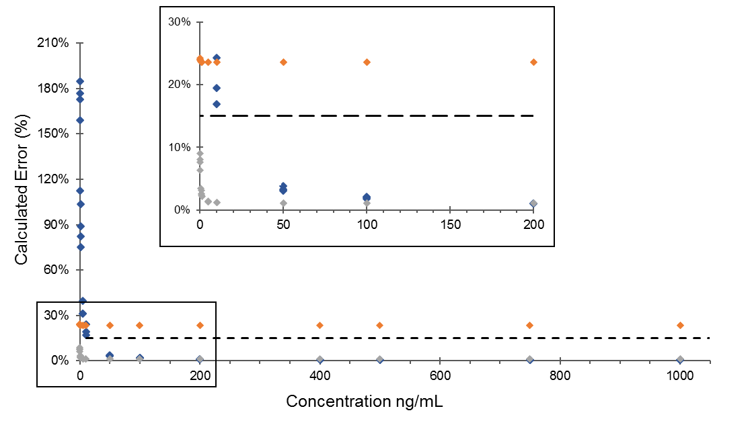
Figure S1 Three weighting schemes evaluated via percentage error across the full range, an example using azithromycin. No weighting x (blue); weighting 1/x (grey); weighting 1/x² (orange); 15 % maximum error is marked as the FDA's guideline for validation of bioanalytical methods. The origin has been enlarged for clarity.

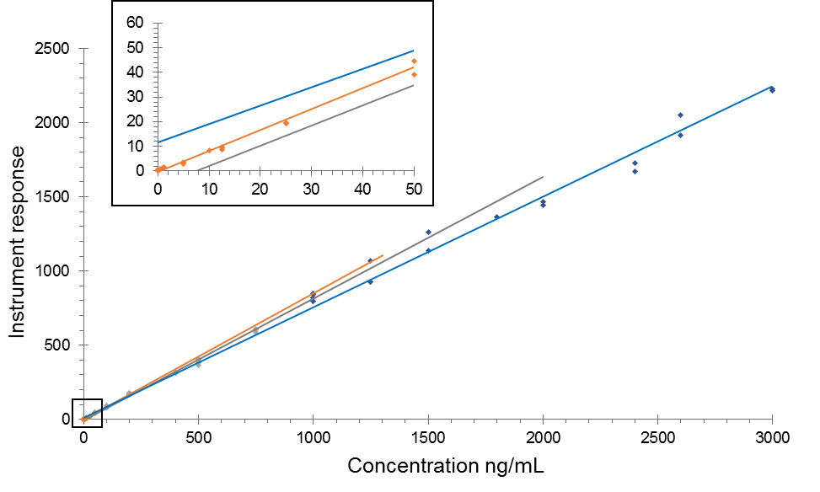
Figure S2 Example of split calibration ranges with an emphasis on accuracy near the origin (region enlarged), an example using erythromycin. First range (0.005-200 µg L⁻¹, r² 0.998, orange); second range (200-1000 µg L⁻¹, r² 0.995, grey); third range (1000-3000 µg L⁻¹, r² 0.996, blue). Trend lines were extrapolated forwards to exhibit the decrease in gradient as the concentration approached instrument saturation.

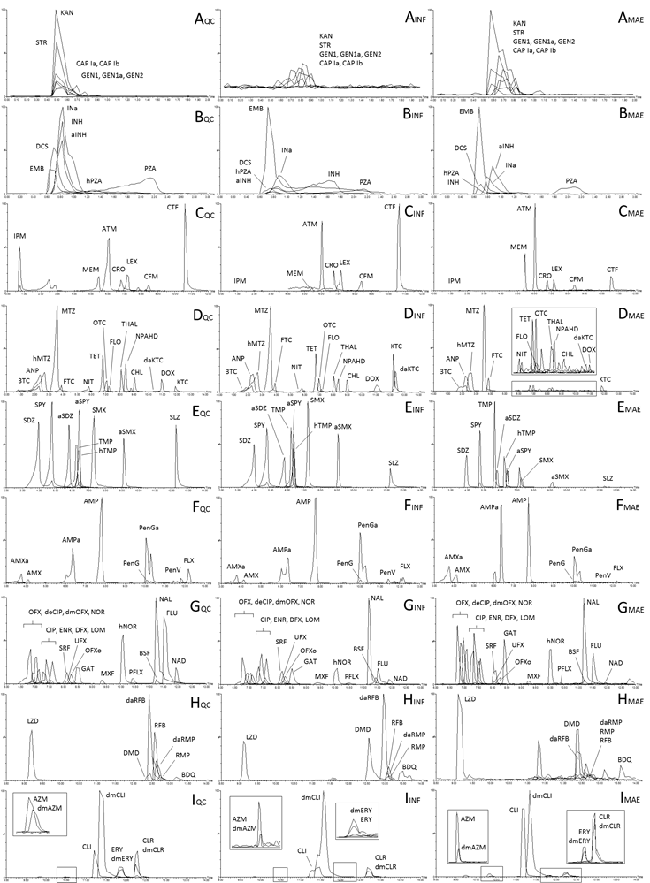
Figure S3 Overlaid chromatograms, scaled by relative intensity, highlighting regions by chemical class (A-I). Vertically: overlaid extracted ion chromatograms (EICs), sorted by chemical class. Aminoglycosides (A); TB drugs early-eluting (B); cephalosporins and carbapenems (C); ARVs, azoles, nitrofurans, cyclines, amphenicols (D); sulfonamides (E); penicillins (F), quinolones (G); TB drugs late-eluting (H); macrolides and lincomycins (I). Horizontally: matrix effect of spiked wastewater influent (INF) and suspended particulate matter via microwave assisted extraction (MAE); compared to a mobile phase quality control (QC). The EICs displayed have not been smoothed, contrary to the method.

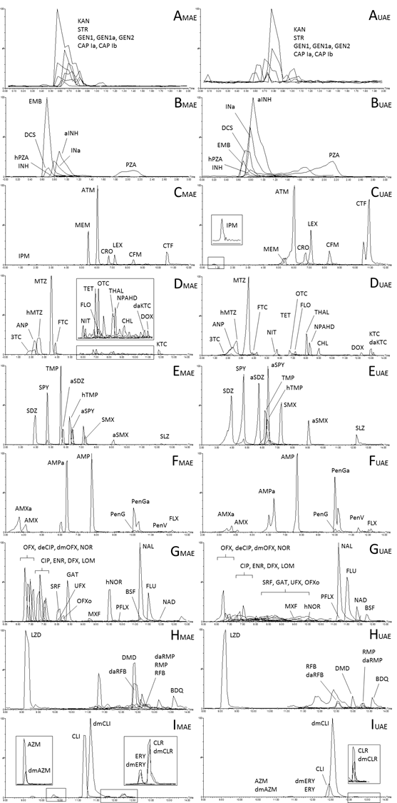
Figure S4 Overlaid chromatograms, scaled by relative intensity, highlighting regions by chemical class (A-I). Vertically: overlaid extracted ion chromatograms (EICs), sorted by chemical class. Aminoglycosides (A); TB drugs early-eluting (B); cephalosporins and carbapenems (C); ARVs, azoles, nitrofurans, cyclines, amphenicols (D); sulfonamides (E); penicillins (F); fluoroquinolones (G); TB drugs late-eluting (H); macrolides and lincomycins (I). Horizontally: extraction method efficacy for activated sludge, comparing microwave assisted extraction (MAE), and ultra-sonication assisted extraction (UAE). The EICs displayed have not been smoothed, contrary to the method.

Table S10 Compound structural information, grouped by drug class and corresponding drug metabolites (9 pages)
Chemical group | Compound | Formula | Monoisotopic mass | R₁ | R₂ | R₃ | R₄
PENICILLINS | Amoxicillin | C₁₆H₁₉N₃O₅S | 365.1045 | phenol | NH₂
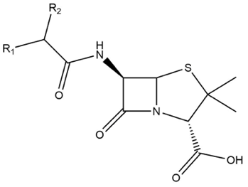 | Ampicillin | C₁₆H₁₉N₃O₄S | 349.1096 | phenyl | NH₂
 | Flucloxacillin | C₁₉H₁₇ClFN₃O₅S | 453.0561 | 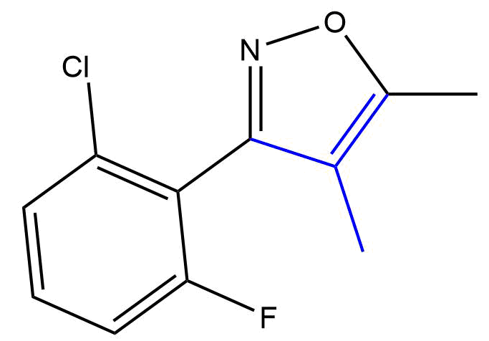 | [See R₁]
 | Penicillin G | C₁₆H₁₈N₂O₄S | 334.0987 | phenyl | H
 | Penicillin V | C₁₆H₁₈N₂O₅S | 350.0936 | phenoxymethyl | H
PENICILLIN METABOLITES  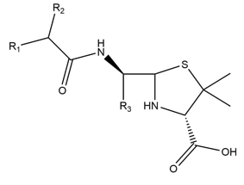 | Amoxicilloic acid | C₁₆H₂₁N₃O₆S | 383.1151 | As amoxicillin | As amoxicillin | COOH
 | Ampicilloic acid | C₁₆H₂₁N₃O₅S | 367.1202 | As ampicillin | As ampicillin | COOH
 | Penicilloic G acid | C₁₆H₂₀N₂O₅S | 352.1093 | As penicillin G | As penicillin G | COOH
CEPHALOSPORINS | Cefaclor ≠ | C₁₅H₁₄ClN₃O₄S | 367.0394 | amine | phenyl | H | Cl
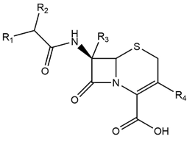 | Cefalexin | C₁₆H₁₇N₃O₄S | 347.0940 | amine | phenyl | H | CH₃
 | Cefixime | C₁₆H₁₅N₅O₇S₂ | 453.0413 | aminothiazole | 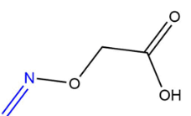 | H | ethane
 | Cefoxitin ≠ | C₁₆H₁₇N₃O₇S₂ | 427.0508 | aminothiazole | H | methoxy | methylcarbamate
 | Ceftazidime ≠ | C₂₂H₂₂N₆O₇S₂ | 546.0991 | aminothiazole | 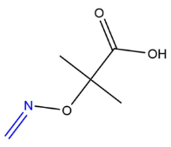 | H | CH₃-pyridine
 | Ceftiofur | ‎C₁₉H₁₇N₅O₇S₃ | 523.0290 | aminothiazole | 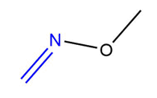 | H | 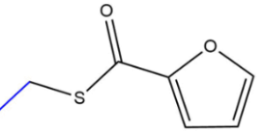
 | Ceftriaxone | C₁₈H₁₈N₈O₇S₃ | 554.0461 | aminothiazole |  | H | 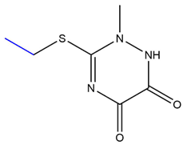

Chemical group | Compound | Formula | Monoisotopic mass | R₁ | R₂ | R₃ | R₄
ISONIAZID & METABOLITES  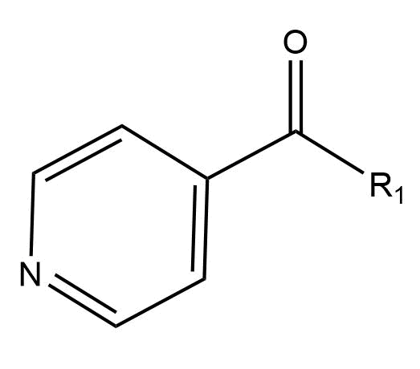 | Isoniazid | C₆H₇N₃O | 137.0589 | hydrazine
 | Isoniazid acetyl | C₈H₉N₃O₂ | 179.0695 | hydrazine-acetyl
 | Isonicotinic acid | C₆H₅NO₂ | 123.0320 | OH
PYRAZINAMIDE & METABOLITES  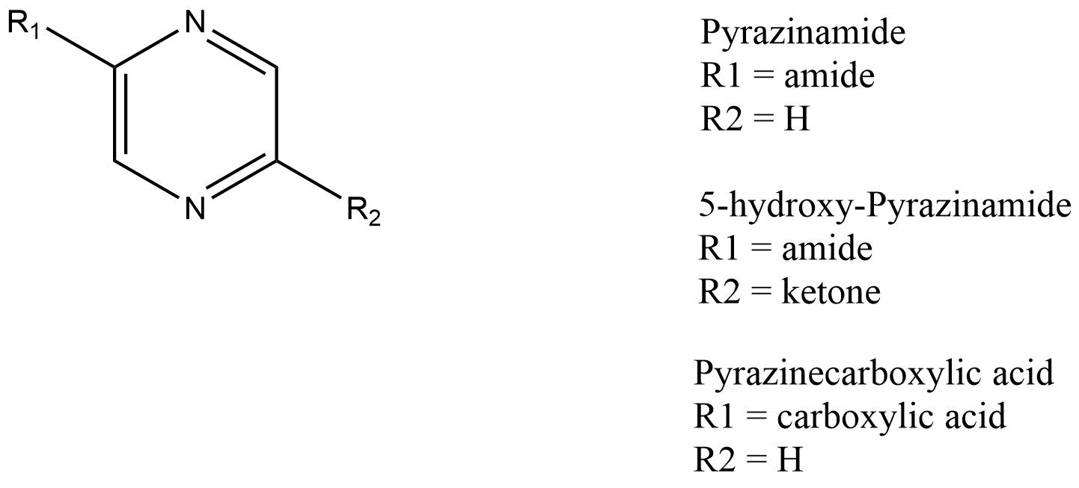 | Pyrazinamide | C₅H₅N₃O | 123.0433 | amide | H |  | Prodrug
 | Pyrazinoic acid ≠ | C₅H₄N₂O₂ | 124.0273 | amide | ketone |  | Active metabolite
 | Pyrazinoic acid  5-hydroxy | C₅H₄N₂O₃ | 140.0222 | carboxylic acid | H
RIFAMYCINS  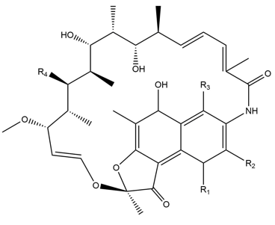 | Rifabutin | C₄₆H₆₂N₄O₁₁ | 846.4415 | 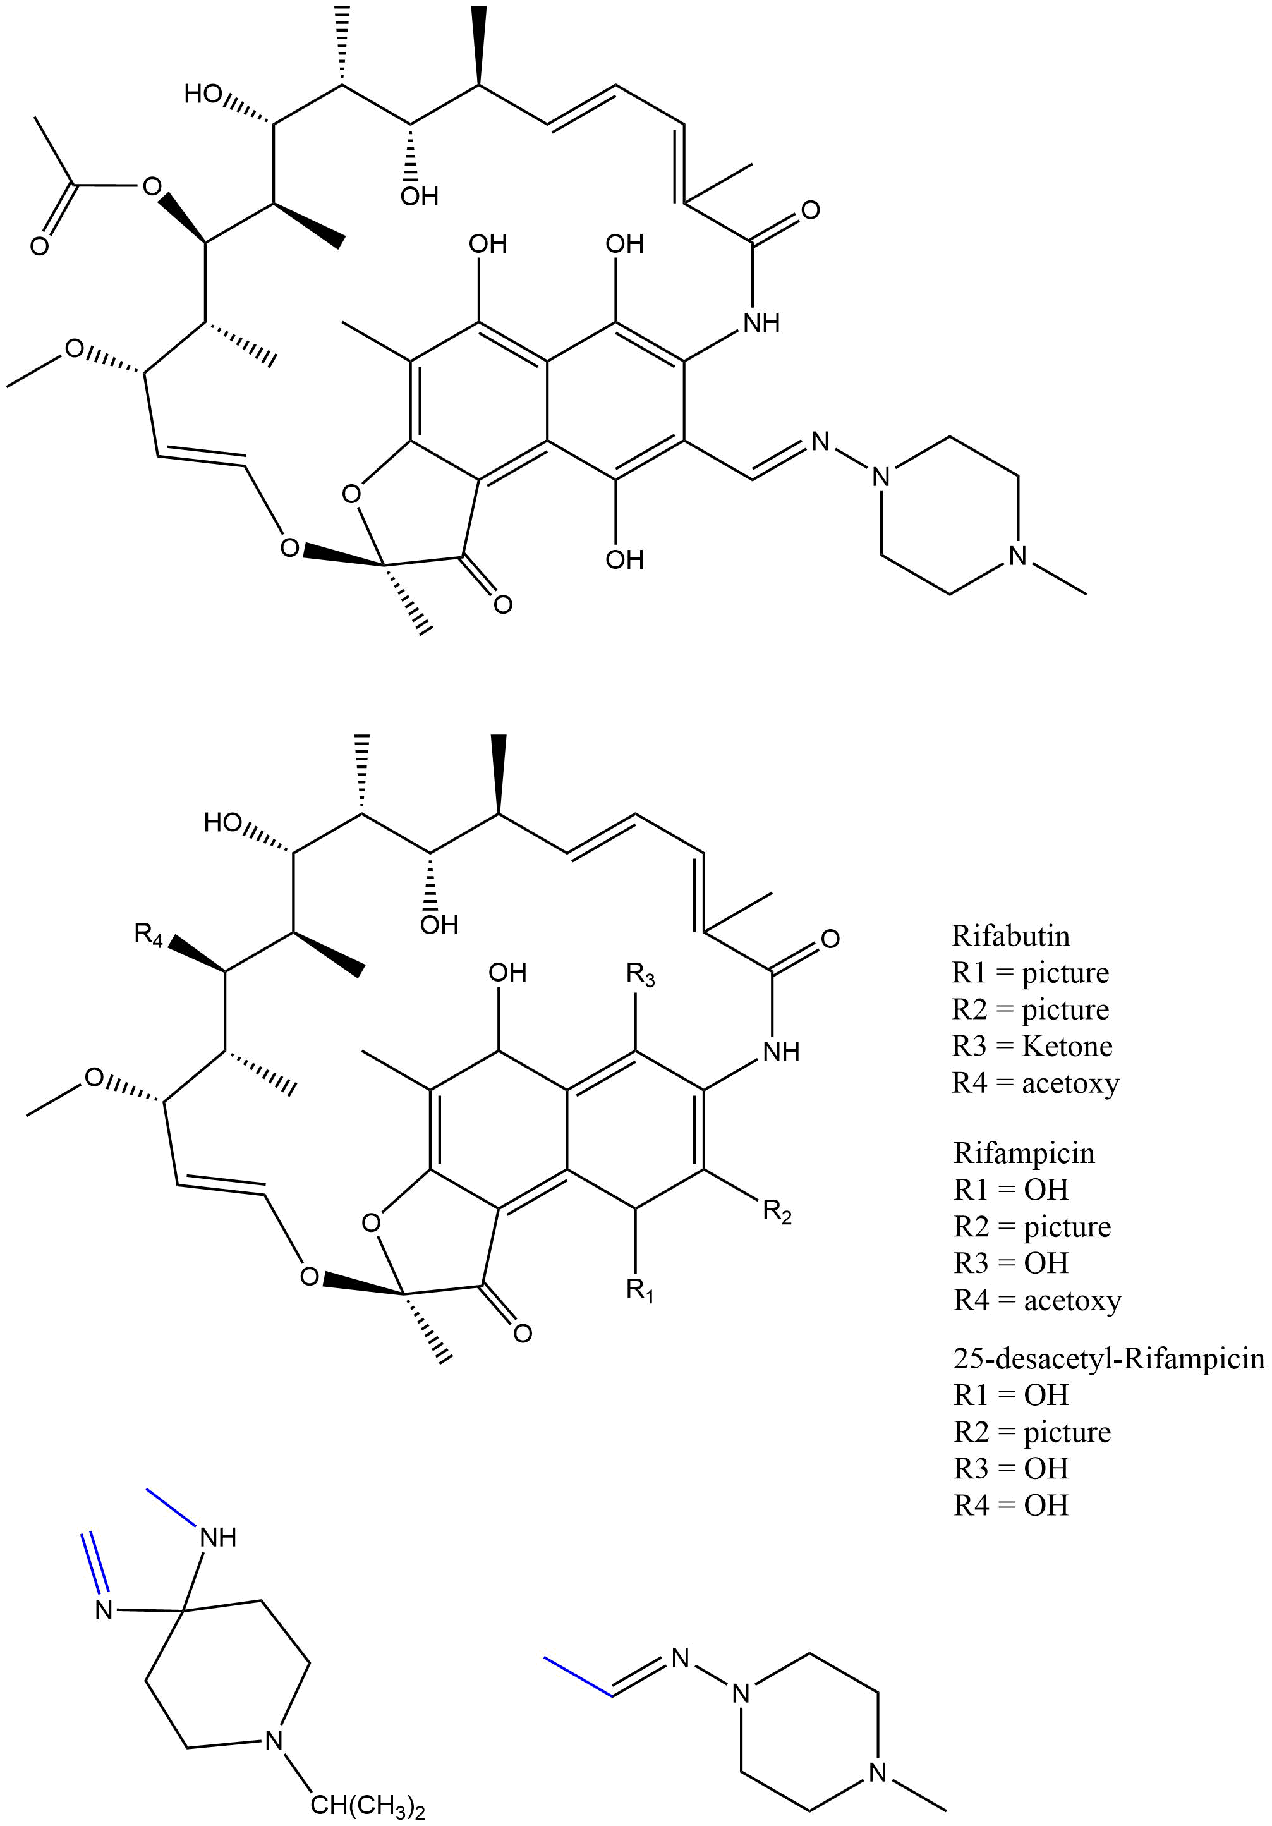 | [See R₁] | ketone | acetoxy
 | Rifampicin | C₄₃H₅₈N₄O₁₂ | 822.4051 | OH |  | OH | acetoxy
RIFAMYCIN METABOLITES | Rifabutin 25-O-desacetyl | C₄₄H₆₀N₄O₁₀ | 804.4309 | As rifabutin | As rifabutin | As rifabutin | methoxy
 | Rifampicin 25-desacetyl | C₄₁H₅₆N₄O₁₁ | 780.3946 | As rifampicin | As rifampicin | As rifampicin | methoxy
TERIZIDONE & METABOLITE  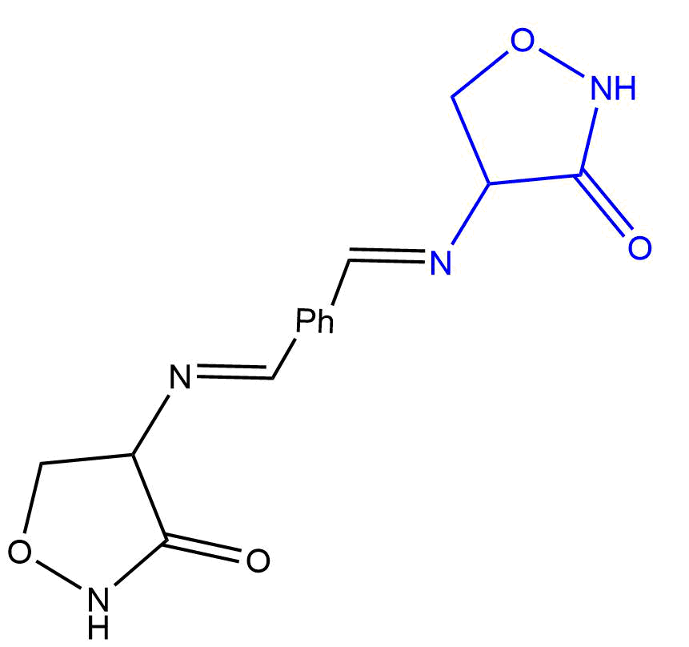 | Terizidone ≠ | C₁₄H₁₄N₄O₄ | 302.1015 | Whole structure  (Ph = 1,4-phenyl) |  | Prodrug
 | Cycloserine | C₃H₆N₂O₂ | 102.0429 | Amino isoxazolidinone group  (blue) |  | Active metabolite

Chemical group | Compound | Formula |  |  | Monoisotopic mass |  |  | R₁ |  |  | R₂ |  | R₃
IMIDAZOLES  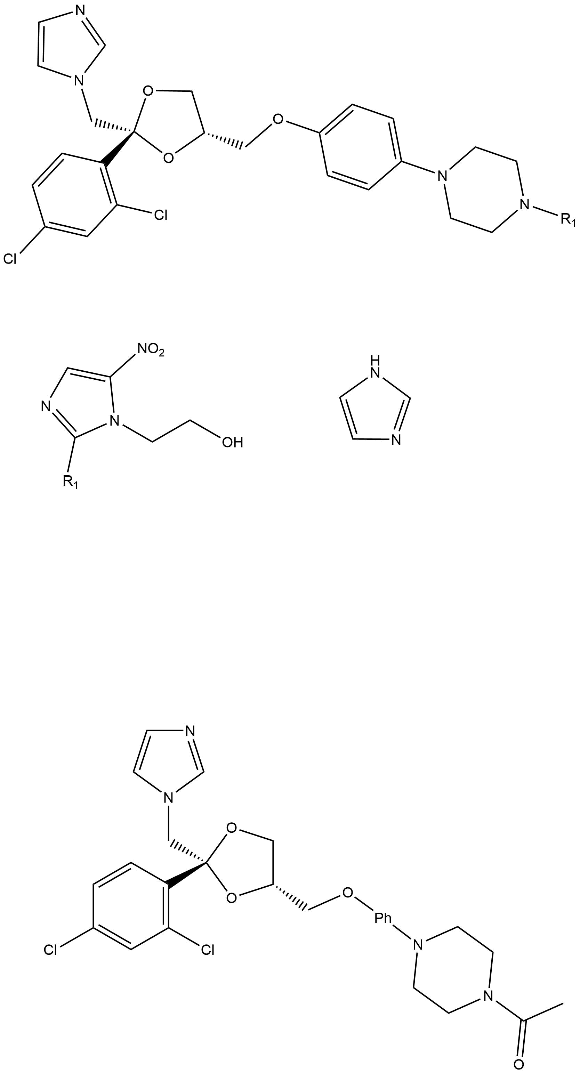 | Ketoconazole |  | C₂₆H₂₈Cl₂N₄O₄ | 530.1488 |  |  |  |  |  |  |  |  |  | R₁ = acetyl
 | Metronidazole |  | C₆H₉N₃O₃ | 171.0644 |  |  |  |  | 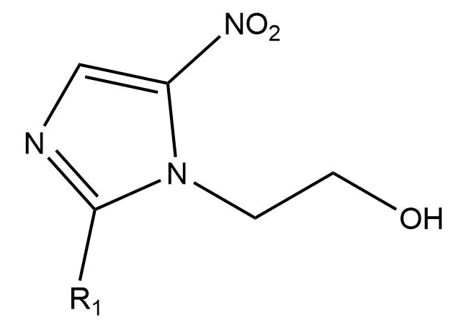 |  |  |  |  | R₁ = CH₃
IMIDAZOLE METABOLITES | Ketoconazole  deacetyl |  | C₂₄H₂₆Cl₂N₄O₃ | 488.1382 |  |  |  |  | As ketoconazole |  |  |  |  | R₁ = H
 | Metronidazole hydroxy |  | C₆H₉N₃O₄ | 187.0593 |  |  |  |  | As metronidazole |  |  |  |  | R₁ = ethanol
TETRACYCLINES | Doxycycline | C₂₂H₂₄N₂O₈ |  |  |  | 444.1533 | H |  |  | CH₃ |  | OH
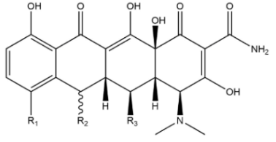 | Minocycline ≠ | C₂₃H₂₇N₃O₇ |  |  |  | 457.1849 | N(CH₃)₂ |  |  | H |  | H
 | Oxytetracycline | C₂₂H₂₄N₂O₉ |  |  |  | 460.1482 | H |  |  | OH |  | OH
 | Tetracycline | C₂₂H₂₄N₂O₈ |  |  |  | 444.1533 | H |  |  | OH |  | H
NITROFURANTOIN | Nitrofurantoin | C₈H₆N₄O₅ |  |  |  | 238.0338 | 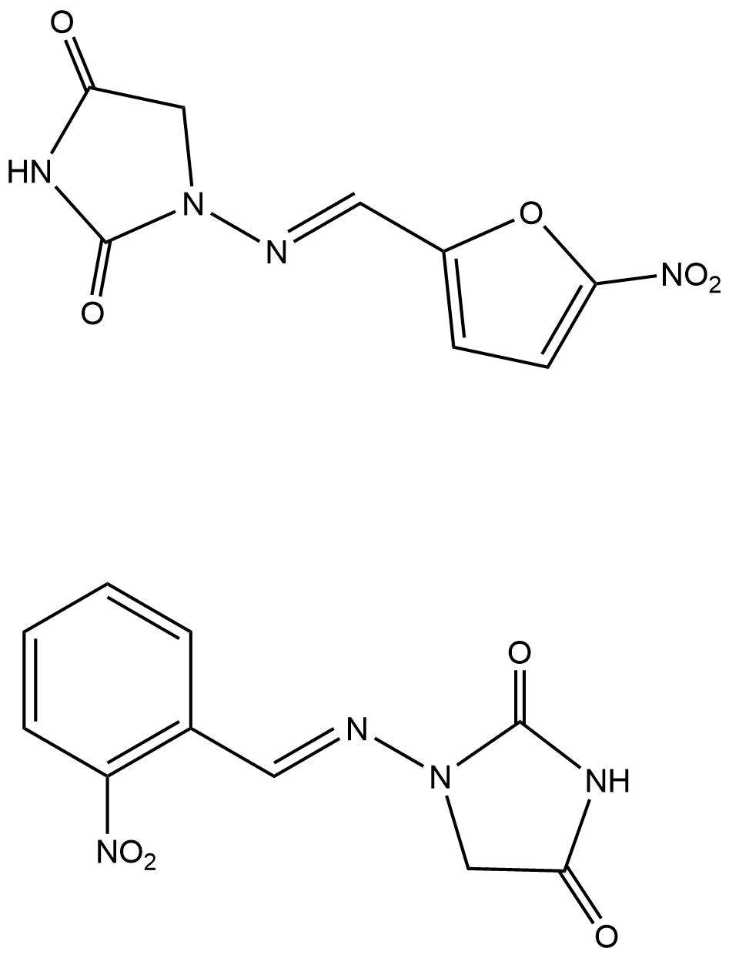
NITROFURANTOIN METABOLITE | NP-AHD | C₁₀H₈N₄O₄ |  |  |  | 248.0546
Chemical group | Compound | Formula |  |  | Monoisotopic mass |  |  | R₁ |  |  | R₂ |  | R₃
FLUOROQUINOLONES | Besifloxacin | C₁₉H₂₁ClFN₃O₃ |  |  | 393.1255 |  |  | cyclopropane |  |  | Cl |  | aminoazepane
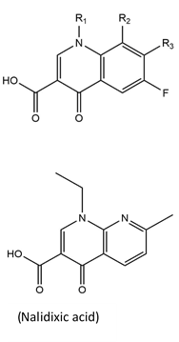 | Ciprofloxacin | C₁₇H₁₈FN₃O₃ |  |  | 331.1332 |  |  | cyclopropane |  |  | H |  | piperazine
 | Danofloxacin | C₁₉H₂₀FN₃O₃ |  |  | 357.1489 |  |  | cyclopropane |  |  | H |  | 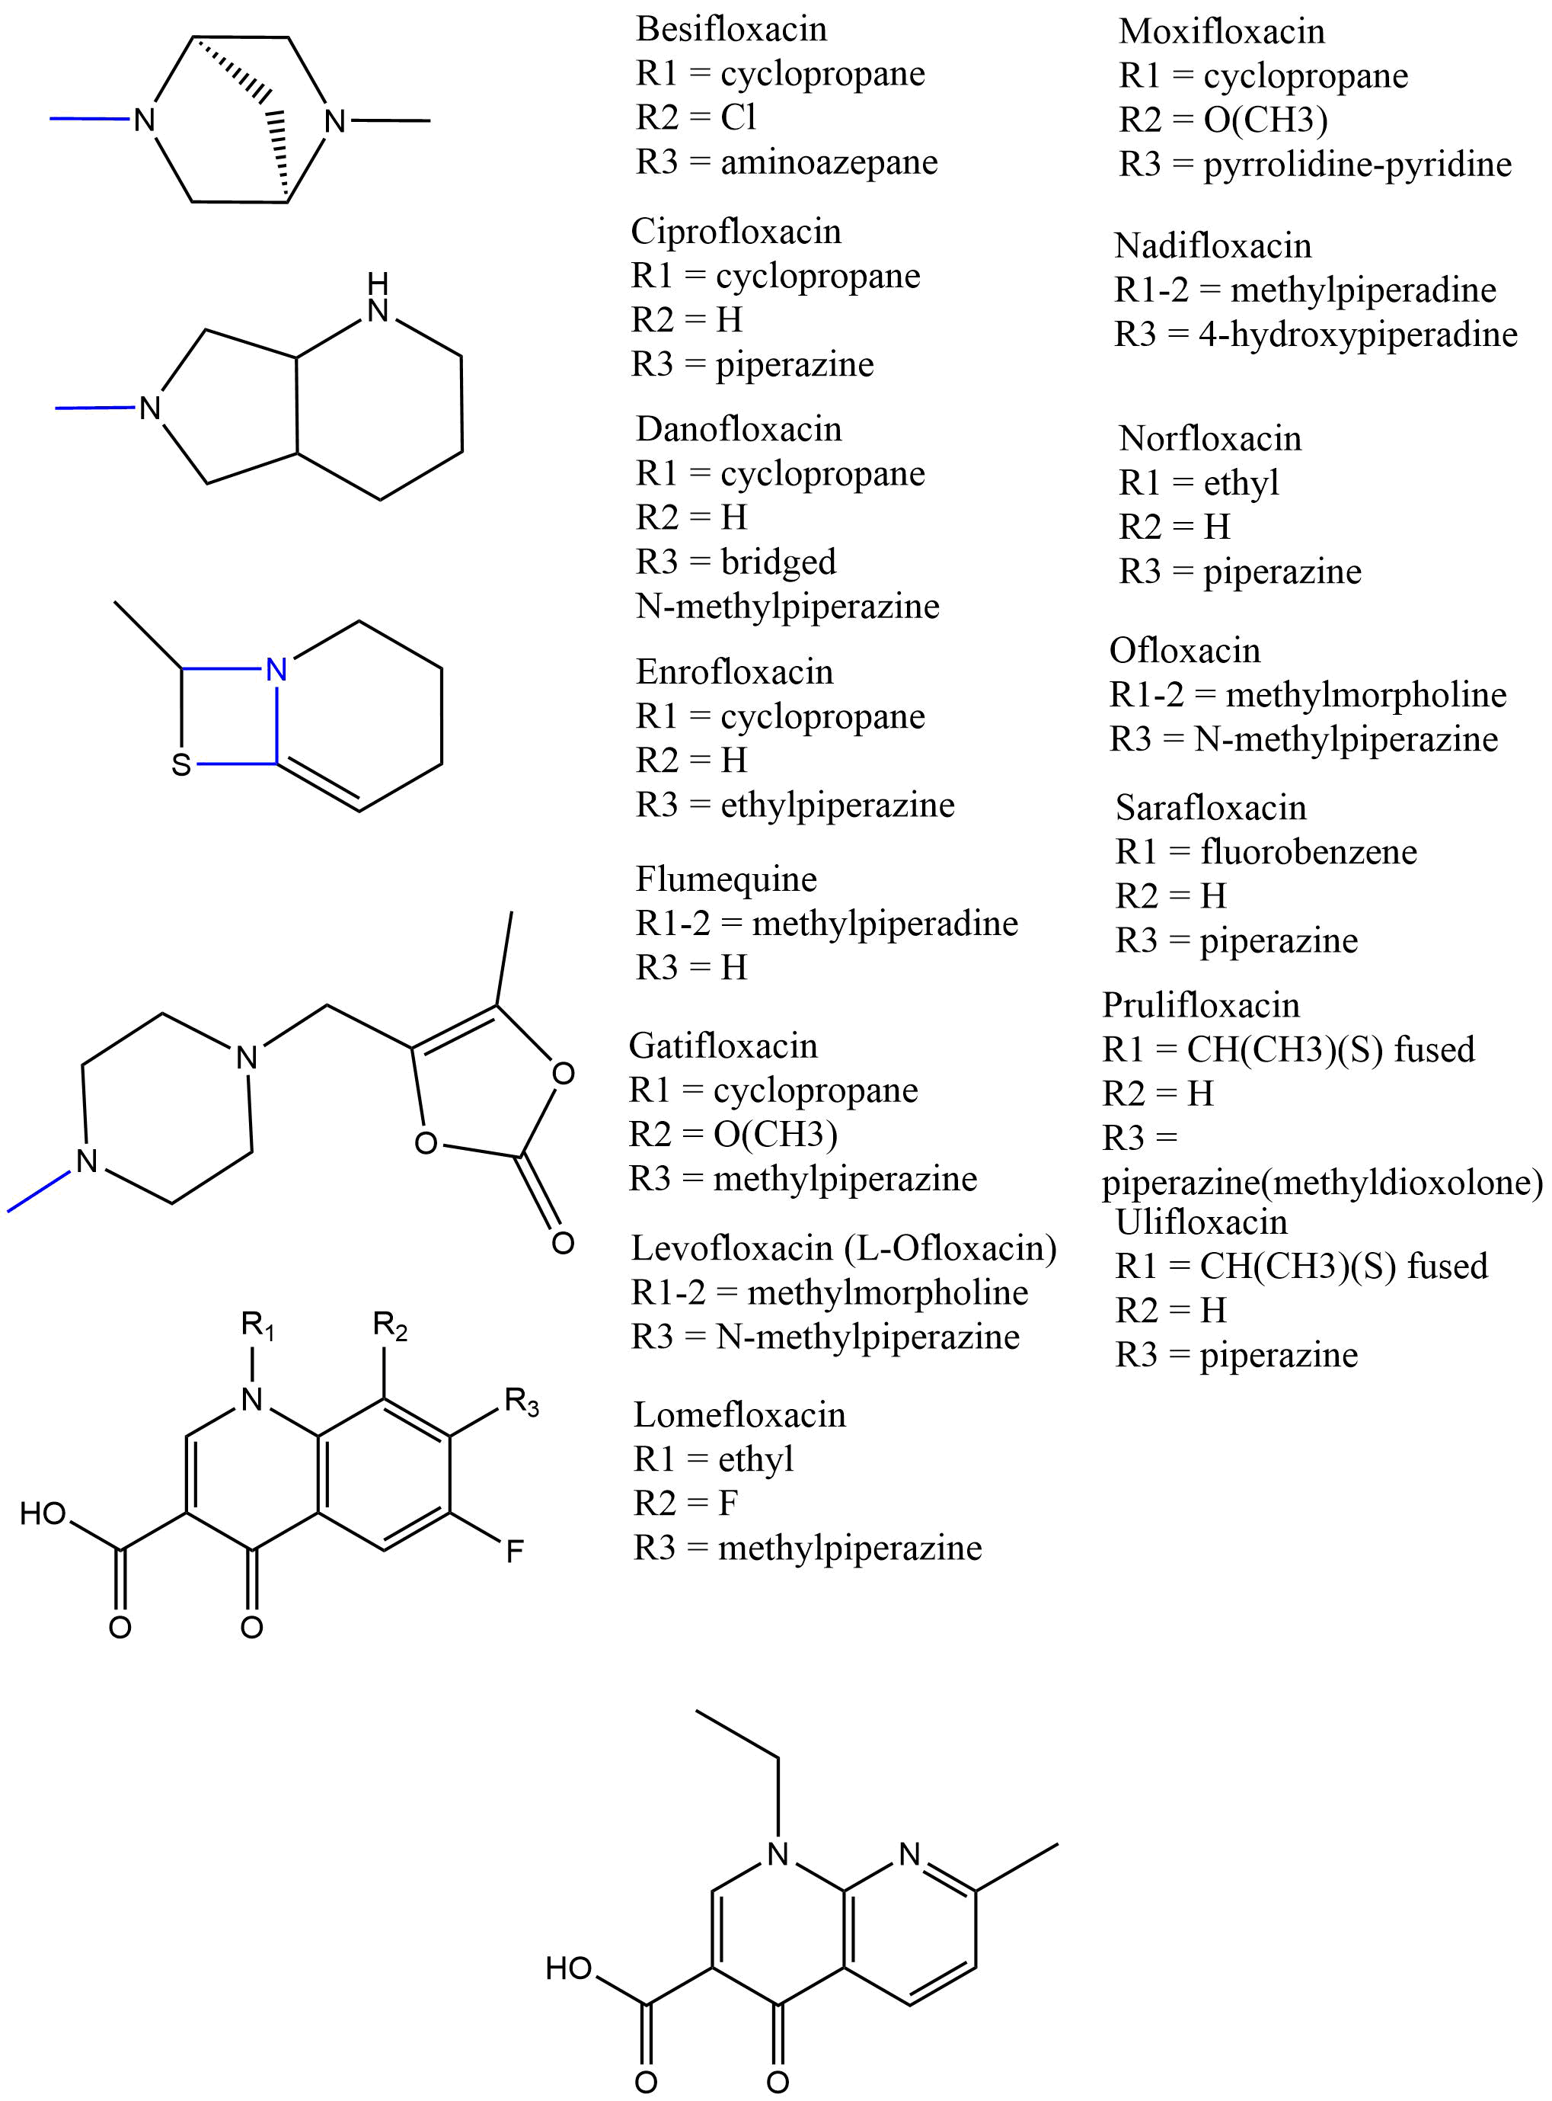
 | Enrofloxacin | C₁₉H₂₂FN₃O₃ |  |  | 359.1645 |  |  | cyclopropane |  |  | H |  | ethylpiperazine
 | Flumequine | C₁₄H₁₂FNO₃ |  |  | 261.0801 |  |  | methylpiperadine |  |  | [See R₁] |  | H
 | Gatifloxacin | C₁₉H₂₂FN₃O₄ |  |  | 375.1594 |  |  | cyclopropane |  |  | methoxy |  | methylpiperazine
 | Lomefloxacin | C17H19F2N3O3 |  |  | 351.1394 |  |  | ethyl |  |  | F |  | methylpiperazine
 | Moxifloxacin | C₂₁H₂₄FN₃O₄ |  |  | 401.1751 |  |  | cyclopropane |  |  | methoxy
 | Nadifloxacin | C₁₉H₂₁FN₂O₄ |  |  | 360.1485 |  |  | methylpiperadine |  |  | [See R₁] |  | 4-hydroxypiperadine
 | Nalidixic acid | C₁₂H₁₂N₂O₃ |  |  | 232.0848 |  |  | pictured (left)
 | Norfloxacin | C₁₆H₁₈FN₃O₃ |  |  | 319.1332 |  |  | ethyl |  |  | H |  | Piperazine
 | Ofloxacin | C₁₈H₂₀FN₃O₄ |  |  | 361.1438 |  |  | methylmorpholine |  |  | [See R₁] |  | N-methylpiperazine
 | Prulifloxacin | C₂₁H₂₀FN₃O₆S |  |  | 461.1057 |  |  | 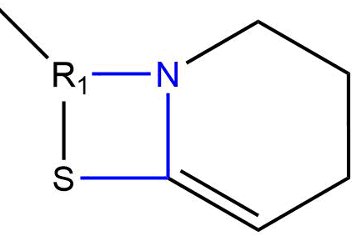 |  |  | H |  | 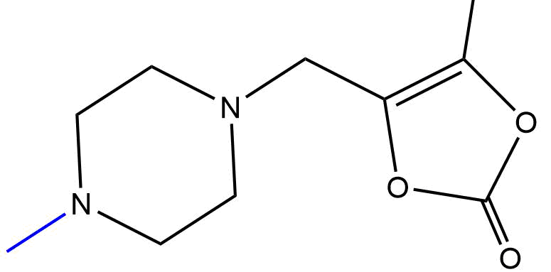
 | Sarafloxacin | C₂₀H₁₇F₂N₃O₃ |  |  | 385.1238 |  |  | fluorobenzene |  |  | H |  | piperazine
 | Ulifloxacin | C₁₆H₁₆FN₃O₃S |  |  | 349.0896 |  |  |  |  |  | H |  | piperazine
FLUOROQUINOLONE METABOLITES | Ciprofloxacin desethylene- | C₁₅H₁₆FN₃O₃ |  |  | 305.1176 |  |  | As ciprofloxacin |  |  | As ciprofloxacin |  | diaminoethane
 | Ciprofloxacin | C₁₇H₁₈FN₃O₃ |  |  | 331.1332 |  |  | As above |  |  | As above |  | As above |  |  | Enrofloxacin metabolite
 | Ofloxacin desmethyl- | C₁₇H₁₈FN₃O₄ |  |  | 347.1281 |  |  | As ofloxacin |  |  | As ofloxacin |  | piperazine
 | Ofloxacin N-oxide | C₁₈H₂₀FN₃O₅ |  |  | 377.1387 |  |  | N-oxide methylmorpholine |  |  | As ofloxacin |  | As ofloxacin
 | Ulifloxacin | C₁₆H₁₆FN₃O₃S |  |  | 349.0896 |  |  | As above |  |  | As above |  | As above |  |  | Prulifloxacin metabolite
 | Norfloxacin  N-hydroxy | C₁₆H₁₈FN₃O₄ |  |  | 335.1281 |  |  | As norfloxacin |  |  | As norfloxacin |  | N-hydroxy Piperazine
Group | Compound | Formula |  |  | Monoisotopic mass |  |  | R₁ |  |  | R₂ |  | R₃
SULFONAMIDES | Sulfadiazine | C₁₀H₁₀N₄O₂S |  |  | 250.0524 |  |  | NH₂ |  |  | 1,3-diazine
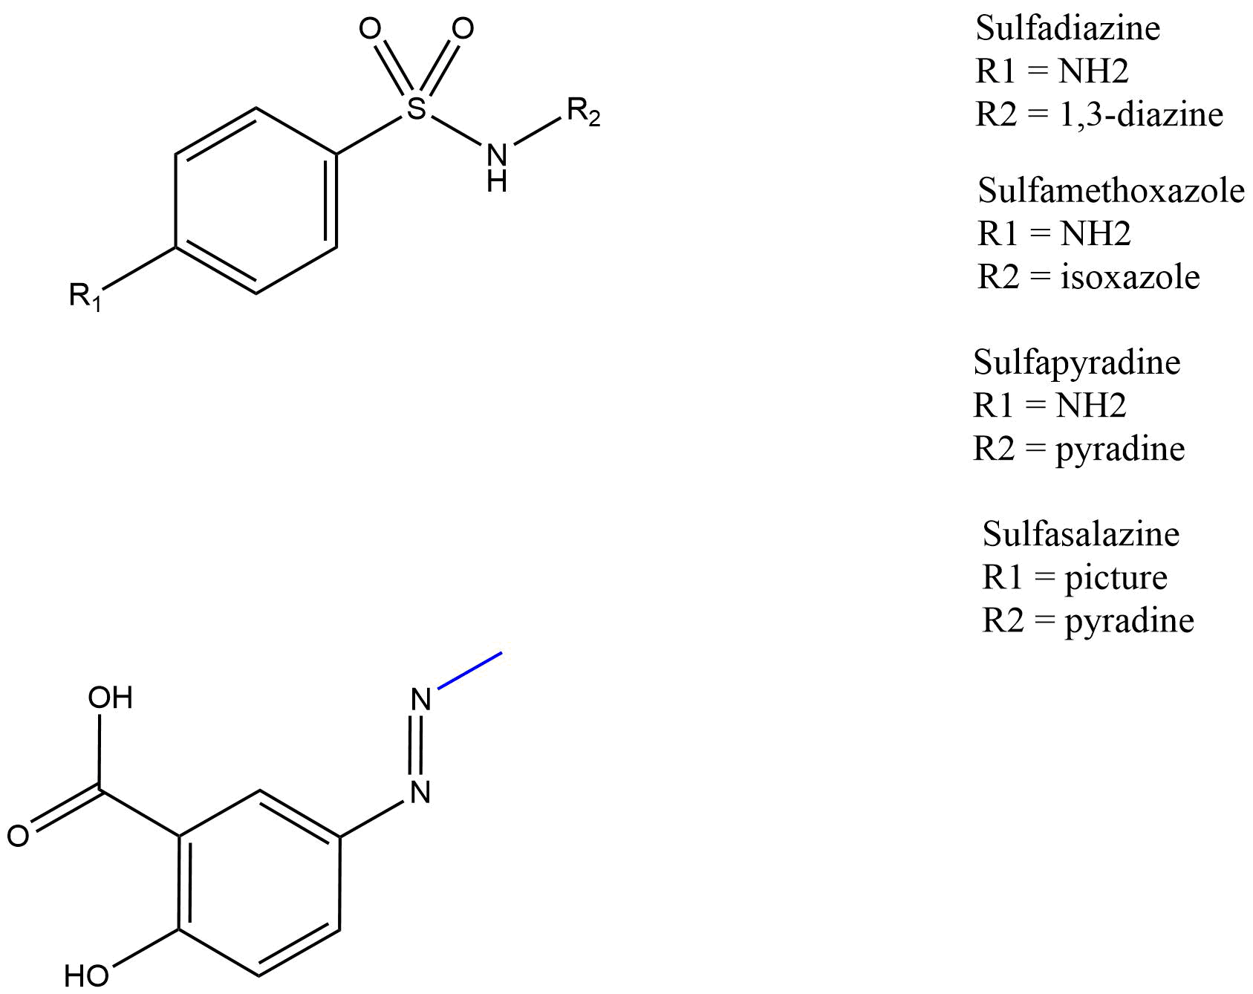 | Sulfamethoxazole | C₁₀H₁₁N₃O₃S |  |  | 253.0521 |  |  | NH₂ |  |  | isoxazole
 | Sulfapyridine | C₁₁H₁₁N₃O₂S |  |  | 249.0572 |  |  | NH₂ |  |  | pyridine
 | Sulfasalazine | C₁₈H₁₄N₄O₅S |  |  | 398.0685 |  |  |  |  |  | pyridine |  |  |  |  | Prodrug
SULFONAMIDE METABOLTES | Sulfadiazine  N-acetyl | C₁₂H₁₂N₄O₃S |  |  | 292.0630 |  |  | N-acetyl |  |  | As sulfadiazine
 | Sulfamethoxazole N-acetyl | C₁₂H₁₃N₃O₄S |  |  | 295.0627 |  |  | N-acetyl |  |  | As sulfamethoxazole
 | Sulfapyridine  N-acetyl | C₁₃H₁₃N₃O₃S |  |  | 291.0678 |  |  | N-acetyl |  |  | As sulfapyridine
 | Sulfapyridine | C₁₁H₁₁N₃O₂S |  |  | 249.0572 |  |  | As above |  |  | As above |  | Sulfasalazine active metabolite
TRIMETHOPRIM & METABOLITES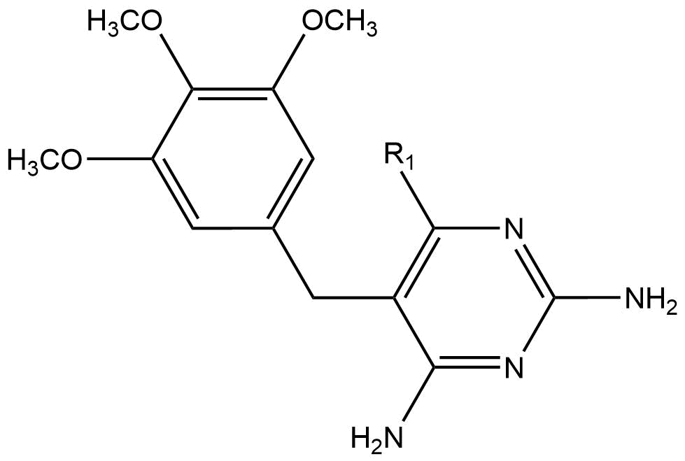 | Trimethoprim | C₁₄H₁₈N₄O₃ |  |  | 290.1379 |  |  | H
 | Trimethoprim 4-hydroxy | C₁₄H₁₈N₄O₄ |  |  | 306.1328 |  |  | OH

Group | Compound | Formula | Monoisotopic mass | R₁ | R₂ | R₃ |  | R₄
AMPHENICOLS  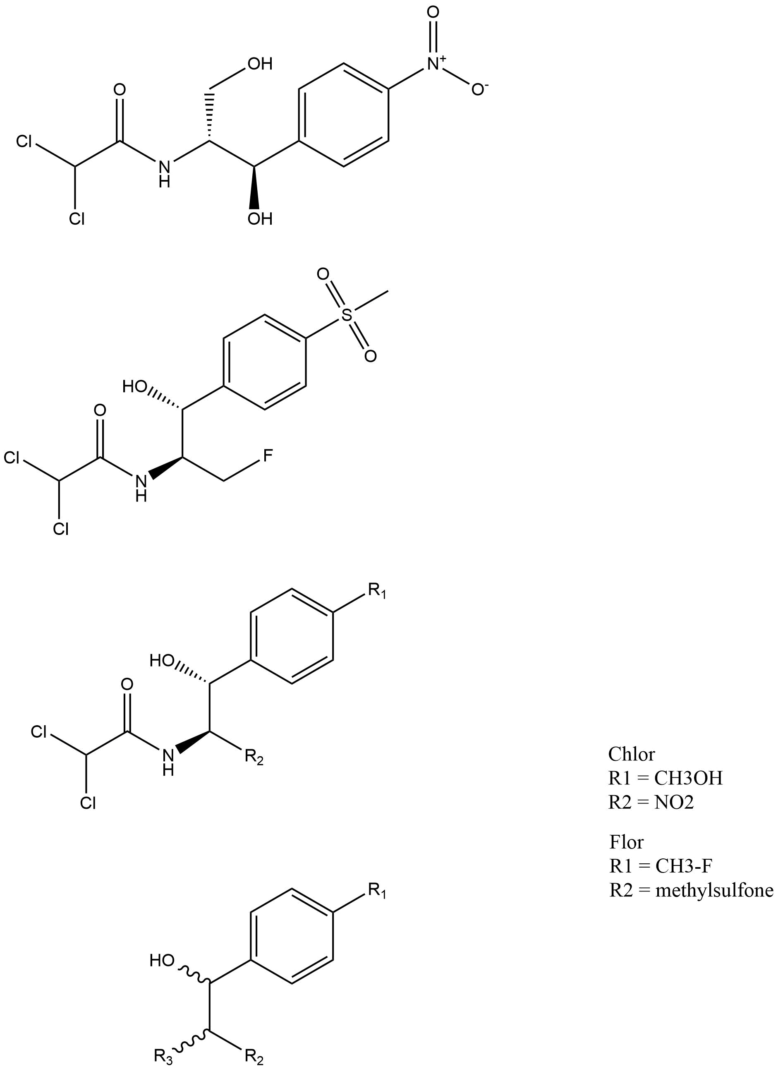 | Chloramphenicol | C₁₁H₁₂Cl₂N₂O₅ | 322.0123 | NO₂ | methanol
 | Florfenicol | C₁₂H₁₄Cl₂FNO₄S | 357.0005 | methyl sulfone | CH₃F
AMPHENICOL METABOLITES | S,S-ANP | C₉H₁₂N₂O₄ | 212.0797 | As chloramphenicol | As chloramphenicol | NH₂
ANTIRETROVIRALS  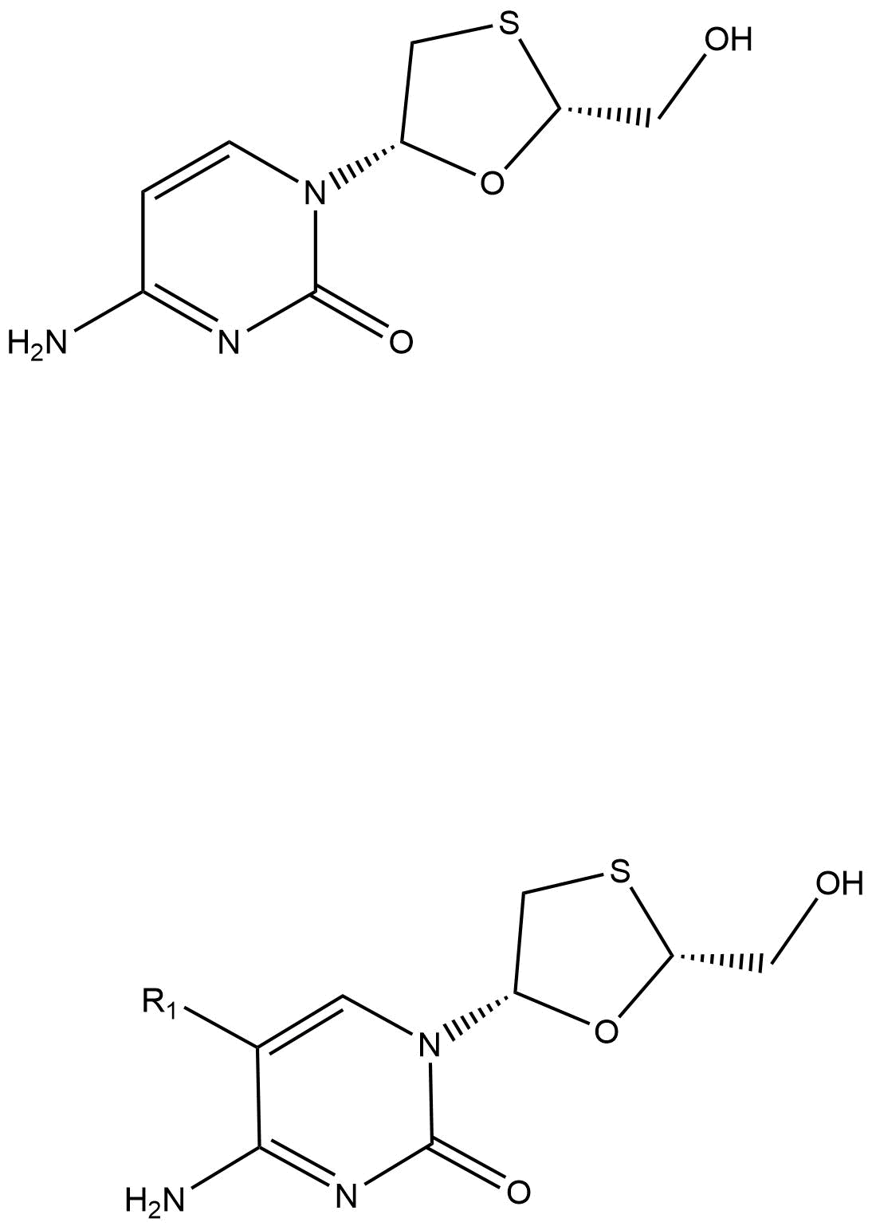 | Emtricitabine | C₈H₁₀FN₃O₃S | 247.0427 | F
 | Lamivudine | C₈H₁₁N₃O₃S | 229.0521 | H
POLYMYXINS & METABOLITES | Colistimethate ≠ | C₅₃H₁₀₂N₁₆O₁₆S | 1250.7380 | 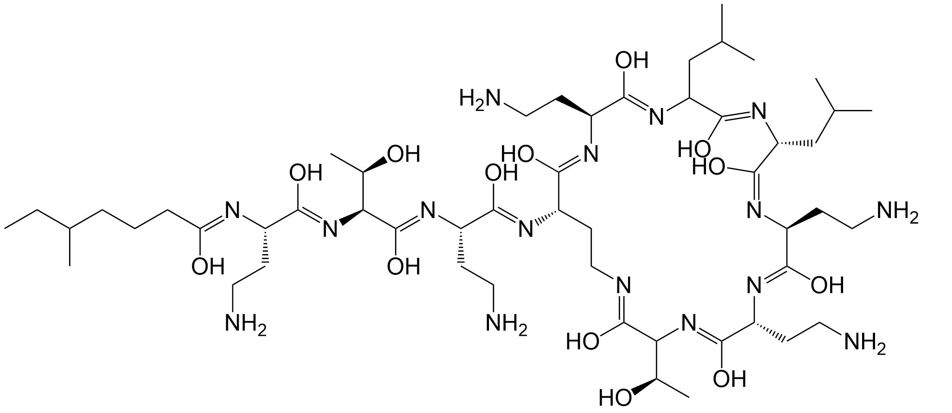 |  |  | Prodrug
POLYMYXINS & METABOLITES | Colistin A ≠  Colistin B ≠ | C₅₃H₁₀₀N₁₆O₁₃  C₅₂H₉₈N₁₆O₁₃ | 1168.7656  1154.7499 | R₁ = CH₃  R₁ = H | 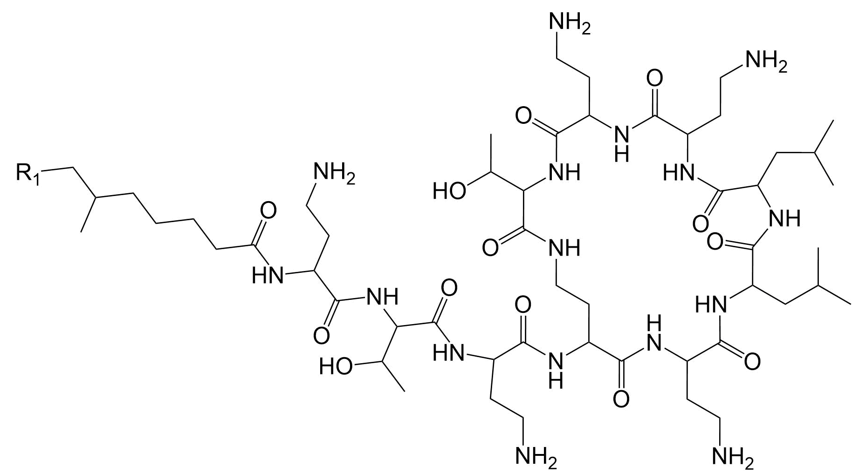 |  | Active metabolite

Group | Compound | Formula | Monoisotopic mass | Aglycone ring | Aglycone ring | Amino sugar (R₁) | Sugar (R₂)
MACROLIDES | Azithromycin A  Azithromycin B ¥ | C₃₈H₇₂N₂O₁₂  C₃₈H₇₂N₂O₁₁ | 748.5085  732.5136 | 15-membered  C₂₂H₄₁NO₅ | 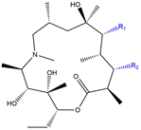 | 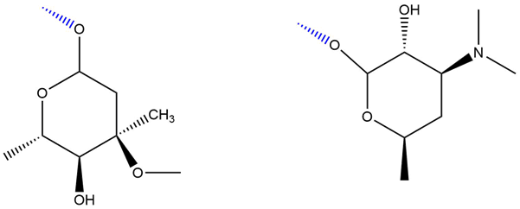
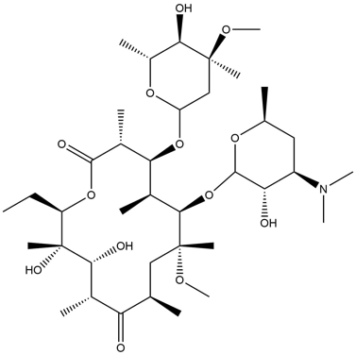e.g. Clarithromycin | Clarithromycin | C₃₈H₆₉NO₁₃ | 747.4769 | 14-membered  C₂₂H₃₈O₆ | 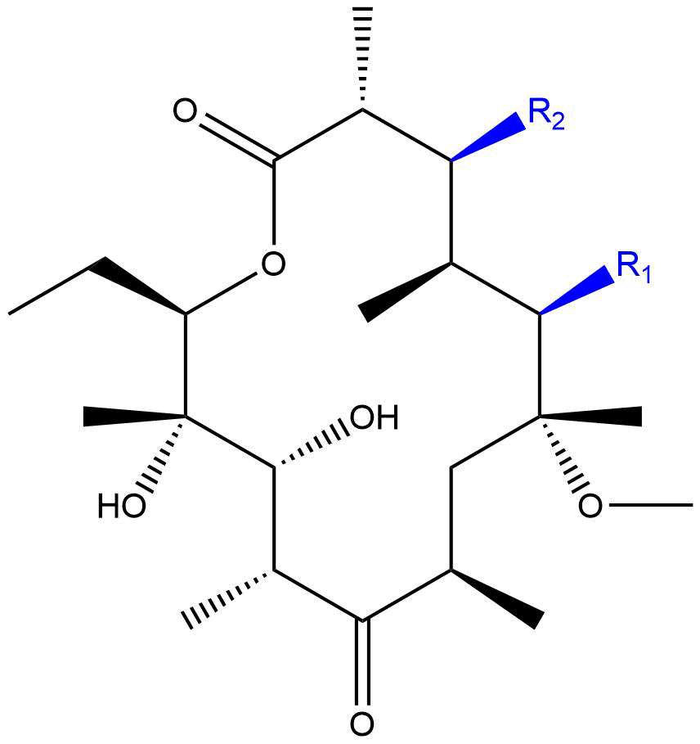
 | Erythromycin A  Erythromycin B ¥  Erythromycin C ¥  Erythromycin D ¥ | C₃₇H₆₇NO₁₃  C₃₇H₆₇NO₁₂  C₃₆H₆₅NO₁₃  C₃₆H₆₅NO₁₂ | 733.4612  717.4663  719.4456  703.4507 | 14-membered  C₂₁H₃₇O₆ | 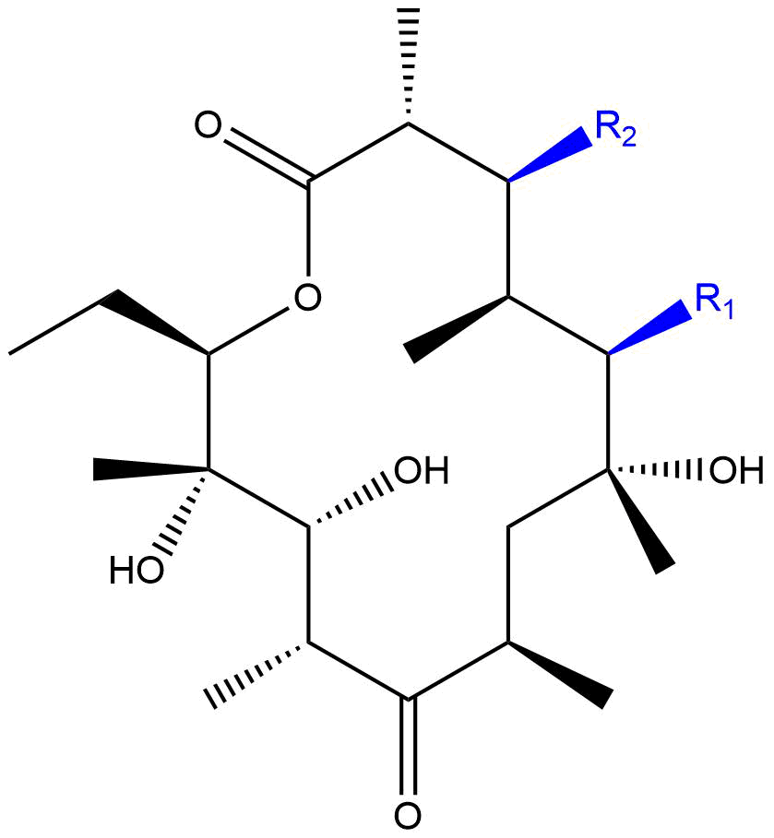
 | Tylosin ≠ | C₄₆H₇₇NO₁₇ | 915.5192 | 16-membered  C₂₃H₃₄O₅ | 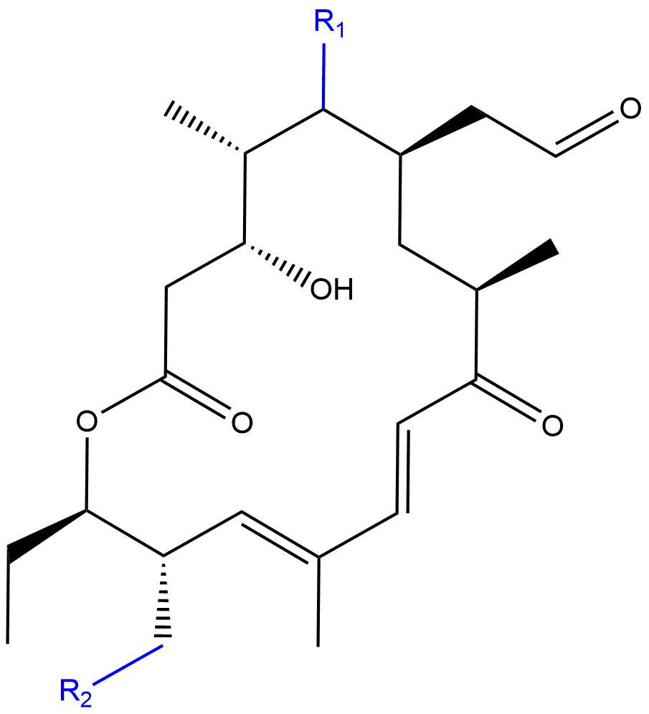 | 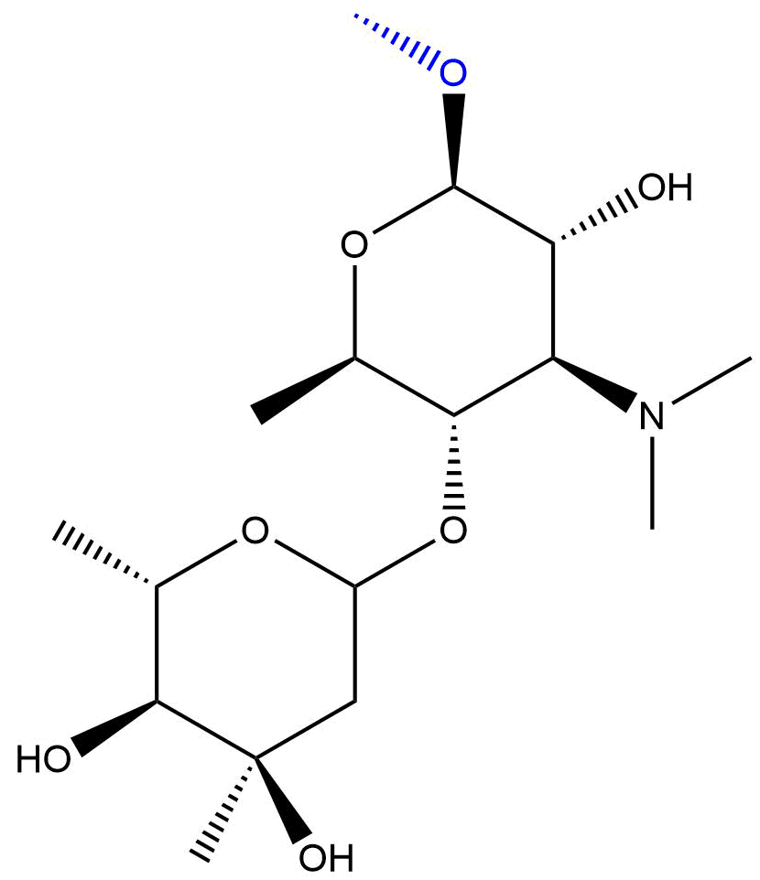 | 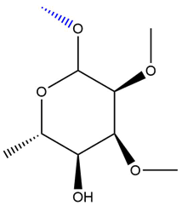
MACROLIDE METABOLITES | Azithromycin A  N’-desmethyl | C₃₇H₇₀N₂O₁₂ | 734.4929 | As azithromycin | As azithromycin | N-desmethyl sugar | As azithromycin
 | Clarithromycin  N-desmethyl | C₃₇H₆₇NO₁₃ | 733.4612 | As clarithromycin | As clarithromycin | N-desmethyl sugar | As clarithromycin
 | Erythromycin A  N-desmethyl | C₃₆H₆₅NO₁₃ | 719.4456 | As erythromycin | As erythromycin | N-desmethyl sugar | As erythromycin

Group | Compound | Formula | Monoisotopic mass | R₁
LINCOSAMIDES & METABOLITES  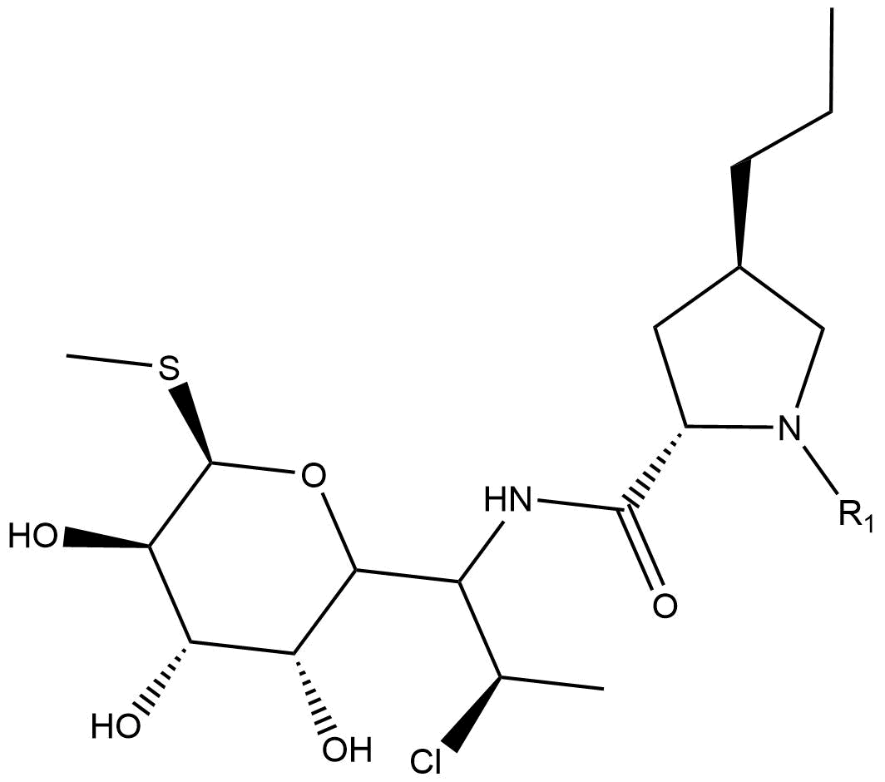 | Clindamycin A  Clindamycin B ¥ | C₁₈H₃₃ClN₂O₅S  C₁₇H₃₁ClN₂O₅S | 424.1799  410.1642 | CH₃  H
 | Clindamycin A  N-desmethyl | C₁₇H₃₁ClN₂O₅S | 410.1642 | H
MONOBACTAMS  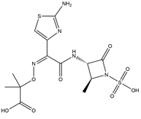 | Aztreonam | C₁₃H₁₇N₅O₈S₂ | 435.0519
CARBPENEMS  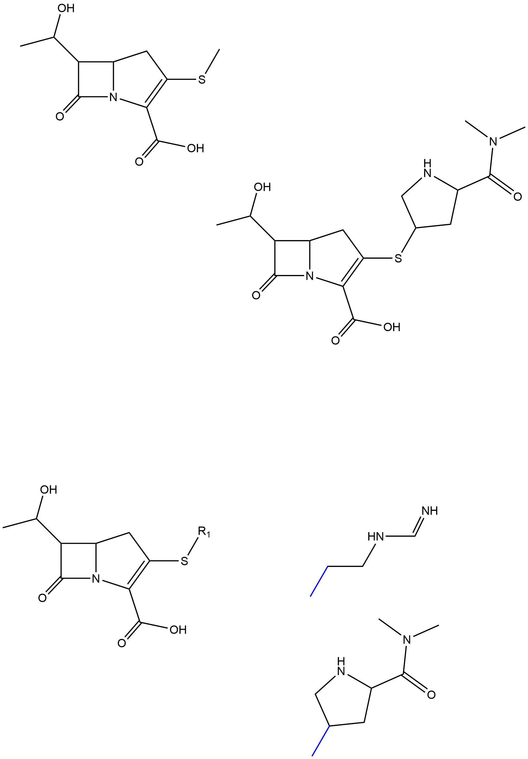 | Meropenem | C₁₇H₂₅N₃O₅S | 383.1515
 | Imipenem | C₁₂H₁₇N₃O₄S | 299.0940
THALIDOMIDE  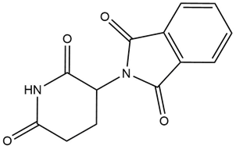 | Thalidomide | C₁₃H₁₀N₂O₄ | 258.0641

Group | Compound info | Group | Compound info | Group | Compound info
AMINOGLYCOSIDES
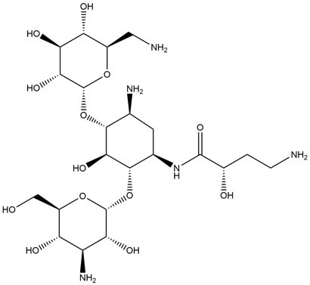 | Amikacin ≠  C₂₂H₄₃N₅O₁₃  M.M. = 585.2857 | 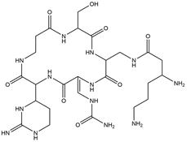 | Capreomycin Ia  C₂₅H₄₄N₁₄O₈  M.M. = 668.3467  Capreomycin Ib  C₂₅H₄₄N₁₄O₇  M.M. = 652.3517 | 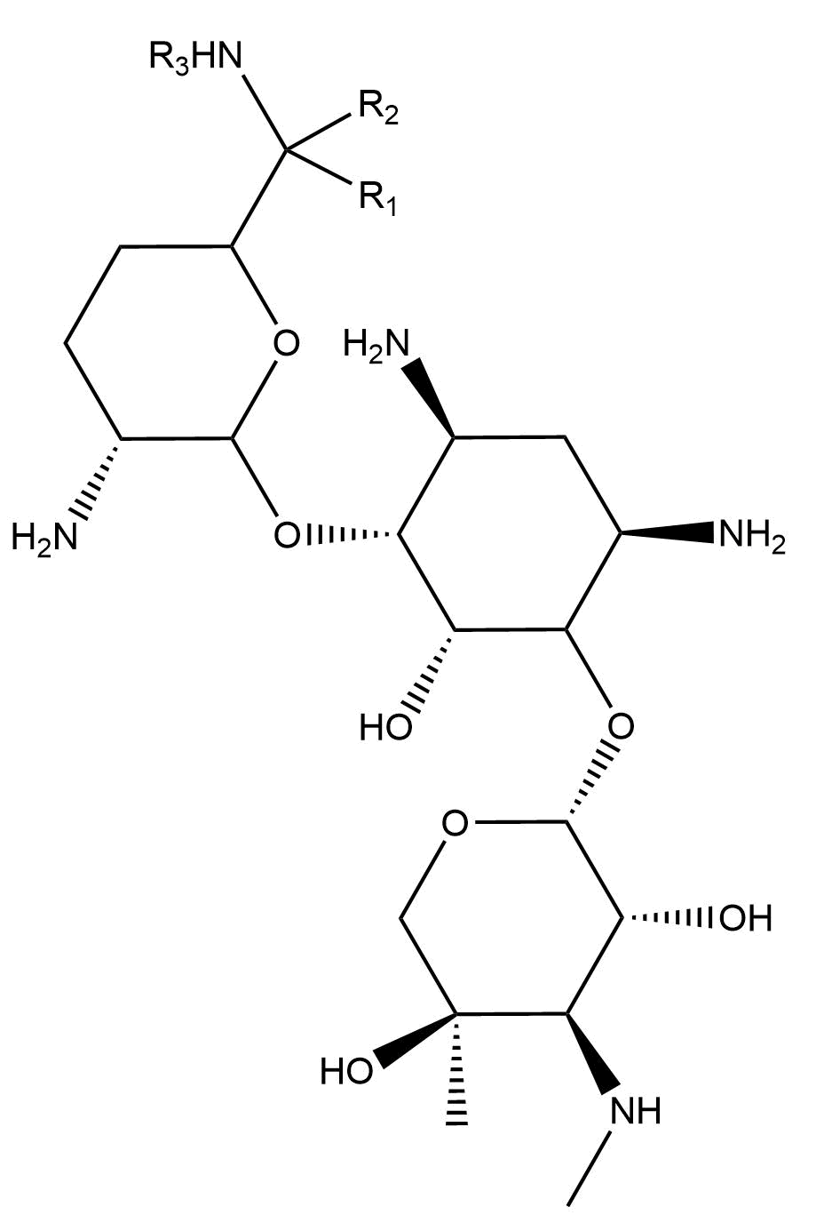 | Gentamicin C1  R₁, R₂, R₃ = Me, H, Me  C₂₁H₄₃N₅O₇: 477.3162  Gentamicin C1a  R₁, R₂, R₃ = H, H, H  C₁₉H₃₉N₅O₇: 449.2849  Gentamicin C2  R₁, R₂, R₃ = Me, H, H  C₂₀H₄₁N₅O₇: 463.3006  Gentamicin C2a  R₁, R₂, R₃ = H, Me, H  C₂₀H₄₁N₅O₇: 463.3006  Gentamicin C2b  R₁, R₂, R₃ = H, H, Me  C₂₀H₄₁N₅O₇: 463.3006
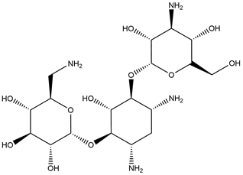 | Kanamycin A (&C)  C₁₈H₃₆N₄O₁₁  M.M. = 484.2381  B: C₁₈H₃₇N₅O₁₀ ¥  M.M. = 483.2540  D&X: C₁₈H₃₅N₃O₁₂ ¥  M.M. = 485.2221 | 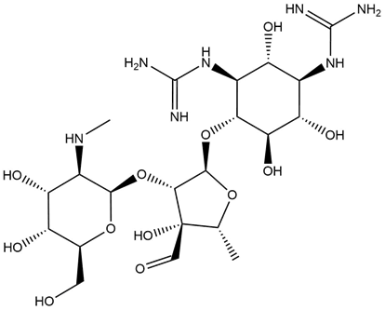 | Streptomycin A  C₂₁H₃₉N₇O₁₂  M.M. = 581.2657  Streptomycin B ¥  C₂₇H₄₉N₇O₁₇  M.M. = 743.3185
TUBERCULOSIS DRUGS
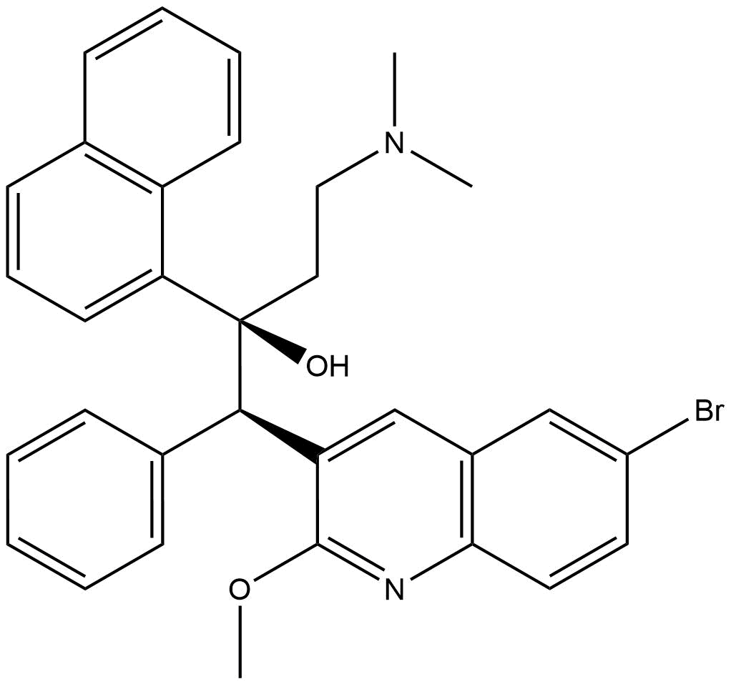 | Bedaquiline  C₃₂H₃₁BrN₂O₂  M.M. = 554.1569 | 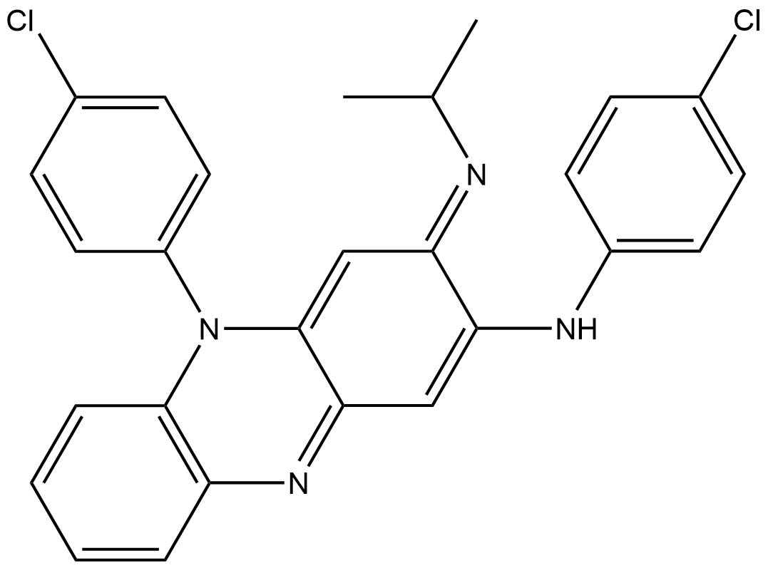 | Clofazimine ≠  C₂₇H₂₂Cl₂N₄  M.M. = 472.1222  Prodrug | Delamanid  C₂₅H₂₅F₃N₄O₆  M.M. = 534.1726
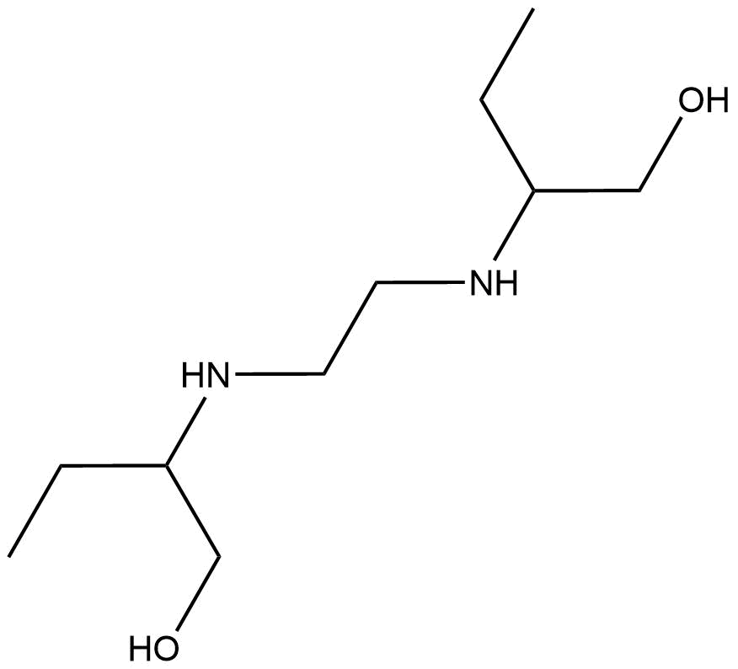 | Ethambutol  C₁₀H₂₄N₂O₂  M.M. = 204.1838 | 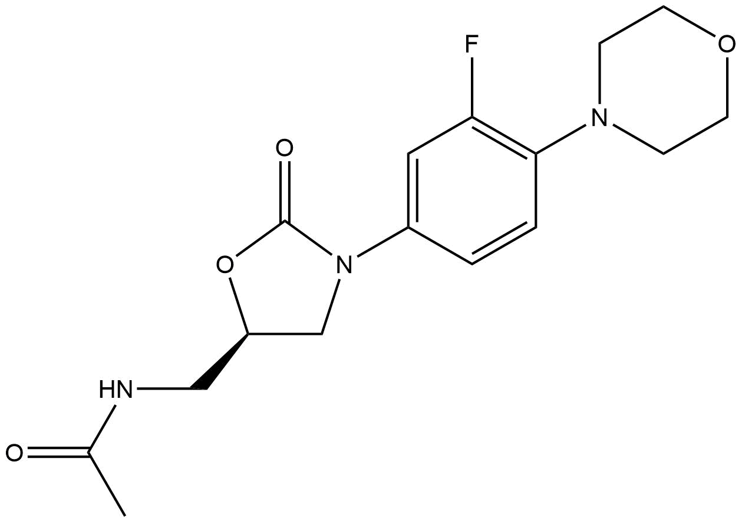 | Linezolid  C₁₆H₂₀FN₃O₄  M.M. = 337.1438
≠ excluded from method; ¥ compound form not analysed, but accounted for in calculations (compound structures display major form only)
Ph = phenyl group; M.M. = Monoisotopic mass; ANP = 2-Amino-1-(4-nitrophenyl)-1,3-propanediol; NP-AHD = 1-[[(2-Nitrophenyl)methylene]amino]-2,4-imidazolidinedione

….

