Supplementary Figure 1
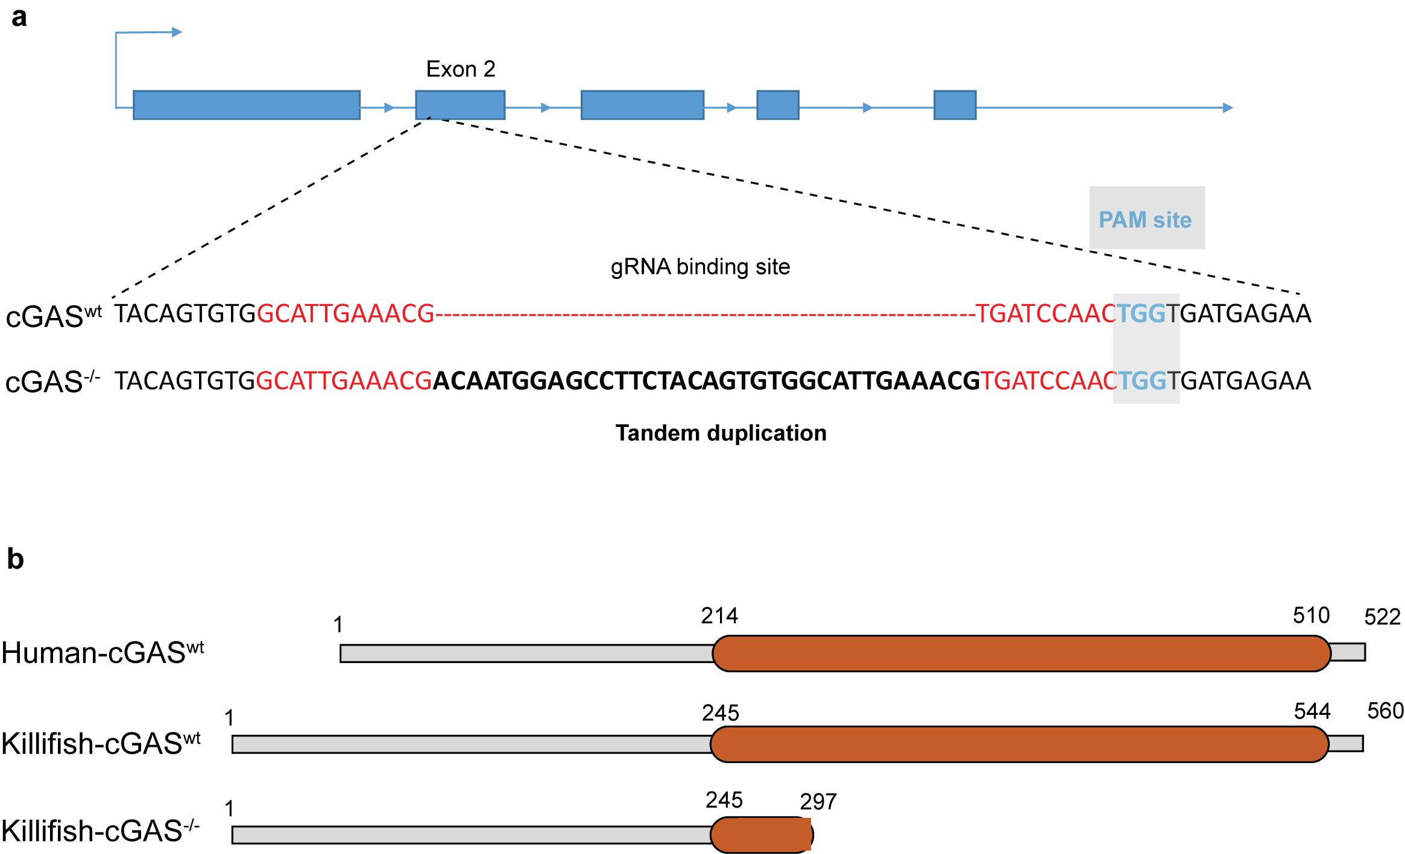

Sup Fig. 1. Crispr-generated knockout of N. furzeri cGAS gene (a), A tandem duplication of 34bp (shown in bold) generated by crispr-mediated cleavage in the cGAS gene leads to a frameshift, resulting in multiple stop codons and truncation of the protein.(b), Protein architecture of human cGAS and killifish cGAS. The mutated killifish cGAS is stopped prematurely, truncating the C-terminal NTAse core and MAB21 domains (shown in orange) required for enzymatic activity.

Supplementary Figure 2
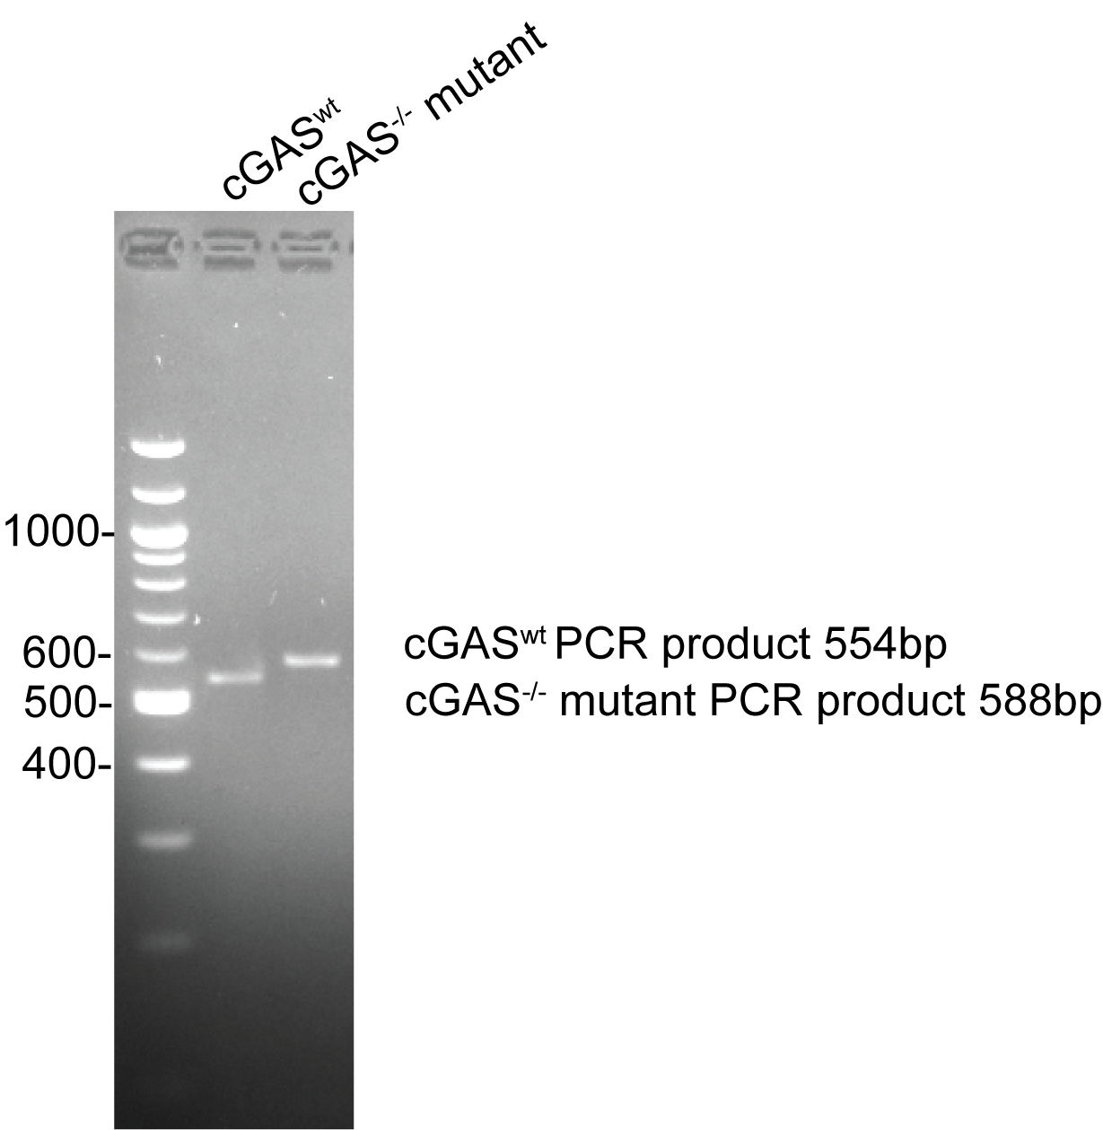

Confirmation of cGAS^{-/-}: Genomic DNA from both cGAS^{wt} and cGAS^{-/-} was amplified with Forward primer: GTTAAGGAACCCCTTCGCACT and Reverse primer: TTGCCGTCATCTCCCATTCTG. PCR product was separated on 2.5% Agarose gel, 50V for 2 hr. The cGAS^{wt} DNA exhibits a PCR product at 554bp, whereas the cGAS^{-/-} DNA, which contains a 34 bp duplicated sequence, has a PCR product at 588bp.

