Supporting Information

Point-of-care human milk testing for maternal secretor status
Author names and affiliation: Saeromi Chung ª, Lars Bode ^{b}, Drew A. Hall ^{a,c,*}
ª Department of Electrical and Computer Engineering, University of California – San Diego, La Jolla, CA 92093, USA
^{b} Department of Pediatrics and Mother-Milk-Infant Center of Research Excellence (MOMI CORE), University of California – San Diego, La Jolla, CA 92093, USA
^{c} Department of Bioengineering, University of California – San Diego, La Jolla, CA 92093, USA
* Corresponding author: drewhall@ucsd.edu

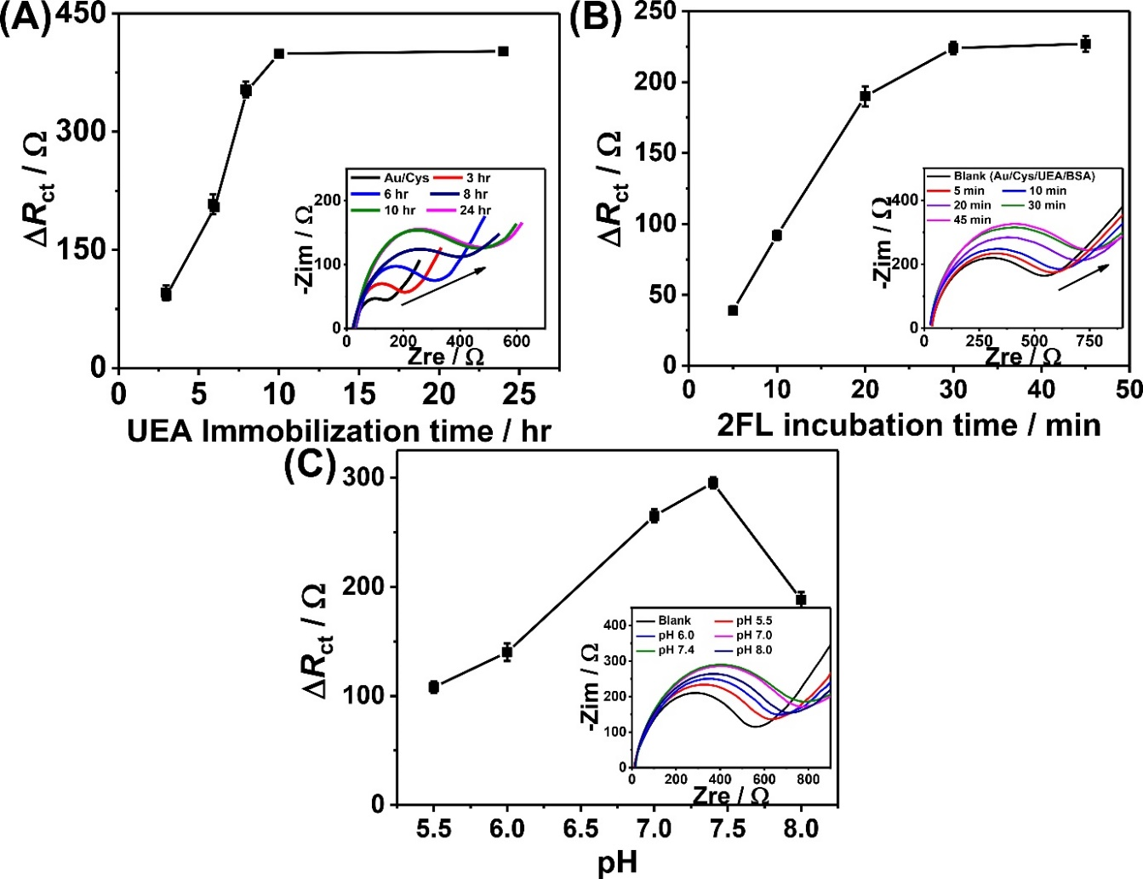
Figure S1. Optimization of experimental parameters. A. UEA immobilization time, B. 2’FL incubation time with 1.5µM 2’FL, and C. pH with 2.0µM 2’FL in 0.1 M PBS containing 5 mM Fe(CN)₆^{3-/4-}.
Table S1. Comparison of concentration of banked samples (HPLC vs. EIS).
Sample ID | EIS  (µM) | HPLC  (µM) | Secretor/non-secretor? | Prediction
A | <330 | 5 | Non-secretor | Correct
B | 10129 | 11985 | Secretor | Correct
C | 7268 | 8197 | Secretor | Correct
D | 5323 | 4017 | Secretor | Correct
E | 10243 | 11378 | Secretor | Correct
F | <330 | 71 | Non-secretor | Correct
G | 8660 | 9159 | Secretor | Correct
H | 4894 | 4632 | Secretor | Correct
I | <330 | 34 | Non-secretor | Correct
J | 6126 | 7045 | Secretor | Correct
K | <330 | 5 | Non-secretor | Correct
L | 9484 | 9585 | Secretor | Correct

Table S2. Cost analysis of proposed assay for 2’FL detection. All prices are from the published price on the vendor’s website in low quantity.
Item |  | Unit Cost (USD) | Cost (USD)/batch (20×)
Top 5 reagents | Cys | $15/10g | $0.15
Top 5 reagents | UEA | $44.40/1mg | $0.44
Top 5 reagents | Glutaraldehyde | $20/10mL | $0.10
Top 5 reagents | 10% BSA | $24.20/10mL | $0.01
Top 5 reagents | NH₄OH | $40/1L | $0.10
Electrode | Au electrode | $350/75 | $50.00
 |  | Cost per test | $2.50

