SUPPLEMENTARY INFORMATION FOR:
Development of a sample preparation procedure for Sr isotope analysis of Portland cements
Anera Kazlagić¹, Francesco F. Russo¹, Jochen Vogl¹, Patrick Sturm², Dietmar Stephan³,
Gregor J. G. Gluth²

¹ Federal Institute for Materials Research and Testing, Division 1.1 Inorganic Trace Analysis, Richard-Willstäter-Straße 11, 12489 Berlin, Germany
² Federal Institute for Materials Research and Testing, Division 7.4 Technology of Construction Materials, Unter den Eichen 87, 12205 Berlin, Germany
³ Technische Universität Berlin, Department of Civil Engineering, Building Materials and Construction Chemistry, Gustav-Meyer-Allee 25, 13355 Berlin, Germany

Correspondence to: anera.kazlagic@bam.de

Contents
Abbreviations S-2
Equation S-2
Fig. S1 S-3
Fig. S2 S-4
Fig. S3 S-5
Fig. S4 S-6
Fig. S5 S-7
Table S1 S-8
Table S2 S-9
Table S3 S-10
Table S4 S-11
Table S5 S-12
Table S6 S-13
Table S7 S-14

Abbreviations:
Sieving – sieving on 11-µm sieve
KOSH - potassium hydroxide/sucrose solution
Conc. acid - Concentrated hydrochloric acid/nitric acid dissolution
Dil. acid - Dilute nitric acid dissolution

Equation:
$$\begin{aligned}Δ_{abs}=\left|{\left(\frac{{}_{ }^{87}{Sr}}{{}_{ }^{86}{Sr}}\right)}_{cement}-{\left(\frac{{}_{ }^{87}{Sr}}{{}_{ }^{86}{Sr}}\right)}_{clinker}\right|\#\left(1\right)\end{aligned}$$
Legend:
Δ_{abs -} Absolute difference of processed cement from the clinker
(⁸⁷Sr/⁸⁶Sr)_{cement} – Sr isotope ratio of processed cement
(⁸⁷Sr/⁸⁶Sr)_{clinker} – Sr isotope ratio of the clinker

Fig. S1. X-ray diffractogram of non-treated cement (directly on top of the sample code) and sieved cement (on top of the respective non-treated pattern) for samples 3022, 3024, 3026, 3027 and 3028. G = Gypsum, A = Anhydrite.

Fig. S2. X-ray diffractogram of non-treated cement (directly on top of the sample code) and sieved cement (on top of the respective non-treated pattern) for samples 3029, 3030,3032, 3050 and 3062. G = Gypsum, A = Anhydrite.

Fig. S3. X- ray diffractogram of non-treated cement (directly on top of the sample code) and sieved cement (on top of the respective non-treated pattern) for samples 3063, 3064, 3075, and 3078. G = Gypsum, A = Anhydrite.
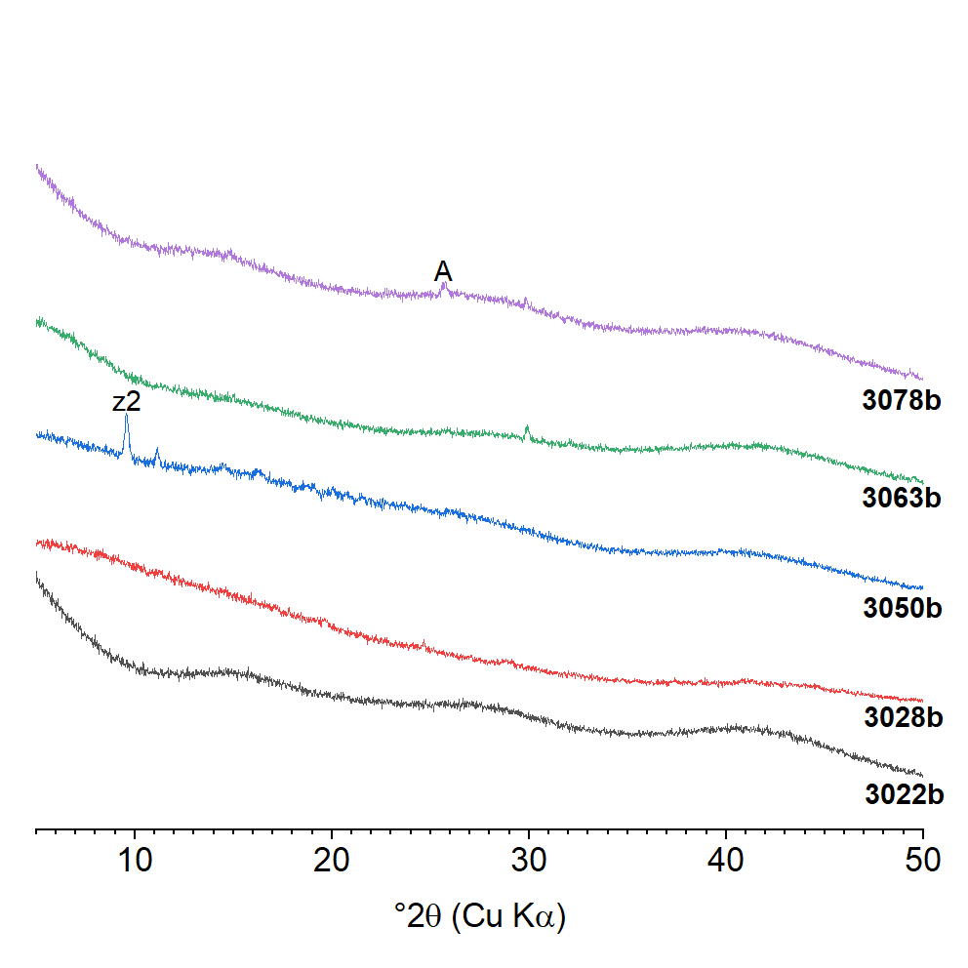
Fig. S4. X-ray diffractograms of the clinker samples 3022b, 3028b, 3050b, 3063b and 3078b after conc. acid treatment; A = anhydrite, z2 = zeolite-type phase.

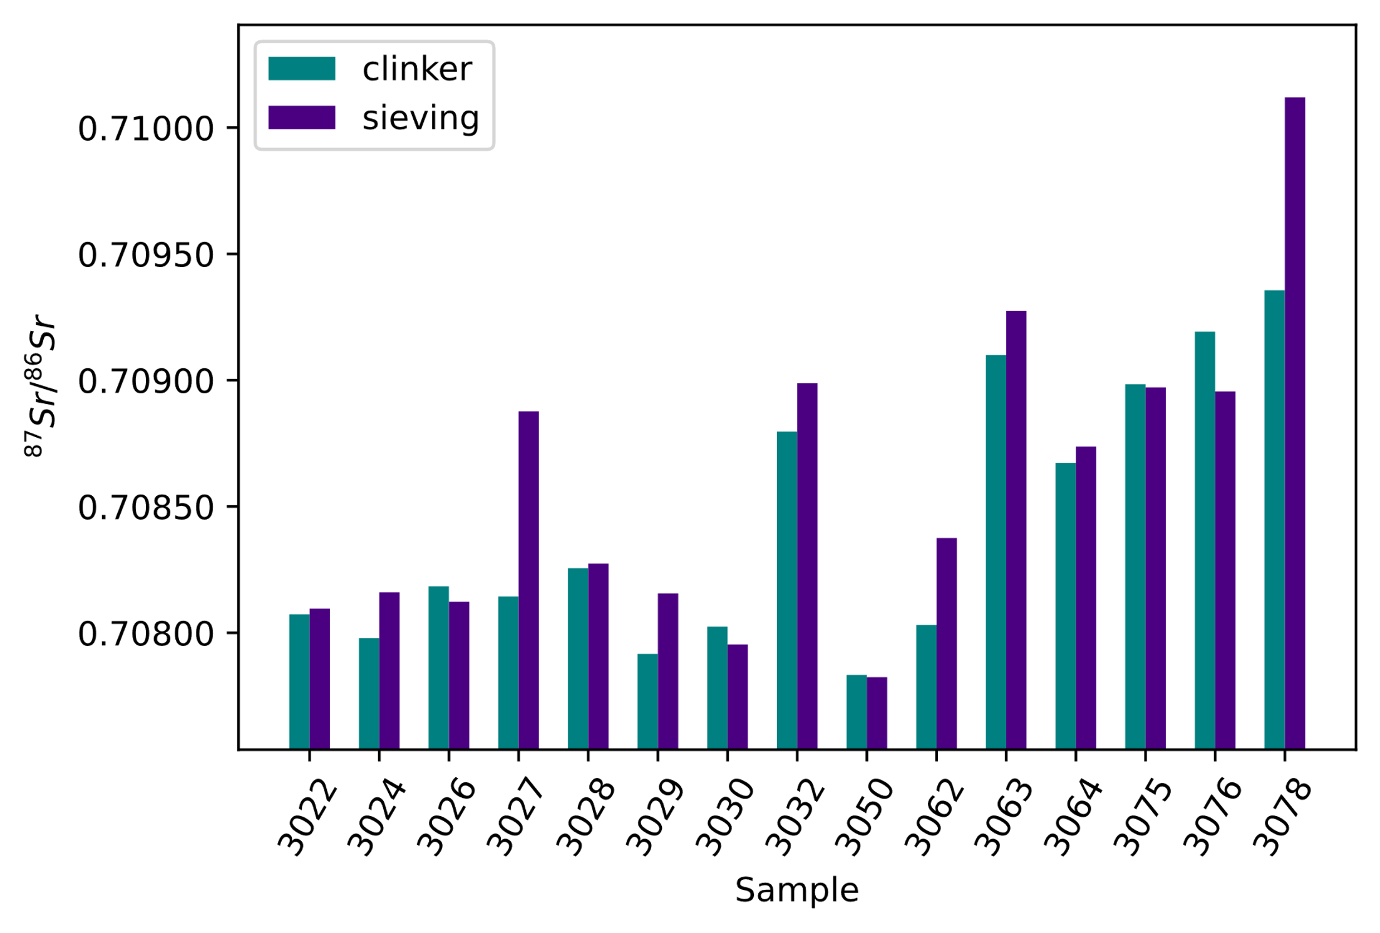
Fig. S5. Comparison of ⁸⁷Sr/⁸⁶Sr isotope ratios from fifteen cement samples prepared with sieving and subsequent conc. acid treatment (purple) and fifteen corresponding clinker samples after conc. acid treatment (blue-green).

Table S1. ⁸⁷Sr/⁸⁶Sr isotope ratio of processed clinkers, and cements after the KOSH and sieving treatment and clinker. 2SE represents 2 x Standard Error (Standard Deviation divided by the square root of number of measured isotope ratios).
Sample | ⁸⁷Sr/⁸⁶Sr (clinker) | 2SE x 10⁻⁵ (clinker) | ⁸⁷Sr/⁸⁶Sr (KOSH) | 2SE x 10⁻⁵ (KOSH) | ⁸⁷Sr/⁸⁶Sr (Sieving) | 2SE x 10⁻⁵ (Sieving)
3022 | 0.70807 | 1 | 0.70810 | 1 | 0.70807 | 1
3024 | 0.70798 | 1 | 0.70816 | 1 | 0.70811 | 1
3026 | 0.70818 | 3 | 0.70812 | 7 | 0.70809 | 1
3027 | 0.70814 | 1 | 0.70888 | 6 | 0.70886 | 1
3028 | 0.70826 | 1 | 0.70827 | 1 | 0.70825 | 2
3029 | 0.70792 | 1 | 0.70816 | 1 | 0.70785 | 1
3030 | 0.70802 | 1 | 0.70795 | 1 | 0.70794 | 1
3032 | 0.70880 | 1 | 0.70899 | 1 | 0.70858 | 1
3050 | 0.70783 | 1 | 0.70782 | 1 | 0.70783 | 1
3062 | 0.70803 | 3 | 0.70838 | 1 | 0.70824 | 1
3063 | 0.70910 | 1 | 0.70927 | 1 | 0.70918 | 1
3064 | 0.70867 | 1 | 0.70874 | 1 | 0.70849 | 1
3075 | 0.70898 | 1 | 0.70897 | 1 | 0.70863 | 1
3076 | 0.70919 | 1 | 0.70896 | 1 | 0.70880 | 1
3078 | 0.70936 | 1 | 0.71012 | 2 | 0.70951 | 1

Table S2. ⁸⁷Sr/⁸⁶Sr isotope ratio of processed cements after the dil. acid and conc. acid treatment.
Sample | ⁸⁷Sr/⁸⁶Sr (Dil. Acid) | 2SE x 10⁻⁵ (Dil. Acid) | ⁸⁷Sr/⁸⁶Sr (Conc. Acid) | 2SE x 10⁻⁵ (Conc. Acid)
3022 | 0.70804 | 1 | 0.70803 | 1
3024 | 0.70811 | 1 | 0.70812 | 1
3026 | 0.70808 | 1 | 0.70808 | 1
3027 | 0.70881 | 1 | 0.70881 | 3
3028 | 0.70823 | 1 | 0.70824 | 1
3029 | 0.70783 | 1 | 0.70786 | 1
3030 | 0.70793 | 1 | 0.70795 | 2
3032 | 0.70856 | 1 | 0.70859 | 1
3050 | 0.70781 | 1 | 0.70783 | 1
3062 | 0.70821 | 1 | 0.70821 | 1
3063 | 0.70917 | 1 | 0.70917 | 3
3064 | 0.70848 | 1 | 0.70848 | 1
3075 | 0.70860 | 1 | 0.70861 | 1
3076 | 0.70879 | 1 | 0.70881 | 1
3078 | 0.70946 | 1 | 0.70948 | 1

Table S3. Absolute difference Δ_{abs} between the ⁸⁷Sr/⁸⁶Sr isotope ratio of the cement and the ⁸⁷Sr/⁸⁶Sr isotope ratio of the corresponding clinker for the four investigated preparation methods. Δ_{abs} was calculated using equation (1).
Sample | Δ_{abs} (KOSH) x 10⁻⁵ | Δ_{abs} (sieving) x 10⁻⁵ | Δ_{abs} (dil. acid) x 10⁻⁵ | Δ_{abs} (conc. acid) x 10⁻⁵
3022 | 2 | 0.03 | 4 | 4
3024 | 18 | 14 | 13 | 14
3026 | 6 | 10 | 11 | 10
3027 | 73 | 72 | 66 | 66
3028 | 2 | 1 | 3 | 2
3029 | 24 | 7 | 8 | 5
3030 | 7 | 8 | 9 | 7
3032 | 19 | 22 | 23 | 20
3050 | 1 | 0.3 | 2 | 1
3062 | 34 | 21 | 18 | 18
3063 | 18 | 8 | 7 | 7
3064 | 6 | 18 | 19 | 19
3075 | 1 | 36 | 39 | 37
3076 | 24 | 39 | 40 | 38
3078 | 76 | 16 | 10 | 12

Table S4. Results of the paired t-test for ⁸⁷Sr/⁸⁶Sr isotope ratios of clinker and KOSH ⁸⁷Sr/⁸⁶Sr isotope ratios of cements as calculated with Excel (Office 365).
t-Test: Paired Two Sample for Means
 | ⁸⁷Sr/⁸⁶Sr Clinker | ⁸⁷Sr/⁸⁶Sr KOSH
Mean | 0.708436 | 0.708592
Variance | 2.74E-07 | 3.8E-07
Observations | 15 | 15
Pearson Correlation | 0.891731
Hypothesized Mean Difference | 0
df | 14
t Stat | -2.15852
P(T<=t) one-tail | 0.024369
t Critical one-tail | 1.76131
P(T<=t) two-tail | 0.048737
t Critical two-tail | 2.144787

Table S5. Results of the paired t-test for clinker ⁸⁷Sr/⁸⁶Sr isotope ratios and sieving ⁸⁷Sr/⁸⁶Sr isotope ratios of cements as calculated with Excel (Office 365).
t-Test: Paired Two Sample for Means
 | ⁸⁷Sr/⁸⁶Sr Clinker | ⁸⁷Sr/⁸⁶Sr Sieved
Mean | 0.708436 | 0.708429
Variance | 2.74E-07 | 2.48E-07
Observations | 15 | 15
Pearson Correlation | 0.865751
Hypothesized Mean Difference | 0
df | 14
t Stat | 0.107146
P(T<=t) one-tail | 0.458097
t Critical one-tail | 1.76131
P(T<=t) two-tail | 0.916194
t Critical two-tail | 2.144787

Table S6. Results of the paired t-test for clinker ⁸⁷Sr/⁸⁶Sr isotope ratios and dil. acid ⁸⁷Sr/⁸⁶Sr isotope ratios of cements as calculated with Excel (Office 365).
t-Test: Paired Two Sample for Means
 | ⁸⁷Sr/⁸⁶Sr Clinker | ⁸⁷Sr/⁸⁶Sr Dil
Mean | 0.708436 | 0.708406
Variance | 2.74E-07 | 2.41E-07
Observations | 15 | 15
Pearson Correlation | 0.873467
Hypothesized Mean Difference | 0
df | 14
t Stat | 0.447992
P(T<=t) one-tail | 0.330507
t Critical one-tail | 1.76131
P(T<=t) two-tail | 0.661014
t Critical two-tail | 2.144787

Table S7. Results of the paired t-test for clinker ⁸⁷Sr/⁸⁶Sr isotope ratios and conc. acid ⁸⁷Sr/⁸⁶Sr isotope ratios of cements as calculated with Excel (Office 365).
t-Test: Paired Two Sample for Means
 | ⁸⁷Sr/⁸⁶Sr Clinker | ⁸⁷Sr/⁸⁶Sr conc
Mean | 0.708436 | 0.708419
Variance | 2.74E-07 | 2.41E-07
Observations | 15 | 15
Pearson Correlation | 0.877963
Hypothesized Mean Difference | 0
df | 14
t Stat | 0.259105
P(T<=t) one-tail | 0.399662
t Critical one-tail | 1.76131
P(T<=t) two-tail | 0.799325
t Critical two-tail | 2.144787

Each cement sample was loaded on a single filament, and the standard deviation was then calculated from minimum 100, maximum 200 measured isotope ratios.

