Supplementary Information (SI)
Neutral Red-carbon nanodots for selective fluorescent DNA sensing.
Emiliano Martínez-Periñán* ª, Álvaro Martínez-Sobrino ª, Iria Bravo ª, Tania García-Mendiola ^{a,b}, Eva Mateo-Martí ^{c}, Félix Pariente ^{a,d}, Encarnación Lorenzo* ^{a,b,d}.
ª Departamento de Química Analítica y Análisis Instrumental, Universidad Autónoma de Madrid, 28049, Madrid, Spain.
^{b} Institute for Advanced Research in Chemical Sciences (IAdChem), Universidad Autónoma de Madrid, 28049, Madrid, Spain.
^{c} Centro de Astrobiología (CSIC-INTA), Ctra. Ajalvir, Km. 4, 28850, Torrejón de Ardoz, Madrid, Spain.
^{d} IMDEA-Nanociencia, Ciudad Universitaria de Cantoblanco, 28049, Madrid, Spain.
∗Corresponding author at: emiliano.martinez@uam.es and encarnacion.lorenzo@uam.es

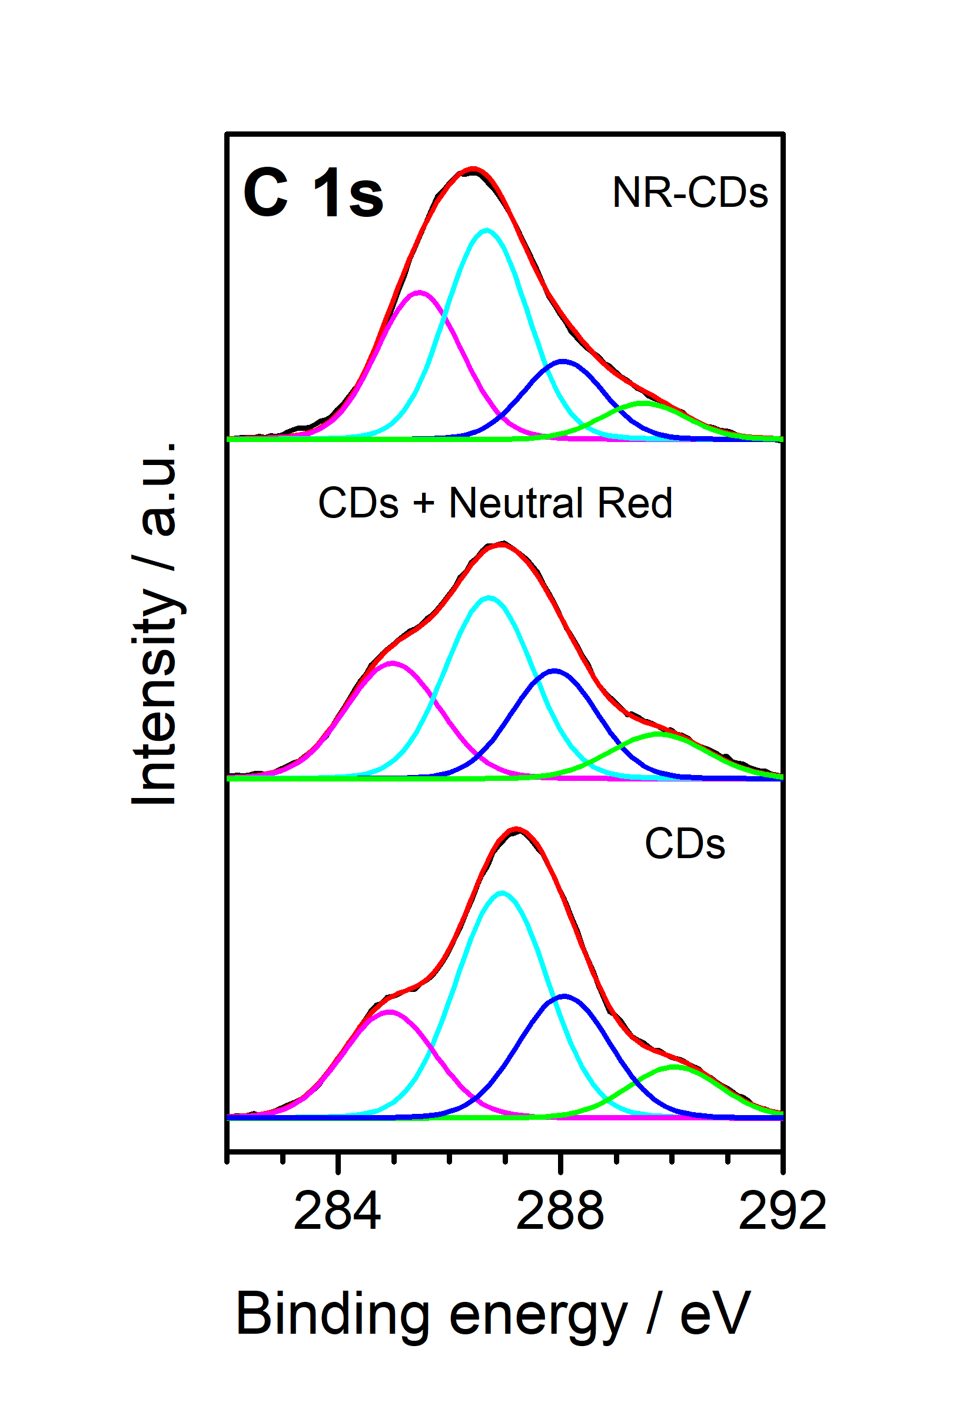
Figure SI 1. XPS spectra of C 1s core level for the gold surfaces of: NR-CDs, CDs + NR and CDs.

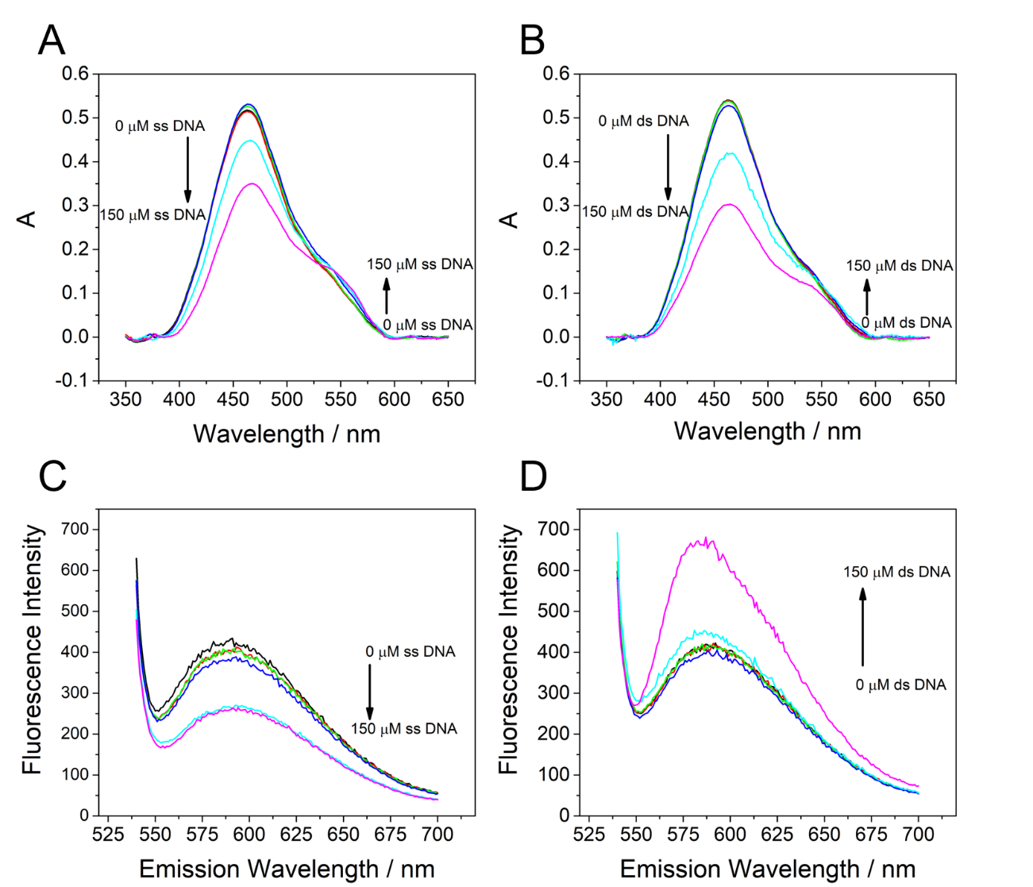
Figure SI 2. UV-Vis absorption spectra (A, B) or fluorescence spectra (C, D) of NR-CDs at 0.1 M PB pH 7 in the absence and in the presence of increasing concentrations (0- 150 µM) of ssDNA (A, C) and dsDNA (B,D).

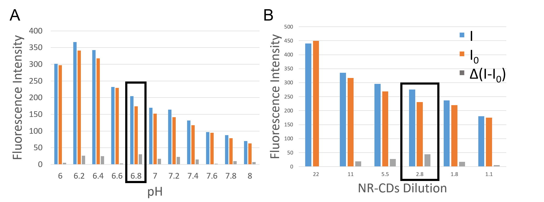
Figure SI 3. (A) Fluorescence emission of NR-CDs (2.8 µg/mL) with E. Coli Probe (200 nM) before (I₀) and after (I) the incubation with E. Coli complementary sequence (200 nM) at different pHs 0.1 M PB buffer. (B) Fluorescence emission of NR-CDs at different concentrations with E. Coli Probe (200 nM) before (I₀) and after (I) the incubation with E. Coli complementary sequence (200 nM) in 0.1 M PB buffer pH 6.8. Δ(I-I₀) represent the difference in emission of I-I₀.

Table S1.Analytical parameter of different work published using carbon dots as fluorescence probe for DNA hybridization detection.
Nanomaterial | LOD | Linear range | λ_{ex} / nm | λ_{em} / nm | Reference
Carbon dots covalently attached to the 5′ phosphate groups of various monobase | 9.9 pM | 10 pM–0.5 μΜ | 400 | 470 | (1)
Carbon dots | No data | No data | 375 | 445 | (2)
Carbon Dots | 270 pM | Up to 200 nM | 340 | 440 | (3)
Thiazole Orange-Modified Carbon Dots (supramolecular structures) | 0.9 nM | No data | 370 | 450 | (4)
NR-CDs | 12 nM | 12- 200 nM | 530 | 580 | This work

Bibliography:
1. Motaghi H, Mehrgardi MA. Spectrofluorometric genotyping of single nucleotide polymorphisms using carbon dots as fluorophores. Spectrochimica Acta Part A: Molecular and Biomolecular Spectroscopy. 2019;206:154-9.
2. Liang C-Y, Xia W, Yang C-Z, Liu Y-C, Bai A-M, Hu Y-J. Exploring the binding of carbon dots to calf thymus DNA: From green synthesis to fluorescent molecular probe. Carbon. 2018;130:257-66.
3. García-Mendiola T, Elosegui CG, Bravo I, Pariente F, Jacobo-Martin A, Navio C, et al. Fluorescent C-NanoDots for rapid detection of BRCA1, CFTR and MRP3 gene mutations. Microchimica Acta. 2019;186(5):293.
4. Jin M, Liu X, Zhang X, Wang L, Bing T, Zhang N, et al. Thiazole Orange-Modified Carbon Dots for Ratiometric Fluorescence Detection of G-Quadruplex and Double-Stranded DNA. ACS Applied Materials & Interfaces. 2018;10(30):25166-73.

