Supporting Information

Composition, thickness, and homogeneity of the coating of core-shell nanoparticles – possibilities, limits, and challenges of X-ray photoelectron spectroscopy

J. Radnik¹, X. Knigge¹, E. Andresen², U. Resch-Genger², D. J. H. Cant³, A. G. Shard³, and C. A. Clifford³
¹ Bundesanstalt für Materialforschung und -prüfung (BAM), Division 6.1 „Surface analysis and interfacial chemistry, Unter den Eichen 44-46, 12203 Berlin, Germany
² Bundesanstalt für Materialforschung und -prüfung (BAM), Division 1.2 „Biophotonics“, Richard-Willstätter-Str. 11, 12489 Berlin, Germany
³National Physical Laboratory, Surface Technology Group, Teddington, TW11 0LW, UK

Details for the measurement conditions, data reduction and data interpretation of…
- …the “ideal” case – 11 nm-sized core/shell quantum dot with a CdSe core and a very thick CdS surface passivation shell can be obtained in:
Weigert, F., Müller, A., Häusler, I., Geißler, D., Skrobin, D., Krumrey, M., Unger, W.E.S., Radnik, J. & Resch-Genger, U. Combining HR-TEM and XPS to Elucidate the Core-Shell Structure of ultrabright CdSe/CdS Semiconductor Quantum Dots, Scientific Reports 10, 20712, doi:10.1038/s41598-020-77530-z (2020)

…the polymer particles PTFE-PMMA and PTFE-PS in:
Müller, A., Heinrich, T., Tougaard, S., Werner, W.S.M., Hronek, M., Kunz, V., Radnik, J. et al. Determining the Thickness of the Shell of Polymer Core-Shell Nanoparticles by X-ray Photoelectron Spectroscopy, Secondary Ion Mass Spectrometry, and Transmission Scanning Electron Microscopy. J. Phys. Chem. C 123, 29765-29775 (2019).

Experimental details of the energy-resolved measurements at the CdSe-CdS core shell nanoparticles
Energy resolved XPS measurements were carried out at the synchrotron BESSY II at HZB. The spectra were acquired at the HE-SGM monochromator dipole magnet CRG beamline at photon energies given in Figure 4. The spectra were measured in normal emission, the angle between the X-ray source and the sample normal was 45°. For the detection of the spectra a Scienta R3000 analyzer was used. The pass energy was 50 eV for the measurements. For the background a modified Tougaard background was used. The peaks were fitted with the sum of Gaussian-Lorentzian curves. The binding energy was referenced to the C 1s peak at 285 eV.
The effective attenuation lengths of the photoelectrons were determined with the NIST standard reference database (version 1.3, SRD 82).
The samples were prepared by dropping a suspension of the nanoparticles in hexane solution on a cleaned Si wafer.

Table S1:
The fitting parameter for
S2p with 460 eV excitation energy:

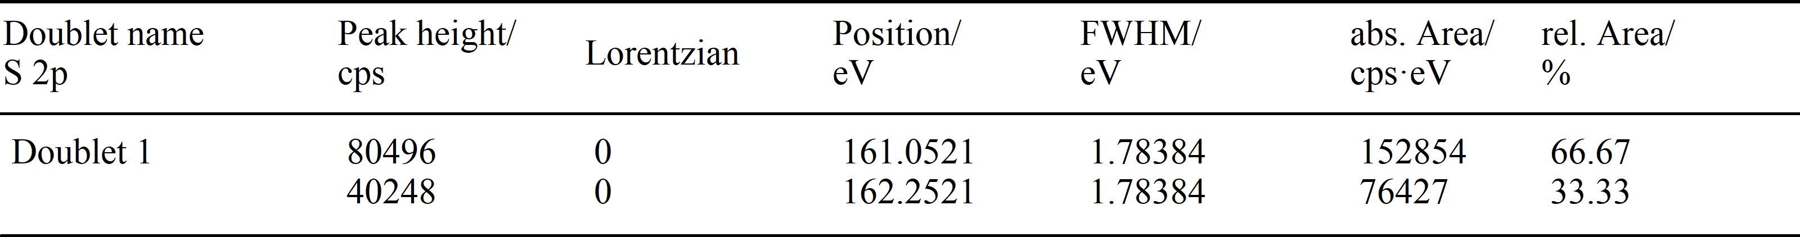

S 2p with 560 eV excitation energy

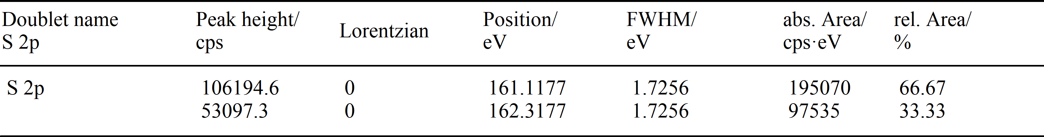

Se 3d with 460 eV excitation energy

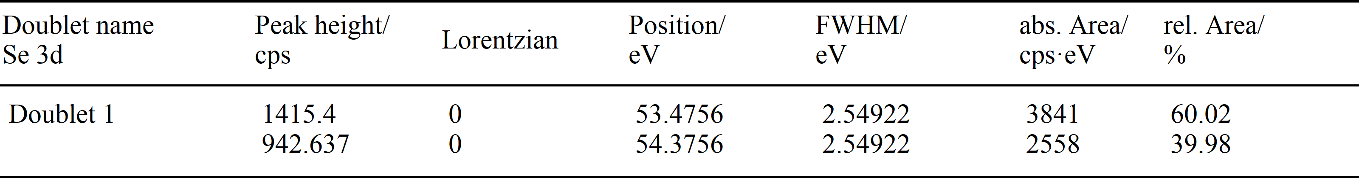

Experimental details of the XPS andHAXPES measurements at the upconversion core shell nanoparticles
These measurements were carried out at a ULVAC-PHI Quantes with an Al Kα-radiation source (1486.6 eV) and a Cr Kα-radiation source (5414.8 eV). The spectra were measured at an emission angle of 45°, the angle between the source and the sample was 49°. For the detection of the spectra a spherical analyzer with a multichannel resistive plate was used. The data processing was performed with MultiPak (version 9.9.1.1). For the background a Shirley background was used. For the quantification the empirical relative sensitivity factors provided by PHI were used.
The samples were prepared by dropping a suspension of the nanoparticles in hexane solution on a Si wafer.
Figure S1: Survey spectra (XPS and HAXPES) of both samples.

Table S2: Quantification results obtained with MultiPak 9.9.1.1.
Peaks | Sample A |  | Sample B
 | XPS | HAXPES | XPS | HAXPES
Na 1s | 8.2 | 12.5 | 6.0 | 12.1
Y 3d | 11.3 | 15.0 | 3.5 | 7.1
F 1s | 34.8 | 42.8 | 26.3 | 39.8
Yb 4d | 0.3 | 0.3 | 2.7 | 2.6
Er 4d | 2.1 | 0.4 | 0.7 | 0.4
C 1s | 39.0 | 24.4 | 57.8 | 31.7
O 1s | 4.3 | 4.6 | 3.0 | 6.3

