Supporting information

Quantitative determination of sn-positional phospholipid isomers in MS^{n} using silver cationization

Johan Lillja, Ingela Lanekoff

Department of Chemistry – BMC, Uppsala University, Uppsala, Sweden

Corresponding author:

Prof. Ingela Lanekoff
Ingela.Lanekoff@kemi.uu.se
Dept. of Chemistry-BMC (576)
Uppsala University
751 23 Uppsala
Sweden

Table of Contents
Figure S1 MS^{n} transitions for PC 16:0/18:1 3
Figure S2 MS³ product ion spectra of [FA+Ag]⁺ type ions of PC 16:0/18:1 and PC 18:1/16:0 3
Figure S3 MS³ product ion spectra for PC 34:1 ionized with ¹⁰⁹Ag and ¹⁰⁷Ag repsectively 4
Figure S4 Driftograms for the cIMS^{n} data 4
Figure S5 MS^{n} Transitions for PC 13:0_12:0 5
Figure S6 Fragmentation efficiency of PC 18:1/16:0 and PC 16:0/18:1 6
Figure S7 Fragmentation efficiency for PC 18:1_16:0 and PC 20:1_16:0 measured from tissue 7
Scheme S1 Fragmentation scheme 8
Equation S1 Type 1 correction factor 8

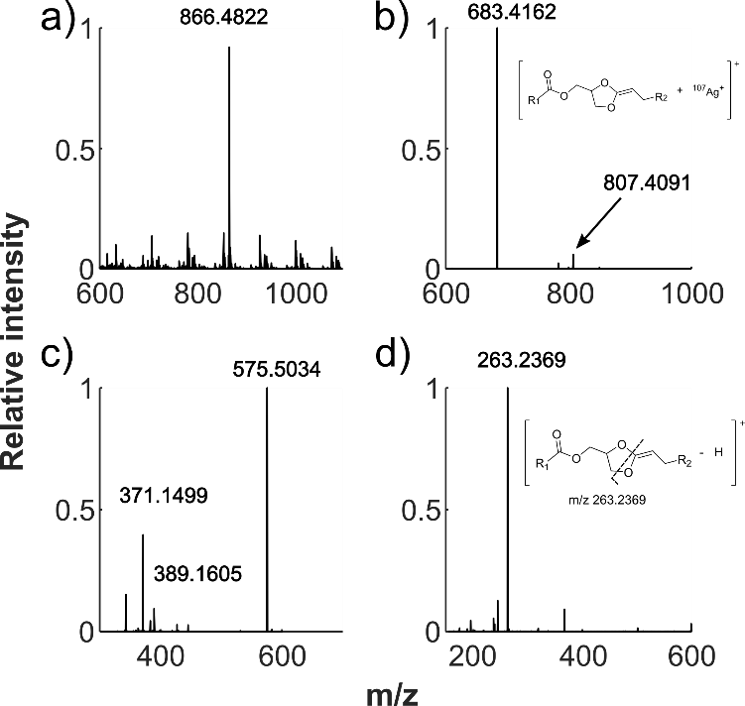
Figure S1 MS^{n} transitions for PC 16:0/18:1 Tandem mass spectrometric transitions of PC 16:0/18:1 a) MS¹ spectrum showing the [M+H]⁺ ion at m/z 760.5839 and [M+Ag]⁺ at m/z 866.4822 b) MS² spectrum of the [M+Ag]⁺ peak giving product ions corresponding to choline loss at m/z 807.4091 and head group loss at m/z 683.4162 c) MS³ spectrum using 683.4162 as precursor ion, where the main product ion at m/z 575.5034 corresponds to a NL of AgH and the other annotated ions represent acyl chain losses and d) MS⁴ of the 575.5034 ion giving diagnostic product ions with respect to the sn position.

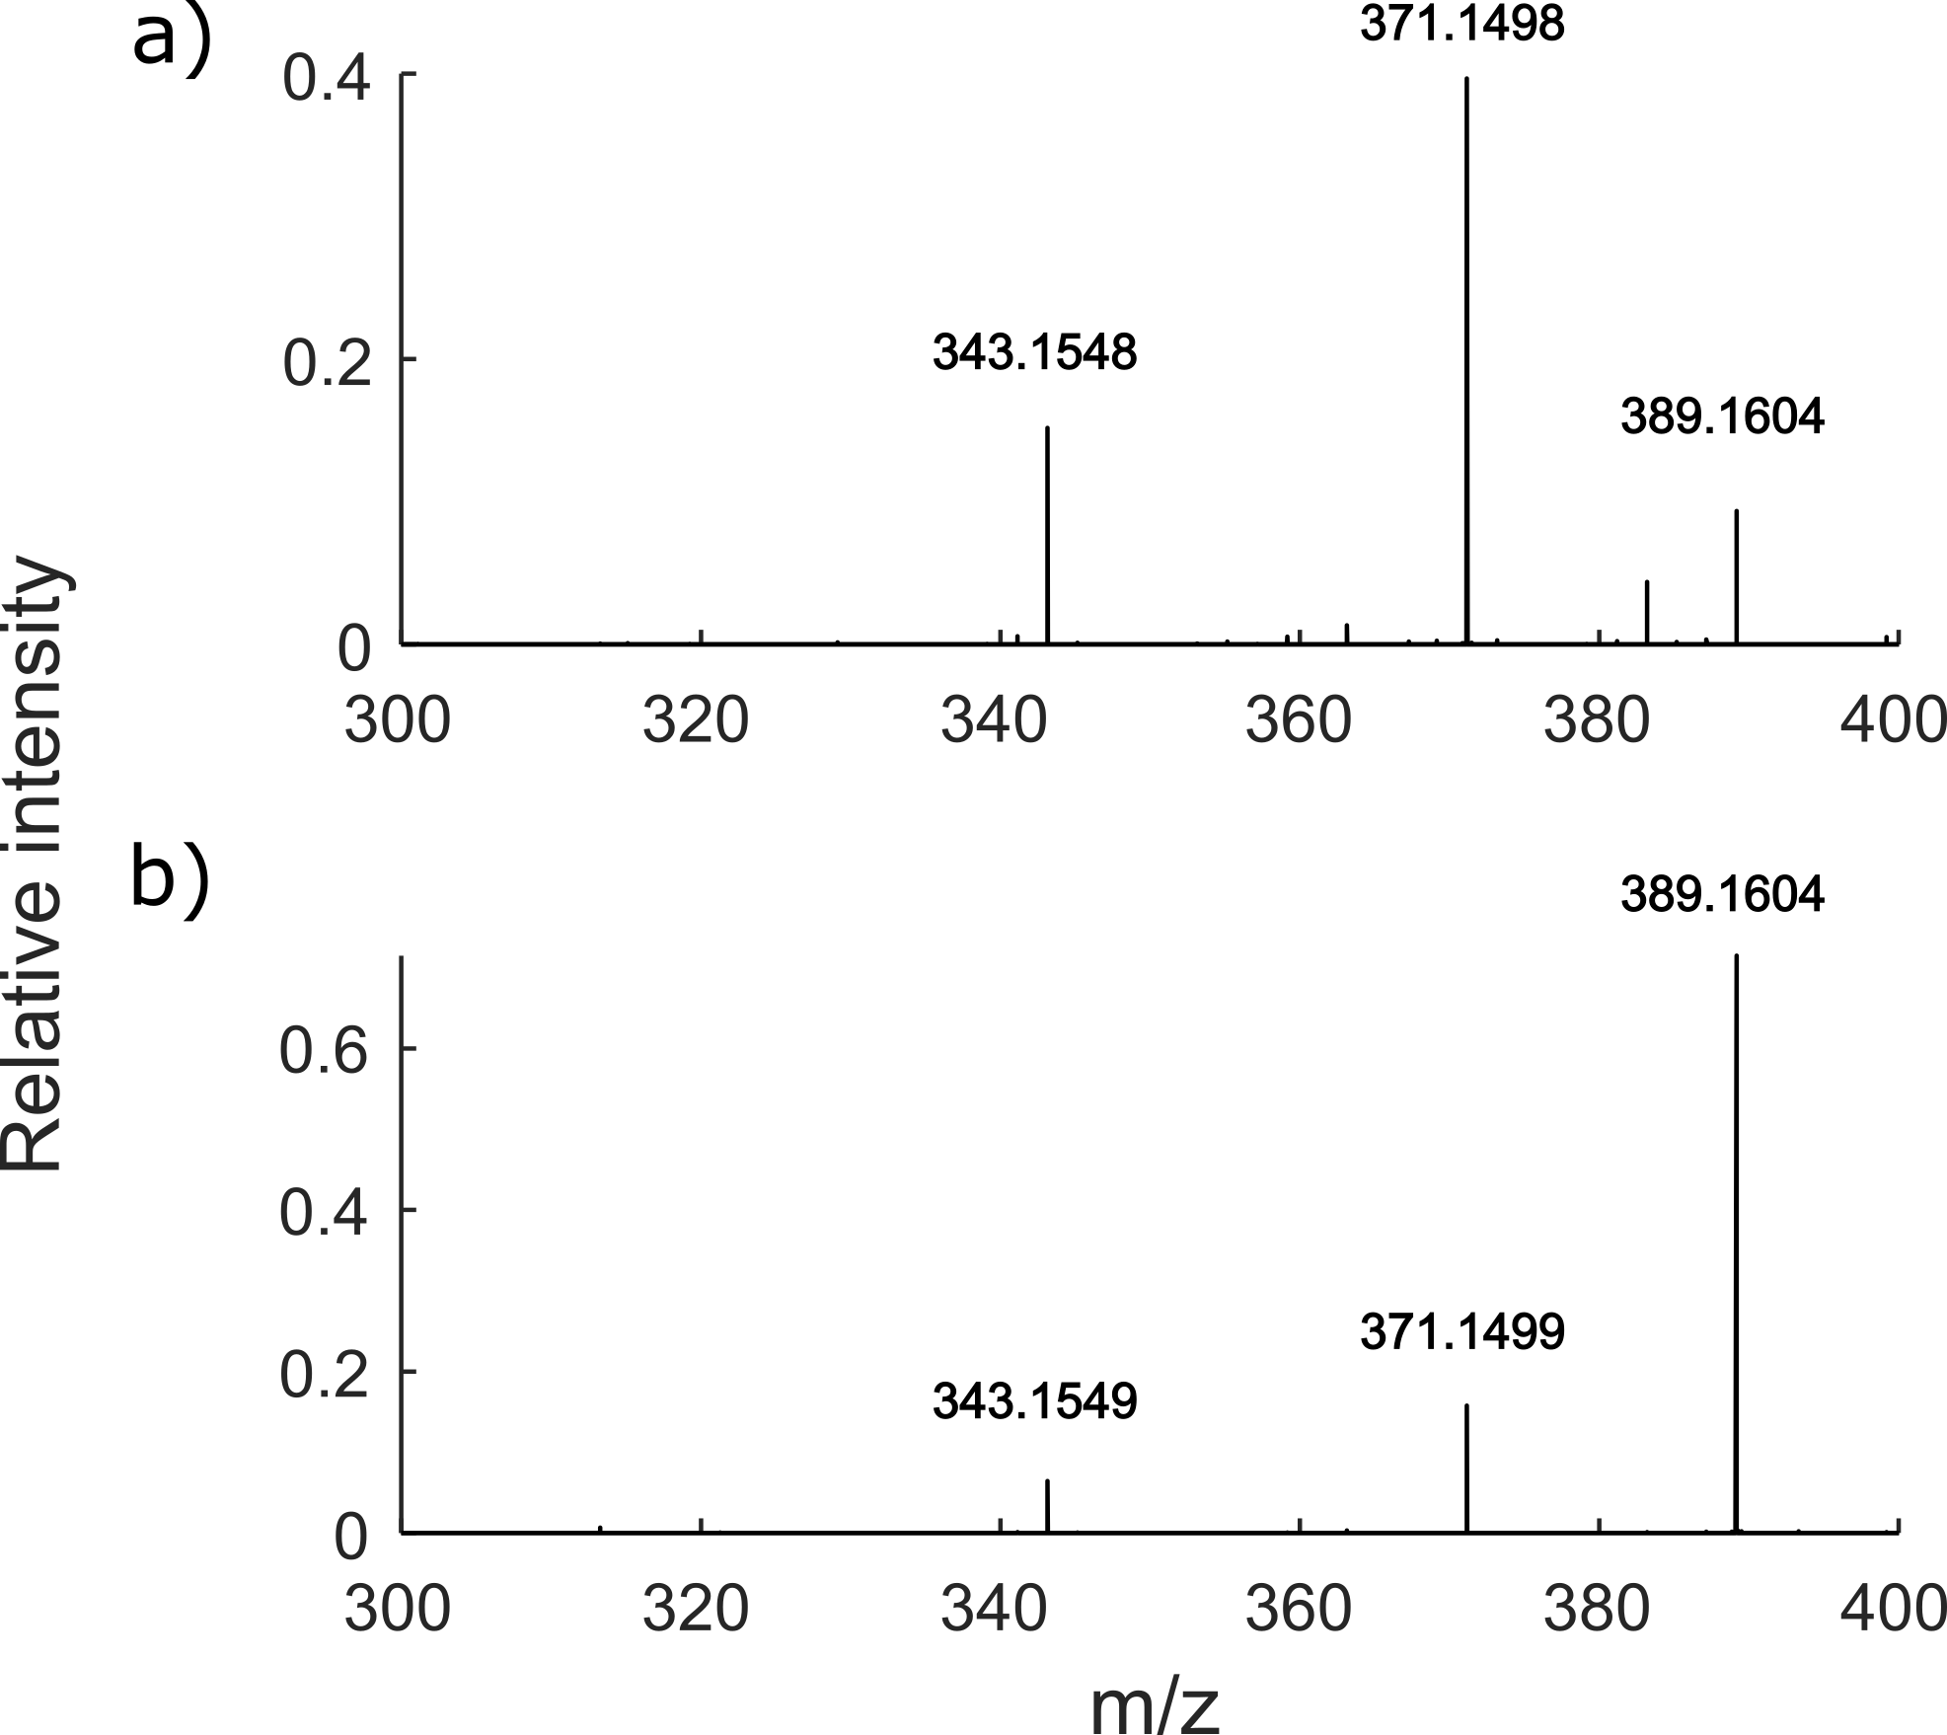
Figure S2 MS³ product ion spectra of [FA+Ag]⁺ type ions of PC 16:0/18:1 and PC 18:1/16:0 Product ions in MS³ from isomers of a) PC 16:0/18:1 and b) PC 18:1/16:0 with m/z 389.1604 ([FA 18:1 + ¹⁰⁷Ag]⁺) , 371.1498 ([FA 18:1 + ¹⁰⁷Ag - H₂O]⁺) and 343.1549 ([FA 18:1 + ¹⁰⁷Ag - H₂O - CO]⁺) formed from both PC 18:1/16:0 and PC 16:0/18:1 isomers. The ions are not unique for the respective isomer and can therefore not be used directly for quantification.
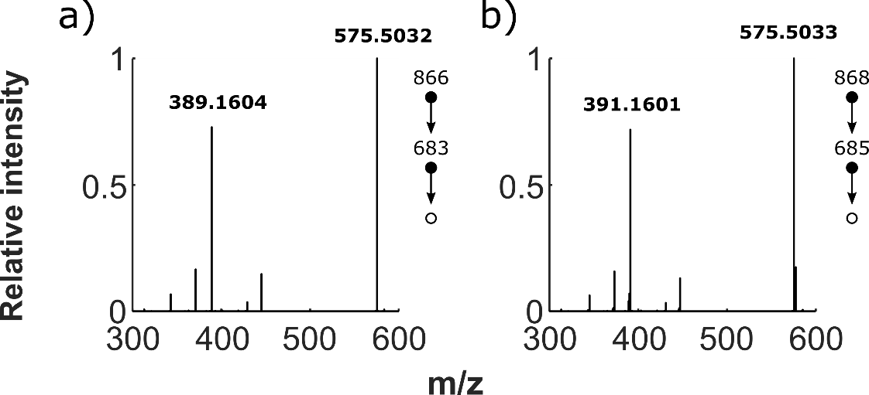
Figure S3 MS³ product ion spectra for PC 34:1 ionized with ¹⁰⁹Ag and ¹⁰⁷Ag repsectively a) MS³ spectrum of [M+¹⁰⁷Ag]⁺ showing the –AgH peak at m/z 575.5032 and [FA+¹⁰⁷Ag]⁺ at m/z 389.1604 b) MS³ spectrum of [M+¹⁰⁹Ag]⁺ showing the –AgH peak at m/z 575.5033 and [FA+¹⁰⁹Ag]⁺ at m/z 391.1601. The difference in mass between ¹⁰⁷Ag⁺ and ¹⁰⁹Ag⁺ is 1.9997 Da, which equals the difference in mass of [FA+¹⁰⁷Ag]⁺ at m/z 389.1604 and and [FA+¹⁰⁹Ag]⁺ at m/z 391.1601.

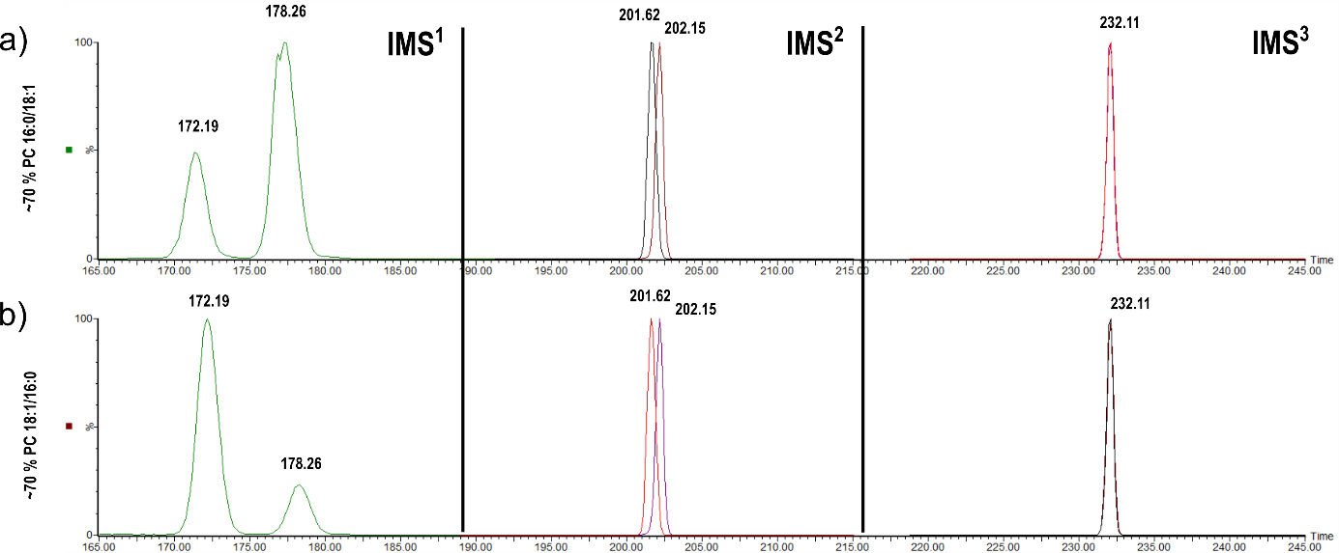
Figure S4 Driftograms for the cIMS^{n} data Driftogram of the ions in this fragmentation pathway in IMS¹, IMS² and IMS³. A) Direct infusion of 1 µM PC 16:0/18:1 spiked with 0.4 µM PC 18:1/16:0 in IMS¹ with 10 passes in the cyclic IMS (cIMS). The drift time of the sn-1 isomer is 172.19 ms and 178.26 ms for the sn-2 isomer. In IMS² the separated isomers from IMS¹ were used as precursors. In the driftogram of m/z 683.4204 the sn-1 isomer product ion has a drift time of 201.62 ms wheras the product ion of the sn-2 isomer has a drift time of 202.15 ms using one pass in the cIMS device. In IMS³ the precursor was chosen in the same way and the driftogram of the product ion at m/z 575.5067 is shown with the drift time 232.11 ms using one pass in the cIMS device for both isomers. B) 1 µM PC 18:1/16:0 spiked with 0.4 µM PC 18:1/16:0 in IMS¹ the drift time of the sn-1 isomer is 172.19 ms and 178.26 for the sn-2 isomer with 10 passes in the cIMS device. In IMS² the separated isomers from IMS¹ was used as precursors the driftogram of m/z 683.4204 where the sn-1 isomer product ion has a drift time of 201.62 ms wheras the product ion of the sn-2 isomer has a drift time of 202.15 ms with one pass in the cIMS device. In IMS³ the precursor was chosen in the same way and the driftogram of the product ion at m/z 575.5067 is shown with the drift time 232.11 with one pass in the cIMS device for both isomers.
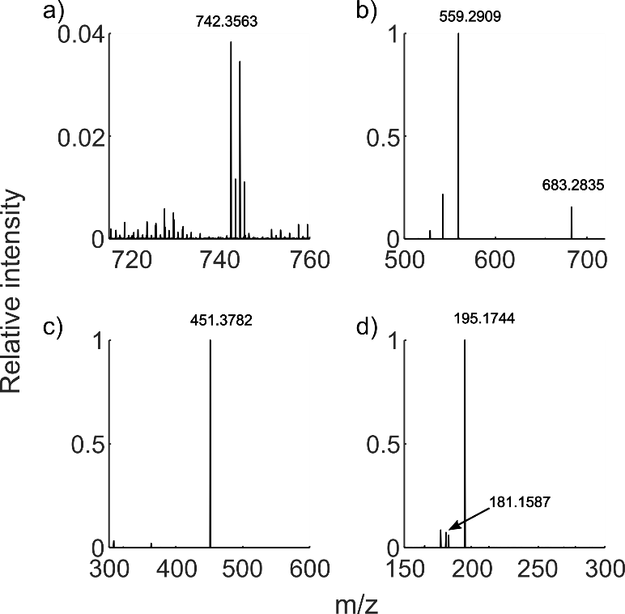
Figure S5 MS^{n} Transitions for PC 13:0_12:0 Tandem mass spectrometric transitions of PC 13:0_12:0 a) MS¹ spectrum showing the [M+Ag]⁺ at m/z 742.3563 b) MS² spectrum of the [M+Ag]⁺ peak giving product ions corresponding to choline loss at m/z 683.2835 and head group loss at m/z 559.2909 c) MS³ spectrum using 559.2909 as precursor ion, where the main product ion at m/z 451.3782 corresponds to a NL of AgH d) MS⁴ of the 451.3782 ion giving diagnostic product ions with respect to the sn position of the 12:0 and 13:0 acyl chains.
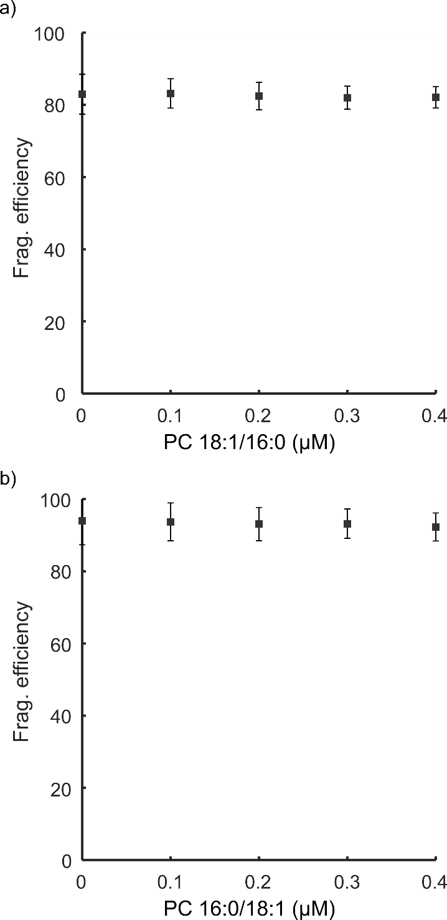
Figure S6 Fragmentation efficiency of PC 18:1/16:0 and PC 16:0/18:1 Fragmentation efficiency for the sn-2 type product ion from 0 - 0.4 µM a) fragmentation efficiency for the 16:0 in sn-2 product ion (m/z 237) was estimated to 82% ± 3.5 % b) fragmentation efficiency for the 18:1 in sn-2 product ion (m/z 263) was estimated to 93 % ± 4 %. Error bars represent one standard deviation.
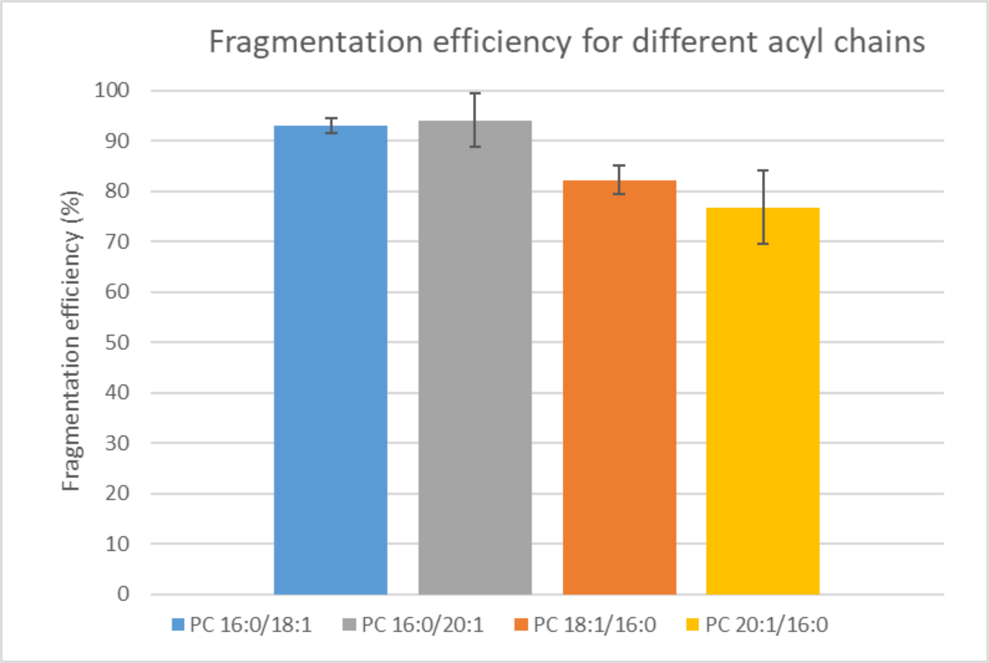
Figure S7 Fragmentation efficiency for PC 18:1_16:0 and PC 20:1_16:0 measured from tissue The fragmentation efficiency of PC 16:0/18:1 was 93 ± 1.5 %, PC 16:0/20:1 was 94 ± 5 %, PC 18:1/16:0 was 82 ± 3 %, and PC 20:1/16:0 was 77 ± 7 %. The observed fragmentation efficiency mirrors the measured efficiency in standards, which was 93 ± 4 % and 82 ± 3.5 for PC 16:0/18:1 and PC 18:1/16:0 respectively. Error bars represent one standard deviation.

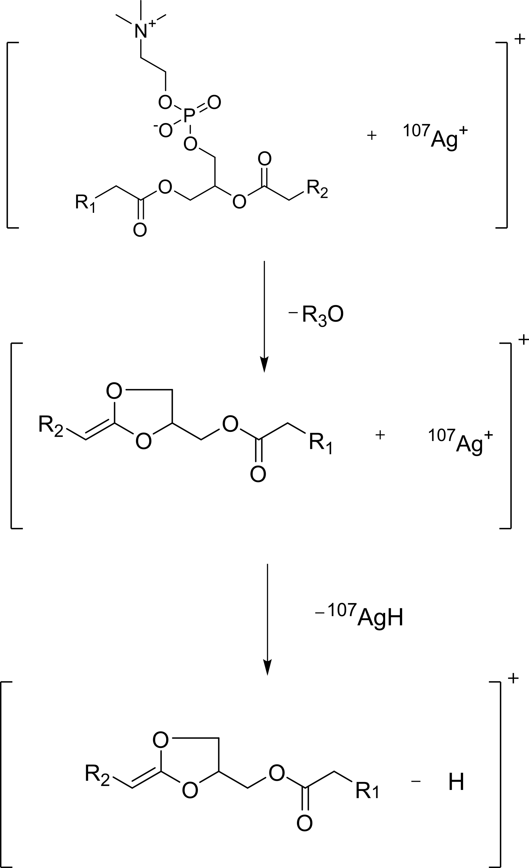
Scheme S1 Fragmentation scheme General fragmentation scheme of a glycerolipid where R₁ and R₂ are acyl chains and R₃ is either an acyl chain or a modified phosphate headgroup.

$$Z=\frac{1+0.0109n+\frac{{0.0109}^{2}n\left(n-1\right)}{2}}{1+0.0109s+\frac{{0.0109}^{2}s\left(s-1\right)}{2}}$$
Equation S1 Type 1 correction factor n is the number of carbons in the analyte and s is the number of carbons in the internal standard. 0.0109 is the probability of having a carbon 13 isotope in the analyte. [1]

1. Yang K, Han X (2011) Accurate quantification of lipid species by electrospray ionization mass spectrometry - Meets a key challenge in lipidomics. Metabolites 1:21–40. https://doi.org/10.3390/metabo1010021

