Potential of atmospheric pressure ionization sources for the analysis of free fatty acids in clinical and biological samples by gas chromatography-mass spectrometry

Paul E. Görs, Pia Wittenhofer, Juan F. Ayala-Cabrera, Sven W. Meckelmann
Applied Analytical Chemistry, University of Duisburg-Essen, Universitätsstrasse 5, 45141 Essen, Germany

Table S1: m/z values of all analyzed fatty acids. All standards that were used as standards are printed bold.

Compound | m/z |  | Compound | m/z
FA 6:0 | 115.2 |  | FA 21:0 | 325.5
FA 7:0 | 129.2 |  | FA 21:1 | 323.5
FA 8:0 | 143.2 |  | FA 21:2 | 321.5
FA 9:0 | 157.2 |  | FA 21:3 | 319.5
FA 10:0 | 171.2 |  | FA 22:0 | 339.6
²H₂-FA 10:0 | 173.3 |  | FA 22:1 | 337.6
FA 10:1 | 169.2 |  | FA 22:2 | 335.6
FA 11:0 | 185.3 |  | FA 22:3 | 333.6
FA 11:1 | 183.3 |  | FA 22:4 | 331.6
FA 12:0 | 199.3 |  | FA 22:5 | 329.5
FA 12:1 | 197.3 |  | FA 22:6 | 327.5
FA 13:0 | 213.4 |  | FA 23:0 | 353.6
FA 13:1 | 211.4 |  | FA 23:1 | 351.6
FA 14:0 | 227.4 |  | FA 23:2 | 349.6
FA 14:1 | 225.4 |  | FA 23:3 | 347.6
FA 15:0 | 241.4 |  | FA 23:4 | 345.6
²H₂-FA 15:0 | 243.4 |  | FA 23:5 | 343.6
FA 15:1 | 239.4 |  | FA 23:6 | 341.6
FA 16:0 | 255.5 |  | FA 24:0 | 367.7
FA 16:1 | 253.5 |  | ²H₄-FA 24:0 | 371.7
FA 16:2 | 251.5 |  | FA 24:1 | 365.7
FA 17:0 | 269.5 |  | FA 24:2 | 363.7
FA 17:1 | 267.5 |  | FA 24:3 | 361.7
FA 18:0 | 283.5 |  | FA 24:4 | 359.7
²H₄-FA 18:0 | 287.5 |  | FA 24:5 | 357.7
FA 18:1 | 281.5 |  | FA 24:6 | 355.7
FA 18:2 | 279.5 |  | FA 25:0 | 381.7
FA 18:3 | 277.5 |  | FA 25:1 | 379.7
FA 18:4 | 275.5 |  | FA 25:2 | 377.7
FA 19:0 | 297.5 |  | FA 26:0 | 395.7
FA 19:1 | 295.5 |  | FA 26:1 | 393.7
FA 19:2 | 293.5 |  | FA 26:2 | 391.7
FA 20:0 | 311.5 |  | FA 26:3 | 389.7
FA 20:1 | 309.5 |  | FA 26:4 | 387.7
FA 20:2 | 307.5 |  | FA 26:5 | 385.7
FA 20:3 | 305.5 |  | FA 26:6 | 383.7
FA 20:4 | 303.5
²H₈-FA 20:4 | 311.5
FA 20:5 | 301.5

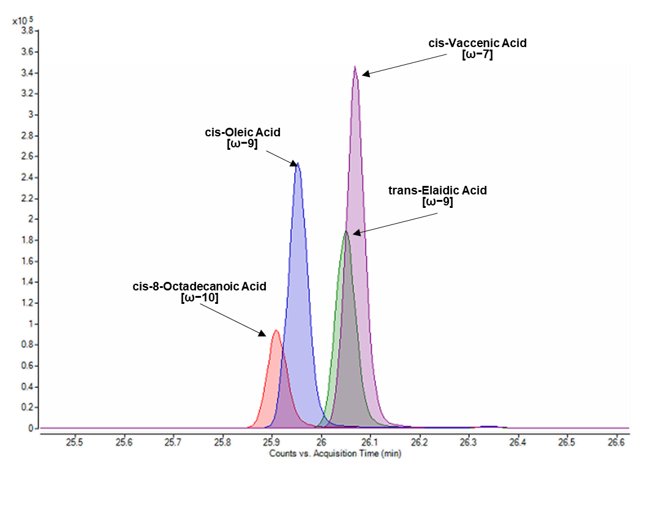
Figure S1: Separation of cis-8-octadecanoic acid, cis-oleic acid, trans-elaidic acid and cis-vaccenic acid derivatized with PFB and subsequently measured by GC-APCI-MS. A separation of the cis/trans isomers as well as a separation of the fatty acids from a difference of the double bond position of at least 2 carbon atoms could be detected.
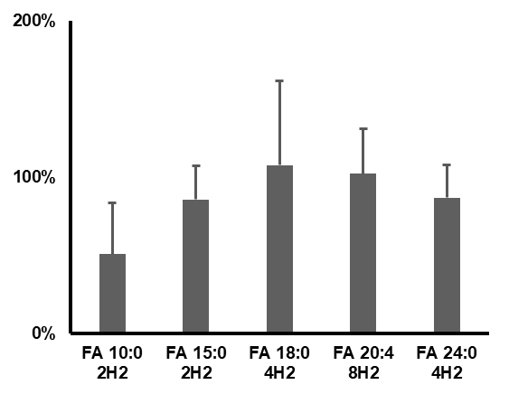
Figure S2: Recovery of the internal standard using the described extraction method (n=5). Recovery was determined by comparing the area of the internal standards spiked to a blank extraction at the beginning and at the end of the extraction.

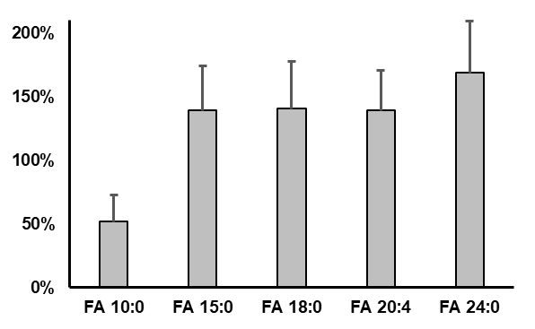
Figure S3: Matrix effect on the internal standards in a series of cell samples (n=40). For the determination of the matrix effect, a series of cell samples were analyzed and the areas of the internal standards were compared to the area of a reference measurement with the same concentration (2,000 nM).

