Supplementary Information

Analytical and Bioanalytical Chemistry

Towards Harmonization of Directly-Measured Free 25-Hydroxyvitamin D Using an Enzyme-linked Immunosorbent Assay

Christopher T. Sempos^{1,2}, Ernst Lindhout³, Nicolas Heureux^{4,5}, Michel Hars⁴, Damon A. Parkington⁶, Emily Dennison⁷, Ramón Durazo-Arvizu⁸, Kerry S. Jones^{6*} and Stephen A. Wise¹

¹ Office of Dietary Supplements, National Institutes of Health, Bethesda, MD 20892, USA
² Vitamin D Standardization Program, LLC, Havre de Grace, MD 21078, USA
³ Future Diagnostics, Nieuweweg 279, 6603 BN Wijchen, The Netherlands
⁴ DIAsource Immunoassays, B-1348 Louvain-La-Neuve, Belgium
⁵ BioSweet srl, B-5030 Lonzee, Belgium
⁶ Nutritional Biomarker Laboratory, MRC Epidemiology Unit, University of Cambridge, Cambridge CB2 0AH, United Kingdom
⁷ Immuno-Biological Laboratories Inc (IBL-America), Minneapolis, MN 55432, USA
⁸ The Saban Research Institute, Children's Hospital Los Angeles, Los Angeles, CA 90027, USA
*Corresponding author: kerry.jones@mrc-epid.cam.ac.uk

Table S1. Instrumentation Used by Participating Laboratories in this Study
Instrumentation/Assay | Future Diagnostics Solutions | Nutritional Biomarker Laboratory (NBL), University of Cambridge
Free 25(OH)D method | Free 25OH Vitamin D ELISA | Free 25OH Vitamin D ELISA
37 °C incubator | Shaker-incubator from Thermo | BMG THERMOstar
Reader | Biotek elx800 | Thermo Multiskan
Washer | Biotek elx50 | Thermo Wellwash
Shaker | Shaker-incubator from Thermo | BMG THERMOstar
Volume of serum used per analysis | 10 µL | 10 µL
Analysis Time per sample | 0.52 s per well | 0.52 s per well

Table S2. Instrument Controls Used by Both Laboratories in this Study
Manufacturer | Future Diagnostics | NBL Cambridge | Control ID | Acceptable concentration range |  | Future Diagnostics | NBl Cambridge
Manufacturer | Lot No. |  | Control ID | Lower (pg/mL) | Upper (pg/mL) | Free 25(OH)D (pg/mL)
Day 1, Run 1 | M68132 | M68132
 | M68132 | M67415 | CTRL-1 | 3.2 | 6.0 | 4.7 | 5.4
 | M68132 | M67340 | CTRL-2 | 11.4 | 21.4 | 16.4 | 14.9
Day 1, Run 2 | M68132 | M68132
 | M68132 | M67415 | CTRL-1 | 3.2 | 6.0 | 5.0 | 4.7
 | M68132 | M67340 | CTRL-2 | 11.4 | 21.2 | 17.6 | 15.7
Day 2, Run 1 | M68132 | M68132
 | M68132 | M67415 | CTRL-1 | 3.2 | 6.0 | 4.1 | 5.6
 | M68132 | M67340 | CTRL-2 | 11.4 | 21.2 | 17.4 | 15.2
Day 2, Run 2 | M68132 | M68132
 | M68132 | M67415 | CTRL-1 | 3.2 | 6.0 | 4.1 | 5.2
 | M68132 | M67340 | CTRL-2 | 11.4 | 21.2 | 16.1 | 16.0
Day 3, Run 1 | M68132 | M68132
 | M68132 | M67415 | CTRL-1 | 3.2 | 6.0 | 4.6 | 5.4
 | M68132 | M67340 | CTRL-2 | 11.4 | 21.2 | 18.3 | 15.2
Day 3, Run 2 | M68132 | M68132
 | M68132 | M67415 | CTRL-1 | 3.2 | 6.0 | 4.8 | 5.3
 | M68132 | M67340 | CTRL-2 | 11.4 | 21.2 | 16.1 | 15.8

Table S3. Calibrator Information for Free 25(OH)D Assay Used by Both Laboratories in this Studyª
 | Analyte | Manufacturer | Lot No. | Designation | Concentration (pg/mL)
Calibrator Level 1 | Free 25-hydroxyvitamin D | Future Diagnostics | M67333 | CAL A | 0.9
Calibrator Level 2 | Free 25-hydroxyvitamin D | Future Diagnostics | M67334 | CAL B | 3.1
Calibrator Level 3 | Free 25-hydroxyvitamin D | Future Diagnostics | M67335 | CAL C | 6.5
Calibrator Level 4 | Free 25-hydroxyvitamin D | Future Diagnostics | M67336 | CAL D | 11.6
Calibrator Level 5 | Free 25-hydroxyvitamin D | Future Diagnostics | M67337 | CAL E | 23.2
Calibrator Level 6 | Free 25-hydroxyvitamin D | Future Diagnostics | M67338 | CAL F | 40.3

ª Same calibrators were used for runs 1 and 2 on days 1, 2, and 3.

Table S4. Measurements of Free 25(OH)D using the ELISA assay in 40 patient samples at NBL Cambridge compared with 25(OH)D concentration determined using a Reference Measurement Procedure

Sample No. | Free 25(OH)D (pg/mL) |  |  |  |  |  |  |  |  |  | Total  25(OH)D  (ng/mL)ª | Percent  Free 25(OH)D
Sample No. | Day 1 |  |  | Day 2 |  | Day 3 |  |  |  |  | Total  25(OH)D  (ng/mL)ª | Percent  Free 25(OH)D
Sample No. | Rep 1 | Rep 2 | Rep 1 |  | Rep 2 | Rep 1 | Rep 2 | Mean | SD | CV | Total  25(OH)D  (ng/mL)ª | Percent  Free 25(OH)D
1 | 12.1 | 11.0 | 11.0 |  | 10.4 | 11.6 | 10.3 | 11.1 | 0.7 | 6.3 | 61.1 | 0.0182
2 | 12.7 | 11.6 | 11.7 |  | 11.3 | 12.3 | 11.1 | 11.8 | 0.6 | 5.2 | 59.8 | 0.0197
3 | 11.3 | 10.3 | 10.8 |  | 9.90 | 11.0 | 10.3 | 10.6 | 0.5 | 4.9 | 56.2 | 0.0189
4 | 13.8 | 12.7 | 13.8 |  | 13.1 | 14.2 | 13.8 | 13.6 | 0.6 | 4.1 | 45.1 | 0.0302
5 | 10.3 | 9.51 | 10.4 |  | 10.1 | 10.4 | 10.0 | 10.1 | 0.3 | 3.4 | 42.9 | 0.0235
6 | 14.1 | 12.1 | 13.7 |  | 13.0 | 13.5 | 12.9 | 13.2 | 0.7 | 5.3 | 35.1 | 0.0376
7 | 9.16 | 7.81 | 8.88 |  | 8.09 | 8.74 | 8.33 | 8.5 | 0.5 | 6.0 | 29.2 | 0.0291
8 | 10.7 | 8.83 | 9.62 |  | 8.58 | 10.0 | 9.23 | 9.5 | 0.8 | 8.3 | 31.1 | 0.0305
9 | 2.62 | 2.90 | 2.63 |  | 2.56 | 2.93 | 2.90 | 2.8 | 0.2 | 6.2 | 6.5 | 0.0431
10 | 9.18 | 8.95 | 9.05 |  | 9.08 | 9.54 | 9.28 | 9.2 | 0.2 | 2.3 | 35.8 | 0.0257
11 | 9.11 | 8.53 | 8.74 |  | 9.41 | 8.99 | 9.52 | 9.1 | 0.4 | 4.2 | 35.9 | 0.0253
12 | 8.54 | 8.32 | 8.37 |  | 8.28 | 8.48 | 8.31 | 8.4 | 0.1 | 1.2 | 32.5 | 0.0258
13 | 9.37 | 8.81 | 9.44 |  | 9.29 | 9.06 | 9.79 | 9.3 | 0.3 | 3.6 | 30.6 | 0.0304
14 | 5.44 | 5.11 | 5.49 |  | 5.12 | 5.57 | 5.67 | 5.4 | 0.2 | 4.3 | 21.6 | 0.0250
15 | 6.94 | 6.33 | 6.25 |  | 6.37 | 6.95 | 6.55 | 6.6 | 0.3 | 4.7 | 29.4 | 0.0224
16 | 10.9 | 10.4 | 10.5 |  | 10.2 | 11.1 | 10.7 | 10.6 | 0.3 | 3.1 | 24.9 | 0.0426
17 | 3.54 | 3.64 | 3.25 |  | 3.82 | 4.11 | 3.81 | 3.7 | 0.3 | 7.9 | 13.6 | 0.0272
18 | 4.64 | 4.48 | 4.11 |  | 4.25 | 4.66 | 4.65 | 4.5 | 0.2 | 5.3 | 17.3 | 0.0260
19 | 16.3 | 16.8 | 16.6 |  | 16.5 | 17.9 | 18.2 | 17.1 | 0.8 | 4.7 | 50.2 | 0.0341
20 | 4.96 | 4.59 | 5.18 |  | 4.71 | 5.02 | 4.89 | 4.9 | 0.2 | 4.4 | 25.5 | 0.0192
21 | 7.24 | 7.28 | 7.37 |  | 6.97 | 7.32 | 7.48 | 7.3 | 0.2 | 2.4 | 32.5 | 0.0225
22 | 3.59 | 3.50 | 3.36 |  | 3.35 | 3.70 | 3.75 | 3.5 | 0.2 | 4.8 | 12.3 | 0.0285
23 | 4.31 | 3.90 | 4.15 |  | 4.13 | 4.33 | 4.18 | 4.2 | 0.2 | 3.7 | 17.2 | 0.0244
24 | 3.58 | 3.18 | 3.44 |  | 2.95 | 3.44 | 3.49 | 3.3 | 0.2 | 7.0 | 11.6 | 0.0284
25 | 4.75 | 4.98 | 4.68 |  | 4.85 | 5.26 | 5.12 | 4.9 | 0.2 | 4.5 | 30.1 | 0.0163
26 | 4.02 | 3.95 | 3.54 |  | 3.76 | 4.06 | 3.91 | 3.9 | 0.2 | 5.0 | 12.0 | 0.0325
27 | 8.34 | 8.49 | 8.68 |  | 8.90 | 9.39 | 9.04 | 8.8 | 0.4 | 4.4 | 33.8 | 0.0260
28 | 5.03 | 4.65 | 4.60 |  | 5.05 | 5.35 | 4.89 | 4.9 | 0.3 | 5.7 | 21.3 | 0.0230
29 | 5.37 | 5.52 | 5.52 |  | 5.66 | 5.65 | 5.57 | 5.5 | 0.1 | 1.9 | 20.2 | 0.0272
30 | 6.65 | 6.47 | 6.86 |  | 6.42 | 6.60 | 6.86 | 6.6 | 0.2 | 2.8 | 24.6 | 0.0268
31 | 6.44 | 6.23 | 6.28 |  | 5.86 | 6.04 | 6.05 | 6.2 | 0.2 | 3.4 | 32.3 | 0.0192
32 | 2.98 | 2.74 | 3.09 |  | 2.58 | 3.06 | 2.97 | 2.9 | 0.2 | 6.9 | 8.5 | 0.0341
33 | 4.69 | 5.19 | 4.81 |  | 5.14 | 4.85 | 5.27 | 5.0 | 0.2 | 4.8 | 25.3 | 0.0198
34 | 7.59 | 7.82 | 7.60 |  | 7.46 | 7.33 | 7.74 | 7.6 | 0.2 | 2.4 | 39.9 | 0.0190
35 | 4.89 | 5.08 | 4.70 |  | 5.25 | 4.90 | 4.92 | 5.0 | 0.2 | 3.8 | 16.4 | 0.0305
36 | 6.72 | 6.70 | 7.01 |  | 6.81 | 6.83 | 6.77 | 6.8 | 0.1 | 1.6 | 27.3 | 0.0249
37 | 12.9 | 13.1 | 12.7 |  | 13.3 | 13.3 | 13.3 | 13.1 | 0.3 | 1.9 | 39.9 | 0.0328
38 | 14.5 | 14.2 | 14.8 |  | 15.0 | 15.1 | 15.4 | 14.8 | 0.4 | 2.9 | 51.9 | 0.0285
39 | 8.60 | 7.84 | 8.35 |  | 7.80 | 8.15 | 7.97 | 8.1 | 0.3 | 3.8 | 46.0 | 0.0176
40 | 4.82 | 4.49 | 4.82 |  | 4.30 | 4.73 | 4.72 | 4.6 | 0.2 | 4.5 | 23.2 | 0.0198
ª Values for Total 25(OH)D determined at NIST using RMPs as reported in Wise et al. [6].

Table S5. Measurements of Free 25(OH)D using the ELISA assay in 40 patient samples at Future Diagnostics compared with 25(OH)D concentration determined using a Reference Measurement Procedure

Sample No. | Free 25(OH)D (pg/mL) |  |  |  |  |  |  |  |  |  | Total  25(OH)D  (ng/mL)ª | Percent  Free 25(OH)D
Sample No. | Day 1 |  |  | Day 2 |  | Day 3 |  |  |  |  | Total  25(OH)D  (ng/mL)ª | Percent  Free 25(OH)D
Sample No. | Rep 1 | Rep 2 | Rep 1 |  | Rep 2 | Rep 1 | Rep 2 | Mean | SD | CV | Total  25(OH)D  (ng/mL)ª | Percent  Free 25(OH)D
1 | 11.7 | 9.97 | 10.9 |  | 9.98 | 10.8 | 9.92 | 10.55 | 0.72 | 6.8 | 61.1 | 0.0173
2 | 11.3 | 10.4 | 11.1 |  | 9.26 | 11.5 | 10.3 | 10.64 | 0.83 | 7.8 | 59.8 | 0.0178
3 | 9.97 | 9.48 | 9.79 |  | 8.65 | 10.0 | 9.01 | 9.48 | 0.55 | 5.8 | 56.2 | 0.0169
4 | 12.9 | 12.0 | 12.1 |  | 12.6 | 13.0 | 12.3 | 12.48 | 0.42 | 3.3 | 45.1 | 0.0277
5 | 9.90 | 9.52 | 9.79 |  | 8.96 | 9.59 | 9.51 | 9.55 | 0.33 | 3.4 | 42.9 | 0.0223
6 | 12.2 | 12.2 | 12.0 |  | 11.5 | 12.8 | 11.8 | 12.08 | 0.44 | 3.6 | 35.1 | 0.0344
7 | 8.70 | 7.79 | 8.06 |  | 7.42 | 7.93 | 8.29 | 8.03 | 0.44 | 5.4 | 29.2 | 0.0275
8 | 9.46 | 8.85 | 9.61 |  | 8.32 | 9.49 | 8.78 | 9.09 | 0.51 | 5.6 | 31.1 | 0.0292
9 | 2.86 | 2.77 | 2.58 |  | 2.40 | 2.61 | 2.55 | 2.63 | 0.16 | 6.2 | 6.5 | 0.0405
10 | 9.17 | 8.32 | 10.2 |  | 8.62 | 9.37 | 8.89 | 9.10 | 0.66 | 7.2 | 35.8 | 0.0254
11 | 9.06 | 8.67 | 8.51 |  | 8.64 | 8.57 | 8.60 | 8.68 | 0.20 | 2.3 | 35.9 | 0.0242
12 | 7.86 | 7.87 | 8.05 |  | 7.77 | 8.12 | 7.99 | 7.94 | 0.13 | 1.7 | 32.5 | 0.0244
13 | 8.50 | 8.80 | 8.53 |  | 8.42 | 8.78 | 8.78 | 8.64 | 0.17 | 2.0 | 30.6 | 0.0282
14 | 5.22 | 5.04 | 5.51 |  | 4.62 | 5.28 | 4.78 | 5.08 | 0.33 | 6.5 | 21.6 | 0.0235
15 | 6.04 | 6.59 | 6.40 |  | 6.21 | 6.31 | 6.53 | 6.35 | 0.20 | 3.2 | 29.4 | 0.0216
16 | 10.2 | 10.6 | 11.5 |  | 10.2 | 10.9 | 10.5 | 10.65 | 0.49 | 4.6 | 24.9 | 0.0428
17 | 3.62 | 3.40 | 3.27 |  | 3.08 | 3.48 | 3.27 | 3.35 | 0.19 | 5.6 | 13.6 | 0.0246
18 | 4.49 | 4.69 | 4.29 |  | 3.91 | 4.57 | 3.98 | 4.32 | 0.32 | 7.4 | 17.3 | 0.0250
19 | 16.1 | 16.5 | 14.5 |  | 14.9 | 15.4 | 15.6 | 15.50 | 0.74 | 4.8 | 50.2 | 0.0309
20 | 4.58 | 4.74 | 4.32 |  | 4.39 | 4.75 | 4.52 | 4.55 | 0.18 | 3.9 | 25.5 | 0.0178
21 | 7.04 | 6.94 | 6.33 |  | 6.31 | 6.79 | 6.94 | 6.73 | 0.32 | 4.8 | 32.5 | 0.0207
22 | 3.83 | 3.72 | 2.98 |  | 3.27 | 3.32 | 3.43 | 3.43 | 0.31 | 9.1 | 12.3 | 0.0279
23 | 4.07 | 4.44 | 3.42 |  | 4.00 | 3.77 | 4.08 | 3.96 | 0.34 | 8.6 | 17.2 | 0.0230
24 | 3.45 | 3.49 | 2.81 |  | 3.33 | 3.21 | 3.37 | 3.28 | 0.25 | 7.6 | 11.6 | 0.0283
25 | 5.13 | 4.96 | 4.72 |  | 4.23 | 4.96 | 4.82 | 4.80 | 0.31 | 6.5 | 30.1 | 0.0159
26 | 3.84 | 4.10 | 3.51 |  | 3.95 | 3.82 | 3.82 | 3.84 | 0.19 | 5.1 | 12.0 | 0.0320
27 | 9.06 | 8.75 | 8.49 |  | 8.23 | 8.42 | 8.60 | 8.59 | 0.29 | 3.4 | 33.8 | 0.0254
28 | 4.69 | 4.56 | 4.43 |  | 4.53 | 4.57 | 4.60 | 4.56 | 0.09 | 1.9 | 21.3 | 0.0214
29 | 5.51 | 5.21 | 4.98 |  | 5.33 | 4.85 | 5.46 | 5.22 | 0.26 | 5.1 | 20.2 | 0.0258
30 | 6.87 | 7.21 | 6.39 |  | 6.30 | 6.40 | 6.31 | 6.58 | 0.37 | 5.7 | 24.6 | 0.0267
31 | 6.20 | 6.11 | 6.06 |  | 5.76 | 6.15 | 6.08 | 6.06 | 0.16 | 2.6 | 32.3 | 0.0188
32 | 2.77 | 3.10 | 2.24 |  | 2.63 | 2.81 | 2.96 | 2.75 | 0.30 | 10.8 | 8.5 | 0.0324
33 | 4.80 | 4.82 | 4.89 |  | 4.75 | 4.93 | 4.94 | 4.86 | 0.08 | 1.6 | 25.3 | 0.0192
34 | 7.31 | 6.90 | 7.69 |  | 7.33 | 7.48 | 7.19 | 7.32 | 0.27 | 3.6 | 39.9 | 0.0183
35 | 4.83 | 4.93 | 4.69 |  | 4.47 | 4.59 | 4.83 | 4.72 | 0.17 | 3.6 | 16.4 | 0.0288
36 | 6.16 | 5.96 | 6.36 |  | 6.68 | 6.58 | 6.35 | 6.35 | 0.26 | 4.2 | 27.3 | 0.0233
37 | 12.6 | 11.6 | 12.7 |  | 11.6 | 11.7 | 12.2 | 12.07 | 0.50 | 4.2 | 39.9 | 0.0303
38 | 14.5 | 13.7 | 14.1 |  | 14.3 | 14.3 | 13.5 | 14.07 | 0.39 | 2.8 | 51.9 | 0.0271
39 | 7.46 | 7.75 | 7.38 |  | 7.86 | 7.79 | 7.96 | 7.70 | 0.23 | 3.0 | 46.0 | 0.0167
40 | 4.52 | 4.36 | 4.43 |  | 4.63 | 4.66 | 4.63 | 4.54 | 0.12 | 2.7 | 23.2 | 0.0173
ª Values for Total 25(OH)D determined at NIST using RMPs as reported in Wise et al. [6].

Figure S1. Ordinary least squares linear regression for free 25(OH)D and total 25(OH)D in 40 single-donor patient samples. Black circles are the single-donor samples and the solid red line is the regression line. Red dashed line is the 95% confidence interval for the regression line. Free 25(OH)D measurements performed at Future Diagnostics.
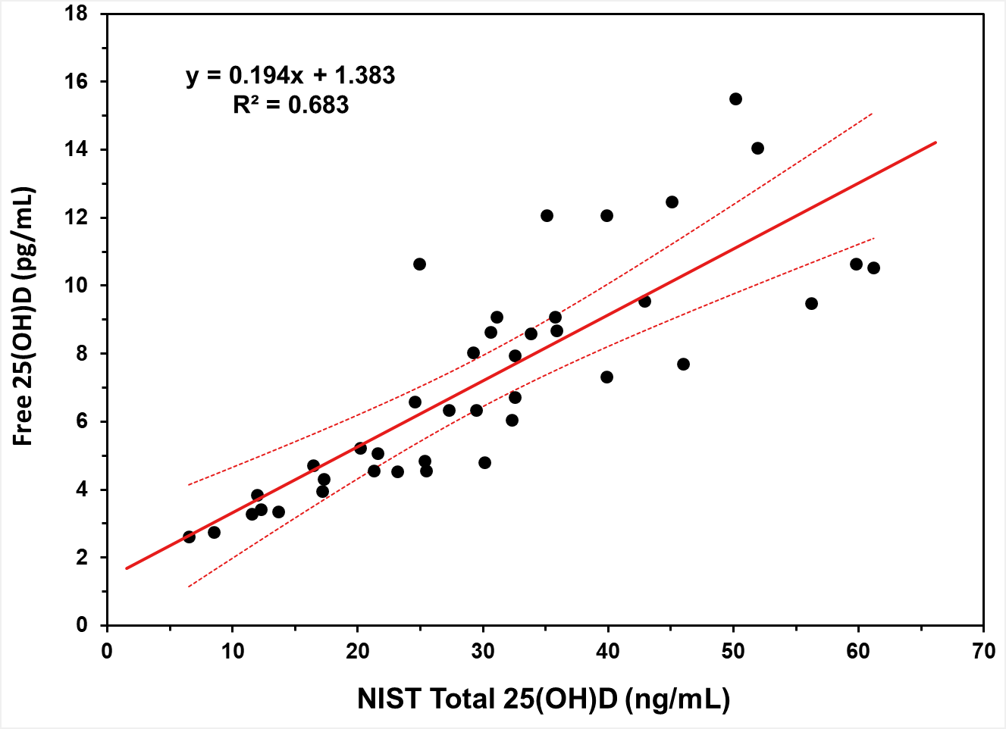

Figure S2. Distribution of free 25-hydroxyvitamin D (pg/mL) measurements by laboratory for NIST SRM 972a – Vitamin D Metabolites in Frozen Human Serum (Level 1). Blue diamonds are the individual measurements. Black bar is the mean value of the 12 measurements.

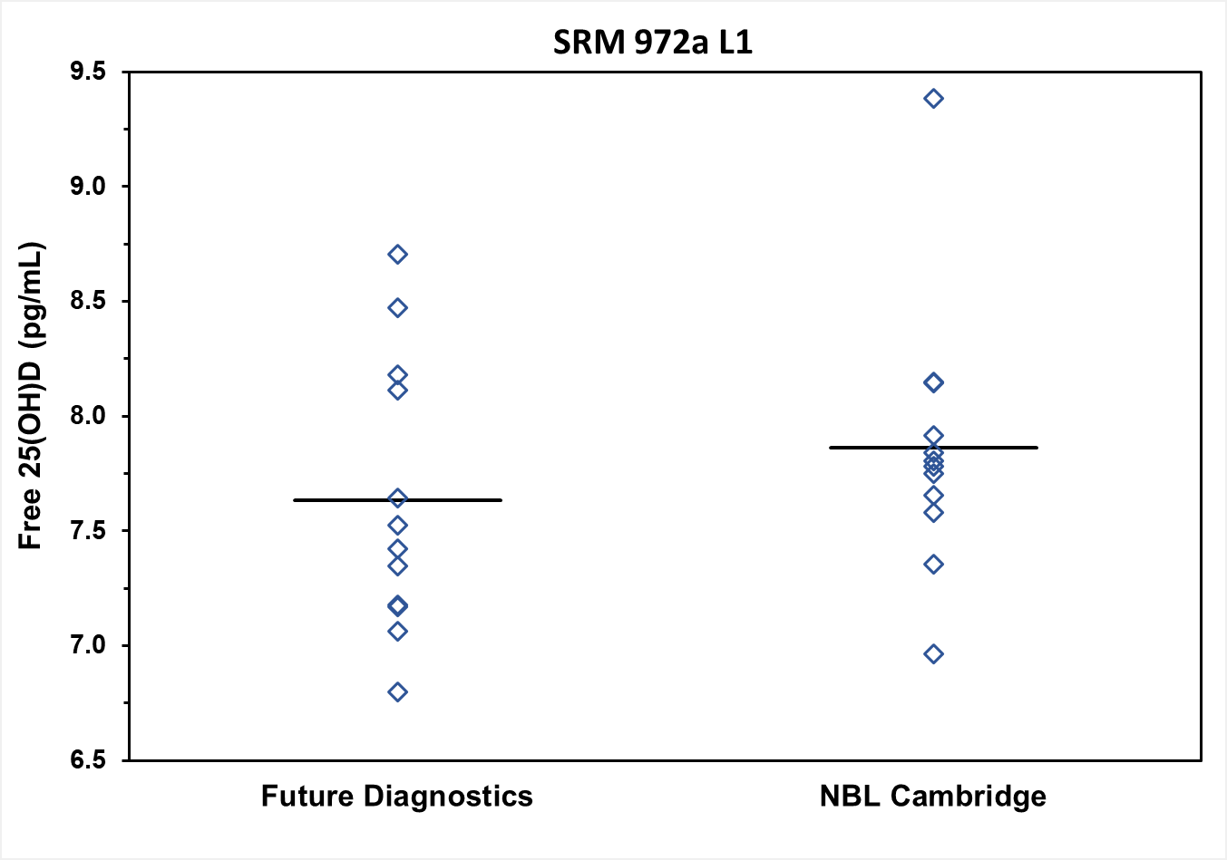
Figure S3. Distribution of free 25-hydroxyvitamin D (pg/mL) measurements by laboratory for NIST SRM 972a – Vitamin D Metabolites in Frozen Human Serum (Level 2). Blue diamonds are the individual measurements. Black bar is the mean value of the 12 measurements.

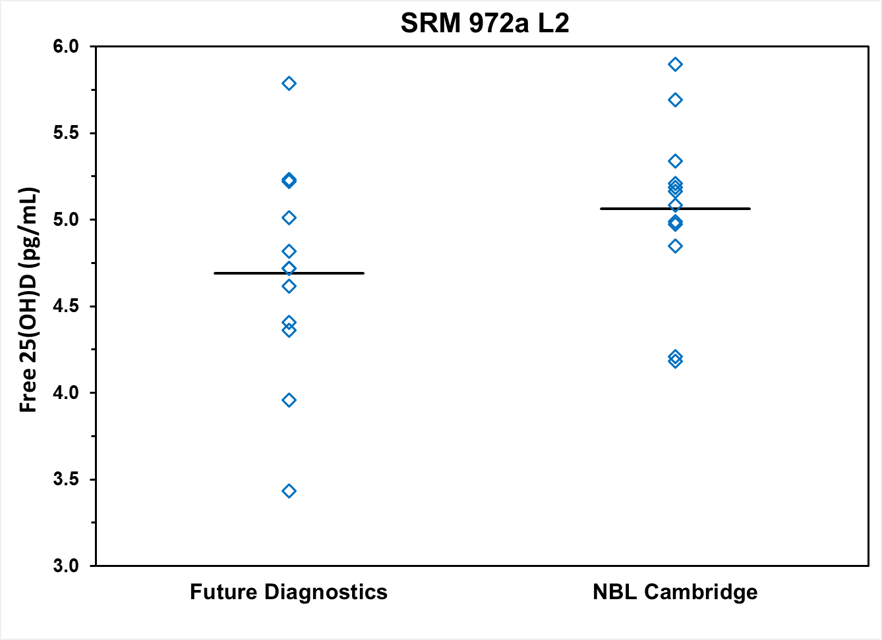

Figure S4. Distribution of free 25-hydroxyvitamin D (pg/mL) measurements by laboratory for NIST SRM 972a – Vitamin D Metabolites in Frozen Human Serum (Level 4). Blue diamonds are the individual measurements. Black bar is the mean value of the 12 measurements.

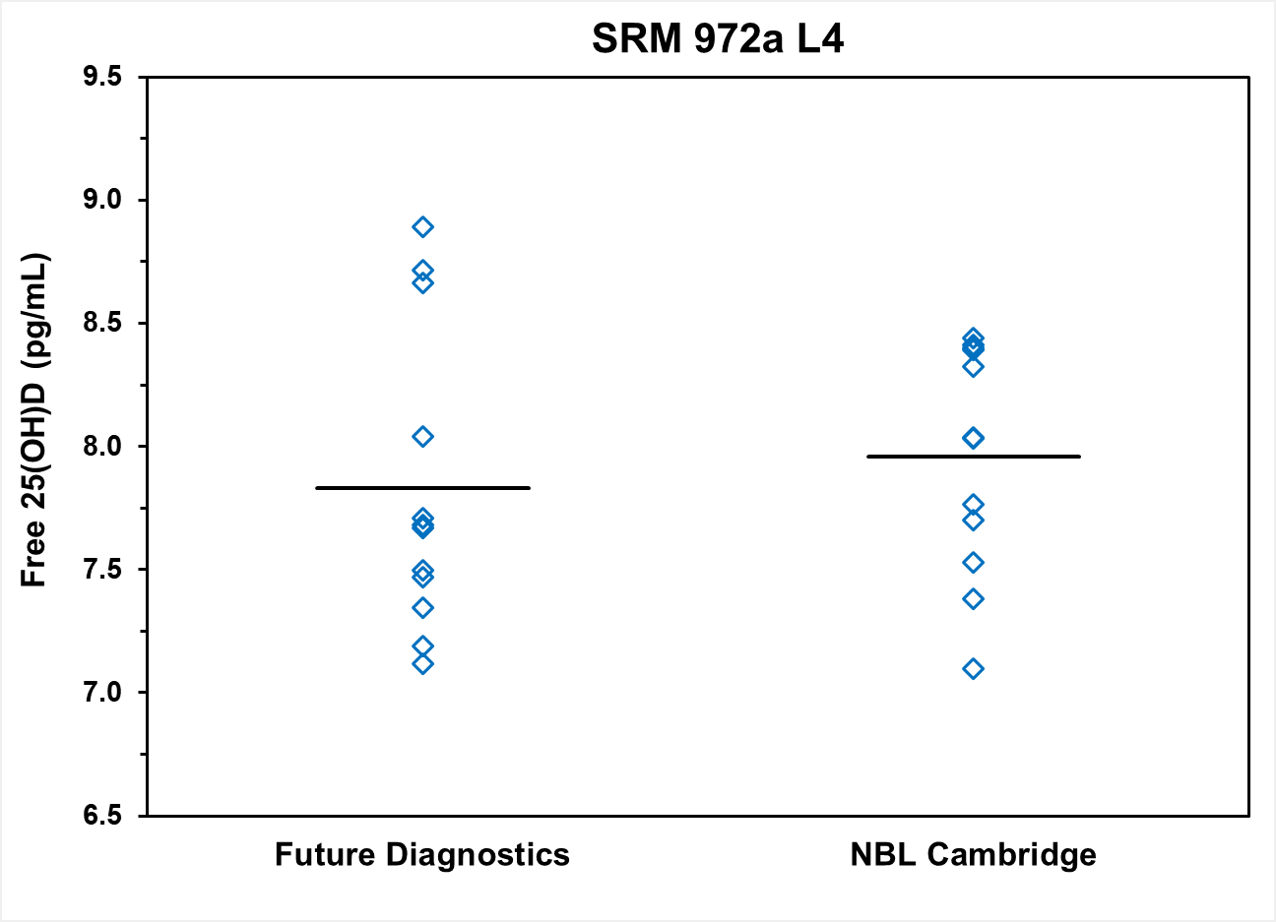

Figure S5. Distribution of free 25-hydroxyvitamin D (pg/mL) measurements by laboratory for NIST SRM 2973 – Vitamin D Metabolites in Frozen Human Serum (High Level). Blue diamonds are the individual measurements. Black bar is the mean value of the 12 measurements.

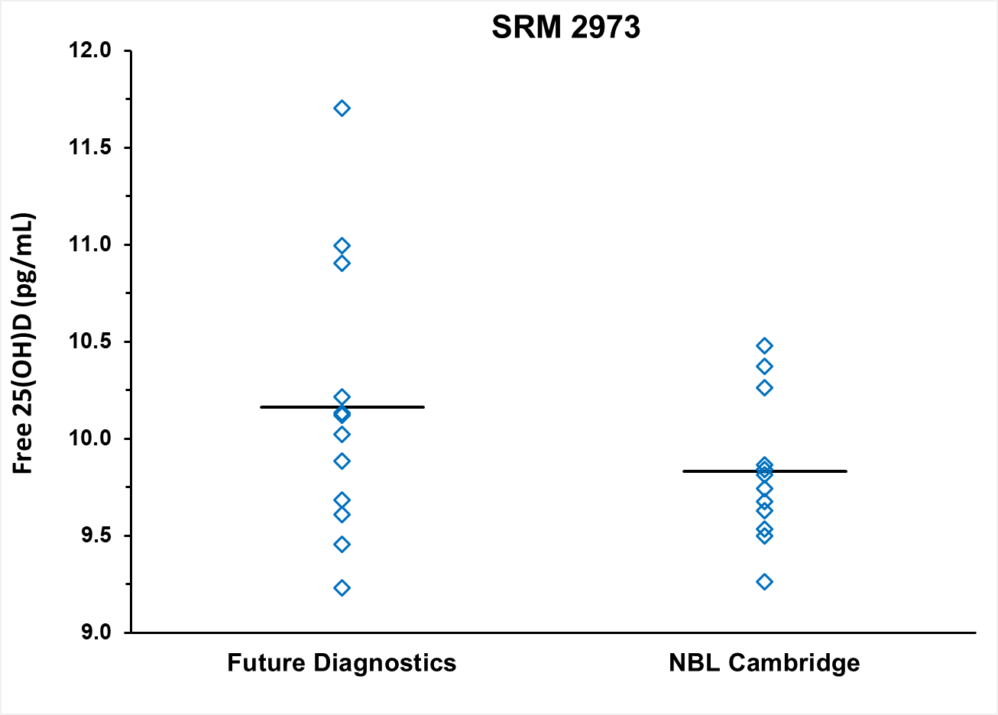
Figure S6. Distribution of free 25-hydroxyvitamin D (pg/mL) measurements by laboratory for NIST SRM 1949 – Frozen Human Prenatal Serum (Non-Pregnant). Blue diamonds are the individual measurements. Black bar is the mean value of the 12 measurements.

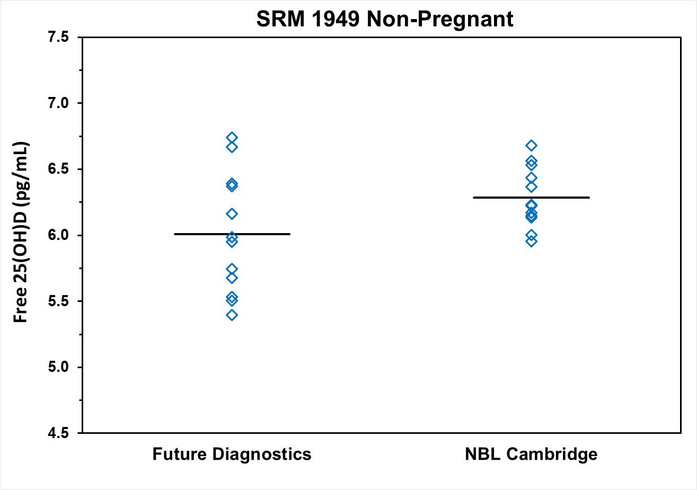
Figure S7. Distribution of free 25-hydroxyvitamin D (pg/mL) measurements by laboratory for NIST SRM 1949 – Frozen Human Prenatal Serum (First Trimester). Blue diamonds are the individual measurements. Black bar is the mean value of the 12 measurements.

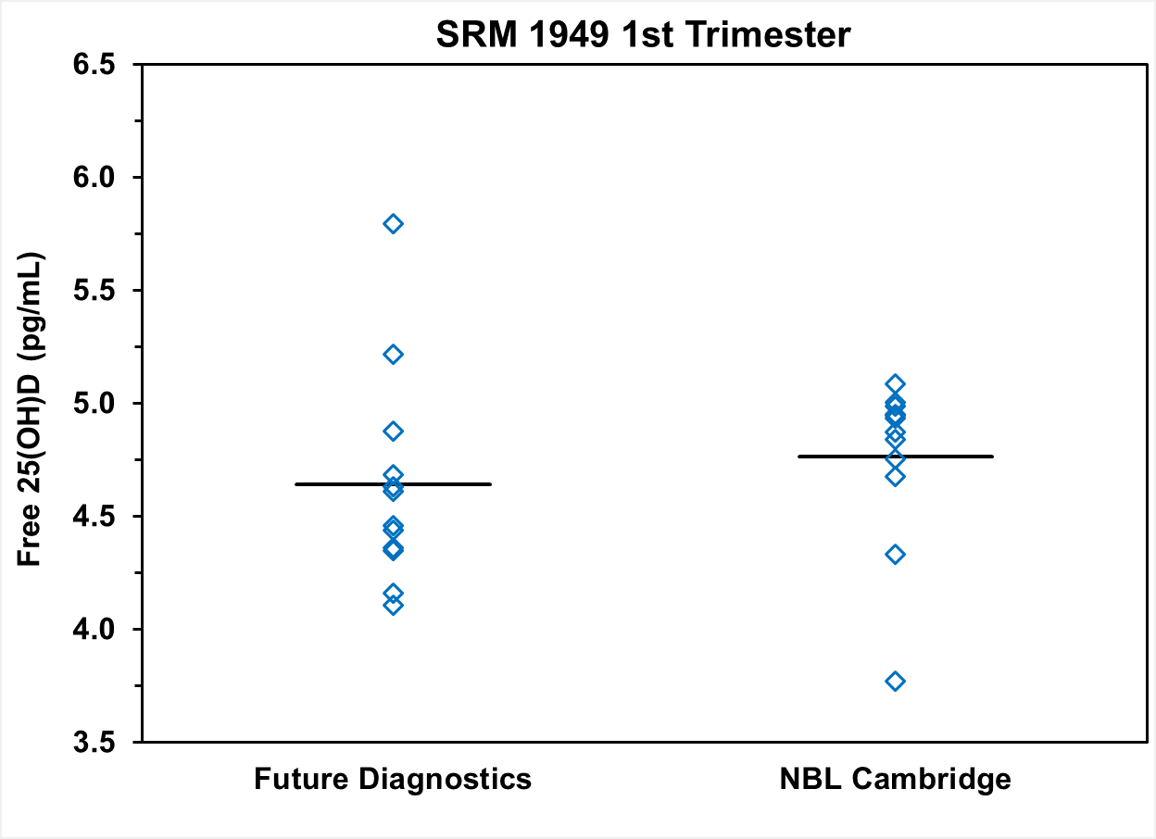

Figure S8. Distribution of free 25-hydroxyvitamin D (pg/mL) measurements by laboratory for NIST SRM 1949 – Frozen Human Prenatal Serum (Second Trimester). Blue diamonds are the individual measurements. Black bar is the mean value of the 12 measurements.

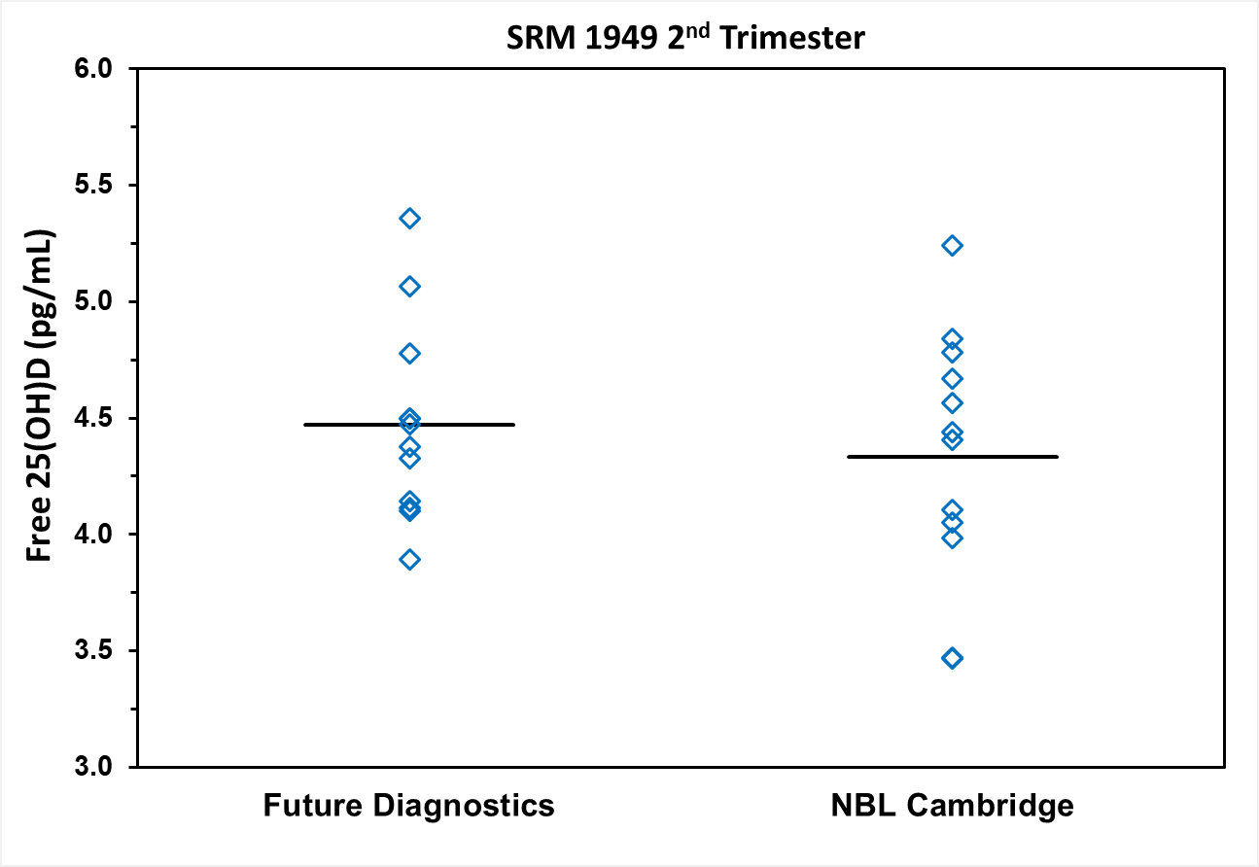

Figure S9. Distribution of free 25-hydroxyvitamin D (pg/mL) measurements by laboratory for NIST SRM 1949 – Frozen Human Prenatal Serum (Third Trimester). Blue diamonds are the individual measurements. Black bar is the mean value of the 12 measurements.

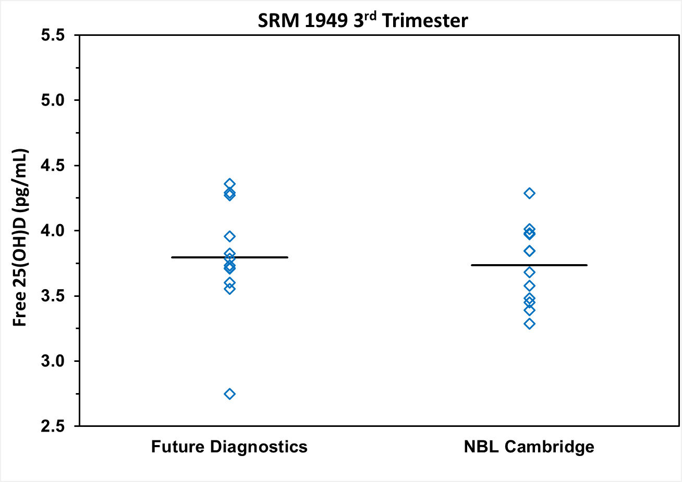

Figure S10. Standardized residual plot for ordinary least squares regression model of the means of directly measured free 25-hydroxyvitamin D concentrations for Future Diagnostic and NBL Cambridge.

