Supplemental Material
Label-free Sub-Micrometer 3D Imaging of Ciprofloxacin in Native-State Biofilms with Cryo-Time-of-Flight Secondary-Ion-Mass Spectrometry
Anoosheh Akbari¹, Anzhela Galstyan², Richard E. Peterson¹, Heinrich F. Arlinghaus¹, and Bonnie J. Tyler^{1*}
- Physikalisches Institut and Center for Soft Nanoscience, University of Münster, Wilhelm-Klemm-Straße 10, Münster, Germany

- Department of Chemistry, Center for Nanointegration Duisburg-Essen (CENIDE) and Centre for Water and Environmental Research (ZWU), University of Duisburg-Essen, Universitätsstrasse 5, 45141 Essen.

* Corresponding author email: tyler@uni-muenster.de

Table of Contents.
Figure S1
Figure S2
Figure S3

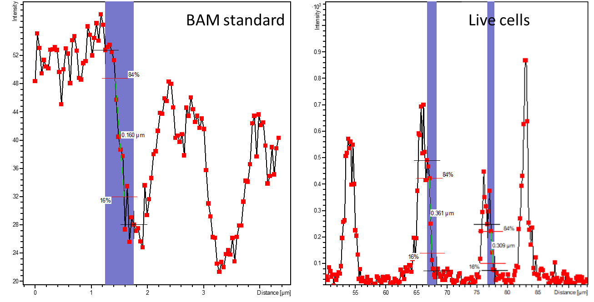
Figure S1: The lateral resolution from a line scan on resolution standard BAM-L200 is less than 200 nm. A line scan across the MCR image of the live cells shows a measured edge resolution in the 300 nm range. Because the edge of the cell is not a sharp edge, the measured resolution will be larger.

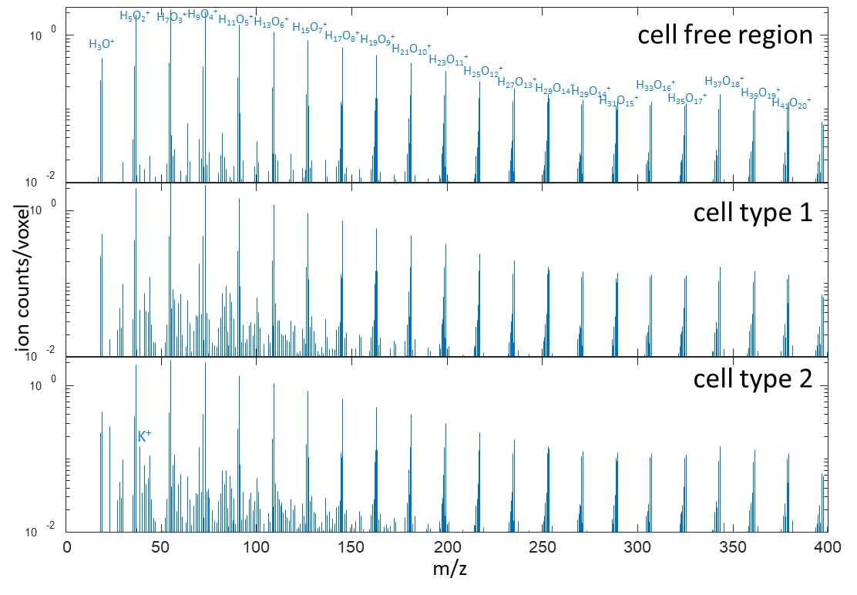
Figure S2: Cryo-ToF-SIMS spectra from three volumes in a B. subtilis biofilm that had not been treated with antibiotic. The dominant peaks in the cell-free volume, cell type 1 and cell type 2 are from water clusters. The volumes of interest were generated in 3 dimensions in MatLab.

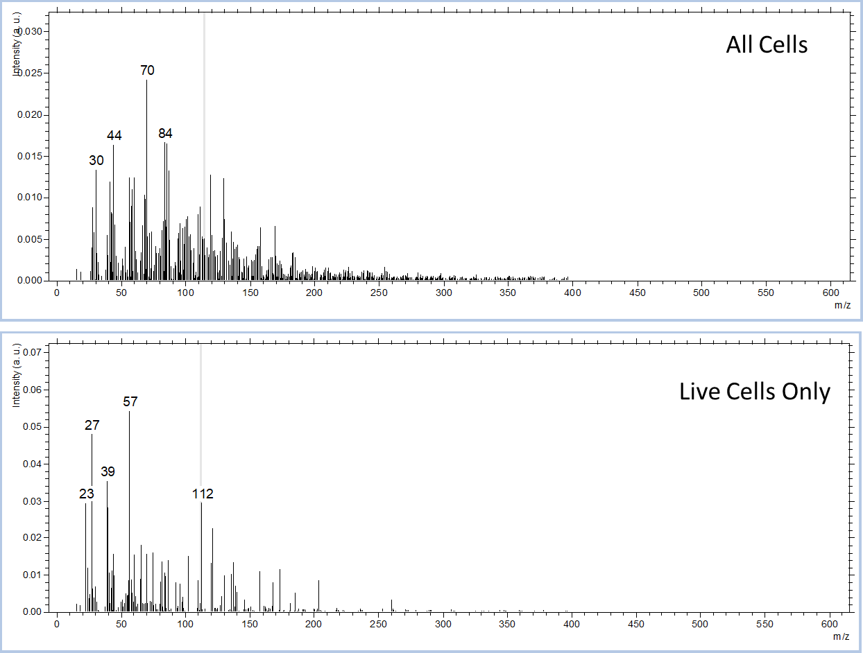
Figure S3: MCR factor spectra for all of the cells and for only the live cells.

