Supporting Information
Assessment of the stability of antimicrobials and resistance genes during short and long-term storage condition: accounting for uncertainties in bioanalytical workflows

Like Xu¹, Barbara Kasprzyk-Hordern^{1,2,3}*
¹Department of Chemistry, University of Bath, Claverton Down, Bath BA2 7AY, United Kingdom
²Institute for Sustainability, University of Bath, Claverton Down, Bath BA2 7AY, United Kingdom
³Water and Innovation Research Centre, University of Bath, Claverton Down, Bath BA2 7AY, United Kingdom

* Email address: b.kasprzyk-hordern@bath.ac.uk

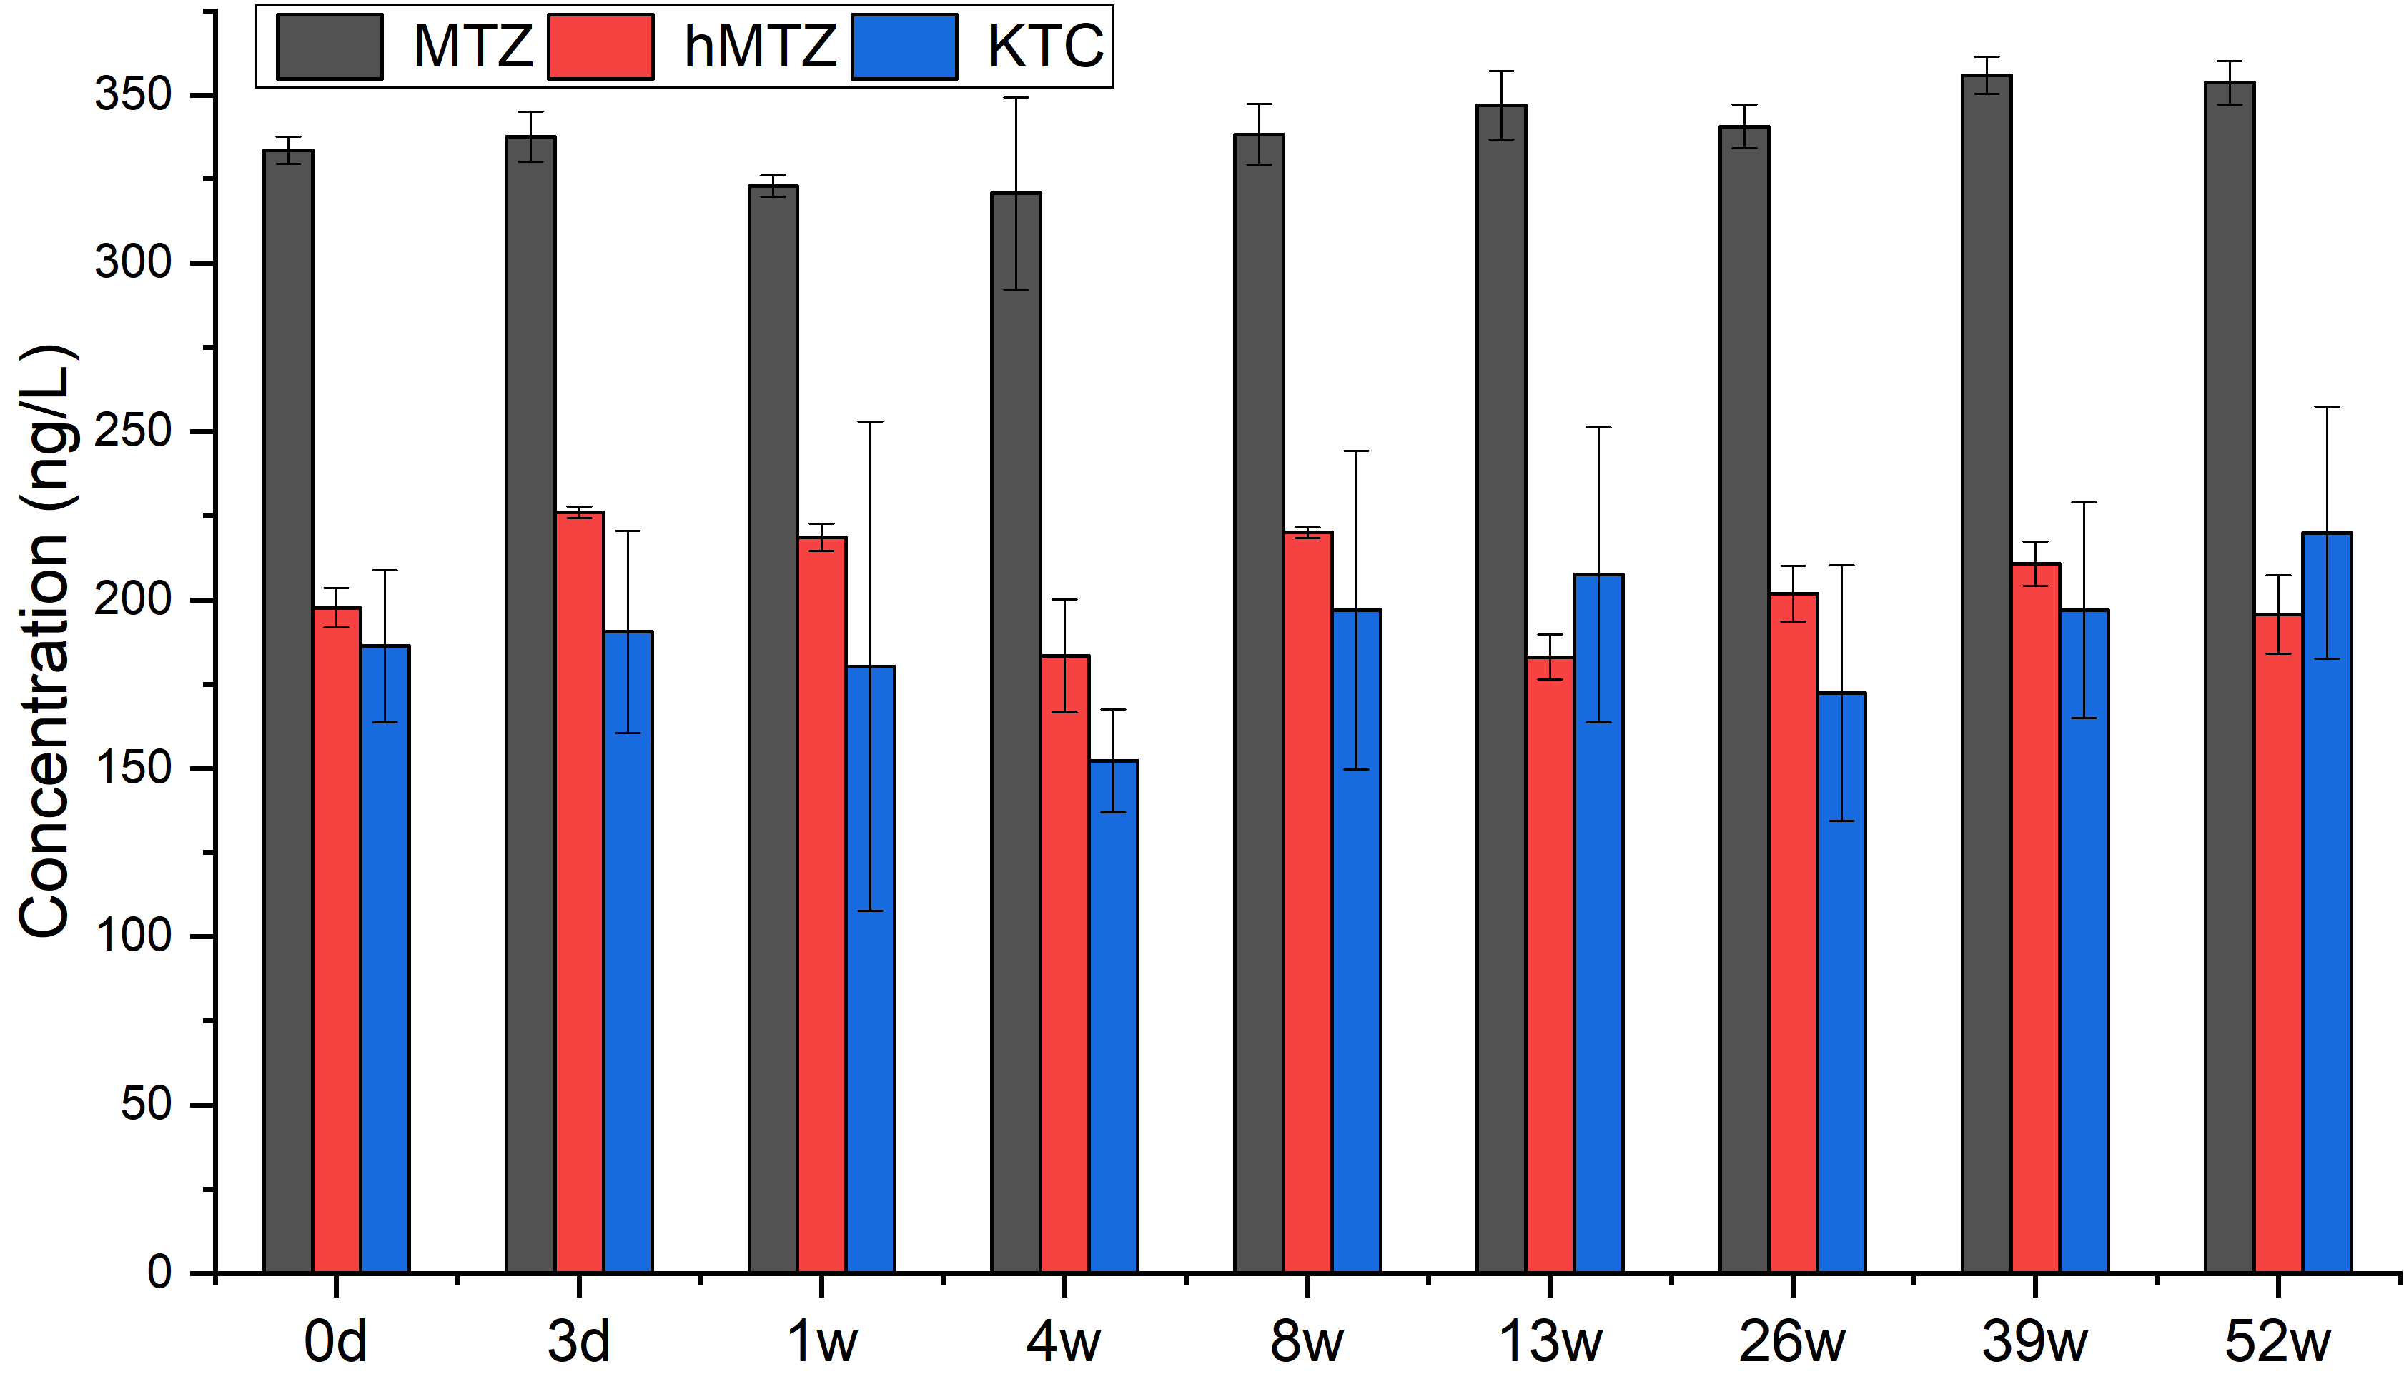
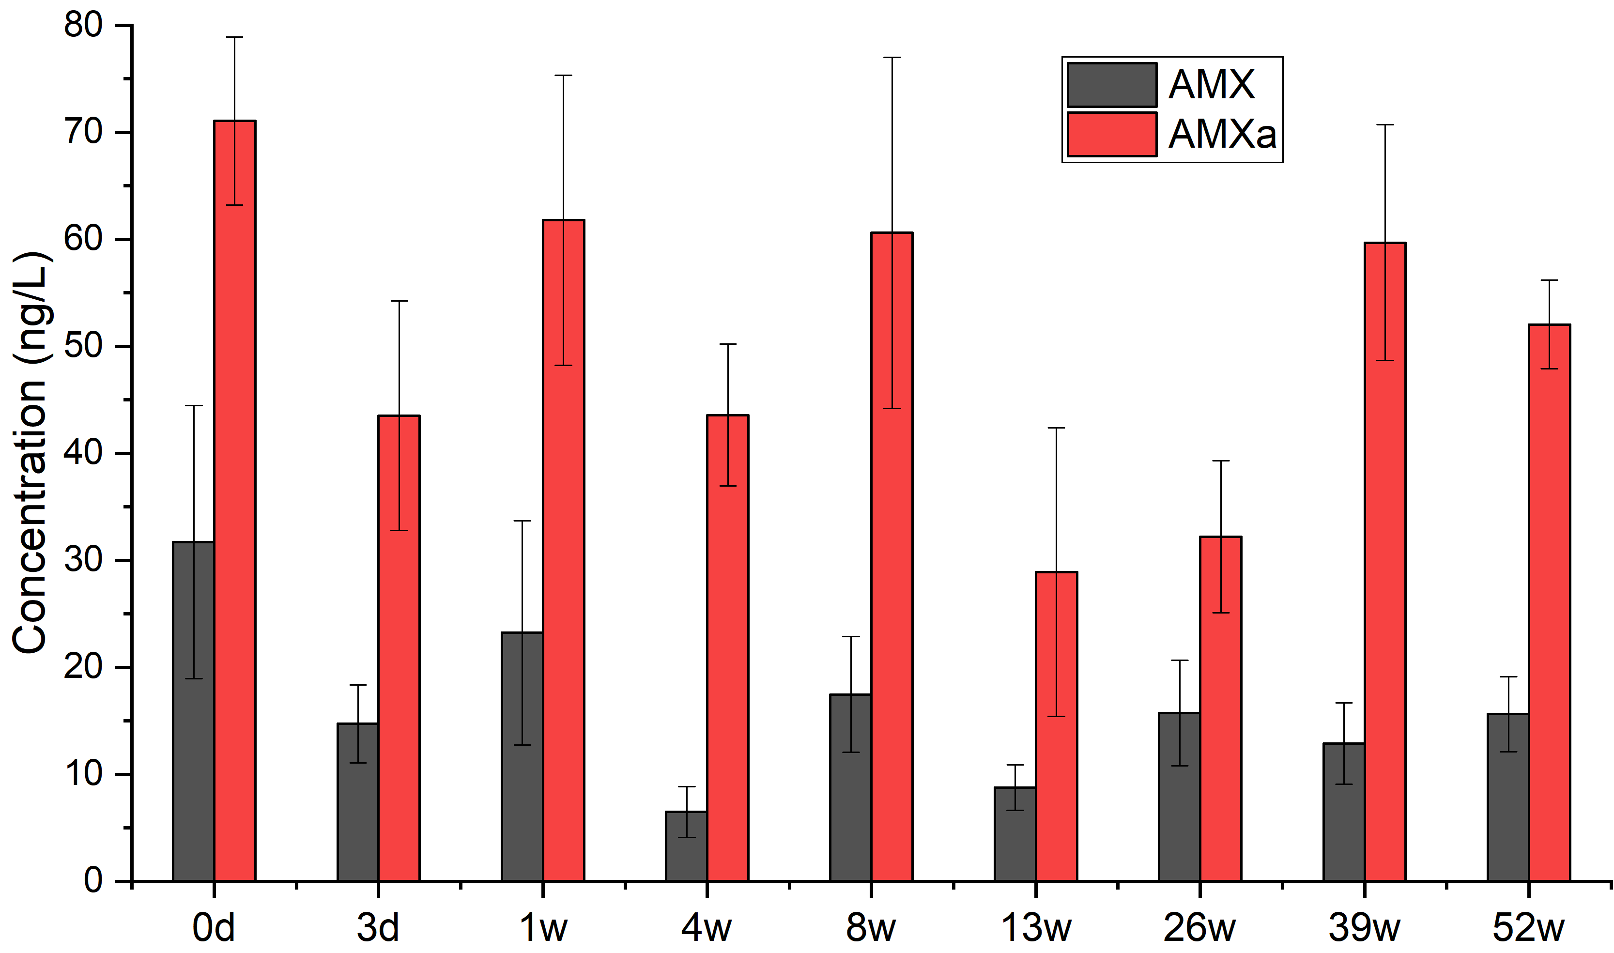
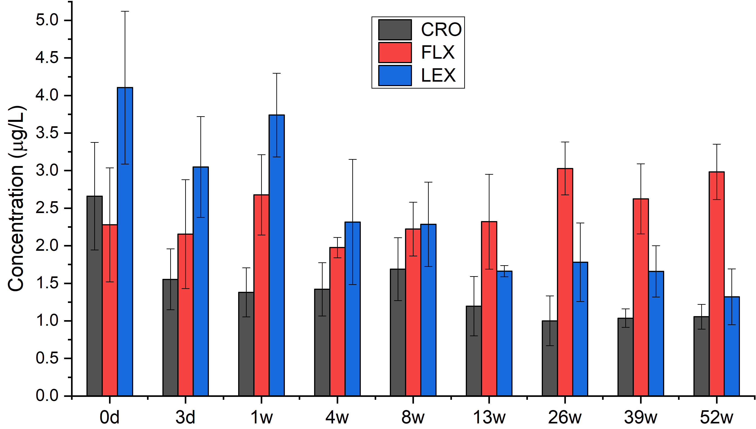
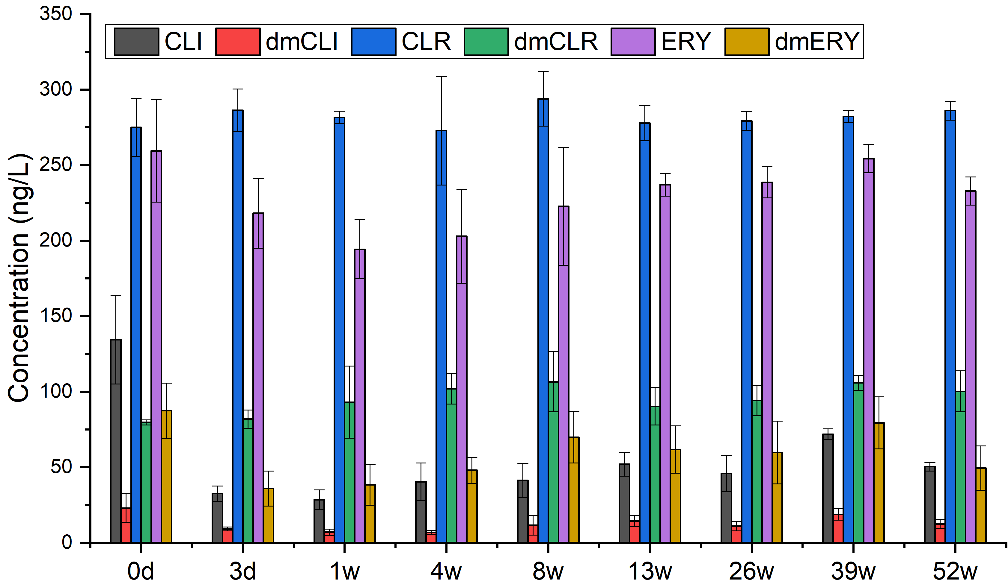
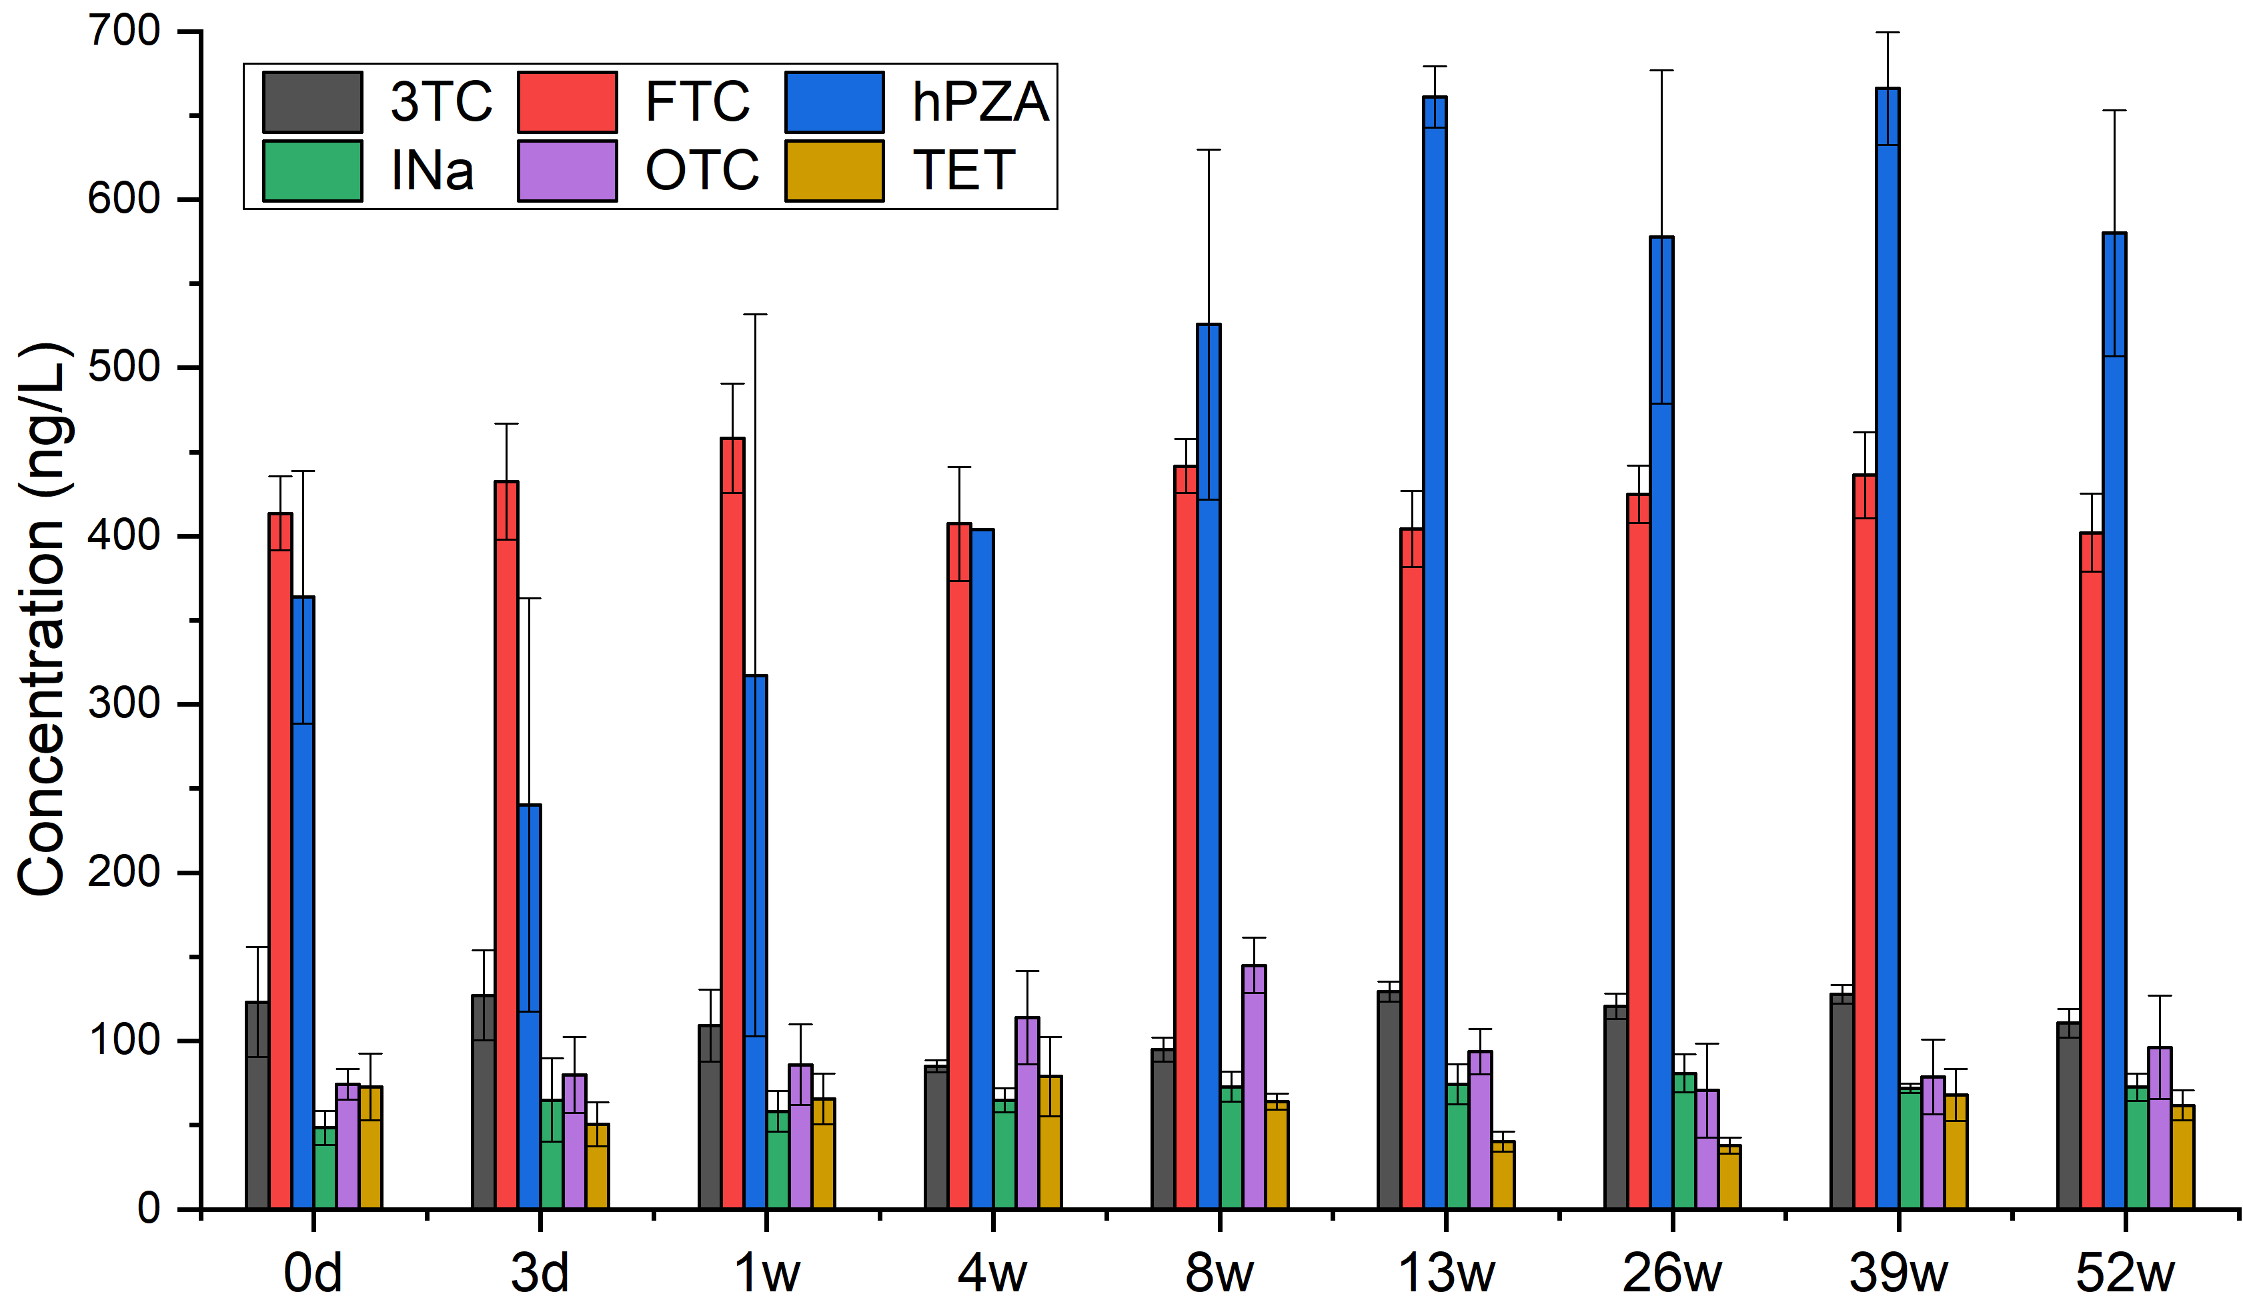
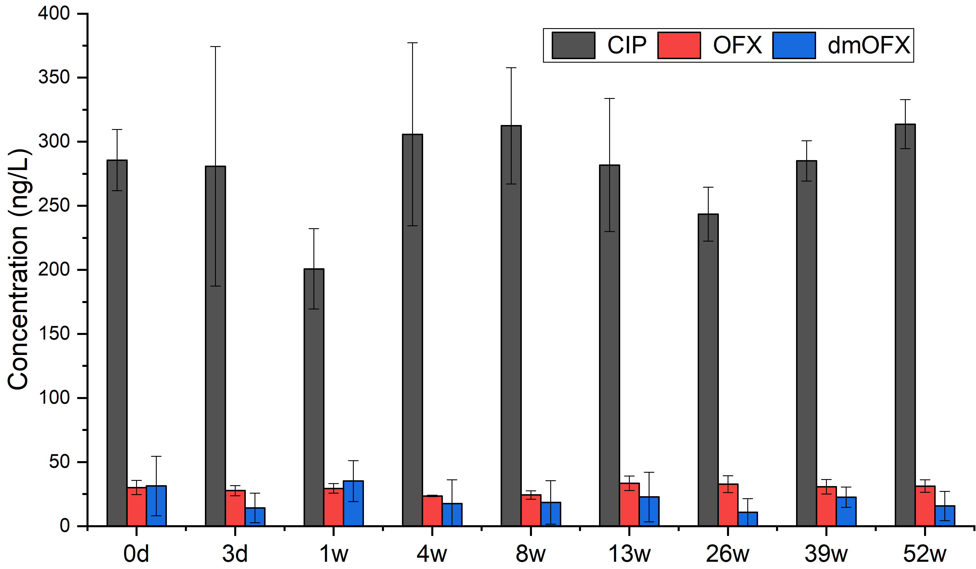
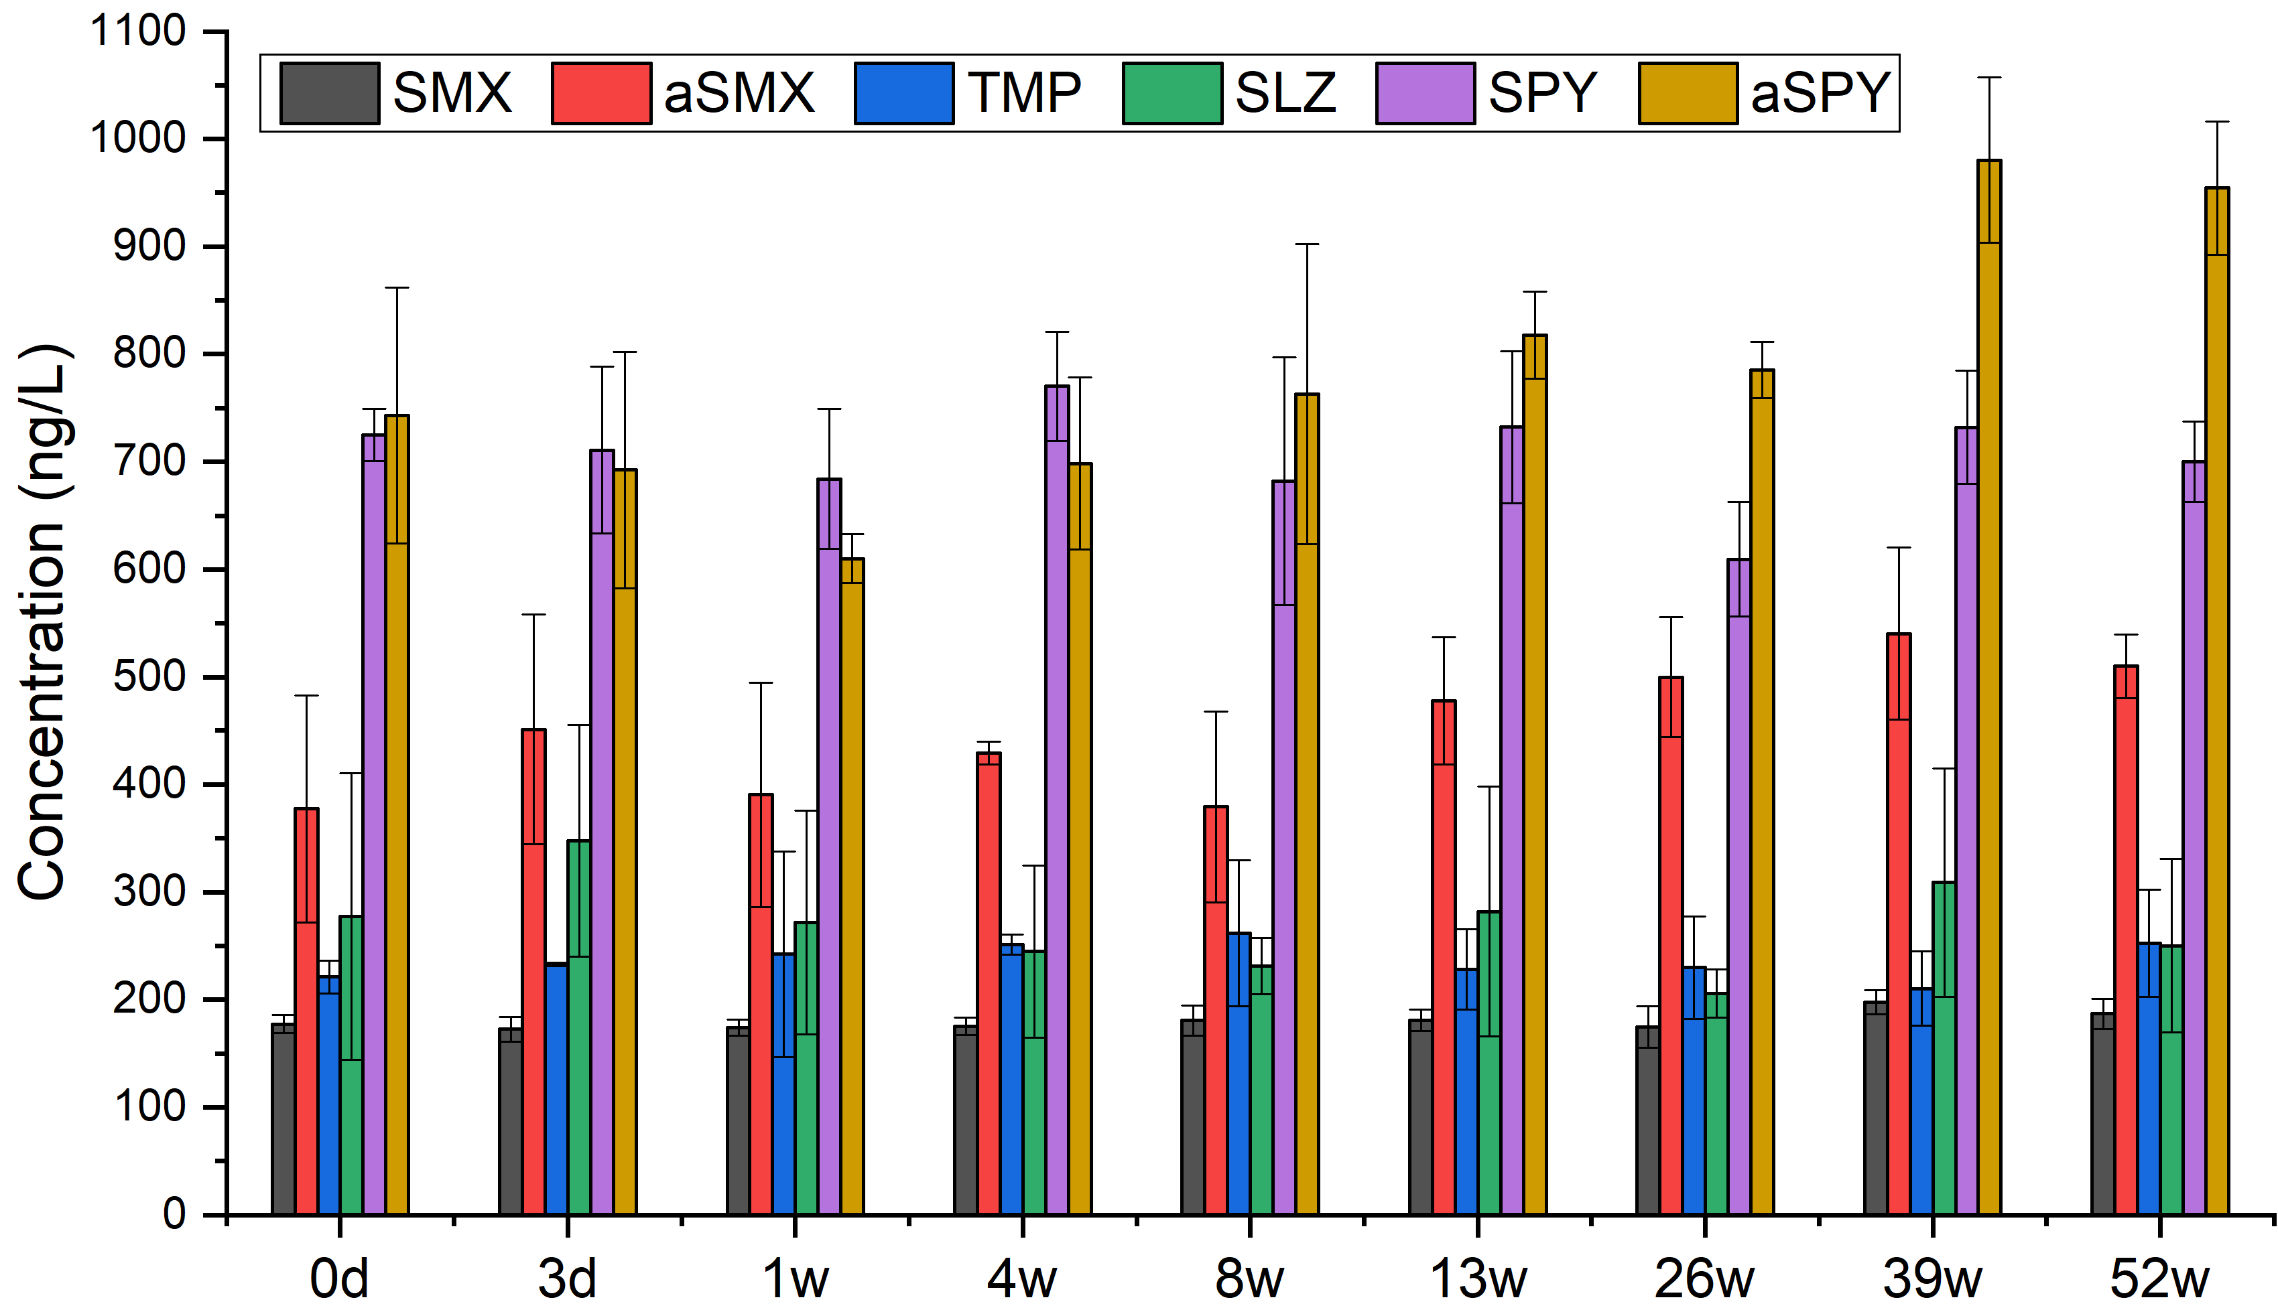
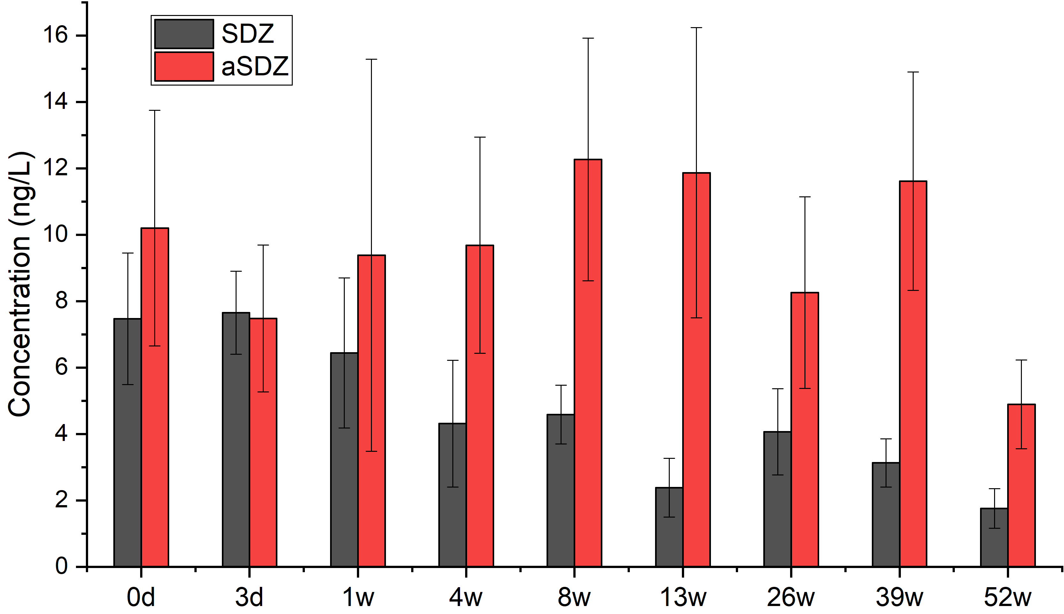
Figure S1. Concentrations of antimicrobials detected in stability samples (n = 3).

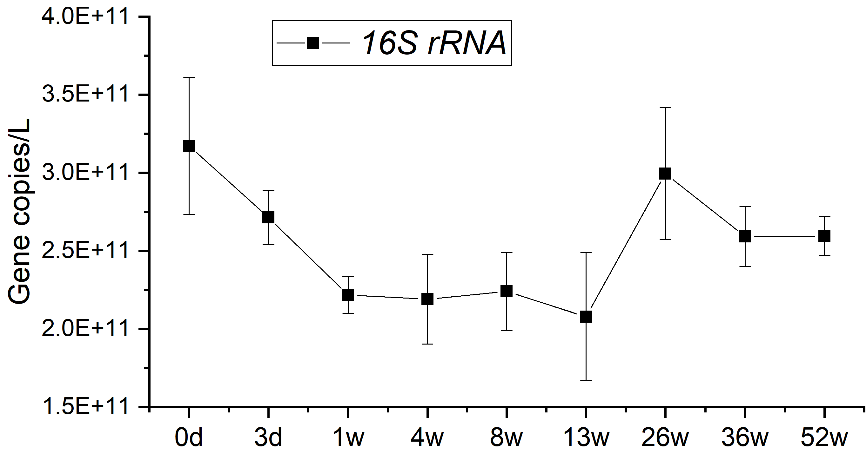  15% | 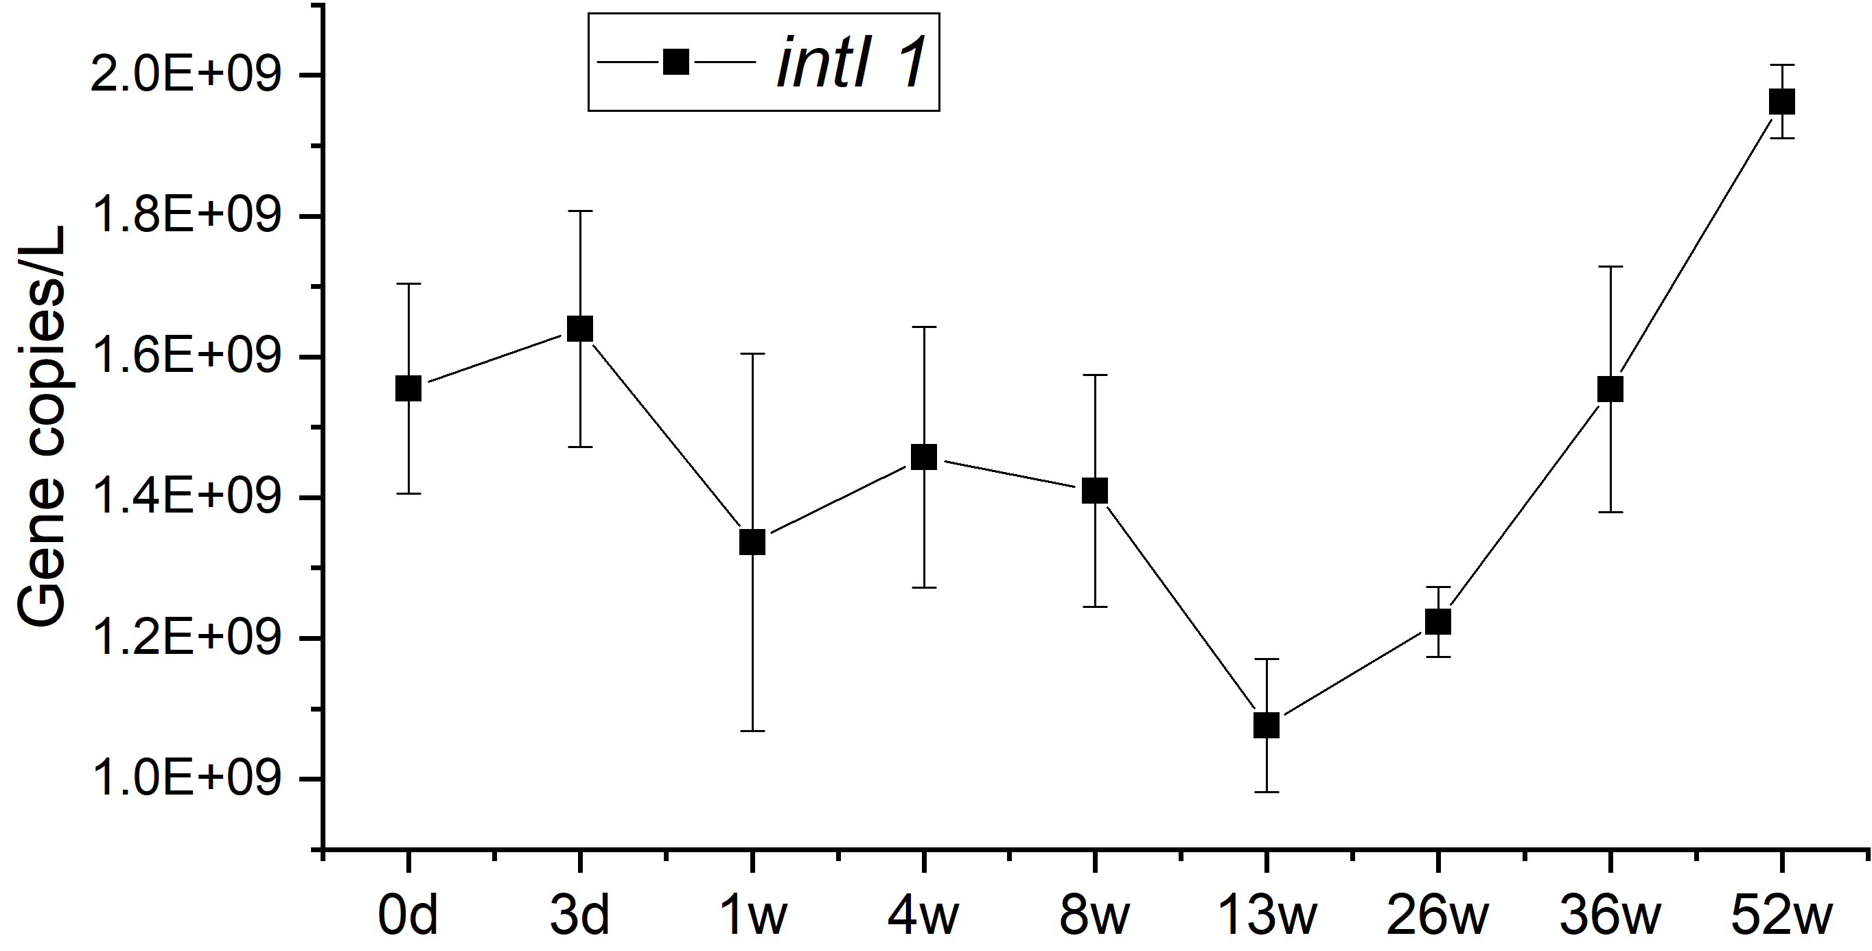  17%
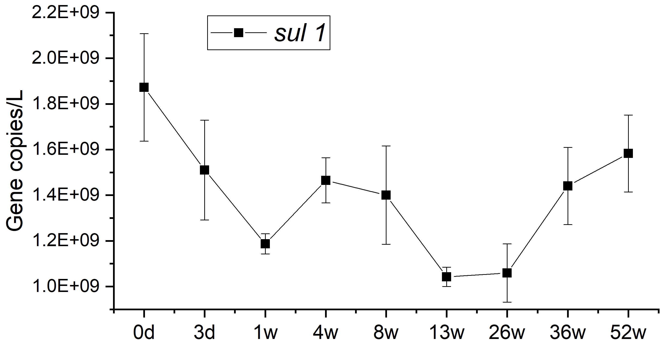  19% | 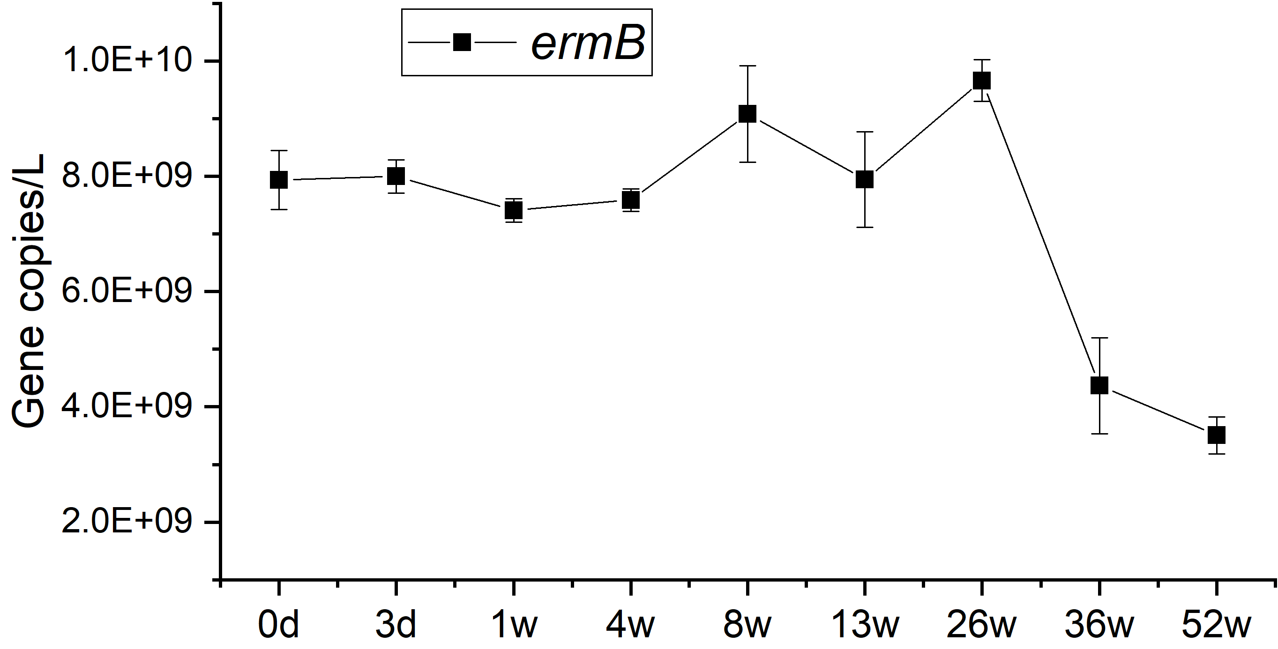  28%
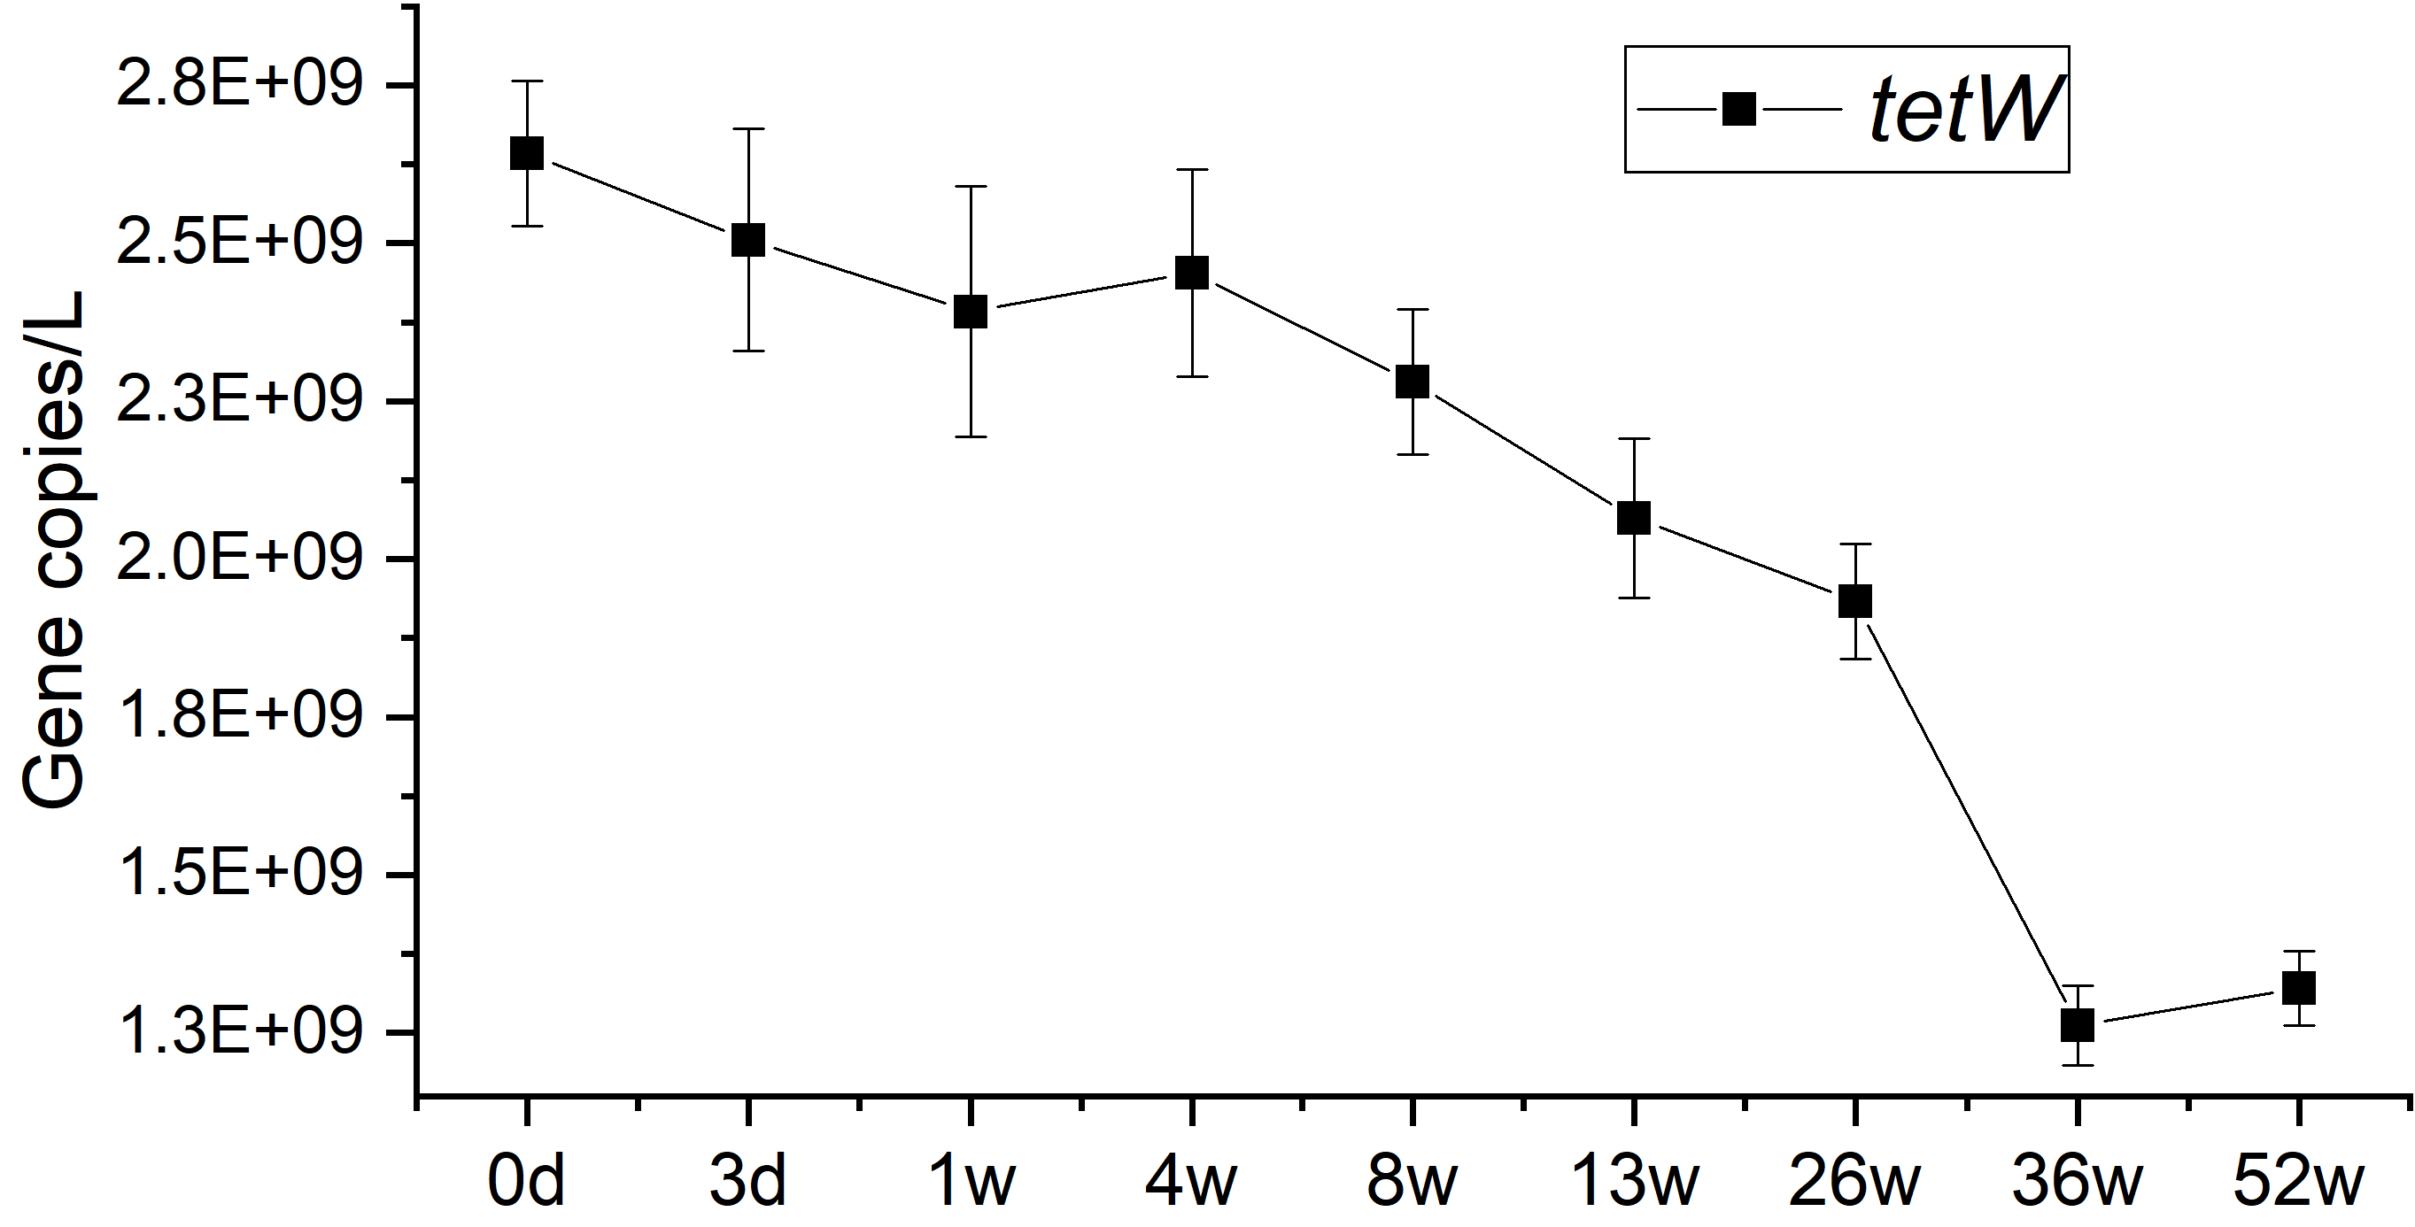  24% | 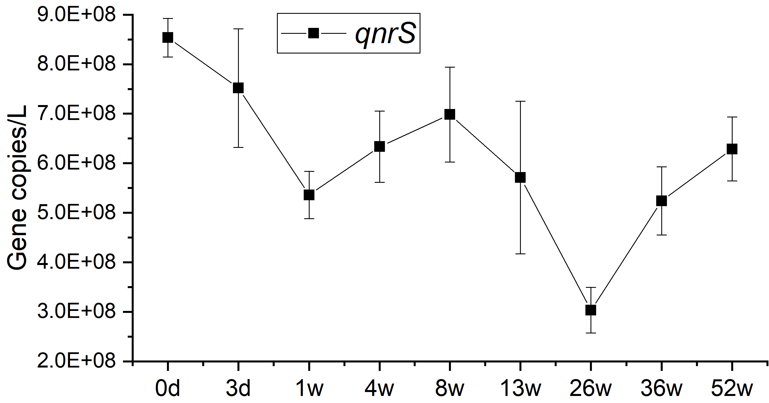  26%
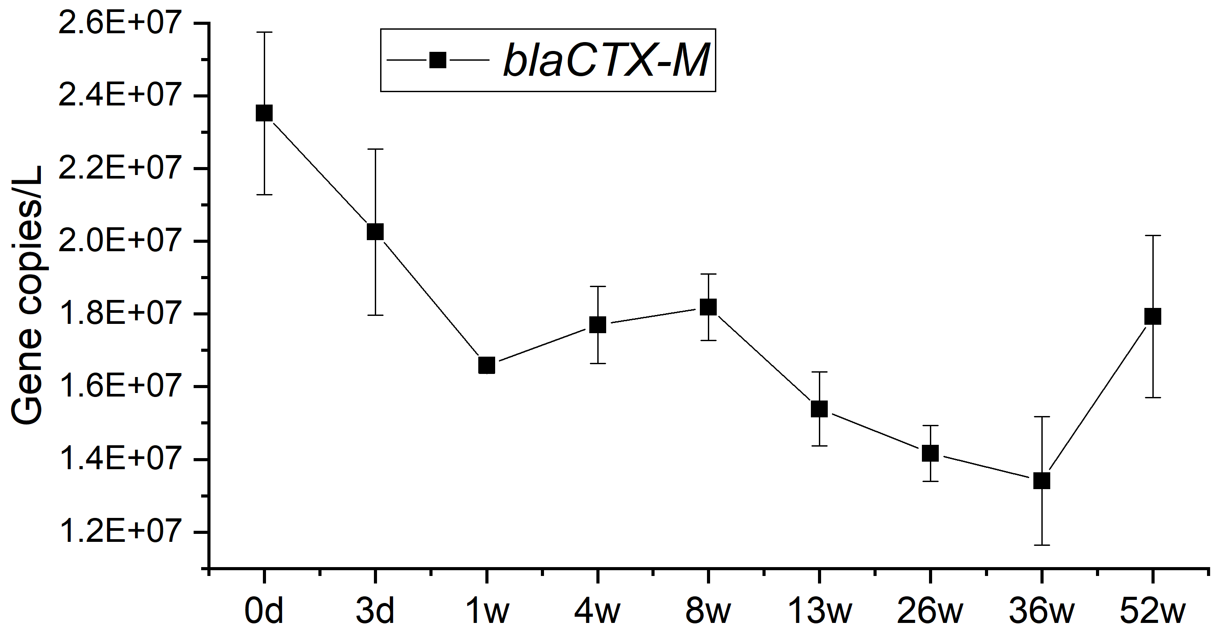
18%
Figure S2. Variation of target genes across 1-year freezing period. Results are provided as gene copies per litre and percentage variation.

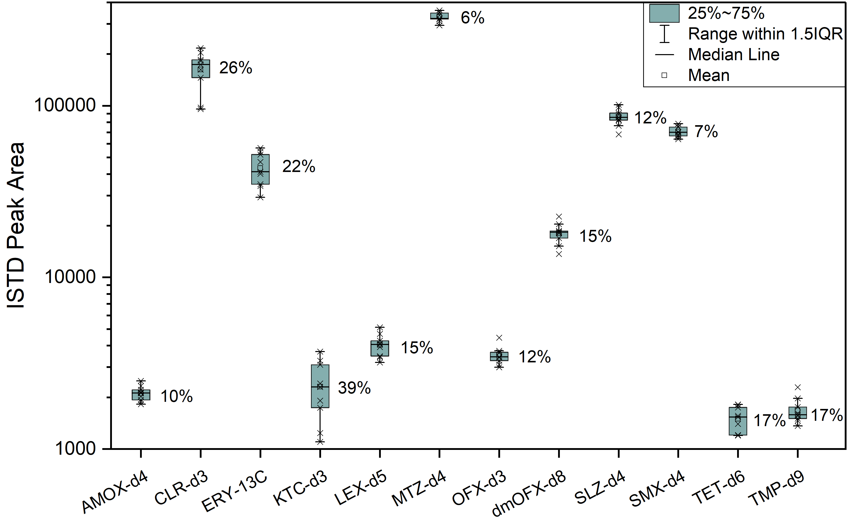
Figure S3. Box plot showing internal standard peak areas throughout the stability study. Percentage indicates the coefficient variance.

