ELECTRONIC SUPPORTING INFORMATION

Evaluation of different isotope dilution mass spectrometry strategies for the characterisation of naturally abundant and isotopically labelled peptide standards
Jesús Nicolás Carcelén¹, Helí Potes Rodríguez¹, Adriana González-Gago¹, Juan Manuel Marchante-Gayón*¹, Alfredo Ballesteros², José Manuel González², José Ignacio García Alonso¹ and Pablo Rodríguez-González¹
¹Department of Physical and Analytical Chemistry. Faculty of Chemistry. University of Oviedo. Spain.
²Department of Organic and Inorganic Chemistry. Faculty of Chemistry. University of Oviedo. Spain.
*To whom correspondence should be addressed: marchant@uniovi.es

Number of Pages: 15
Number of Figures: 7
Number of Tables: 6

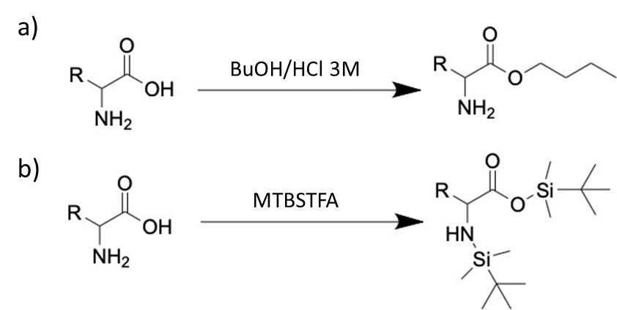
Figure S1.- Amino acids derivatization reactions: a) esterification for their determination by LC-MS/MS and b) silanization for their determination by GC-MS/MS.

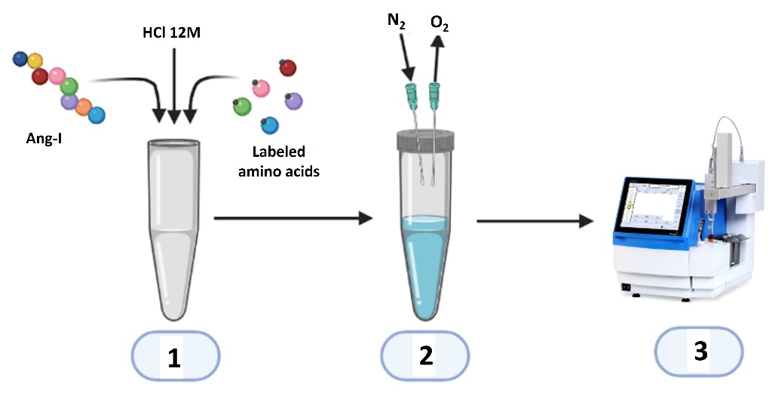
Figure S2.- Sample preparation procedure for the focused microwave assisted peptide hydrolysis.

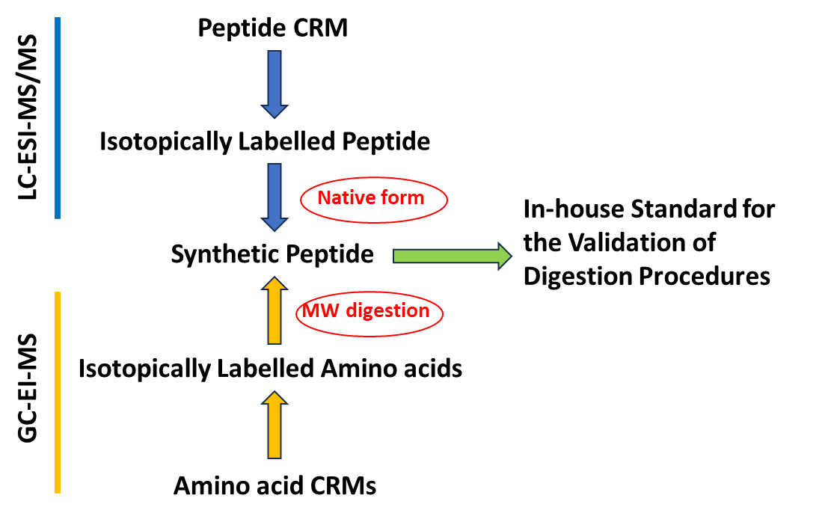
Figure S3. Study design carried out in this work

Table S1.- Chromatographic and mass spectrometric conditions for the analysis of esterified amino acids and angiotensin I by LC-MS/MS.
Liquid chromatograph | Agilent Infinity 1290
Column | Zorbax Eclipse Plus C18  (50 x 2.1mm x 1.8µm)
Flow | 0.4 mL min⁻¹
Mobile phase A | H₂O, 0.1 % formic acid
Mobile phase B | ACN, 0.1 % formic acid
Separation program | 0 min (5 %B )  1 min (5 %B)  8 min (40 %B)  9 min (60 %B)  10 min (5 %B)  12 min (5 %B)
Injection volume | 1 μL
Column temperature | 25ºC
Mass spectrometer | Agilent 6460
Ionization Source | Electrospray jet stream
Ionization mode | Positive
Gas temperature | 250 °C
Gas flow | 8 mL/min
Sheath gas T | 300 °C
Sheath gas flow | 10 mL/min
Nebulizer pressure | 50 psi
Capillary voltage | 2000 V
Nozzle voltage | 500 V
Collision Energy | 15 eV

Table S2.- Chromatographic and mass spectrometric conditions for the analysis of silanized amino acids by GC-MS.
Gas chromatograph | Agilent 7879A
Column | DB-5MS, 5%phenyl-95%dimethylpolysiloxane  (30m x 0.25 mm x 0.25 μm)
Helium flow | 2 mL min⁻¹
Separation program | 40ºC (5 min)  40 - 105ºC (3.5 min) a 5ºC min⁻¹  105ºC - 120º (3 min) a 5 ºC min⁻¹  120º - 145º a 10 ºC min⁻¹  145º - 185º a 5 ºC min⁻¹  185 - 200º (0.5 min) a 10ºC min⁻¹  Total time = 40 min
Injection volume | 1 μL
Injection temperature | 280ºC
Injection mode | Splitless
Mass spectrometer | Agilent 7000
Temperature of Transfer Line | 250 ºC
Temperature of Ion Source | 230ºC
Temperature of quadrupole analyzer | 150ºC

Table S3.- Parameters used for the separation by semipreparative liquid chromatography of the synthesized peptides: natural and isotopically labelled angiotensin I.
Chromatograph | Agilent Infinity 1260
Column | AerisPeptide XB-C18 (Phenomenex)
Column dimensions | 250x4.6mm x5µm
Temperature | 25 °C
Detection wavelenght | 280 nm
Injection volume | 100 µL
Flow | 2 mL/min
Phase A | 0.1% formic acid in water
Phase B | ACN, 0.1% formic acid
Separation | Time (min) - % B
 | 0 8
 | 5 8
 | 24 70
 | 29 70
 | 29.5 8
 | 49.5 8

Table S4.- Measured transitions, theorical and experimental values of the isotopic abundances of these transitions and standard deviation of the measurements for the reported amino acids obtained from n=5 injections in the LC-MS/MS system.
Amino acid | MRM Transition  Protonated molecules→Product ions | Theoretical value | Experimental value | Standard deviation (n=5)
Arginine | 231→214 | 0.8819 | 0.8828 | 0.0013
 | 232→215 | 0.1078 | 0.1070 | 0.0014
 | 233→216 | 0.0097 | 0.0096 | 0.0002
 | 234→217 | 0.0006 | 0.0006 | 0.0001
¹⁵N₄-Arginine* | 235→217 | 0.8916 | 0.8916 | 0.0014
¹⁵N₄-Arginine* | 236→218 | 0.0991 | 0.0996 | 0.0011
¹⁵N₄-Arginine* | 237→219 | 0.0087 | 0.0083 | 0.0004
¹⁵N₄-Arginine* | 238→220 | 0.0006 | 0.0004 | 0.0001
Proline | 172→116 | 0.9385 | 0.9367 | 0.0001
Proline | 173→117 | 0.0560 | 0.0575 | 0.0001
Proline | 174→118 | 0.0052 | 0.0055 | 0.0000
Proline | 175→119 | 0.0002 | 0.0003 | 0.0000
¹³C₁-Proline | 172→116 | 0.0000 | 0.0004 | 0.0001
¹³C₁-Proline | 173→117 | 0.9489 | 0.9482 | 0.0003
¹³C₁-Proline | 174→118 | 0.0463 | 0.0464 | 0.0002
¹³C₁-Proline | 175→119 | 0.0048 | 0.0050 | 0.0001
Valine | 174→118 | 0.9383 | 0.9371 | 0.0014
Valine | 175→119 | 0.0562 | 0.0594 | 0.0016
Valine | 176→120 | 0.0053 | 0.0035 | 0.0003
Valine | 177→121 | 0.0002 | 0.0000 | 0.0000
¹³C₁-Valine | 174→118 | 0.0012 | 0.0005 | 0.0006
¹³C₁-Valine | 175→119 | 0.9485 | 0.9494 | 0.0013
¹³C₁-Valine | 176→120 | 0.0465 | 0.0454 | 0.0016
¹³C₁-Valine | 177→121 | 0.0048 | 0.0047 | 0.0008
Tyrosine | 238→182 | 0.8966 | 0.8972 | 0.0019
Tyrosine | 239→183 | 0.0928 | 0.0928 | 0.0016
Tyrosine | 240→184 | 0.0099 | 0.0096 | 0.0005
Tyrosine | 241→185 | 0.0007 | 0.0005 | 0.0001
¹³C₂-Tyrosine | 238→182 | 0.0001 | 0.0222 | 0.0004
¹³C₂-Tyrosine | 239→183 | 0.0199 | 0.0189 | 0.0006
¹³C₂-Tyrosine | 240→184 | 0.9057 | 0.8815 | 0.0005
¹³C₂-Tyrosine | 241→185 | 0.0742 | 0.0696 | 0.0006
Leucine | 188→132 | 0.9281 | 0.9227 | 0.0013
Leucine | 189→133 | 0.0658 | 0.0698 | 0.0014
Leucine | 190→134 | 0.0058 | 0.0073 | 0.0005
Leucine | 191→135 | 0.0003 | 0.0001 | 0.0001
¹³C₁-Leucine | 188→132 | 0.0096 | 0.0002 | 0.0001
¹³C₁-Leucine | 189→133 | 0.9293 | 0.9355 | 0.0008
¹³C₁-Leucine | 190→134 | 0.0559 | 0.0593 | 0.0007
¹³C₁-Leucine | 191→135 | 0.0052 | 0.0050 | 0.0004
Isoleucine | 188→69 | 0.9467 | 0.9472 | 0.0003
Isoleucine | 189→70 | 0.0522 | 0.0517 | 0.0002
Isoleucine | 190→71 | 0.0012 | 0.0011 | 0.0000
Isoleucine | 191→72 | 0.0000 | 0.0000 | 0.0000
¹³C₁-Isoleucine** | 189→69 | 0.9467 | 0.9476 | 0.0017
¹³C₁-Isoleucine** | 190→70 | 0.0522 | 0.0525 | 0.0015
¹³C₁-Isoleucine** | 191→71 | 0.0012 | 0.0011 | 0.0001
¹³C₁-Isoleucine** | 192→72 | 0.00001 | 0.00004 | 0.00003
Phenylalanine | 222→166 | 0.8988 | 0.9001 | 0.0007
Phenylalanine | 223→167 | 0.0927 | 0.0917 | 0.0007
Phenylalanine | 224→168 | 0.0080 | 0.0078 | 0.0001
Phenylalanine | 225→169 | 0.0005 | 0.0004 | 0.0001
¹³C₁-Phenylalanine | 222→166 | 0.0049 | 0.0055 | 0.0009
¹³C₁-Phenylalanine | 223→167 | 0.9054 | 0.9039 | 0.0010
¹³C₁-Phenylalanine | 224→168 | 0.0828 | 0.0834 | 0.0008
¹³C₁-Phenylalanine | 225→169 | 0.0069 | 0.0071 | 0.0007
*Loss of ¹⁵N₁
**Loss of ¹³C₁
Table S5.- Measured transitions, theorical and experimental values of the isotopic abundances of these transitions and standard deviation of the measurements for the reported amino acids obtained from n=5 injections in the GC-MS/MS system.
Amino acid | MRM Transition  Protonated molecules→Product ions | Theoretical value | Experimental value | Standard deviation (n=5)
Proline | 286 → 258 | 0.7306 | 0.7421 | 0.0003
Proline | 287 → 259 | 0.1838 | 0.1771 | 0.0006
Proline | 288 → 260 | 0.0737 | 0.0700 | 0.0006
Proline | 289 → 261 | 0.0118 | 0.0109 | 0.0001
¹³C₁-Proline* | 287 → 258 | 0.7421 | 0.7309 | 0.0007
¹³C₁-Proline* | 288 → 259 | 0.1771 | 0.1829 | 0.0006
¹³C₁-Proline* | 289 → 260 | 0.0700 | 0.0743 | 0.0003
¹³C₁-Proline* | 290 → 261 | 0.0109 | 0.0019 | 0.0001
Valine | 288 → 260 | 0.7419 | 0.7283 | 0.0005
Valine | 289 → 261 | 0.1772 | 0.1840 | 0.0003
Valine | 290 → 262 | 0.0700 | 0.0753 | 0.0003
Valine | 291 → 263 | 0.0109 | 0.0124 | 0.0001
¹³C₁-Valine* | 289 → 260 | 0.7419 | 0.7279 | 0.0003
¹³C₁-Valine* | 290 → 261 | 0.1772 | 0.1843 | 0.0003
¹³C₁-Valine* | 291 → 262 | 0.0700 | 0.0758 | 0.0002
¹³C₁-Valine* | 292 → 263 | 0.0109 | 0.0121 | 0.0001
Tyrosine | 466 → 438 | 0.6155 | 0.6072 | 0.0009
Tyrosine | 467 → 439 | 0.2461 | 0.2481 | 0.0006
Tyrosine | 468 → 440 | 0.1105 | 0.1154 | 0.0004
Tyrosine | 469 → 441 | 0.0280 | 0.0293 | 0.0002
¹³C₂-Tyrosine | 468 → 440 | 0.6285 | 0.6266 | 0.0010
¹³C₂-Tyrosine | 469 → 441 | 0.2377 | 0.2377 | 0.0007
¹³C₂-Tyrosine | 470 → 442 | 0.1076 | 0.1090 | 0.0008
¹³C₂-Tyrosine | 471 → 443 | 0.0262 | 0.0266 | 0.0003
Leucine | 302 → 274 | 0.7339 | 0.7177 | 0.0010
Leucine | 303 → 275 | 0.1834 | 0.1914 | 0.0004
Leucine | 304 → 276 | 0.0712 | 0.0778 | 0.0005
Leucine | 305 → 277 | 0.0115 | 0.0131 | 0.0001
¹³C₁-Leucine* | 303 → 274 | 0.7339 | 0.7185 | 0.0009
¹³C₁-Leucine* | 304 → 275 | 0.1834 | 0.1907 | 0.0009
¹³C₁-Leucine* | 305 → 276 | 0.0712 | 0.0777 | 0.0003
¹³C₁-Leucine* | 306 → 277 | 0.0115 | 0.0131 | 0.0004
Isoleucine | 302 → 274 | 0.7339 | 0.7141 | 0.0006
Isoleucine | 303 → 275 | 0.1834 | 0.1931 | 0.0010
Isoleucine | 304 → 276 | 0.0712 | 0.0795 | 0.0005
Isoleucine | 305 → 277 | 0.0115 | 0.0132 | 0.0003
¹³C₁-Isoleucine* | 303 → 274 | 0.7339 | 0.7171 | 0.0019
¹³C₁-Isoleucine* | 304 → 275 | 0.1834 | 0.1919 | 0.0014
¹³C₁-Isoleucine* | 305 → 276 | 0.0712 | 0.0778 | 0.0004
¹³C₁-Isoleucine* | 306 → 277 | 0.0115 | 0.0132 | 0.0002
Phenylalanine | 336 → 308 | 0.7110 | 0.6971 | 0.0007
Phenylalanine | 337 → 309 | 0.2006 | 0.2079 | 0.0003
Phenylalanine | 338 → 310 | 0.0749 | 0.0803 | 0.0006
Phenylalanine | 339 → 311 | 0.0135 | 0.0147 | 0.0003
¹³C₁-Phenylalanine* | 337 → 308 | 0.7110 | 0.7064 | 0.0022
¹³C₁-Phenylalanine* | 338 → 309 | 0.2006 | 0.2038 | 0.0026
¹³C₁-Phenylalanine* | 339 → 310 | 0.0749 | 0.0760 | 0.0012
¹³C₁-Phenylalanine* | 340 → 311 | 0.0135 | 0.0137 | 0.0006
Arginine | 213 → 171 | 0.7912 | 0.7734 | 0.0008
Arginine | 214 → 172 | 0.1389 | 0.1487 | 0.0004
Arginine | 215 → 173 | 0.0629 | 0.0699 | 0.0003
Arginine | 216 → 174 | 0.0070 | 0.0080 | 0.0001
¹⁵N₄-Arginine** | 215 → 173 | 0.7962 | 0.7934 | 0.0006
¹⁵N₄-Arginine** | 216 → 174 | 0.1350 | 0.1367 | 0.0005
¹⁵N₄-Arginine** | 217 → 175 | 0.0622 | 0.0632 | 0.0002
¹⁵N₄-Arginine** | 218 → 176 | 0.0066 | 0.0067 | 0.0001
*Loss of ¹³C₁
**Loss of ¹⁵N₂

Table S6.- Measured transitions, theorical and experimental values of the isotopic abundances for the three transitions measured and standard deviations of the measurements by LC-MS/MS for natural abundance and isotopically labelled angiotensin I.
Compound | Transition | Theoretical value | Experimental value | Standard deviation (n=5)
Angiotensin I | 433→534 | 0.7378 | 0.7311 | 0.0006
Angiotensin I | 433→535 | 0.2154 | 0.2225 | 0.0007
Angiotensin I | 433→536 | 0.0410 | 0.0399 | 0.0005
Angiotensin I | 433→537 | 0.0058 | 0.0065 | 0.0002
¹³C₁-Angiotensin I | 433→534 | 0.0057 | 0.0253 | 0.0010
¹³C₁-Angiotensin I | 433→535 | 0.7416 | 0.7377 | 0.0042
¹³C₁-Angiotensin I | 433→536 | 0.2084 | 0.1983 | 0.0035
¹³C₁-Angiotensin I | 433→537 | 0.0389 | 0.0387 | 0.0015
Angiotensin I | 433→647 | 0.6871 | 0.6852 | 0.0013
Angiotensin I | 433→648 | 0.2464 | 0.2519 | 0.0014
Angiotensin I | 433→649 | 0.0556 | 0.0530 | 0.0005
Angiotensin I | 433→650 | 0.0094 | 0.0100 | 0.0002
¹³C₁-Angiotensin I | 433→647 | 0.0062 | 0.0075 | 0.0003
¹³C₁-Angiotensin I | 433→648 | 0.6904 | 0.7087 | 0.0031
¹³C₁-Angiotensin I | 433→649 | 0.2399 | 0.2351 | 0.0029
¹³C₁-Angiotensin I | 433→650 | 0.0532 | 0.0487 | 0.0014
Angiotensin I | 433→619 | 0.6962 | 0.6938 | 0.0011
Angiotensin I | 433→620 | 0.2419 | 0.2404 | 0.0009
Angiotensin I | 433→621 | 0.0523 | 0.0504 | 0.0005
Angiotensin I | 433→622 | 0.0084 | 0.0080 | 0.0002
¹³C₁-Angiotensin I | 433→619 | 0.0063 | 0.0093 | 0.0003
¹³C₁-Angiotensin I | 433→620 | 0.6995 | 0.6978 | 0.0031
¹³C₁-Angiotensin I | 433→621 | 0.2352 | 0.2342 | 0.0033
¹³C₁-Angiotensin I | 433→622 | 0.0499 | 0.0482 | 0.0001

Figure S4. Separation of amino acids mixtures at 10 µg·g⁻¹ detected in MRM mode: A) LC and B) GC.

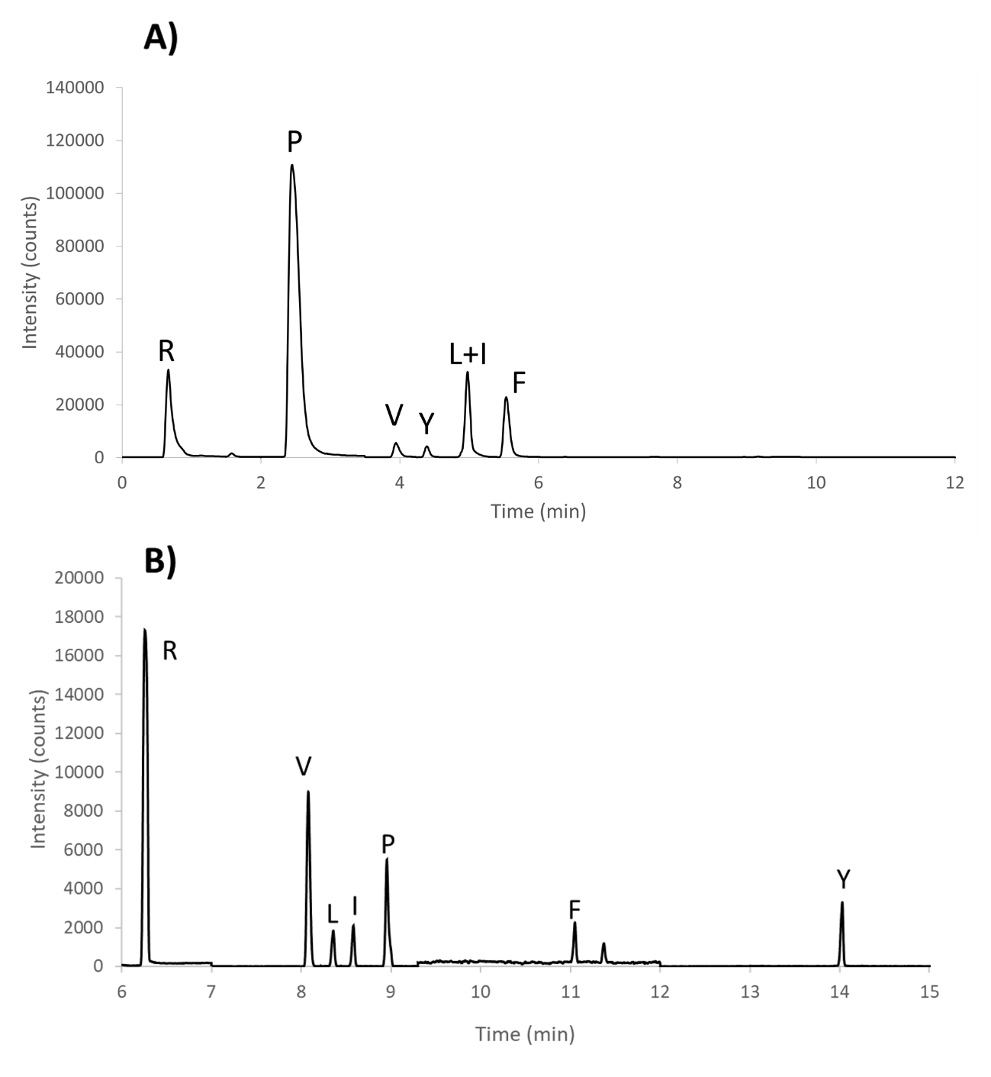

Figure S5.- Mean recoveries obtained for the CRM SRM 998 Angiotensin I by classical acid hydrolysis measuring the amino acids cleaved by GC-MS/MS.

Figure S6. Mass spectra of the product ions for the precursor ion [M+H₃]³⁺ at mass 432.8 (natural angiotensin, top) and 433.2 (labelled angiotensin, bottom).
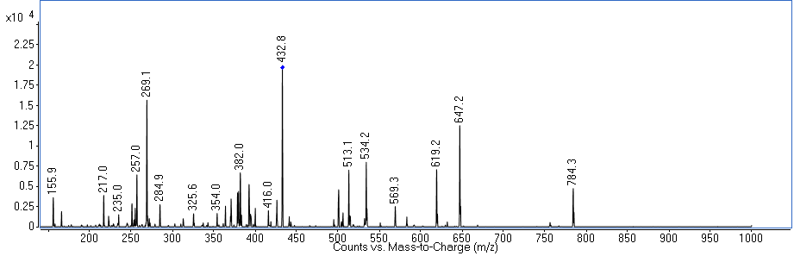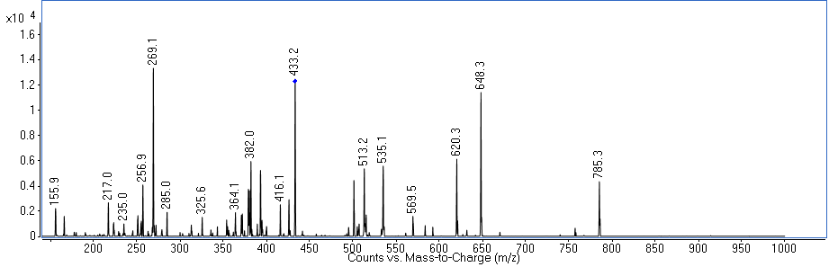

Figure S7.- Precursor ion scan of the mixture of natural and isotopically enriched angiotensin for the product ion 647.7, 648.7, 649.7 and 650.7 corresponding to ion b5+ in four transmission conditions: G=20, W=4, B) G=10, W=4, C) G=10, W=2, D) G=10, W=1. (G= gain offset, W= width offset)
