Supplementary Information

Polyphenol exposure of mothers and infants assessed by
LC-MS/MS based biomonitoring in breast milk

Sabrina Berger†, Ian Oesterle†,‡,§, Kolawole I. Ayeni†,⁑, Chibundu N. Ezekiel⁺, Annette Rompel‡, and Benedikt Warth†,||,*

†University of Vienna, Faculty of Chemistry, Department of Food Chemistry and Toxicology, 1090 Vienna, Austria
‡Universität Wien, Fakultät für Chemie, Institut für Biophysikalische Chemie, 1090 Wien, Austria; www.bpc.univie.ac.at
§University of Vienna, Vienna Doctoral School of Chemistry (DoSChem), 1090 Vienna, Austria
⁑Department of Microbiology, Babcock University, Ilishan Remo, Ogun State, Nigeria
⁺University of Natural Resource and Life Science Vienna (BOKU), Department of Agrobiotechnology (IFA-Tulln), Institute for Bioanalytics and Agro-Metabolomics, Konrad-Lorenz Str. 20, 3430 Tulln, Austria.
||Exposome Austria, Research Infrastructure and National EIRENE Node, Austria
*Corresponding author: Benedikt Warth. benedikt.warth@univie.ac.at, +43-1-4277-70806

Figure S1: Molecular structures of the analytes included in this study……………………………...…….2
Table S1: Supplier information on the reagents, solvents, and chemicals used……...……………...…...….3
Table S2: Multiple reaction monitoring (MRM) parameters………….…………...…..…………..…….…8
Table S3: LC gradient……………………………...……………………………………………...……....12
Table S4: Spiking levels, recovery, intermediate precision and repeatability………......................….…...13
Table S5: Method validation outcome……………………………..……………..………..…………..….17
Figure S2: Analytical figures of merit obtained during the method validation of the remaining eight polyphenol classes…………………………………………………………………………………………20
Table S6: Estimated daily polyphenol intake……………………..……………..………..…………..…...21
Table S7: Calibration curves………………………………………………………………………………23
References……………………………………………………………………………………….………..33

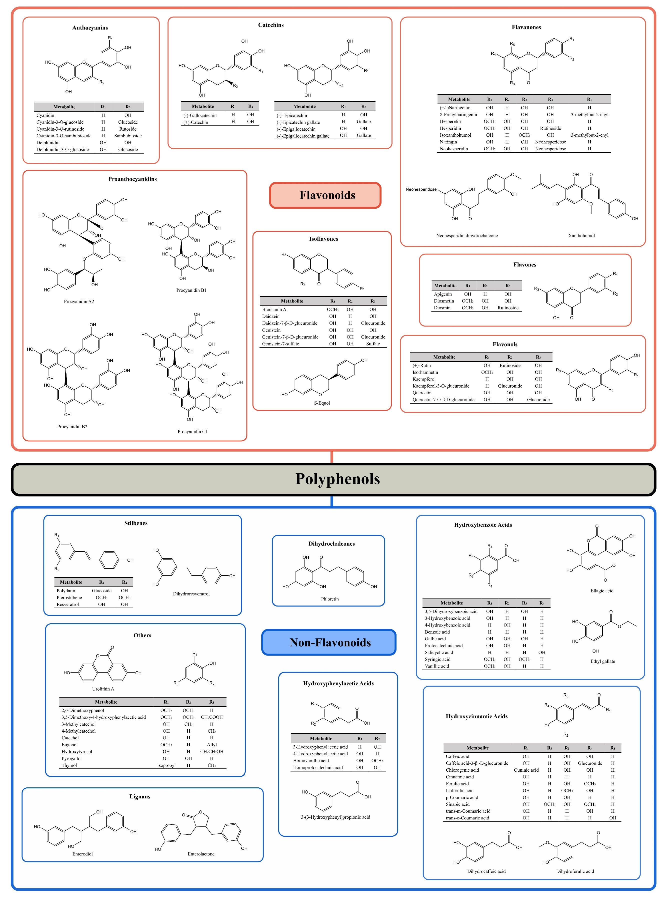
Figure S1. Molecular structures of the analytes included in this study, divided into their polyphenol classes [1].
Table S1. Supplier information on the reagents, solvents, and chemicals used. The polyphenol standards are the same as reported by Oesterle et al. [1]
Item | Supplier | Item Number | Lot Number | Purity
Dihydrochalcones
Phloretin | Cayman Chemical Company | 14452-1g | 0447930-17 | 1
Hydroxybenzoic Acids
Caffeic acid | Sigma | C0625 | 089K1114 | 0.993
3-Hydroxybenzoic acid | Sigma-Aldrich | 36333-100mg | BCBV2381 | 0.998
4-Hydroxybenzoic acid | Sigma | 240141-50g | BCCB8991 | 1
Benzoic acid | Sigma-Aldrich | 242381 | MKBG9391V | 0.999
Ellagic acid | Sigma | E-2250 | 70K1240 | 0.99
Ethyl gallate | Phytolab | 83080-100mg | 5950 | 1
Gallic acid | Sigma | G7384-100g | SLBW1280 | 1
Protocatechuic acid | Sigma | P-5630 | 072K3446 | 0.998
Salicyclic acid | Sigma-Aldrich | 247588 | 09712LE | 0.998
Syringic acid | Sigma | S6881-5g | BCCB1235 | 0.995
Vanillic acid | Sigma | V-2250 | 50H7714 | 0.99
Hydroxycinnamic Acids
Caffeic acid | Sigma | C0625 | 089K1114 | 99.3
Caffeic acid-3-β-D-glucuronide | Toronto Research Chemicals | C080015-1mg | 1-KMR-141-3 | 0.9965
Chlorogenic acid | Aldrich | C3878 | SLBL9959V | 0.99
Cinnamic acid | Fluka | 96340 | 408492/1 | 0.993
Dihydrocaffeic acid | Aldrich | 10.260-1 | 1235963 | 0.98
Dihydroferulic acid | Aldrich | 17803 | BCBH4069V | 1
Ferulic acid | Fluka | 46278 | 357835/1 | 1.0004
Isoferulic acid | Toronto Research Chemicals | H946180-2.5mg | 12-XJZ-152-1 | 0.98
p-Coumaric acid | Sigma | C9008-5g | 095K1340 | 0.997
Sinapic acid | Sigma | D7927 | 0000071240 | 0.985
trans-m-Coumaric acid | Phytolab | 83258-10mg | 10022 | 1
Item | Supplier | Item Number | Lot Number | Purity
trans-o-Coumaric acid | Phytolab | 82343-100mg | 4341 | 0.9985
Hydroxyphenylacetic Acids
3-(3-Hydroxyphenyl)propionic acid | Sigma-Aldrich | 91779-10mg | BCCB6466 | 0.998
3-Hydroxyphenylacetic acid | Aldrich | H49901-5g | STBB5523 | 0.992
4-Hydroxyphenylacetic acid | Sigma | H50004-5g | BCCB4700 | 0.997
Homoprotocatechuic acid | Aldrich | 85,021-7 | S23418-404 | 0.994
Homovanillic acid | Sigma-Aldrich | 69673-25mg | BCCC5315 | 0.996
Lignans
Enterodiol | Phytolab | 80436-10mg | 11769 | 0.9846
Enterolactone | Phytolab | 80437-10mg | 5185 | 0.9907
Others
2,6-Dimethoxyphenol | Aldrich | D135550 | MKBG7714V | 0.994
3,5-Dimethoxy-4-hydroxyphenylacetic acid | Aldrich | 631310 | 07406JC | 0.991
3-Methylcatechol | Aldrich | M34006 | MKBB9900 | 0.991
4-Methylcatechol | Aldrich | M34200 | MKBB9773 | 0.988
Catechol | Sigma | C-9510 | 96F-0536 | 0.99
Eugenol | Extrasynthese | 6178 S | 08-0921/0 | 0.9978
Hydroxytyrosol | Extrasynthese | 4999 S | 12-0520/0 | 1
Pyrogallol | Merck | 612 | 1151574 | 0.995
Thymol | Sigma | 16254 | SZBB0460V | 0.994
Urolithin A | Sigma-Aldrich | SML1791-5mg | 0000076439 | 0.988
Stilbenes
Dihydroresveratrol | Toronto Research Chemicals | D678960-1mg | 2-MJJ-97-1 | 0.98
Polydatin | Extrasynthese | 4974 S | 02-0822/0 | 0.992
Pterostilbene | Toronto Research Chemicals | P839890-50mg | 1-NYL-63-1 | 0.98
Resveratrol | Extrasynthese | 4963 S | 02-1219/0 | 0.997
Item | Supplier | Item Number | Lot Number | Purity
Anthocyanins
Cyanidin chloride | Extrasynthese | 0909 S | 38-0723/0 | 0.98
Cyanidin-3-O-glucoside chloride | Extrasynthese | 0915 S | 45 – 1114/0 | 0.976
Cyanidin-3-O-rutinoside chloride | Extrasynthese | 0914 S | 31 – 0917/0 | 0.973
Cyanidin-3-O-sambubioside chloride | Extrasynthese | 0949 S | 04 – 0311/0 | 0.972
Delphinidin chloride | Extrasynthese | 0904 S | 63 – 0814/0 | 0.978
Delphinidin-3-O-glucoside chloride | Extrasynthese | 0938 S | 27 – 1023/0 | 0.995
Catechins
(-)-Epicatechin | Sigma | E-1753 | 32H2519 | 0.98
(-)-Epicatechin gallate | Extrasynthese | 0978 S | 12-0721/0 | 0.993
(-)-Epigallocatechin | Extrasynthese | 0979 S | 11-0703/0 | 0.992
(-)-Epigallocatechin gallate | Sigma | E4143 | 031M1175V | 0.95
(-)-Gallocatechin | Extrasynthese | 0973 S | 05-1014/0 | 0.989
(+)-Catechin | Extrasynthese | 0976 S | 25-0204/0 | 1
Flavanones
(+/-)-Naringenin | Sigma | N5893-1g | BCBC1784 | 0.96
8-Prenylnaringenin | Sigma | 75119-5mg | BCCB4227 | 1
Hesperetin | Cayman Chemical Company | Cat. 10006084 | 121938-5 | 0.984
Hesperidin | Fluka | 52040 | 1117099 | 0.923
Isoxanthohumol | Extrasynthese | 1367 S | 01-1020/0 | 0.995
Naringin hydrate | Alfa Aesar | L10163 | 10126866 | 0.98
Neohesperidin | Extrasynthese | 1132 S | 09-0924/0 | 0.996
Neohesperidin dihydrochalcone | SAFC | W381101-25g-K | MKBD9742V | 0.85
Xanthohumol | Extrasynthese | 1346 S | 03-0524/0 | 1
Flavones
Apigenin | Sigma | 10798-25mg | E445301/1V | 0.954
Diosmetin | Extrasynthese | 1108 S | 15-0312/0 | 0.998
Item | Supplier | Item Number | Lot Number | Purity
Diosmin | Extrasynthese | 1109 S | 11-1021/0 | 0.996
Flavonols
(+)-Rutin trihydrate | Aldrich | R230-3 | 10422EW | 0.95
Isorhamnetin | Extrasynthese | 1120 S | 32-0215/0 | 0.993
Kaempferol | Sigma | 60010 | BCCC4134 | 0.997
Kaempferol-3-O-glucuronide | Extrasynthese | 1356 S | 03-0302/0 | 0.996
Quercetin | Sigma | Q4951-10g | 060M1196V | 0.98
Quercetin-7-O-β-D-glucuronide | Toronto Research Chemicals | Q509515-2.5mg | 12-QFY-8-3 | 0.9539
Isoflavones
Biochanin A | Extrasynthese | 1349 S | 01-0106/0 | 0.999
Daidzein | Extrasynthese | 1370 S | 03-0204/0 | 0.995
Daidzein-7-β-D-glucuronide potassium salt | Toronto Research Chemicals | D103510-5mg | 3-LGA-24-2 | 0.95
Genistein | Extrasynthese | 1372 S | 01 – 0114/0 | 1
Genistein-7-β-D-glucuronide | Toronto Research Chemicals | G350015-2.5mg | 3-JAE-172-1 | 0.95
Genistein-7-sulfate sodium salt | Toronto Research Chemicals | G350045-2.5mg | 10-JLI-110-4 | 0.9989
S-equol | Sigma | SML2147-5mg | 0000081122 | 0.97
Proanthocyanidins
Procyanidin A2 | Extrasynthese | 0985 S | 05-0128/0 | 0.999
Procyanidin B1 | Phytolab | 89764-5mg | 14872 | 0.9739
Procyanidin B2 | Toronto Research Chemicals | P755830-1mg | 52-GHZ-187-1 | 0.9826
Procyanidin C1 | Phytolab | 89537-5mg | 15436 | 0.974
Reagents

Methanol | Honeywell | 34966 | Various | LC-MS grade
Acetonitrile | Honeywell | 34967 | Various | LC-MS grade
Water | VWR | 63645.320 | Various | LC-MS grade
Formic acid | Bartelt | SO9679B001 | 1373 811 | UPLC-MS Optigrade
Hexane | Roth | 7567.1 | Various | ≥ 96%
Item | Supplier | Item Number | Lot Number | Purity
Ethylacetate | Sigma-Aldrich | 33211-1L-R | SZBD128SV | ≥ 99.5%
2-Propanol | Honeywell | 34965 | Various | LC-MS grade
Magnesium sulfate, anhydrous | Acros Organics | 4134850000 | A0379632 | 97%
Sodium chloride | Roth | 0962.2 | 390289120 | ≥ 99.8%

Table S2. Multiple reaction monitoring (MRM) parameters of the included analytes. All values that could not be determined are marked as n.d. (not determined). The delustering potential for all analytes was set to -10V.
Analyte | Retention Time  (min) | Total Retention Time Window (s) | Parent Ion  m/z | Product Ions (Quantifier/Qualifier)  m/z | Collision Energy (V) | Cell Exit Potential (V) | Ion  Ratio  (%)
Dihydrochalcones
Phloretin | 8.3 | 20 | 272.982 | 166.9/123.2 | -26/-30 | -17/-47 | 22
Hydroxybenzoic Acids
3,5-Dihydroxybenzoic acid | 2.6 | 25 | 152.862 | 108.8/67 | -28/-28 | -17/-19 | 12
3-Hydroxybenzoic acid | 4.7 | 20 | 136.873 | 92.9/64.9 | -16/-32 | -11/-35 | 9
4-Hydroxybenzoic acid | 4.0 | 20 | 136.891 | 92.9/65.1 | -18/-38 | -23/-9 | 16
Benzoic acid | 6.3 | 20 | 120.945 | 77.1 | -18 | -13 | n.d.ª
Ellagic acid | 5.9 | 25 | 300.873 | 145.0/255.3 | -50/-16 | -9/-19 | n.d.
Ethyl gallate | 5.4 | 20 | 196.970 | 123.9/168.9 | -26/-24 | -23/-11 | 58
Gallic acid | 1.3 | 20 | 168.915 | 125.0/79.0 | -20/-26 | -9/-7 | 16
Protocatechuic acid | 2.7 | 25 | 152.939 | 108.1/80.9 | -34/-26 | -11/-11 | 26
Salicylic acid | 6.6 | 20 | 136.937 | 92.9/65.1 | -24/-36 | -13/-13 | 15
Syringic acid | 4.8 | 20 | 196.943 | 181.9/121.1 | -18/-22 | -17/-23 | 15
Vanillic acid | 4.6 | 20 | 166.926 | 152.0/108.1 | -18/-26 | -13/-7 | 64
Hydroxycinnamic Acids
Caffeic acid | 4.7 | 20 | 178.914 | 107.0/89.0 | -30/-42 | -7/-7 | 85
Caffeic acid-3-β-D-glucuronide | 4.2 | 20 | 355.074 | 135.0/179.2 | -36/-30 | -21/-5 | 110
Chlorogenic acid | 4.3 | 20 | 353.006 | 191.0/85.0 | -20/-52 | -13/-11 | 17
Cinnamic acid | 7.7 | 20 | 146.936 | 77.0/103.0 | -28/-14 | -7/-17 | 660
Dihydrocaffeic acid | 4.4 | 20 | 180.971 | 58.9/121.0 | -22/-22 | -9/-9 | 42
Dihydroferulic acid | 5.6 | 20 | 194.954 | 136.0/121.1 | -24/-34 | -11/-9 | 48
Ferulic acid/Isoferulic acid | 5.8 | 20 | 192.941 | 134.1/178.0 | -22/-18 | -9/-11 | 56
p-Coumaric acid | 5.5 | 20 | 162.923 | 119.0/92.9 | -22/-38 | -13/-11 | 17
Analyte | Retention Time  (min) | Total Retention Time Window (s) | Parent Ion  m/z | Product Ions (Quantifier/Qualifier)  m/z | Collision Energy (V) | Cell Exit Potential (V) | Ion  Ratio  (%)
Sinapic acid | 5.9 | 20 | 222.999 | 208.0/164.1 | -18/-18 | -13/-11 | 55
trans-m-Coumaric acid | 6.0 | 20 | 162.864 | 119.1/91.0 | -12/-32 | -7/-33 | 18
trans-o-Coumaric acid | 6.5 | 20 | 162.942 | 118.8/116.9 | -18/-34 | -47/-17 | 18
Hydroxyphenylacetic Acids
3-(3-Hydroxyphenyl)propionic acid | 5.7 | 20 | 164.973 | 106.1/121.0 | -28/-16 | -1/-23 | 310
3-Hydroxyphenylacetic acid | 4.8 | 20 | 150.972 | 107.1/79.2 | -12/-28 | -11/-39 | 10
4-Hydroxyphenylacetic acid | 4.4 | 20 | 150.937 | 79.1/107.1 | -22/-10 | -9/-7 | 350
Homovanillic acid | 4.8 | 20 | 180.887 | 122.0/135.9 | -24/-10 | -19/-21 | 9
Homoprotocatechuic acid | 3.4 | 20 | 166.928 | 123.0/121.9 | -12/-30 | -13/-7 | 14
Lignans
Enterodiol | 7.4 | 20 | 300.927 | 253.1/271.2 | -30/-30 | -11/-23 | 33
Enterolactone | 8.6 | 20 | 296.944 | 253.1/107.1 | -28/-32 | -13/-17 | 53
Others
2,6-Dimethoxyphenol | 6.2 | 20 | 154.833 | 123.1/77.1 | 15/25 | 10/4 | 48
3,5-Dimethoxy-4-hydroxyphenylacetic acid | 5.0 | 20 | 211.02 | 167.1/136.9 | -10/-32 | -21/-9 | 55
3-Methylcatechol | 5.8 | 20 | 122.97 | 107.8/95.0 | -24/-22 | -55/-7 | 24
4-Methylcatechol | 5.4 | 20 | 122.935 | 108.0/104.9 | -30/-28 | -11/-11 | 51
Catechol | 2.6 | 25 | 108.908 | 91.0/80.9 | -26/-22 | -13/-39 | 66
Eugenol | 9.2 | 20 | 164.896 | 136.8/123.9 | 13/23 | 14/6 | 40
Hydroxytyrosol | 2.7 | 25 | 152.936 | 123.1/122.5 | -20/-30 | -13/-9 | 10
Pyrogallol | 1.5 | 25 | 124.932 | 69.0/79.0 | -24/-26 | -11/-19 | 180
Thymol | 5.8 | 20 | 149.012 | 134.0/133.6 | -20/-16 | -11/-23 | 39
Urolithin A | 7.3 | 20 | 226.838 | 197.8/181.8 | -44/-38 | -11/-13 | 44
Stilbenes
Dihydroresveratrol | 7.2 | 20 | 230.956 | 121.1/137.1 | 21/25 | 6/4 | 130
Polydatin | 5.8 | 20 | 389.061 | 227.3/143.1 | -16/-58 | -13/-21 | 21
Pterostilbene | 11.0 | 20 | 257.118 | 242.4/133.2 | 33/27 | 14/12 | 260
Analyte | Retention Time  (min) | Total Retention Time Window (s) | Parent Ion  m/z | Product Ions (Quantifier/Qualifier)  m/z | Collision Energy (V) | Cell Exit Potential (V) | Ion  Ratio  (%)
Resveratrol | 7.1 | 20 | 226.977 | 185.0/142.9 | -26/-34 | -29/-51 | 57
Anthocyanins
Cyanidin | 4.5 | 30 | 286.837 | 230.9/213.1 | 33/39 | 20/24 | 33
Cyanidin-3-O-glucoside | 4.5 | 30 | 448.866 | 286.8/212.8 | 35/77 | 44/10 | 13
Cyanidin-3-O-rutinoside | 4.6 | 30 | 595.127 | 287.0/449.1 | 31/29 | 24/22 | 16
Cyanidin-3-O-sambubioside | 4.5 | 30 | 581.015 | 286.9/212.9 | 35/95 | 40/12 | 13
Delphinidin | 5.1 | 20 | 302.813 | 229.0/201.2 | 37/37 | 14/18 | 29
Delphinidin-3-O-glucoside | 4.2 | 30 | 465.163 | 303.1/228.9 | 35/71 | 24/18 | 16
Catechins
(-)- Epicatechin | 5.0 | 20 | 288.948 | 245.1/203.0 | -20/-26 | -17/-15 | 46
(-)-Epicatechin gallate | 5.9 | 20 | 440.878 | 169.0/289.0 | -22/-28 | -27/-17 | 70
(-)-Epigallocatechin | 4.3 | 25 | 304.943 | 124.9/179.0 | -26/-20 | -35/-9 | 57
(-)-Epigallocatechin gallate | 5.1 | 20 | 457.091 | 168.9/125.0 | -24/-48 | -11/-13 | 41
(-)-Gallocatechin | 2.6 | 25 | 304.962 | 124.9/219.0 | -22/-20 | -13/-37 | 31
(+)-Catechin | 4.4 | 20 | 288.903 | 123.2/203.0 | -42/-26 | -5/-33 | 110
Flavanones
(+/-)-Naringenin | 8.3 | 20 | 271.004 | 151.0/119.1 | -24/-34 | -13/-3 | 56
8-Prenylnaringenin | 10.6 | 20 | 339.074 | 219.0/119.0 | -26/-40 | -29/-7 | 58
Hesperetin | 6.5 | 20 | 609.045 | 301.0/286.2 | -34/-52 | -25/-21 | 47
Hesperidin | 8.6 | 20 | 300.976 | 163.9/135.9 | -32/-38 | -9/-7 | 29
Isoxanthohumol | 9.4 | 20 | 352.998 | 118.9/233.1 | -26/-26 | -27/-55 | 89
Naringin | 6.3 | 20 | 580.954 | 272.8/152.8 | 21/65 | 16/22 | 55
Neohesperidin | 6.5 | 20 | 610.963 | 449.1/303.0 | 11/27 | 32/18 | 290
Neohesperidin dihydrochalcone | 7.1 | 20 | 611.058 | 303.0/125.0 | -46/-52 | -19/-13 | 25
Xanthohumol | 12.3 | 20 | 352.996 | 233.2/119.1 | -24/-56 | -29/-15 | 83
Flavones
Apigenin | 8.3 | 30 | 268.945 | 117.0/151.0 | -44/-36 | -9/-19 | 55
Analyte | Retention Time  (min) | Total Retention Time Window (s) | Parent Ion  m/z | Product Ions (Quantifier/Qualifier)  m/z | Collision Energy (V) | Cell Exit Potential (V) | Ion  Ratio  (%)
Diosmetin | 6.3 | 20 | 607.023 | 298.9/283.8 | -36/-68 | -43/-17 | 79
Diosmin | 8.6 | 25 | 298.925 | 284.1/256.0 | -32/-40 | -19/-27 | 14
Flavonols
(+)-Rutin | 5.7 | 20 | 609.041 | 300.1/301.0 | -44/-38 | -9/-21 | 51
Isorhamnetin | 8.6 | 25 | 314.919 | 299.8/151.0 | -34/-34 | -17/-5 | 22
Kaempferol | 8.5 | 35 | 284.952 | 117.1/184.9 | -54/-40 | -13/-15 | 120
Kaempferol-3-O-glucuronide | 6.3 | 20 | 460.963 | 284.9/112.9 | -32/-20 | -17/-17 | 35
Quercetin | 7.6 | 25 | 300.911 | 151.0/178.9 | -32/-26 | -9/-27 | 47
Quercetin-7-O-β-D-glucuronide | 5.8 | 20 | 477.062 | 300.8/150.9 | -28/-48 | -25/-11 | 17
Isoflavones
Biochanin A | 10.5 | 20 | 282.89 | 267.9/239.0 | -26/-44 | -21/-21 | 30
Daidzein | 7.3 | 20 | 253.013 | 131.9/224.0 | -50/-36 | -19/-21 | 150
Daidzein-7-β-D-glucuronide | 5.3 | 20 | 429.141 | 252.8/113.0 | -32/-22 | -23/-17 | 74
Genistein | 8.4 | 20 | 268.962 | 133.0/132.1 | -38/-54 | -15/-13 | 46
Genistein-7-β-D-glucuronide | 6.1 | 20 | 444.932 | 269.0/174.9 | -40/-18 | -45/-17 | 53
Genistein-7-sulfate | 7.1 | 30 | 348.798 | 268.9/133.1 | -38/-58 | -53/-7 | 18
S-Equol | 8.4 | 20 | 240.938 | 120.9/119.0 | -20/-26 | -19/-13 | 72
Proanthocyanidins
Procyanidin A2 | 6.0 | 20 | 574.998 | 284.9/448.9 | -38/-26 | -35/-35 | 71
Procyanidin B1 | 4.1 | 20 | 579.296 | 409.2/288.9 | 27/19 | 26/18 | 83
Procyanidin B2 | 4.7 | 20 | 578.552 | 426.8/409.0 | 23/29 | 32/34 | 83
Procyanidin C1 | 5.1 | 20 | 867.202 | 579.1/577.2 | 21/21 | 26/36 | 66

Table S3. LC gradient applied in the final method.
Time [min] | Eluent A [%] | Eluent B [%]
0 | 95 | 5
2 | 95 | 5
12 | 36 | 64
12.01 | 5 | 95
14 | 5 | 95
14.01 | 95 | 5
16 | 95 | 5

Table S4. Concentration of the three different spiking levels: low level (LL), middle level (ML), and high level (HL), used during validation for each analyte. The calculated recovery (R_{E}), Intermediate precision (RSD_{R}) and interday repeatability (RSD_{r}) are given. Figures of merit which could not be determined are listed as n.d.
Analyte | Spiking Level (LL/ML/HL)  (ng*mL⁻¹) | R_{E} ± RSD_{R} (LL) (%) | R_{E} ± RSD_{R} (ML) (%) | R_{E} ± RSD_{R} (HL) (%) | RSD_{r}  (LL/ML/HL)  (%)
Dihydrochalcones
Phloretin | 0.22/2.8/8.8 | 98 ± 10 | 96 ± 12 | 94 ± 12 | 7/10/7
Hydroxybenzoic Acids
3,5-Dihydroxybenzoic acid | 2.9/39/120 | 39 ± 36 | 47 ± 8 | 46 ± 13 | 85/36/43
3-Hydroxybenzoic acid | 18/240/710 | 92 ± 7 | 99 ± 6 | 96 ± 9 | 4/5/4
4-Hydroxybenzoic acidb | 1.1/14/42 | 75 ± 31 | 93 ± 6 | 95 ± 8 | 30/5/3
Benzoic acid^{b} | 47/630/1900 | n.d. | 80 ± 12 | 88 ± 14 | n.d./10/9
Ellagic acid^{b} | 23/310/930 | n.d. | 10 ± 39 | 6 ± 26 | n.d./19/6
Ethyl gallate | 0.071/0.95/2.9 | 84 ± 5 | 90 ± 4 | 91 ± 9 | 8/7/3
Gallic acid | 0.3/4.1/12 | 18 ± 53 | 40 ± 8 | 41 ± 14 | 50/28/37
Protocatechuic acid | 0.2/2.6/7.9 | 42 ± 53 | 37 ± 12 | 46 ± 14 | 59/42/71
Salicylic acid^{b} | 2.7/36/110 | 74 ± 31 | 92 ± 14 | 91 ± 19 | 32/6/4
Syringic acid | 0.32/4.3/13 | 104 ± 26 | 91 ± 10 | 91 ± 12 | 27/7/5
Vanillic acid | 2.1/28/84 | 101 ± 10 | 91 ± 7 | 89 ± 14 | 15/7/7
Hydroxycinnamic Acids
Caffeic acid | 4/53/160 | 86 ± 21 | 91 ± 7 | 88 ± 8 | 26/5/3
Caffeic acid-3-β-D-glucuronide | 0.2/2.7/8.2 | 63 ± 8 | 71 ± 9 | 72 ± 12 | 17/10/6
Chlorogenic acid | 3.8/51/150 | 58 ± 19 | 59 ± 9 | 63 ± 10 | 5/8/3
Cinnamic acid | 19/260/780 | 92 ± 15 | 89 ± 7 | 89 ± 8 | 17/7/5
Dihydrocaffeic acid | 1.1/15/44 | 88 ± 22 | 89 ± 7 | 86 ± 8 | 17/7/4
Dihydroferulic acid^{b} | 1.5/20/59 | 113 ± 27 | 95 ± 16 | 92 ± 15 | 24/10/8
Ferulic acid/Isoferulic acidb | 1/14/41 | 80 ± 15 | 95 ± 6 | 93 ± 10 | 13/7/4
p-Coumaric acid | 0.58/7.8/23 | 90 ± 11 | 96 ± 4 | 95 ± 7 | 14/3/3
Analyte | Spiking Level (LL/ML/HL)  (ng*mL⁻¹) | R_{E} ± RSD_{R} (LL) (%) | R_{E} ± RSD_{R} (ML) (%) | R_{E} ± RSD_{R} (HL) (%) | RSD_{r}  (LL/ML/HL)  (%)
Sinapic acidb | 0.33/4.4/13 | 99 ± 34 | 95 ± 7 | 95 ± 9 | 30/10/3
trans-m-Coumaric acid | 3.3/45/130 | 63 ± 42 | 99 ± 9 | 95 ± 10 | 27/4/4
trans-o-Coumaric acid | 1.9/26/77 | 93 ± 14 | 94 ± 8 | 95 ± 8 | 7/6/4
Hydroxyphenylacetic Acids
3-(3-Hydroxyphenyl)propionic acidb | 1.1/15/44 | 91 ± 49 | 98 ± 7 | 95 ± 9 | 42/8/3
3-Hydroxyphenylacetic acid | 27/360/1100 | 93 ± 23 | 104 ± 10 | 96 ± 9 | 46/5/3
4-Hydroxyphenylacetic acid | 34/460/1400 | 101 ± 22 | 89 ± 17 | 92 ± 19 | 22/9/6
Homovanillic acid | 9.9/130/400 | 97 ± 23 | 97 ± 9 | 96 ± 12 | 28/5/5
Homoprotocatechuic acid | 5.5/73/220 | 88 ± 17 | 97 ± 8 | 93 ± 8 | 15/4/2
Lignans
Enterodiol | 0.064/0.85/2.6 | 87 ± 36 | 87 ± 8 | 91 ± 8 | 23/7/6
Enterolactone | 0.2/2.7/8.1 | 84 ± 13 | 90 ± 13 | 92 ± 15 | 16/5/4
Others
2,6-Dimethoxyphenol | 0.62/8.3/25 | 100 ± 13 | 100 ± 11 | 95 ± 14 | 13/14/14
3,5-Dimethoxy-4 -hydroxyphenylacetic acid^{b} | 4.3/58/170 | 94 ± 14 | 102 ± 10 | 94 ± 12 | 19/7/4
3-Methylcatechol | 2/27/80 | 90 ± 11 | 96 ± 6 | 95 ± 11 | 12/4/3
4-Methylcatechol | 4.4/59/180 | 92 ± 7 | 94 ± 6 | 95 ± 10 | 9/5/3
Catecholb | 13/170/520 | 85 ± 45 | 53 ± 36 | 34 ± 53 | 68/59/38
Eugenol | 30/390/1200 | 87 ± 24 | 93 ± 15 | 92 ± 13 | 26/12/8
Hydroxytyrosol | 0.56/7.5/23 | 87 ± 9 | 91 ± 5 | 91 ± 8 | 13/5/2
Pyrogallol | 5.8/77/230 | 92 ± 33 | 92 ± 9 | 89 ± 13 | 45/23/14
Thymol | 8.9/120/360 | n.d. | n.d. | 76 ± 32 | n.d./n.d./44
Urolithin A | 0.11/1.5/4.4 | 87 ± 20 | 90 ± 6 | 92 ± 10 | 16/7/4
Stilbenes
Dihydroresveratrol | 0.47/6.2/19 | 88 ± 17 | 92 ± 11 | 93 ± 13 | 18/5/8
Polydatin | 0.15/2.1/6.2 | 121 ± 38 | 88 ± 21 | 87 ± 13 | 60/10/7
Pterostilbeneb | 0.21/2.9/8.6 | 99 ± 19 | 91 ± 11 | 91 ± 10 | 26/8/7
Analyte | Spiking Level (LL/ML/HL)  (ng*mL⁻¹) | R_{E} ± RSD_{R} (LL) (%) | R_{E} ± RSD_{R} (ML) (%) | R_{E} ± RSD_{R} (HL) (%) | RSD_{r}  (LL/ML/HL)  (%)
Resveratrol | 0.42/5.6/17 | 86 ± 15 | 92 ± 8 | 89 ± 11 | 24/4/4
Anthocyanins
Cyanidin | 59/780/2400 | n.d. | 43 ± 15 | 48 ± 15 | n.d./39/43
Cyanidin-3-O-glucoside | 0.81/11/32 | n.d. | 16 ± 13 | 14 ± 14 | n.d./20/6
Cyanidin-3-O-rutinoside | 0.69/9.2/28 | n.d. | 20 ± 18 | 21 ± 20 | n.d./22/9
Cyanidin-3-O-sambubioside | 1.5/20/61 | n.d. | 7 ± 28 | 6 ± 19 | n.d./37/13
Delphinidin | 70/940/2800 | n.d. | 23 ± 17 | 22 ± 13 | n.d./35/36
Delphinidin-3-O-glucoside | 30/400/1200 | n.d. | 11 ± 31 | 8 ± 16 | n.d./43/13
Catechins
(-)- Epicatechin | 2.7/36/110 | 94 ± 12 | 85 ± 9 | 91 ± 10 | 20/10/8
(-)-Epicatechin gallate | 1.1/14/43 | 90 ± 17 | 65 ± 12 | 66 ± 8 | 32/5/6
(-)-Epigallocatechin | 19/250/740 | 101 ± 37 | 89 ± 9 | 87 ± 14 | 46/27/11
(-)-Epigallocatechin gallate | 13/180/530 | 123 ± 31 | 50 ± 19 | 49 ± 18 | 22/14/13
(-)-Gallocatechin | 19/250/740 | 90 ± 35 | 84 ± 9 | 84 ± 12 | 87/17/12
(+)-Catechin | 1.6/21/64 | 85 ± 16 | 78 ± 5 | 85 ± 13 | 16/4/6
Flavanones
(+/-)-Naringeninb | 0.11/1.4/4.3 | 78 ± 50 | 88 ± 11 | 91 ± 16 | 43/6/3
8-Prenylnaringenin | 0.26/3.5/11 | 93 ± 8 | 95 ± 6 | 92 ± 11 | 4/4/3
Hesperetinb | 0.11/1.5/4.6 | 96 ± 16 | 91 ± 10 | 92 ± 8 | 10/6/5
Hesperidin | 0.079/1.1/3.2 | 99 ± 15 | 94 ± 10 | 95 ± 7 | 14/7/12
Isoxanthohumolb | 0.054/0.73/2.2 | 96 ± 13 | 92 ± 6 | 92 ± 7 | 19/5/4
Naringin | 3/40/120 | 85 ± 28 | 86 ± 14 | 80 ± 17 | 16/13/14
Neohesperidin | 4/54/160 | 86 ± 22 | 84 ± 8 | 84 ± 9 | 14/11/6
Neohesperidin dihydrochalcone | 0.079/1/3.1 | 86 ± 16 | 82 ± 15 | 87 ± 12 | 9/9/9
Xanthohumolb | 0.16/2.1/6.3 | 92 ± 14 | 91 ± 10 | 90 ± 8 | 8/5/3
Flavones
Apigenin | 0.12/1.6/4.7 | 87 ± 6 | 86 ± 9 | 94 ± 11 | 6/6/3
Analyte | Spiking Level (LL/ML/HL)  (ng*mL⁻¹) | R_{E} ± RSD_{R} (LL) (%) | R_{E} ± RSD_{R} (ML) (%) | R_{E} ± RSD_{R} (HL) (%) | RSD_{r}  (LL/ML/HL)  (%)
Diosmetin | 0.086/1.2/3.5 | 92 ± 25 | 92 ± 9 | 95 ± 11 | 7/6/3
Diosmin | 0.34/4.5/14 | 120 ± 20 | 93 ± 20 | 79 ± 21 | 17/18/12
Flavonols
(+)-Rutinb | 0.39/5.2/16 | 78 ± 13 | 61 ± 9 | 62 ± 12 | 12/12/8
Isorhamnetin | 0.079/1.1/3.2 | 95 ± 15 | 71 ± 5 | 72 ± 10 | 28/5/2
Kaempferol | 1.8/24/72 | 93 ± 13 | 90 ± 10 | 88 ± 13 | 8/8/8
Kaempferol-3-O-glucuronide | 0.1/1.4/4.2 | 91 ± 18 | 85 ± 9 | 84 ± 16 | 21/6/11
Quercetinb | 0.71/9.5/28 | 97 ± 15 | 47 ± 12 | 44 ± 13 | 15/11/11
Quercetin-7-O-β-D-glucuronide | 0.43/5.8/17 | 80 ± 22 | 55 ± 21 | 51 ± 20 | 34/13/11
Isoflavones
Biochanin A | 0.12/1.6/4.7 | 88 ± 18 | 91 ± 5 | 91 ± 8 | 12/4/3
Daidzein | 0.15/2/5.9 | 84 ± 35 | 91 ± 7 | 93 ± 9 | 11/5/4
Daidzein-7-β-D-glucuronide | 0.43/5.7/17 | 88 ± 22 | 88 ± 9 | 88 ± 10 | 16/9/3
Genistein | 0.13/1.7/5.1 | 78 ± 6 | 65 ± 16 | 93 ± 17 | 5/7/5
Genistein-7-β-D-glucuronide | 0.48/6.5/19 | 94 ± 15 | 91 ± 13 | 90 ± 16 | 12/10/5
Genistein-7-sulfateb | 3.8/51/150 | 89 ± 7 | 59 ± 23 | 30 ± 62 | 6/4/3
S-Equol | 5.8/77/230 | 77 ± 61 | 94 ± 13 | 92 ± 12 | 40/11/6
Proanthocyanidins
Procyanidin A2 | 0.93/12/37 | 94 ± 34 | 78 ± 13 | 73 ± 11 | 38/14/17
Procyanidin B1 | 15/200/590 | 60 ± 16 | 71 ± 7 | 71 ± 8 | 12/4/3
Procyanidin B2 | 3.9/53/160 | n.d. | 70 ± 56 | 68 ± 22 | n.d./21/8
Procyanidin C1 | 2.8/37/110 | 80 ± 31 | 53 ± 12 | 48 ± 12 | 51/12/6

Table S5. Method validation outcomes, the analytes where all figures of merit fit the validation criteria are check marked, while for the others the criteria that are out of acceptable range are listed. Evaluated figures of merit are regression coefficient (R²), recovery (R_{E}), intermediate precision (RSD_{R}) and repeatability (RSD_{r}) at the low (LL), middle (ML) and high (HL) spiking level.
Analyte | Validation Outcome
Dihydrochalcones
Phloretin | ✓
Hydroxybenzoic Acids
3,5-Dihydroxybenzoic acid | R_{E} LL/ML/HL, RSD_{R} LL, RSD_{r} LL/ML/HL
3-Hydroxybenzoic acid | ✓
4-Hydroxybenzoic acid | ✓
Benzoic acid | R_{E} LL, RSD_{R} LL, RSD_{r} LL
Ellagic acid | R_{E} LL/ML/HL, RSD_{R} LL, RSD_{r} LL
Ethyl gallate | ✓
Gallic acid | R_{E} LL/ML/HL, RSD_{R} LL, RSD_{r} LL/HL
Protocatechuic acid | R_{E} LL/ML/HL, RSD_{R} LL, RSD_{r} LL/ML/HL, R²
Salicylic acid | ✓
Syringic acid | ✓
Vanillic acid | ✓
Hydroxycinnamic Acids
Caffeic acid | ✓
Caffeic acid-3-β-D-glucuronide | ✓
Chlorogenic acid | ✓
Cinnamic acid | ✓
Dihydrocaffeic acid | ✓
Dihydroferulic acid | ✓
Ferulic acid/Isoferulic acid | ✓
p-Coumaric acid | ✓
Sinapic acid | ✓
trans-m-Coumaric acid | ✓
trans-o-Coumaric acid | ✓
Hydroxyphenylacetic Acids
3-(3-Hydroxyphenyl)propionic acid | RSD_{R} LL, RSD_{r} LL
3-Hydroxyphenylacetic acid | RSD_{r} LL
4-Hydroxyphenylacetic acid | ✓
Homovanillic acid | ✓
Homoprotocatechuic acid | ✓
Lignans
Enterodiol | ✓
Analyte | Validation Outcome
Enterolactone | ✓
Others
2,6-Dimethoxyphenol | ✓
3,5-Dimethoxy-4-hydroxyphenylacetic acid | ✓
3-Methylcatechol | ✓
4-Methylcatechol | ✓
Catechol | R_{E} ML/HL, RSD_{R} LL/ML/HL, RSD_{r} LL/ML/HL, R²
Eugenol | ✓
Hydroxytyrosol | ✓
Pyrogallol | R_{E} LL, RSD_{r} LL
Thymol | R_{E} LL/ML, RSD_{R} LL/ML/HL, RSD_{r} LL/ML/HL, R²
Urolithin A | ✓
Stilbenes
Dihydroresveratrol | ✓
Polydatin | RSD_{r} LL
Pterostilbene | ✓
Resveratrol | ✓
Anthocyanins
Cyanidin | R_{E} LL/ML/HL, RSD_{R} LL, RSD_{r} LL/ML/HL
Cyanidin-3-O-glucoside | R_{E} LL/ML/HL, RSD_{R} LL, RSD_{r} LL
Cyanidin-3-O-rutinoside | R_{E} LL/ML/HL, RSD_{R} LL, RSD_{r} LL
Cyanidin-3-O-sambubioside | R_{E} LL/ML/HL, RSD_{R} LL, RSD_{r} LL/ML
Delphinidin | R_{E} LL/ML/HL, RSD_{R} LL, RSD_{r} LL
Delphinidin-3-O-glucoside | R_{E} LL/ML/HL, RSD_{R} LL/ML, RSD_{r} LL/ML
Catechins
(-)-Epicatechin | ✓
(-)-Epicatechin gallate | ✓
(-)-Epigallocatechin | R_{E} LL, RSD_{r} LL
(-)-Epigallocatechin gallate | R_{E} LL
(-)-Gallocatechin | R_{E} LL, RSD_{r} LL
(+)-Catechin | ✓
Flavanones
(+/-)-Naringenin | RSD_{R} LL, RSD_{r} LL
8-Prenylnaringenin | ✓
Hesperetin | ✓
Hesperidin | ✓
Isoxanthohumol | ✓
Analyte | Validation Outcome
Naringin | ✓
Neohesperidin | ✓
Neohesperidin dihydrochalcone | ✓
Xanthohumol | ✓
Flavones
Apigenin | ✓
Diosmetin | ✓
Diosmin | ✓
Flavonols
(+)-Rutin | ✓
Isorhamnetin | ✓
Kaempferol | ✓
Kaempferol-3-O-glucuronide | ✓
Quercetin | R_{E} HL
Quercetin-7-O-β-D-glucuronide | ✓
Isoflavones
Biochanin A | ✓
Daidzein | ✓
Daidzein-7-β-D-glucuronide | ✓
Genistein | ✓
Genistein-7-β-D-glucuronide | ✓
Genistein-7-sulfate | RSD_{R} HL, R²
S-Equol | RSD_{R} LL, RSD_{r} LL
Proanthocyanidins
Procyanidin A2 | ✓
Procyanidin B1 | ✓
Procyanidin B2 | R_{E} LL, RSD_{R} LL/ML, RSD_{r} LL
Procyanidin C1 | R_{E} HL, RSD_{r} LL

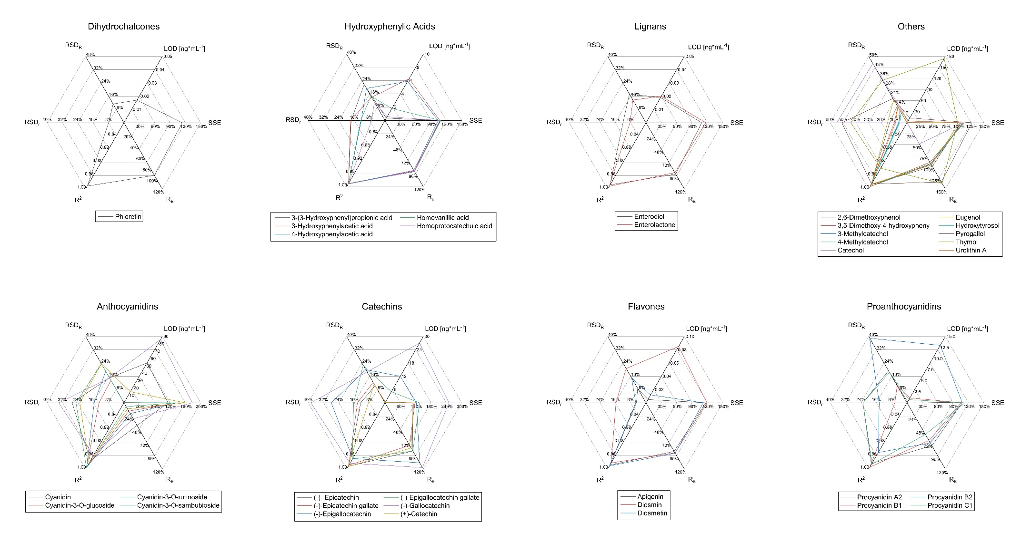

Figure S2. Analytical figures of merit evaluated during the method validation for remaining eight polyphenol classes (see Figure 1). The limit of quantification (LOQ), regression coefficient (R²), average recovery (R^{E}), average intermediate precision (RSD_{R}) and average repeatability (RSD_{r}) are displayed.
Table S6. Estimated daily polyphenol intake calculated for each breast milk sample (S1-S10) from one month after birth and calculated mean and median values. All values are given in microgram analyte per kilogram infant bodyweight per day (µg*kg⁻¹ bw day⁻¹).
Analyte | Mean | Median |  | S1 |  | S2 |  | S3 |  | S4 |  | S5 |  | S6 |  | S7 |  | S8 |  | S9 |  | S10
Dihydrochalcones
Phloretin | 0.0044 | 0.0044 | - |  | - |  | - |  | - |  | - |  | - |  | - |  | - |  | 0.0044 |  | -
Hydroxybenzoic Acids
3,5-Dihydroxybenzoic acid | 8.6 | 0.34 | - |  | - |  | 0.42 |  | 4.1 |  | 0.1 |  | 47 |  | 0.25 |  | - |  | 0.1 |  | -
3-Hydroxybenzoic acid | 0.46 | 0.44 | - |  | - |  | 0.44 |  | 0.53 |  | 0.25 |  | 0.88 |  | 0.23 |  | - |  | 0.66 |  | 0.21
4-Hydroxybenzoic acid | 7.5 | 1.9 | 0.91 |  | 0.83 |  | 6 |  | 11 |  | 1.1 |  | 48 |  | 0.94 |  | 1.4 |  | 2.4 |  | 2.3
Gallic acid | 0.032 | 0.032 | - |  | - |  | - |  | - |  | - |  | 0.032 |  | - |  | - |  | - |  | -
Protocatechuic acid | 0.72 | 0.024 | 0.015 |  | - |  | 0.038 |  | 0.39 |  | - |  | 4.5 |  | 0.024 |  | - |  | 0.015 |  | 0.015
Salicylic acid | 11 | 0.54 | 1.1 |  | 0.32 |  | 0.51 |  | 28 |  | 0.5 |  | 42 |  | 36 |  | 0.16 |  | 0.49 |  | 0.56
Vanillic acid | 0.14 | 0.15 | 0.056 |  | - |  | 0.11 |  | 0.2 |  | 0.087 |  | 0.21 |  | 0.19 |  | - |  | - |  | -
Hydroxycinnamic Acids
Chlorogenic acid | 0.68 | 0.67 | - |  | 1 |  | - |  | - |  | 0.34 |  | - |  | - |  | - |  | - |  | -
Dihydrocaffeic acid | 1.3 | 0.16 | - |  | - |  | - |  | 0.16 |  | - |  | 3.8 |  | 0.041 |  | - |  | - |  | -
Dihydroferulic acid | 0.49 | 0.50 | 0.58 |  | - |  | - |  | - |  | - |  | 0.41 |  | - |  | - |  | - |  | -
Ferulic acid/Isoferulic acid | 0.12 | 0.094 | 0.046 |  | 0.091 |  | 0.39 |  | 0.06 |  | 0.096 |  | 0.21 |  | 0.026 |  | 0.11 |  | 0.076 |  | 0.11
p-Coumaric acid | 1.1 | 0.79 | - |  | - |  | 0.08 |  | 1.9 |  | - |  | 1.5 |  | 2.8 |  | 0.012 |  | - |  | 0.012
Sinapic acid | 0.021 | 0.021 | - |  | 0.021 |  | - |  | - |  | - |  | - |  | - |  | - |  | - |  | -
Hydroxyphenylacetic Acids
3-(3-Hydroxyphenyl)propionic acid | 0.2 | 0.195 | 0.27 |  | 0.095 |  | - |  | - |  | 0.12 |  | - |  | - |  | - |  | - |  | 0.31
4-Hydroxyphenylacetic acid | 180 | 5.5 | 1.5 |  | - |  | 58 |  | 19 |  | 2.9 |  | 1500 |  | 5.5 |  | 1.5 |  | 47 |  | 2
Homovanillic acid | 0.64 | 0.66 | - |  | - |  | 0.81 |  | - |  | - |  | 0.46 |  | - |  | - |  | - |  | 0.66
Homoprotocatechuic acid | 7.8 | 7.8 | - |  | - |  | - |  | - |  | - |  | 7.8 |  | - |  | - |  | - |  | -
Lignans
Enterodiol | 0.054 | 0.054 | - |  | - |  | - |  | - |  | - |  | 0.091 |  | - |  | - |  | 0.017 |  | -
Analyte | Mean | Median | S1 |  | S2 |  | S3 |  | S4 |  | S5 |  | S6 |  | S7 |  | S8 |  | S9 |  | S10
Enterolactone | 0.099 | 0.031 | - |  | - |  | 0.03 |  | 0.24 |  | - |  | - |  | - |  | - |  | 0.031 |  | -
Others
2,6-Dimethoxyphenol | 0.04 | 0.04 | - |  | - |  | - |  | - |  | - |  | 0.04 |  | - |  | - |  | - |  | -
3,5-Dimethoxy-4-hydroxyphenylacetic acid | 1.7 | 1.7 | - |  | - |  | - |  | 0.66 |  | - |  | 2.8 |  | - |  | - |  | - |  | -
4-Methylcatechol | 1.4 | 1.4 | - |  | - |  | - |  | - |  | - |  | 1.4 |  | - |  | - |  | - |  | -
Catechol | 89 | 31 | 13 |  | 1.3 |  | - |  | 160 |  | 1.3 |  | 290 |  | - |  | - |  | 31 |  | 120
Hydroxytyrosol | 1.5 | 1.5 | - |  | - |  | - |  | - |  | - |  | 2.9 |  | - |  | - |  | 0.019 |  | -
Pyrogallol | 0.47 | 0.47 | 0.5 |  | 0.44 |  | - |  | - |  | - |  | - |  | - |  | - |  | - |  | -
Flavanones
(+/-)-Naringenin | 0.27 | 0.14 | 0.012 |  | 0.009 |  | 0.24 |  | 0.24 |  | - |  | 0.17 |  | 0.14 |  | 0.013 |  | 1.6 |  | 0.043
8-Prenylnaringenin | 0.16 | 0.16 | - |  | - |  | - |  | - |  | - |  | - |  | - |  | - |  | 0.16 |  | -
Hesperetin | 0.17 | 0.17 | - |  | - |  | - |  | - |  | - |  | 0.29 |  | 0.052 |  | - |  | - |  | -
Flavones
Apigenin | 0.093 | 0.037 | - |  | - |  | 0.009 |  | 0.037 |  | - |  | 0.23 |  | - |  | - |  | - |  | -
Diosmetin | 0.055 | 0.022 | 0.0038 |  | 0.011 |  | 0.04 |  | 0.1 |  | - |  | 0.2 |  | - |  | - |  | 0.022 |  | 0.0088
Flavonols
Isorhamnetin | 0.0073 | 0.0045 | 0.0023 |  | - |  | - |  | 0.015 |  | - |  | 0.0045 |  | - |  | - |  | - |  | -
Kaempferol | 0.043 | 0.043 | - |  | - |  | - |  | 0.043 |  | - |  | - |  | - |  | - |  | 0.043 |  | -
Kaempferol-3-O-glucuronide | 0.1 | 0.1 | - |  | 0.1 |  | - |  | - |  | - |  | - |  | - |  | - |  | - |  | -
Isoflavones
Daidzein | 0.26 | 0.066 | - |  | - |  | 0.0085 |  | 1.1 |  | - |  | 0.066 |  | 0.099 |  | - |  | - |  | 0.0085
Genistein | 0.043 | 0.018 | - |  | - |  | 0.018 |  | 0.14 |  | - |  | 0.014 |  | 0.026 |  | - |  | - |  | 0.013
Genistein-7-sulfate | 0.045 | 0.045 | - |  | - |  | - |  | 0.045 |  | - |  | - |  | 0.045 |  | 0.045 |  | - |  | 0.045
Proanthocyanidins
Procyanidin C1 | 0.15 | 0.15 | 0.16 |  | - |  | 0.15 |  | - |  | 0.15 |  | 0.15 |  | - |  | - |  | - |  | -

Table S7. Calibration curves for each analyte, with the analyte concentration [ng*mL⁻¹] on the x-axis and the peak area on the y-axis.
Catechol  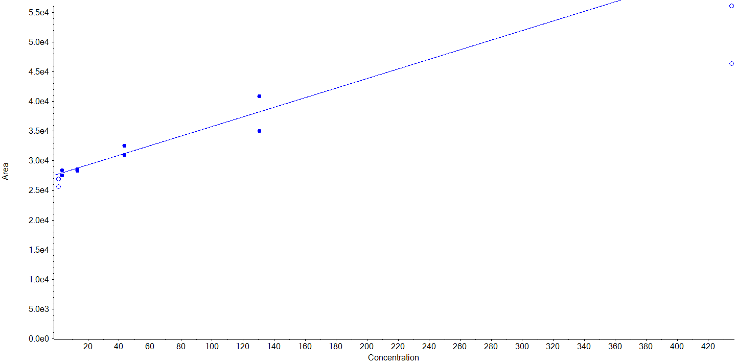 | Benzoic acid  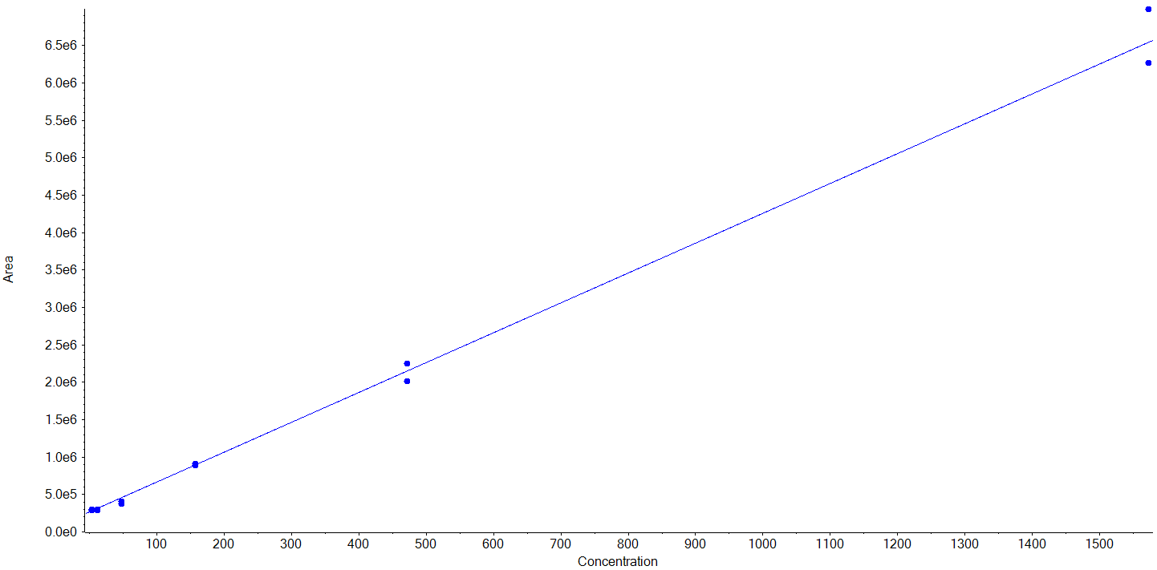 | 4-Methylcatechol  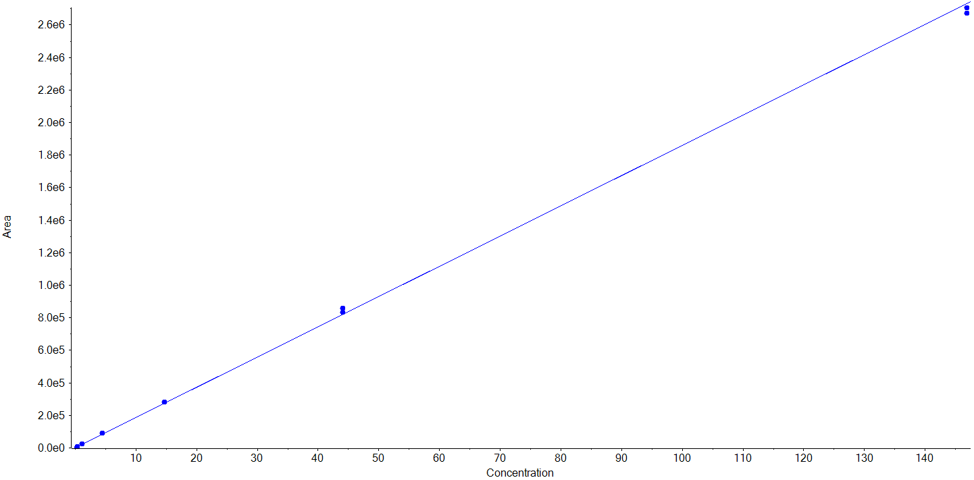
4-Hydroxybenzoic acid  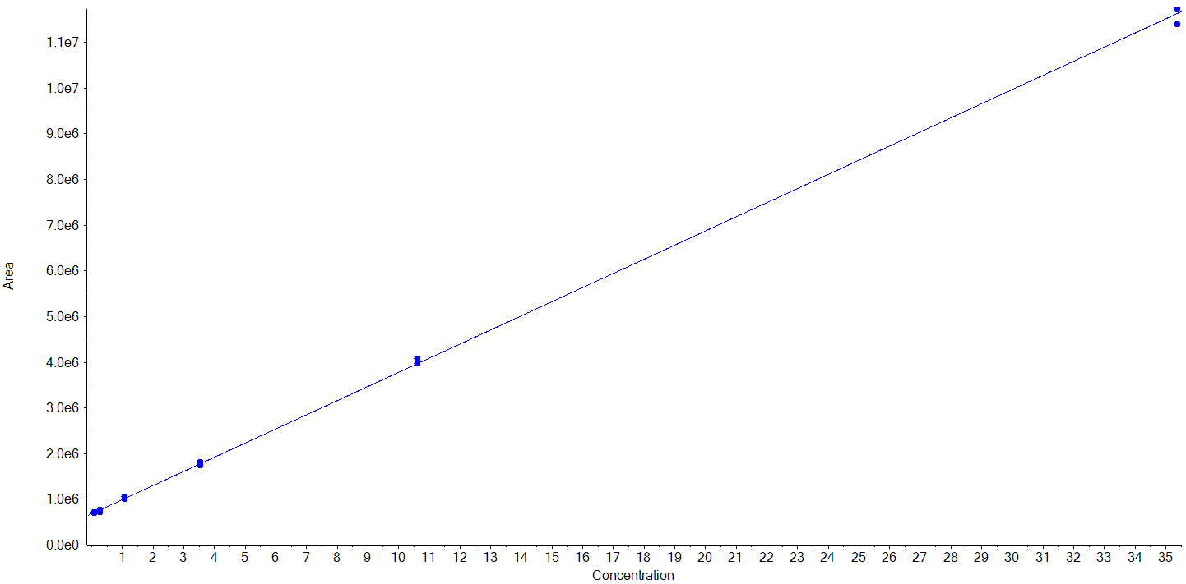 | Salicylic acid  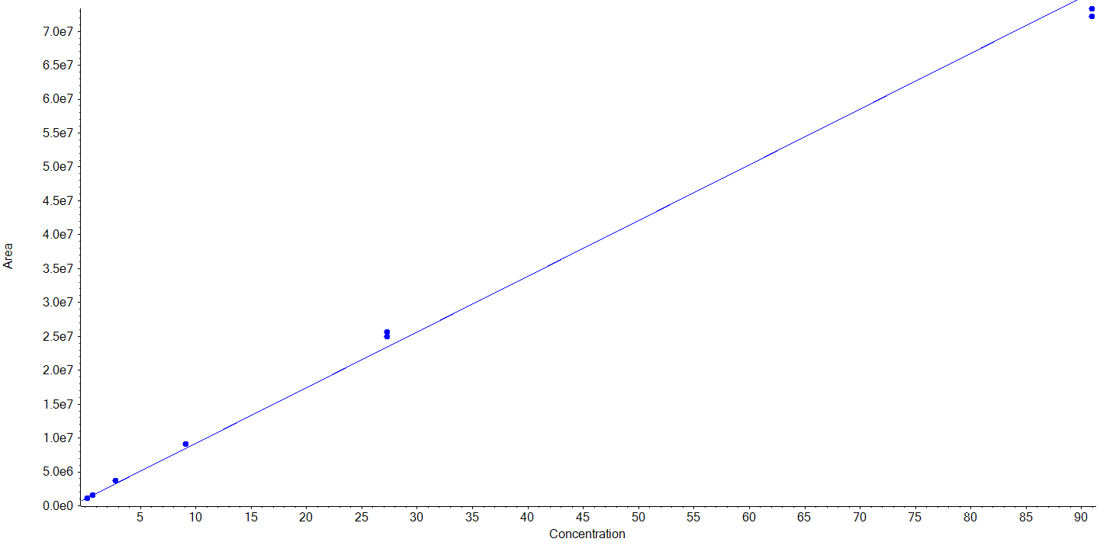 | Cinnamic acid  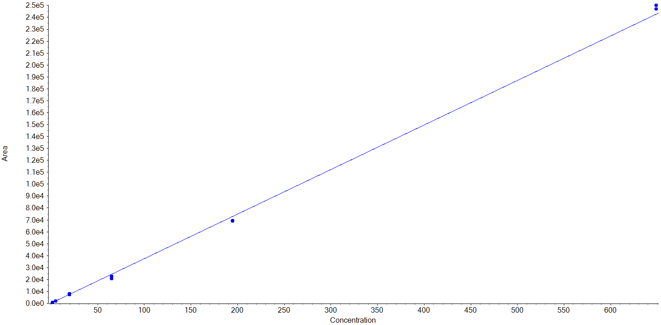
3-Methylcatechol  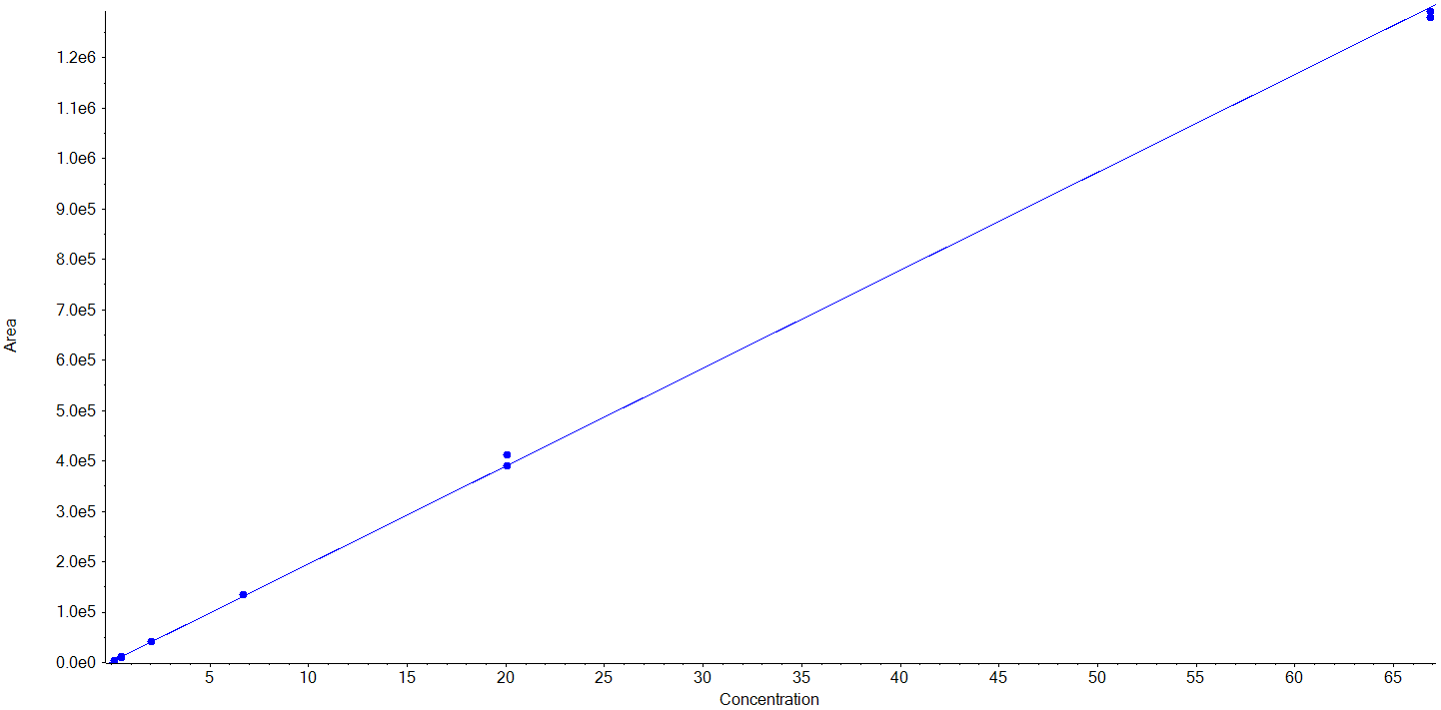 | Pyrogallol  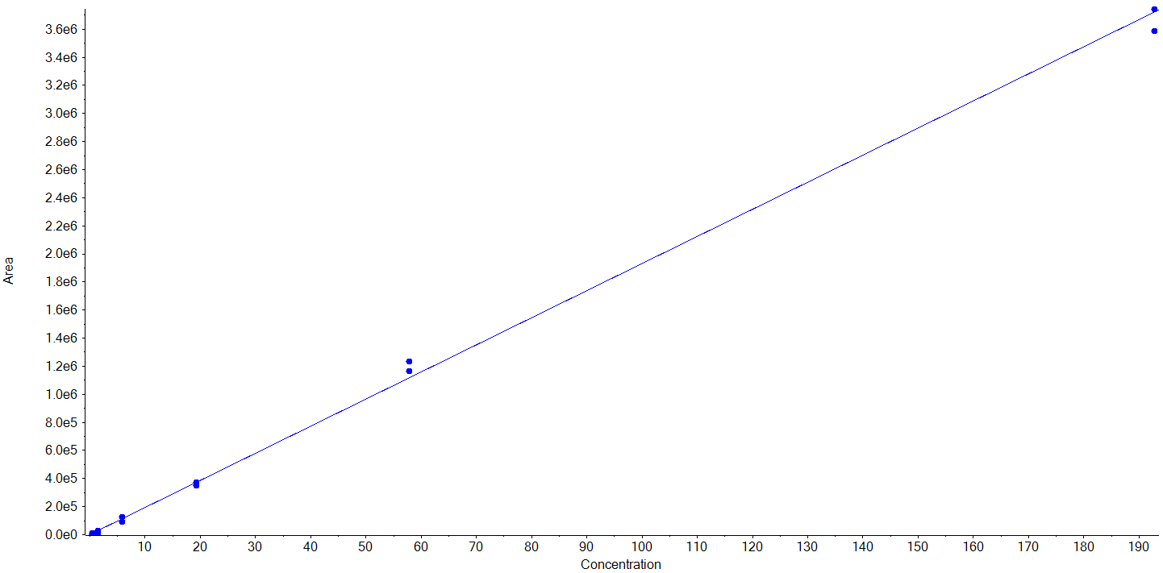 | 3-Hydroxybenzoic acid  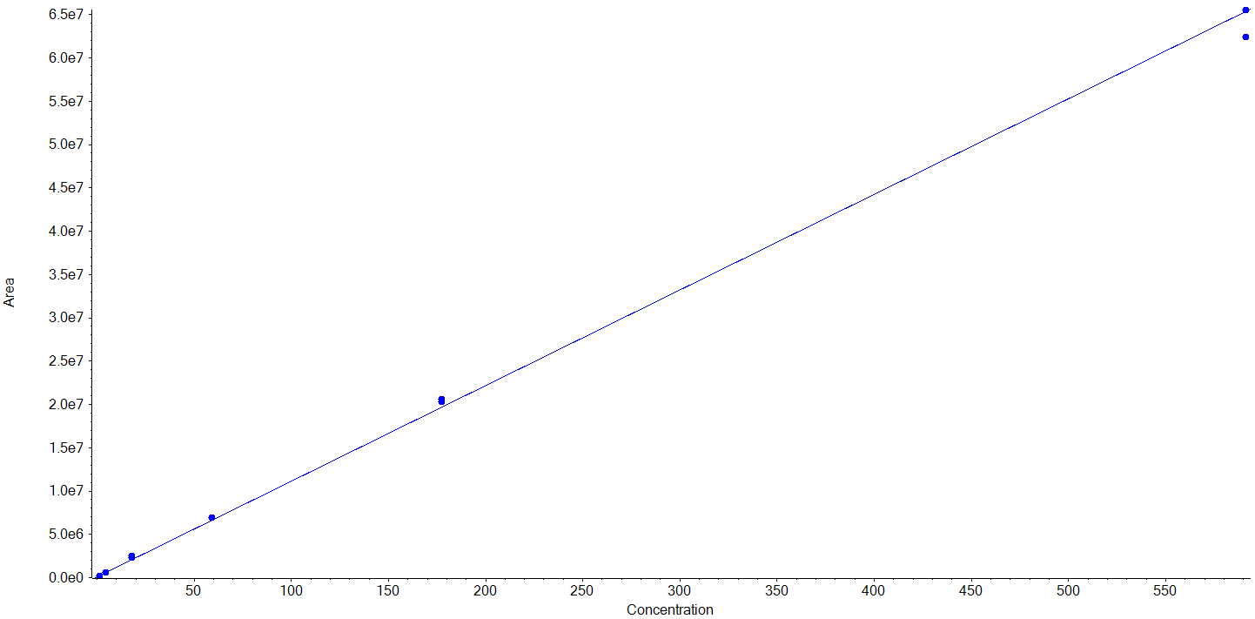
Thymol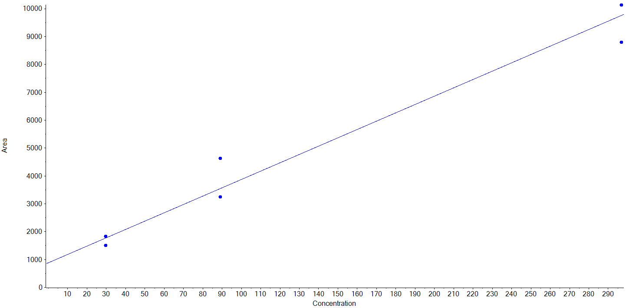 | 4-Hydroxyphenylacetic acid  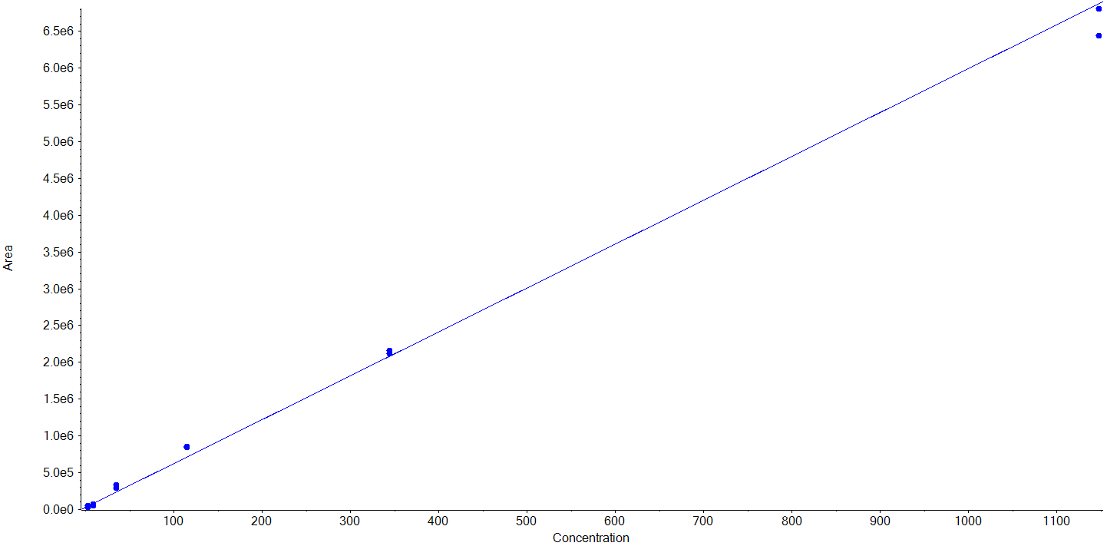 | 3-Hydroxyphenylacetic acid  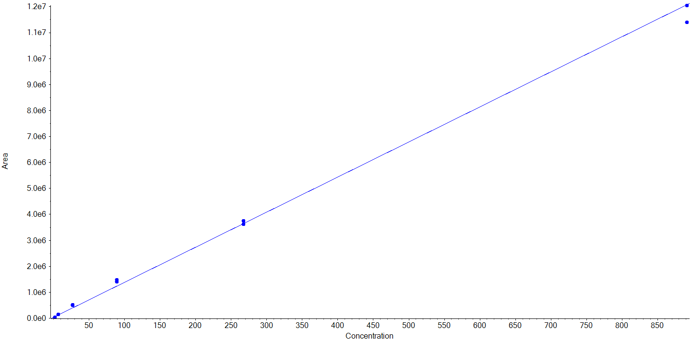
3,5-Dihydroxybenzoic acid  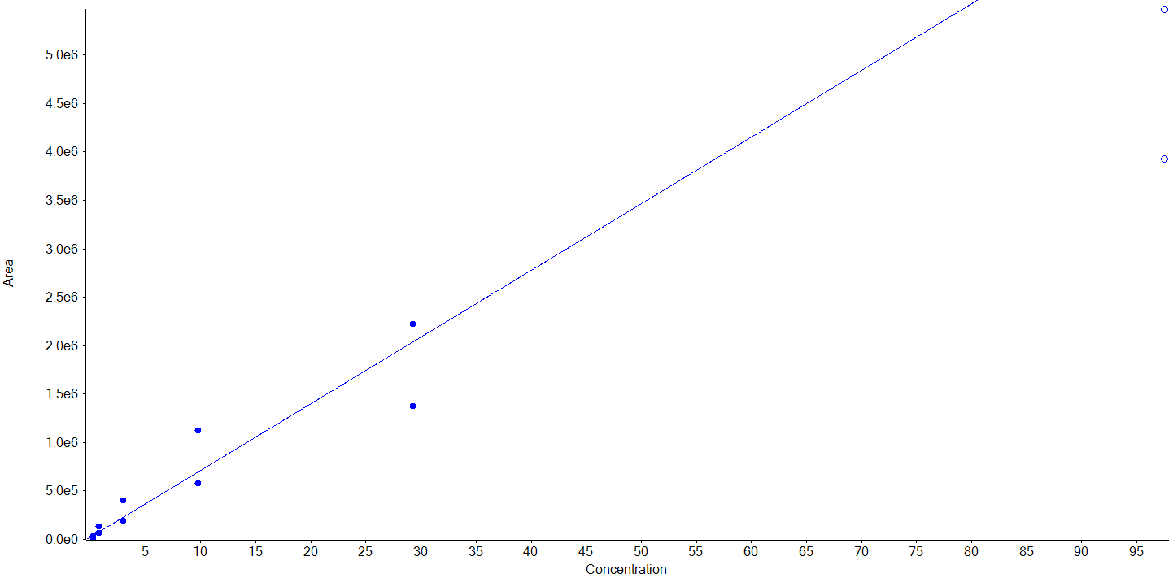 | Hydroxytyrosol  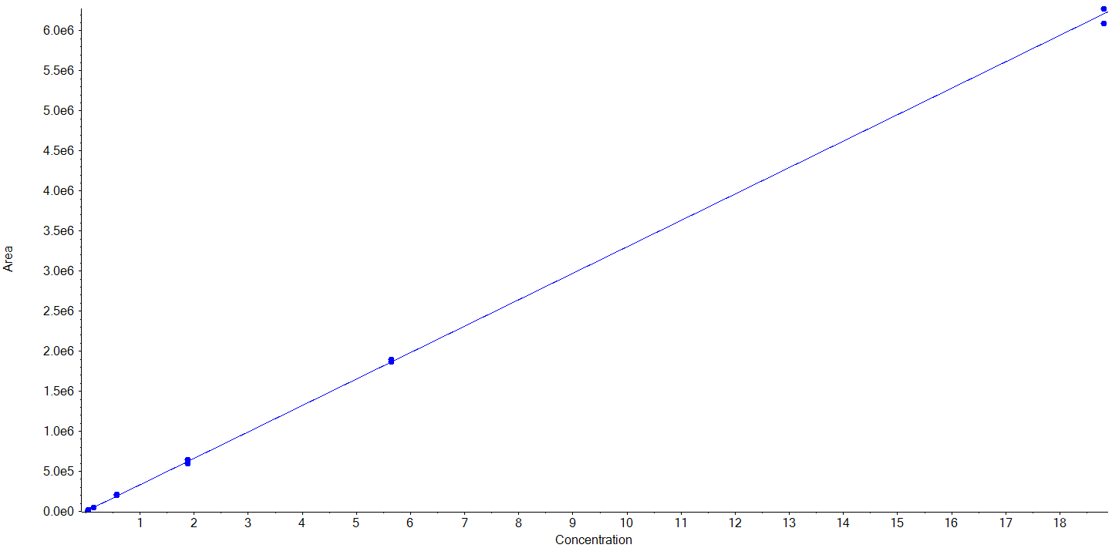 | Protocatechuic acid  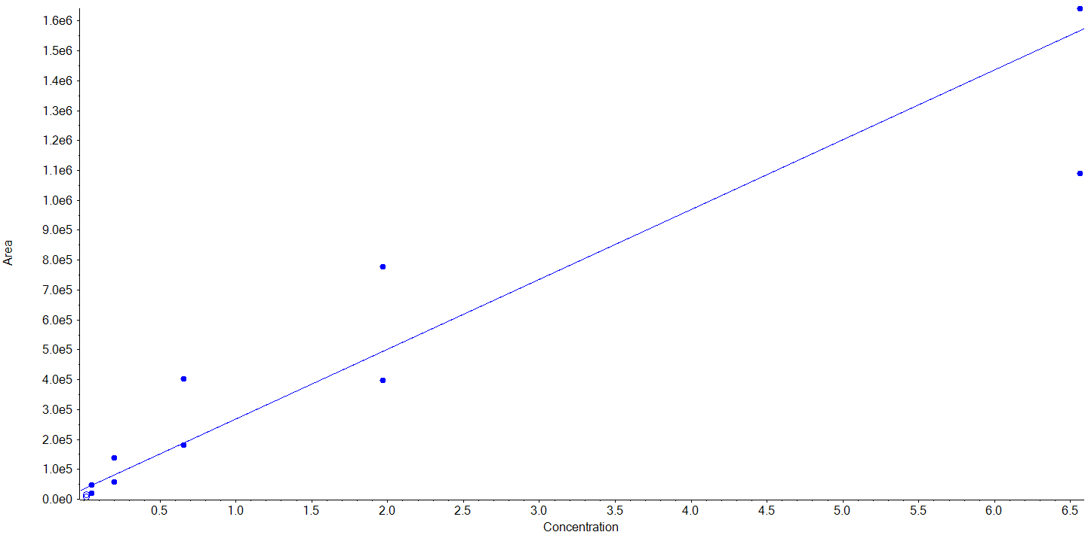
trans-m-Coumaric acid  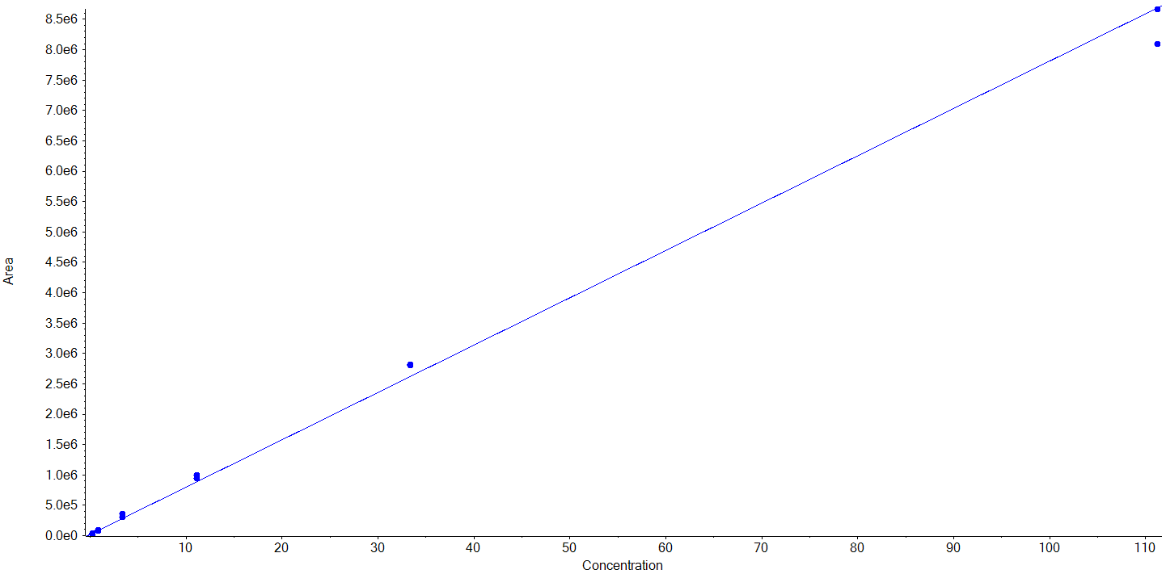 | p-Coumaric acid  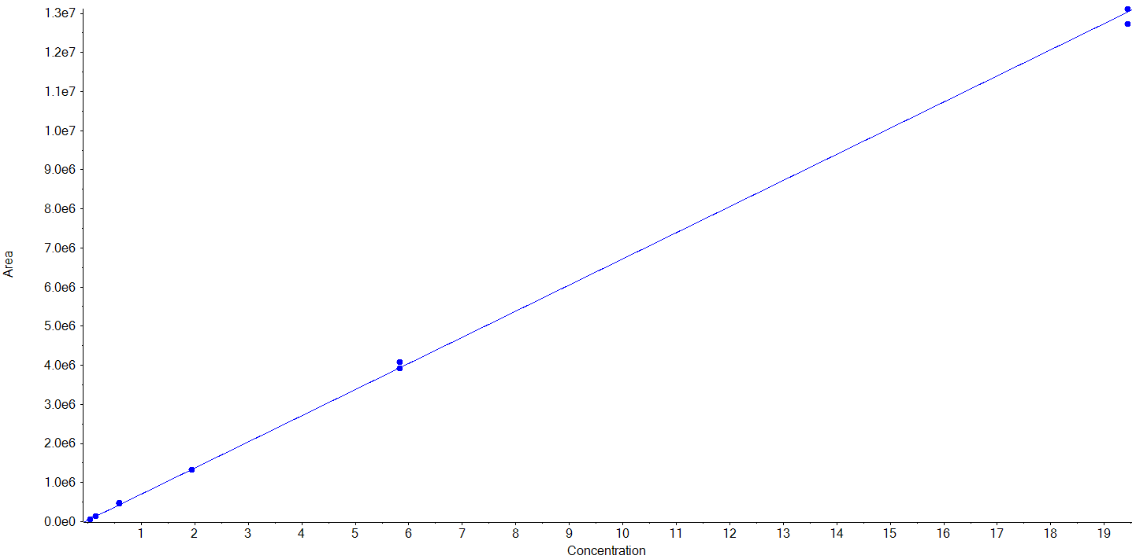 | trans-o-Coumaric acid  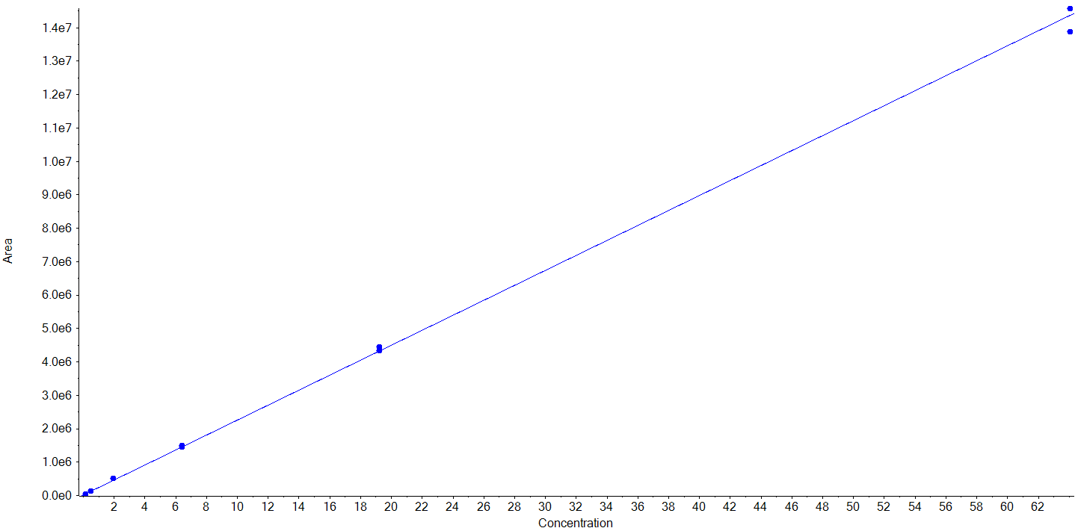
3-(3-Hydroxyphenyl)propionic acid  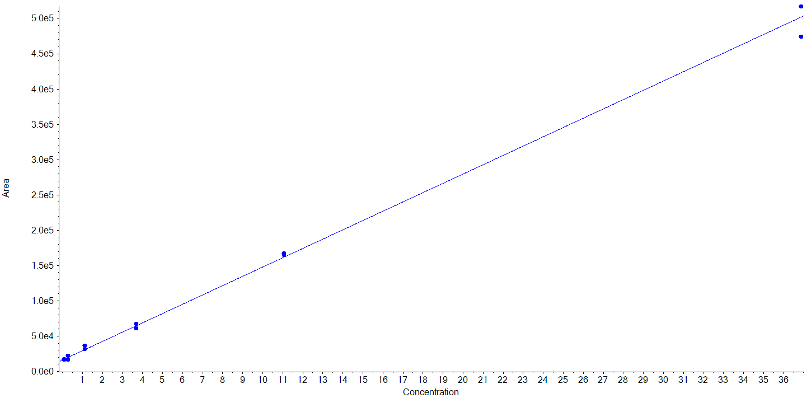 | Vanillic acid  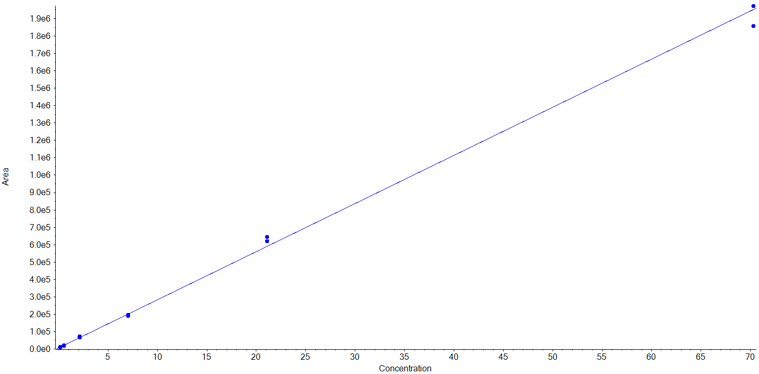 | Homoprotocatechuic acid  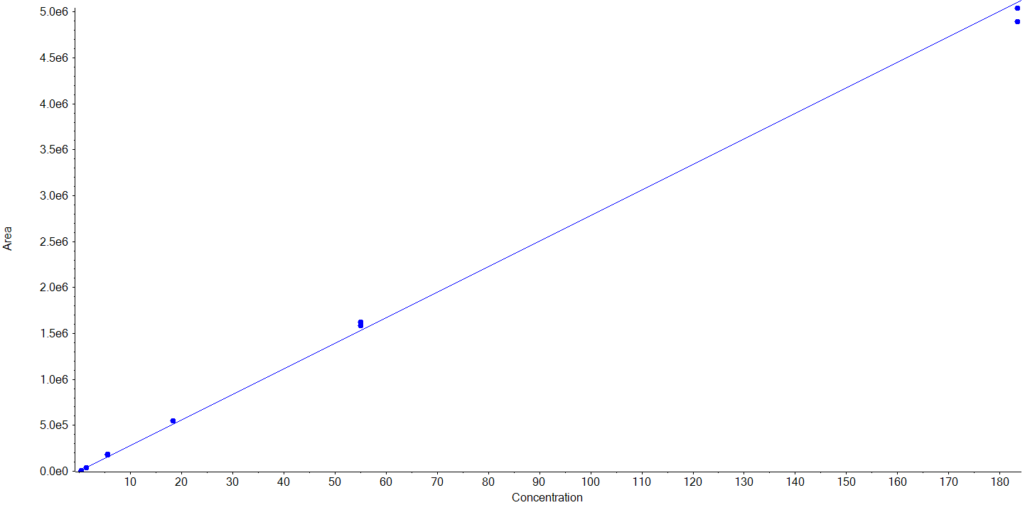
Gallic acid  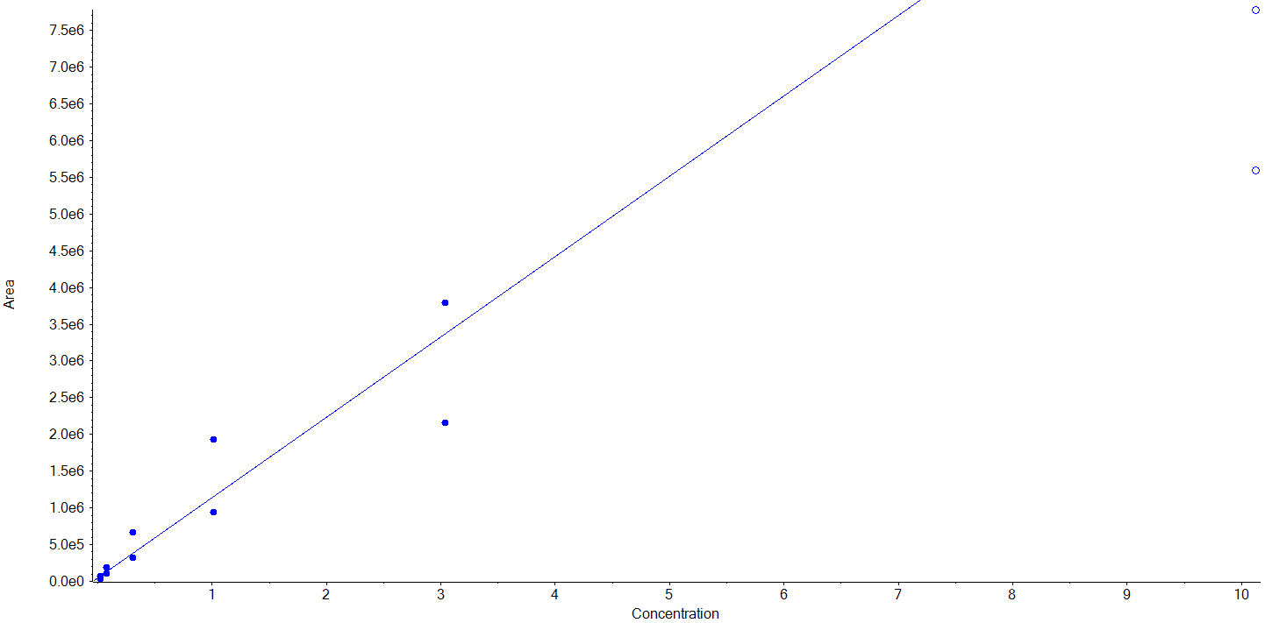 | Caffeic acid  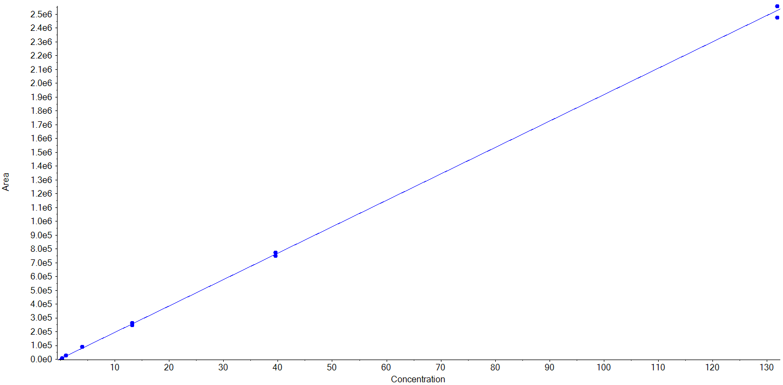 | Homovanillic acid  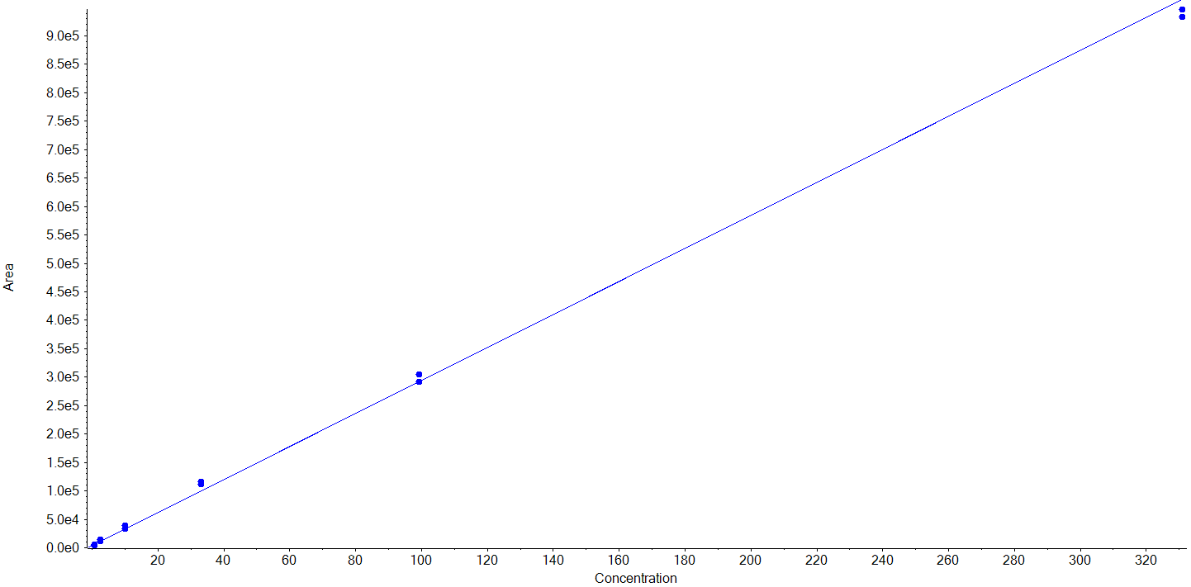
Dihydrocaffeic acid  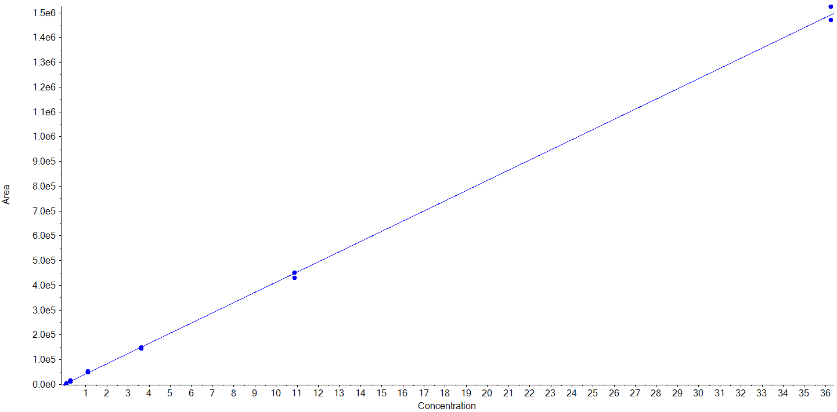 | Ferulic acid/Isoferulic acid  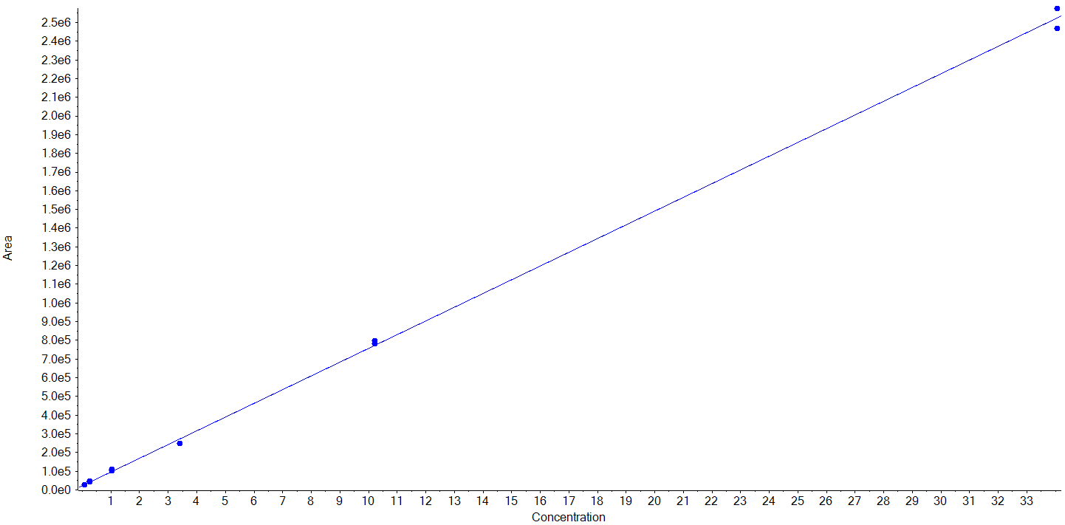 | Dihydroferulic acid  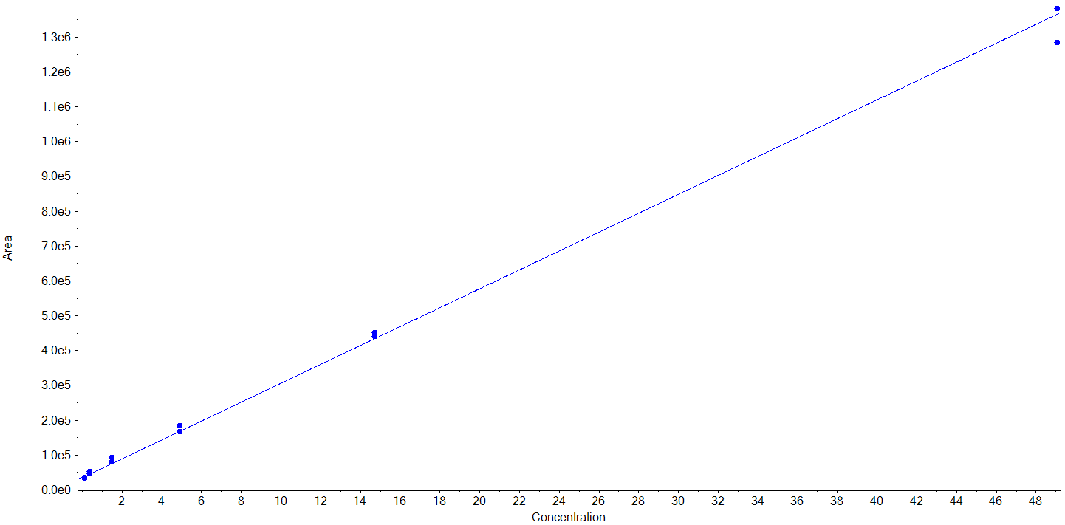
Syringic acid  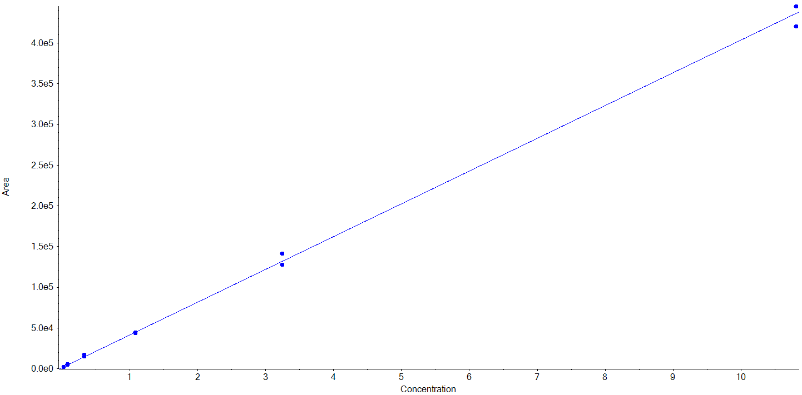 | Ethyl gallate  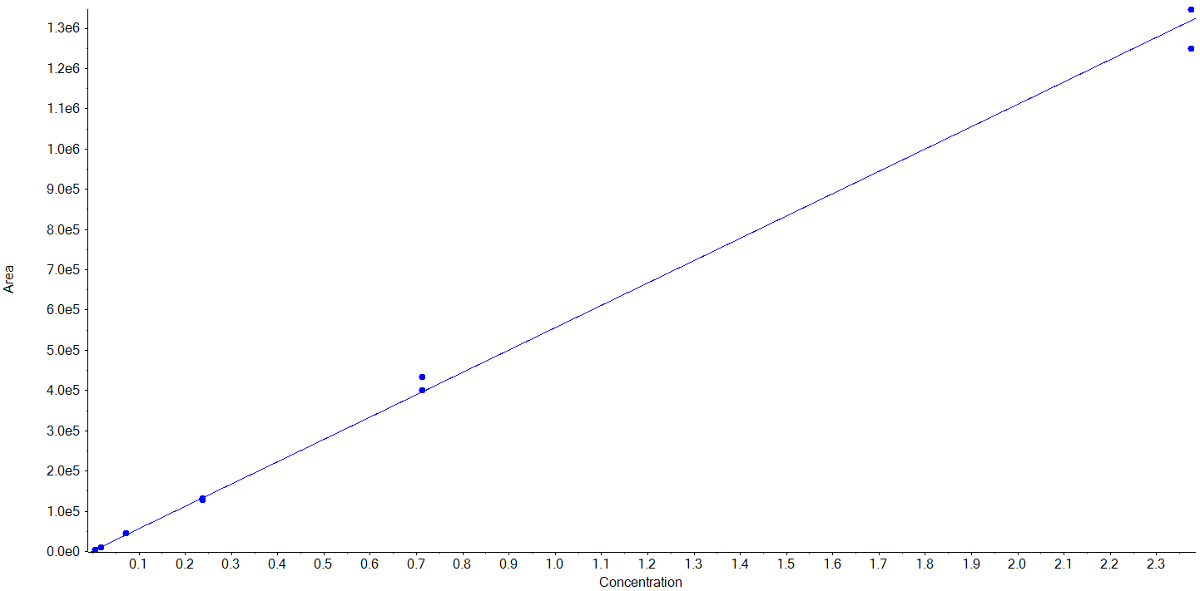 | 3,5-Dimethoxy-4 -hydroxyphenylacetic acid  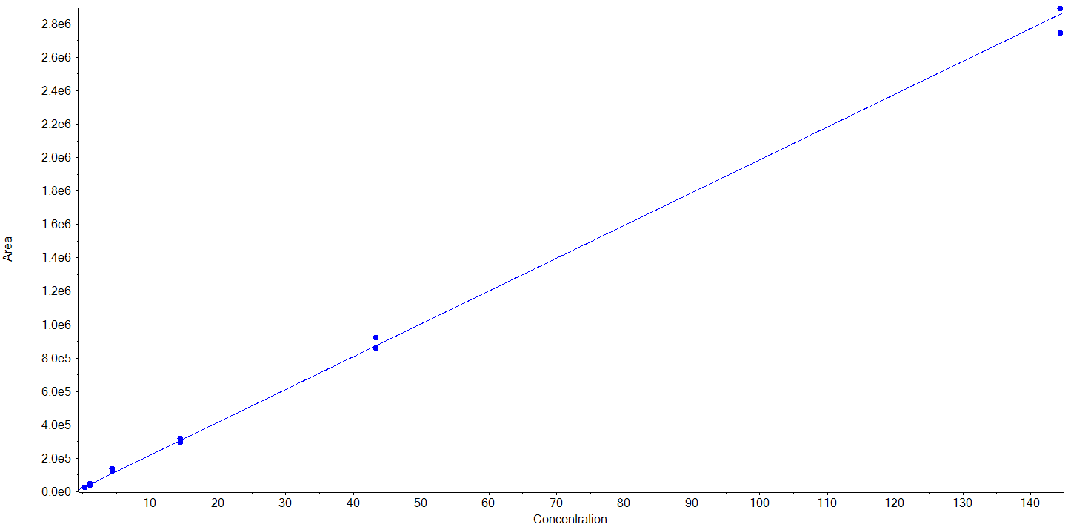
Sinapic acid  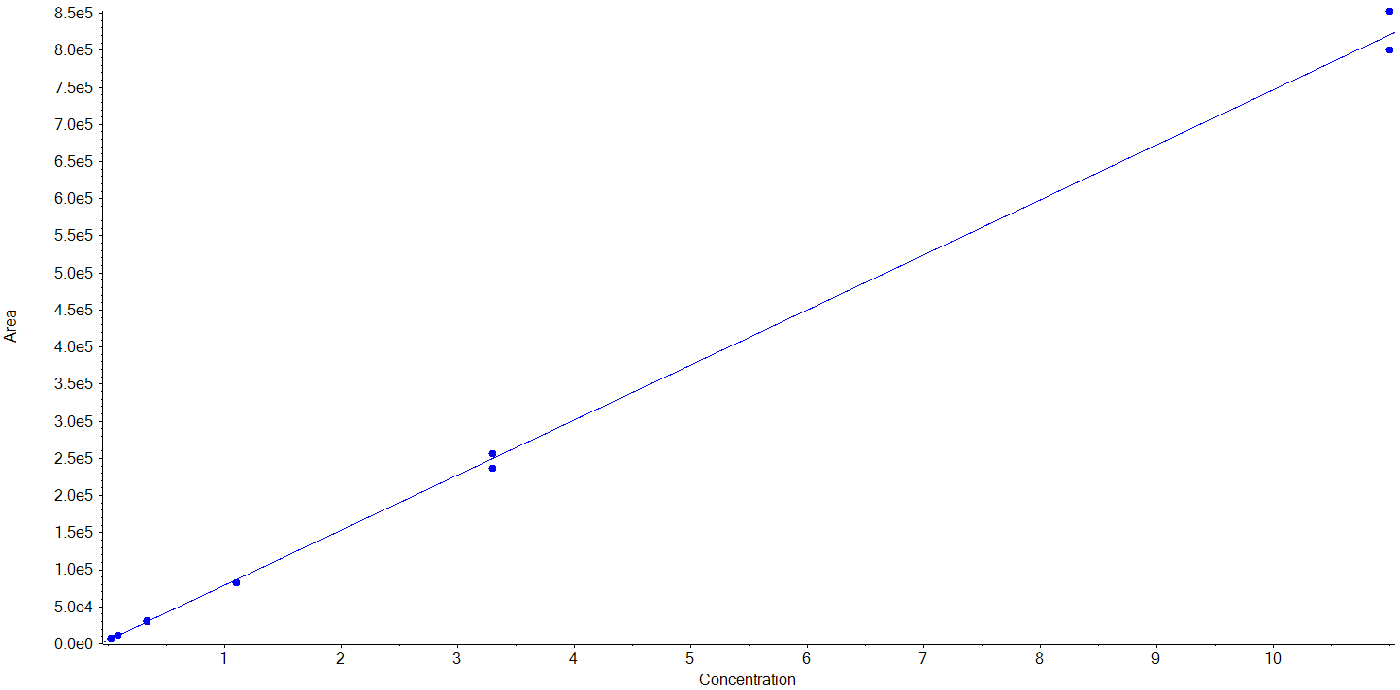 | Urolithin A  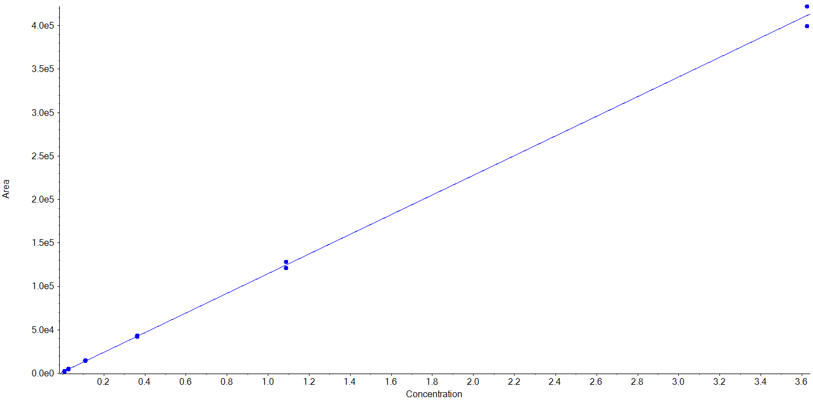 | Resveratrol  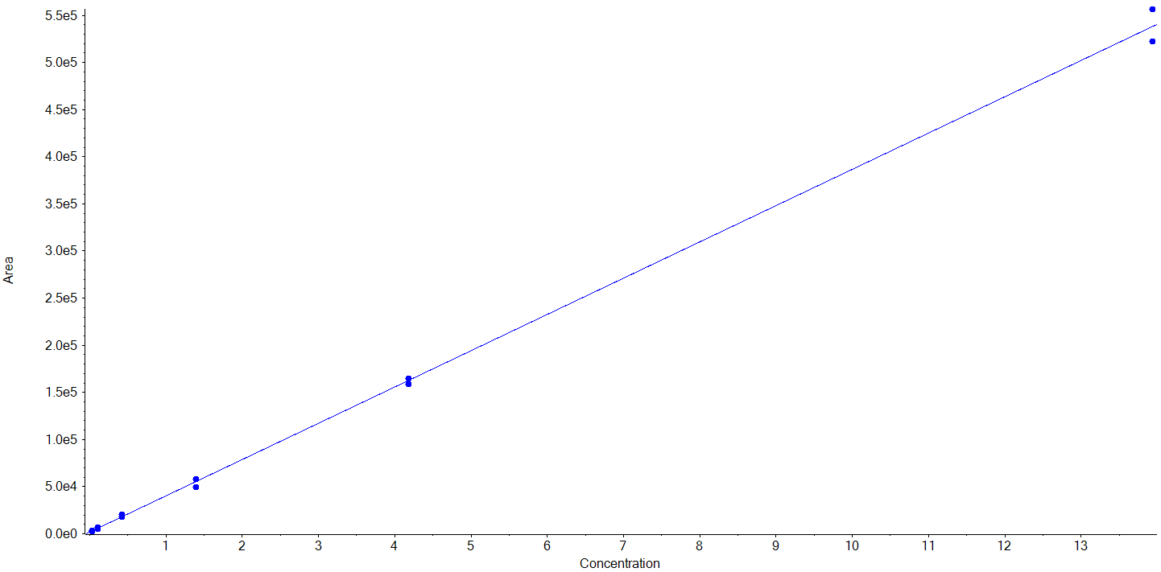
S-Equol  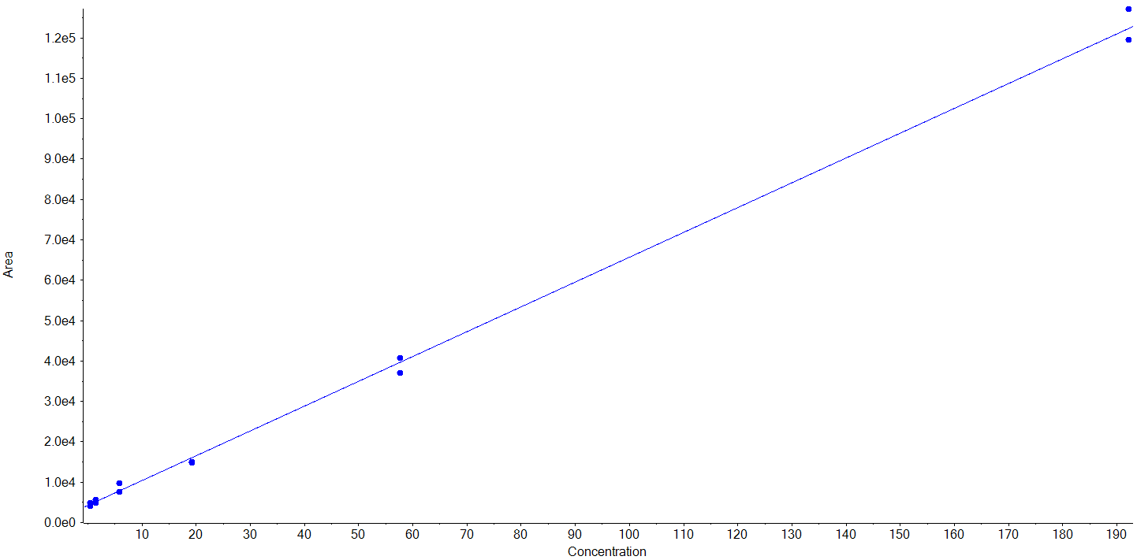 | Daidzein  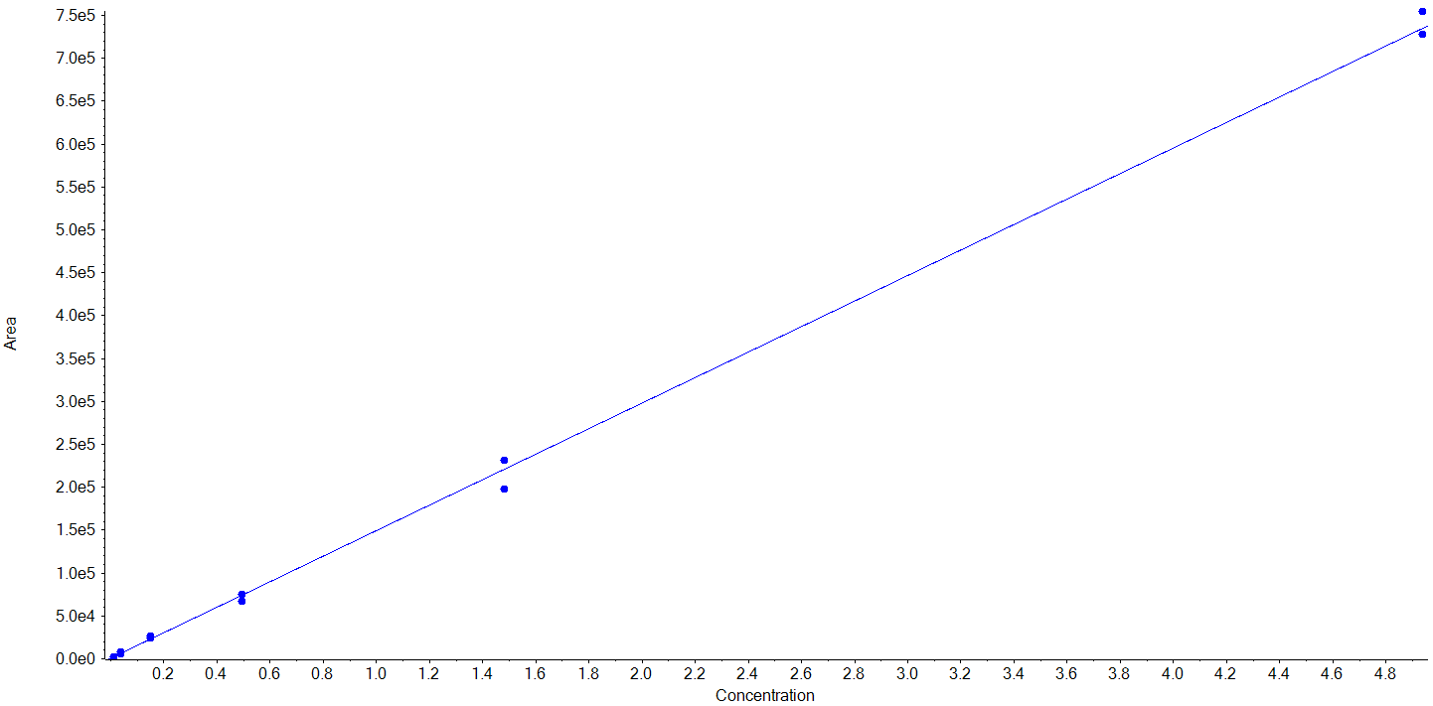 | Apigenin  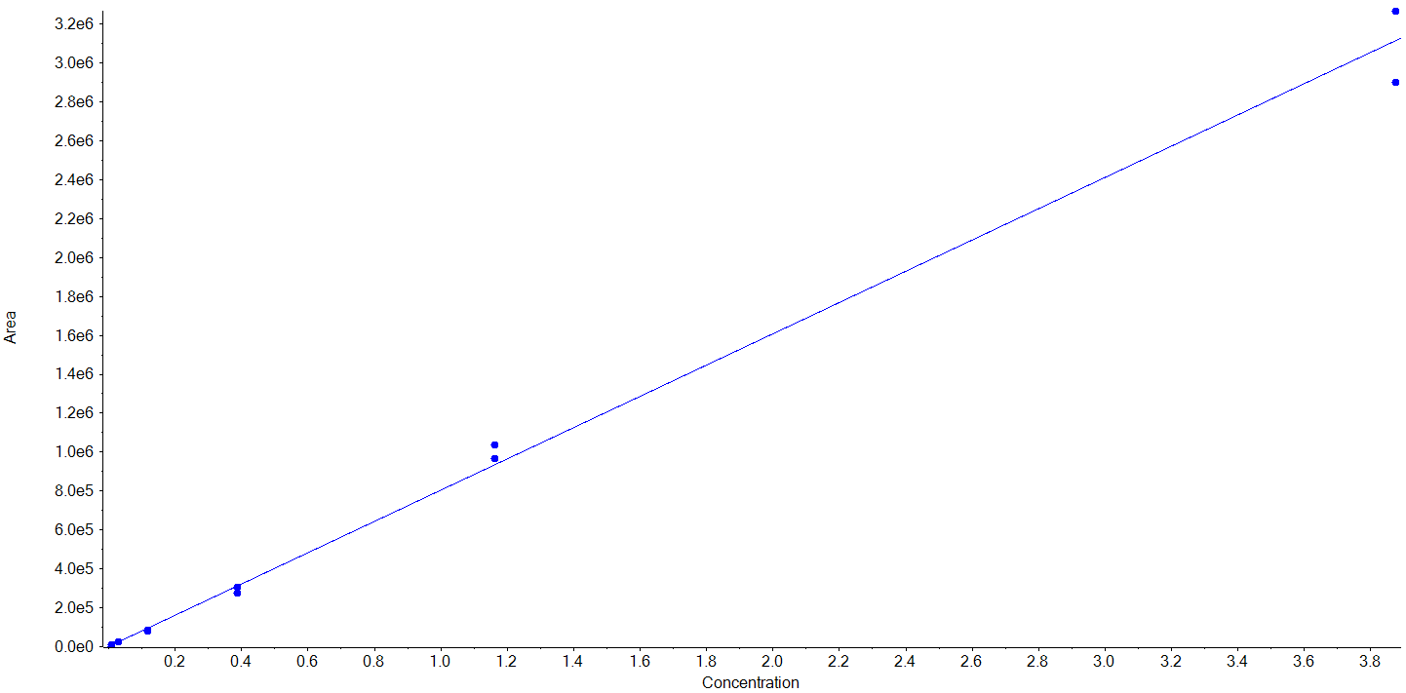
Genistein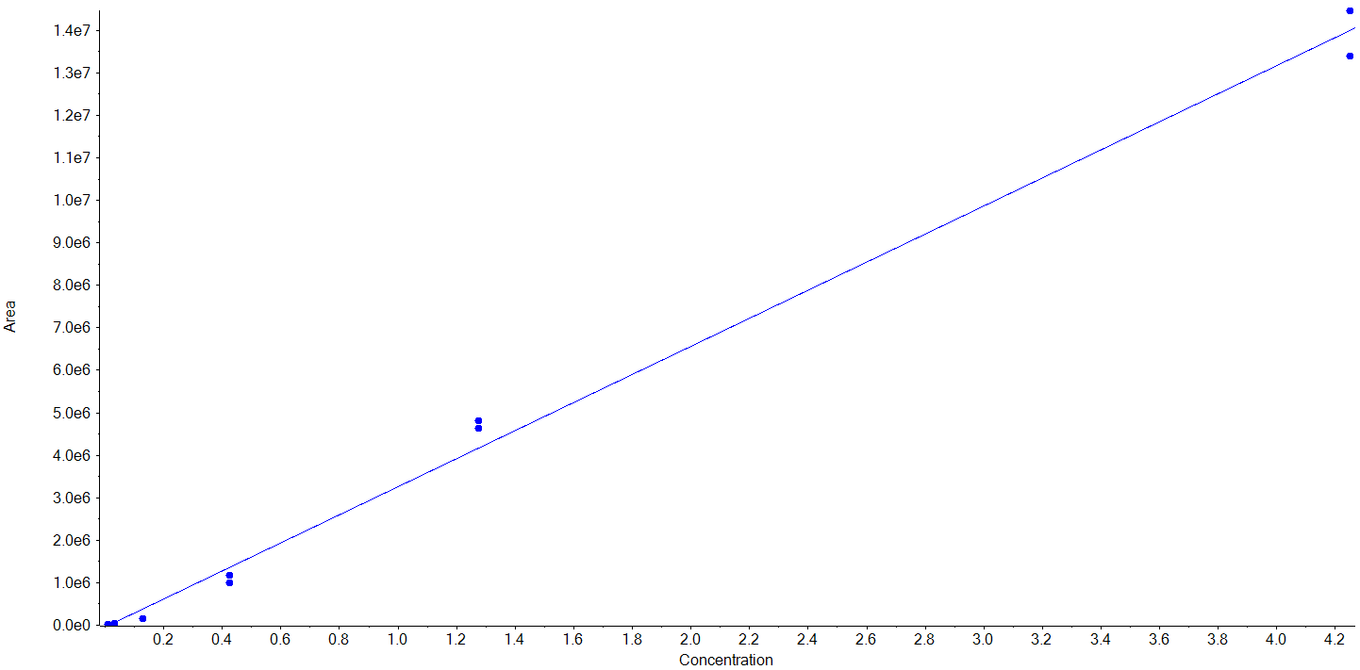 | (+/-)-Naringenin  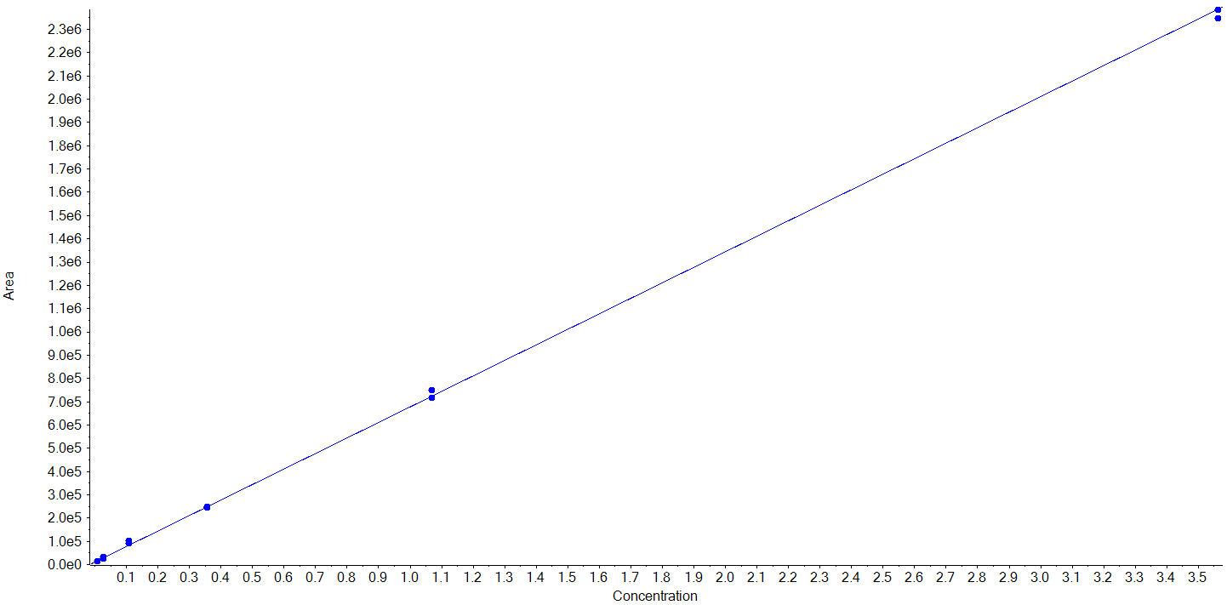 | Phloretin  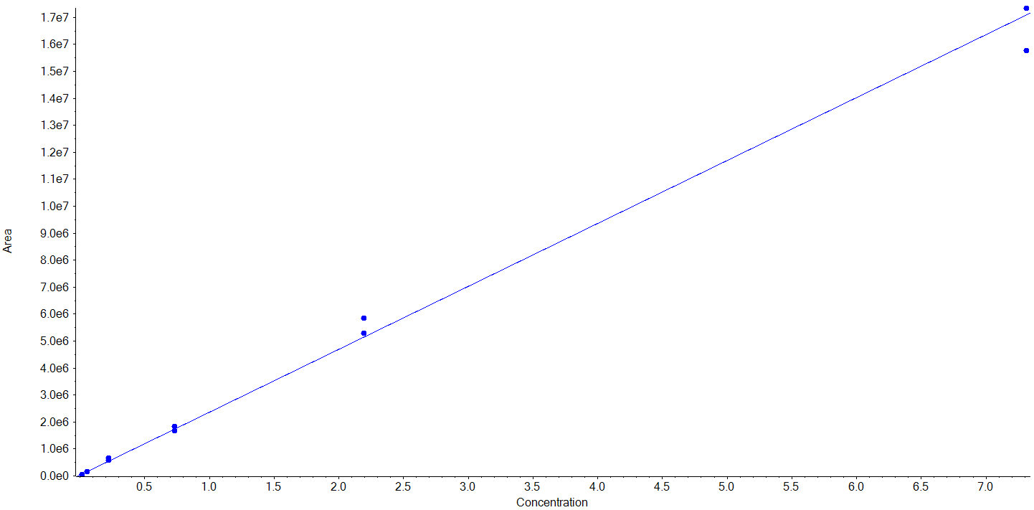
Kaempferol  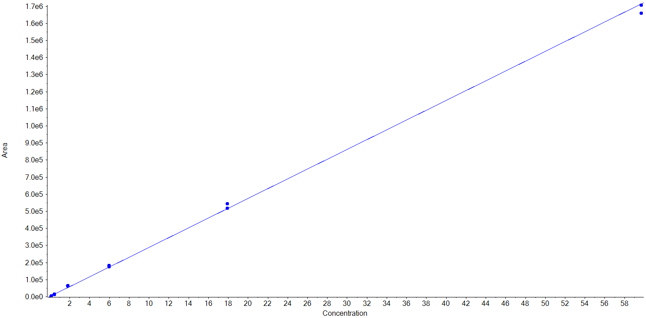 | (+)-Catechin  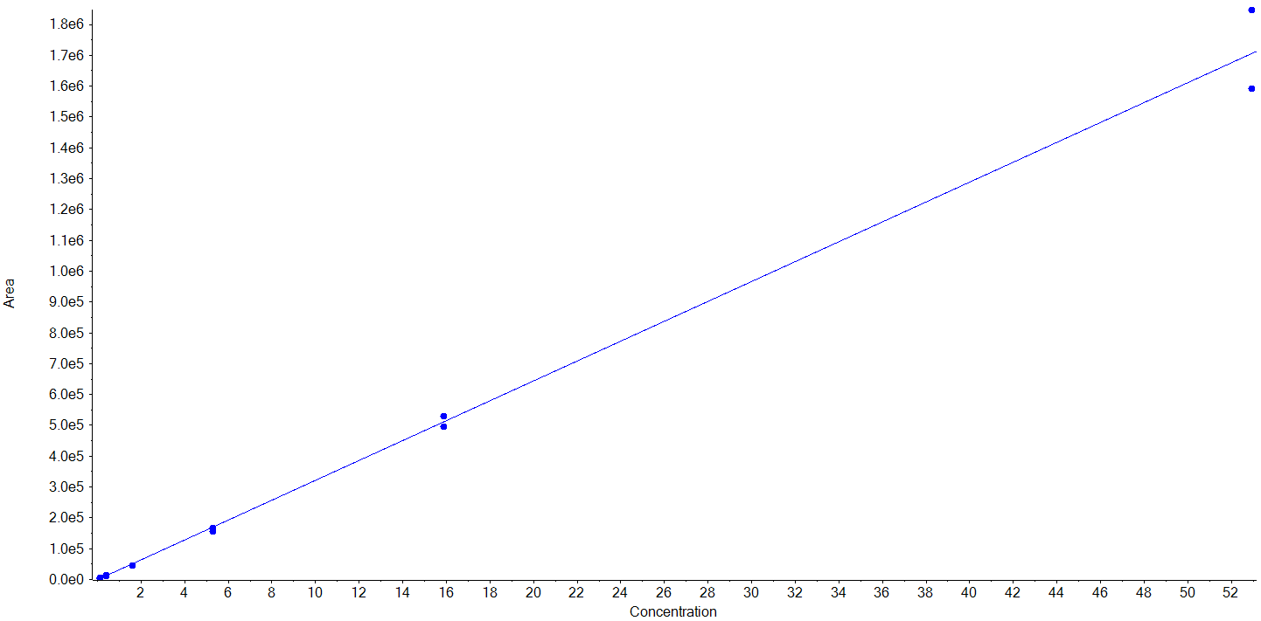 | (-)- Epicatechin  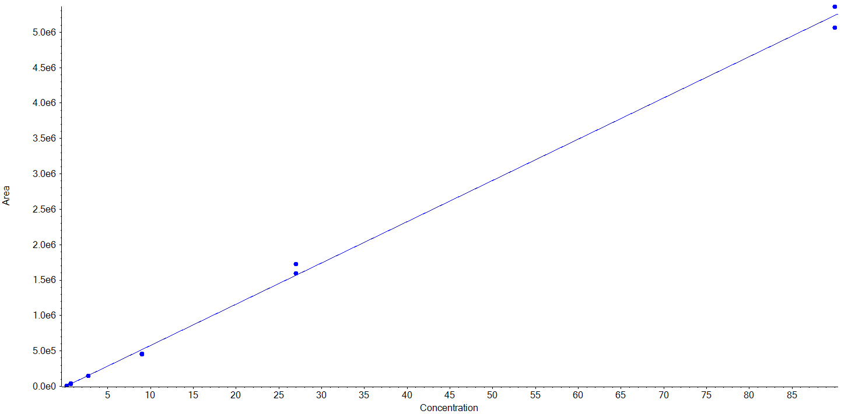
Enterolactone  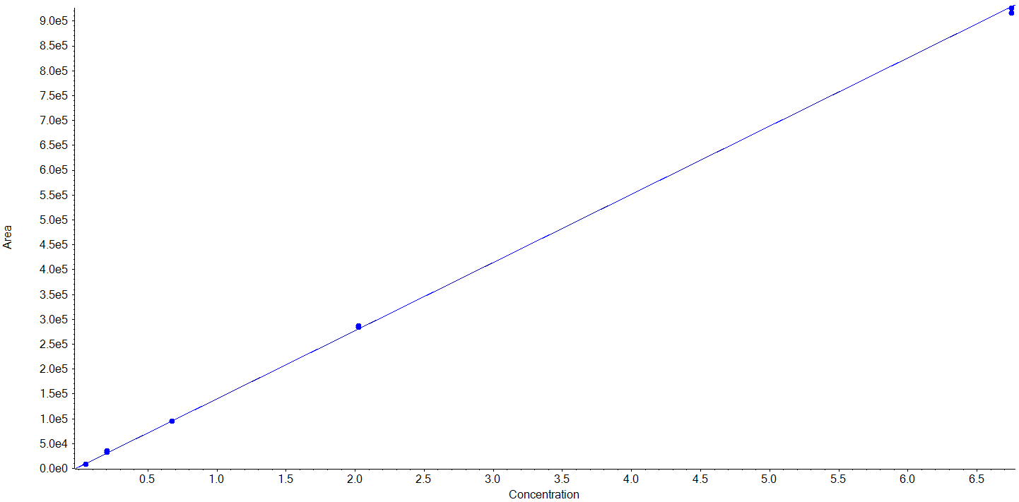 | Diosmetin  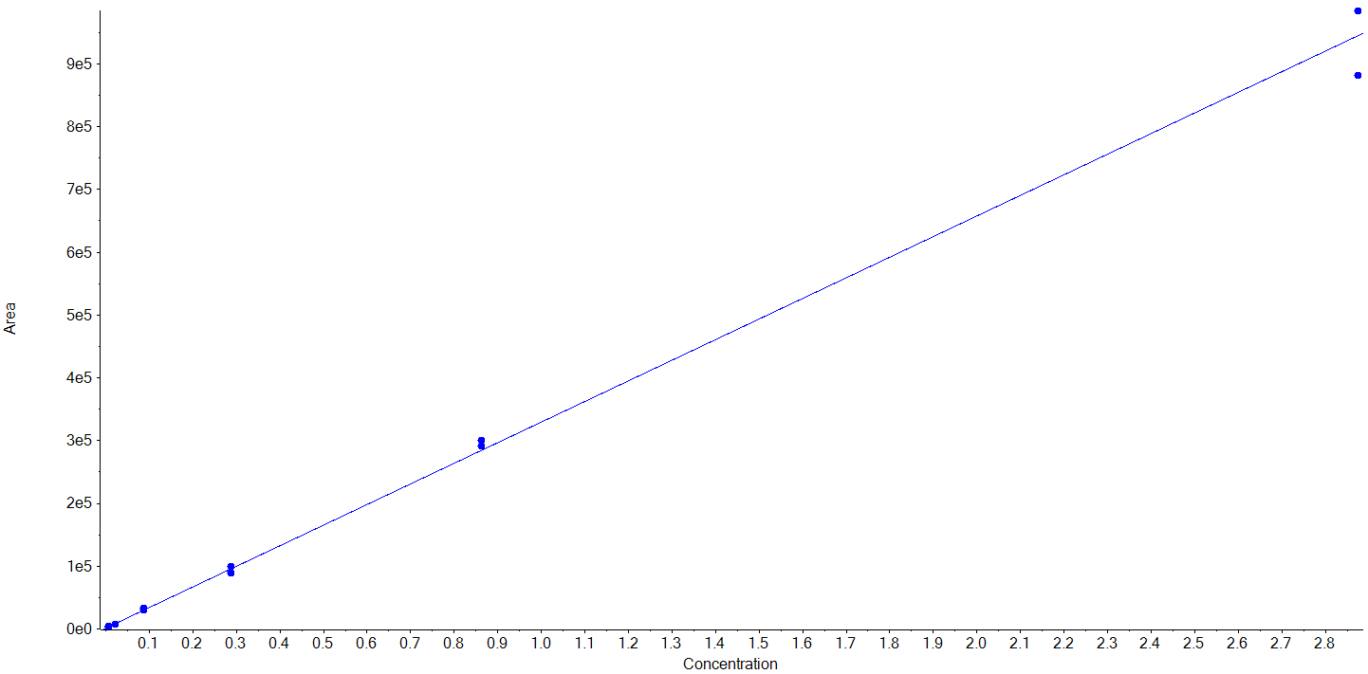 | Ellagic acid  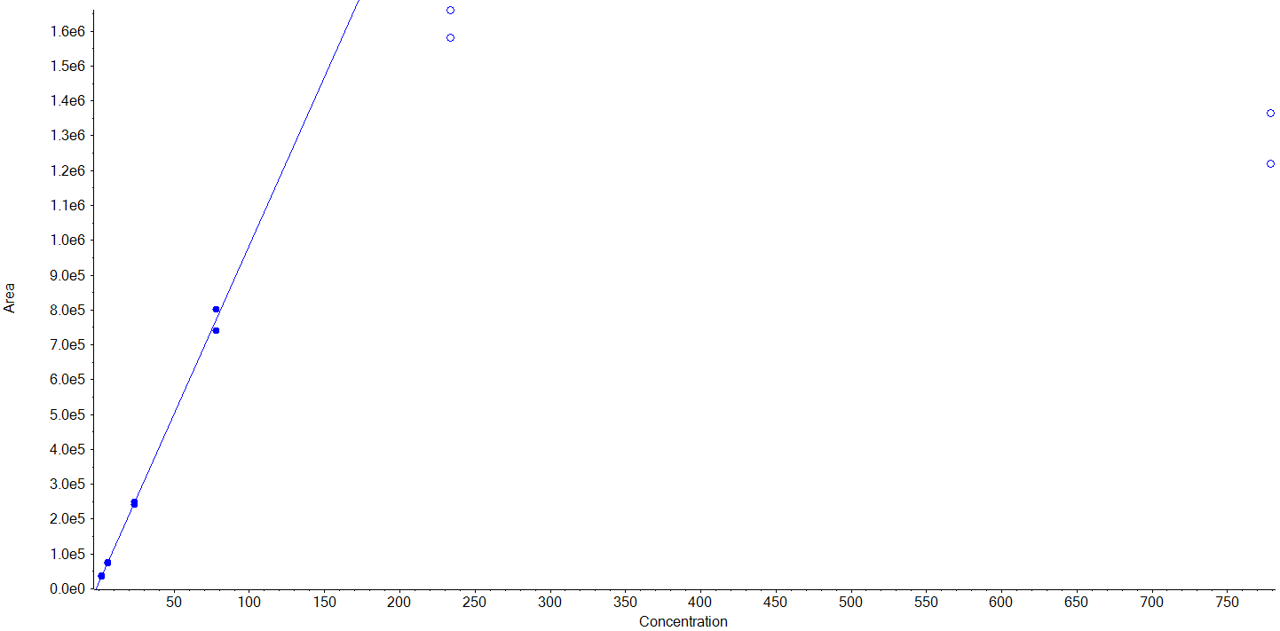
Quercetin  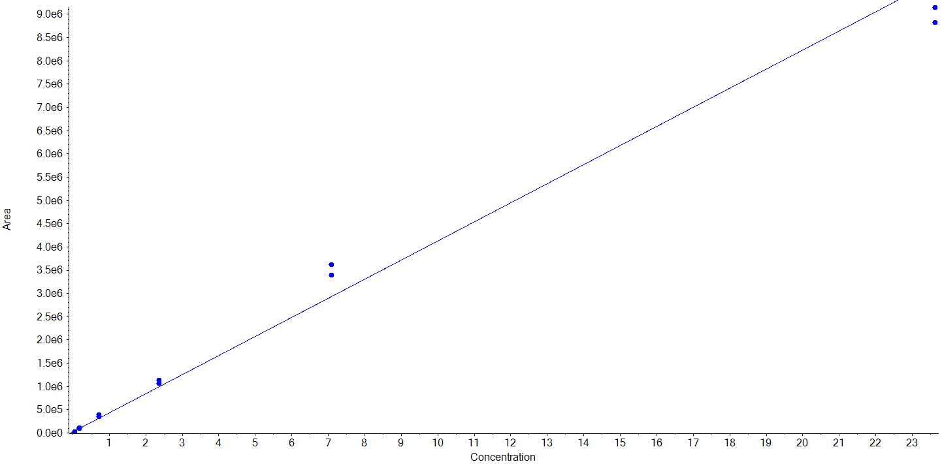 | Enterodiol  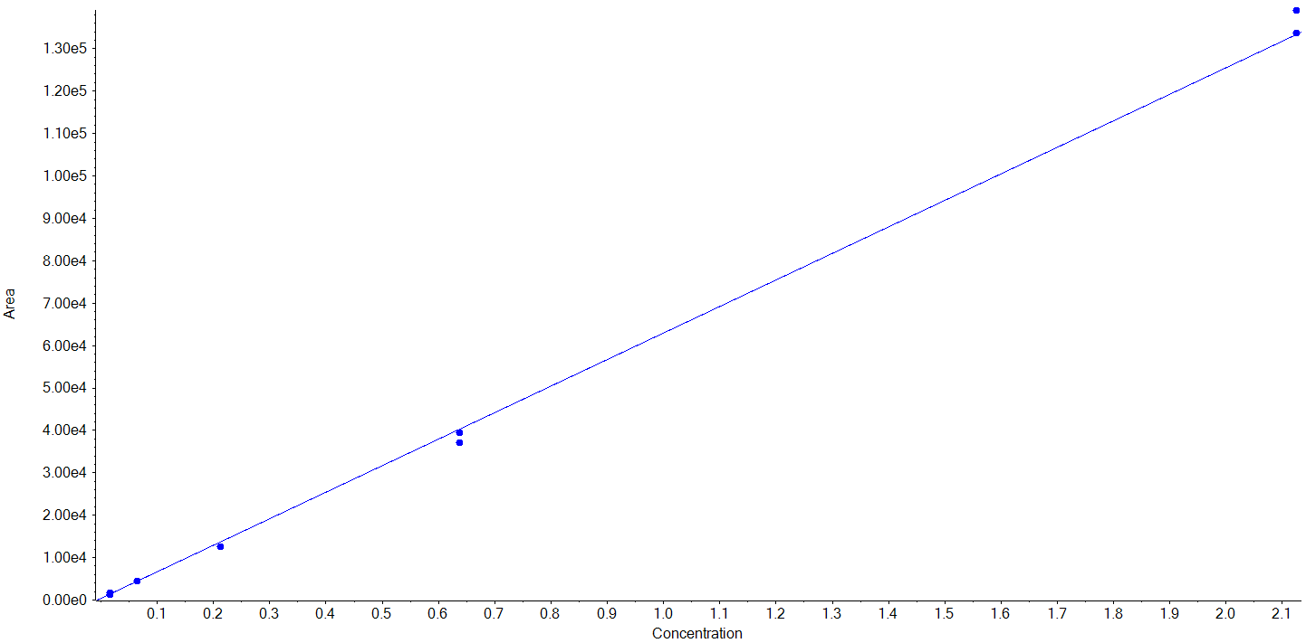 | Hesperetin  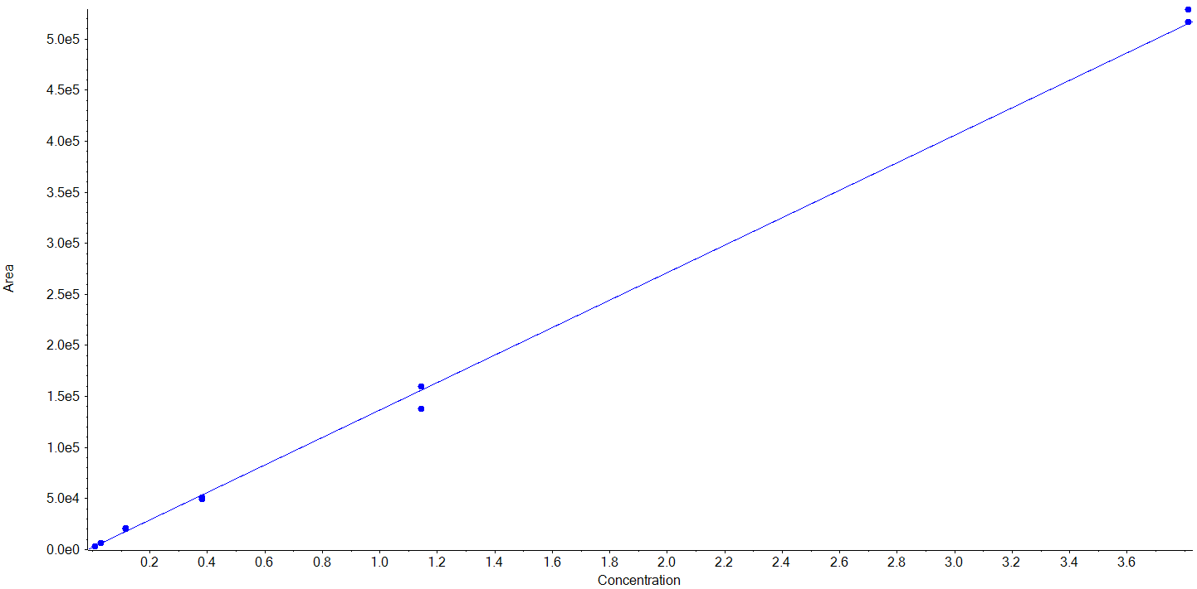
(-)-Epigallocatechin  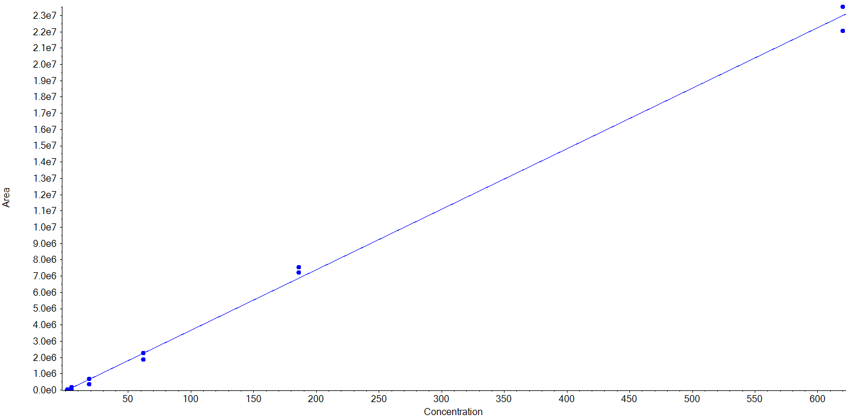 | (-)-Gallocatechin  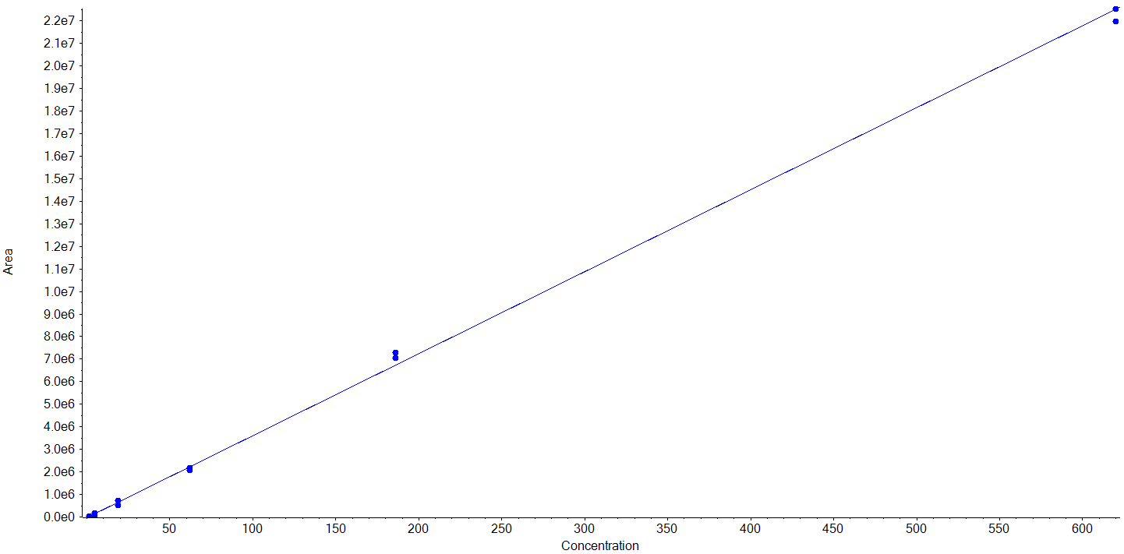 | Isorhamnetin  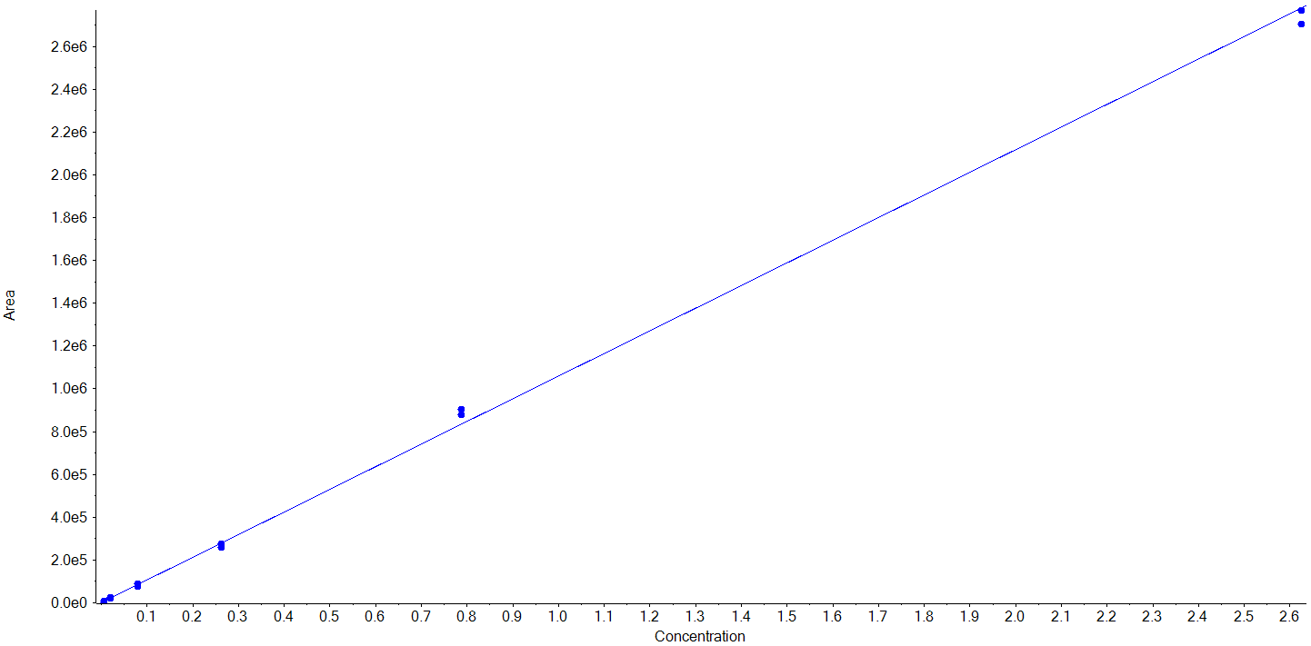
8-Prenylnaringenin  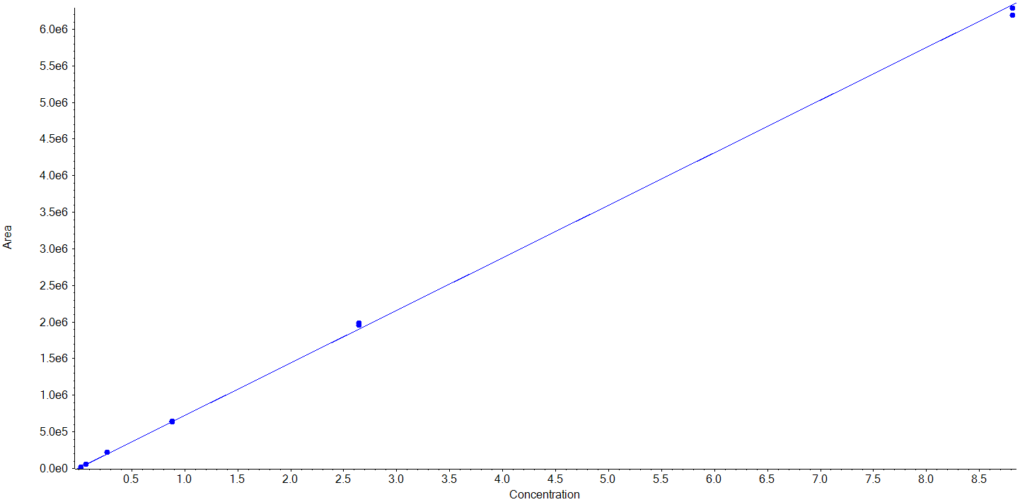 | Genistein-7-sulfate  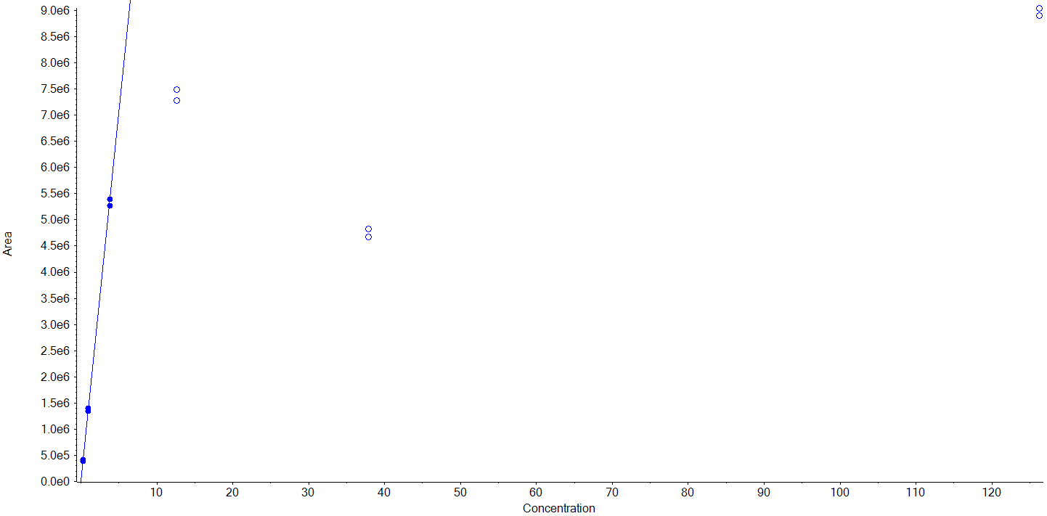 | Xanthohumol  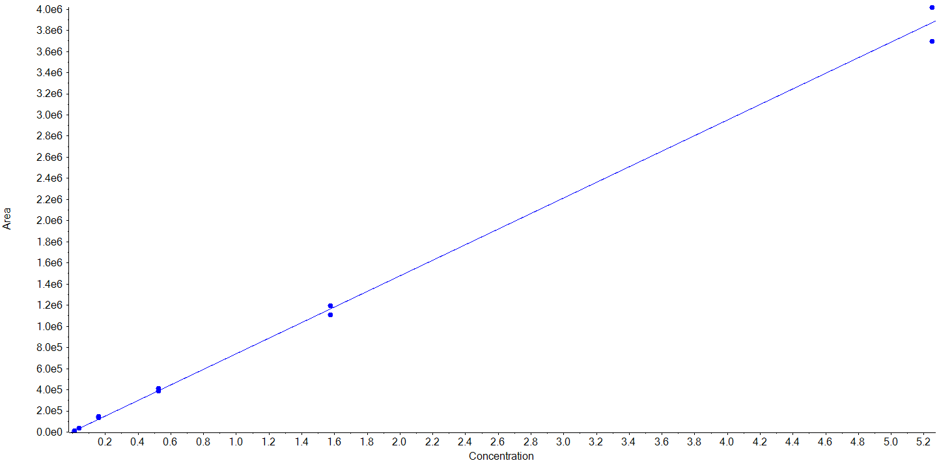
Isoxanthohumol  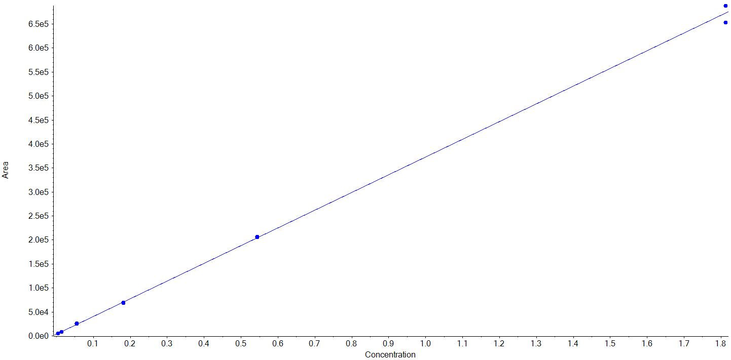 | Chlorogenic acid  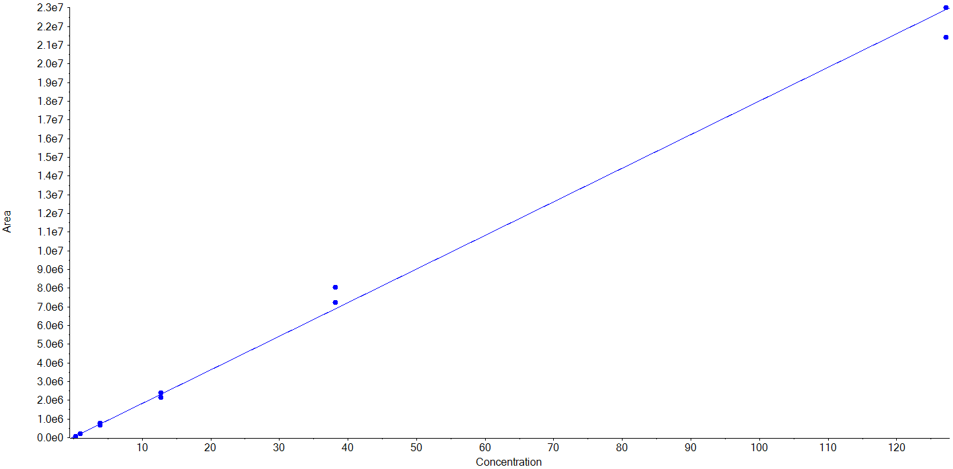 | Caffeic acid-3-β-D-glucuronide  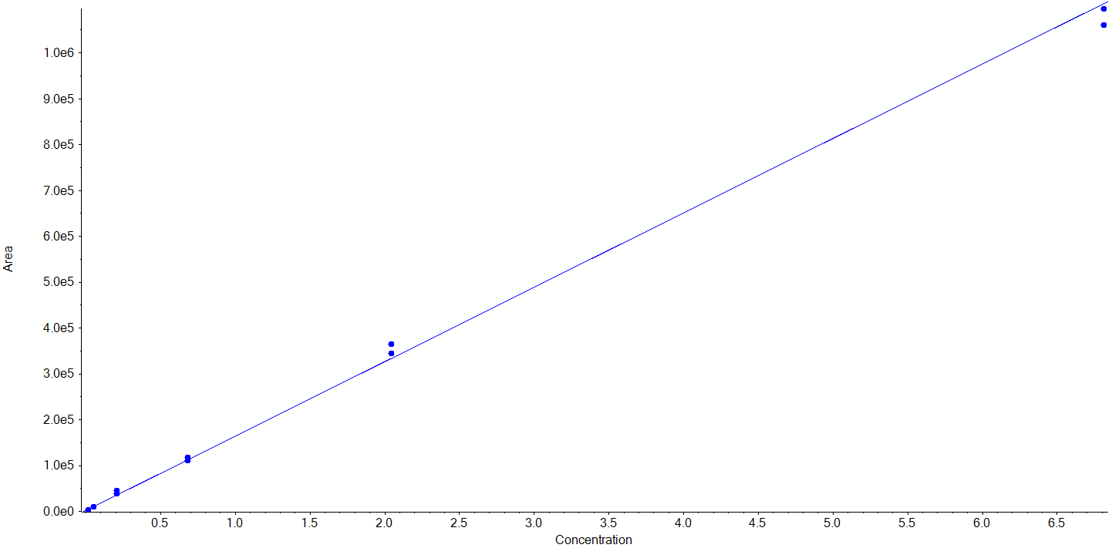
Polydatin  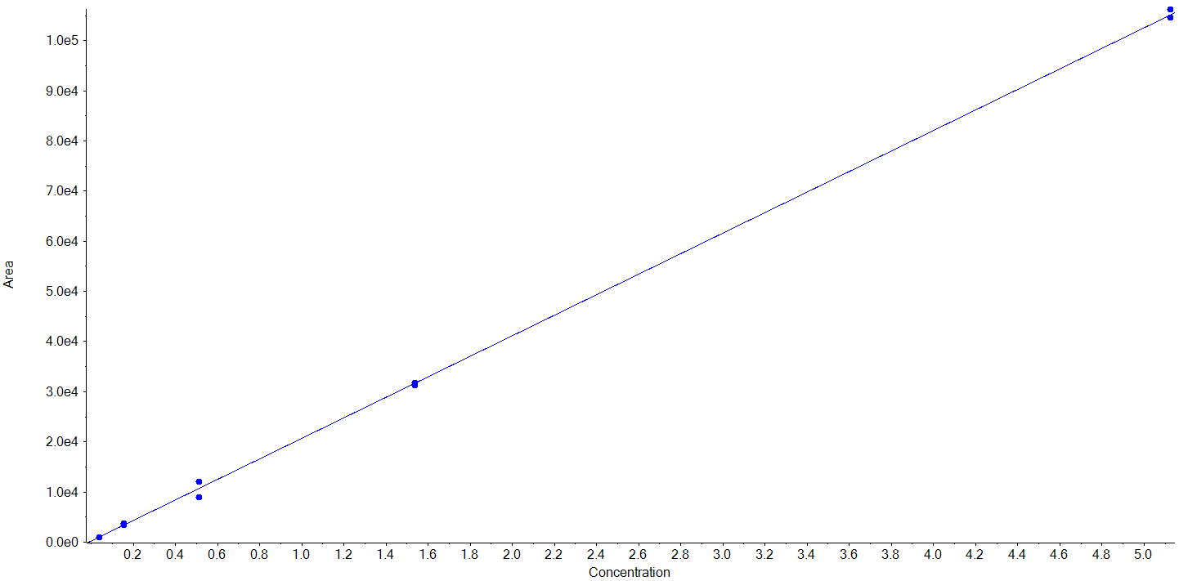 | Daidzein-7-β-D-glucuronide  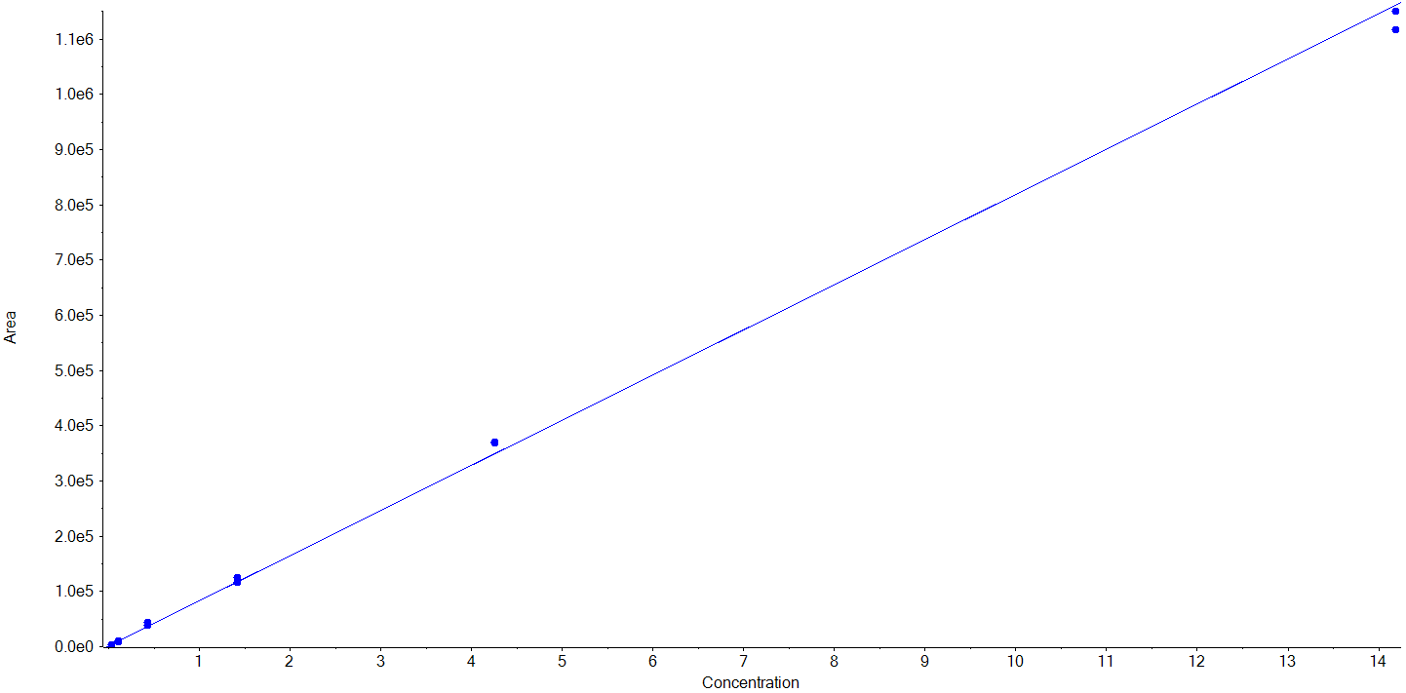 | (-)-Epicatechin gallate  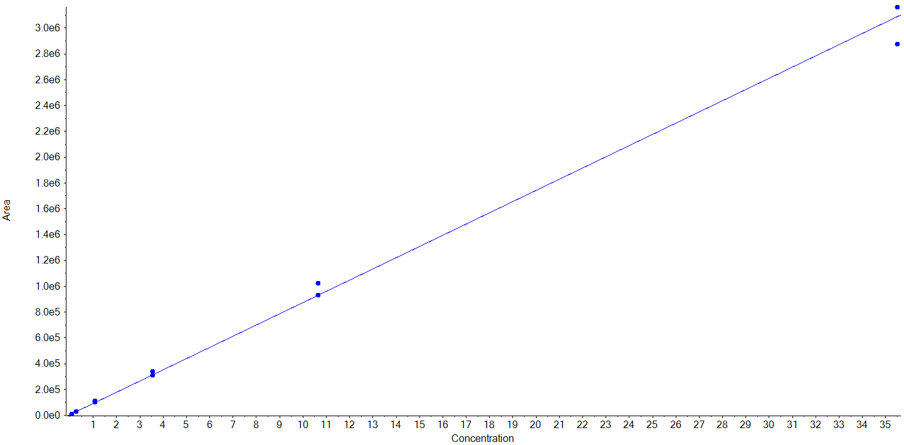
Genistein-7-β-D-glucuronide  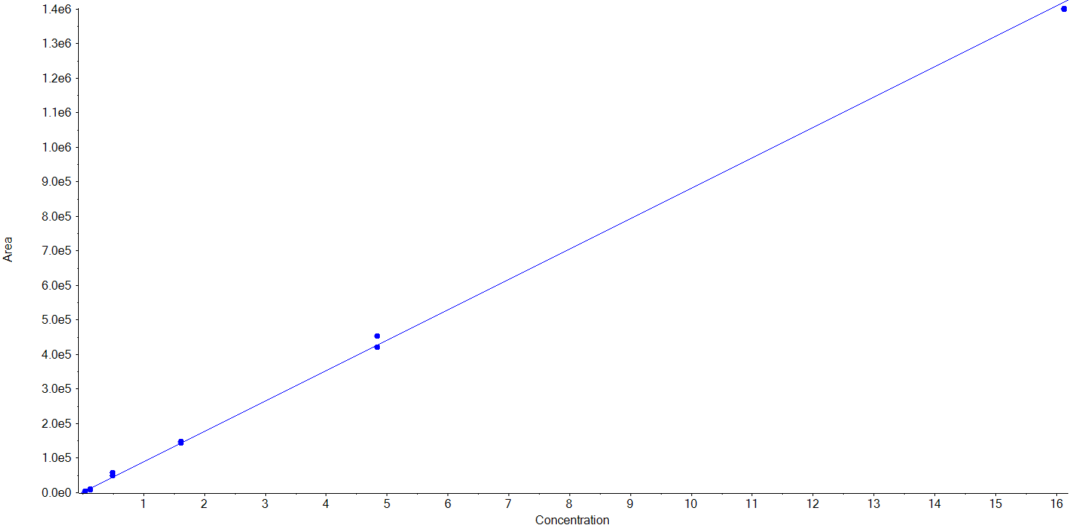 | (-)-Epigallocatechin gallate  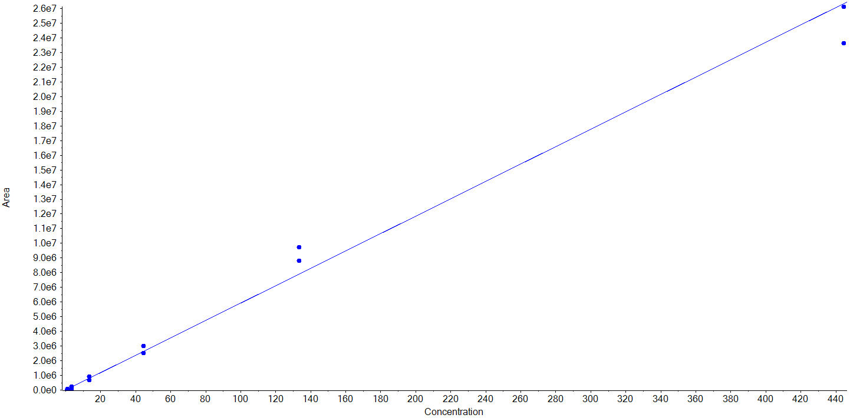 | Kaempferol-3-O-glucuronide  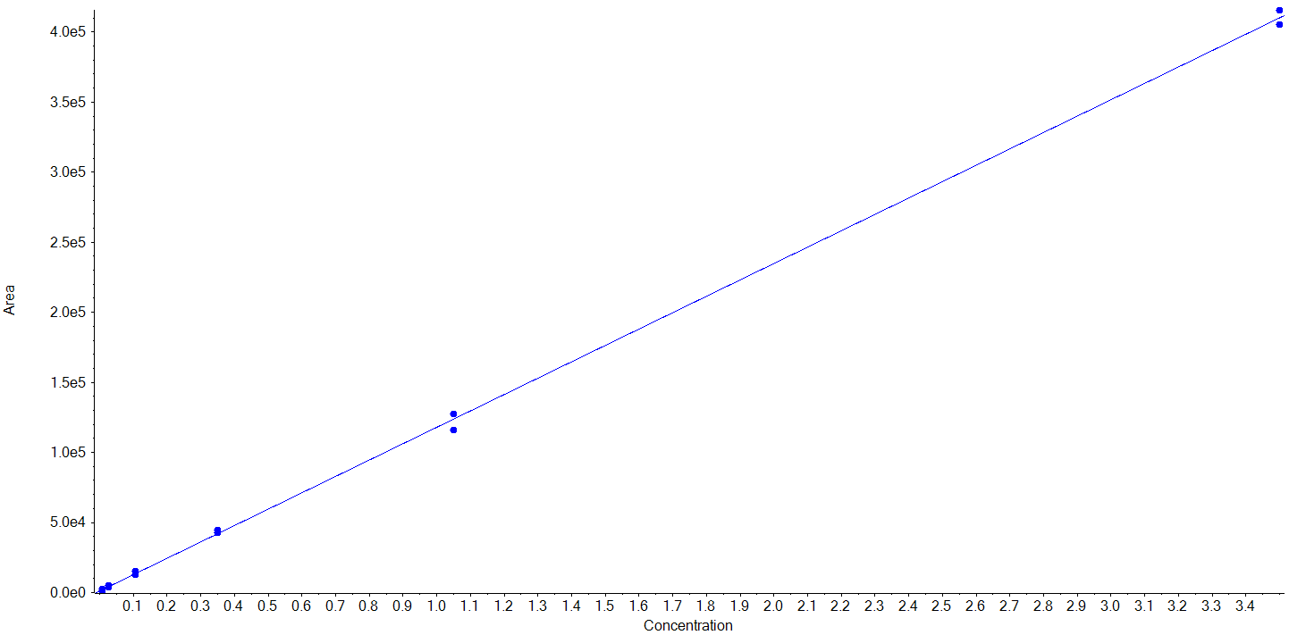
Quercetin-7-O-β-D-glucuronide  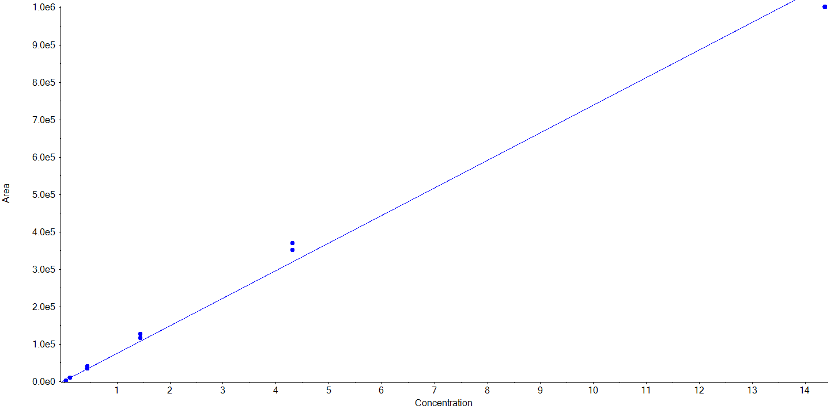 | Procyanidin A2  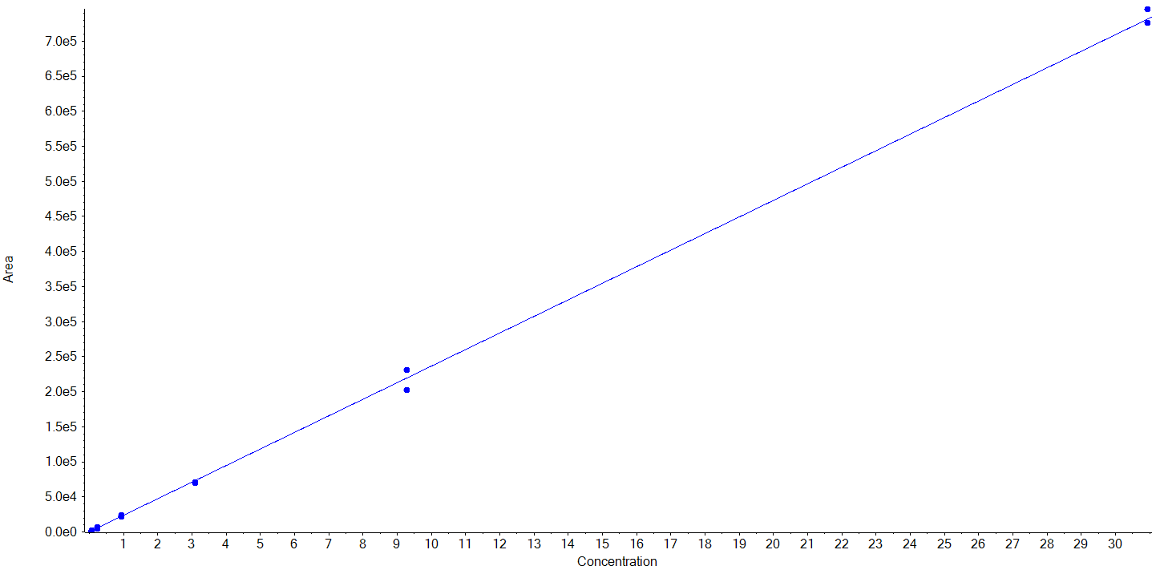 | Diosmin  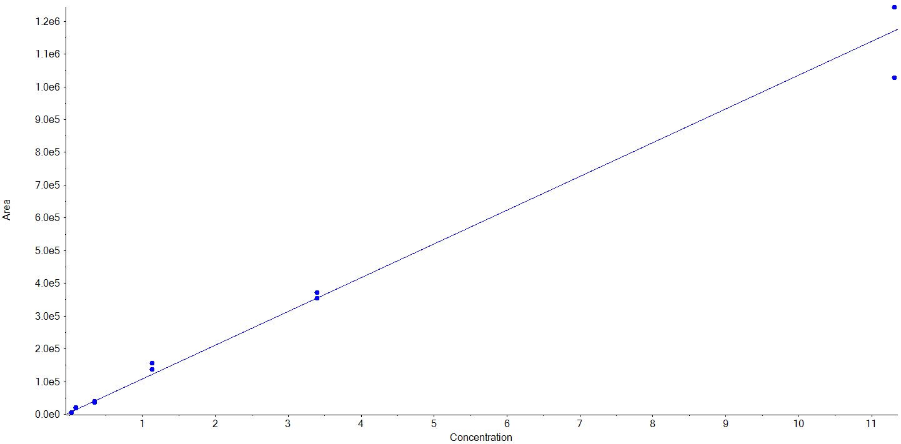
(+)-Rutin  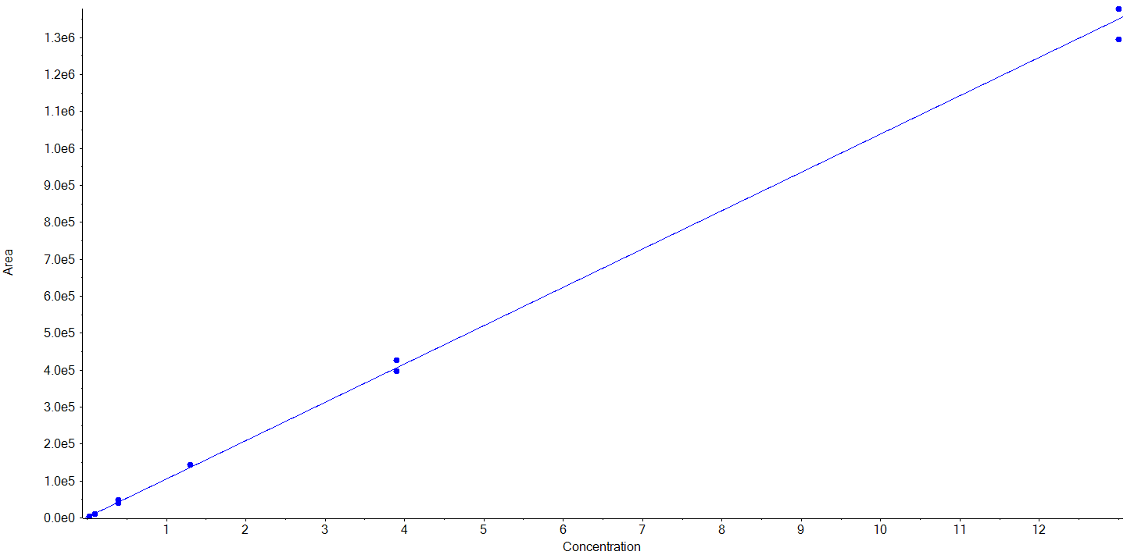 | Hesperidin  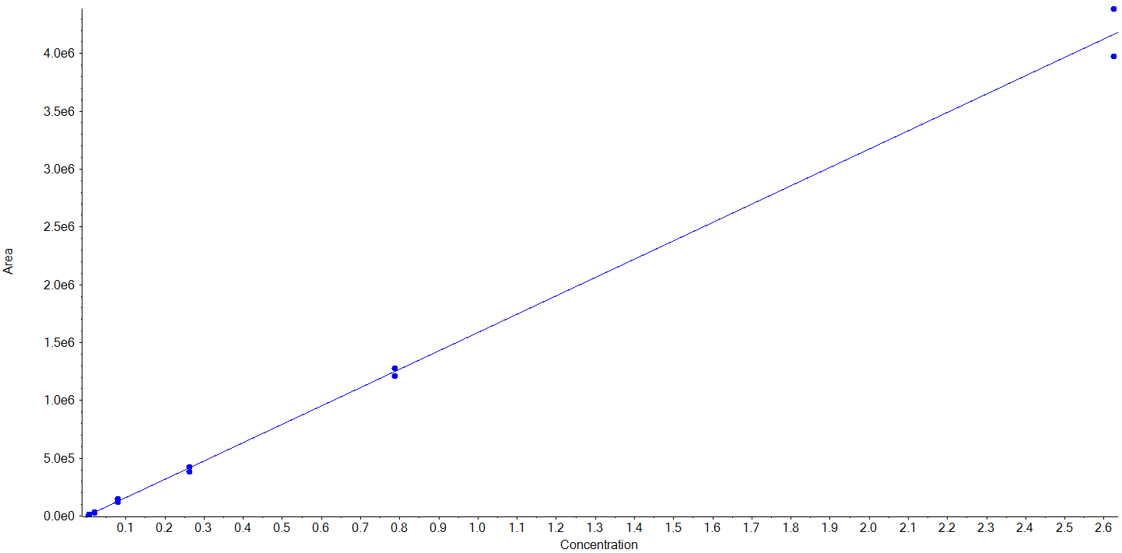 | Neohesperidin dihydrochalcone  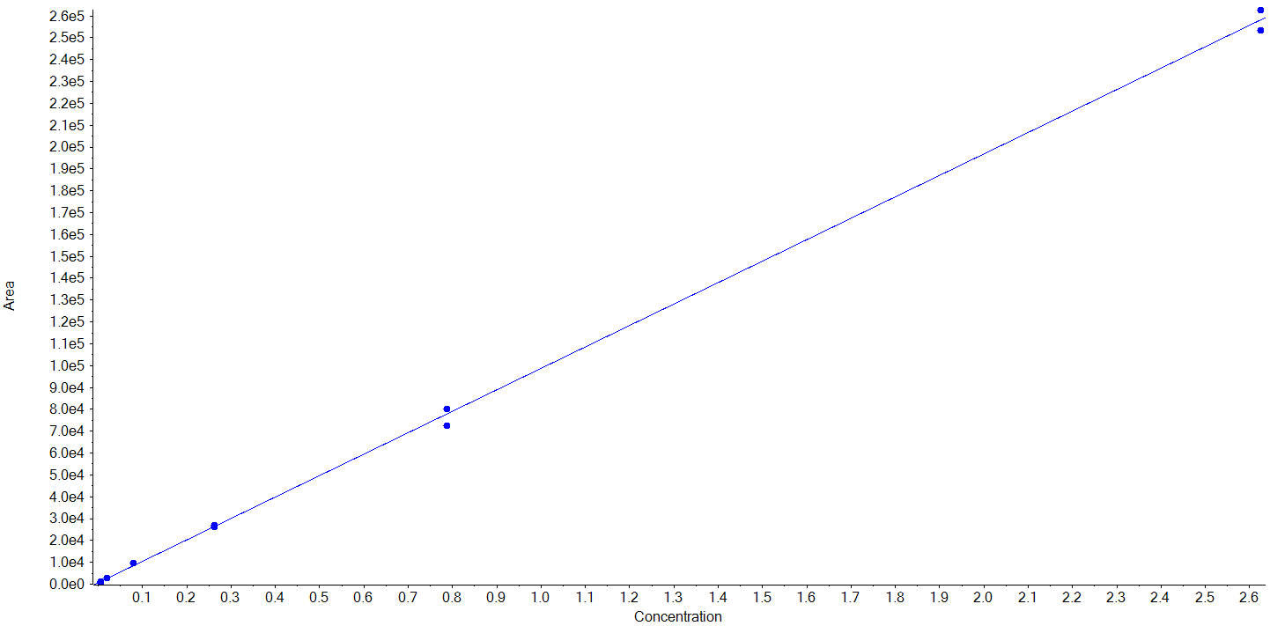
Biochanin A  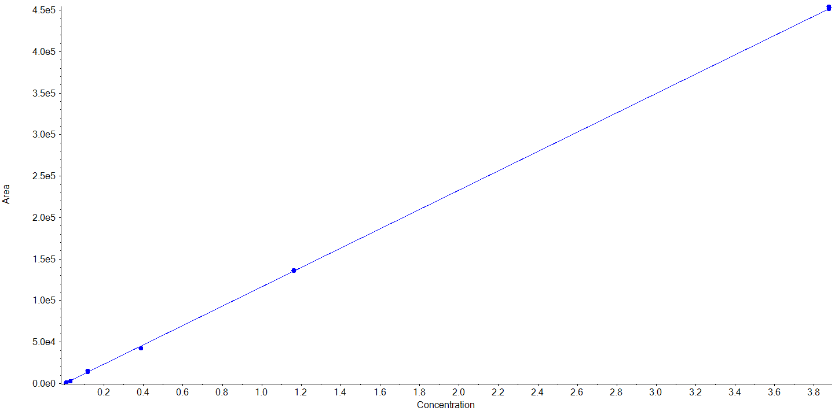 | 2,6-Dimethoxyphenol  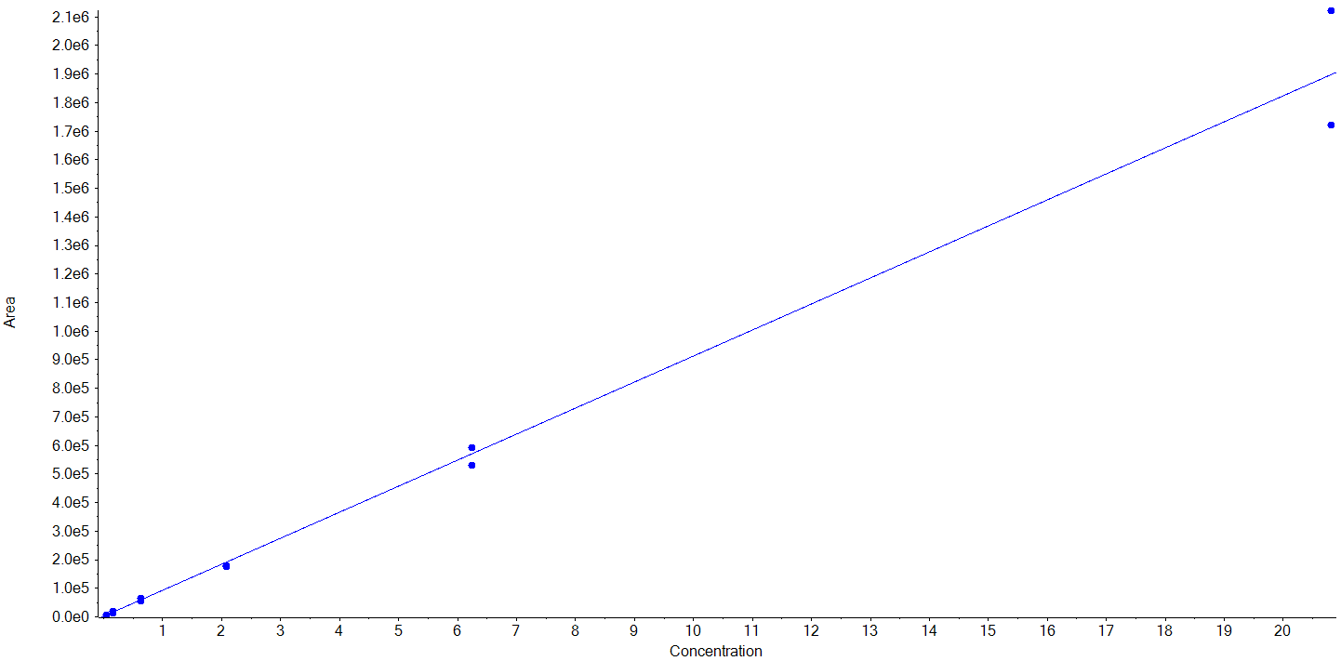 | Eugenol  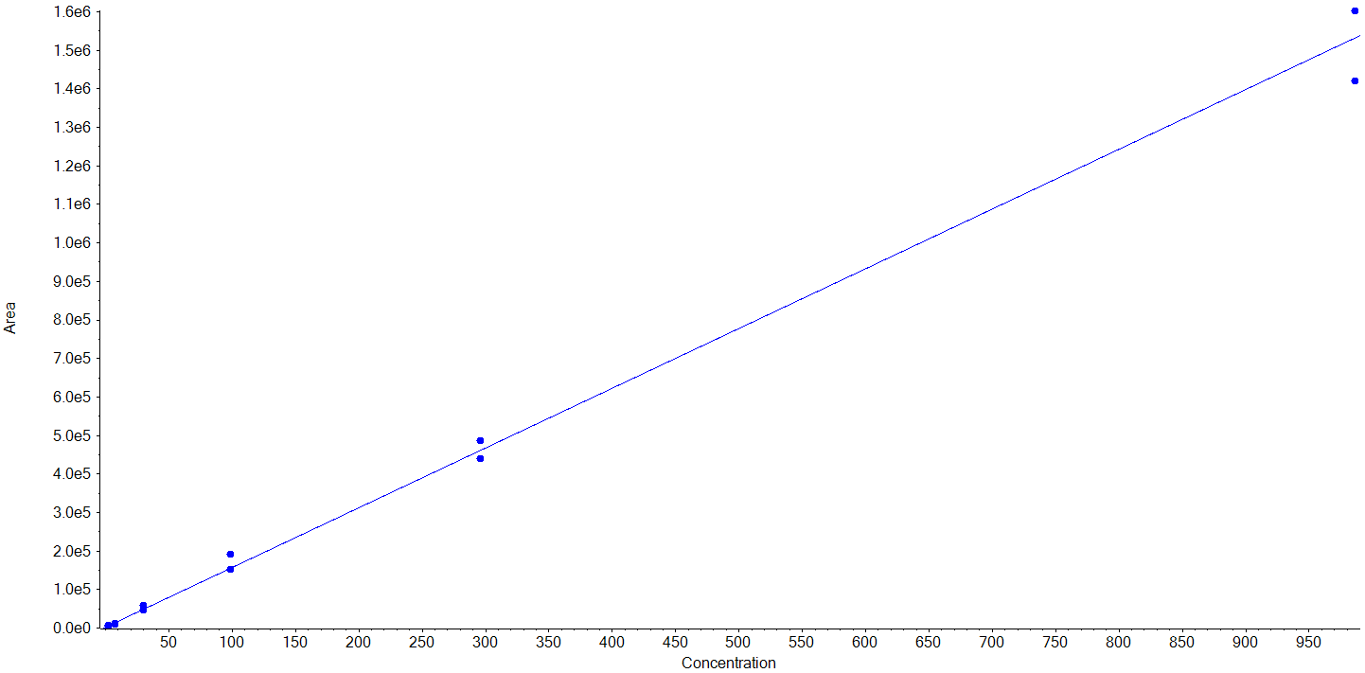
Dihydroresveratrol  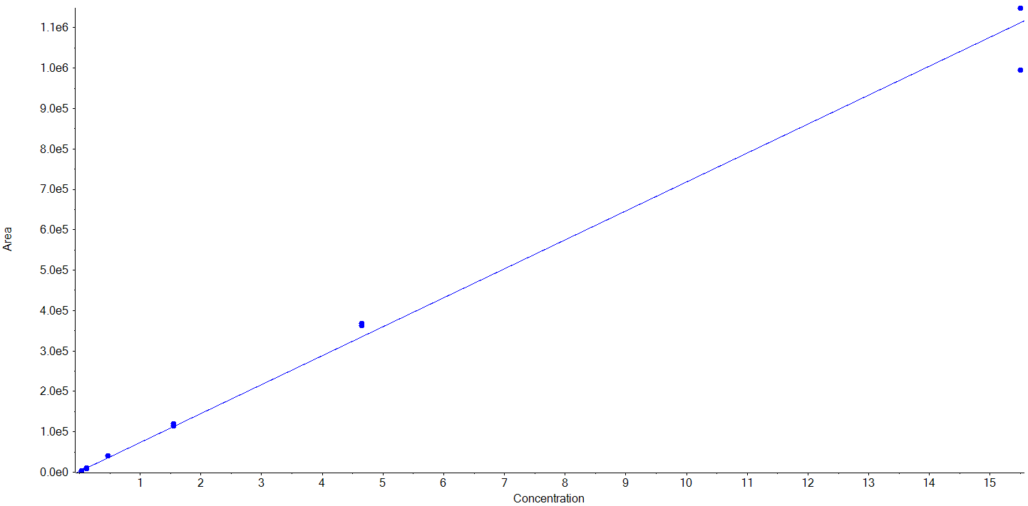 | Pterostilbene  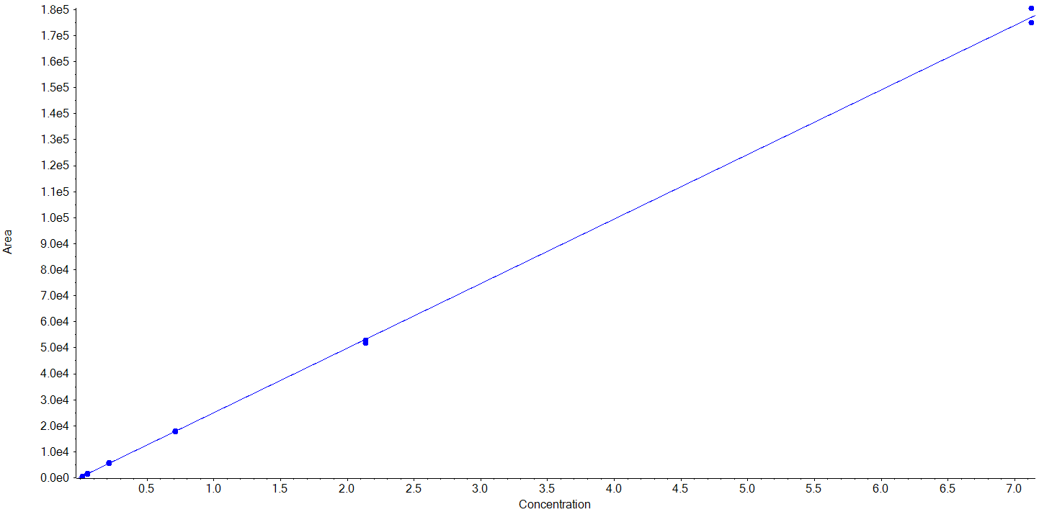 | Cyanidin  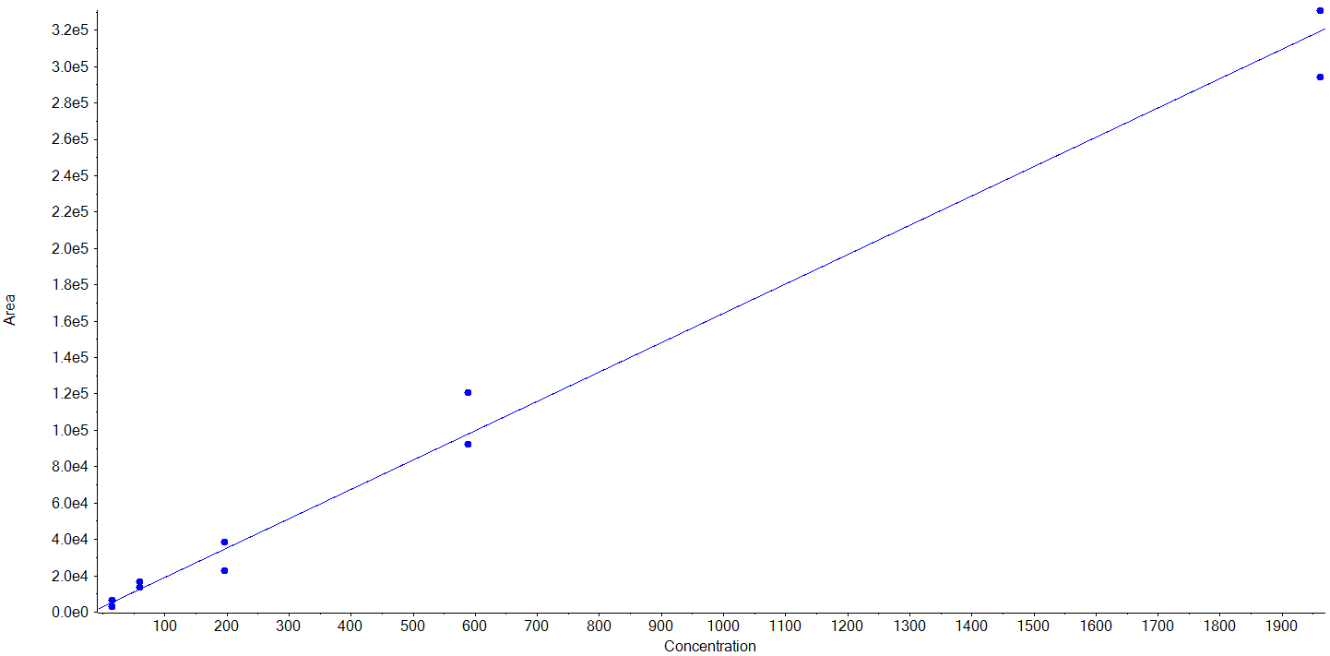
Cyanidin-3-O-glucoside  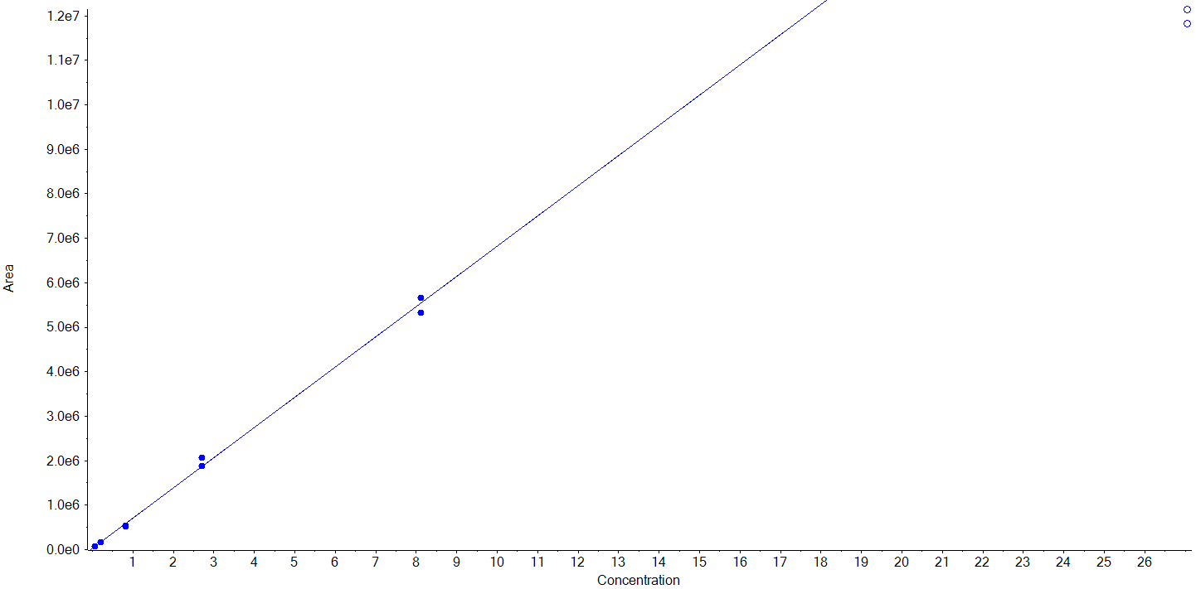 | Delphinidin-3-O-glucoside  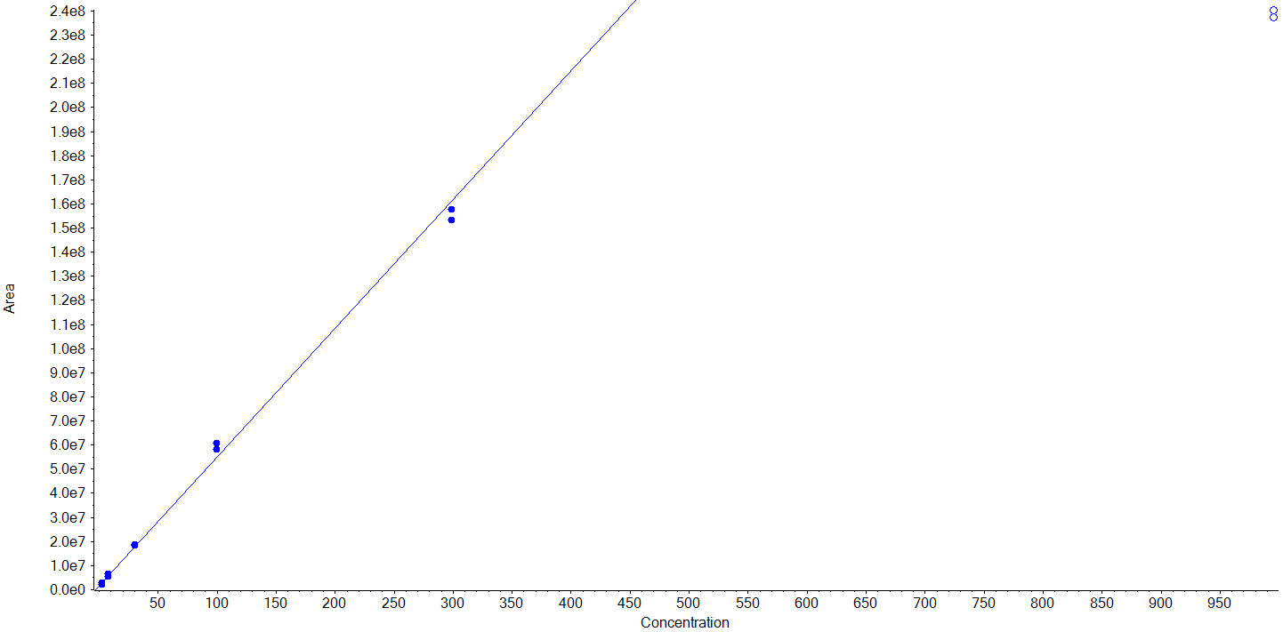 | Procyanidin B2  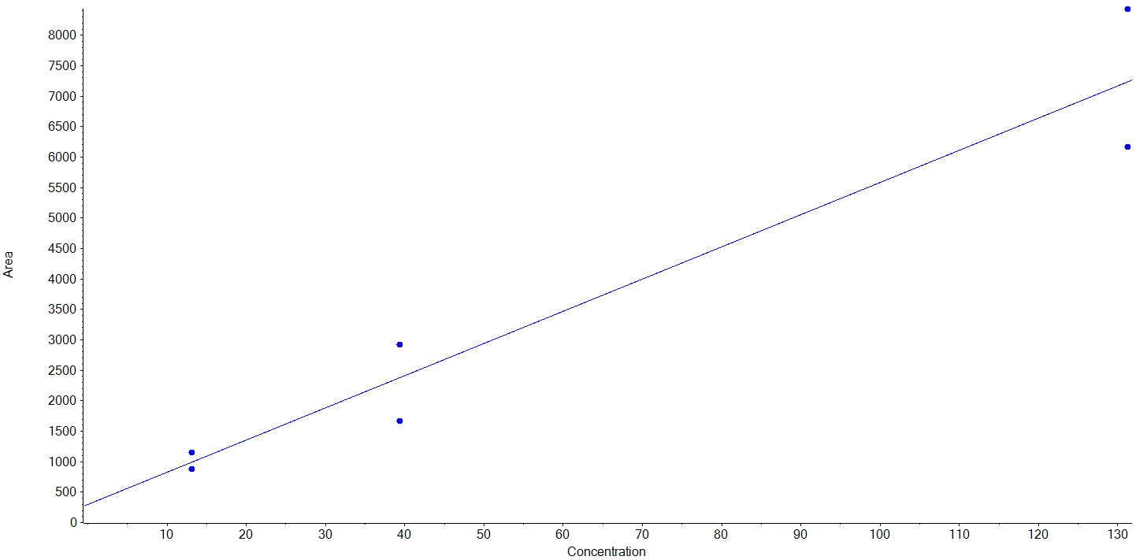
Procyanidin B1  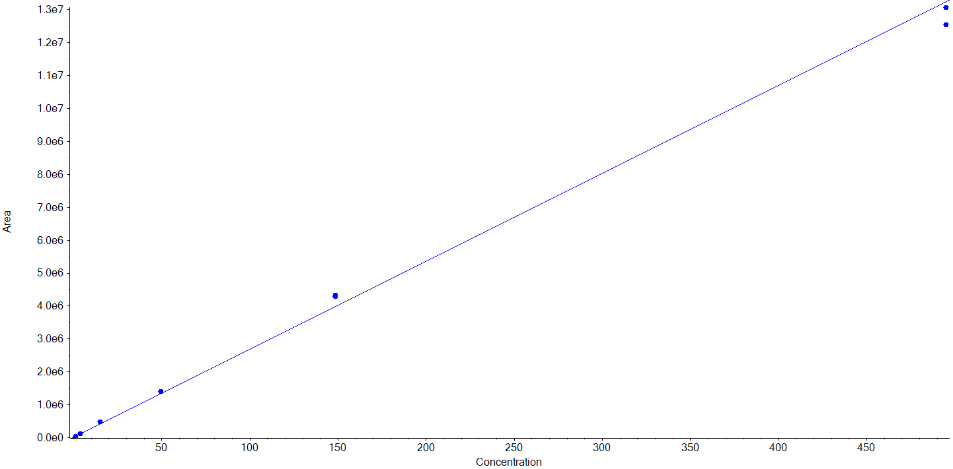 | Naringin  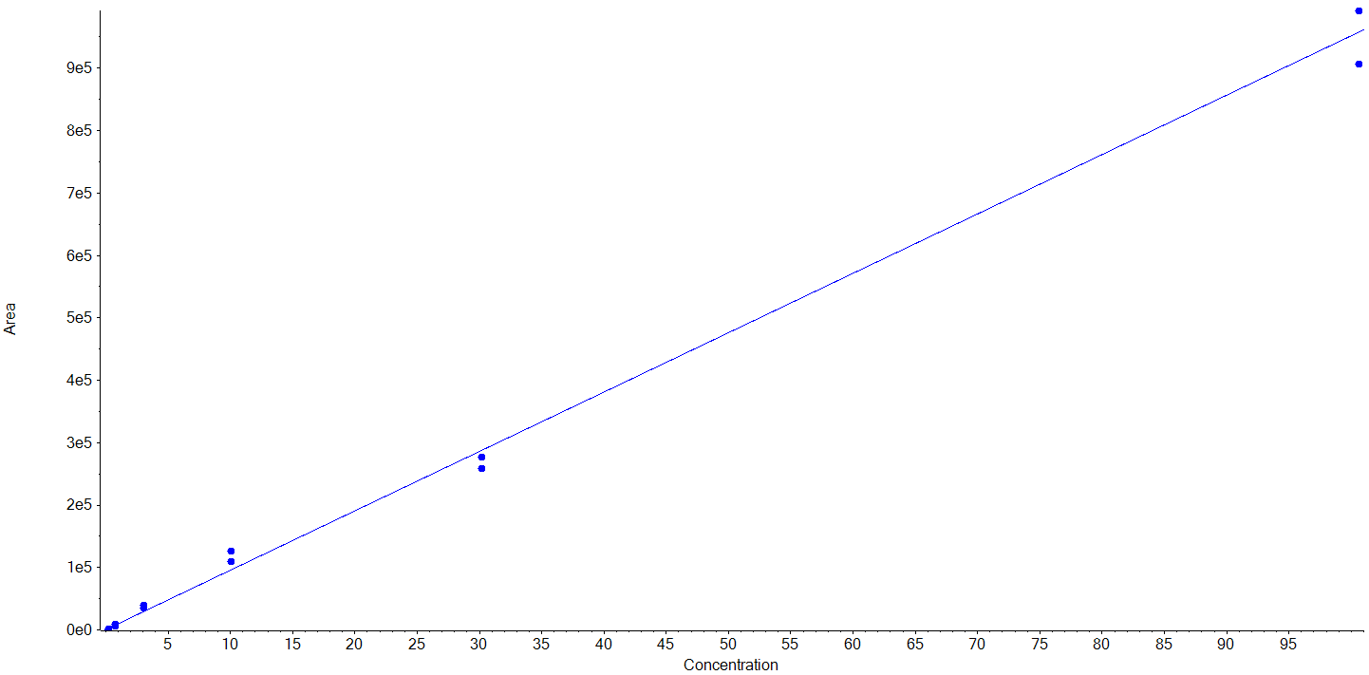 | Cyanidin-3-O-sambubioside  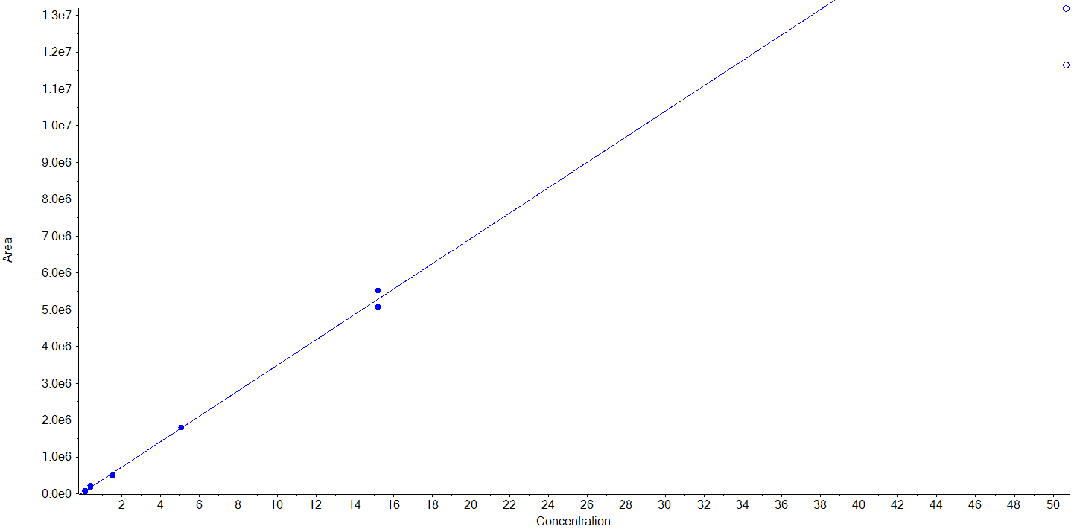
Cyanidin-3-O-rutinoside  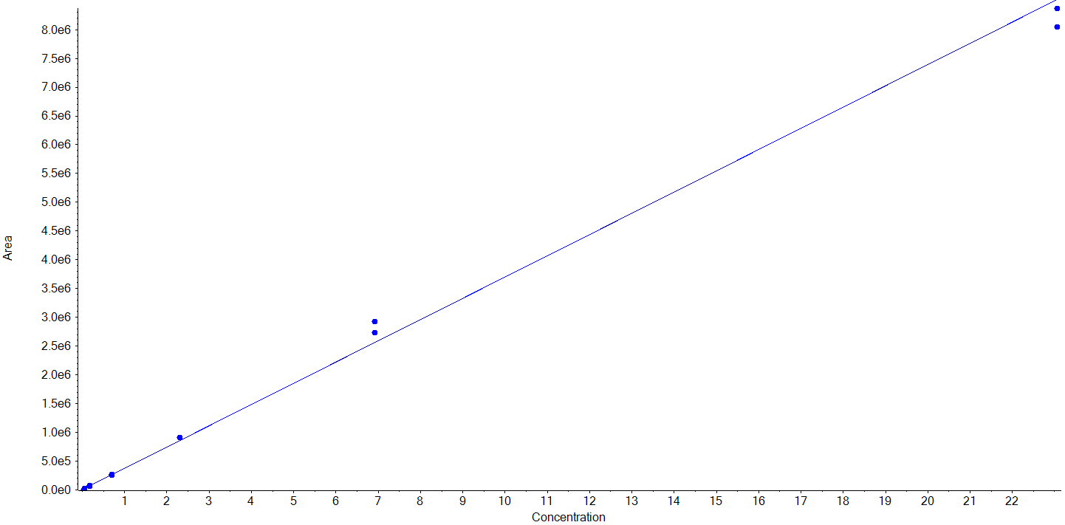 | Procyanidin C1  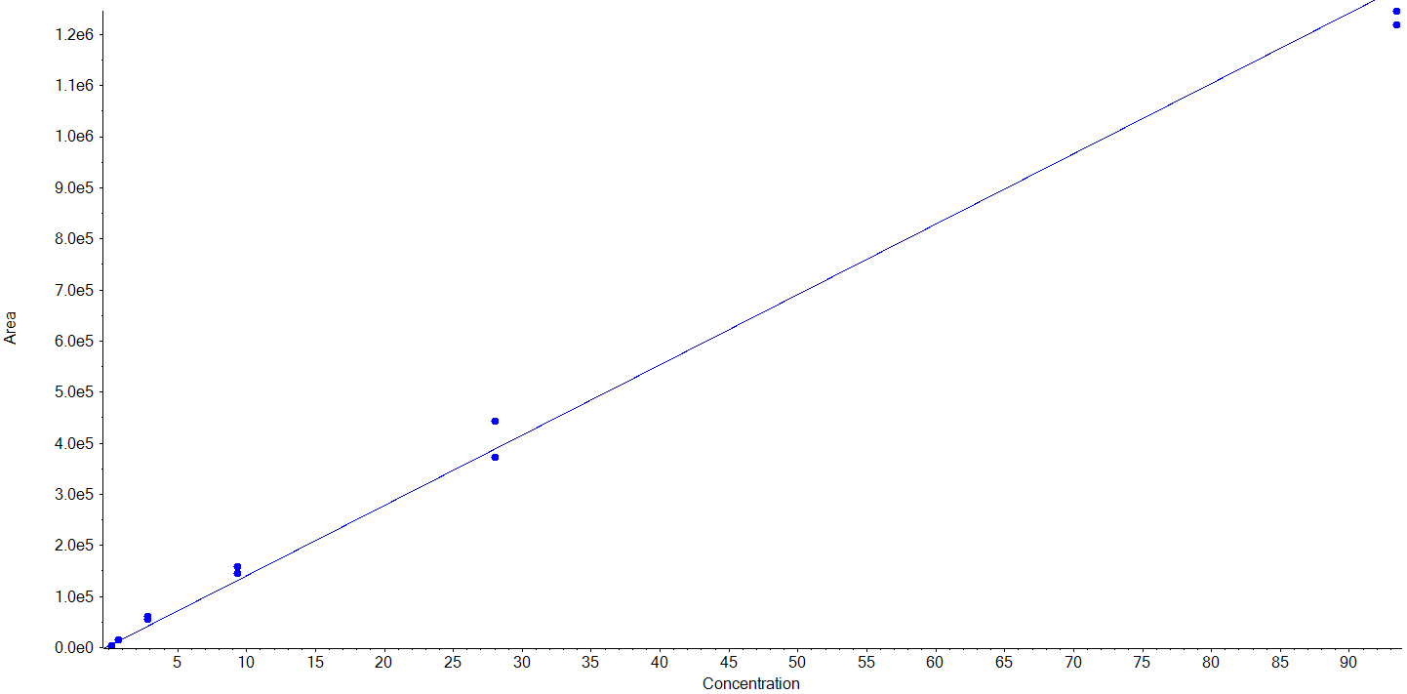 | Delphinidin  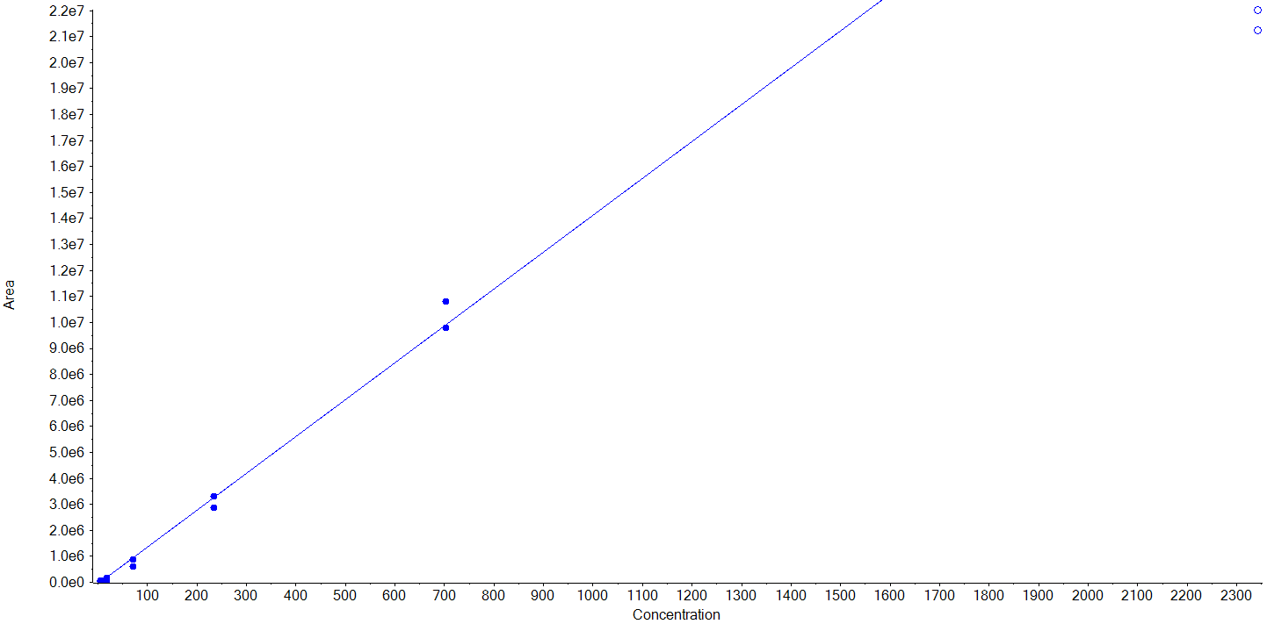

Neohesperidin

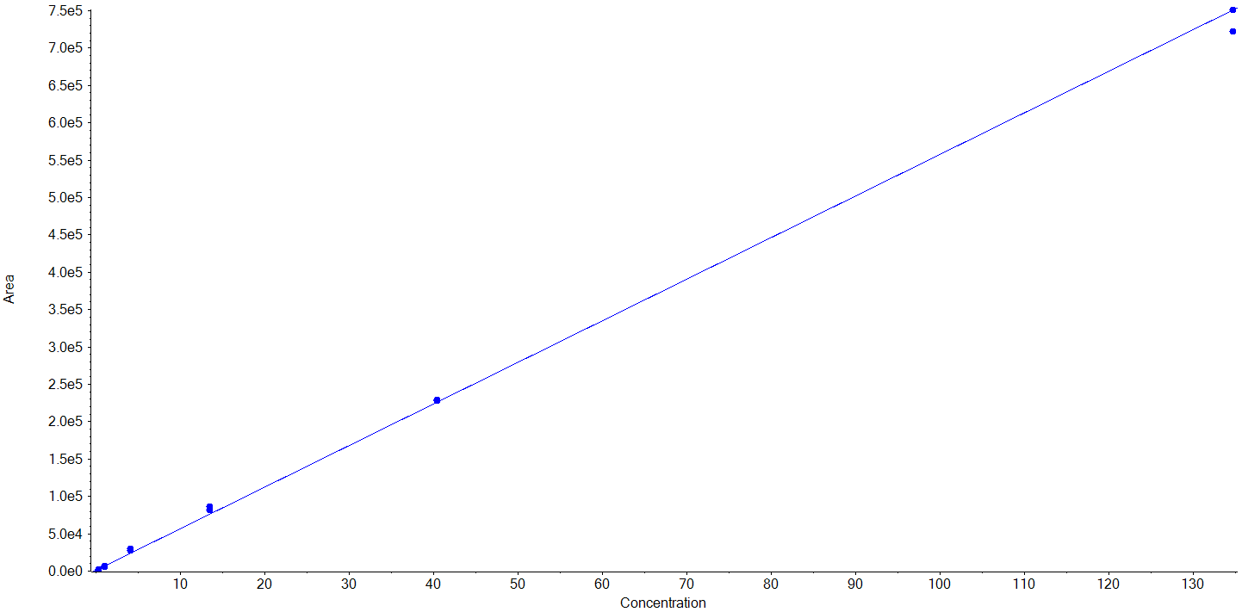

References
1. Oesterle I, Braun D, Rompel A, Warth B (2022) Quantifying up to 90 polyphenols simultaneously in human bio-fluids by LC-MS/MS. Anal Chim Acta 1216:339977. https://doi.org/10.1016/j.aca.2022.339977

No ion ratio could be determined since only one transition showed a chromatographic peak
Analyte with standard addition applied as a chromatographic peak was present in the matrix-matched blank.

