Supplementary Information

Table of Contents
Table S1 HILIC-UHPLC Parameters
Table S2 MAM LC-MS Parameters
Table S3 Intact LC-MS Parameters
Table S4 Glycan structures
Figure S1 Example HILIC-UHPLC Chromatograms
Table S5 HILIC-FLD Results
Figure S2 Example MAM Chromatograms
Table S6 Peptide Sequences Identified by MAM analysis
Table S7 MAM LC-MS Results
Figure S3 Intact deconvoluted spectra
Table S8 Intact Mass Results
Figure S4 Representative 1H-13C HSQC spectra
Table S9 HSQC Results
Appendix S1 Preparation of Samples for HILIC-FLD analysis

Table S1. HILIC-UHPLC Parameters
Parameter |  | Setting
Column |  | Waters Acquity BEH Amide cloumn, 2.1 × 150 mm, 1.7 µm, 130 Å
Injection volume |  | 10.0 µL
Column temperature |  | 60 ⁰C
Auto-sampler temperature |  | 10 ⁰C
Mobile Phase A |  | 100 mM Ammonium Formate, pH 4.5
Mobile Phase B |  | 100% Acetonitrile
Detector |  | FLD
Excitation λ |  | 330 nm
Emission λ |  | 420 nm
Total run time |  | 47.5 min

HPLC Gradient
Time (min) | % Mobile Phase A | % Mobile Phase B | Flow (mL / min)
0 | 25 | 75 | 0.50
31.5 | 35.2 | 64.8 | 0.50
32.0 | 100 | 0 | 0.25
35.0 | 100 | 0 | 0.25
36.0 | 25 | 75 | 0.25
40.0 | 25 | 75 | 0.25
41.0 | 25 | 75 | 0.50
47.5 | 25 | 75 | 0.50

Table S2. MAM LC-MS Parameters
Parameter
Column | Agilent Zorbax RRHD StableBond C18  300 Å, 2.1 mm x 150 mm, 1.8 µm
Flow Rate | 250 uL/min
Column Temperature | 50 °C
Injection Volume | 5 uL
Mobile Phase A | 0.1% formic acid in water
Mobile Phase B | 0.1% formic acid in acetonitrile
Gradient
Time | % Mobile Phase A | % Mobile Phase B | Divert Valve
0 | 99 | 1 | MS
5 | 99 | 1 | MS
6 | 90 | 10 | MS
70 | 65 | 35 | MS
72 | 10 | 90 | Waste
77 | 10 | 90 | Waste
77.1 | 99 | 1 | Waste
90 | 99 | 1 | Waste
LC System | Thermo Accela
MS System | Thermo Q-Exactive Quadrupole-Orbitrap
Spray Voltage | 3.5 kV
Capillary Temperature | 250 C
MS Mode | Positive
m/z Range | 300 – 1800

Table S3. Intact and reduced LC-MS Parameters
Parameter
Column | Waters Acquity UPLC Protein BEH C4, 300 Å, 1 mm x 150 mm, 1.7 µm
Flow Rate | 150 uL/min
Column Temperature | 65°C
Injection Volume | 5 uL
Mobile Phase A | 0.1% formic acid in water
Mobile Phase B | 0.1% formic acid in acetonitrile
Gradient
Time | % Mobile Phase A | % Mobile Phase B
0 | 95 | 5
1 | 95 | 5
2 | 80 | 20
15 | 40 | 60
16 | 5 | 95
18 | 5 | 95
19 | 95 | 5
20 | 95 | 5
LC System | Dionex UHPLC 3000
MS System | Thermo Orbitrap Fusion
Spray Voltage | 3.5 kV
Capillary Temperature | 250 C
MS Mode | Positive
m/z Range | 1000-4000
Resolution | 15,000

Table S4. Glycan structures with Oxford notation names
Name | Structure
De-glycosylated
A1 | 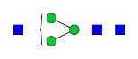
FA1 | 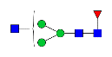
FA1G1 | 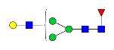
A2 | 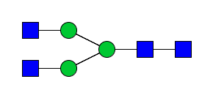
FA2 | 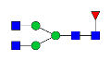
M5 | 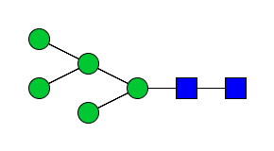
A2[6]G1 | 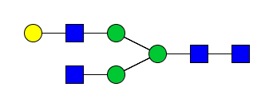
A2[3]G1 | 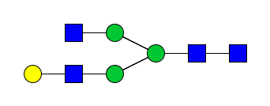
FA2G1 | 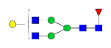
FA2[6]G1 | 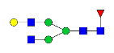
FA2[3]G1 | 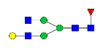
A2G2 | 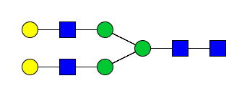
FA2G2 | 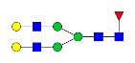
FA2G1S1 | 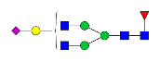
FA2G2S1 | 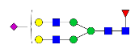
FA2G2S2 | 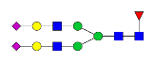

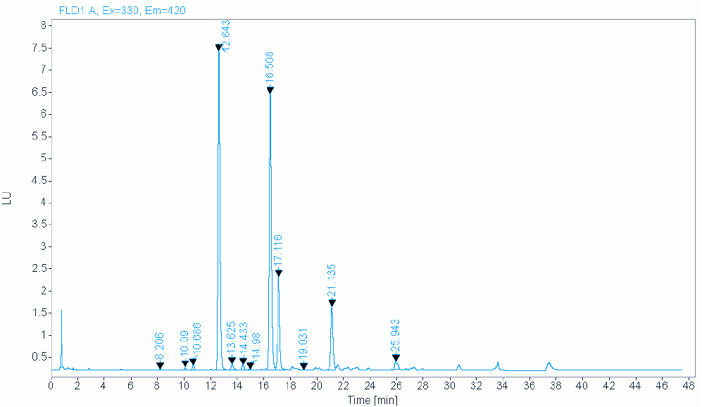
A1
FA2
FA2[6]G1
A2G2
FA2G2
FA2G2S1
M5
FA1
A2
A2[3]G1
FA2[3]G1
A2[6]G1
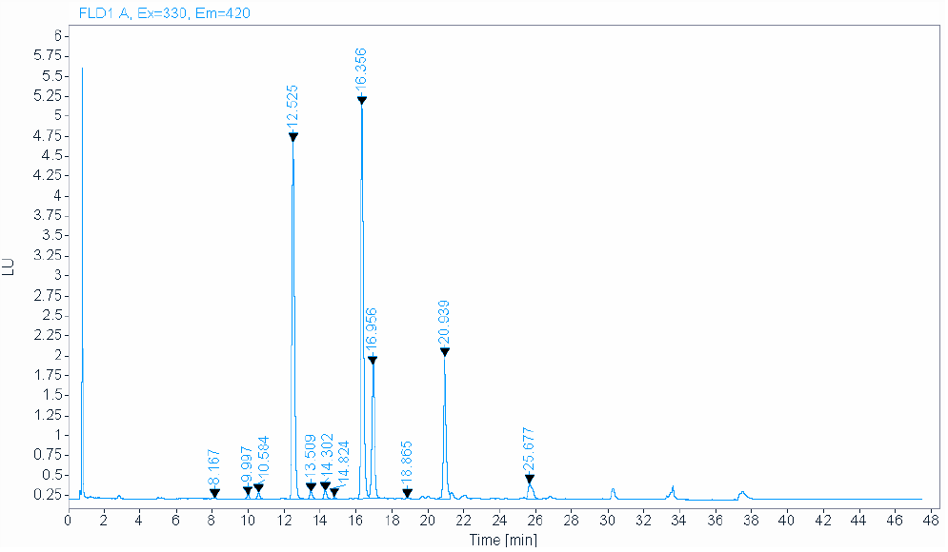
A1
A2
FA2
A2[3]G1
FA2[6]G1
A2G2
FA2G2
FA2G2S1
A2[6]G1
FA2[3]G1
M5
FA1
Figure S1. Example HILIC-UHPLC Chromatograms for Product A (Top) and Product B (Bottom)

Table S5. Glycan Quantitation with HILIC-FLD Results

 | M5 | FA1 | A2 | FA2 | A2[3]G1 | A2[6]G1 | FA2[3]G1 | FA2[6]G1 | FA2G2 | FA2G2S1
 | Average Fractional Abundance (%)
A1 | 0.56 | 0.244 | 0.32 | 28 | <LOQ | 0.723 | 13.3 | 38.2 | 16.4 | 2.1
A2 | 0.72 | 0.50 | 0.654 | 35.5 | <LOQ | 0.83 | 12.4 | 34.9 | 12.6 | 2.0
A3 | 0.60 | 0.27 | 0.45 | 30 | <LOQ | 0.70 | 13.10 | 37.3 | 15.2 | 2.4
A4 | 0.58 | 0.28 | 0.45 | 29.5 | <LOQ | 0.68 | 13.16 | 37.3 | 15.5 | 2.5
A5 | 0.74 | 0.47 | 0.57 | 36 | <LOQ | 0.77 | 12.4 | 35.96 | 11.9 | 1.7
A6 | 0.75 | 0.39 | 0.51 | 33.2 | <LOQ | 0.89 | 12.7 | 35.6 | 13.6 | 2.30
A7 | 0.72 | 0.33 | 0.90 | 39.3 | 0.22 | 0.876 | 12.55 | 34.06 | 9.8 | 1.2
B1 | 0.81 | 0.29 | 0.59 | 41 | <LOQ | 0.69 | 12.4 | 35.5 | 7.8 | 1.2
B2 | 1.52 | 0.98 | 1.61 | 46.9 | 0.23 | 1.66 | 10.7 | 29.8 | 6.0 | 0.63
 | Standard Deviation
A1 | 0.02 | 0.009 | 0.01 | 1 | N/A | 0.008 | 0.1 | 0.4 | 0.8 | 0.7
A2 | 0.05 | 0.01 | 0.009 | 0.5 | N/A | 0.01 | 0.1 | 0.3 | 0.4 | 0.6
A3 | 0.04 | 0.01 | 0.02 | 1 | N/A | 0.02 | 0.09 | 0.1 | 0.8 | 0.2
A4 | 0.03 | 0.02 | 0.03 | 0.2 | N/A | 0.03 | 0.07 | 0.3 | 0.2 | 0.2
A5 | 0.03 | 0.02 | 0.02 | 1 | N/A | 0.03 | 0.2 | 0.10 | 0.9 | 0.2
A6 | 0.03 | 0.02 | 0.01 | 0.4 | N/A | 0.02 | 0.3 | 0.2 | 0.4 | 0.09
A7 | 0.02 | 0.02 | 0.03 | 0.8 | 0.01 | 0.002 | 0.06 | 0.06 | 0.7 | 0.2
B1 | 0.07 | 0.03 | 0.06 | 2 | N/A | 0.01 | 0.5 | 0.9 | 0.9 | 0.1
B2 | 0.05 | 0.01 | 0.06 | 0.6 | 0.01 | 0.03 | 0.1 | 0.3 | 0.3 | 0.06

 | M5 | A1 | FA1 | A2 | FA2 | A2[3]G1 | A2[6]G1 | FA2[3]G1 | FA2[6]G1 | A2G2 | FA2G2 | FA2G2S1
 | Average Fractional Abundance (%)
A1 | 0.56 | 0.02 | 0.24 | 0.32 | 28 | 0.10 | 0.72 | 13.3 | 38.1 | 0.026 | 16.4 | 2.1
A2 | 0.71 | 0.07 | 0.50 | 0.65 | 35.4 | 0.147 | 0.82 | 12.3 | 34.8 | 0.03 | 12.5 | 2.0
A3 | 0.60 | 0.05 | 0.27 | 0.45 | 30 | 0.12 | 0.70 | 13.1 | 37.2 | 0.01 | 15.2 | 2.4
A4 | 0.58 | 0.02 | 0.27 | 0.45 | 29.5 | 0.11 | 0.68 | 13.1 | 37.2 | 0.02 | 15.5 | 2.5
A5 | 0.74 | 0.06 | 0.46 | 0.57 | 35 | 0.12 | 0.76 | 12.3 | 35.9 | 0.02 | 11.9 | 1.7
A6 | 0.75 | 0.03 | 0.39 | 0.51 | 33.1 | 0.14 | 0.891 | 12.7 | 35.5 | 0.04 | 13.6 | 2.3
A7 | 0.71 | 0.04 | 0.33 | 0.90 | 39.3 | 0.22 | 0.88 | 12.5 | 34.0 | 0.05 | 9.8 | 1.2
B1 | 0.81 | 0.028 | 0.29 | 0.59 | 41 | 0.13 | 0.68 | 12.4 | 35.4 | 0.016 | 7.8 | 1.2
B2 | 1.52 | 0.10 | 0.98 | 1.60 | 46.8 | 0.23 | 1.66 | 10.7 | 29.7 | 0.01 | 6.0 | 0.63
 | Standard Deviation
A1 | 0.02 | 0.01 | 0.01 | 0.01 | 1 | 0.01 | 0.01 | 0.1 | 0.4 | 0.005 | 0.8 | 0.7
A2 | 0.05 | 0.02 | 0.01 | 0.01 | 0.5 | 0.005 | 0.02 | 0.1 | 0.4 | 0.02 | 0.3 | 0.6
A3 | 0.04 | 0.03 | 0.01 | 0.02 | 1 | 0.01 | 0.02 | 0.1 | 0.1 | 0.01 | 0.8 | 0.2
A4 | 0.03 | 0.01 | 0.02 | 0.03 | 0.2 | 0.01 | 0.03 | 0.1 | 0.3 | 0.01 | 0.2 | 0.2
A5 | 0.03 | 0.01 | 0.02 | 0.02 | 1 | 0.01 | 0.03 | 0.2 | 0.1 | 0.01 | 0.9 | 0.2
A6 | 0.03 | 0.02 | 0.02 | 0.01 | 0.4 | 0.01 | 0.02 | 0.3 | 0.2 | 0.01 | 0.4 | 0.1
A7 | 0.02 | 0.01 | 0.02 | 0.03 | 0.8 | 0.01 | 0.002 | 0.1 | 0.1 | 0.02 | 0.7 | 0.2
B1 | 0.07 | 0.004 | 0.03 | 0.06 | 2 | 0.01 | 0.01 | 0.5 | 0.9 | 0.002 | 0.9 | 0.1
B2 | 0.05 | 0.02 | 0.01 | 0.06 | 0.6 | 0.01 | 0.03 | 0.1 | 0.3 | 0.01 | 0.3 | 0.06

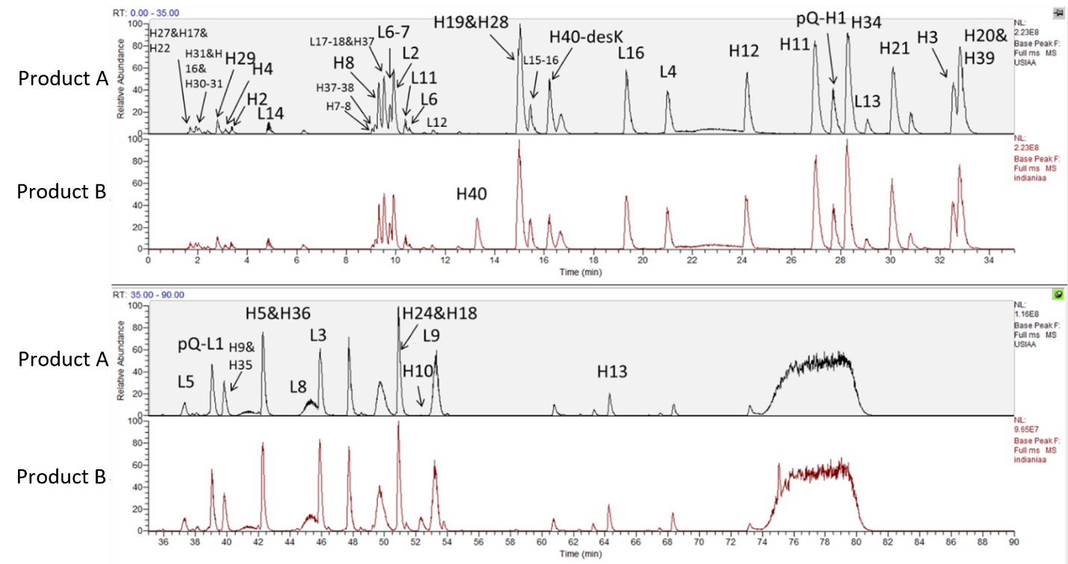
Figure S2. MAM TIC of US Product A and Product B with identified tryptic peptides.

Table S6: Peptide Sequences Identified by MAM analysis
Label | Peptide sequence | Start | End | Modification State | Theoretical monoisotopic mass (uncharged)
pQ-H1 | QVQLQQPGAELVKPGASVK | 1 | 19 | Gln1(Pyro-Glu) | 1959.0790
H2 | MSCK | 20 | 23 | C22(Carboxymethyl) | 525.1927
H3 | ASGYTFTSYNMHWVK | 24 | 38 |  | 1790.8086
H4 | QTPGR | 39 | 43 |  | 557.2921
H5 | GLEWIGAIYPGNGDTSYNQK | 44 | 63 |  | 2182.0331
H7-8 | GKATLTADK | 66 | 74 |  | 718.3861
H8 | ATLTADK | 68 | 74 |  | 718.3861
H9 | SSSTAYMQLSSLTSEDSAVYYCAR | 75 | 98 | C96(Carboxymethyl) | 2677.1524
H10 | STYYGGDWYFNVWGAGTTVTVSAASTK | 99 | 125 |  | 2888.3293
H11 | GPSVFPLAPSSK | 126 | 137 |  | 1185.6394
H12 | STSGGTAALGCLVK | 138 | 151 | C148(Carboxymethyl) | 1321.6548
H13 | DYFPEPVTVSWNSGALTSGVHTFPAVLQSSGLYSLSSVVTVPSSSLGTQTYICNVNHKPSNTK | 152 | 214 | C204(Carboxymethyl) | 6713.2912
H16 | AEPK | 219 | 222 |  | 443.2380
H17 | SCDK | 223 | 226 | C224(Carboxymethyl) | 509.1792
H18 | THTCPPCPAPELLGGPSVFLFPPKPK | 227 | 252 | C230(Carboxymethyl), C233(Carboxymethyl) | 2845.4183
H19 | DTLMISR | 253 | 259 |  | 834.4269
H20 | TPEVTCVVVDVSHEDPEVK | 260 | 278 | C265(Carboxymethyl) | 2139.0042
H21 | FNWYVDGVEVHNAK | 279 | 292 |  | 1676.7947
H22 | TKPR | 293 | 296 |  | 500.3071
H24 | VVSVLTVLHQDWLNGK | 306 | 321 |  | 1806.9992
H27 | VSNK | 327 | 330 |  | 446.2489
H28 | ALPAPIEK | 331 | 338 |  | 837.4960
H29 | TISK | 339 | 342 |  | 447.2693
H31 | GQPR | 345 | 348 |  | 456.2445
H30-31 | AKGQPR | 343 | 348 |  | 655.3765
H34 | NQVSLTCLVK | 365 | 374 | C371(Carboxymethyl) | 1161.6064
H35 | GFYPSDIAVEWESNGQPENNYK | 375 | 396 |  | 2543.1241
H36 | TTPPVLDSDGSFFLYSK | 397 | 413 |  | 1872.9145
H37 | LTVDK | 414 | 418 |  | 574.3326
H37-38 | LTVDKSR | 414 | 420 |  | 817.4657
H39 | WQQGNVFSCSVMHEALHNHYTQK | 421 | 443 | C429(Carboxymethyl) | 2801.2438
H40 | SLSLSPGK | 444 | 451 |  | 787.4439
H40-desK | SLSLSPG | 444 | 450 |  | 659.3490
pQ-L1 | QIVLSQSPAILSASPGEK | 1 | 18 | Gln1(Pyro-Glu) | 1806.9728
L2 | VTMTCR | 19 | 24 | C23(Carboxymethyl) | 767.3306
L3 | ASSSVSYIHWFQQKPGSSPKPWIYATSNLASGVPVR | 25 | 60 |  | 3932.0009
L4 | FSGSGSGTSYSLTISR | 61 | 76 |  | 1605.7634
L5 | VEAEDAATYYCQQWTSNPPTFGGGTK | 77 | 102 | C87(Carboxymethyl) | 2878.2392
L6 | LEIK | 103 | 106 |  | 501.3162
L6-7 | LEIKR |  |  |  | 657.4173
L8 | TVAAPSVFIFPPSDEQLK | 108 | 125 |  | 1945.0197
L9 | SGTASVVCLLNNFYPR | 126 | 141 | C133(Carboxymethyl) | 1797.8720
L11 | VQWK | 145 | 148 |  | 559.3118
L12 | VDNALQSGNSQESVTEQDSK | 149 | 168 |  | 2134.9614
L13 | DSTYSLSSTLTLSK | 169 | 182 |  | 1501.7511
L14 | ADYEK | 183 | 187 |  | 624.2755
L16 | VYACEVTHQGLSSPVTK | 190 | 206 | C193(Carboxymethyl) | 1875.9037
L15-16 | HKVYACEVTHQGLSSPVTK | 188 | 206 | C(Carboxymethyl) | 2141.0575
L17-18 | SFNRGEC | 207 | 213 | C(Carboxymethyl) | 869.3338

Table S7. Glycan quantitation with MAM LC-MS Results
 | degly | M5 | FA1 | A2 | FA1G1 | FA2 | FA2G1 | FA2G2 | FA2G1S1 | FA2G2S1 | FA2G2S2
 | Average Fractional Abundance (%)
A1 | 0.74 | 0.99 | 1.11 | 4.45 | 0.66 | 34.89 | 44.05 | 10.92 | 0.27 | 1.13 | 0.79
A2 | 0.75 | 1.28 | 1.56 | 3.29 | 0.75 | 41.75 | 40.36 | 8.26 | 0.31 | 0.91 | 0.78
A3 | 0.71 | 0.87 | 1.13 | 4.08 | 0.55 | 36.9 | 43.98 | 9.88 | 0.27 | 0.97 | 0.67
A4 | 0.74 | 0.64 | 0.37 | 8.43 | 0.22 | 39.8 | 43.07 | 6.37 | <LOQ | 0.23 | 0.12
A5 | 0.65 | 1.25 | 1.43 | 4.12 | 0.61 | 41.24 | 41.07 | 8.27 | 0.18 | 0.61 | 0.56
A6 | 0.85 | 1.34 | 1.35 | 4.17 | 0.77 | 39.92 | 41.22 | 8.64 | 0.24 | 0.8 | 0.69
A7 | 1.02 | 1.23 | 1.21 | 4.06 | 0.55 | 45.71 | 38.68 | 6.42 | 0.17 | 0.39 | 0.55
B1 | 0.63 | 1.32 | 0.69 | 5.13 | 0.23 | 46.59 | 40.02 | 4.57 | 0.2 | 0.4 | 0.23
B2 | 0.42 | 2.5 | 2.28 | 3.05 | 1.44 | 52.22 | 33.54 | 3.69 | 0.17 | 0.17 | 0.52
 | Standard Deviation
A1 | 0.06 | 0.07 | 0.13 | 0.65 | 0.08 | 0.28 | 0.41 | 0.23 | 0.04 | 0.04 | 0.05
A2 | 0.04 | 0.05 | 0.06 | 0.75 | 0.07 | 1.47 | 1.35 | 0.42 | 0.02 | 0.08 | 0.03
A3 | 0.02 | 0.06 | 0.08 | 0.52 | 0.05 | 1.63 | 1.41 | 0.53 | 0.04 | 0.08 | 0.03
A4 | 0.05 | 0.25 | 0.08 | 0.55 | 0.04 | 1.59 | 1.54 | 0.37 | N/A | 0.06 | 0.07
A5 | 0.03 | 0.03 | 0.09 | 1.13 | 0.03 | 0.71 | 1.08 | 0.63 | 0.02 | 0.08 | 0.03
A6 | 0.04 | 0.05 | 0.10 | 0.33 | 0.02 | 1.71 | 1.21 | 0.55 | 0.04 | 0.11 | 0.11
A7 | 0.08 | 0.08 | 0.07 | 0.39 | 0.10 | 1.39 | 1.08 | 0.35 | 0.02 | 0.08 | 0.04
B1 | 0.00 | 0.18 | 0.11 | 0.35 | 0.08 | 1.80 | 1.40 | 0.28 | 0.06 | 0.03 | 0.05
B2 | 0.01 | 0.05 | 0.09 | 0.28 | 0.04 | 1.00 | 1.07 | 0.26 | 0.11 | 0.03 | 0.10

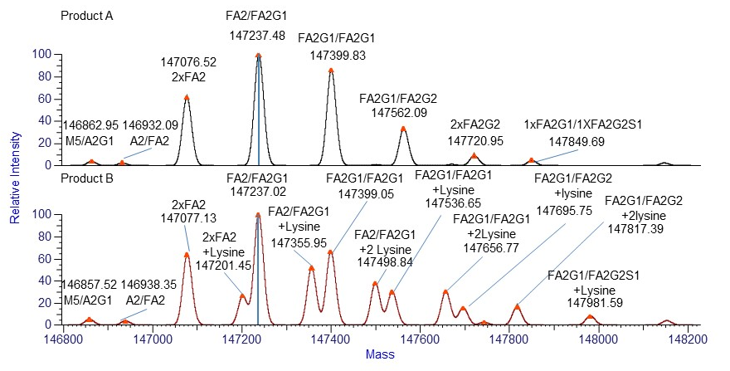
Figure S3. Intact deconvoluted spectra

Table S8. Glycan Quantitation using LC-MS Intact Mass Analysis Results
 | A2G1/  M5 | FA2/  FA2 | FA2/  FA2G1 | FA2/  FA2G2 | FA2G1/  FA2G2 | FA2G2/  FA2G2 | FA2G1/  FA2G2S1
 | Average Fractional Abundance (%)
A1 | 1.22 | 16.2 | 32.1 | 31.2 | 13.7 | 3.2 | 2.1
A2 | 1.60 | 23.2 | 33.2 | 27.0 | 10.4 | 2.3 | 1.5
A3 | 1.19 | 17.4 | 32.8 | 30.6 | 12.9 | 2.7 | 1.8
A4 | 1.2 | 18.4 | 32.9 | 29.9 | 12.5 | 2.7 | 1.9
A5 | 1.5 | 22.0 | 33.1 | 28.4 | 11.0 | 2.3 | 1.2
A6 | 1.4 | 20.8 | 34.2 | 28.0 | 10.9 | 2.5 | 1.4
A7 | 1.43 | 26.2 | 37.1 | 25.0 | 8.4 | 1.8 | <LOQ
B1 | <LOQ | 24 | 37 | 29.8 | 6.6 | ND | <LOQ
B2 | <LOQ | 37 | 31 | 26 | 4.1 | ND | <LOQ
 | Standard Deviation
A1 | 0.09 | 0.2 | 0.1 | 0.3 | 0.3 | 0.2 | 0.2
A2 | 0.07 | 0.2 | 0.4 | 0.3 | 0.2 | 0.2 | 0.2
A3 | 0.09 | 0.4 | 0.2 | 0.5 | 0.3 | 0.3 | 0.2
A4 | 0.1 | 0.3 | 0.6 | 0.5 | 0.2 | 0.2 | 0.2
A5 | 0.2 | 0.3 | 0.5 | 0.5 | 0.2 | 0.3 | 0.3
A6 | 0.2 | 0.4 | 0.5 | 0.3 | 0.2 | 0.2 | 0.3
A7 | 0.09 | 0.7 | 0.4 | 0.6 | 0.4 | 0.3 | NA
B1 | NA | 1 | 2 | 2 | 0.7 | NA | NA
B2 | NA | 3 | 4 | 2 | 1 | NA | NA

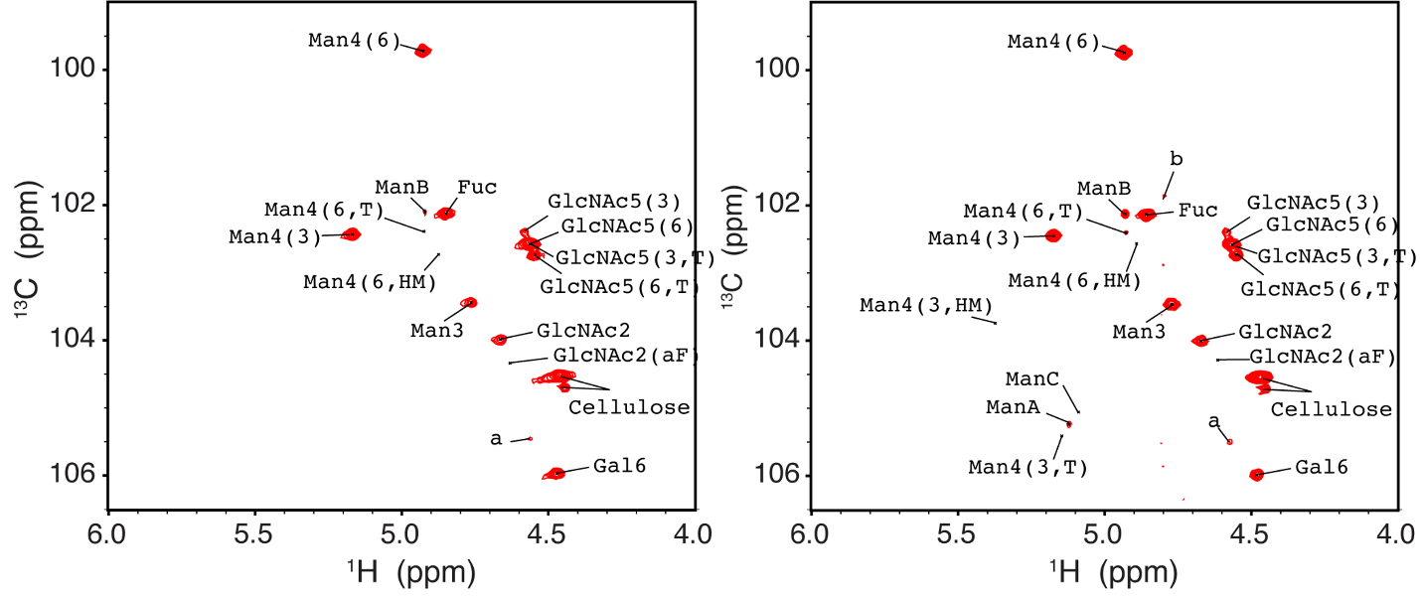
Figure S4. The representative 1H-13C HSQC spectra of rituximab from Product A (left) and Product B (right). The shown spectrum was from the samples of lot 3209283 and RIBV3412. The plotting threshold was set to S/N = 5. Peaks of Man4(3,T), Man4(3,HM), ManA (mannose at position 5 of 1-6/1-3branch) and ManC (mannose at position 5 of 1-3 branch) were not observed in product A, suggesting less mannose species in product A.

Table S9. Glycan analysis (%) by HSQC peak intensities for rituximab Fc fragment.
Drug Product |  | Total  Afucosylation | High-mannose  (M4-M9) | Galactosylationª
Equation |  | 1 | 2 | 3
Product A | A1 | 15.5 | 3.79 | 35.2
Product A | A2 | 11.6 | NA^{b} | 30.0
Product A | A3 | 14.4 | NA^{b} | 32.4
Product A | A4 | NA^{b} | NA^{b} | 33.6
Product A | A5 | NA^{b} | NA^{b} | 29.9
Product A | A6 | NA^{b} | NA^{b} | 31.4
Product A | A7 | 9.65 | NA^{b} | 28.9
Product A | Average | 12.8 | 3.8 | 31.6
Product A | STDV | 2.7 | - | 2.2
Product A | CV% | 21 | - | 7
Product B | B1 | 8.42 | NA^{b} | 27.3
Product B | B2 | 13.9 | 4.93 | 24.1
Product B | Average | 11.2 | 4.9 | 25.7
Product B | STDV | 3.9 | - | 2.3
Product B | CV% | 35 | - | 9
ª 100% galactosylation here is two galactoses in one complex N-glycan, e.g., (F)A2G2.
^{b} Not available due to low signal to noise ratio. The signal to noise cut-off is S/N >=3.

Appendix S1: Preparation of Samples for HILIC-FLD analysis

Centrifugal Filter Preparation
- Equilibrate the filter (10KD, PALL Corporation, Ref OD010C33, Lot FE3150) by adding 100 µL of digestion buffer.
- Centrifuge at 10000 × g for 3 min.
- Add another 100 µL of digestion buffer to the filter.
- Add 20 µL of rituximab sample (equivalent to 200 µg) to the filter.
- Centrifuge at 13000 × g for 2 min.
- Discard the flow through.
- Wash the filter with 350 µL of digestion buffer.
- Centrifuge at 13000 × g for 5 minutes.
- Discard the flow through.
- Repeat steps 7 – 8.
- Discard the flow through and use a new collection tube.

De-Glycosylation
- Add 48 µL of digestion buffer and 2 µL of PNGase F.
- Incubate samples in a heating block at 45 °C for 1 hour while mixing at 500 rpm.
- Cool samples to room temperature.
- Centrifuge at 14000 × g for 5 min, to collect the N-glycans in the collection tube.
- To the collection tube, add 5 µL of 200 mmol/L acetic acid.
- Vortex and spin down.
- Incubate for 15 minutes at 45 °C while mixing at 500 rpm.
- Cool to room temperature.

Labeling
- Add 10 µL of labeling reagent (5 µL of 2-AB solution and 5 µL of Reductant solution)
- Vortex. Spin down briefly.
- Cap the tubes tightly and incubate for 2 hours at 65 °C in a heating block at 500 rpm.
- Cool samples to room temperature.
- Spin down.

Removal of excess labeling reagent
- Add 1 mL of 96% acetonitrile to the labeled glycans and mix.
- Rinse required number of cartridges with 1 mL of water under low vacuum.
- Rinse cartridges with 1 mL of 96% acetonitrile under low vacuum or gravity.
- Apply each labeled glycan mixture to individual cartridges.
- Let sample flow through by gravity.
- Wash cartridges 3x with 1.0 mL of 96% acetonitrile under gravity.
- After, 3rd washing, put the cartridges into 1.5 µL tubes and do lower speed centrifuging at 1000 × g for 1 min to completely dry the cartridge.
- Transfer the cartridges into a new 1.5 mL tube.
- Add 100 µL of 20% acetonitrile and allow to absorb into the cartridge.
- Elute the labeled glycans by centrifuging briefly at 2000 × g for 2 min.
- Mix samples 1:1 with 96% acetonitrile (100 µL) prior to HPLC analysis.
- Vortex, spin down and transfer the sample into a HPLC vial.

