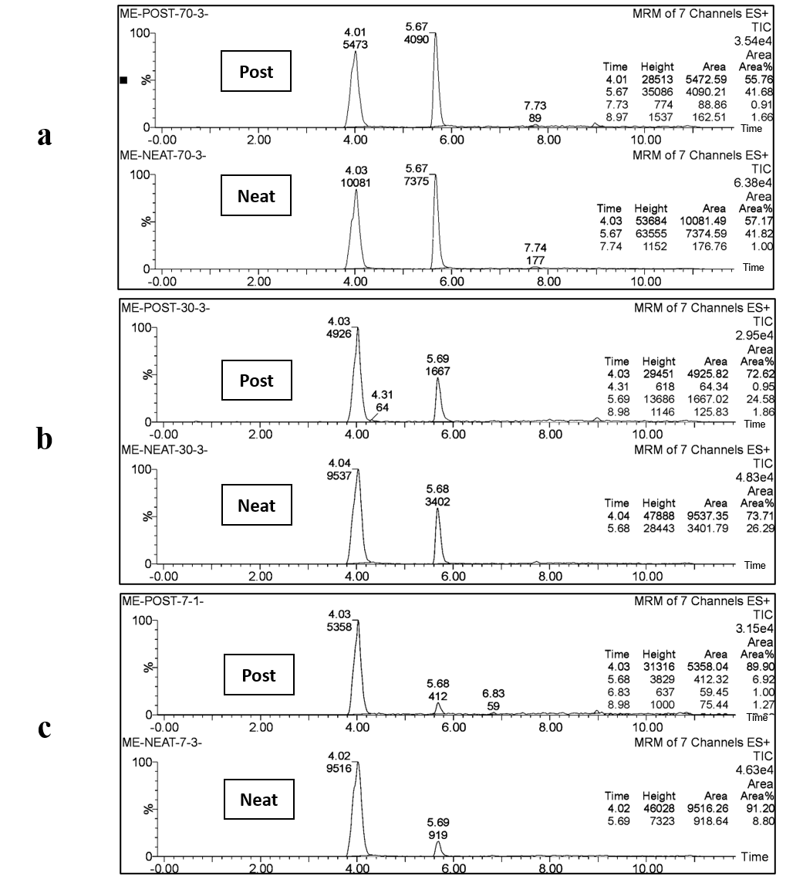

Fig. S1 Chromatograms of QC samples of STZ (t_{R}~5.68) with 100 µL of (5 µg ml⁻¹) DEXA (t_{R}~4.03) in neat solution (neat) and post extraction spiked urine (post), where a, b and c are the 3 concentration levels of 7,30,70 ng ml⁻¹ of STZ respectively.

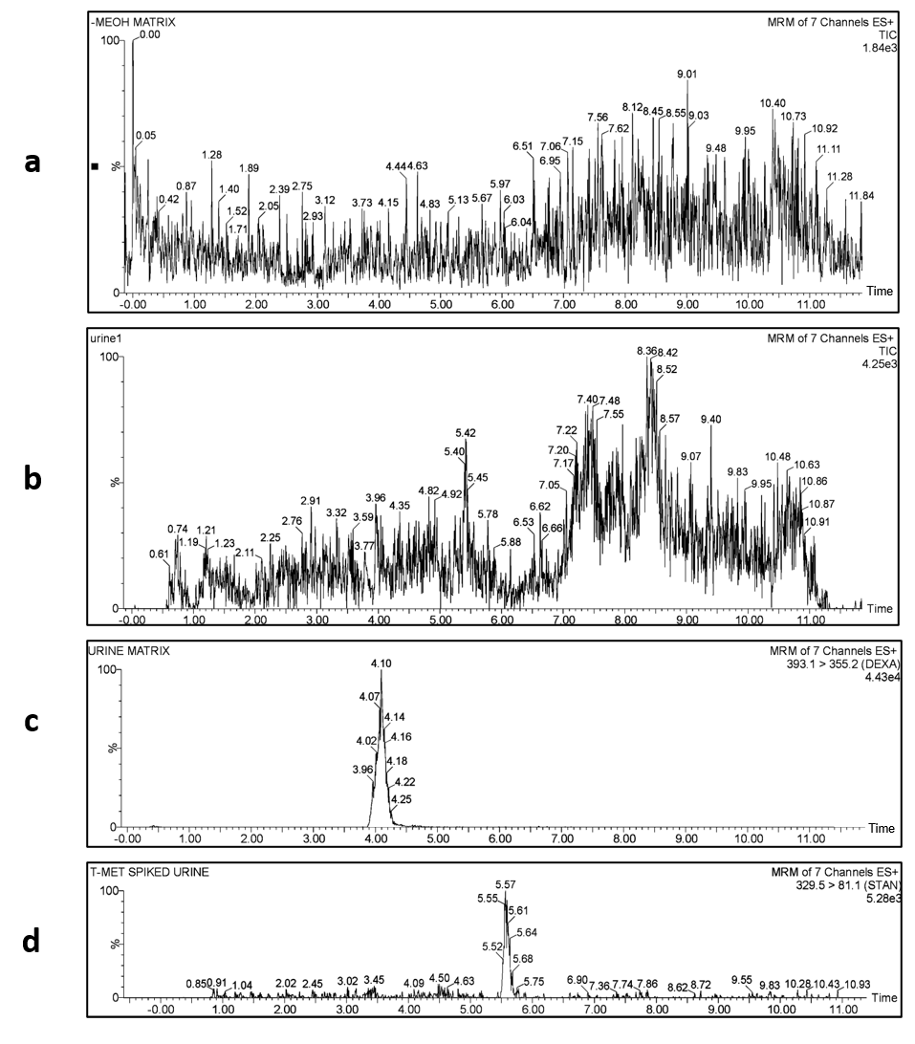

Fig. S2 Chromatograms of (a): Blank MeOH, (b): Blank urine, (c): DEXA (IS) added to a blank urine and (d): 50 ng mL⁻¹ STZ added to a blank urine.

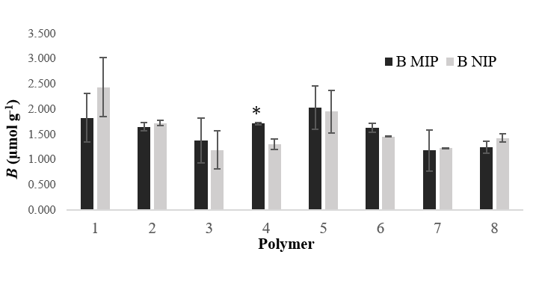
Fig. S3 Binding capacities of all DMIPs and their corresponding NIPs (readings are mean of 3 measurements ± RSD).

Fig. S4 Binding isotherm of DMIP# 4 (STZ: MAA: EGDMA, 1:10:80) and its corresponding NIP (readings are average of three measurements ± SD).

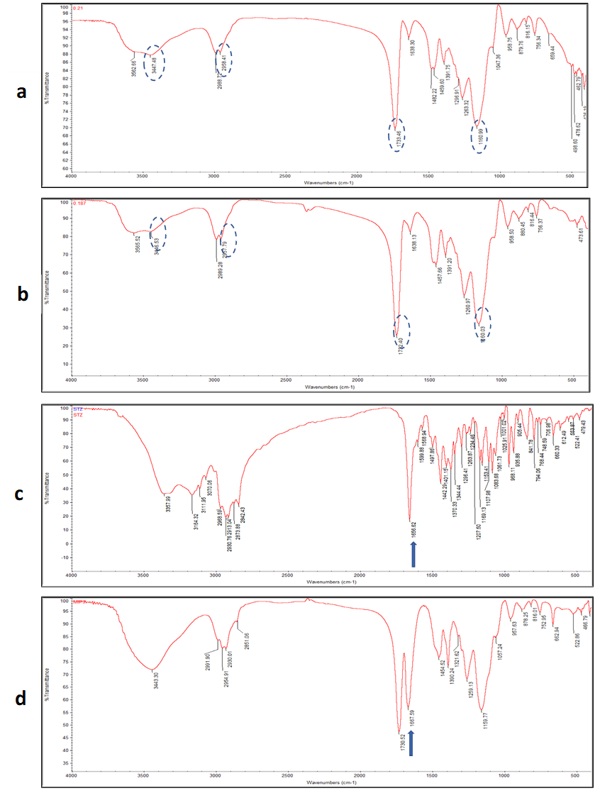

Fig. S5 FT-IR spectra for (a) NIP 4, (b) leached DMIP# 4, (c) STZ and (d) unleached DMIP# 4 (STZ: MAA: EGDMA, 1:10:80)

