Supplementary Information
A stochastic approach for parameter optimization of feature detection algorithms for non-target screening in mass spectrometry

Mohammad Sadiaª, Youssef Boudguiyerª, Rick Helmusª, Marianne Seijoª, Antonia Praetoriusª, Saer Samanipour^{b}.

ª Institute for Biodiversity and Ecosystem Dynamics, University of Amsterdam, Amsterdam, The Netherlands.
^{b} Van ‘t Hoff Institute for Molecular Sciences (HIMS), University of Amsterdam, Amsterdam, The Netherlands

Isotopologue Parameter Optimization
The Isotopologue Parameter Optimization (IPO) was developed to automatically optimize the parameter settings of XCMS algorithm for metabolomics analysis [1]. It uses natural stable ¹³C isotopes to calculate a peak picking score (PPS). Users can define an initial parameter range for optimization, and IPO maximizes its PPS, which in essence means that the algorithm attempts to increase the number of detectable features. We applied IPO to optimize the parameter of other tested algorithms using environmental datasets (in our case drinking water).
Initially, OpenMS and XCMS3 were optimized by applying the IPO algorithm optimization, due to their fast feature detection. A large number of features for both OpenMS (~ 3 million features) and XCMS3 (88750 features) were generated by using the IPO optimization. However, some parameters, like noiseThrInt, chromSNR, chromFWHM, minFWHM for OpenMS, and snthresh and noise for XCMS3, exceeded their lowest possible value and iterated down to a value of one, leading to unrealistic settings, which might be an error that limit our test. On the contrary, IPO had shown to be valuable in selecting appropriate parameters for metabolomics data analysis [1, 2]. The IPO algorithm optimizes feature detection algorithms by trying to maximize the number of features that could be detected with high PPS. As a result, it will seek as many features as possible, leading to iterating the parameter values downwards as this yields more features. These features however are probably mostly background noise. Due to this limitation, we did not further test IPO with other algorithms.

Table S1: List of PFAS in the spiked mixture.
Compound | Acronym | Molecular Formula | MS2_Fragment | Retention time (s)
Trifluoroacetic acid | TFA | C2HF3O2 | CF3 | 272
Pentafluoropropionic acid | PFPrA | C3HF5O2 | C2F5 | 434
Perfluoropropanesulfonic acid | PFPrS | C3HF7O3S | SO3 | 780
Potassium pentafluoroethanesulfonate | PFEtS | C2HF5O3S | SO3; FSO3 | 570
Perfluorobutyric acid | PFBA | C4HF7O2Ê | C3F7 | 611
Perfluoropentanoic acid | PFPeA | C5HF9O2 | C4F9 | 778
Perfluorohexanoic acid | PFHxA | C6HF11O2 | C5F11 | 919
Perfluoroheptanoic acid | PFHPA | C7HF13O2 | C6F13 | 1050
Perfluorooctanoic acid | PFOA | C8HF15O2 | C8F15O2 | 1167
Perfluorononanoic acid | PFNA | C9HF17O2 | C8F17 | 1279
Perfluorodecanoic acid | PFDA | C10HF19O2 | C9F19 | 1369
Perfluoroundecanoic acid | PFUdA | C11HF21O2 | C10F21 | 1437
Perfluorododecanoic acid | PFDoA | C12HF23O2 | C12F23O2 | 1487
Perfluorotridecanoic acid | PFTrDA | C13HF25O2 | C13F25O2 | 1526
Perfluorotetradecanoic acid | PFTeDA | C14HF27O2 | C14F27O2 | 1554
Perfluorobutylsulphonamide | FBSA | C4H2F9NO2S | NO2S | 794
Perfluorohexanesulfonamide | FHxSA | C6H2F13NO2S | NO2S | 990
Perfluorooctanesulfonamide | FOSA | C8H2F17NO2S | NO2S | 1147
N-methylperfluorooctane sulfonamidoacetic acid | L-N-MeFOSAA | C11H6F17NO4S | C8F17 | 1279
N-ethylperfluorooctane sulfonamidoacetic acid | L-N-EtFOSAA | C12H8F17NO4S | C8F17 | 1311
Potassium perfluoro-1-butanesulfonate | PFBS | C4HF9O3S | FSO3;SO3 | 929
Sodium perfluoro-1-pentanesulfonate | PFPeS | C5HF11O3S | FSO3;SO3 | 1060
Potassium perfluorohexanesulfonate | L-PFHxS | C6HF13O3S | FSO3;SO3 | 1172
Sodium perfluoro-1-heptanesulfonate | PFHpS | C7HF15O3S | FSO3;SO3 | 1267
Potassium perfluorooctanesulfonate | L-PFOS | C8HF17O3S | FSO3;SO3 | 1344
Sodium perfluoro-1-nonanesulfonate | PFNS | C9HF19O3S | FSO3;SO3 | 1410
Sodium perfluoro-1-decanesulfonate | PFDS | C10HF21O3S | FSO3;SO3 | 1456
Sodium 1H, 1 H,2H,2H-perfluoro-1-hexanesulfonate | 4_2FTS | C6H5F9O3S | C6H3F8SO3;SO3 | 832
Sodium 1 H, 1 H,2H,2H-perfluoro-1-octanesulfonate | 6_2FTS | 6-2FTS | C8H3F12SO3;SO3 | 1082
Sodium 1 H, 1 H,2H,2H-perfluoro-1-decanesulfonate | 8_2FTS | C10H5F17O3SÊ | C10H3F16SO3;SO3 | 1298
Sodium dodecafluoro-3H-4,8-dioxanonanoate | ADONA | C7H2F12O4 | C4F9O2 | 1078
Potassium 9-chlorohexadecafluoro-3-oxanonane-1-sulfonate | 9Cl-PF3ONS | C8HClF16O4S | C8F12ClO | 1396
Potassium 11-chloroeicosafluoro-3-oxaundecane-1-sulfonate | 11Cl-PF3OUDS | C10ClF20HO4S | C8F20ClO | 1482
Perfluoro-4-oxapentanoic acid | PF4OPeA | C4HF7O3 | CF3O | 680
Perfluro-5-oxahexanoic acid | PF5OHxA | C5HF9O3 | CF3O | 822
Perfluoro-3,6-dioxaheptanoic acid | 3,6-OPFHpA | C5HF9O4 | CF3O | 899
Potassium perfluoro(2-ethoxyethane)sulfonate | PFEESA | C4F9HO4S | CF3O | 994
Potassium perfluoro-4-ethylcyclohexanesulfonate | PFECHS | C8HF15O3S | C8F15;FSO3 | 1266
Sodium bis(1H,1H,2H,2H-perfluorooctyl)phosphate | 6_2diPAP | C16H9F26O4P | H2O4P | 1572
N-ethylperfluoro-1-octanesulfonamidoacetic acid | N-EtFOSA | C10H6F17NO2S | C3F7 | 1306
N-methylperfluoro-1-octanesulfonamidoacetic acid | N-MeFOSA | C9H4F17NO2S | C3F7 | 1257
2-(N-ethylperfluoro-1-octanesulfonamido)-ethanol | N-EtFOSE | C12H10F17NO3S | C2H3O2 | 1306
2-(N-methylperfluoro-1-octanesulfonamido)-ethanol | N-MeFOSE | C11H8F17NO3S | C2H3O2 | 1257
3-Perfluoropropyl propanoic acid (3:3) | 4_2FTA | C6H5F7O2 | C5H3F6 | 753
3-Perfluoropentyl propanoic acid (5:3) | 6_2FTA | C8H5F11O2 | C7HF8;C7F7 | 976
3-Perfluoroheptyl propanoic acid (7:3) | 8_2FTA | C10H5F15O2 | C9HF12 | 968

Table S2. Parameters used for optimization of each feature detection algorithm along with their descriptions.

Algorithm | Parameter | Description
SAFD[3] | Resolution | the expected mass resolution of the used instrument
SAFD[3] | minInt | the minimum signal intensity for the features
SAFD[3] | maxNumbIter | the maximum number of cycles that the algorithm will perform
SAFD[3] | minPeakWS | removes features that have less seconds than the threshold
SAFD[3] | maxTPeakW | removes features that have more seconds than this threshold
SAFD[3] | S2N | the signal-to-noise ratio threshold.
OpenMS[4] | noiseThrInt | sets the noise intensity threshold
OpenMS[4] | chromSNR | sets the signal-to-noise intensity threshold
OpenMS[4] | chromFWHM | sets the expected chromatographic peak width denoted in seconds
OpenMS[4] | minFWHM | the minimum FWHM a feature must have denoted in seconds
OpenMS[4] | maxFWHM | sets the maximum FWHM for a feature denoted in seconds
OpenMS[4] | mzPPM | sets the maximum allowed mass deviation within a mass trace
XCMS[5] | snthresh | sets the signal-to-noise ratio threshold
XCMS[5] | peakwidthmin | sets the expected minimum peak width
XCMS[5] | peakwidthmax | sets the expected maximum peak width
XCMS[5] | mzPPM | sets the maximum m/z tolerance within a mass trace
XCMS[5] | k | sets a minimum threshold of how many peaks should be present within a mass trace
XCMS[5] | minIntensity | sets a minimum threshold of how many peaks should be present within a mass trace
XCMS[5] | noise | essentially performs the same as the minIntensity parameter.
KPIC2[6] | level | only retains mass traces if their maximum values are over a certain threshold
KPIC2[6] | min_snr | sets the minimal signal-to-noise ratio

Table S3. Parameters used for optimization of the OpenMS alignment-and-grouping algorithm along with their descriptions.

Alignment algorithm | Parameter | Description
OpenMS - feature alignment | maxAlignRT | sets the maximum retention time
OpenMS - feature alignment | maxAlignMZ | sets the maximum m/z difference
OpenMS - feature grouping | maxGroupRT | sets the maximum retention time difference between features
OpenMS - feature grouping | maxGroupMZ | sets the maximum m/z difference limit.

Table S4. Parameter used in filtering step along with their descriptions

Filter | Value | Description
absMinIntensity | 10000 |  | Minimum intensity in absolute terms for features to be kept.
preAbsMinIntensity | 100 |  | Identical to absMinIntensity but applied before any other filtering step.
relMinReplicateAbundance | 1 |  | Minimum relative abundance of a feature that must be present within a feature group.
maxReplicateIntRSD | 0.75 |  | Maximum relative standard deviation (RSD) of intensities for features within a feature group. A feature group is removed if the RSD is above this threshold.
blankThreshold | 5 |  | Feature groups that are also present in the blanks are removed unless their relative intensity is above this value.
retentionRange | 200-inf |  | Range of retention time (in seconds)
mzRange | 100-1000 |  | Range of mass (in m/z)

Table S5. Selected parameters and values used for optimizing feature detection parameters.

Algorithm | Parameters | First optimization round |  | Second optimization round |  | Third optimization round |  | Optimized values |  | Default
Algorithm | Parameters | Selected initial values | Correlation | New values | Correlation | New values | Correlation
SAFD | Resolution | 10⁴ - 10⁵ | No | 50000 | - | - |  | 50000 |  | 30000
SAFD | minInt | 10³-5000 | No | 3000 | - |  |  | 3000 |  | 2000
SAFD | maxNumbIter | 1000-5000 | No | 3000 | - |  |  | 5000 |  | 1000
SAFD | minPeakWS | 3—10 | No | 6 | - |  |  | 6 |  | 3
SAFD | maxTPeakW | 11—30 | No | 20 | - |  |  | 20 |  | 300
SAFD | S2N | 3-100 | Yes (-0.65) | 2—10 | No |  |  | 2 |  | 2
OpenMS | noiseThrInt | 1000-5000 | Yes (-0.74) | 500-3000 | Yes (-0.82) | 500-1000 | No | 750 |  | 1000
OpenMS | chromSNR | 3-100 | Yes (-0.43) | 2—10 | No | 6 | - | 6 |  | 3
OpenMS | chromFWHM | 3—30 | No | 15 | - | 15 | - | 15 |  | 5
OpenMS | minFWHM | 3—10 | No | 6 | - | 6 | - | 6 |  | 1
OpenMS | maxFWHM | 11—30 | No | 20 | - | 20 | - | 20 |  | 30
OpenMS | mzPPM | 2—30 | No | 15 | - | 15 | - | 15 |  | 10
XCMS3 | snthresh | 2-100 | Yes (-0.6) | 44836 | No | - |  | 6 |  | 10
XCMS3 | peakwidthmin | 3—10 | No | 6 | - |  |  | 6 |  | 20
XCMS3 | peakwidthmax | 11—30 | No | 20 | - |  |  | 20 |  | 50
XCMS3 | mzPPM | 2—30 | No | 15 | - |  |  | 15 |  | 25
XCMS3 | k | 2—10 | No | 6 | - |  |  | 6 |  | 3
XCMS3 | minIntensity | 1000-5000 | No | 3000 | - |  |  | 3000 |  | 1000
XCMS3 | noise | 1000-5000 | No | 3000 |  |  |  | 3000 |  | 0
KPIC2 | level | 1000-5000 | No | - |  |  |  |  | 1000
KPIC2 | min_snr | 3-100 | No |  |  |  |  |  | 4

Table S6 : The number of features, feature groups, filtered groups, and suspect hits for the studied algorithms using the default and optimized parameters for the test dataset.
 |  | SAFD |  | OpenMS |  | XCMS3 |  | KPIC2 | Bruker
 |  | Default | Optimized  (compare to default%) | Default | Optimized  (compare to default%) | Default | Optimized  (compare to default%) | Default | Default
Features | Sample1 | 1401 | 2612 (86%) | 6723 | 2909 (-57%) | 8563 | 7116 (-17%) | 59070 | 6537
Features | Sample2 | 1360 | 2526 (86%) | 6112 | 2625 (-57%) | 8967 | 6598 (-26%) | 55127 | 5922
Features | Sample3 | 1367 | 2222 (63%) | 7685 | 3152 (-59%) | 8371 | 7576 (-9%) | 59320 | 7261
Feature groups | Sample1 | 1151 | 2185 (90%) | 5536 | 2433 (-56%) | 7055 | 6060 (-14%) | 55093 | 5542
Feature groups | Sample2 | 1130 | 2198 (95%) | 5141 | 2260 (-56%) | 7734 | 5822 (-25%) | 51950 | 5133
Feature groups | Sample3 | 1193 | 2006 (68%) | 6843 | 2937 (-57%) | 7399 | 6931 (-6%) | 56050 | 6668
Suspect hits | Sample 1 | 9 | 25 (178%) | 30 | 30 (0%) | 31 | 32 (3%) | 28 | 10
Suspect hits | Sample 2 | 8 | 23 (188%) | 32 | 27 (-16%) | 33 | 30 (-9%) | 32 | 7
Suspect hits | Sample 3 | 11 | 21 (91%) | 32 | 28 (-13%) | 36 | 33 (-8%) | 33 | 11
Filtered feature groups | Sample1 | 406 | 721 (78%) | 2563 | 489 (-81%) | 899 | 1463 (63%) | 1351 | 849
Filtered feature groups | Sample2 | 365 | 709 (94%) | 2156 | 406 (-81%) | 864 | 1404 (63%) | 1194 | 667
Filtered feature groups | Sample3 | 659 | 1354 (105%) | 1536 | 1029 (-33%) | 1755 | 2836 (62%) | 2770 | 1883
Filtered suspect hits | Sample1 | 7 | 20 (186%) | 27 | 26 (-4%) | 25 | 27 (8%) | 25 | 5
Filtered suspect hits | Sample2 | 7 | 23 (229%) | 30 | 25 (-17%) | 26 | 28 (8%) | 27 | 4
Filtered suspect hits | Sample3 | 9 | 21 (133%) | 27 | 25 (-7%) | 28 | 28 (0%) | 28 | 8

Table S7. Results from manual inspection of sampled 100 features from feature groups and 10 features from filtered feature groups, respectively. The table indicates the count of noise in the overlapped regions and the number of true peaks in the non-overlapped regions for both feature groups and filtered feature groups.

Scenario to define the true-positive |  | Feature group (sampling of 100 features) |  |  |  | Filtered feature group (sampling of 10 features)
 |  | DF |  | OP |  | DF |  | OP
 |  | noise (overlapped region) | peak (non-ovelapped regoin) | noise (overlapped region) | peak (non-ovelapped regoin) | noise (overlapped region) | peak (non-ovelapped regoin) | noise (overlapped region) | peak (non-ovelapped regoin)
Overlapping of 4 algorithms |  | 3 | 2 | 4 | 2 | 0 | 4 | 0 | 6
Overlapping of 3 Algorithms | KPIC2/SAFD/XCMS | 2 | 4 | 3 | 0 | 2 | 4 | 1 | 7
Overlapping of 3 Algorithms | KPIC2/OpenMS/ SAFD | 4 | 1 | 5 | 0 | 0 | 5 | 2 | 4
Overlapping of 3 Algorithms | KPIC2/OpenMS/XCMS | 6 | 3 | 6 | 1 | 0 | 5 | 0 | 4
Overlapping of 3 Algorithms | OpenMS/SAFD/XCMS | 2 | 6 | 4 | 4 | 0 | 6 | 0 | 5
Overlapping of 2 Algorithms | OpenMS/XCMS | 45 | 22 | 30 | 12 | 2 | 2 | 2 | 6
Overlapping of 2 Algorithms | OpenMS/SAFD | 8 | 40 | 16 | 31 | 2 | 5 | 1 | 5
Overlapping of 2 Algorithms | OpenMS/KPIC2 | 44 | 4 | 32 | 2 | 1 | 4 | 1 | 4
Overlapping of 2 Algorithms | XCMS/SAFD | 12 | 20 | 6 | 25 | 0 | 3 | 0 | 6
Overlapping of 2 Algorithms | XCMS/KPIC2 | 48 | 8 | 45 | 4 | 3 | 3 | 1 | 4
Overlapping of 2 Algorithms | SAFD/KPIC2 | 8 | 4 | 23 | 4 | 0 | 4 | 1 | 6

Correlation plots of feature detection algorithms
SAFD - First optimization round
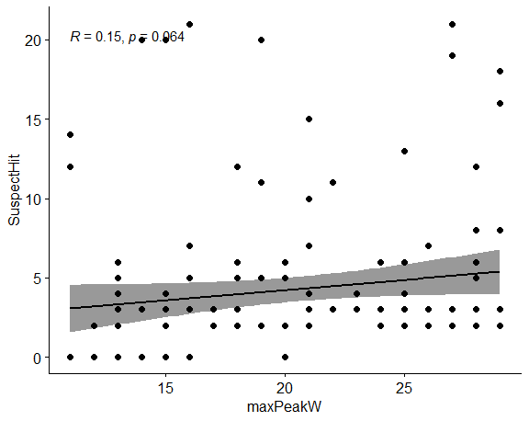 | 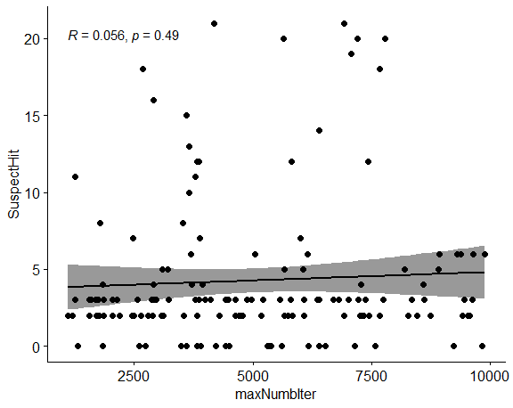
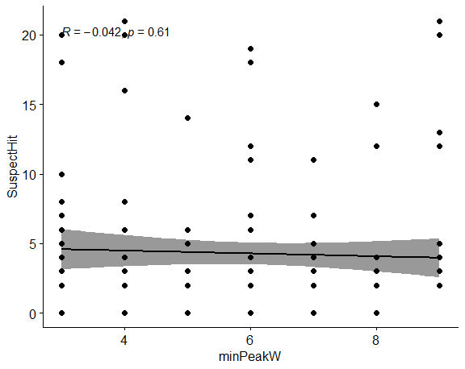 | 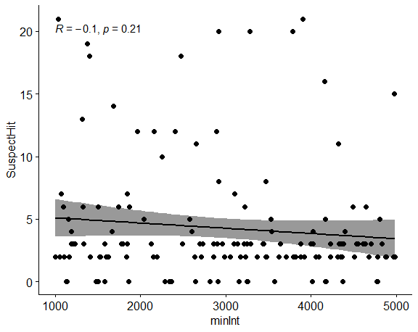
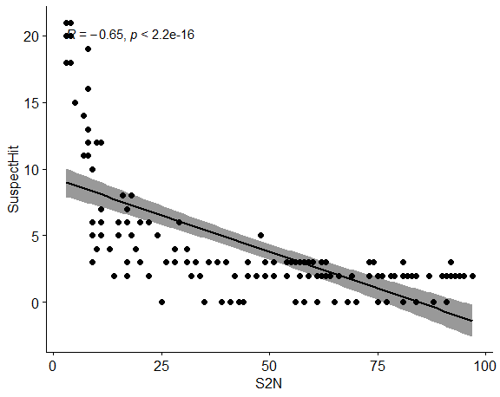 | 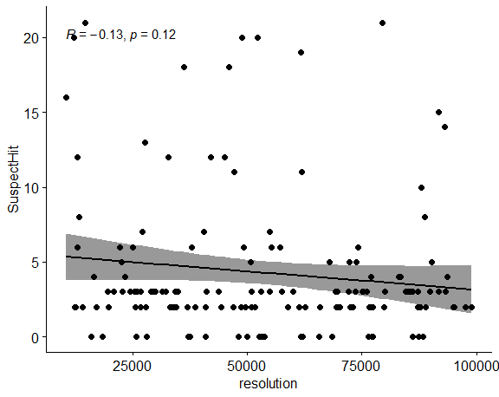
SAFD - Second optimization round
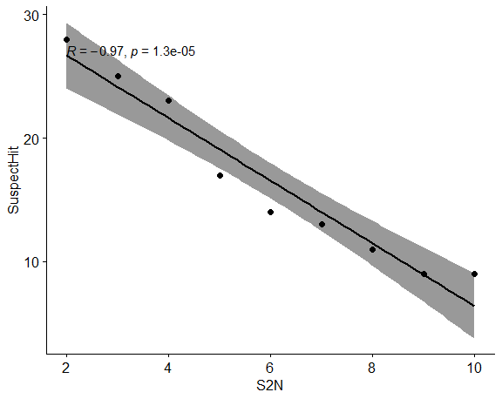
Figure S1. Correlation plots between the parameters of SAFD algorithms and suspect hit for first and second round.

OpenMS- First optimization round
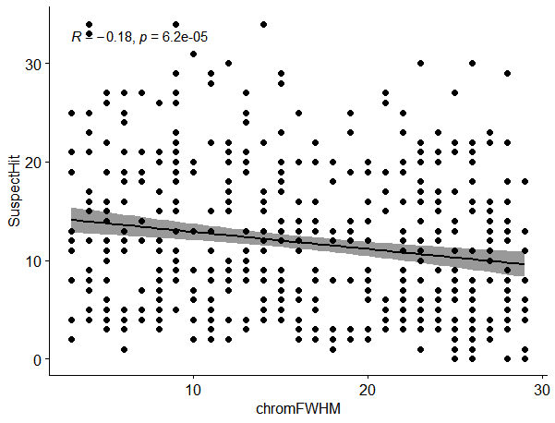 |  | 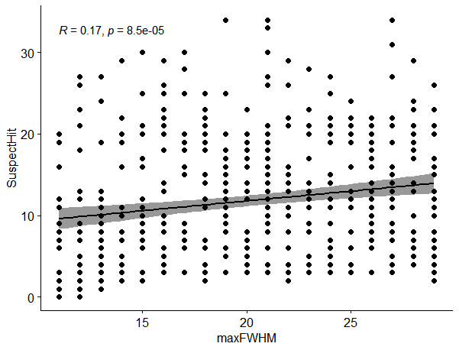
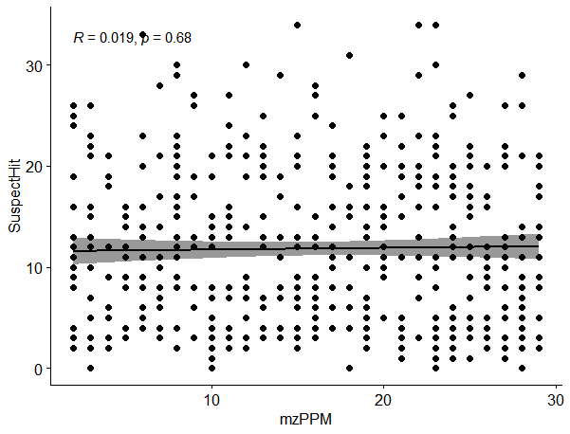 |  | 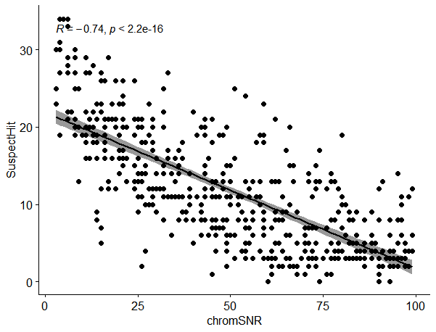
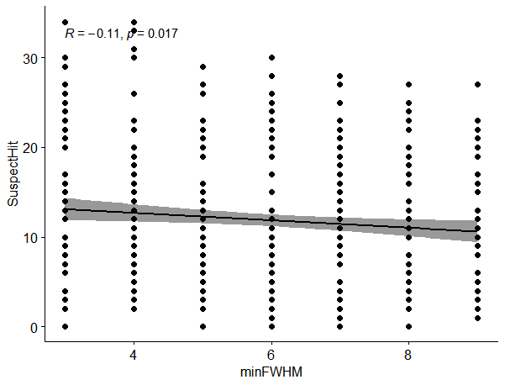 |  | 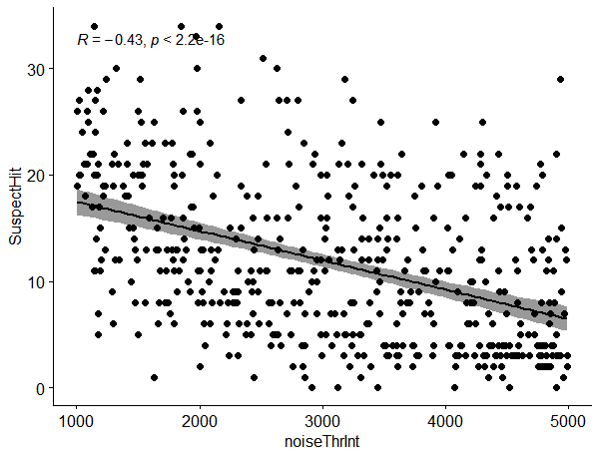
OpenMS- Second optimization round
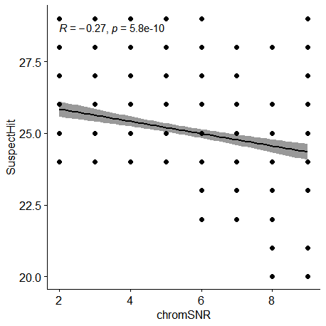 | 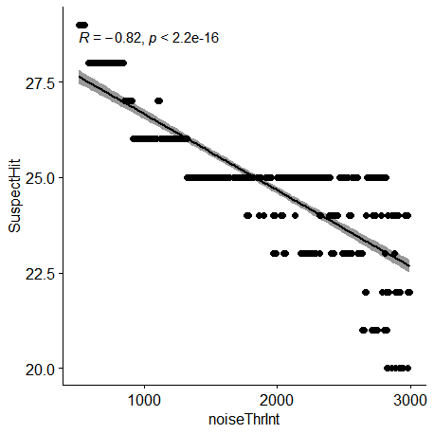
OpenMS- Third optimization round
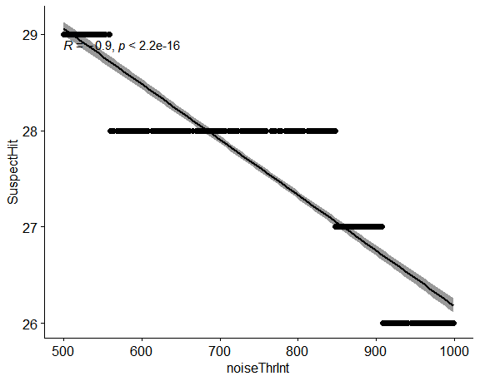
Figure S2. Correlation plots between the parameters of OpenMS algorithms and suspect hit for first, second, and third round.

XCMS - First optimization round
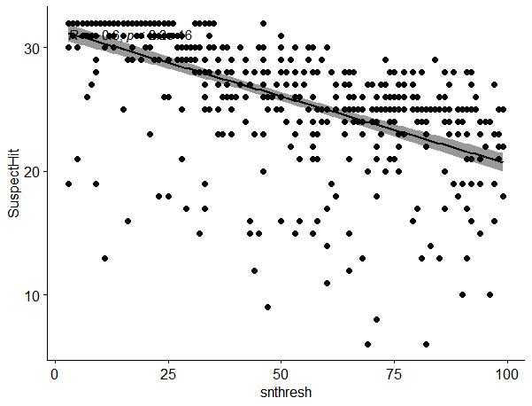 | 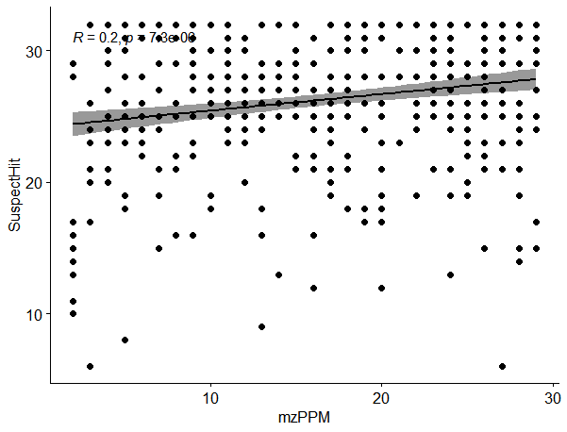
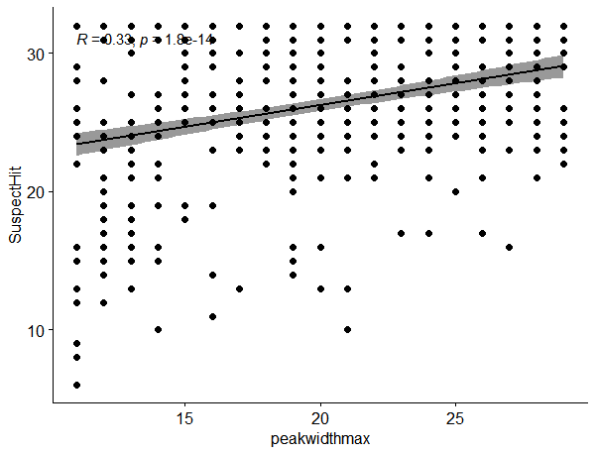 | 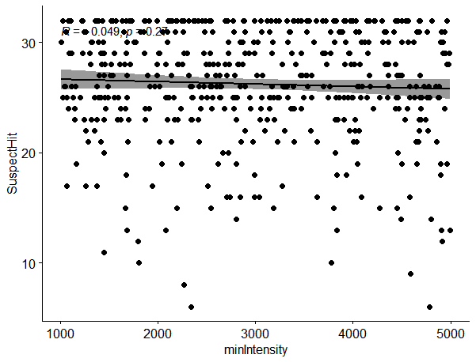
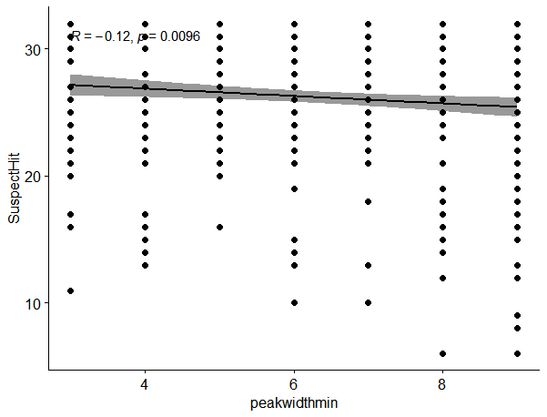 | 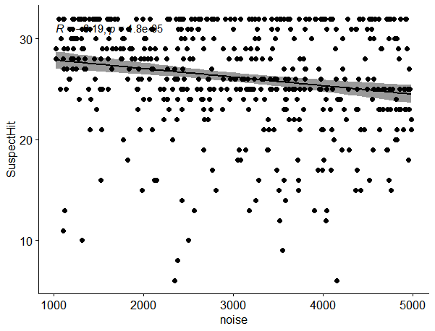
XCMS - Second optimization round
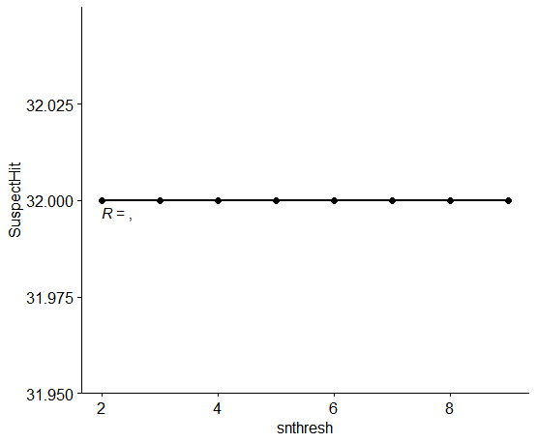
Figure S3. Correlation plots between the parameters of XCMS algorithms and suspect hit for first, and second round.

KPIC- First optimization round
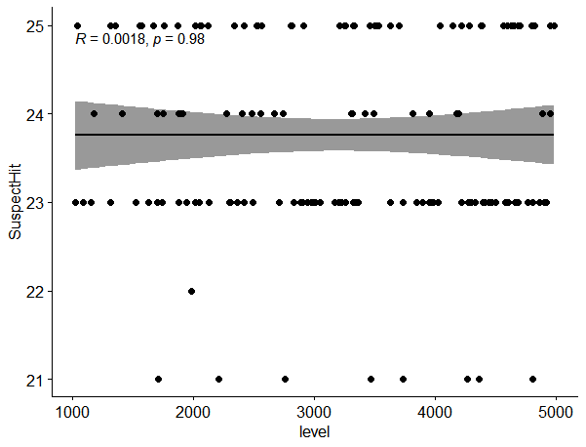 | 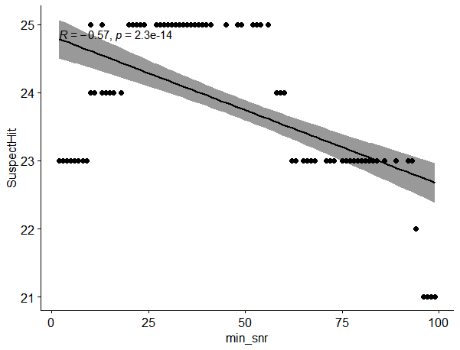
Figure S4. Correlation plots between the parameters of KPIC algorithms and suspect hit for first round.

Correlation plots of the OpenMS feature alignment-and-grouping algorithm
SAFD First optimization round
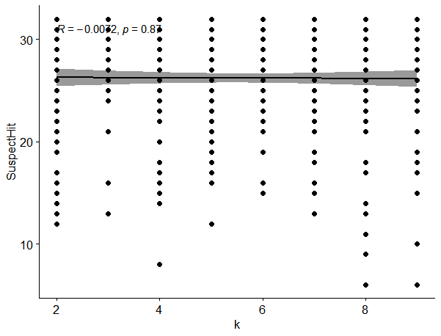 | 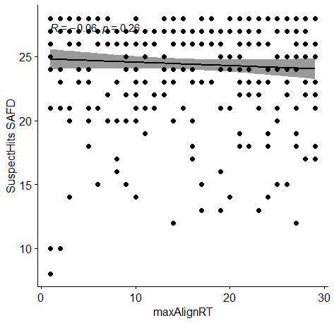
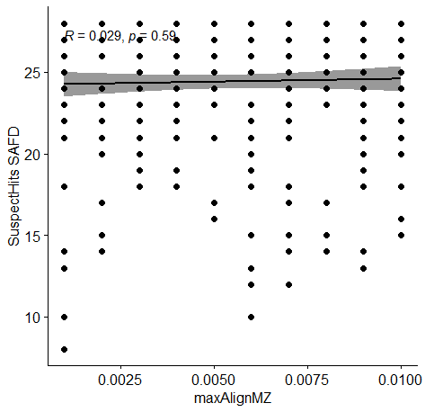 | 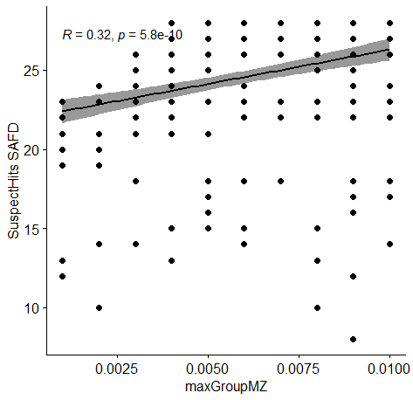
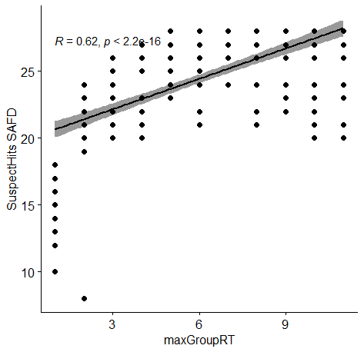
SAFD Second optimization round
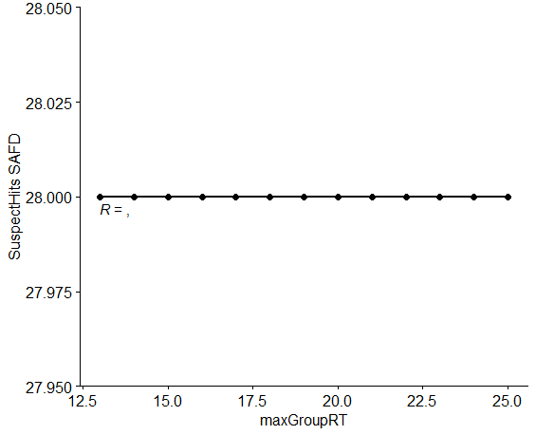
Figure S5. Correlation plots between the parameters of OpenMS feature alignment-and-grouping algorithm and suspect hit for first and second round in case of SAFD data.

OpenMS First optimization round
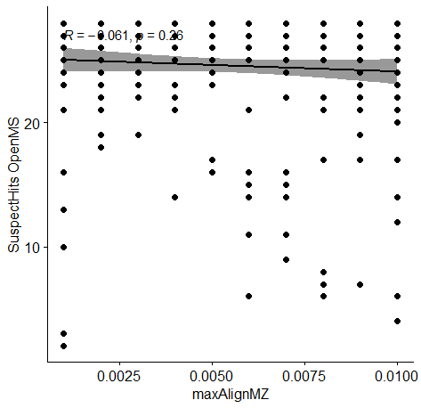 | 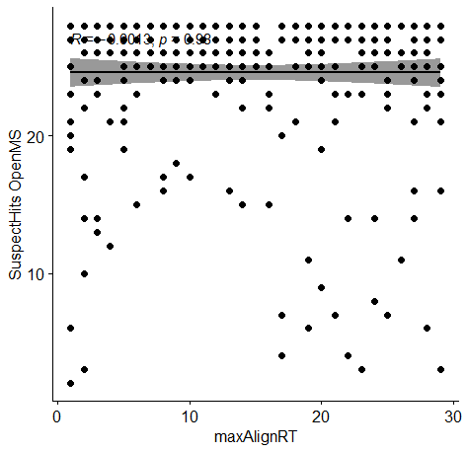
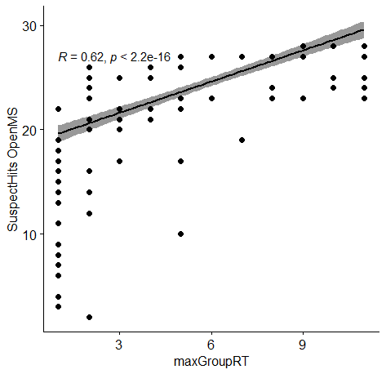 | 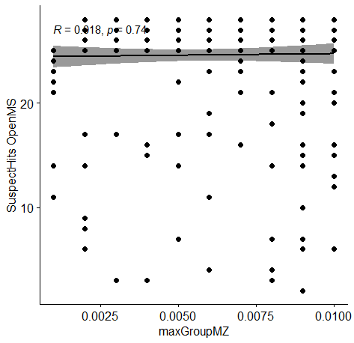
OpenMS Second optimization round
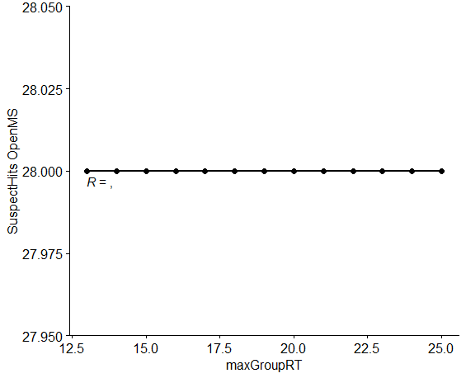
Figure S6. Correlation plots between the parameters of OpenMS feature alignment-and-grouping algorithm and suspect hit for first and second round in case of OpenMS data.

XCMS First optimization round
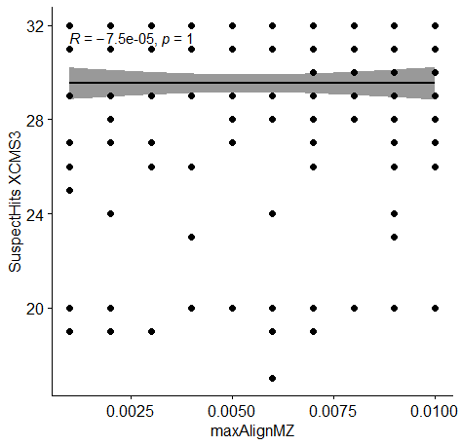 | 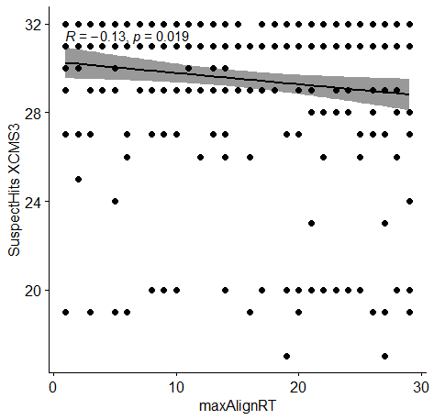
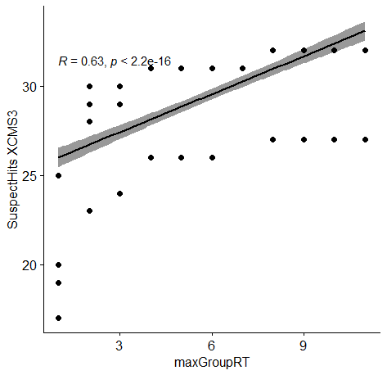 | 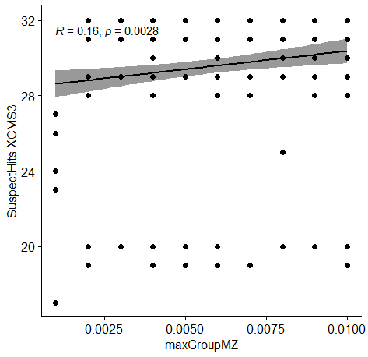
XCMS Second optimization round
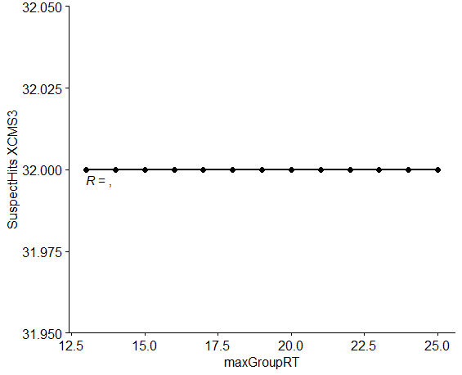
Figure S7. Correlation plots between the parameters of OpenMS feature alignment-and-grouping algorithm and suspect hit for first and second round in case of XCMS data.

KPIC First optimization round
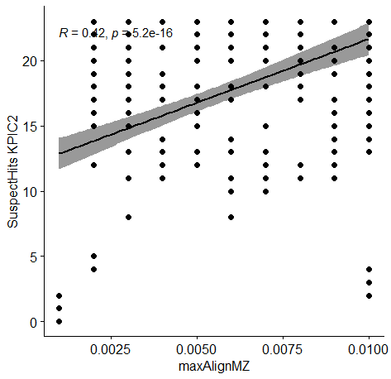 | 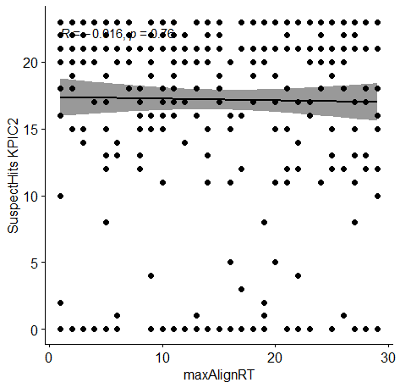
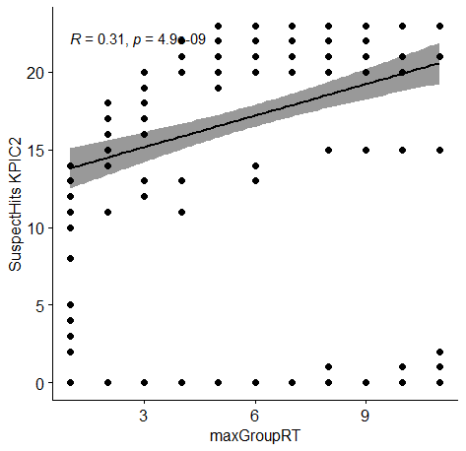 | 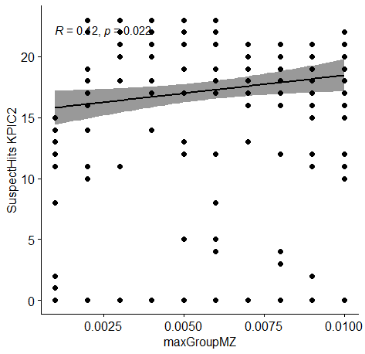
Figure S8. Correlation plots between the parameters of OpenMS feature alignment-and-grouping algorithm and suspect hit for first and second round in case of KPIC data.

A Venn diagram for overlapping features between different algorithms using the default (DF) and optimized (OP) setting
Using the features groups

Using default parameter | Using optimized parameter
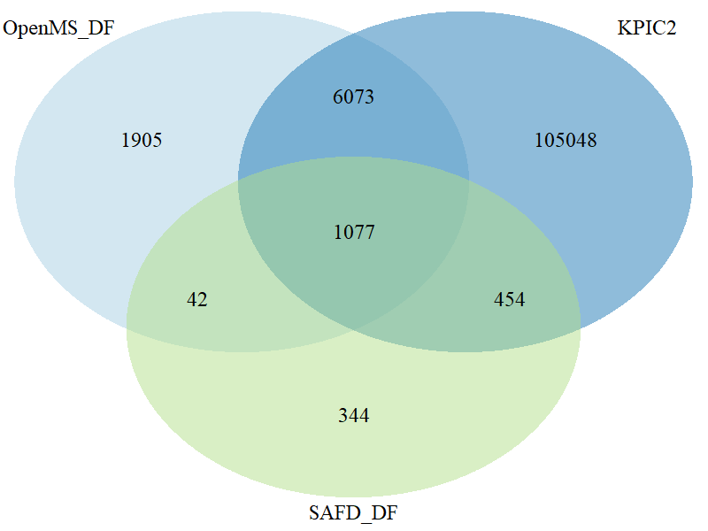 | 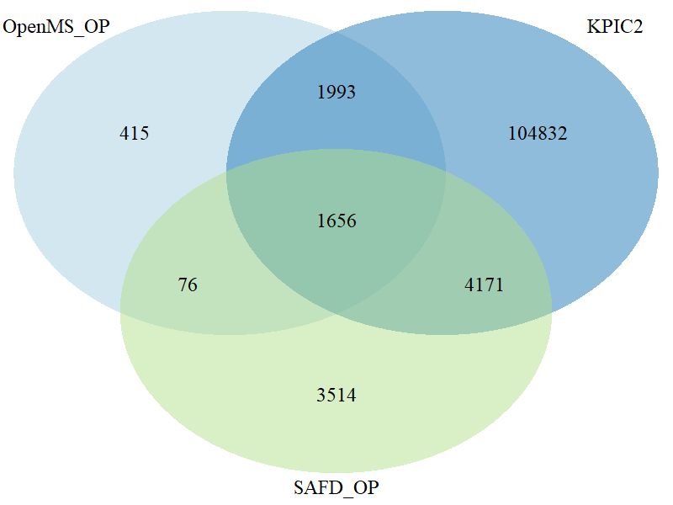
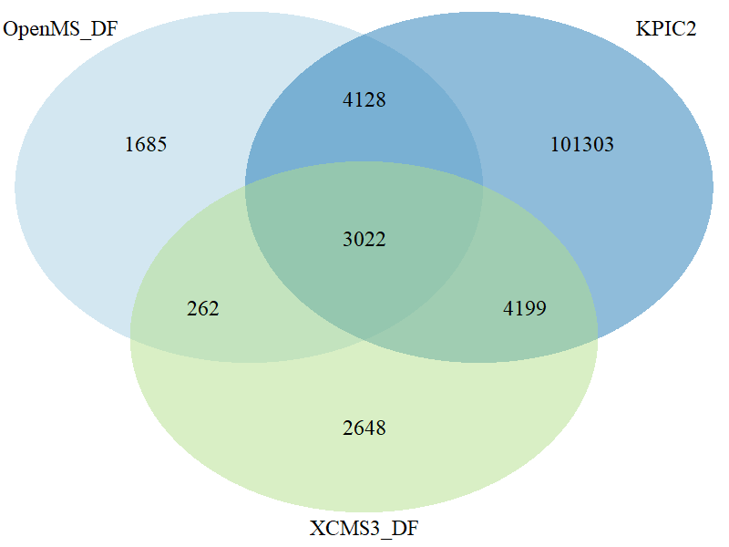
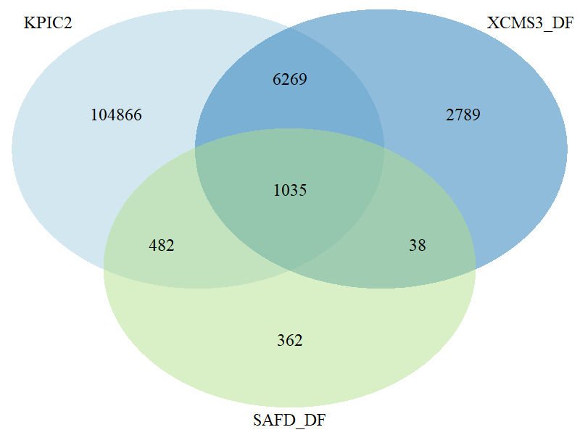 | 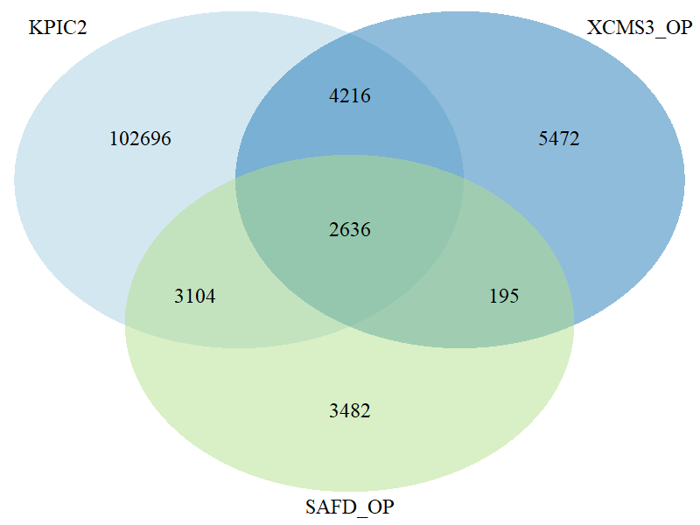
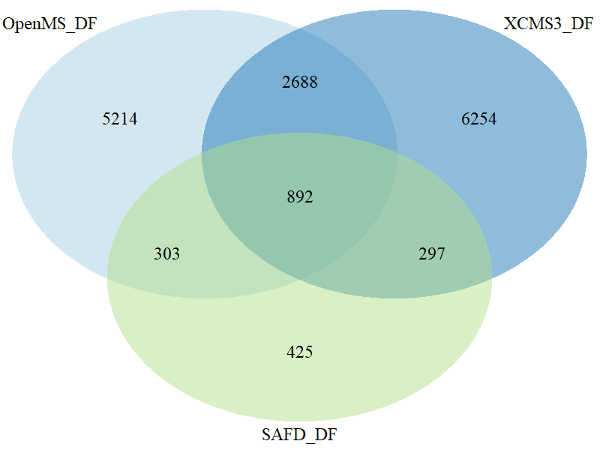 | 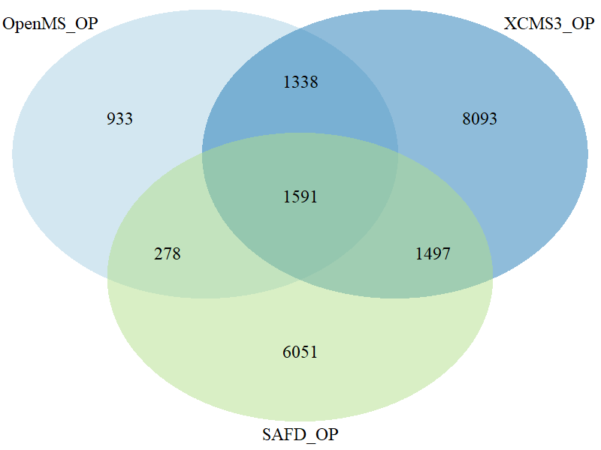

Figure S9. Venn diagram for overlapping features between three algorithms using the default (DF) and optimized (OP) setting (second scenario) using feature groups.
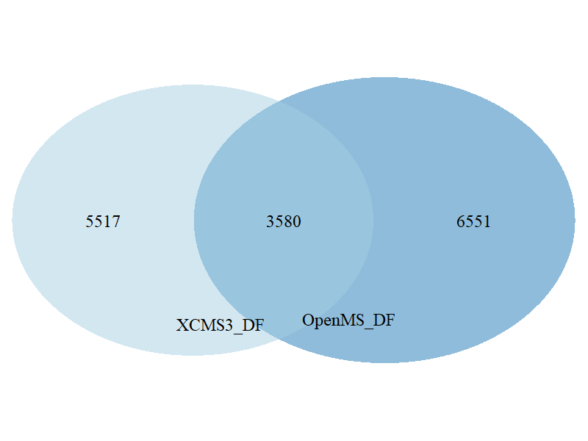 | 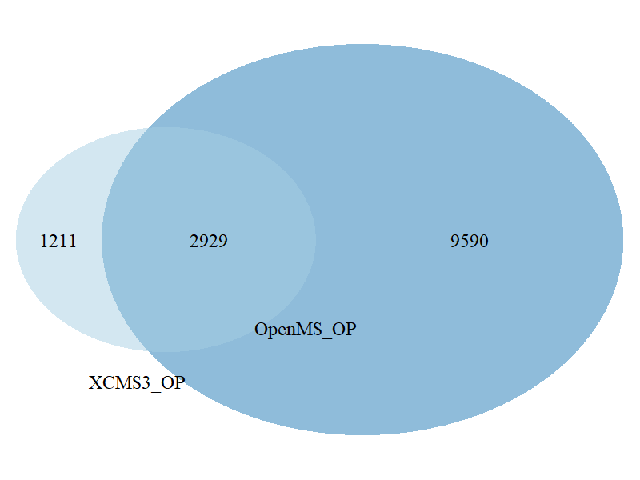
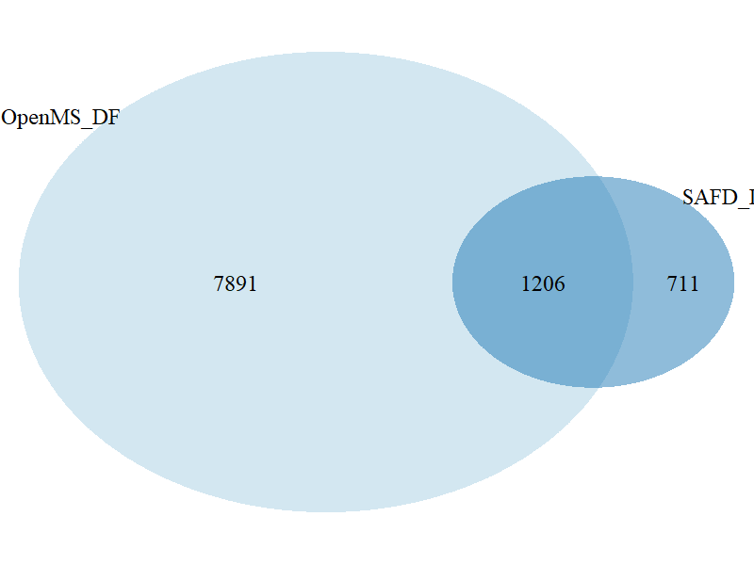 | 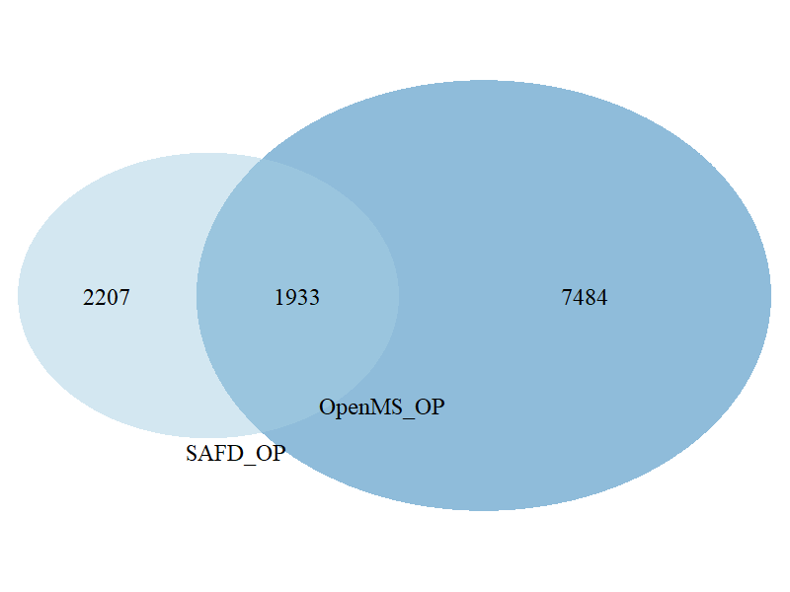
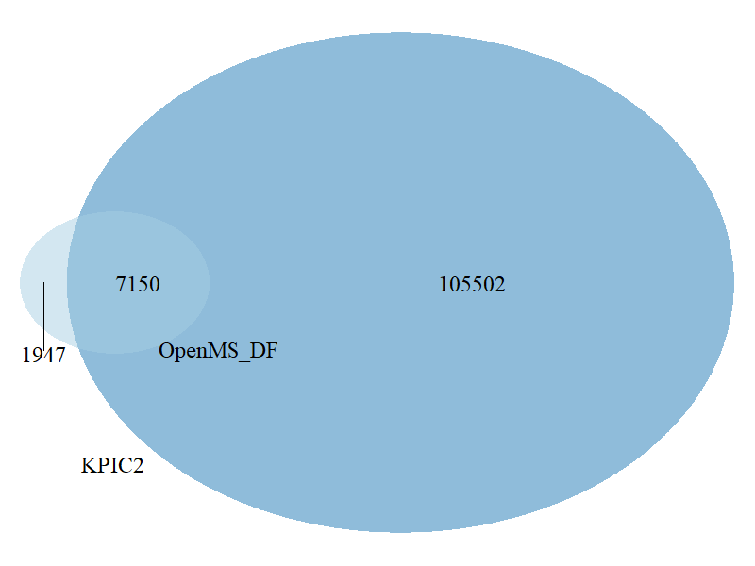 | 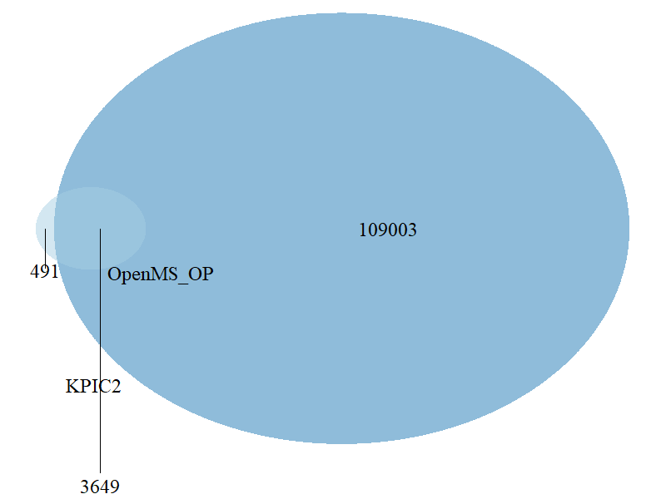
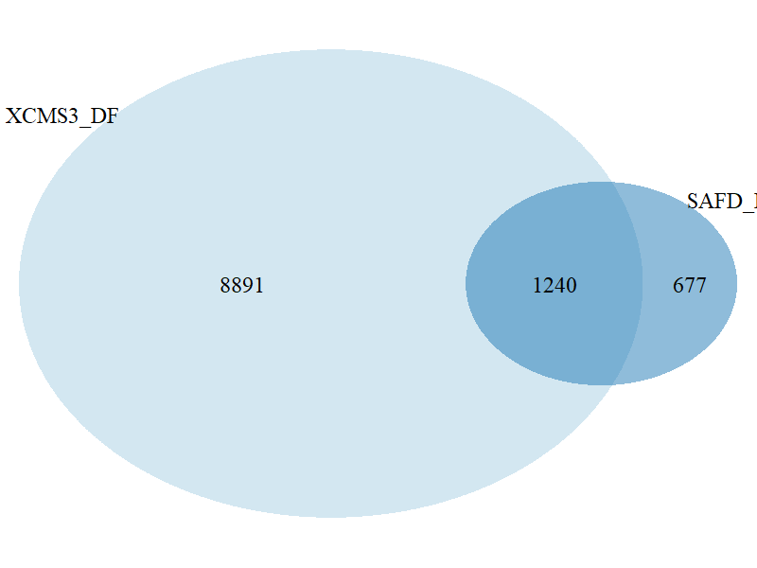
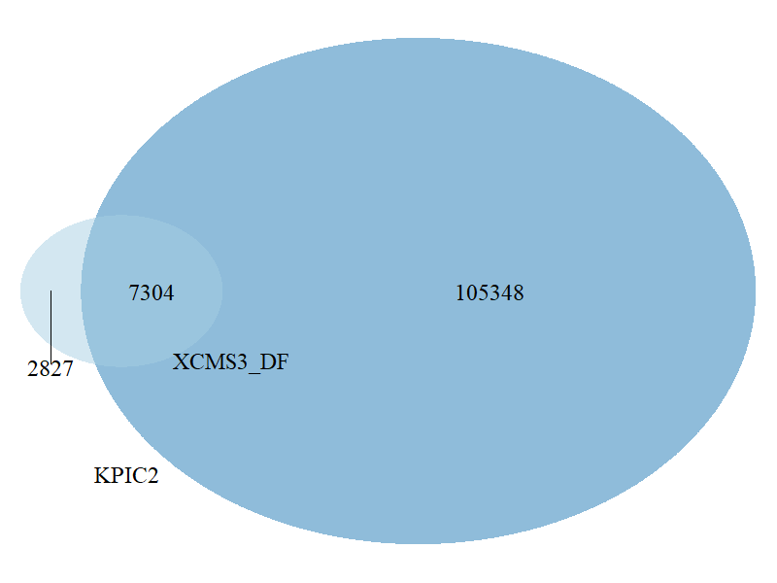 | 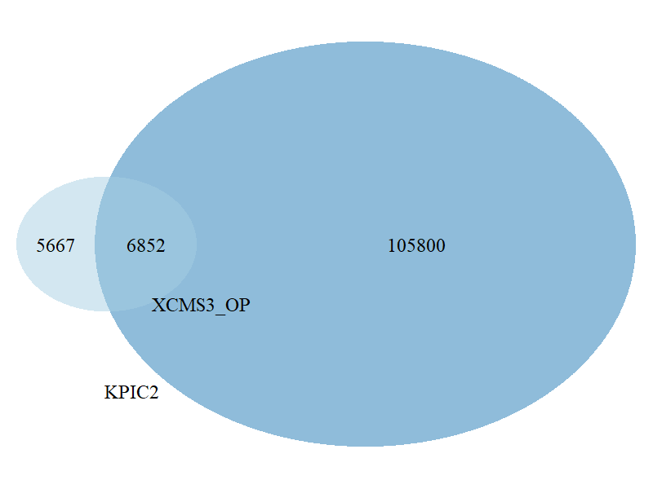
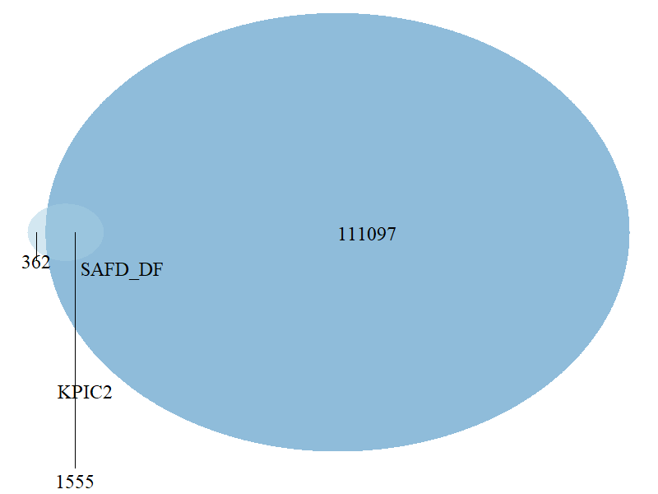 | 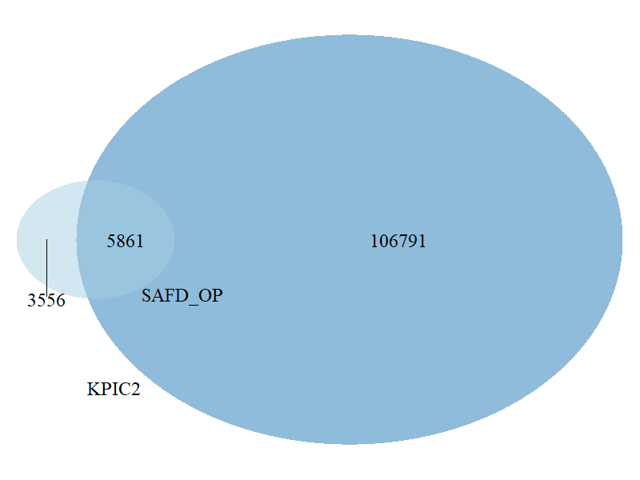

Figure S10. Venn diagram for overlapping features between two algorithms using the default (DF) and optimized (OP) setting (third scenario) using feature groups.

Using the filtered feature groups

Using default parameter | Using optimized parameter
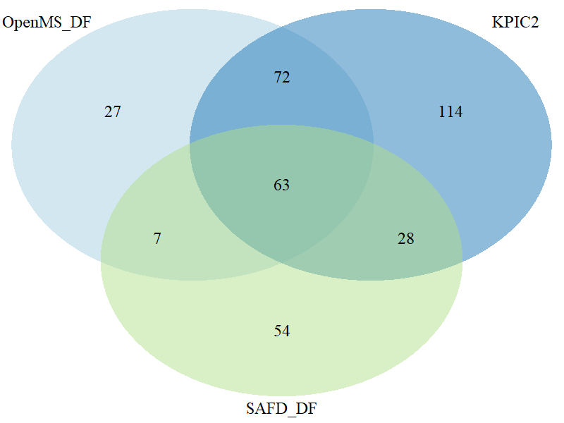 | 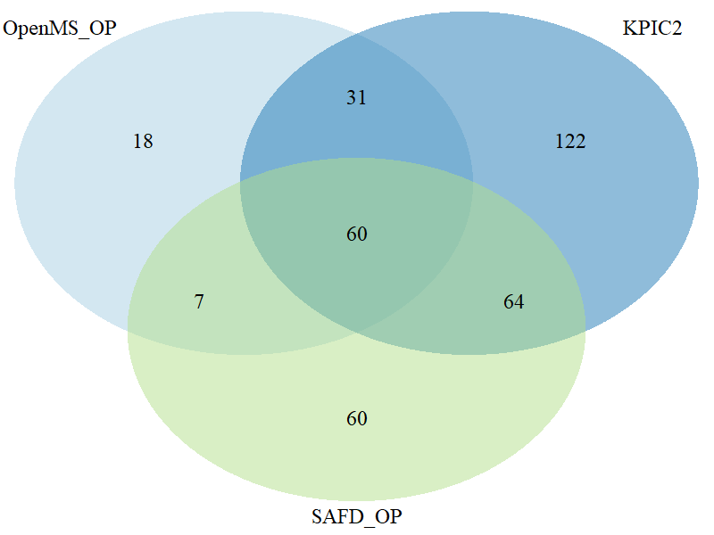
 | 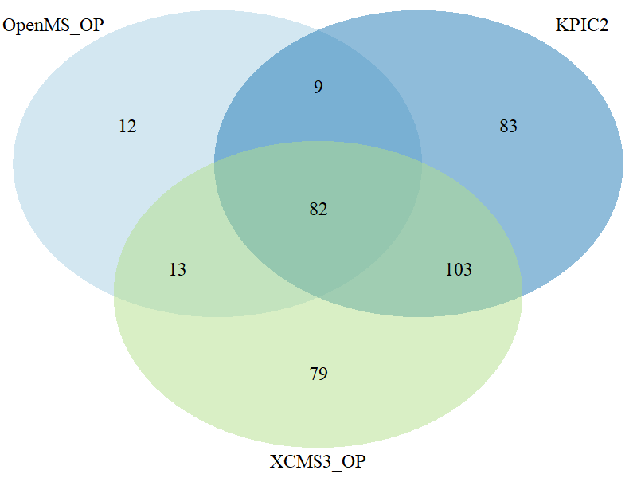
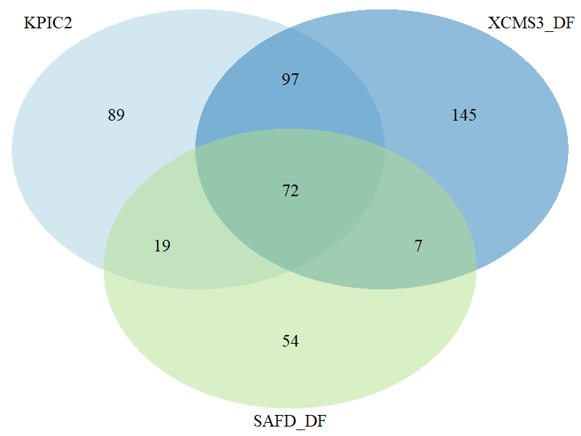 | 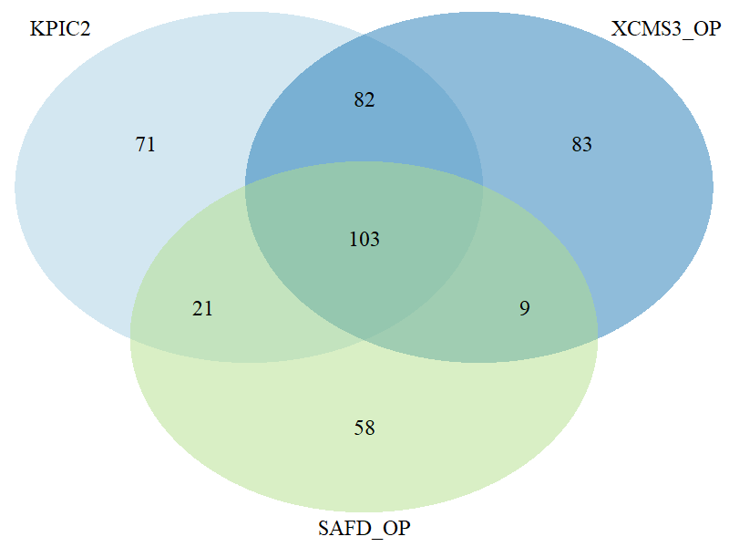
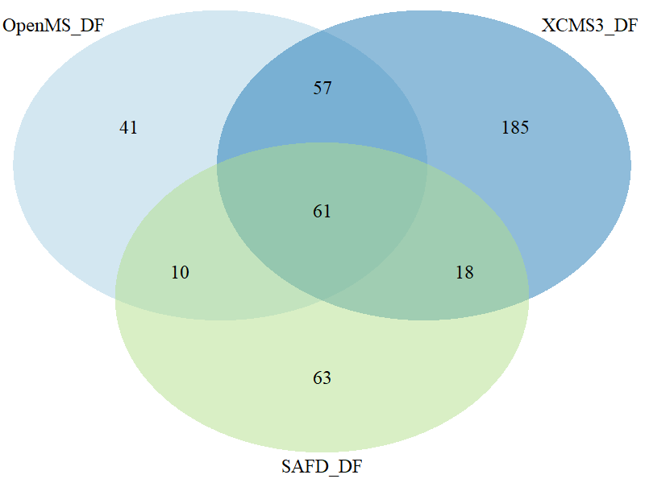 | 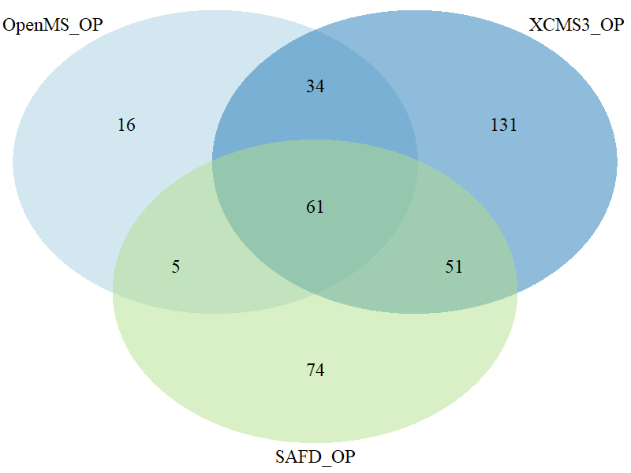
Figure S11. Venn diagram for overlapping features between three algorithms using the default (DF) and optimized (OP) setting (second scenario) using filtered feature groups.

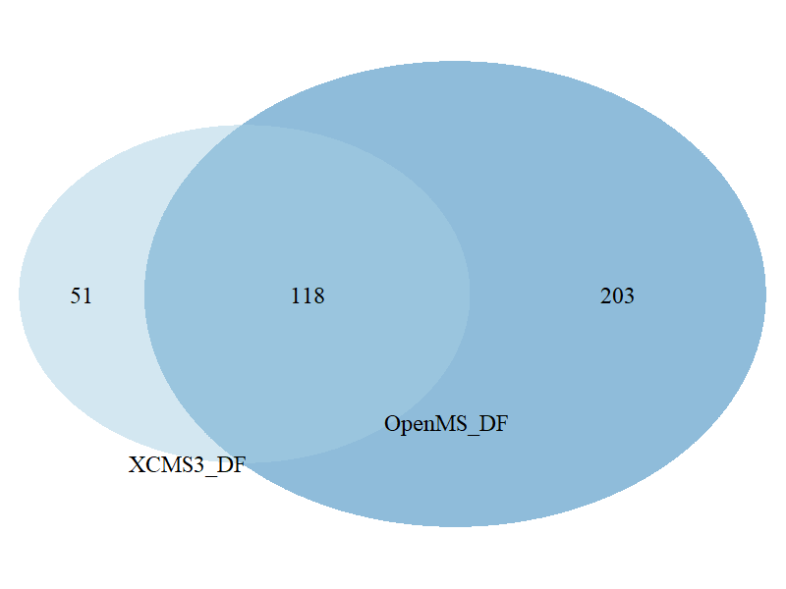 | 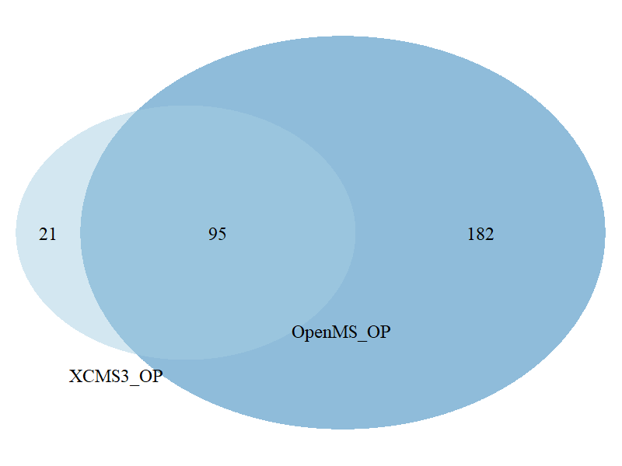
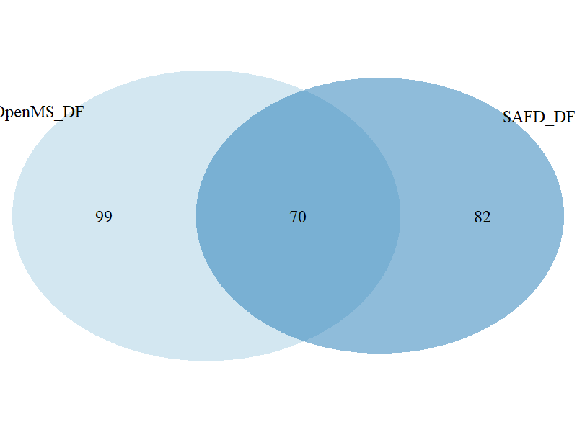 | 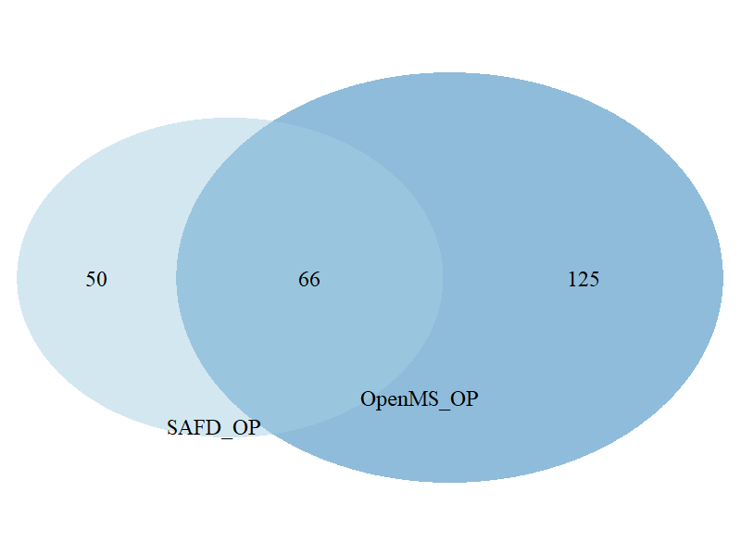
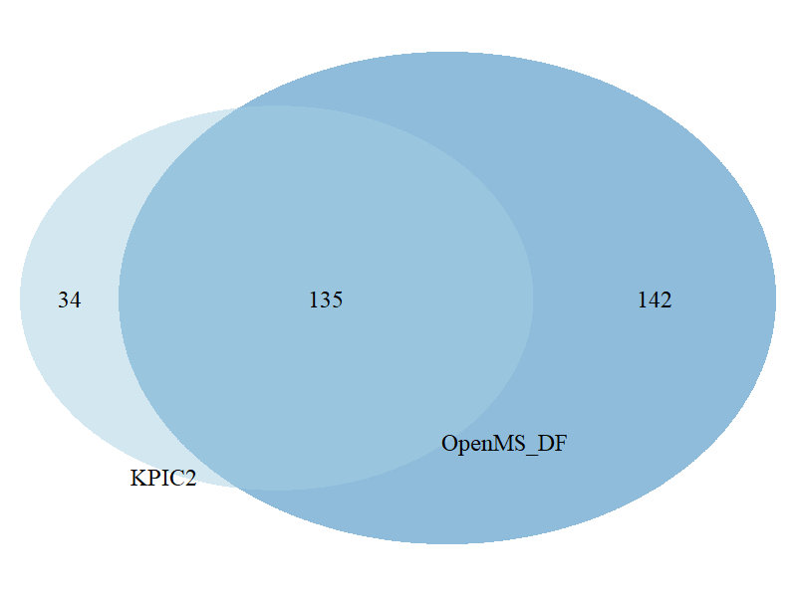 | 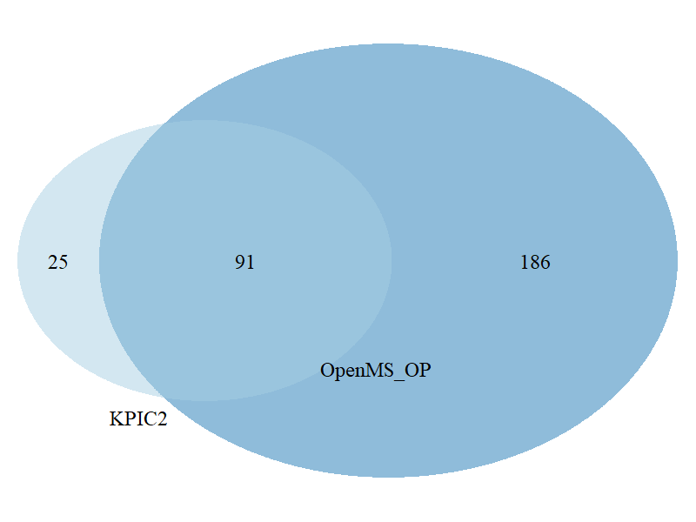
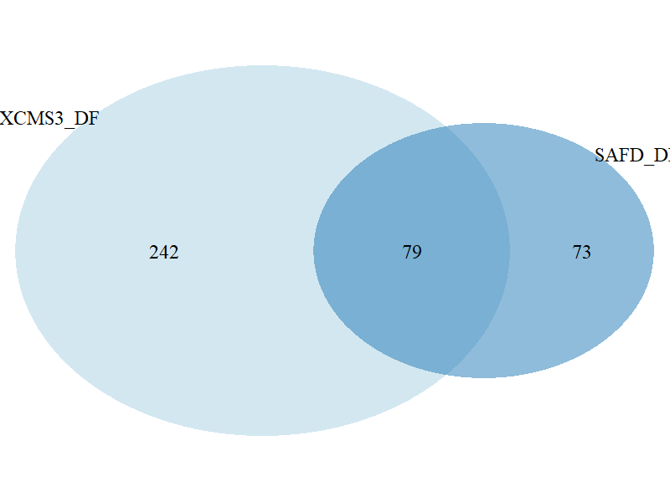 | 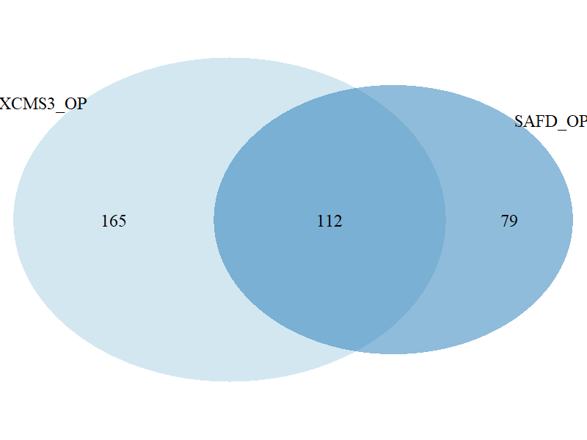
 | 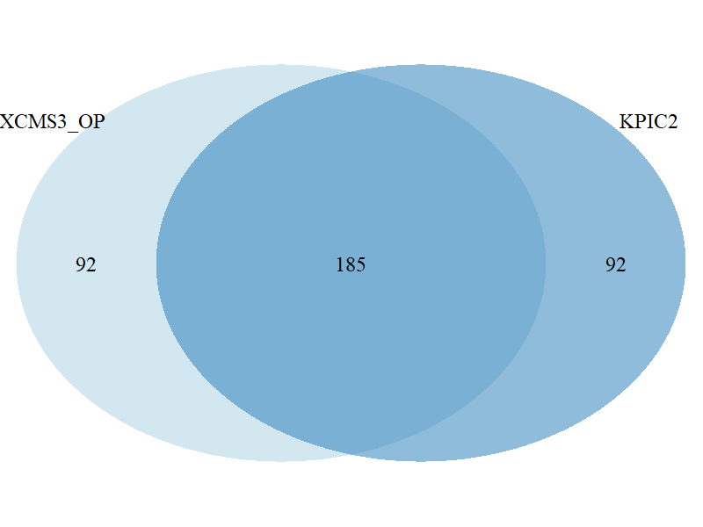
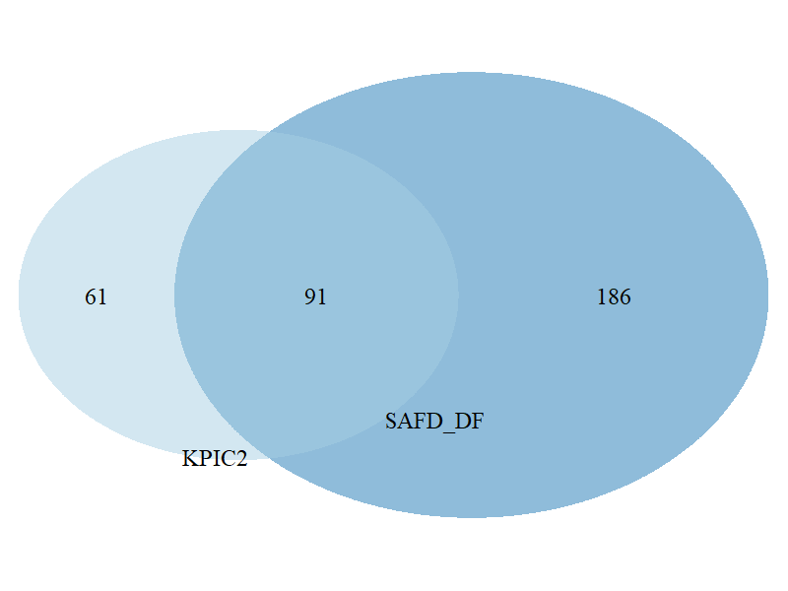 | 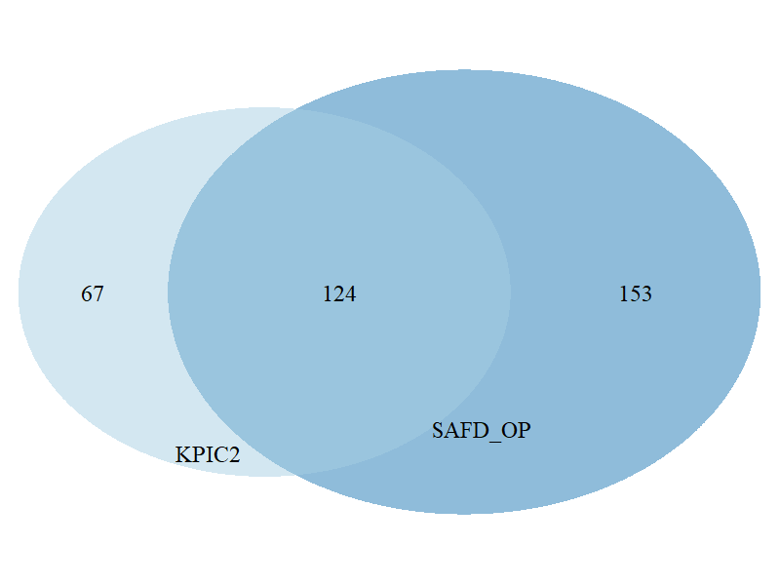
Figure S12. Venn diagram for overlapping features between two algorithms using the default (DF) and optimized (OP) setting (third scenario) using filtered feature groups.

References
1. Libiseller G, Dvorzak M, Kleb U, Gander E, Eisenberg T, Madeo F, Neumann S, Trausinger G, Sinner F, Pieber T, Magnes C (2015) IPO: a tool for automated optimization of XCMS parameters. BMC Bioinformatics 16:118. https://doi.org/10.1186/s12859-015-0562-8
2. Albóniga OE, González O, Alonso RM, Xu Y, Goodacre R (2020) Optimization of XCMS parameters for LC–MS metabolomics: an assessment of automated versus manual tuning and its effect on the final results. Metabolomics 16:14. https://doi.org/10.1007/s11306-020-1636-9
3. Samanipour S, O’Brien JW, Reid MJ, Thomas KV (2019) Self Adjusting Algorithm for the Nontargeted Feature Detection of High Resolution Mass Spectrometry Coupled with Liquid Chromatography Profile Data. Anal Chem 91:10800–10807. https://doi.org/10.1021/acs.analchem.9b02422
4. Röst HL, Sachsenberg T, Aiche S, Bielow C, Weisser H, Aicheler F, Andreotti S, Ehrlich H-C, Gutenbrunner P, Kenar E, Liang X, Nahnsen S, Nilse L, Pfeuffer J, Rosenberger G, Rurik M, Schmitt U, Veit J, Walzer M, Wojnar D, Wolski WE, Schilling O, Choudhary JS, Malmström L, Aebersold R, Reinert K, Kohlbacher O (2016) OpenMS: a flexible open-source software platform for mass spectrometry data analysis. Nature Methods 13:741–748. https://doi.org/10.1038/nmeth.3959
5. Benton HP, Wong DM, Trauger SA, Siuzdak G (2008) XCMS2: Processing Tandem Mass Spectrometry Data for Metabolite Identification and Structural Characterization. Anal Chem 80:6382–6389. https://doi.org/10.1021/ac800795f
6. Ji H, Zeng F, Xu Y, Lu H, Zhang Z (2017) KPIC2: An Effective Framework for Mass Spectrometry-Based Metabolomics Using Pure Ion Chromatograms. Anal Chem 89:7631–7640. https://doi.org/10.1021/acs.analchem.7b01547

