Navigating the Maze of Mass Spectra: A Machine-Learning Guide to Identifying Diagnostic Ions in O-Glycan Analysis
James Urban¹, Roman Joeres^{1,2,3}, Luc Thomès⁴, Kristina A. Thomsson⁵, Daniel Bojar^{1,*}
¹Department of Chemistry and Molecular Biology, University of Gothenburg, Gothenburg, Sweden. Wallenberg Centre for Molecular and Translational Medicine, University of Gothenburg, Gothenburg, Sweden.
²Helmholtz Institute for Pharmaceutical Research Saarland, Helmholtz Center for Infection Research, Saarbruecken, Germany
³Center for Bioinformatics, Saarland University, Saarbruecken, Germany
⁴University Lille, CHU Lille, ULR 7364 - RADEME - Maladies RAres du DÉveloppement embryonnaire et du Métabolisme, 59000 Lille, France.
⁵Proteomics Core Facility at Sahlgrenska Academy, University of Gothenburg, Gothenburg, Sweden
*Corresponding author: daniel.bojar@gu.se

Supplementary Figures

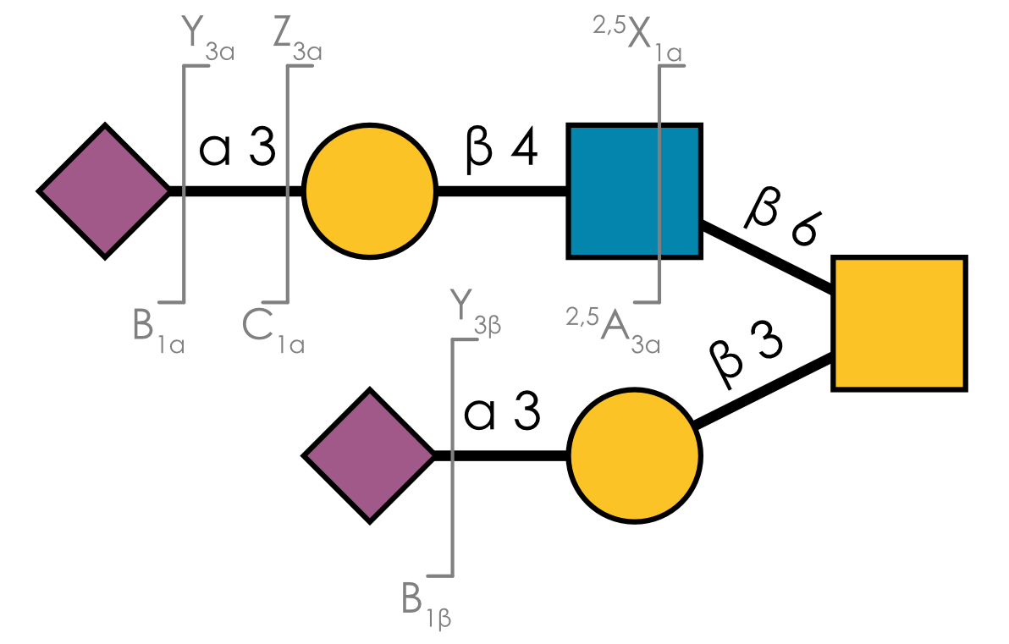
Supplementary Figure 1. Fragmentation pattern of glycans in mass spectrometry. Breaking points are indicated by gray lines, labeled by the corresponding fragment in Domon-Costello nomenclature. Fragments indicating the left part of the molecule are labeled at the bottom of the break, while fragments indicating the right part of the molecule are labeled at the top. The inclusion of the glycosidic linkage oxygen in the fragment is indicated by the position of the linkage. The glycan is depicted via the Symbol Nomenclature for Glycans.
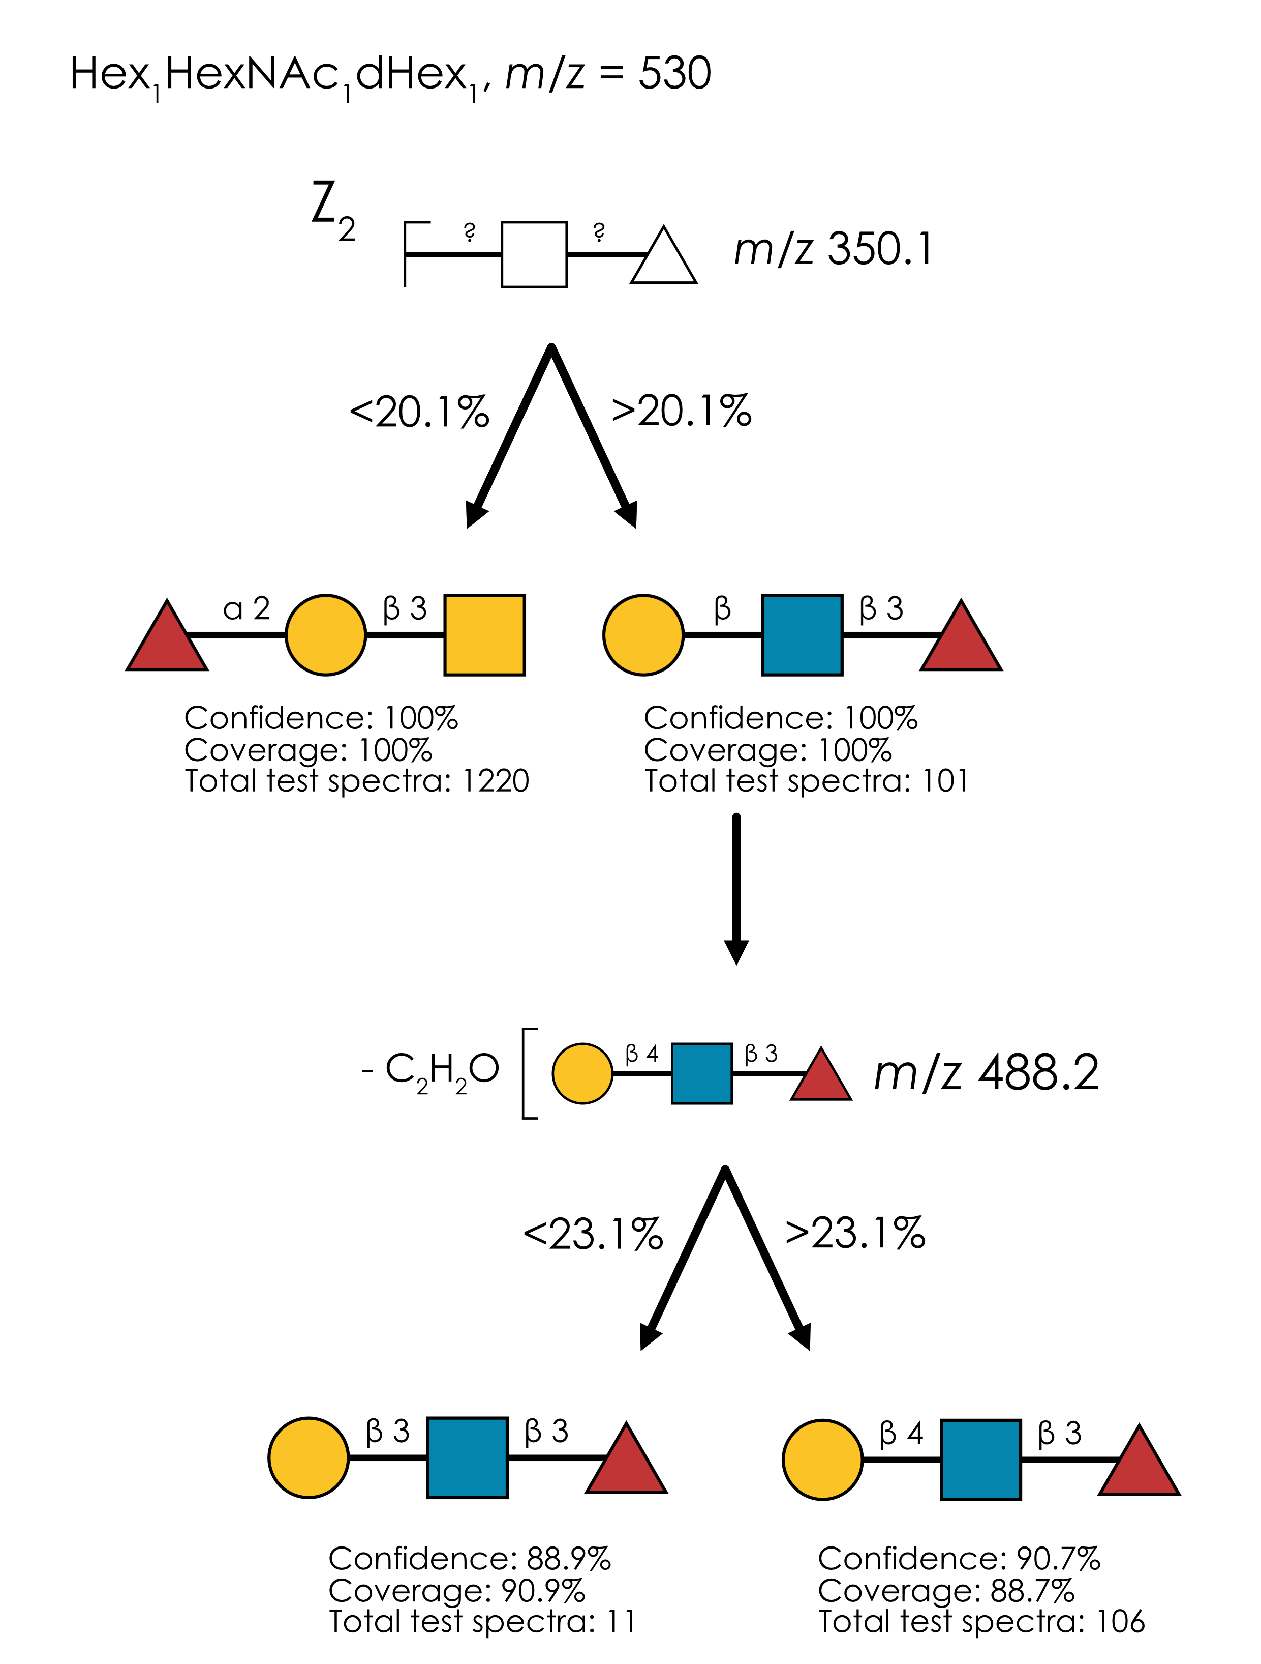
Supplementary Figure 2. Learned annotation rules for Hex₁HexNAc₁dHex₁ (m/z 530). Using our rule-based machine learning approach, we present the best splitting rules for distinguishing isomers of this composition. Thresholds are provided as % of the maximum intensity peak or as ratio values.

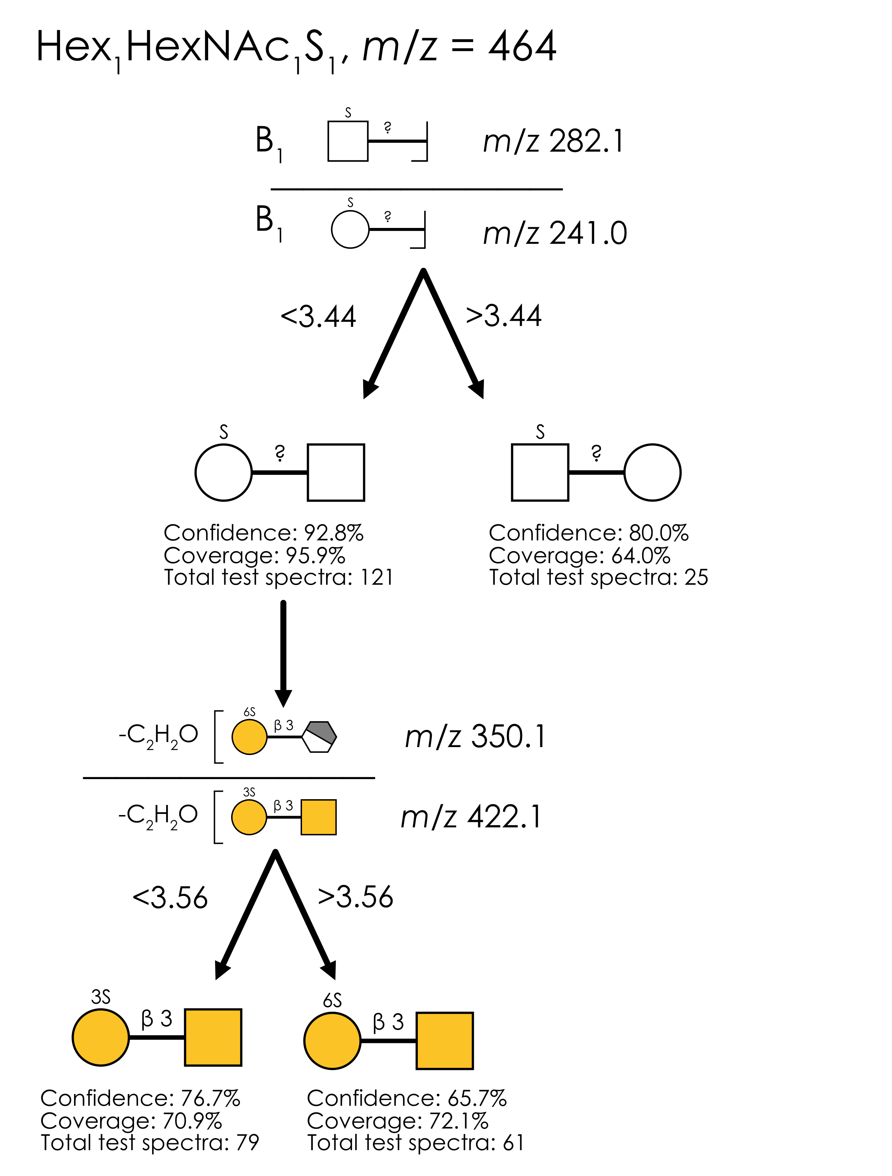
Supplementary Figure 3. Learned annotation rules for Hex₁HexNAc₁S₁ (m/z 464). Using our rule-based machine learning approach, we present the best splitting rules for distinguishing isomers of this composition. Thresholds are provided as % of the maximum intensity peak or as ratio values.

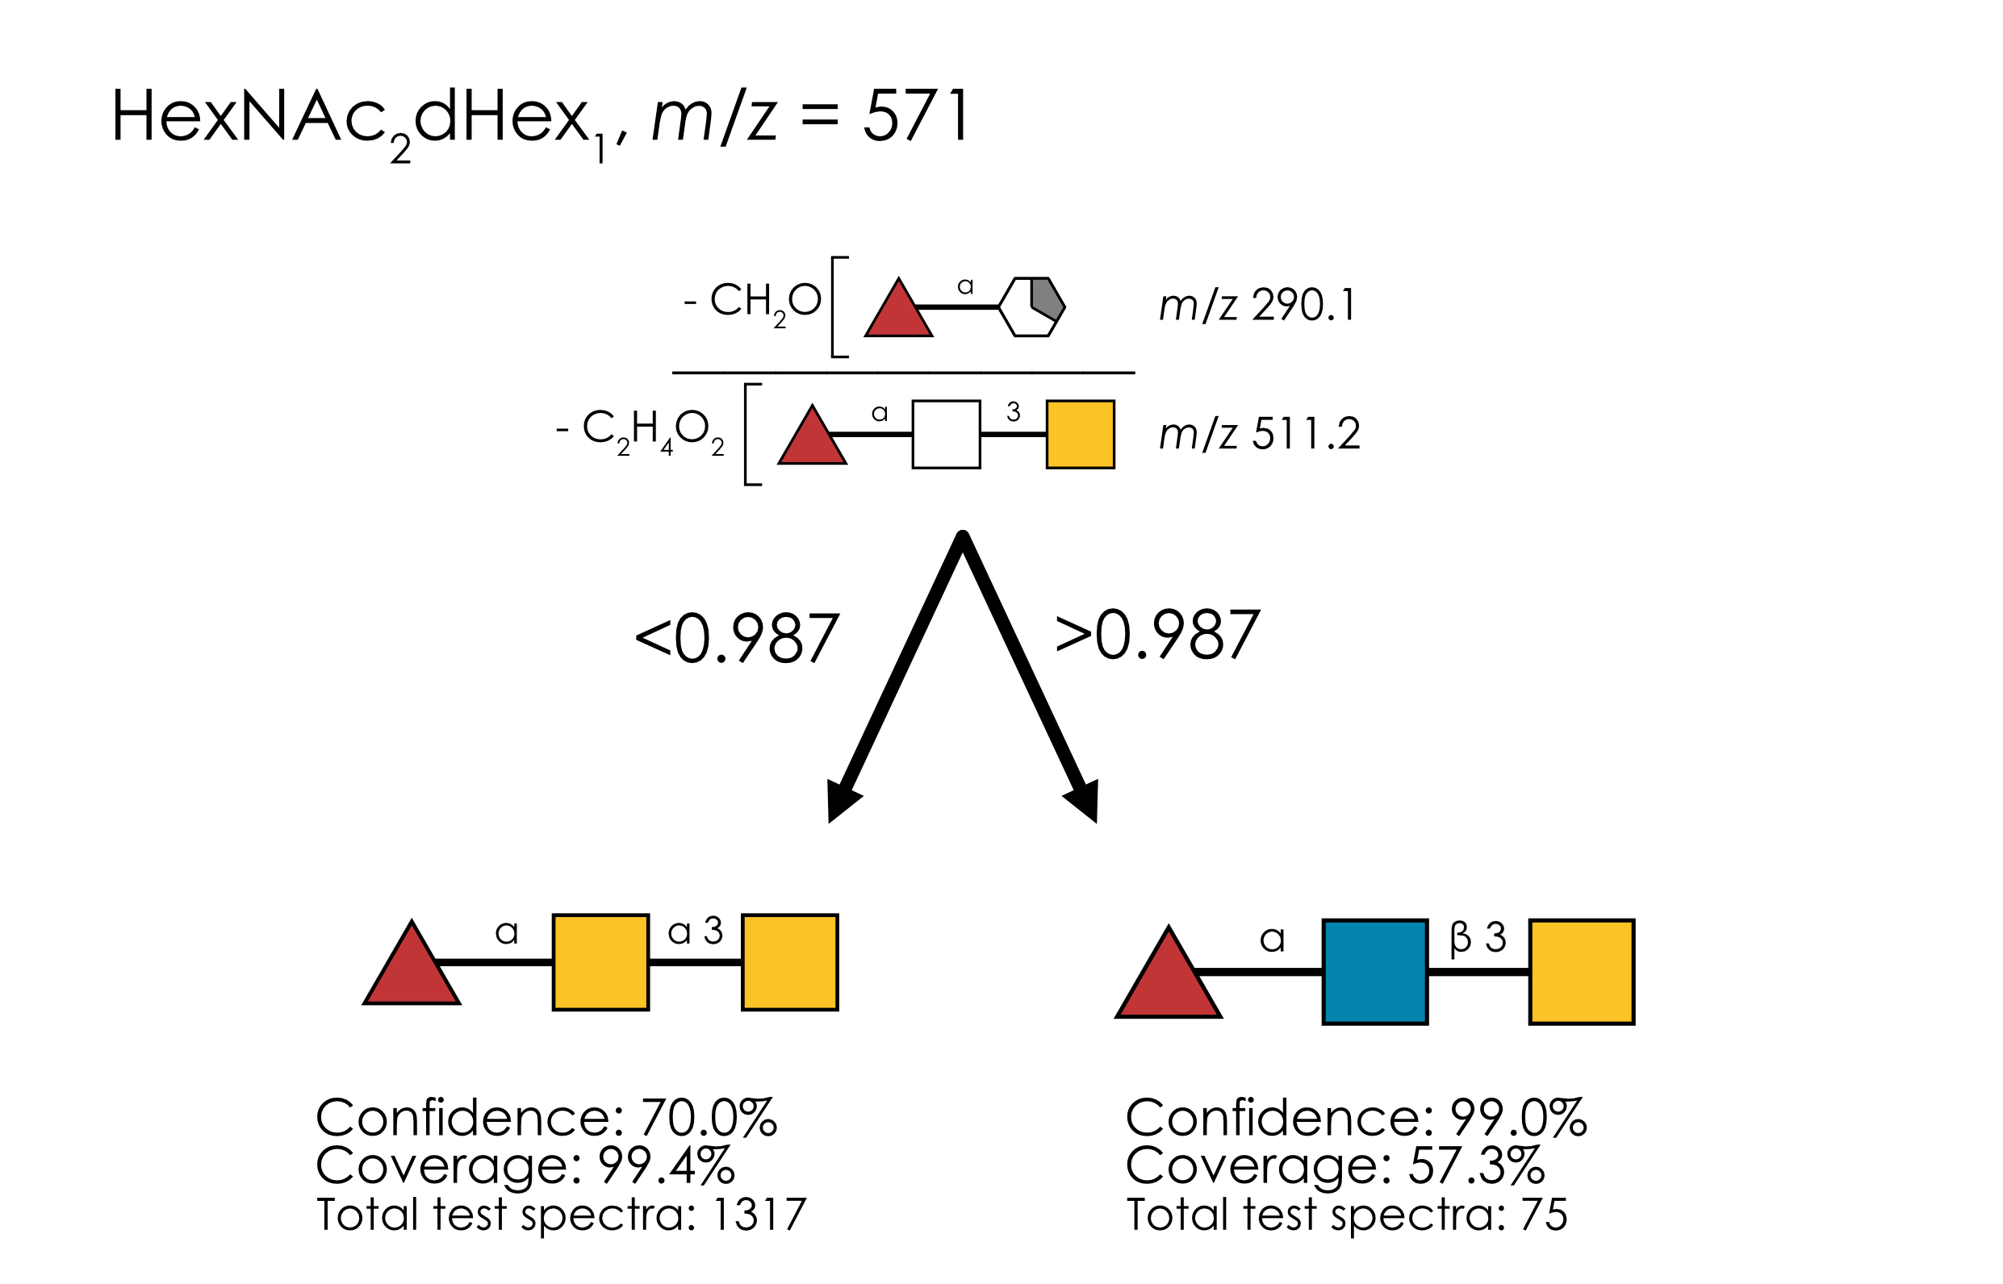
Supplementary Figure 4. Learned annotation rules for HexNAc₂dHex₁ (m/z 571). Using our rule-based machine learning approach, we present the best splitting rules for distinguishing isomers of this composition. Thresholds are provided as % of the maximum intensity peak or as ratio values.

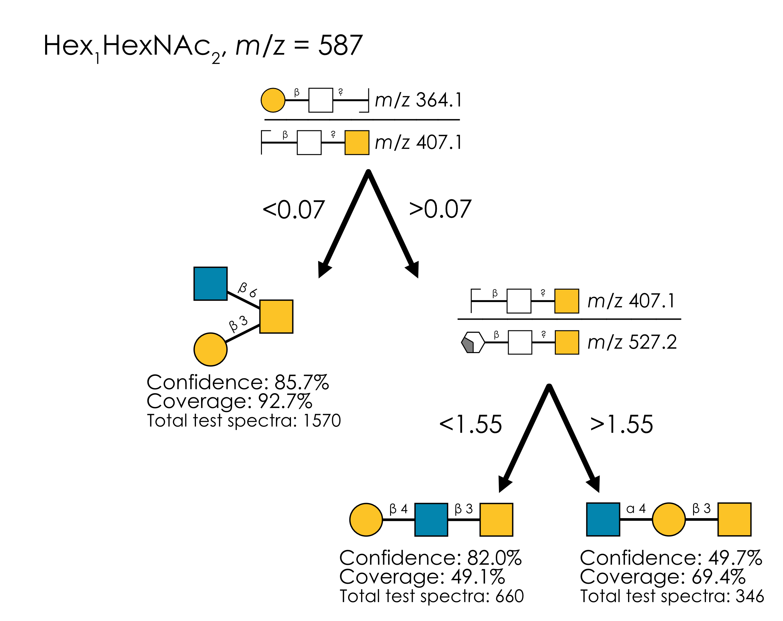
Supplementary Figure 5. Learned annotation rules for Hex₁HexNAc₂ (m/z 587). Using our rule-based machine learning approach, we present the best splitting rules for distinguishing isomers of this composition. Thresholds are provided as % of the maximum intensity peak or as ratio values.

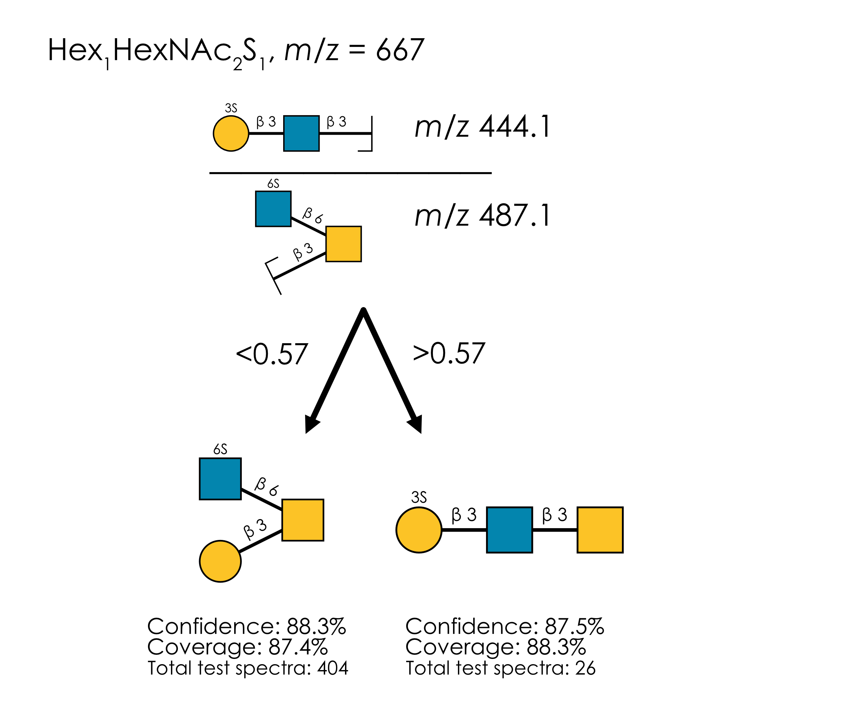
Supplementary Figure 6. Learned annotation rules for Hex₁HexNAc₂S₁ (m/z 667). Using our rule-based machine learning approach, we present the best splitting rules for distinguishing isomers of this composition. Thresholds are provided as % of the maximum intensity peak or as ratio values.

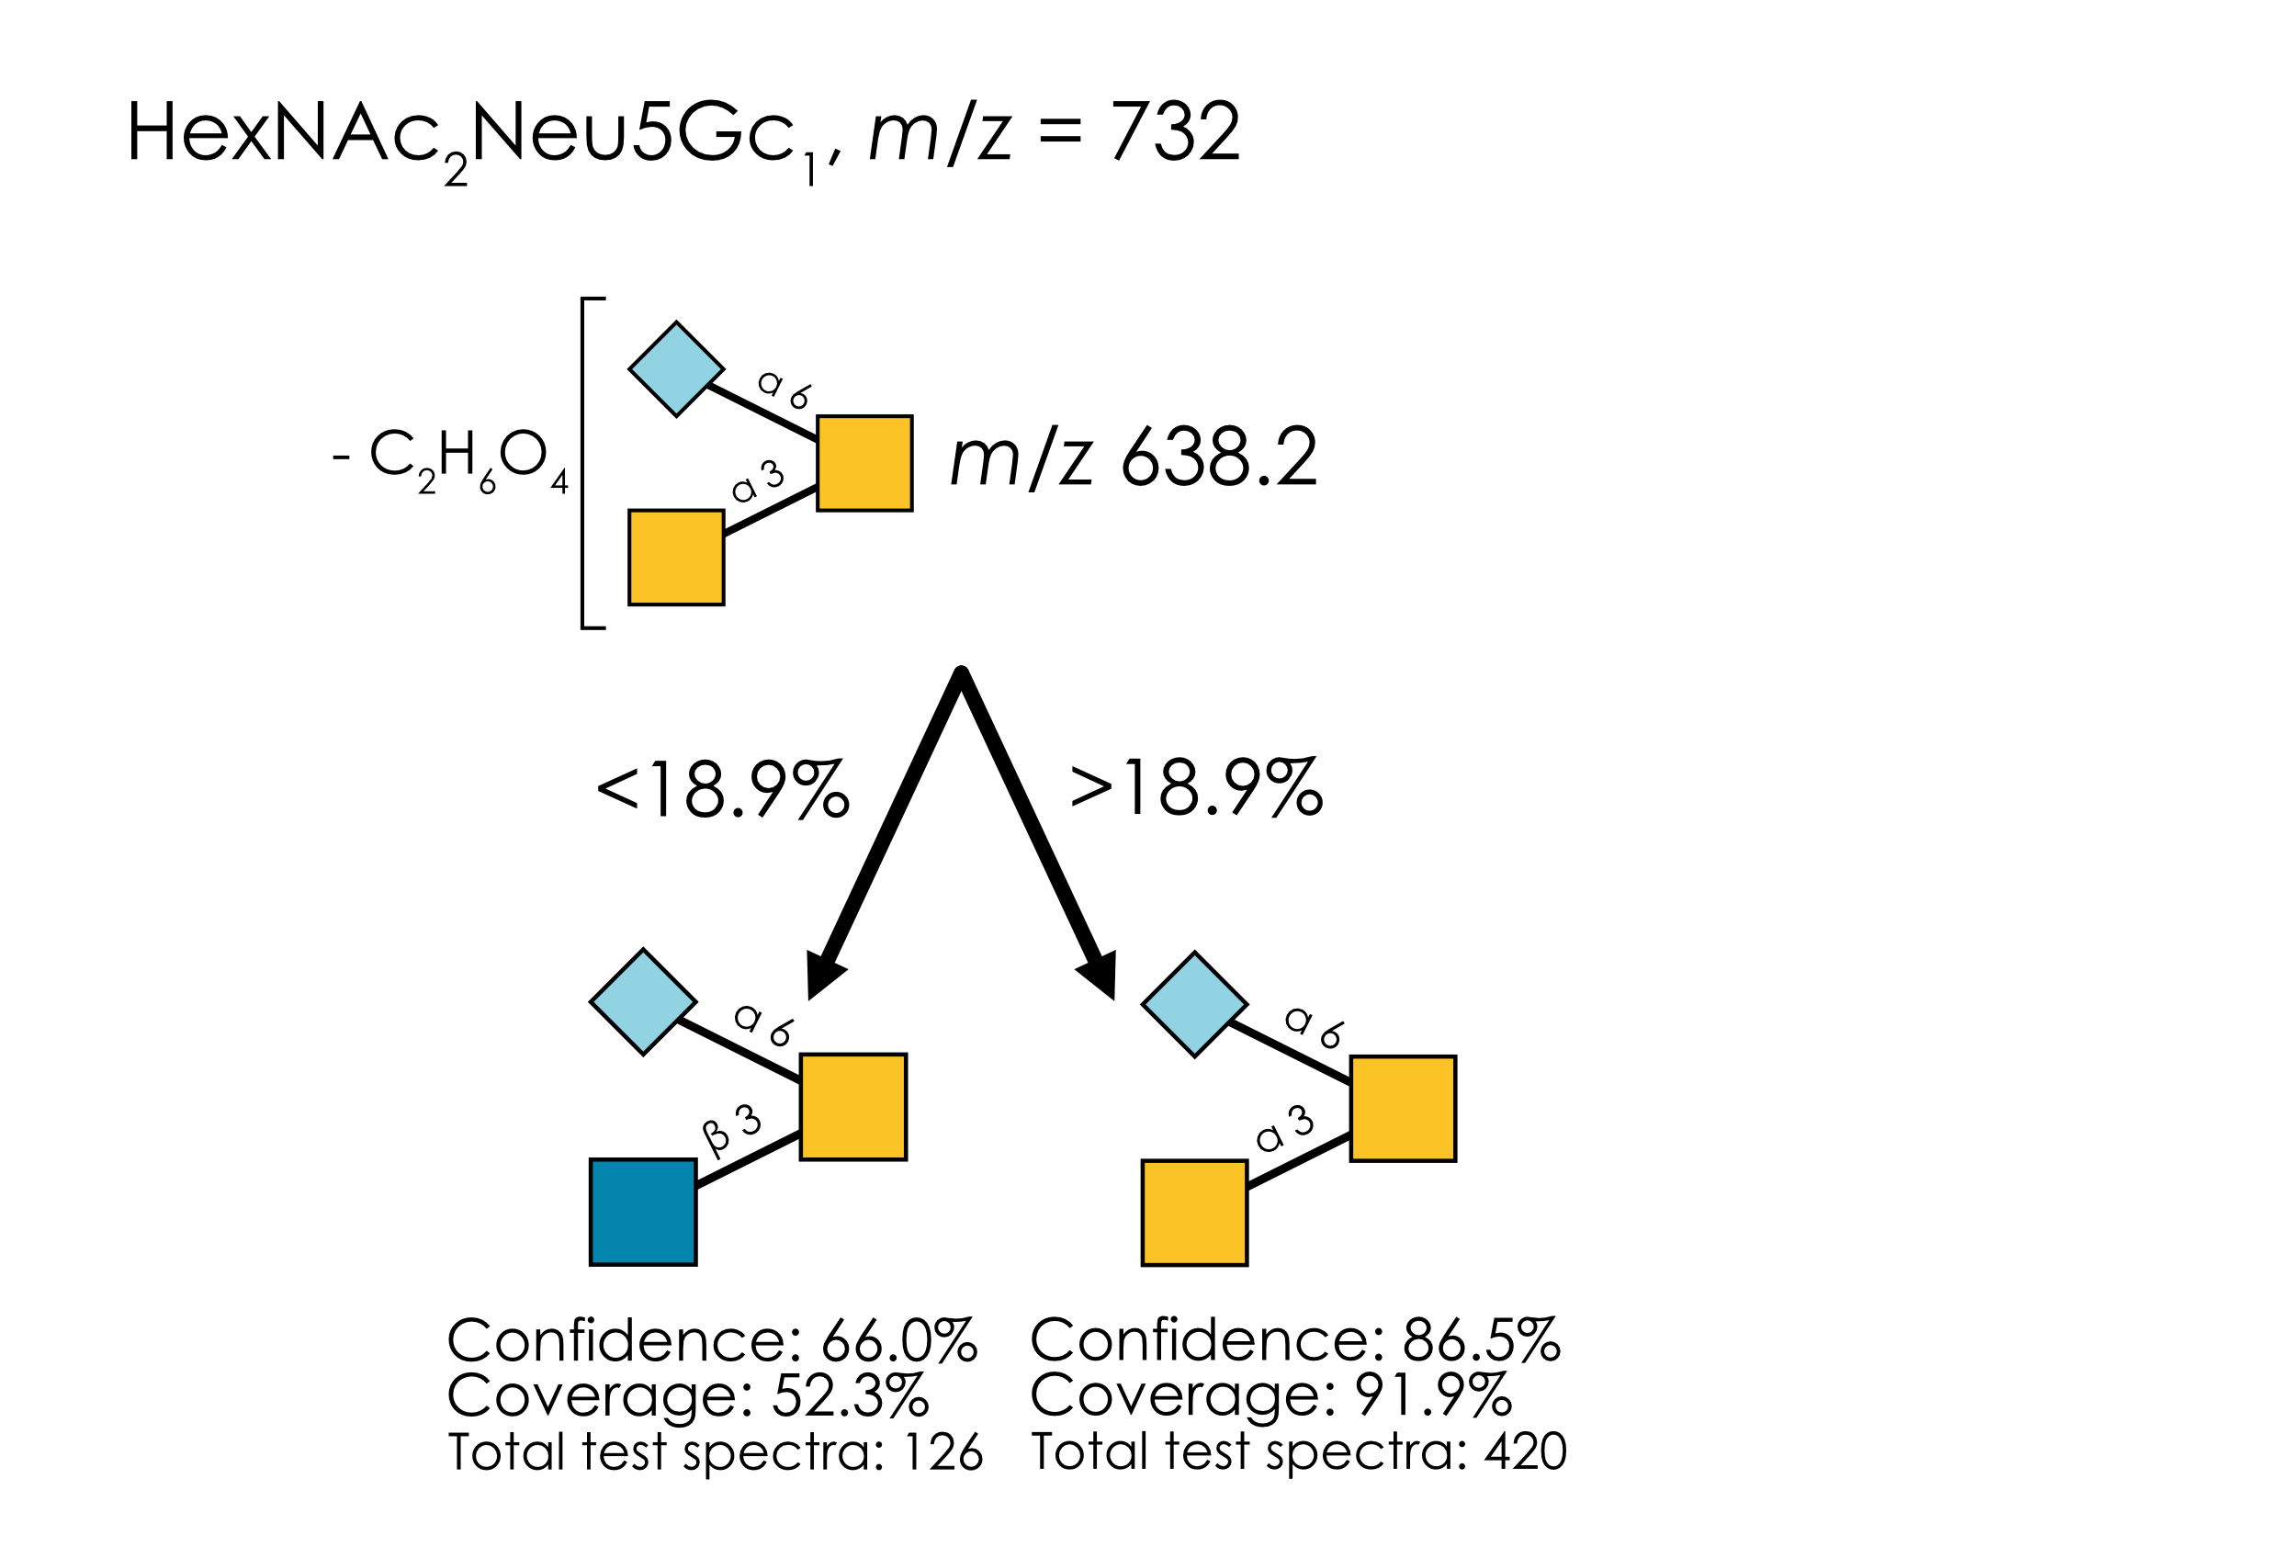
Supplementary Figure 7. Learned annotation rules for HexNAc₂Neu5Gc₁ (m/z 732). Using our rule-based machine learning approach, we present the best splitting rules for distinguishing isomers of this composition. Thresholds are provided as % of the maximum intensity peak or as ratio values.

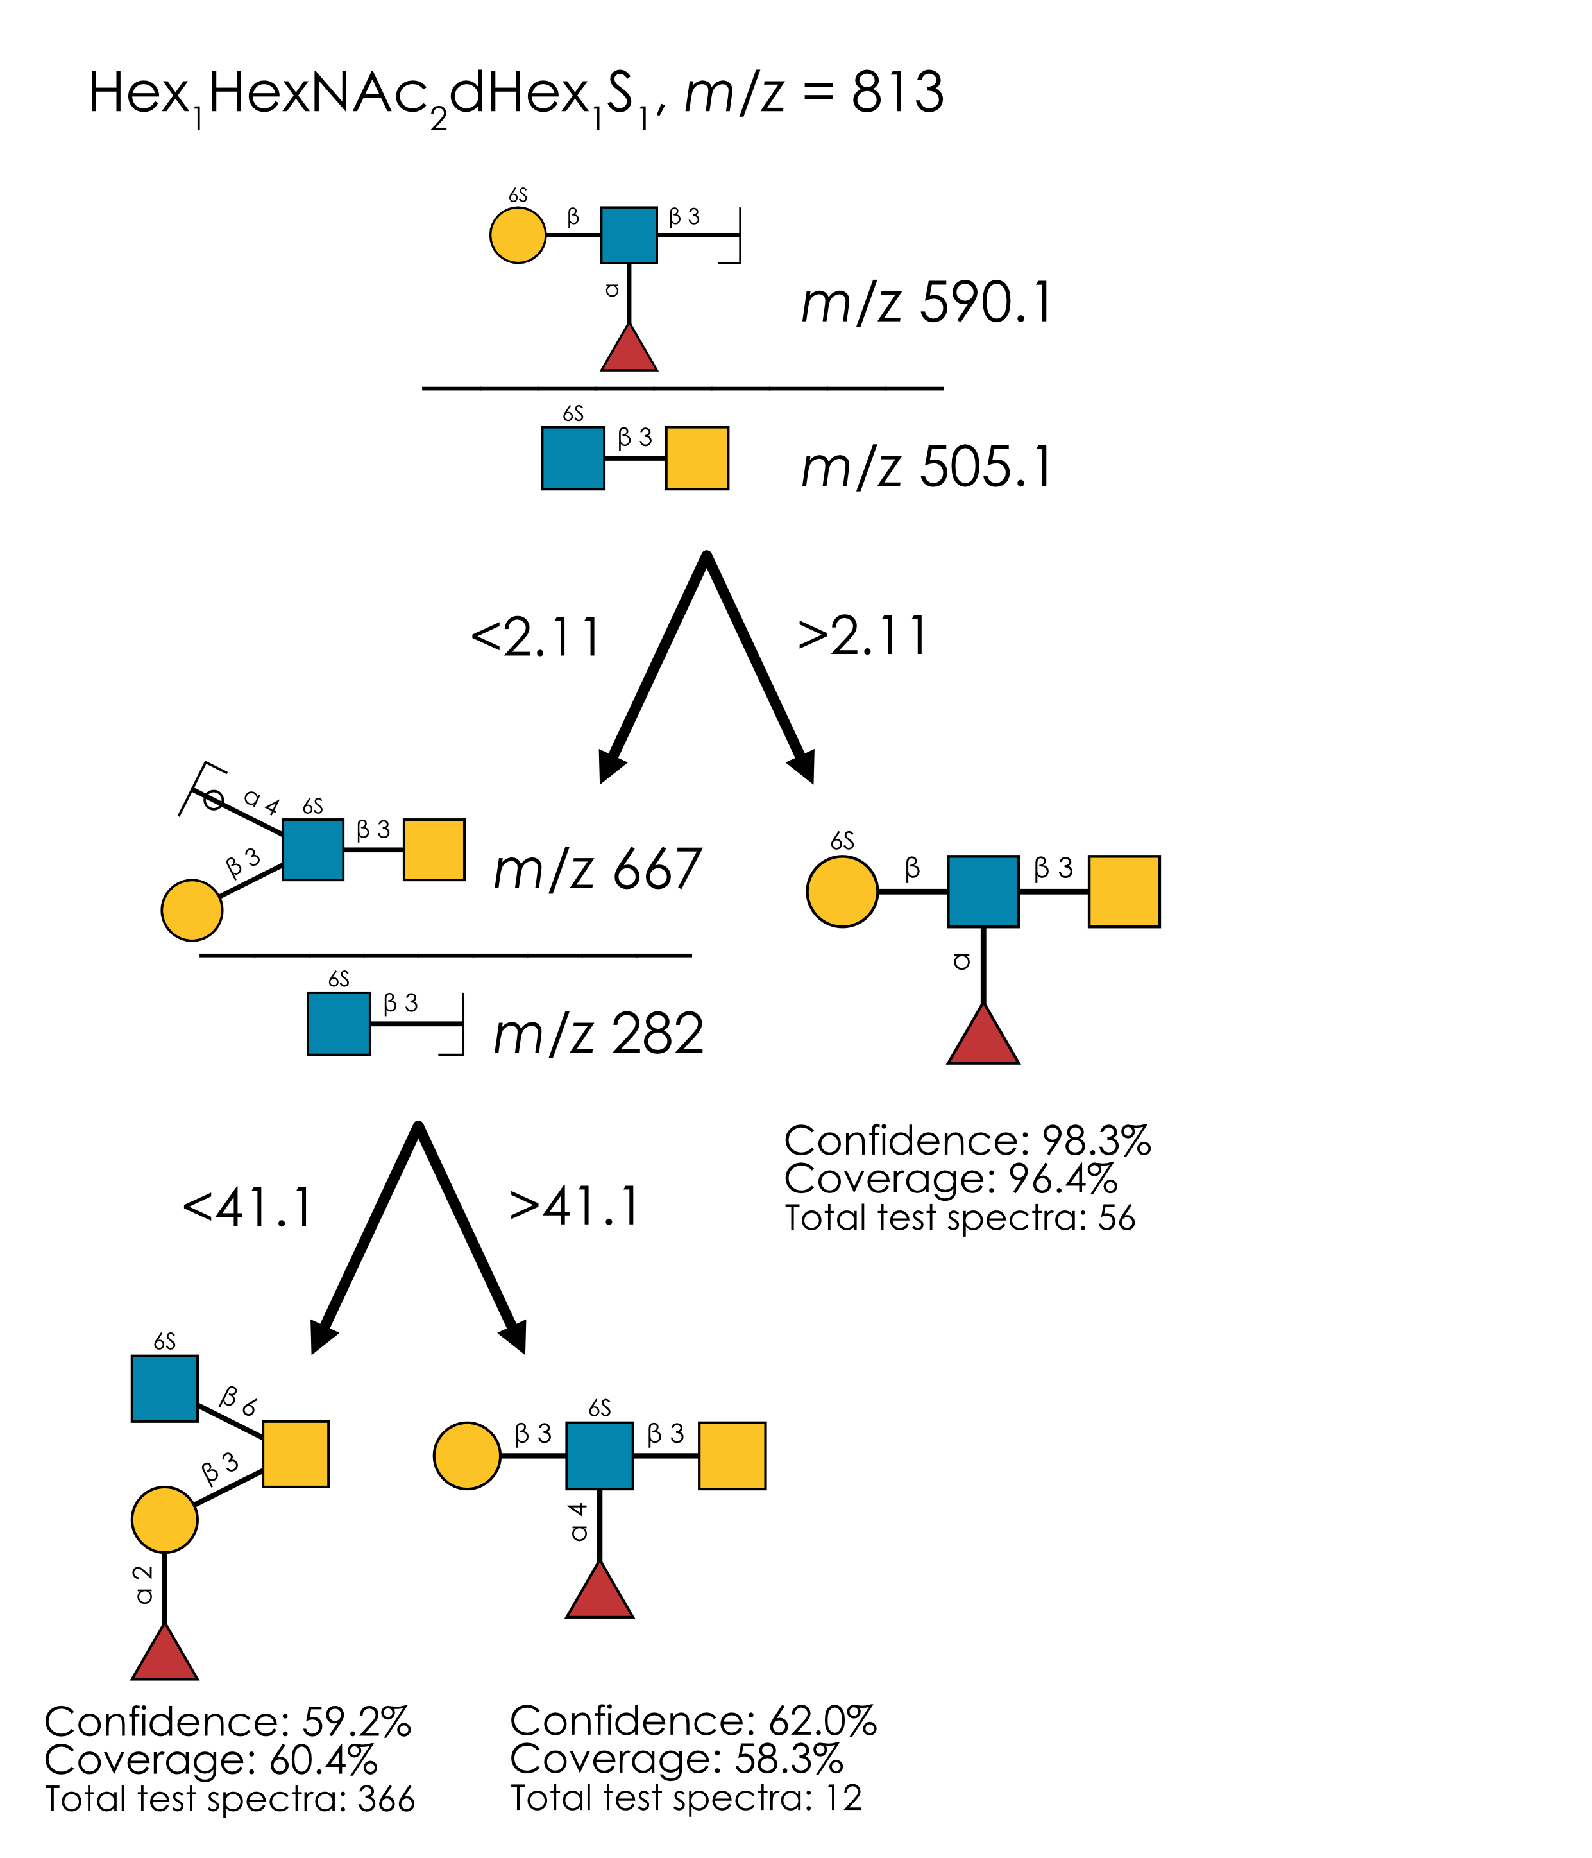
Supplementary Figure 8. Learned annotation rules for Hex₁HexNAc₂dHex₁S₁ (m/z 813). Using our rule-based machine learning approach, we present the best splitting rules for distinguishing isomers of this composition. Thresholds are provided as % of the maximum intensity peak or as ratio values.

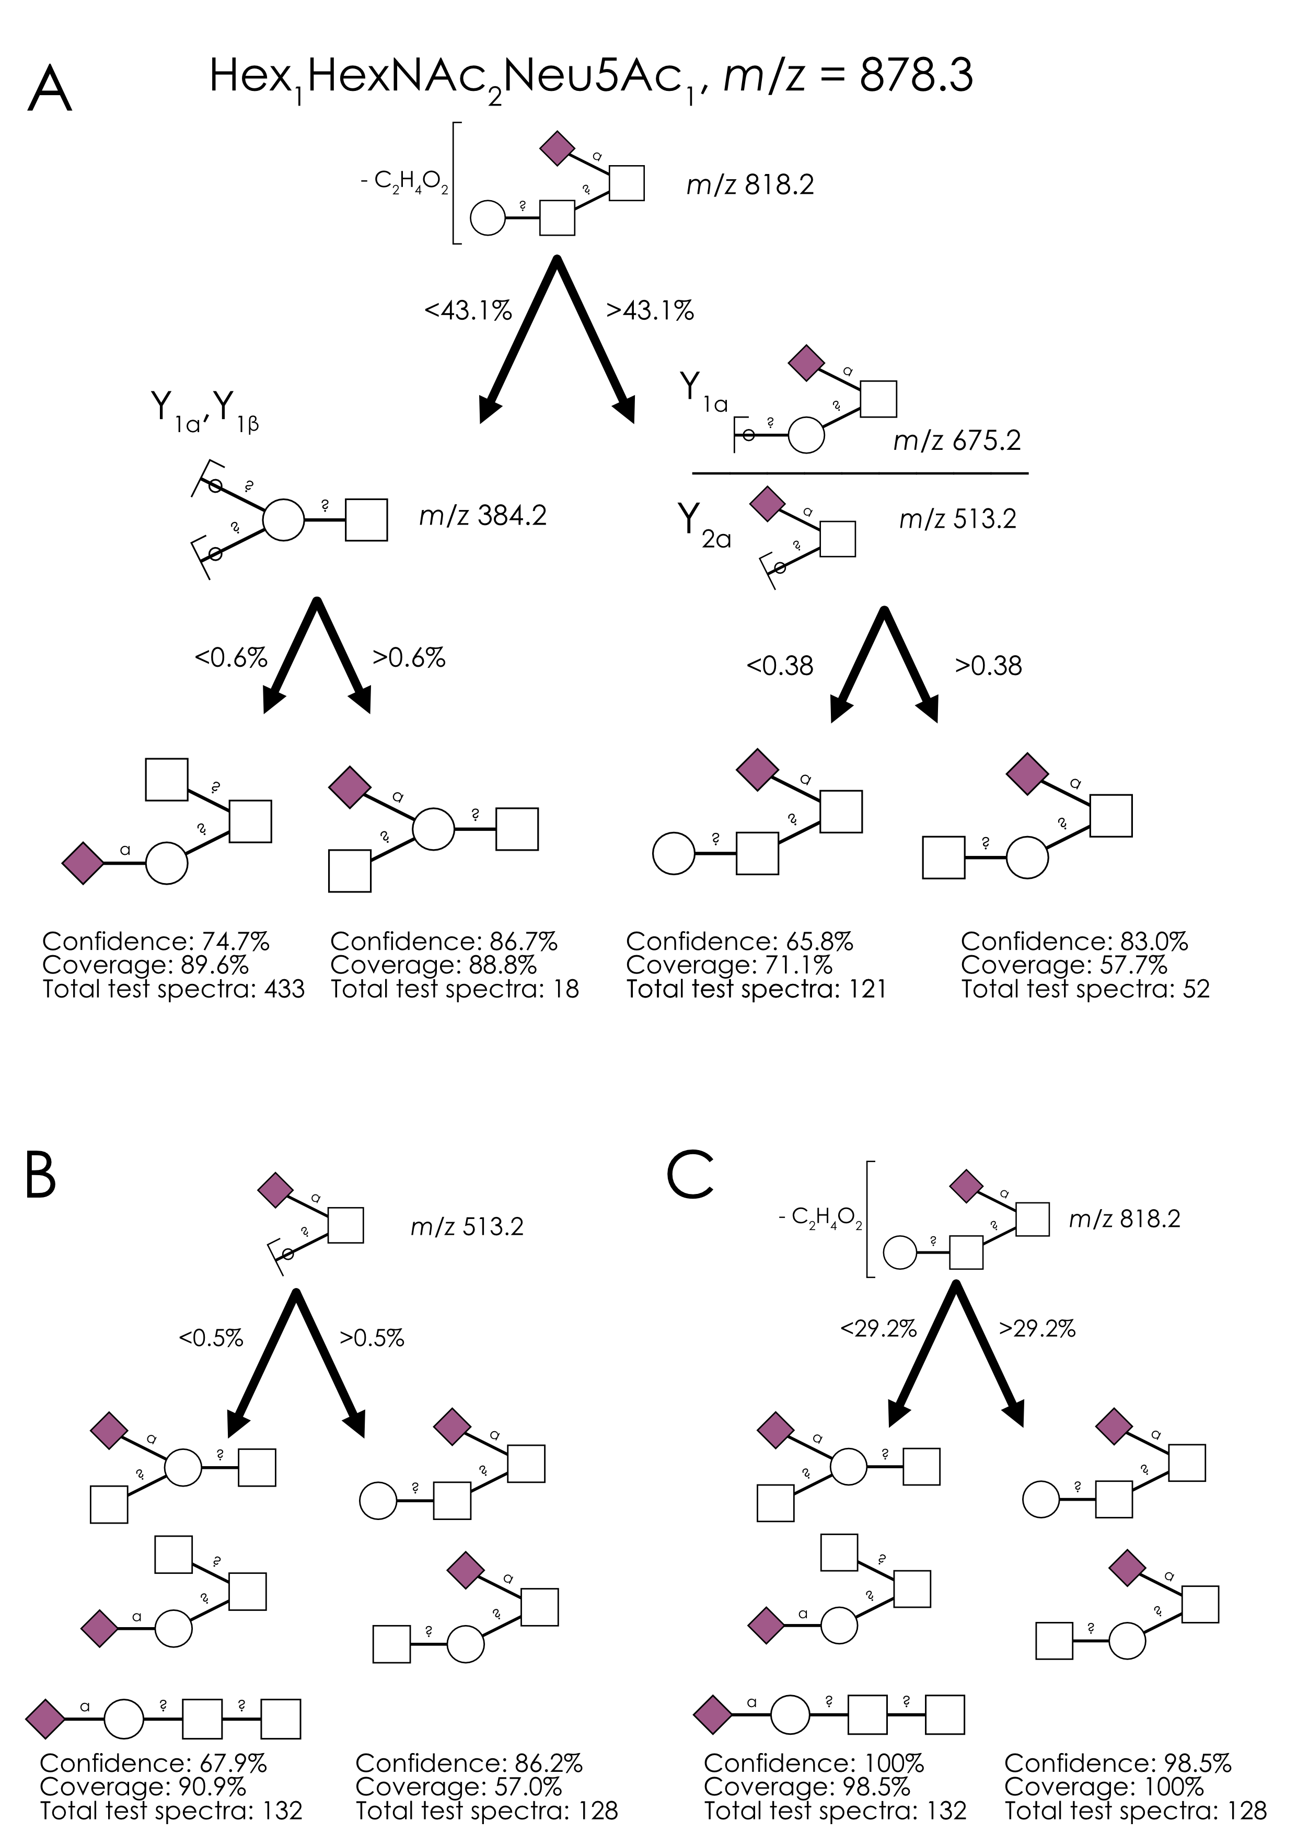
Supplementary Figure 9. Annotating Hex₁HexNAc₂Neu5Ac₁ (m/z 878.3) with different diagnostic fragments. a-c) Using our rule-based machine learning approach, we present the best splitting rules for distinguishing isomers of this composition. Thresholds are provided as % of the maximum intensity peak or as ratio values. The best model used M-C₂H₂O-H₂O (m/z 818.2) as the topological distinguisher (a), which achieved higher confidence than using the traditional m/z 513.2 fragment (b). We further showed that using the M-C₂H₂O-H₂O fragment (m/z 818.2), indicative of Sia-HexNAc in many other isomers, also achieved a higher average confidence and coverage than the aforementioned m/z 513.2 fragment (c).

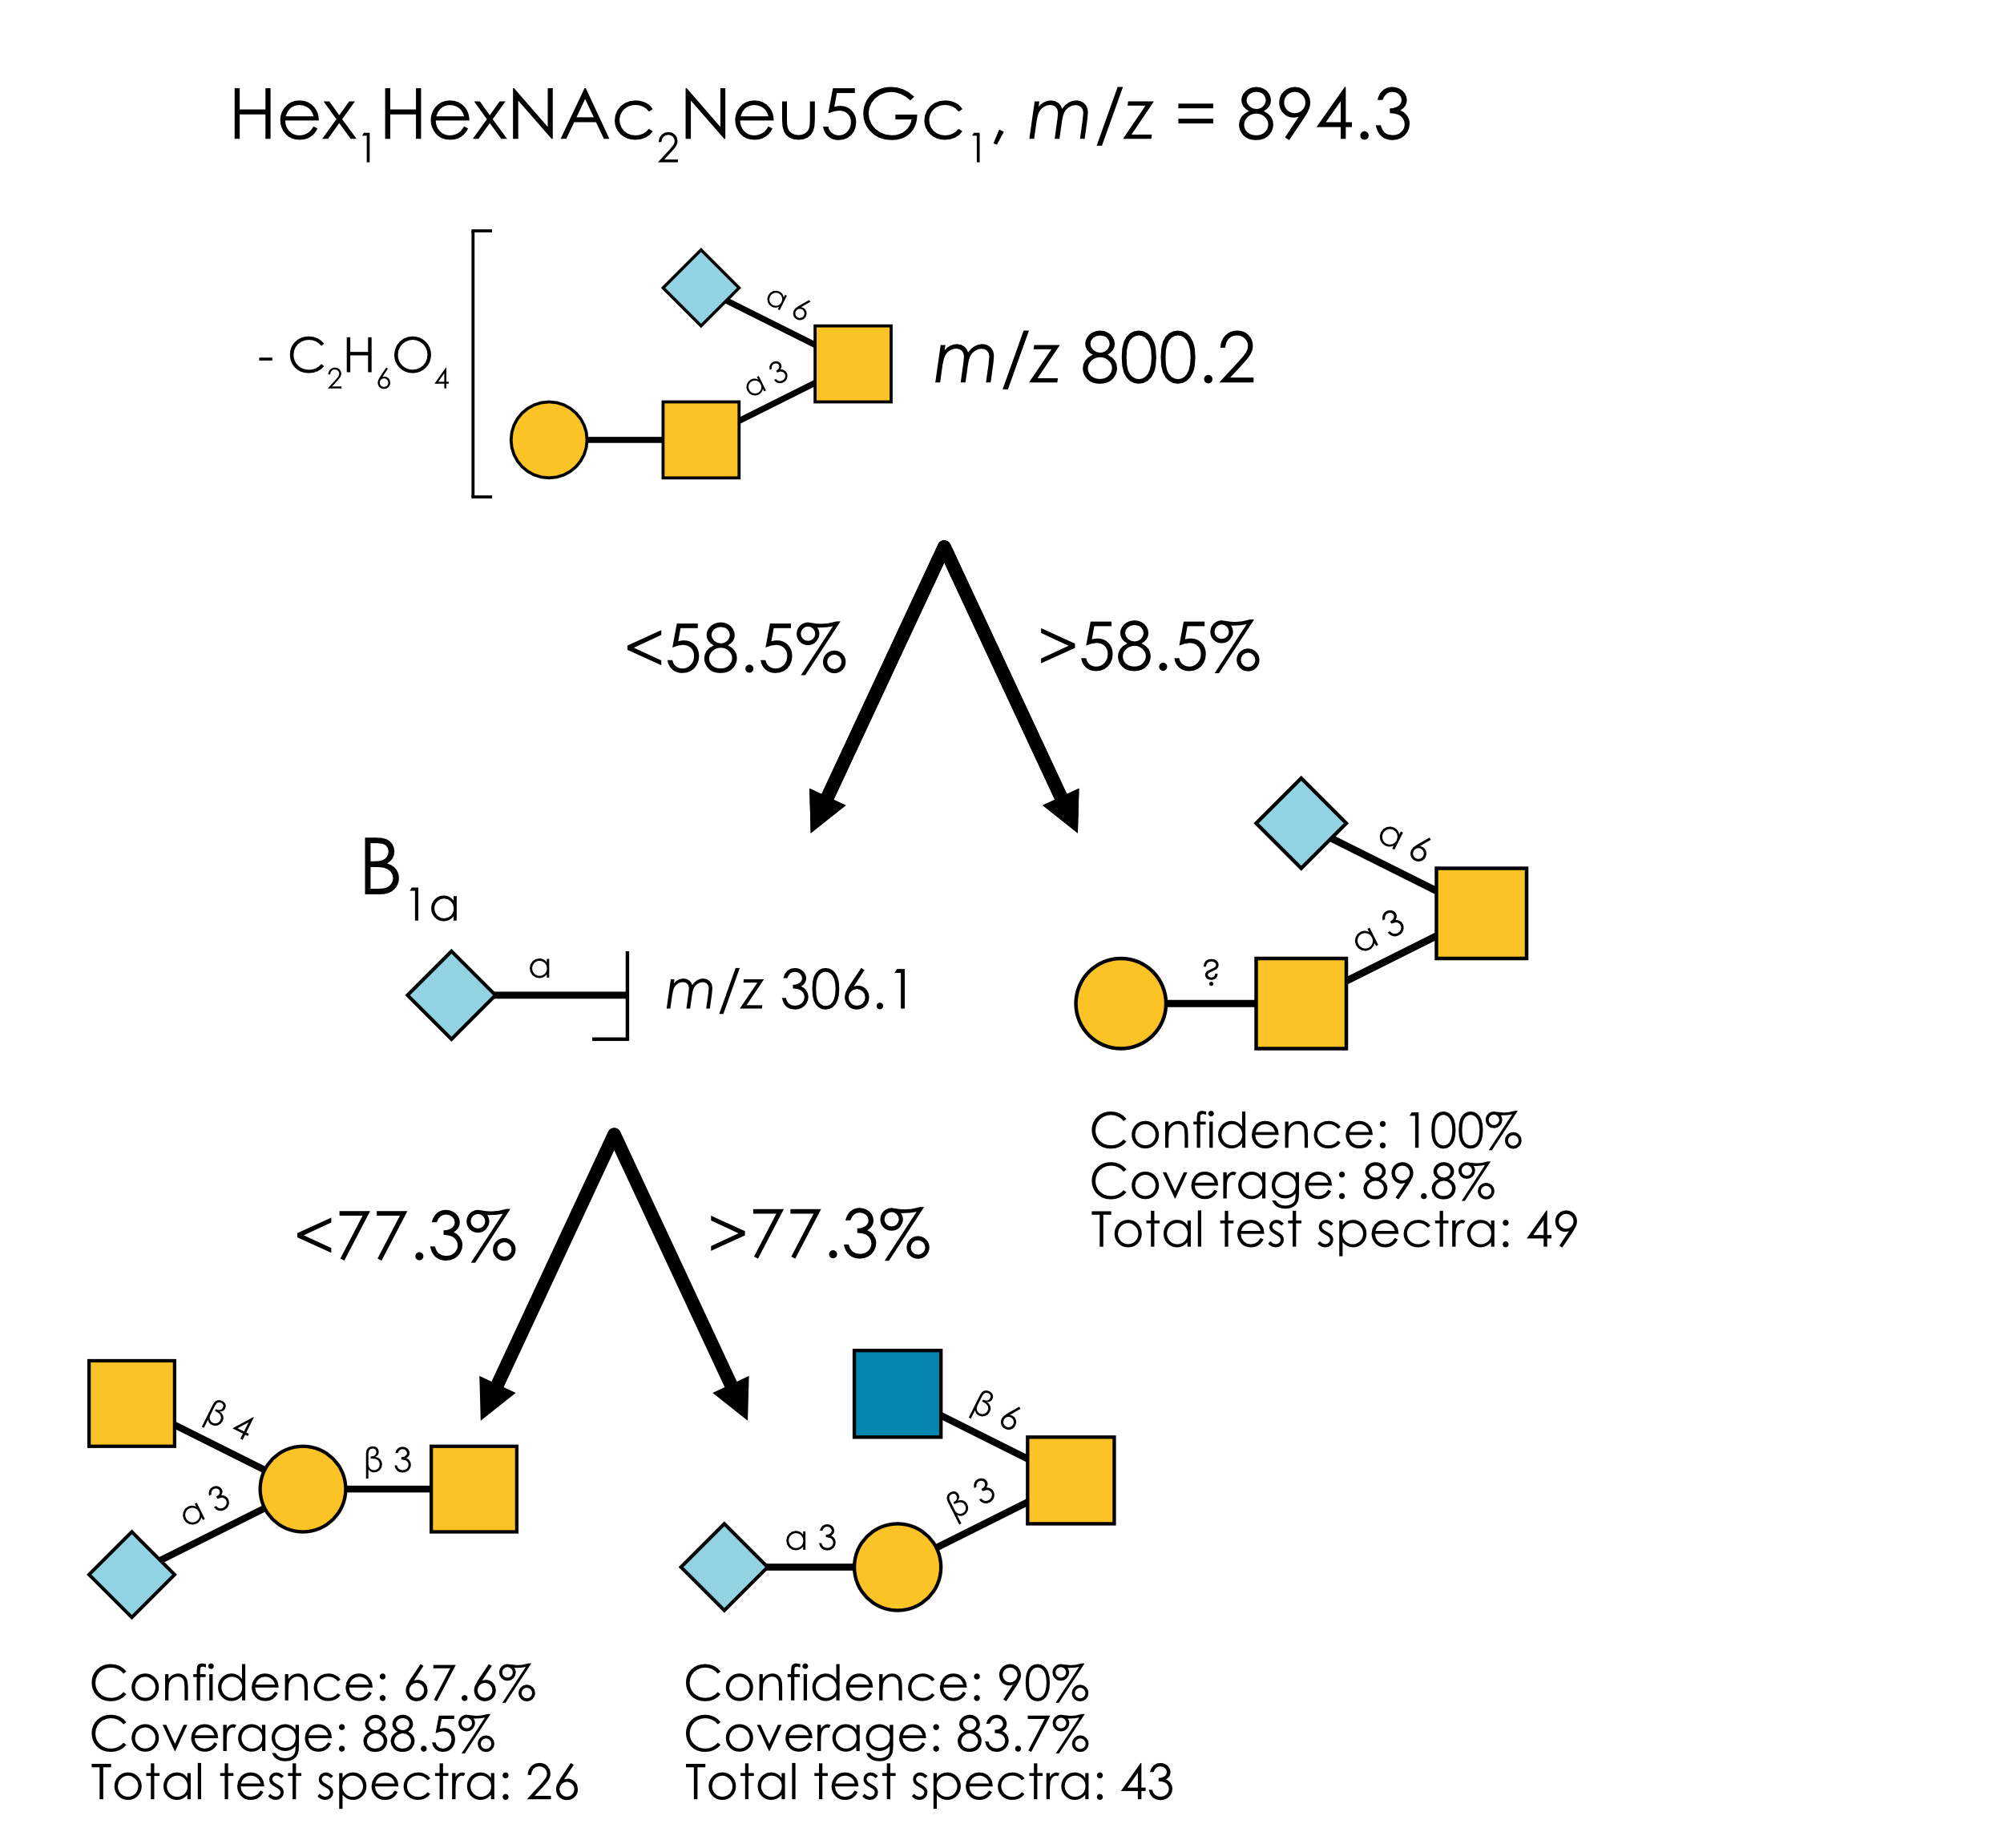
Supplementary Figure 10. Learned annotation rules for Hex₁HexNAc₂Neu5Gc₁ (m/z 894.3). Using our rule-based machine learning approach, we present the best splitting rules for distinguishing isomers of this composition. Thresholds are provided as % of the maximum intensity peak or as ratio values.

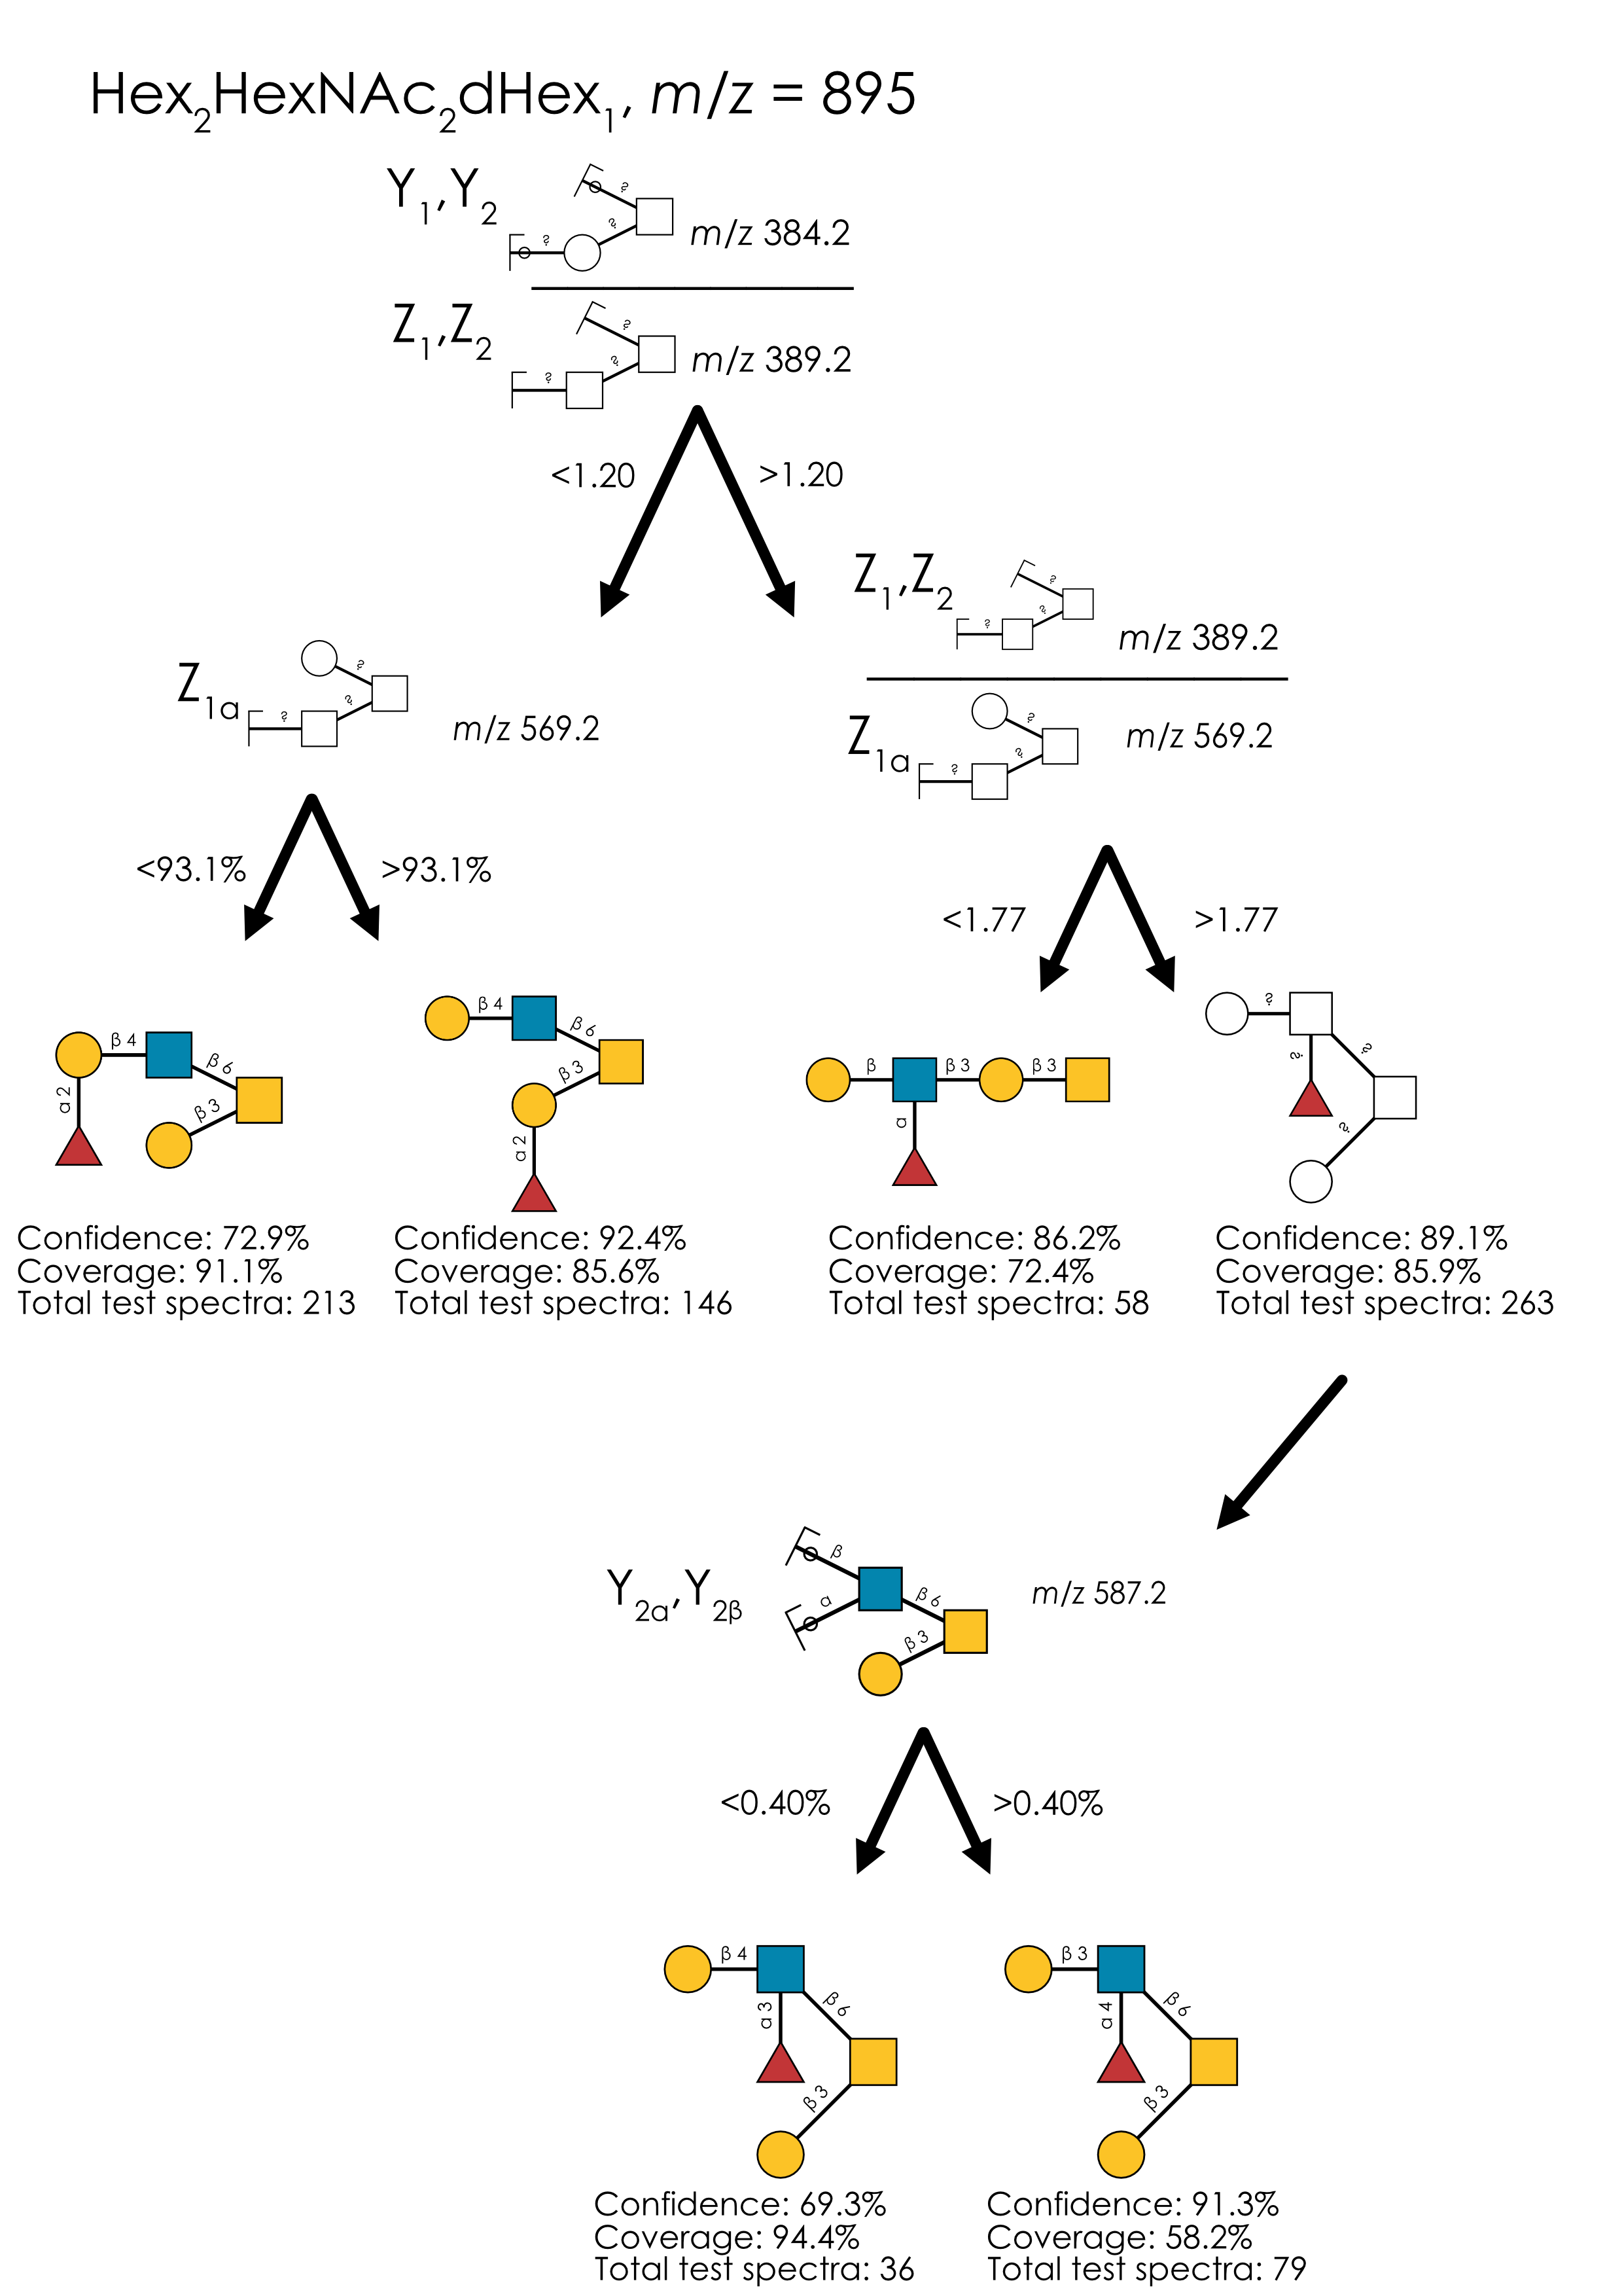
Supplementary Figure 11. Learned annotation rules for Hex₂HexNAc₂dHex₁ (m/z 895). Using our rule-based machine learning approach, we present the best splitting rules for distinguishing isomers of this composition. Thresholds are provided as % of the maximum intensity peak or as ratio values.
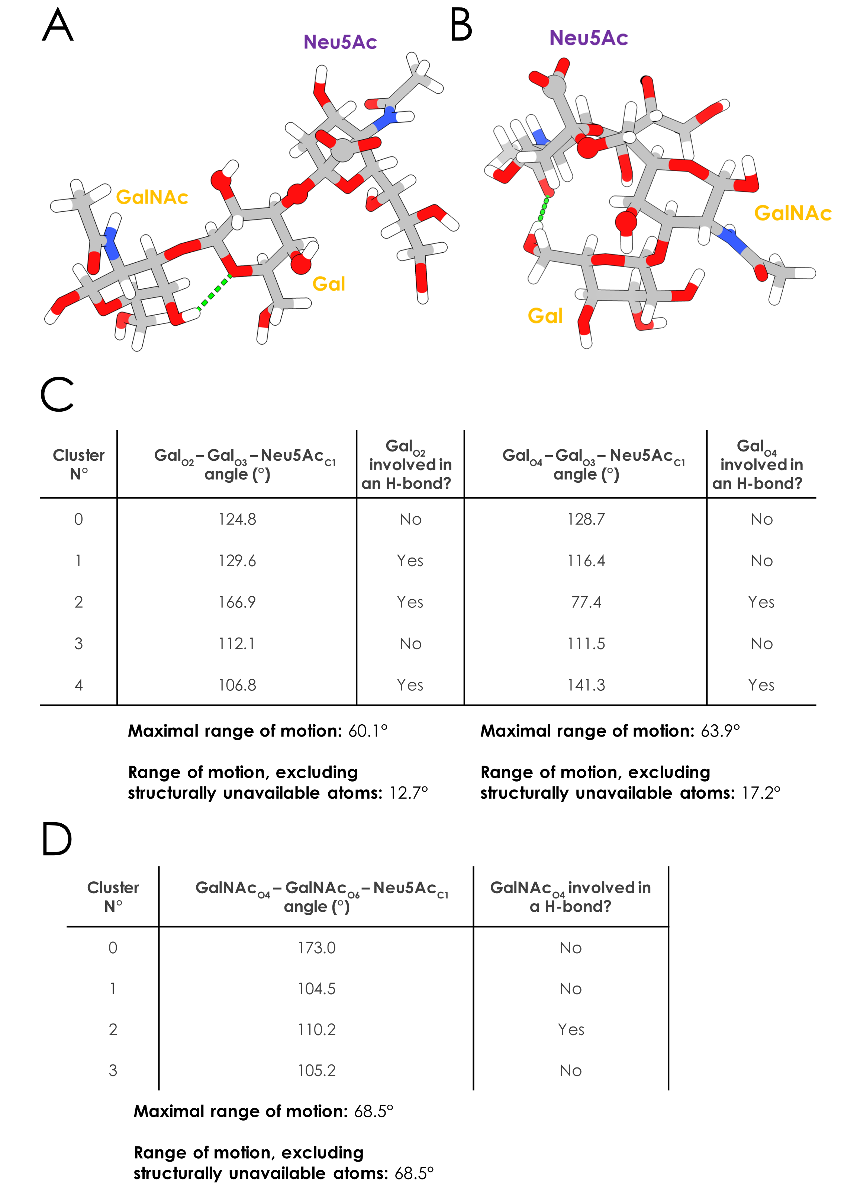
Supplementary Figure 12. Structural flexibility of Hex₁HexNAc₁Neu5Ac₁ isomers. A-B) Representative 3D structures of Neu5Acα2-3Galβ1-3GalNAc (A) and Galβ1-3(Neu5Acα2-6)GalNAc (B) from GlycoShape. Green dotted lines represent predicted hydrogen bonds. Gal_{O2}, Gal_{O3}, and Gal_{O4} (in A), GalNAc_{O4} and GalNAc_{O6} (in B) together with Neu5Ac_{C1}, used to compute torsion angles, are depicted with larger spheres. C-D) Torsion angles from all structural clusters of Neu5Acα2-3Galβ1-3GalNAc (C) and Galβ1-3(Neu5Acα2-6)GalNAc (D). Participation of Gal_{O2} and Gal_{O4} (C) and GalNAc_{O4} (D) in predicted hydrogen bonds is also presented, impacting structural availability.

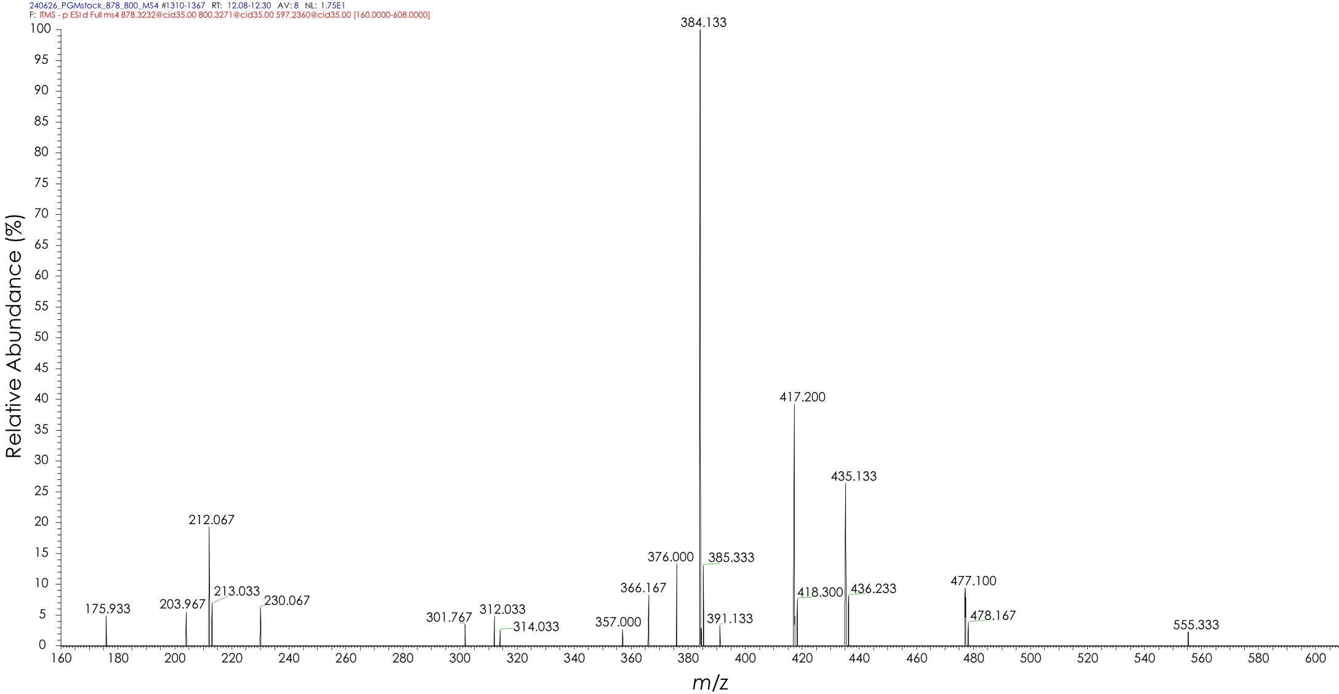
Supplementary Figure 13. Similarity of HexNAc?1-?Galβ1-3(Neu5Acα2-6)GalNAc and Galβ1-3(Neu5Acα2-6)GalNAc diagnostic fragments. MS⁴ spectrum of m/z 597 (-C₂H₆O₃ -HexNAc) fragment taken from the fragmentation of the m/z 800 (-C₂H₆O₃) fragment produced by HexNAc?1-?Galβ1-3(Neu5Acα2-6)GalNAc in porcine gastric mucin.

