Supplementary material

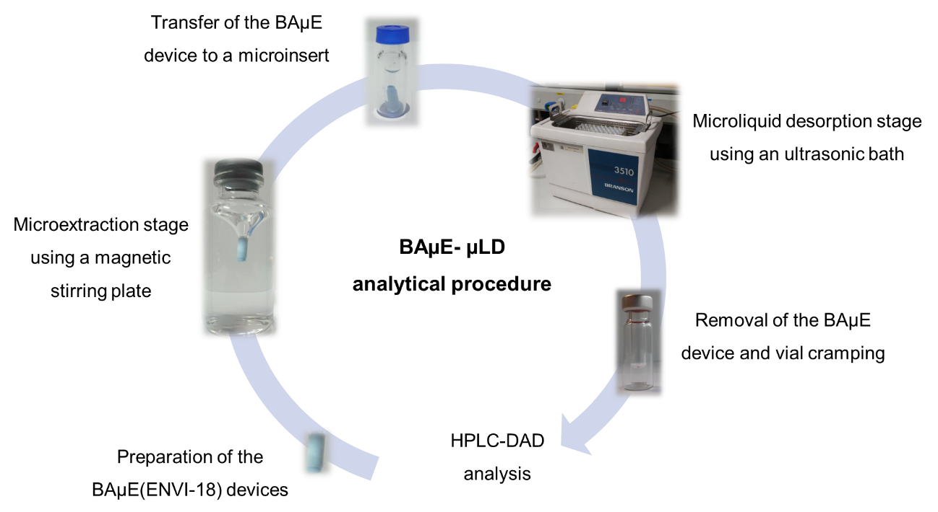

Supplementary data S1 - Simplified schematic of the proposed experimental procedure.

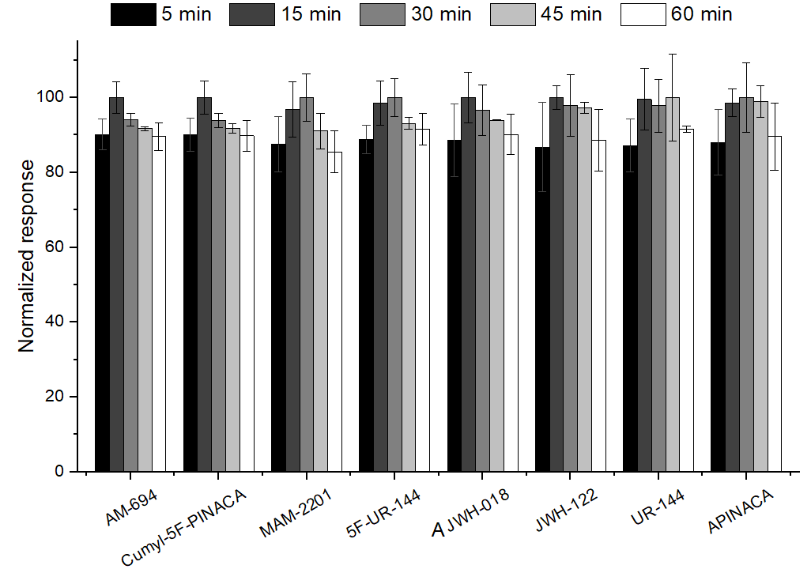

Supplementary data S2 - Effect of sonication time on the back-extraction process for the microextraction of the eight SCs in aqueous media obtained by BAµE-µLD/HPLC-DAD methodology. The error bars represent the standard deviation of three replicates.

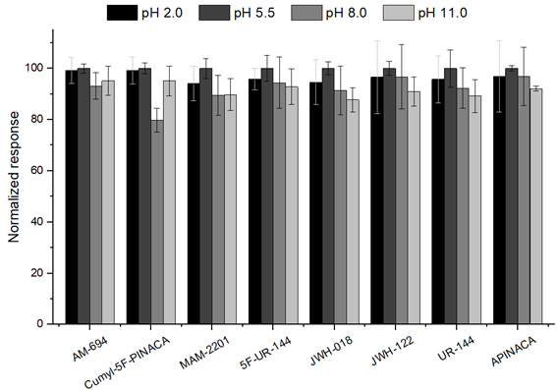

Supplementary data S3 - Effect of matrix pH on the microextraction of the eight SCs in aqueous media obtained by BAµE-µLD/HPLC-DAD methodology. The error bars represent the standard deviation of three replicates.

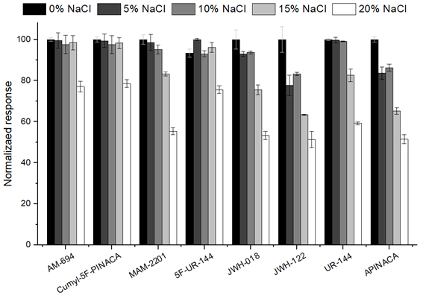

Supplementary data S4 - Effect of ionic strength on the microextraction of the eight SCs in aqueous media obtained by BAµE-µLD/HPLC-DAD methodology. The error bars represent the standard deviation of three replicates.

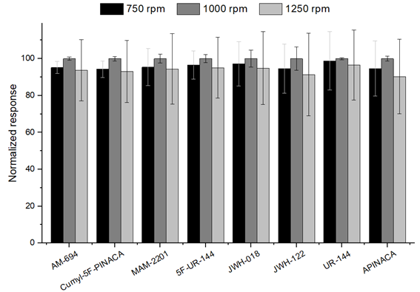

Supplementary data S5 - Effect of stirring rate on the microextraction of the eight SCs in aqueous media obtained by BAµE-µLD/HPLC-DAD methodology. The error bars represent the standard deviation of three replicates.

