Supplementary Information

Determination of Per- and Polyfluoroalkyl substances (PFAS) in six different fish species from Swiss lakes

Mylène Soudani¹, Lucie Hegg², Camille Rime³, Camille Coquoz⁴, Denise Bussien Grosjean⁵, Francesco Danza⁶, Nicola Solcà⁶, Fiorella Lucarini*^{1,7} and Davide Staedler*^{1,8}
¹TIBIO Suisse romande, Chemin de Bérée 4C, 1010 Lausanne, Switzerland
²Center for Primary Care and Public Health (Unisanté), University of Lausanne, Route de la Corniche 2, 1066 Epalinges-Lausanne, Switzerland
³TIBIOLab Sàrl, Route d’Yverdon 34, 1373 Chavornay, Switzerland
⁴Département de la mobilité, du territoire et de l’environnement (DMTE), Service de l’environnement (SEN), Avenue de la Gare 25, 1950 Sion, Switzerland.
⁵Direction de l’environnement industriel, urbain et rural, Direction générale de l’environnement, Etat de Vaud, Chemin des Boveresses 155, 1066 Epalinges, Switzerland
⁶Dipartimento del Territorio, Divisione dell’Ambiente, Sezione della protezione dell'aria dell'acqua e del suolo, Via Franco Zorzi 13, 6501 Bellinzona, Switzerland
⁷School of Engineering and Architecture of Fribourg, Institute of Chemical Technology, HES-SO University of Applied Sciences and Arts of Western Switzerland, Boulevard de Pérolles 80, 1700 Fribourg, Switzerland
⁸Department of Biomedical Sciences, University of Lausanne, Rue du Bugnon 27, 1011 Lausanne, Switzerland
*corresponding authors: fiorella.lucarini@hefr.ch, davide.staedler@unil.ch

Table S1. Standards employed for the calibration curve and sample spiking.
Compounds | Abbrev. | N° CAS | Concentration  µg/mL | Chemical purity %
Perfluorobutanoic acid | PFBA | 375-22-4 | 100 ±3.5 | 98.4
Perfluoropentanoic acid | PFPeA | 2706-90-3 | 100 ±3.5 | 99.6
Perfluorohexanoic acid | PFHxA | 307-24-4 | 100 ±3.5 | 99.0
Perfluoroheptanoic acid | PFHpA | 375-85-9 | 100 ±3.5 | 99.0
Perfluorooctanoic acid | PFOA | 335-67-1 | 100 ±3.5 | 99.0
Perfluorononanoic acid | PFNA | 375-95-1 | 100 ±3.5 | 98.0
Perfluorohexane sulfonic acid | PFHxS | 3871-99-6 | 100 ±3.5 | 98.5
Perfluorobutane sulfonic acid | PFBS | 29420-49-3 | 100 ±3.5 | 99.9
Perfluorooctane sulfonic acid | PFOS | 2795-39-3 | 100 ±3.5 | 99.0
Perfluorodecanoic acid | PFDA | 335-76-2 | 100 ±3.5 | 99.1
Perfluoroundecanoic acid | PFUnA | 2058-94-8 | 100 ±3.5 | 96.0
Perfluorododecanoic acid | PFDoDA | 307-55-1 | 100 ±3.5 | 97.0
Perfluoropentane sulfonic acid | PFPeS | 630402-22-1 | 100 ±3.5 | 95.8
Perfluorooctane sulfonamide | PFOSA | 754-91-6 | 100 ±3.5 | 95.0
Perfluorotetradecanoic acid | PFTA | 376-06-7 | 100 ±3.5 | 99.9

Table S2. Internal standards.
Compound | Abbreviation | Conc. µg/mL | Chemical purity % | Isotopical purity %
Sodium perfluoro-1-(13C8)-octanesulfonate | M8PFOS | 50 | <98 | <99
Perfluoro-n-(1,2-13C2)-hexanoic acid | MPFHxA | 50 | <98 | <99
Perfluoro-n-(13C8)- octanoic acid | M8PFOA | 50 | <98 | <99

Table S3. Details of MS analyses. Parameters for MRM detection in negative mode were: gas flow 15 L min⁻¹; gas temperature 140°C; nebulizer gas 40 psi; sheath gas temperature 375°C; sheath gas flow: 12 L min⁻¹; voltage of the MS capillary 2500 V in negative polarity.
Compounds | Target transition (Tg)  Precursor ion (m/z) | Production ion  (m/z) | Collision energy (V) | Qualifier transition  Precursor ion  (m/z) | Production ion  (m/z) | Retention time
Sodium perfluoro-1-(13C8)-octanesulfonate | 507.00 | 506.90 | 40 | 507.00 | 80.00 | 10.691
Perfluoro-n-(1,2-13C2)-hexanoic acid | 315.00 | 119.00 | 11 | 315.00 | 223.00 | 7.723
Perfluoro-n-(13C8)- octanoic acid | 421.10 | 375.95 | 10 | 421.00 | 172.05 | 9.856
Perfluorobutanoic acid | 213.10 | 169.05 | 9 | 213.10 | 169.05 | 3.169
Perfluoropentanoic acid | 263.00 | 219.05 | 8 | 263.00 | 69.00 | 6.400
Perfluorohexanoic acid | 313.10 | 269.00 | 9 | 313.10 | 119.00 | 7.733
Perfluoroheptanoic acid | 363.10 | 319.05 | 10 | 363.10 | 169.00 | 8.889
Perfluorooctanoic acid | 413.00 | 369.95 | 10 | 413.00 | 169.05 | 9.767
Perfluorononanoic acid | 463.00 | 418.95 | 10 | 463.00 | 219.00 | 10.660
Perfluorohexane sulfonic acid | 399.00 | 98.95 | 47 | 399.00 | 79.95 | 8.919
Perfluorobutane sulfonic acid | 298.90 | 79.90 | 34 | 298.90 | 98.95 | 6.765
Perfluorooctane sulfonic acid | 498.90 | 79.95 | 59 | 498.90 | 98.90 | 10.676
Perfluorodecanoic acid | 513.00 | 468.95 | 11 | 512.90 | 219.00 | 11.408
Perfluoroundecanoic acid | 563.00 | 518.95 | 11 | 563.10 | 269.00 | 12.081
Perfluorododecanoic acid | 612.90 | 569.00 | 11 | 612.90 | 169.00 | 12.638
Perfluoropentane sulfonic acid | 349.00 | 79.90 | 10 | 349.00 | 98.90 | 7.918
Perfluorooctane sulfonamide | 498.10 | 77.95 | 35 | 498.10 | 219.00 | 12.125
Perfluorotetradecanoic acid | 712.90 | 669.10 | 10 | 712.90 | 169.00 | 13.574

Table S4. Mean recovery of spiked standard in water at 0.1 and 0.5 μg/kg in triplicate calculated with respect to calibration curve in solvent.

 | Recovery % (RSD, %)
PFBS | 91% (3.5)
PFDA | 103% (5.4)
PFHpA | 97% (2.1)
PFHpS | 95% (4.3)
PFHxA | 90% (1.5)
PFHxS | 98% (6.3)
PFNA | 94% (4.1)
PFOA | 89% (3.9)
PFOS | 105% (6.3)
PFOSA | 87% (5.2)
PFPeA | 93% (4.6)
PFPeS | 111% (6.7)
PFTA | 85% (7.4)
PFDoDA | 96% (3.7)
PFUnA | 108% (5.8)

Table S5. Mean recovery of PFAS calculated on 22 spiked samples at PFAS concentrations of 0.1 and 0.5 μg/kg.
 | QuEChERS extraction
 | Recovery % (RSD, %)
PFBS | 110% (10.5)
PFDA | 115% (9.2)
PFHpA | 98% (8.5)
PFHpS | 91% (7.3)
PFHxA | 83% (2.8)
PFHxS | 106% (7.5)
PFNA | 96% (1.2)
PFOA | 98% (4.2)
PFOS | 98% (5.4)
PFOSA | 75% (6.9)
PFPeA | 90% (3.0)
PFPeS | 97% (4.3)
PFTA | 101% (8.8)
PFDoDA | 103% (6.7)
PFUnA | 102% (6.9)

Fig. S1. Box‐whisker plot of the fillet perfluorononanoic acid (PFNA) concentration. Concentration is compared between species by a t-test: p-value >0.05 for all comparisons.

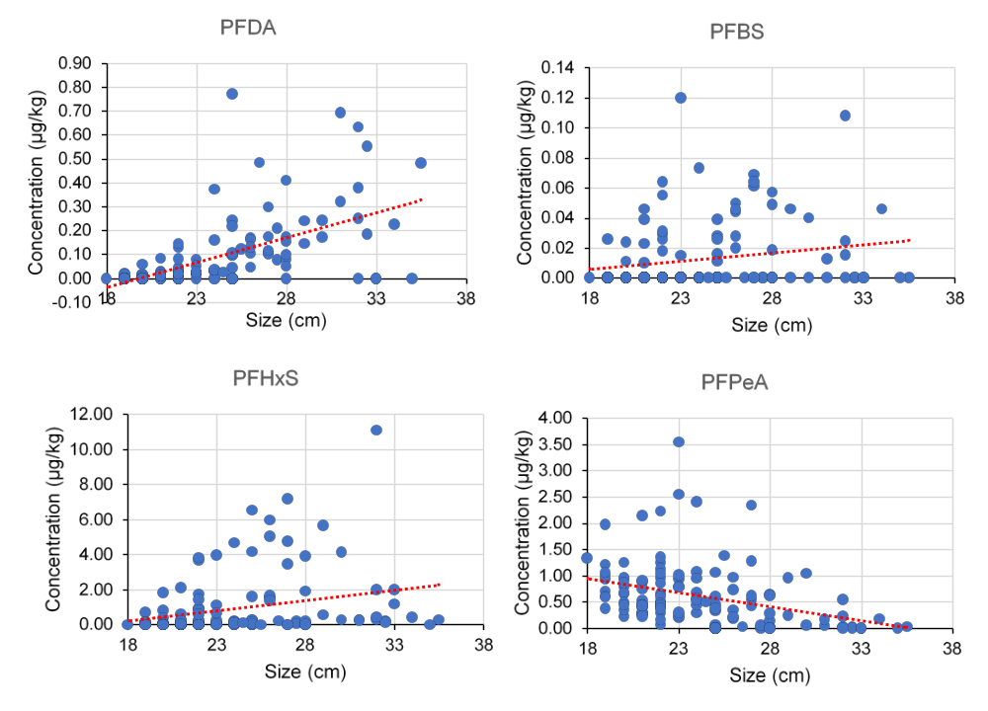
Fig. S2. PFAS and fish size correlation for PFDA (significant positive correlation), PFBS (significant positive correlation), PFHxS (significant positive correlation) and PfPeA (significant negative correlation). In red: trend line (linear).

