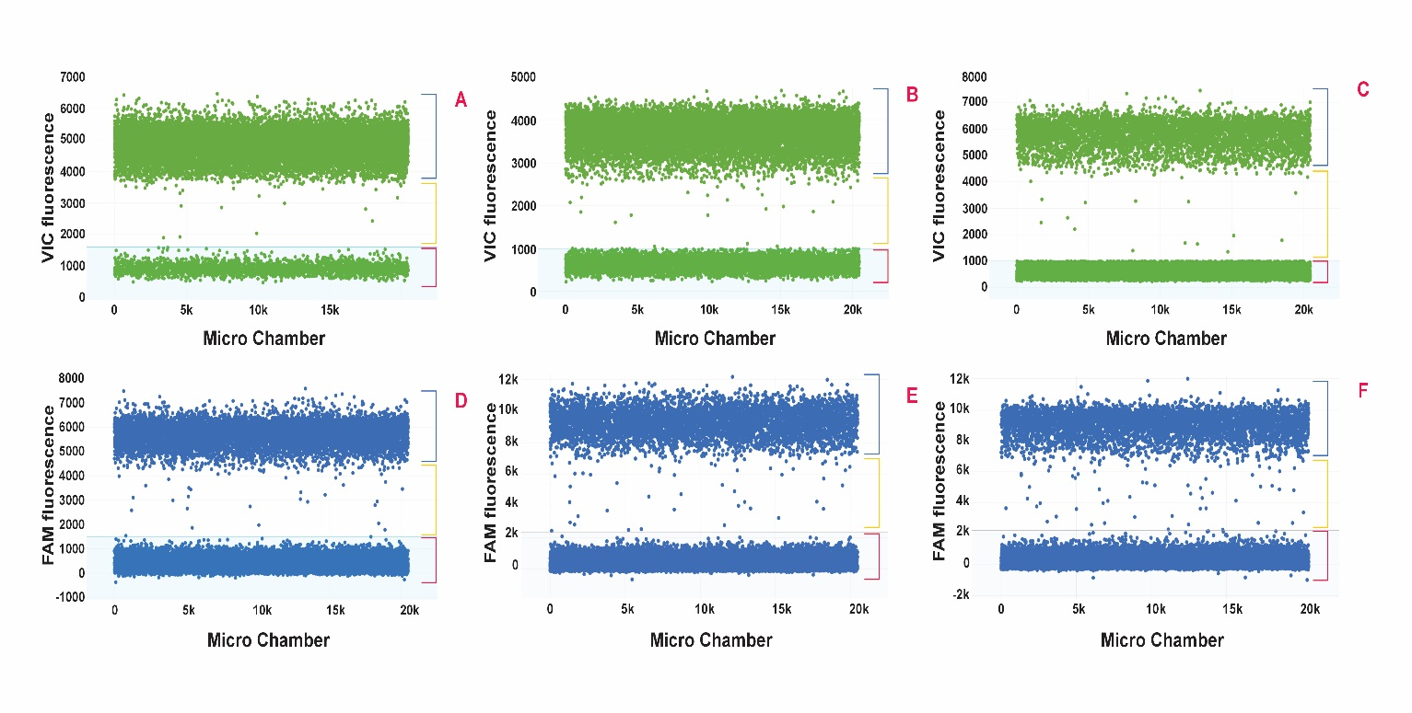

Fig S1. Representative digital PCR amplification plots for the Tri5 assay (A, B, and C) and species-specific assay (D, E, and F). The Tri5 assay utilized genomic DNA extracted from pure cultures of F. langsethiae (A), F. poae (B), and F. sporotrichioides (C), analysed at an annealing temperature of 60°C with a primer/probe combination of 600/200 nm. Species-specific assays (Fl, Fp, and Fs) employed genomic DNA extracts of specific targets, each analysed at the appropriate annealing temperature and primer/probe combination. (E) Fl assay amplification plot for F. langsethiae DNA (60°C and 300/200 nm). (F) Fp assay amplification plot for F. poae DNA (59°C and 600/150 nm). (G) Fs assay amplification plot for F. sporotrichioides DNA (59°C and 600/250 nm). Blue brackets represent positive droplets, red indicates negative droplets, and yellow represents intermediate droplets (rains).

