Supplementary information

Study of sampling phases for body odor sampling prior to analysis by TD-GC×GC/ToFMS

Elsa Boudard^{a,b}, Lisa Fissonª, Nabil Moumane^{b}, José Dugayª, Jérôme Vialª, Didier Thiébautª
ª UMR CBI, Laboratoire des Sciences Analytiques, Bioanalytiques et Miniaturisation, ESPCI Paris, PSL Research University, 10 rue Vauquelin, 75231 Paris Cedex 05, France
^{b} SenseDetect Health-Care, 21 grande rue, 78240 Aigremont, France
Corresponding author Elsa Boudard at UMR CBI, Laboratoire des Sciences Analytiques, Bioanalytiques et Miniaturisation, ESPCI Paris, PSL Research University, 10 rue Vauquelin, 75231 Paris Cedex 05, France
E-mail address: elsa.boudard@espci.fr (Elsa Boudard, ORCID: 0000-0003-3844-5008)

Table S1 List of the 57 compounds of the mix 57
Compound | CAS number | Mass (g/mol) | ¹t_{R} (s) | ²t_{R} (s) | Main Ions (m/z)
Dodecane | 112-40-3 | 170.34 | 1511.9 | 1.273 | 57.09  71.09
Docosane | 629-97-0 | 310.30 | 3692.76 | 1.370 | 57.09  71.09
Eicosane | 112-95-8 | 282.50 | 3338.79 | 1.351 | 57.09  71.09
Heneicosane | 629-94-7 | 296.34 | 3521.77 | 1.392 | 57.09  71.09
Hexadecane | 544-76-3 | 226.44 | 2516.84 | 1.333 | 57.09  71.09
Nonane | 111-84-2 | 128.26 | 650.958 | 1.182 | 57.09
Octane | 111-65-9 | 114.23 | 407.974 | 1.050 | 57.09
Pentadecane | 629-62-9 | 212.42 | 2288.85 | 1.373 | 57.09  71.09
Tetradecane | 629-59-4 | 198.39 | 2039.87 | 1.350 | 57.09  71.09
Tridecane | 629-50-5 | 184.36 | 1784.89 | 1.291 | 57.09  71.09
Hexane | 110-54-3 | 86.18 | 161.99 | 0.737 | 57.09
n-heptane | 142-82-5 | 100.2 | 245.984 | 0.885 | 57.09
Undecane | 1120-21-4 | 156.31 | 1229.92 | 1.305 | 57.09  71.09
Dodecene | 112-41-4 | 168.32 | 1487.9 | 1.347 | 55.08
α-pinene | 7785-70-8 | 136.23 | 737.953 | 1.298 | 93.07  91.05
β-Pinene | 19902-08-0 | 136.23 | 857.945 | 1.379 | 93.07
Camphene | 79-92-5 | 136.23 | 776.95 | 1.345 | 93.07  121.09
Caryophyllene | 87-44-5 | 204.35 | 2090.87 | 1.590 | 93.07  55.07  69.08
D-limonene | 5989-27-5 | 136.23 | 1010.94 | 1.425 | 68.08  93.07
Hexadecene | 629-73-2 | 224.43 | 2501.84 | 1.378 | 55.08  57.09
Pentadecene | 13360-61-7 | 210.40 | 2267.85 | 1.369 | 55.08  57.09
1-Phenylethylester acetic acid ( 2 phenethyl acetate) | 103-45-7 | 164.20 | 1664.89 | 2.050 | 104.15
2-hydroxy, hexyl ester benzoic acid (hexyl salicylate) | 6259-76-3 | 222.30 | 2687.83 | 1.900 | 120.02
Decanoic acid, methyl ester (methyl caprate) | 110-42-9 | 186.29 | 1850.88 | 1.622 | 74.05  87.04
Furancarboxylic acid, methyl ester (methyl 2-furoate) | 611-13-2 | 126.11 | 860.945 | 2.044 | 95.02
Octanoic acid, methyl ester (methyl octanoate) | 111-11-5 | 158.24 | 1295.92 | 1.653 | 74.05
1-octanol | 111-87-5 | 130.23 | 1139.93 | 1.919 | 55.08  69.08
1-tetradecanol | 112-72-1 | 214.39 | 2687.83 | 1.772 | 55.08  69.08  83.09
2-(2-propyl)-5-methyl-1-cyclohexanol (menthol) | 89-78-1 | 156.27 | 1430.91 | 1.903 | 81.07  55.07  67.07
2-ethyl hexanol | 104-76-7 | 130.23 | 1016.93 | 1.869 | 57.09  55.07  70.09
Pentanol | 71-41-0 | 88.15 | 347.978 | 1.506 | 55.08
2-Furanmethanol (Furfuryl Alcohol) | 98-00-0 | 98.10 | 533.966 | 2.356 | 81.04  53.06  97.03
3,7-Dimethyl-1,6-Octadien-2-ol (linalol) | 78-70-6 | 154.25 | 1223.92 | 1.819 | 93.07  55.07  69.08
3,7-Dimethyl-2,6-Octadien-1-ol (geraniol) | 106-24-1 | 154.25 | 1661.89 | 1.955 | 69.08  93.06
3,7-Dimethyl-6-Octen-1-ol (citronellol) | 7540-51-4 | 156.27 | 1589.9 | 1.935 | 69.08  55.07  67.07
Benzyl Alcohol | 100-51-6 | 108.14 | 1025.93 | 2.658 | 79.06  77.04  107.04
Cedrol | 77-53-2 | 222.37 | 2519.84 | 1.930 | 119.08  93.06
p-cresol | 106-44-5 | 108.14 | 1157.93 | 0.398 | 107.05  108.05
2-Furancarboxaldehyde (Furfural) | 98-01-1 | 96.09 | 476.969 | 1.999 | 96.02  95.01
2-Methyl-2-butenal | 497-03-0 | 84.12 | 305.98 | 1.331 | 55.08  84.06
2-nonenal | 18829-56-6 | 140.22 | 1394.91 | 2.013 | 55.07  57.05  70.05
Benzaldehyde | 100-52-7 | 106.12 | 806.948 | 2.112 | 77.05  51.04  105.03
Decanal | 112-31-2 | 156.27 | 1526.9 | 1.781 | 57.08  55.07
Hexanal | 66-25-1 | 100.16 | 407.974 | 1.429 | 56.08  57.06
α-Hexyl cinnamaldehyde | 101-86-0 | 216.32 | 2687.83 | 1.900 | 120.02
α-Methyl-β-(p-tert-butylphenyl)propanal (Lilial) | 80-54-6 | 204.31 | 2348.85 | 2.046 | 189.12  131.08  147.11
Benzene, 1,3,5-trimethyl (mesitylene) | 108-67-8 | 120.19 | 836.946 | 1.545 | 105.16  120.09
Toluene | 108-88-3 | 92.14 | 344.978 | 1.208 | 91.07  92.06
Naphthalene | 91-20-3 | 128.17 | 1451.91 | 1.964 | 128.05
Carene | 13466-78-9 | 136.23 | 956.939 | 1.375 | 93.07
6-methyl-5-Hepten-2-one (sulcatone) | 110-93-0 | 126.20 | 893.943 | 1.829 | 55.08  67.07  108.09
1-Phenyl-ethanone (acetophenone) | 98-86-2 | 120.15 | 1115.93 | 2.217 | 105.03  77.04
3,5,5-trimethylcyclohex-2-en-1-one (isophorone) | 78-59-1 | 138.21 | 1274.92 | 2.326 | 82.05
6,10-Dimethyl-5,9-Undecadien-2-one | 3796-70-1 | 194.32 | 2126.86 | 1.872 | 69.08
Menthone | 14073-97-3 | 154.25 | 1373.91 | 1.943 | 69.07  55.07  112.08
Camphre | 76-22-2 | 152.23 | 1343.91 | 2.048 | 95.08  55.07  81.07

Fig. S1 Pictures of the 5 studied sampling phases, from left to right: gauze, glass beads, PowerSorb®, Getxent® microtube, PSP.
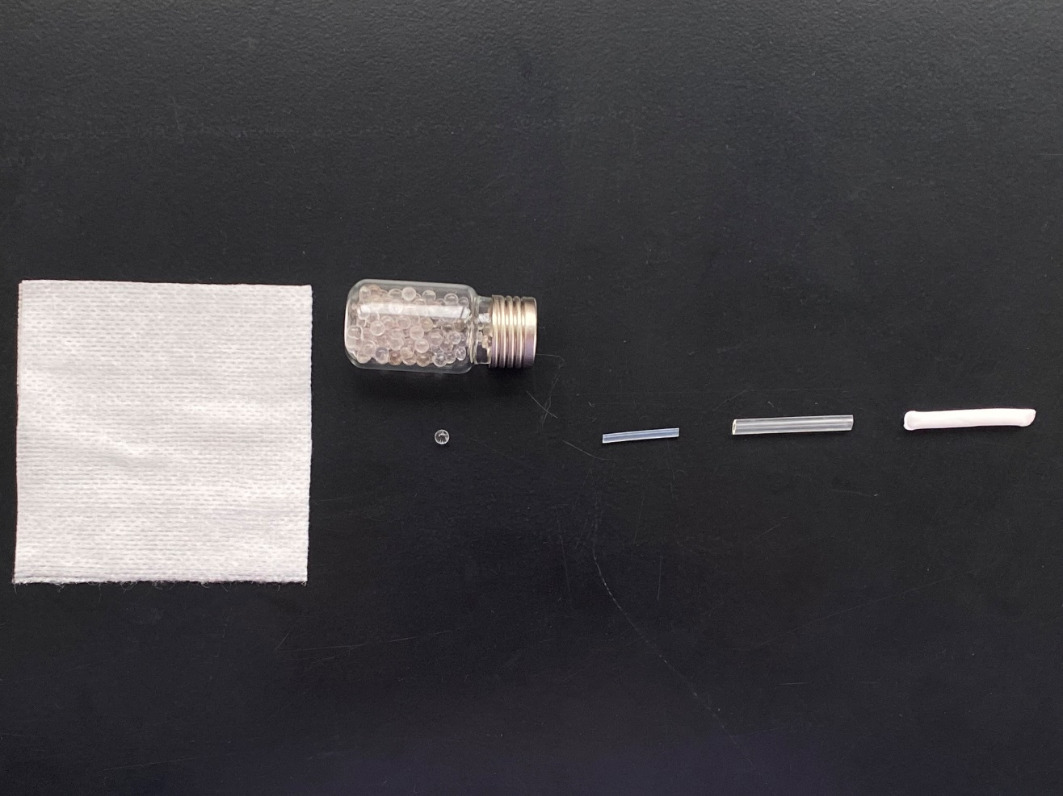
Fig. S2 TD-GC×GC/ToFMS contour plot chromatograms of the emissions of the sampling system trapped on PSP (left) and PowerSorb® (right)
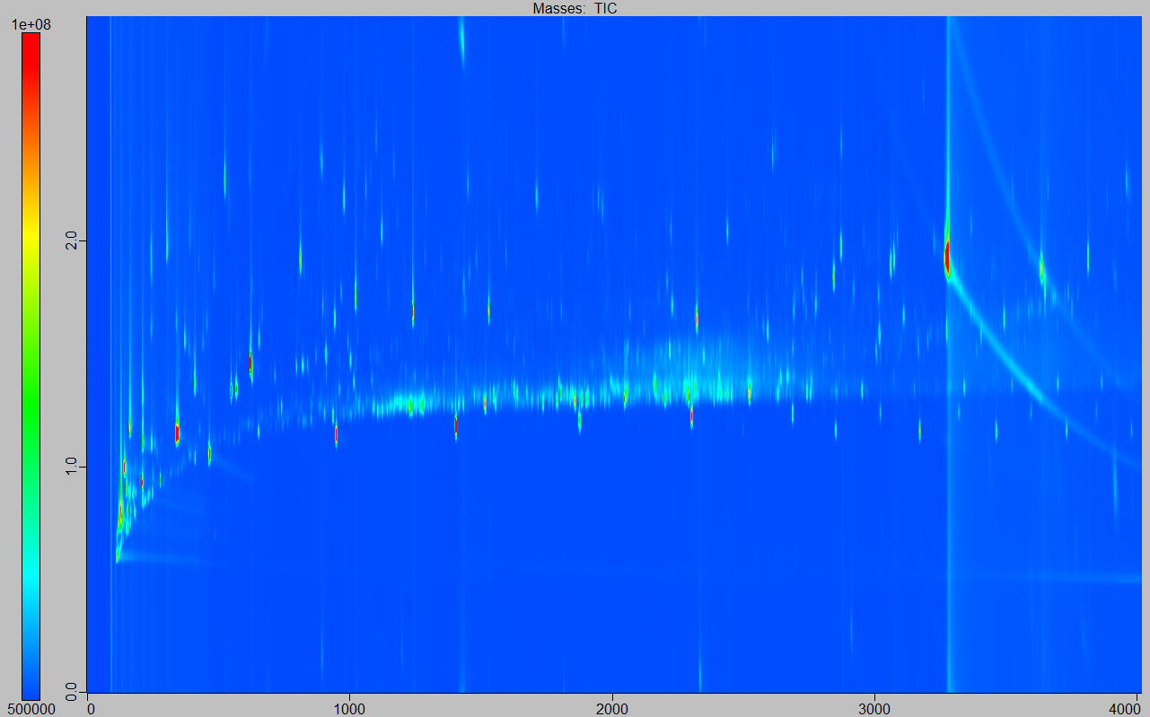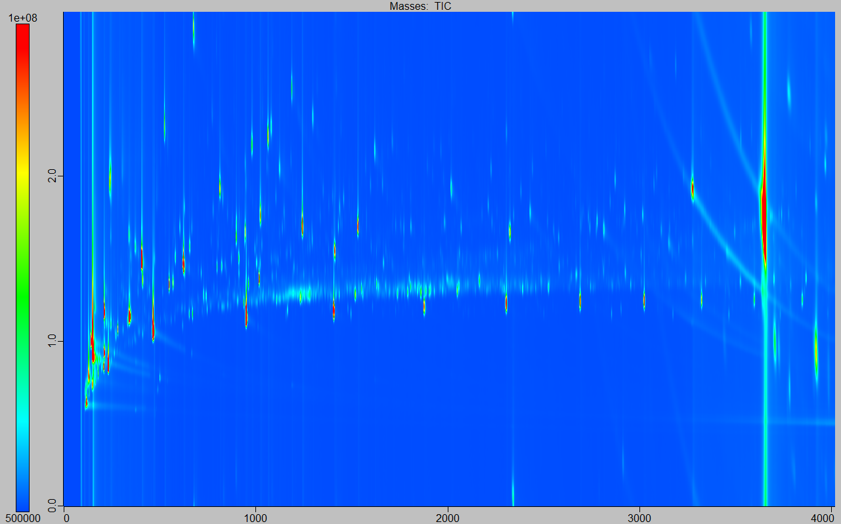

Table S2. List of peaks detected and tentatively identified in real body odor samples taken with both PowerSorb® and PSP.
Peak Name | RT 1D | RT 2D | Area | Selected mass for integration
Carbon disulfide | 140.991 | 0.715 | 60140819 | XIC(75.95±500ppm)
Butanal, 3-methyl- | 203.987 | 0.986 | 134140218 | XIC(44.04±500ppm)
1-Butanol | 209.987 | 1.111 | 1155062940 | XIC(56.08±500ppm)
Butanal, 2-methyl- | 212.986 | 0.998 | 151418413 | XIC(57.08±500ppm)
Sulfide, allyl methyl | 245.984 | 1.002 | 54159688 | XIC(88.03±500ppm)
1,3,6-Trioxocane | 257.983 | 1.099 | 242394358 | XIC(88.05±500ppm)
Acetoin | 257.983 | 1.404 | 1249340156 | XIC(45.06±500ppm)
1-Propene, 1-(methylthio)-, (Z)- | 296.981 | 1.094 | 69872232 | XIC(44.99±500ppm)
Peak 159 | 452.971 | 1.291 | 9347293 | XIC(114.07±500ppm)
Butanoic acid, 3-methyl- | 515.967 | 2.165 | 167376509 | XIC(60.03±500ppm)
Butanoic acid, 2-methyl- | 542.965 | 2.123 | 122551905 | XIC(74.04±500ppm)
Peak 185 | 650.958 | 1.439 | 11910169 | XIC(72.07±500ppm)
2(5H)-Furanone | 683.956 | 2.933 | 285311420 | XIC(55.03±500ppm)
1,3,5,7-Tetroxane | 689.956 | 1.993 | 18970105 | XIC(61.05±500ppm)
2-Nonene, 3-methyl-, (E)- | 788.95 | 1.23 | 242605652 | XIC(55.07±500ppm)
2-Octene, 3,7-dimethyl-, (Z)- | 809.948 | 1.24 | 72427050 | XIC(70.08±500ppm)
3-Nonene, 3-methyl-, (E)- | 815.948 | 1.226 | 198428963 | XIC(55.07±500ppm)
2-Octene, 3,7-dimethyl-, (Z)- | 845.946 | 1.238 | 159558592 | XIC(70.09±500ppm)
β-Myrcene | 911.942 | 1.338 | 28871893 | XIC(93.07±500ppm)
2-Propanol, 1,1'-oxybis- | 998.936 | 2.54 | 1144838291 | XIC(45.05±500ppm)
Benzyl alcohol | 1031.93 | 2.354 | 122222666 | XIC(79.06±500ppm)
1-Propanol, 3,3'-oxybis- | 1052.93 | 2.679 | 986843650 | XIC(59.06±500ppm)
Propanoic acid, 2-methoxy-, methyl ester | 1067.93 | 2.643 | 833335569 | XIC(59.06±500ppm)
1,3,6-Octatriene, 3,7-dimethyl-, (Z)- | 1079.93 | 1.391 | 4601035 | XIC(93.07±500ppm)
1-Propanol, 3,3'-oxybis- | 1121.93 | 2.37 | 198949355 | XIC(59.07±500ppm)
1-Octanol | 1145.93 | 1.771 | 115431957 | XIC(55.07±500ppm)
1-Propanol, 3,3'-oxybis- | 1154.93 | 2.774 | 157897500 | XIC(59.06±500ppm)
Cyclohexene, 1-methyl-4-(1-methylethylidene)- | 1190.92 | 1.404 | 4251953 | XIC(93.07±500ppm)
Benzene, 1-methyl-4-(1-methylethenyl)- | 1193.92 | 1.573 | 12745898 | XIC(117.07±500ppm)
3-Octanol, 3,7-dimethyl- | 1223.92 | 1.641 | 389382347 | XIC(55.07±500ppm)
Peak 297 | 1226.92 | 1.711 | 20907732 | XIC(93.07±500ppm)
α-Terpineol | 1484.9 | 1.822 | 15318707 | XIC(59.07±500ppm)
Peak 340 | 1547.9 | 1.965 | 43721178 | XIC(69.08±500ppm)
2-Octene, 2,6-dimethyl- | 1604.9 | 1.501 | 1255703497 | XIC(55.09±500ppm)
2-Propanol, 1-(2-butoxy-1-methylethoxy)- | 1646.89 | 1.722 | 12865854 | XIC(59.07±500ppm)
Bicyclo[3.1.1]heptane, 6,6-dimethyl-3-methylene- | 1685.89 | 1.608 | 80824908 | XIC(93.07±500ppm)
Cyclohexene, 1-methyl-5-(1-methylethenyl)- | 1916.88 | 1.645 | 123090242 | XIC(93.07±500ppm)
1,5,5-Trimethyl-6-methylene-cyclohexene | 1922.88 | 1.634 | 30780058 | XIC(93.07±500ppm)
4-Hexen-1-ol, 5-methyl-2-(1-methylethenyl)-, acetate | 2003.87 | 1.618 | 132016851 | XIC(69.08±500ppm)
Peak 406 | 2063.87 | 1.268 | 14833876 | XIC(73.06±500ppm)
1H-3a,7-Methanoazulene, 2,3,4,7,8,8a-hexahydro-3,6,8,8-tetramethyl-, [3R-(3α,3aβ,7β,8aα)]- | 2075.87 | 1.511 | 16564076 | XIC(119.08±500ppm)
Peak 412 | 2117.86 | 1.927 | 24032506 | XIC(105.07±500ppm)
cis-Thujopsene | 2123.86 | 1.529 | 23509851 | XIC(119.09±500ppm)
5,9-Undecadien-2-one, 6,10-dimethyl-, (Z)- | 2174.86 | 1.764 | 52543781 | XIC(69.08±500ppm)
Dodecane, 1-chloro- | 2219.86 | 1.521 | 997508042 | XIC(57.09±500ppm)
1-Dodecanol | 2225.86 | 1.724 | 713818839 | XIC(55.07±500ppm)
4H-Inden-4-one, 1,2,3,5,6,7-hexahydro-1,1,2,3,3-pentamethyl- | 2285.85 | 1.959 | 423404905 | XIC(191.14±500ppm)
Peak 443 | 2300.85 | 1.584 | 69551695 | XIC(115.05±500ppm)
Naphthalene, 1,2,3,4-tetrahydro-1,1,2,4,4,7-hexamethyl- | 2315.85 | 1.578 | 13713068 | XIC(201.17±500ppm)
Peak 451 | 2336.85 | 1.719 | 233375677 | XIC(57.08±500ppm)
Peak 452 | 2354.85 | 1.721 | 229080301 | XIC(57.08±500ppm)
Peak 461 | 2405.85 | 1.609 | 27100593 | XIC(115.06±500ppm)
Peak 464 | 2420.85 | 1.74 | 91223677 | XIC(57.08±500ppm)
Peak 466 | 2426.84 | 1.539 | 16648309 | XIC(88.05±500ppm)
Peak 472 | 2441.84 | 1.742 | 70371586 | XIC(57.08±500ppm)
Peak 474 | 2456.84 | 1.272 | 4612268 | XIC(73.06±500ppm)
Dodecanoic acid, ethyl ester | 2510.84 | 1.547 | 45408964 | XIC(88.05±500ppm)
Cedrol | 2525.84 | 1.859 | 81019003 | XIC(119.08±500ppm)
Peak 488 | 2534.84 | 1.535 | 16968586 | XIC(101.06±500ppm)
Peak 492 | 2567.84 | 1.639 | 36764550 | XIC(85.07±500ppm)
Peak 495 | 2582.83 | 1.622 | 52850986 | XIC(99.06±500ppm)
Peak 502 | 2618.83 | 1.538 | 16157524 | XIC(101.06±500ppm)
Peak 504 | 2627.83 | 1.56 | 58191230 | XIC(103.07±500ppm)
1-Iodo-2-methylundecane | 2642.83 | 1.583 | 97578633 | XIC(57.09±500ppm)
Cyclopentaneacetic acid, 3-oxo-2-pentyl-, methyl ester | 2642.83 | 2.069 | 44427574 | XIC(83.05±500ppm)
Amberonne (isomer 1) | 2645.83 | 1.835 | 80071866 | XIC(119.08±500ppm)
Amberonne (isomer 3) | 2663.83 | 1.838 | 1301329526 | XIC(191.19±500ppm)
Benzene, (1-ethylnonyl)- | 2666.83 | 1.491 | 98613930 | XIC(91.05±500ppm)
Amberonne (isomer 3) | 2675.83 | 1.869 | 458147293 | XIC(191.18±500ppm)
Tetradecane, 1-chloro- | 2690.83 | 1.518 | 405647270 | XIC(57.09±500ppm)
1-Tetradecanol | 2690.83 | 1.685 | 321902688 | XIC(55.07±500ppm)
Amberonne (isomer 3) | 2711.83 | 1.89 | 51814417 | XIC(69.08±500ppm)
Peak 534 | 2729.83 | 1.547 | 28286998 | XIC(88.05±500ppm)
Peak 535 | 2729.83 | 1.876 | 226135882 | XIC(135.11±500ppm)
Benzene, (1-methyldecyl)- | 2744.82 | 1.517 | 108661737 | XIC(105.07±500ppm)
1-Nonadecanamine, N,N-dimethyl- | 2759.82 | 1.372 | 287721418 | XIC(58.08±500ppm)
Peak 552 | 2783.82 | 1.654 | 37042419 | XIC(57.05±500ppm)
Peak 559 | 2801.82 | 1.638 | 33464150 | XIC(59.07±500ppm)
Peak 560 | 2801.82 | 1.78 | 18906300 | XIC(137.13±500ppm)
Naphtho[2,1-b]furan, dodecahydro-3a,6,6,9a-tetramethyl- | 2822.82 | 1.782 | 7045385 | XIC(221.19±500ppm)
1-Chloro-2-dodecyloxyethane | 2828.82 | 1.578 | 674376914 | XIC(57.09±500ppm)
Benzene, (1-propylnonyl)- | 2837.82 | 1.486 | 96552364 | XIC(91.05±500ppm)
Octanal, 2-(phenylmethylene)- | 2840.82 | 1.922 | 917826690 | XIC(91.05±500ppm)
Peak 583 | 2849.82 | 1.735 | 21476014 | XIC(213.17±500ppm)
Naphtho[2,1-b]furan, dodecahydro-3a,6,6,9a-tetramethyl- | 2858.82 | 1.817 | 152802042 | XIC(221.19±500ppm)
Peak 589 | 2861.82 | 1.686 | 51232444 | XIC(185.14±500ppm)
Tetradecanoic acid, ethyl ester | 2864.82 | 1.54 | 76697817 | XIC(88.05±500ppm)
Ethanone, 1-[(3R,3aR,7R,8aS)-2,3,4,7,8,8a-hexahydro-3,6,8,8-tetramethyl-1H-3a,7-methanoazulen-5-yl]- | 2891.81 | 1.927 | 312135693 | XIC(161.09±500ppm)
(R)-(-)-14-Methyl-8-hexadecyn-1-ol | 2909.81 | 1.85 | 232672713 | XIC(81.07±500ppm)
Tetradecanoic acid, ethyl ester | 2939.81 | 1.545 | 235552313 | XIC(88.05±500ppm)
Benzene, (1-methylundecyl)- | 2960.81 | 1.517 | 106495569 | XIC(105.07±500ppm)
Peak 628 | 2978.81 | 1.711 | 857630761 | XIC(229.16±500ppm)
Peak 631 | 2984.81 | 1.717 | 1011449413 | XIC(229.16±500ppm)
Peak 641 | 3017.81 | 1.628 | 793621287 | XIC(99.07±500ppm)
Peak 647 | 3026.81 | 1.751 | 52577549 | XIC(229.16±500ppm)
Peak 651 | 3041.81 | 1.751 | 21479001 | XIC(229.16±500ppm)
Benzene, (1-propyldecyl)- | 3044.81 | 1.487 | 52466113 | XIC(91.05±500ppm)
7-Acetyl-6-ethyl-1,1,4,4-tetramethyltetralin | 3059.8 | 1.766 | 4595505548 | XIC(243.27±500ppm)
Peak 658 | 3074.8 | 1.73 | 57023770 | XIC(214.17±500ppm)
Benzene, (1-ethylundecyl)- | 3089.8 | 1.503 | 59125770 | XIC(91.06±500ppm)
7-Acetyl-6-ethyl-1,1,4,4-tetramethyltetralin | 3104.8 | 1.793 | 237130272 | XIC(243.17±500ppm)
Peak 669 | 3116.8 | 1.79 | 183750767 | XIC(243.17±500ppm)
Ethanamine, 2-hydrazino-N,N-dimethyl-2-oxo- | 3134.8 | 1.615 | 523933258 | XIC(58.08±500ppm)
Pentadecanoic acid, ethyl ester | 3140.8 | 1.543 | 61018048 | XIC(88.05±500ppm)
Peak 673 | 3143.8 | 1.788 | 167378101 | XIC(243.17±500ppm)
Peak 681 | 3167.8 | 1.793 | 136816837 | XIC(243.17±500ppm)
Ethanol, 2-(tetradecyloxy)- | 3188.8 | 1.706 | 85145299 | XIC(57.09±500ppm)
Oxacycloheptadec-8-en-2-one, (8Z)- | 3200.8 | 1.855 | 77542517 | XIC(67.07±500ppm)
Octane, 1,1'-oxybis- | 3275.79 | 1.608 | 606250555 | XIC(57.09±500ppm)
Ethyl 9-hexadecenoate | 3281.79 | 1.589 | 35329603 | XIC(55.07±500ppm)
Hexadecanoic acid, ethyl ester | 3332.79 | 1.548 | 111142044 | XIC(88.05±500ppm)
Ethylene brassylate | 3362.78 | 2.073 | 75544588 | XIC(55.07±500ppm)
Peak 715 | 3368.78 | 1.657 | 724434170 | XIC(57.09±500ppm)
N-Dimethylaminomethyl-tert.-butyl-isopropylphosphine | 3509.78 | 1.61 | 201982694 | XIC(58.08±500ppm)
Heneicosane | 3521.77 | 1.361 | 22477231 | XIC(57.09±500ppm)
1-Nonadecanamine, N,N-dimethyl- | 3620.77 | 1.669 | 179816716 | XIC(58.08±500ppm)
Diethylene glycol monododecyl ether | 3692.76 | 1.764 | 89832266 | XIC(57.09±500ppm)
Peak 766 | 3845.75 | 1.734 | 219635023 | XIC(57.09±500ppm)
1-Propanamine, 3-dibenzo[b,e]thiepin-11(6H)-ylidene-N,N-dimethyl-, S-oxide | 3953.75 | 1.669 | 33965718 | XIC(58.08±500ppm)

Table S3. List of peaks detected and tentatively identified only in real body odor sample taken with PSP.
Peak name | 1D RT | 2D RT | Area | Selected mass for integration
Peak 8 | 110.993 | 2.563 | 2742405 | XIC(118.01±500ppm)
Peak 16 | 128.992 | 0.658 | 32557744 | XIC(55.07±500ppm)
Oxalic acid | 134.991 | 1.151 | 1199905554 | XIC(46.02±500ppm)
Propanenitrile, 3-hydroxy- | 137.991 | 0.82 | 91967630 | XIC(53.04±500ppm)
Peak 36 | 143.991 | 0.879 | 13056534 | XIC(57.05±500ppm)
2-Butanone | 146.991 | 0.802 | 23003128 | XIC(72.06±500ppm)
1-Propanol | 146.991 | 0.868 | 15458528 | XIC(59.06±500ppm)
Butanal | 161.99 | 0.865 | 59369235 | XIC(44.04±500ppm)
Peak 59 | 164.989 | 0.809 | 78299842 | XIC(155.01±500ppm)
1,3-Dioxolane, 2-methyl- | 200.987 | 0.936 | 28979720 | XIC(73.04±500ppm)
2-Pentanone | 233.985 | 1.097 | 296725021 | XIC(86.07±500ppm)
Propanoic acid | 257.983 | 1.62 | 1294971846 | XIC(45.01±500ppm)
1H-Pyrrole, 1-methyl- | 305.98 | 1.253 | 7228795 | XIC(81.06±500ppm)
Propanoic acid, 2-methyl- | 338.978 | 1.828 | 33692749 | XIC(73.04±500ppm)
1,3-Dioxolane, 2-ethyl-4-methyl- | 380.976 | 1.189 | 25664166 | XIC(87.04±500ppm)
1,3-Dioxolane, 2-ethyl-4-methyl- | 398.974 | 1.217 | 14545376 | XIC(87.04±500ppm)
Butanoic acid | 398.974 | 1.999 | 477706501 | XIC(60.03±500ppm)
Crotonic acid | 404.974 | 2.064 | 204161225 | XIC(86.03±500ppm)
Pyrazine, methyl- | 458.971 | 1.484 | 13518110 | XIC(94.05±500ppm)
1H-Pyrrole, 2-methyl- | 503.968 | 2.104 | 5514799 | XIC(80.05±500ppm)
Phenylpropiolic acid | 587.962 | 1.502 | 3048816 | XIC(102.04±500ppm)
Oxime-, methoxy-phenyl-_ | 674.957 | 2.869 | 30683334 | XIC(133.01±500ppm)
Pyrazine, 2,3-dimethyl- | 695.955 | 1.623 | 6588500 | XIC(67.06±500ppm)
Formamide, N,N-diethyl- | 746.952 | 2.222 | 16092104 | XIC(58.08±500ppm)
Peak 201 | 755.952 | 1.989 | 3292647 | XIC(59.07±500ppm)
Peak 202 | 776.95 | 1.787 | 3823936 | XIC(211.01±500ppm)
Hexanoic acid | 896.943 | 2.348 | 305266062 | XIC(60.04±500ppm)
Benzene, (1-methylpropyl)- | 959.939 | 1.473 | 6208079 | XIC(105.07±500ppm)
Benzyl chloride | 968.938 | 1.772 | 66407797 | XIC(91.05±500ppm)
D-Limonene | 1016.93 | 1.371 | 239800571 | XIC(68.07±500ppm)
Eucalyptol | 1022.93 | 1.458 | 4182660 | XIC(81.07±500ppm)
Peak 255 | 1061.93 | 2.307 | 8354510 | XIC(60.04±500ppm)
Peak 261 | 1094.93 | 1.461 | 5407103 | XIC(131.05±500ppm)
2,5-Hexanediol, 2,5-dimethyl- | 1103.93 | 2.439 | 55236178 | XIC(59.07±500ppm)
Peak 264 | 1106.93 | 1.495 | 4487169 | XIC(131.05±500ppm)
Octane, 1-chloro- | 1112.93 | 1.48 | 8070385 | XIC(91.03±500ppm)
Acetophenone | 1121.93 | 2.039 | 218237229 | XIC(105.03±500ppm)
Peak 273 | 1133.93 | 1.51 | 3499866 | XIC(117.04±500ppm)
Ethanone, 2,2-dihydroxy-1-phenyl- | 1139.93 | 2.075 | 6774676 | XIC(77.05±500ppm)
Peak 275 | 1145.93 | 1.706 | 33448186 | XIC(59.07±500ppm)
Peak 277 | 1148.93 | 1.257 | 10762247 | XIC(73.06±500ppm)
Peak 290 | 1199.92 | 0.172 | 119596736 | XIC(44.04±500ppm)
Dipropylene glycol (isomer 3) | 1202.92 | 2.568 | 5159331 | XIC(59.07±500ppm)
1,3,8-p-Menthatriene | 1259.92 | 1.5 | 7204467 | XIC(91.06±500ppm)
Peak 307 | 1277.92 | 2.278 | 81220700 | XIC(137.04±500ppm)
Ethanone, 2,2-dihydroxy-1-phenyl- | 1418.91 | 2.088 | 5577278 | XIC(105.03±500ppm)
Benzoic acid | 1436.91 | 2.865 | 784929759 | XIC(105.03±500ppm)
Peak 328 | 1439.91 | 1.375 | 7949771 | XIC(71.06±500ppm)
Octanoic acid | 1454.91 | 2.234 | 125022020 | XIC(60.04±500ppm)
2-Coumaranone | 1595.9 | 2.484 | 5308812 | XIC(78.06±500ppm)
2-Propanol, 1-(2-butoxy-1-methylethoxy)- | 1631.9 | 1.721 | 9878630 | XIC(59.07±500ppm)
(-)-Carvone | 1631.9 | 1.958 | 9077209 | XIC(82.05±500ppm)
Peak 356 | 1667.89 | 1.462 | 11226305 | XIC(59.07±500ppm)
Linalyl acetate | 1670.89 | 1.576 | 49971278 | XIC(93.07±500ppm)
Cyclohexanemethanol, 4-(1-methylethyl)-, trans- | 1679.89 | 1.893 | 9564686 | XIC(95.09±500ppm)
Decane, 1-chloro- | 1694.89 | 1.51 | 11176656 | XIC(55.07±500ppm)
Cyclohexanemethanol, 4-(1-methylethyl)-, cis- | 1706.89 | 1.913 | 38357112 | XIC(95.08±500ppm)
1-Decanol | 1712.89 | 1.748 | 17178120 | XIC(55.07±500ppm)
Bicyclo[3.1.1]heptane, 6,6-dimethyl-3-methylene- | 1751.89 | 1.702 | 6993354 | XIC(93.07±500ppm)
Indole | 1766.89 | 2.929 | 8308432 | XIC(117.06±500ppm)
ortho tert-Butyl cyclohexyl acetate | 1769.89 | 1.673 | 13703916 | XIC(57.09±500ppm)
Peak 371 | 1787.89 | 1.782 | 44838104 | XIC(55.07±500ppm)
Formamide, N,N-dibutyl- | 1790.89 | 2.18 | 39674644 | XIC(72.06±500ppm)
Undecanal | 1805.88 | 1.691 | 9852968 | XIC(55.07±500ppm)
1,2-Benzenedicarboxylic acid | 1811.88 | 2.947 | 131601058 | XIC(104.03±500ppm)
Peak 375 | 1820.88 | 1.804 | 21347784 | XIC(55.07±500ppm)
1,2-Benzenedicarboxylic acid | 1823.88 | 2.911 | 22535106 | XIC(104.03±500ppm)
Peak 378 | 1829.88 | 1.79 | 16896876 | XIC(55.07±500ppm)
Peak 384 | 1877.88 | 1.477 | 2512146 | XIC(47.03±500ppm)
Benzoic acid, 2-(hydroxymethyl)- | 1901.88 | 2.944 | 33032340 | XIC(105.03±500ppm)
Ethanol, 2-(3,3-dimethylcyclohexylidene)-, (Z)- | 1934.88 | 1.681 | 14353037 | XIC(79.06±500ppm)
Bicyclo[3.1.1]heptane, 6,6-dimethyl-2-methylene-, (1S)- | 1955.87 | 1.615 | 6084680 | XIC(93.07±500ppm)
Ethanol, 2-(3,3-dimethylcyclohexylidene)-, (Z)- | 1964.87 | 1.685 | 7768300 | XIC(79.06±500ppm)
n-Decanoic acid | 1964.87 | 2.137 | 49199549 | XIC(60.04±500ppm)
Diphenyl ether | 2042.87 | 1.798 | 3480234 | XIC(170.07±500ppm)
Dodecanal | 2066.87 | 1.685 | 30473601 | XIC(57.07±500ppm)
Peak 410 | 2099.87 | 1.632 | 57037060 | XIC(99.06±500ppm)
1H-Isoindole-1,3(2H)-dione, 2-(hydroxymethyl)- | 2192.86 | 0.07 | 2432288 | XIC(76.04±500ppm)
Undecanoic acid | 2204.86 | 2.091 | 15113624 | XIC(60.04±500ppm)
α Isomethyl ionone | 2240.86 | 1.832 | 9807856 | XIC(135.08±500ppm)
3-Ethyl-4,4-dimethyl-2-(2-methylpropenyl)cyclohex-2-enone | 2243.86 | 1.926 | 7992235 | XIC(177.13±500ppm)
Peak 434 | 2249.86 | 1.925 | 2025897 | XIC(63.96±500ppm)
Vinyl lauryl ether | 2291.85 | 1.438 | 81174313 | XIC(57.08±500ppm)
Peak 446 | 2303.85 | 1.613 | 6664437 | XIC(132.09±500ppm)
Dibenzofuran | 2312.85 | 1.983 | 7571442 | XIC(168.06±500ppm)
Formic acid, dodecyl ester | 2363.85 | 1.594 | 38720818 | XIC(55.07±500ppm)
Benzene, (1-butylhexyl)- | 2378.85 | 1.473 | 36960883 | XIC(91.05±500ppm)
Peak 458 | 2393.85 | 1.537 | 6891588 | XIC(101.06±500ppm)
Benzene, (1-propylheptyl)- | 2396.85 | 1.48 | 28405615 | XIC(91.05±500ppm)
Dodecane, 1-bromo- | 2420.85 | 1.555 | 34136896 | XIC(57.09±500ppm)
Peak 467 | 2429.84 | 1.724 | 9434113 | XIC(66.06±500ppm)
Benzene, (1-ethyloctyl)- | 2438.84 | 1.486 | 25073066 | XIC(91.06±500ppm)
Dodecanoic acid | 2438.84 | 2.038 | 84039429 | XIC(60.04±500ppm)
Peak 478 | 2507.84 | 1.605 | 9848521 | XIC(69.05±500ppm)
Diethyl Phthalate | 2507.84 | 2.167 | 24391839 | XIC(149.03±500ppm)
Cycloheptane, 4-methylene-1-methyl-2-(2-methyl-1-propen-1-yl)-1-vinyl- | 2513.84 | 1.873 | 18939630 | XIC(81.08±500ppm)
Peak 482 | 2516.84 | 1.693 | 12490374 | XIC(58.06±500ppm)
Pentanoic acid, 2,2,4-trimethyl-3-carboxyisopropyl, isobutyl ester | 2516.84 | 1.726 | 67712310 | XIC(71.06±500ppm)
Benzene, (1-methylnonyl)- | 2519.84 | 1.515 | 32256446 | XIC(105.07±500ppm)
Hexadecane | 2522.84 | 1.322 | 212065560 | XIC(57.09±500ppm)
Cycloheptane, 4-methylene-1-methyl-2-(2-methyl-1-propen-1-yl)-1-vinyl- | 2540.84 | 1.862 | 28644564 | XIC(81.08±500ppm)
Peak 491 | 2555.84 | 1.83 | 9052085 | XIC(191.18±500ppm)
Benzophenone | 2579.83 | 2.148 | 19766871 | XIC(105.03±500ppm)
Benzene, (1-pentylhexyl)- | 2591.83 | 1.476 | 42820512 | XIC(91.05±500ppm)
Peak 497 | 2591.83 | 1.599 | 155646161 | XIC(59.06±500ppm)
Oxalic acid, allyl hexadecyl ester | 2597.83 | 1.689 | 168934703 | XIC(57.08±500ppm)
Benzene, (1-butylheptyl)- | 2600.83 | 1.471 | 111023939 | XIC(91.05±500ppm)
Amberonne (isomer 1) | 2600.83 | 1.834 | 19571732 | XIC(119.09±500ppm)
Benzene, (1-propyloctyl)- | 2621.83 | 1.482 | 79013504 | XIC(91.05±500ppm)
Tridecanoic acid | 2657.83 | 2.009 | 7162220 | XIC(60.04±500ppm)
1,3-Dioxolane, 2-pentadecyl- | 2675.83 | 1.562 | 54353659 | XIC(73.03±500ppm)
n-Hexyl salicylate | 2690.83 | 1.803 | 11719325 | XIC(120.02±500ppm)
1,1'-Biphenyl, 2,2',5,5'-tetramethyl- | 2693.83 | 1.747 | 14233933 | XIC(195.12±500ppm)
Peak 528 | 2708.83 | 1.74 | 3513680 | XIC(195.12±500ppm)
Benzene, 1,1'-(1,2-cyclobutanediyl)bis-, trans- | 2723.83 | 1.838 | 73512746 | XIC(104.06±500ppm)
2-Pentadecanone | 2735.82 | 1.693 | 81193912 | XIC(58.06±500ppm)
1-Tetradecanamine, N,N-dimethyl- | 2750.82 | 1.387 | 517122134 | XIC(58.08±500ppm)
4-(1,1-Dimethylheptyl)phenol | 2753.82 | 2.227 | 22269209 | XIC(135.08±500ppm)
Peak 543 | 2756.82 | 1.893 | 10258016 | XIC(203.18±500ppm)
Peak 545 | 2759.82 | 1.5 | 2183109 | XIC(229.20±500ppm)
Peak 546 | 2759.82 | 1.751 | 6819655 | XIC(195.12±500ppm)
Peak 548 | 2771.82 | 1.563 | 6150718 | XIC(59.07±500ppm)
4-(7-Methyloctyl)phenol | 2771.82 | 2.223 | 15928169 | XIC(135.08±500ppm)
Peak 550 | 2774.82 | 1.719 | 355545927 | XIC(57.08±500ppm)
Peak 551 | 2780.82 | 2.22 | 4359191 | XIC(121.07±500ppm)
4-(7-Methyloctyl)phenol | 2789.82 | 2.206 | 11762955 | XIC(135.08±500ppm)
2,6-Diisopropylnaphthalene | 2792.82 | 1.743 | 3762682 | XIC(197.13±500ppm)
Methyl tetradecanoate | 2795.82 | 1.554 | 7390010 | XIC(74.05±500ppm)
Ethanone, 2-bromo-1,2-diphenyl- | 2798.82 | 2.255 | 17232701 | XIC(105.03±500ppm)
Benzene, (1-pentylheptyl)- | 2804.82 | 1.472 | 123798474 | XIC(91.05±500ppm)
Benzene, (1-butyloctyl)- | 2813.82 | 1.476 | 98351820 | XIC(91.05±500ppm)
Peak 564 | 2813.82 | 1.906 | 8154620 | XIC(120.02±500ppm)
Peak 566 | 2819.82 | 1.508 | 2459638 | XIC(215.18±500ppm)
Peak 572 | 2831.82 | 2.209 | 5808552 | XIC(149.10±500ppm)
Peak 580 | 2843.82 | 1.841 | 675762259 | XIC(104.06±500ppm)
Hexestrol, O-(n-propyloxycarbonyl)- | 2852.82 | 2.212 | 32873265 | XIC(135.08±500ppm)
Peak 592 | 2867.82 | 2.225 | 6640564 | XIC(149.10±500ppm)
1,3-Dioxolane, 2-heptyl- | 2870.82 | 1.506 | 9080483 | XIC(73.04±500ppm)
Tetradecanoic acid | 2870.82 | 1.978 | 109208334 | XIC(73.04±500ppm)
Dodecanamide | 2870.82 | 2.434 | 223921683 | XIC(59.05±500ppm)
Tetradecane, 1-bromo- | 2873.82 | 1.562 | 8473696 | XIC(57.09±500ppm)
Benzene, (1-ethyldecyl)- | 2882.82 | 1.498 | 84908618 | XIC(91.05±500ppm)
Peak 599 | 2882.82 | 1.589 | 6568981 | XIC(59.07±500ppm)
Anthracene | 2888.82 | 2.16 | 7450393 | XIC(178.08±500ppm)
Ethyl 9-tetradecenoate | 2891.81 | 1.586 | 8012063 | XIC(55.07±500ppm)
Octadecane, 1-isocyanato- | 2912.81 | 1.625 | 5492650 | XIC(99.07±500ppm)
Peak 616 | 2918.81 | 1.99 | 8507616 | XIC(129.07±500ppm)
Octadecane | 2951.81 | 1.342 | 182902945 | XIC(57.09±500ppm)
Peak 621 | 2951.81 | 1.683 | 9464918 | XIC(58.06±500ppm)
2-Ethylhexyl salicylate | 2963.81 | 1.77 | 13808523 | XIC(120.02±500ppm)
Ethanedione, diphenyl- | 2969.81 | 2.287 | 11217342 | XIC(105.03±500ppm)
Hexadecane, 2,6,10,14-tetramethyl- | 2981.81 | 1.34 | 6224489 | XIC(57.09±500ppm)
Isopropyl myristate | 3005.81 | 1.519 | 25805359 | XIC(60.04±500ppm)
Peak 636 | 3005.81 | 1.611 | 12987395 | XIC(57.09±500ppm)
Benzene, (1-pentyloctyl)- | 3008.81 | 1.476 | 105974539 | XIC(91.05±500ppm)
Peak 638 | 3011.81 | 1.237 | 7641722 | XIC(73.06±500ppm)
Peak 642 | 3017.81 | 1.749 | 22689311 | XIC(229.16±500ppm)
Benzene, (1-butylnonyl)- | 3020.81 | 1.484 | 79416823 | XIC(91.05±500ppm)
Oxalic acid, allyl octadecyl ester | 3023.81 | 1.685 | 50305273 | XIC(57.09±500ppm)
Peak 648 | 3032.81 | 1.545 | 12235414 | XIC(101.06±500ppm)
Eicosane, 10-methyl- | 3035.81 | 1.341 | 13606520 | XIC(57.09±500ppm)
Muscone | 3038.81 | 1.882 | 15055464 | XIC(55.07±500ppm)
Pentadecanoic acid | 3071.8 | 1.941 | 15943152 | XIC(60.04±500ppm)
Peak 661 | 3083.8 | 1.551 | 8032380 | XIC(88.05±500ppm)
1,2-Benzenedicarboxylic acid, bis(2-methylpropyl) ester | 3086.8 | 2.012 | 70994361 | XIC(149.02±500ppm)
1,3-Dioxolane-2-methanol | 3098.8 | 1.562 | 34935505 | XIC(73.04±500ppm)
Hexadecane, 1-chloro- | 3110.8 | 1.531 | 33654023 | XIC(57.09±500ppm)
1-Hexadecanol | 3110.8 | 1.668 | 33282922 | XIC(55.07±500ppm)
Benzene, (1-methyldodecyl)- | 3167.8 | 1.519 | 196511357 | XIC(105.07±500ppm)
Octanamide, N-allyl- | 3191.8 | 2.146 | 50970508 | XIC(57.08±500ppm)
Hexadecanoic acid, methyl ester | 3200.8 | 1.56 | 129756121 | XIC(74.04±500ppm)
Peak 692 | 3206.79 | 1.64 | 8406647 | XIC(57.09±500ppm)
Peak 693 | 3212.79 | 1.584 | 4885525 | XIC(55.07±500ppm)
Ethanol, 2-(tetradecyloxy)- | 3236.79 | 1.575 | 254401679 | XIC(57.09±500ppm)
Peak 698 | 3260.79 | 1.543 | 5548643 | XIC(88.05±500ppm)
Dibutyl phthalate | 3266.79 | 2.038 | 148866661 | XIC(149.02±500ppm)
n-Hexadecanoic acid | 3281.79 | 1.925 | 3155513096 | XIC(73.03±500ppm)
Dodecanamide | 3293.79 | 2.288 | 20723642 | XIC(59.05±500ppm)
Benzene, (1-methyltridecyl)- | 3362.78 | 1.522 | 18855602 | XIC(105.07±500ppm)
1-Octadecanol | 3491.78 | 1.659 | 32085651 | XIC(55.07±500ppm)
2,3-Diphenylmaleic anhydride | 3518.77 | 2.647 | 5408156 | XIC(178.09±500ppm)
Peak 729 | 3545.77 | 1.69 | 6123589 | XIC(67.07±500ppm)
Methyl stearate | 3569.77 | 1.562 | 87380943 | XIC(74.04±500ppm)
Octadecanoic acid | 3635.77 | 1.877 | 411813629 | XIC(73.04±500ppm)
Dodecanamide | 3659.77 | 2.239 | 49697250 | XIC(59.05±500ppm)
Peak 753 | 3725.76 | 1.657 | 166931872 | XIC(57.09±500ppm)
[1,1':3',1''-Terphenyl]-2'-ol | 3737.76 | 2.137 | 6772581 | XIC(246.11±500ppm)
N-Methyl-N-benzyltetradecanamine | 3896.75 | 1.562 | 17564330 | XIC(134.10±500ppm)

