Unraveling the Molecular Dynamics of Wound Healing: Integrating
Spatially Resolved Lipidomics and Temporally Resolved Proteomics
Hongxia Baiª, Alejandra Suarez Arnedo^{b}, Yining Liu^{b}, Tatiana Segura^{b}, David Muddimanª

ªBiomolecular Imaging Laboratory for Disease and Exposure Research (BILDER), Department of Chemistry, North Carolina State University, Raleigh, NC 27695 USA; ^{b}Department of Biomedical Engineering, Duke University, Durham, NC 27708 USA

Submitted to: Analytical and Bioanalytical Chemistry

SUPPLEMENTARY MATERIAL

Keywords: Wound healing, Mass spectrometry imaging, 3D, IR-MALDESI, Multi-omics

*Author for Correspondence
David Muddiman, Ph.D.
Biomolecular Imaging Laboratory for Disease and Exposure Research
Department of Chemistry
North Carolina State University
Phone: 919-513-0084
Email: dcmuddim@ncsu.edu

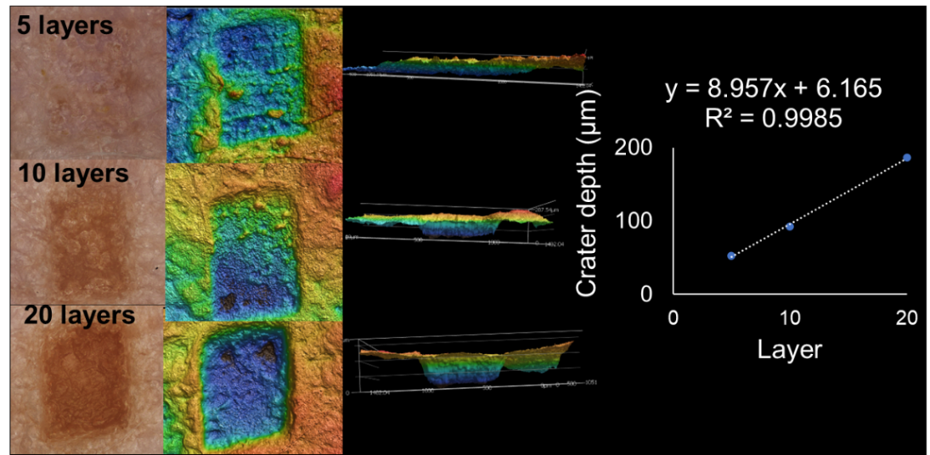

Supplemental Figure 1. Depth resolution determination via continuous ablation. The resolution is gauged by the depth to which the laser penetrates and, specifically, the depth of laser ablation for each layer. A depth profiling of ablated craters in nude mouse skin was executed by ablating the tissue in increments of 5, 10, and 20 layers. Subsequent characterization was carried out using a Keyence confocal microscope. With a burst laser energy ranging between 0.4-0.5 mJ, the depth resolution for the profiles was estimated at approximately 9 µm.

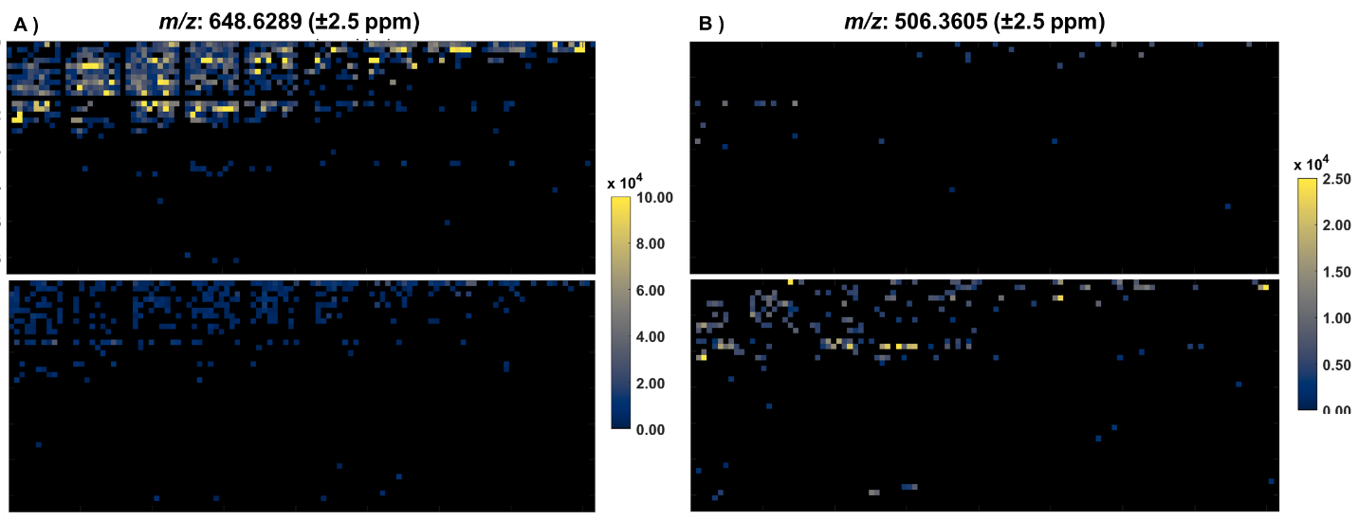
Supplemental Figure 2. Supplemental Figure 2. Differential lipid abundance in normal vs. wound tissue during the inflammation stage. Heatmaps depict the relative levels of a) ceramide (([C₄₂H₈₁NO₃+H⁺]⁺, m/z: 648.6289) and b) ceramide-1-phosphate ([C₂₀H₄₀NO₆P], m/z: 506.3605). The upper panel represents the normal tissue, while the lower illustrates the wound environment at the inflammation stage

