Supporting Information
pH-Tuned Reversible Self-Assembly of Janus Particles for Enhanced Raman Imaging and Sensing

Maria Iftesum^{1, ‖}, Mohan Kumar Dey^{1,†}, Alisha Prasad^{2,†}, Jin Gyun Lee^{3,‖}, Ram Devireddy¹, Bhuvnesh Bharti³, Manas Ranjan Gartia^{1,}*

¹Department of Mechanical and Industrial Engineering, Louisiana State University, Baton Rouge, LA 70803 USA
²Catalent Pharma, St. Petersburg, FL 33716 USA
³Cain Department of Chemical Engineering, Louisiana State University, Baton Rouge, LA 70803 USA

†, ‖Equal contribution authors
*Corresponding author: mgartia@lsu.edu

Table S1. Raman peak positions for the different components of the Janus Particles
 | PS | 11-MUA | EDC | Lysozyme | Au + PS | Au + PS + MUA | Au + PS + MUA + EDC | Au + PS + MUA + EDC + Lys
450 - 550 |  |  |  | 471, 527
551 - 650 | 622 |  |  | 622, 648 | 624 |  | 624 | 624
651 - 750 |  | 738
751 - 850 | 798 |  | 827 | 755, 798 | 793
851 - 950 |  | 909
951 - 1050 | 1005, 1029 |  |  |  | 1004, 1033 | 1004, 1033 | 1004, 1033 | 1004, 1033
1051 - 1150 |  | 1060, 1107 | 1149 | 1122 |  | 1197 |  | 1191
1151 - 1250 | 1157, 1205 |  |  |  | 1201 |  | 1203
1251 - 1350 |  | 1290 |  | 1255
1351 - 1450 |  | 1436
1451 - 1550 | 1452 | 1457 | 1454 |  | 1451
1551 - 1650 | 1603 | 1631 | 1642 | 1551 | 1603 | 1605 | 1602 | 1604
1651 - 1750 |  |  |  | 1715
1751 - 1850
1851 - 1950 |  |  |  | 1883
1951 - 2050
2051 - 2150
2151 - 2250
2251 - 2350
2351 - 2450
2451 - 2550 |  | 2549
2551 - 2650 |  | 2575
2651 - 2750 |  | 2722

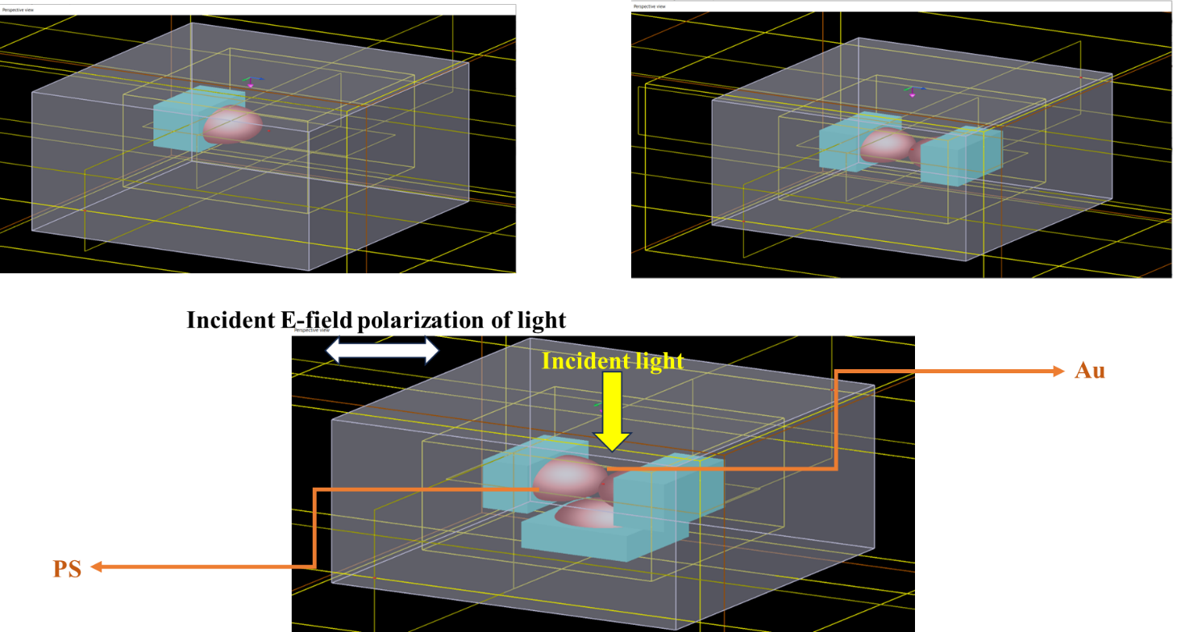
Figure S1. Schematic of FDTD Simulation for one, two, and three Janus particles using Ansys Lumerical software.

