Size-exclusion chromatography with post-column nucleic acid staining and fluorescence detection for ribonucleic acid analysis

Yannick Hoevelmann^{1,2}, Annkathrin Ratter^{1,2}, Fabian Merkel¹, Sebastian Hickert¹, Evgeniia Konishcheva^{1,3}

¹ Merck KGaA, Darmstadt, Germany
² Both authors contributed equally to this work
³ Corresponding author: evgeniia.konishcheva@merckgroup.com

Supplementary information

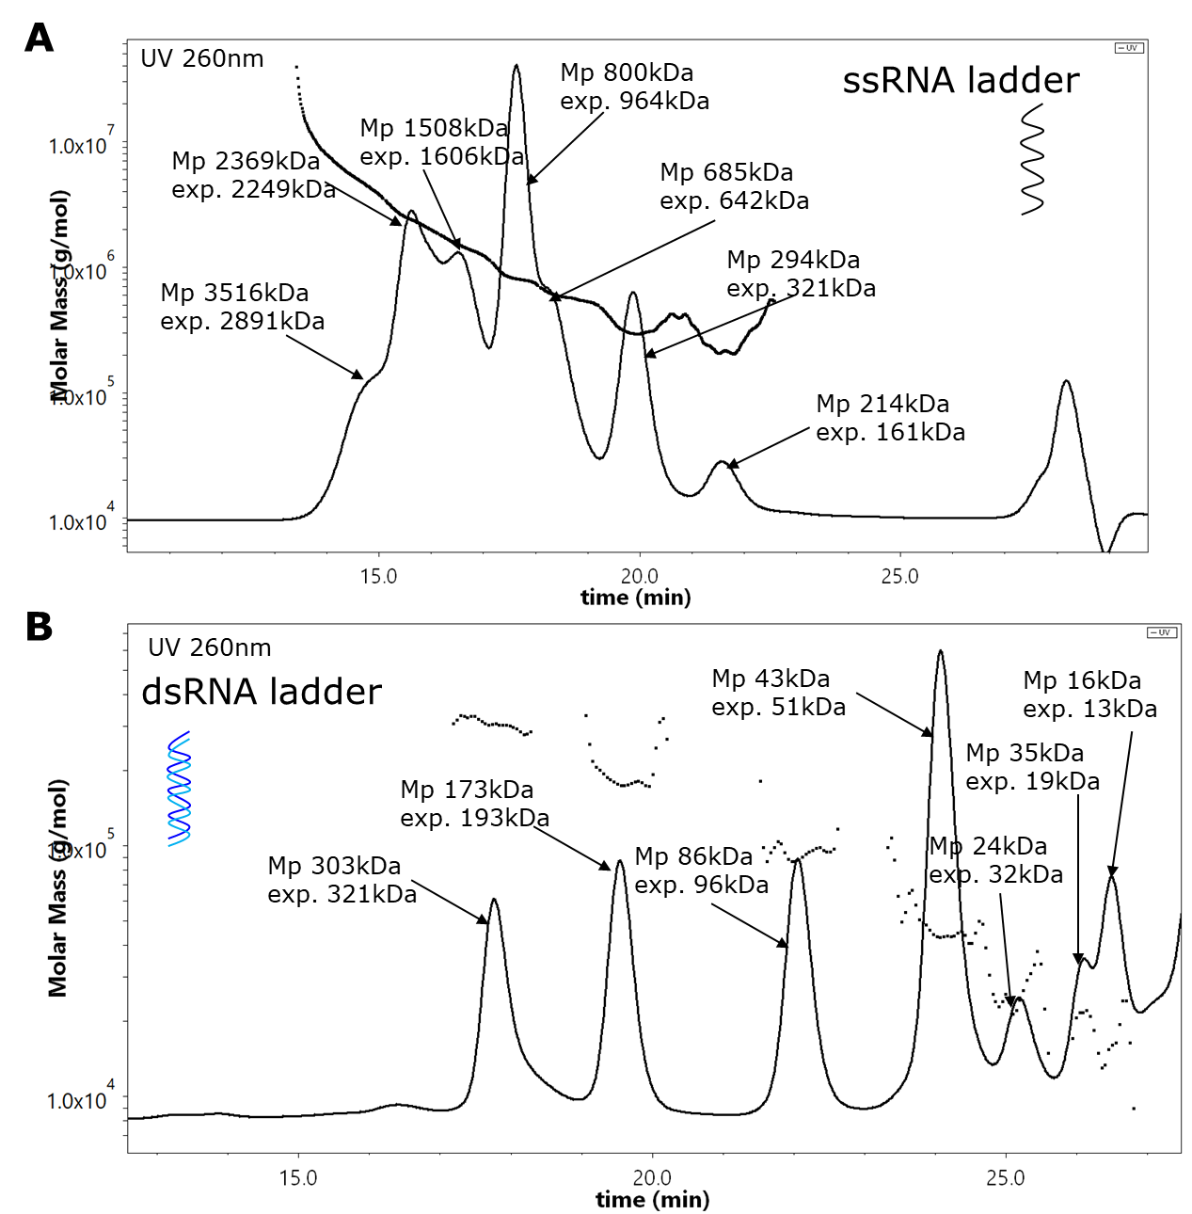
Supplementary Fig. S1 A: SEC traces and molar mass of ssRNA ladder, B: SEC traces and molar mass of dsRNA ladder. Only UV response is shown. MALS, VS, and RI responses are omitted for simplicity reasons. The horizontal black lines correspond to the molar mass (left Y-axis) across the peaks, which was determined from MALS and RI signals: where I is the intensity of scattred light, M is molar mass, c is a concentration from RI and dn/dc=0.17 mL/g for RNA. Molar mass for ssRNA is shown as a continuous line as the species coelute, whereas most dsRNA components are baseline separated, and therefore molar mass can be shown for individual peaks. Mp corresponds to the molar mass at peak maximum, and exp. corresponds to the expected molar mass of the corresponding RNA species. The expected molar mass was calculated from the number of nucleotides (for ssRNA) or base pairs (for dsRNA) provided by a supplier.

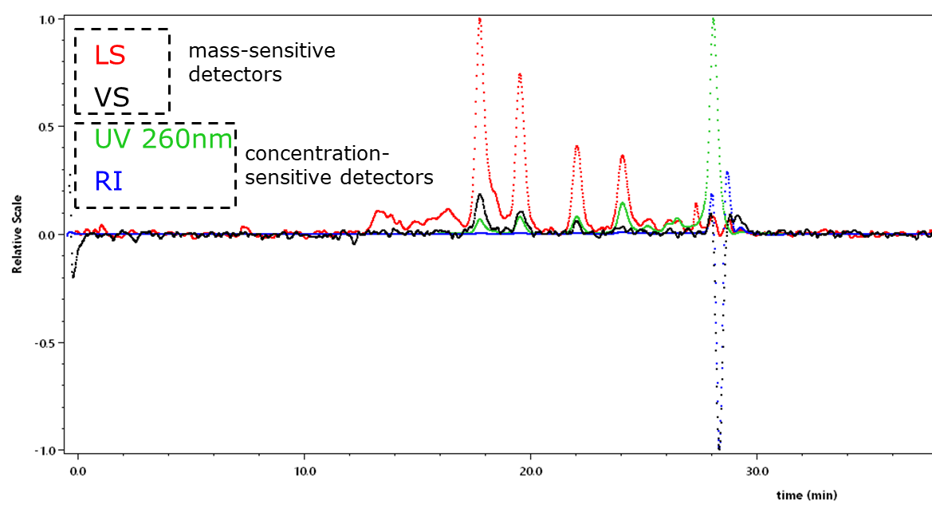
Supplementary Fig. S2 SEC traces of dsRNA ladder: Overlay of UV, LS (in this case light scattering response at one out of 8 angles), VS, and RI detector responses

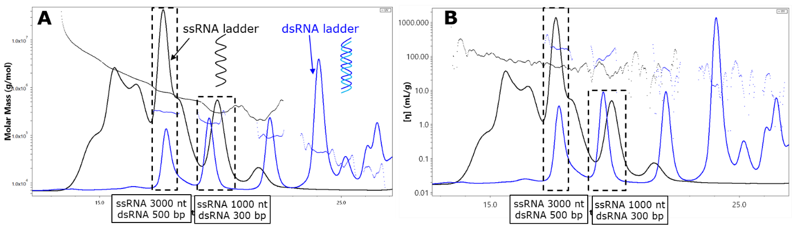
Supplementary Fig. S3 SEC traces (UV response only) of ssRNA (black) and dsRNA (blue) ladders. A: comparison of molar mass depicted on the left Y-axis (horizontal black line corresponds to the molar mass of ssRNA, and the blue lines correspond to the molar mass of dsRNA); B: comparison of intrinsic viscosities depicted on the left Y-axis (horizontal black line corresponds to the intrinsic viscosity of ssRNA, and the blue lines correspond to the intrinsic viscosity dsRNA). Some molar mass and viscosity data show scattering due to relatively low detector response because of low sample concentration. This Figure demonstrates that dsRNA (rod-like conformation) of a comparable nucleotide length elutes before the corresponding ssRNA (random coil conformation) and shows higher viscosity. This illustrates a large impact of conformation and aspect ratio on the elution behavior of RNA in SEC.

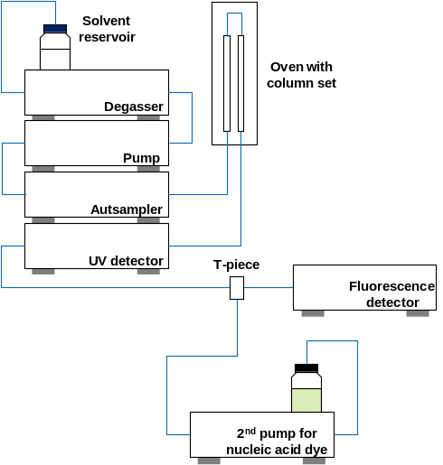
Supplementary Fig. S4 Schematic design of the used instrument platform for analysis of nucleic acids based on size-exclusion chromatography with UV detection and post-column nucleic acid staining prior to fluorescence detection.

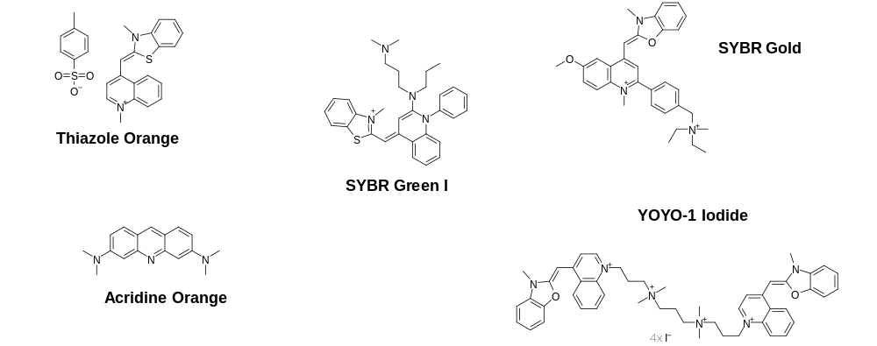
Supplementary Fig. S5 Nucleic acid dyes investigated for their potential regarding analysis of RNA by size-exclusion chromatographic separation and post-column staining with fluorescence detection

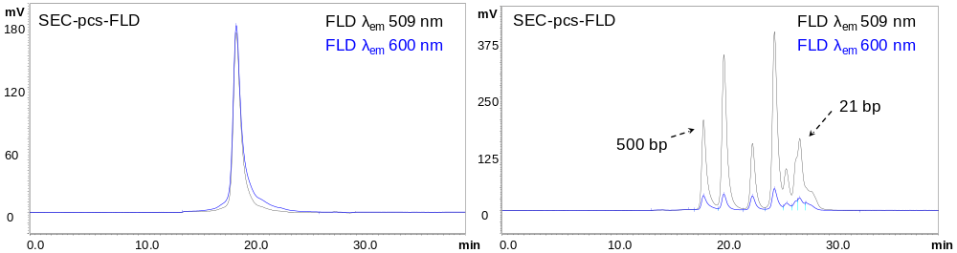
Supplementary Fig. S6 Overlay of SEC-pcs-FLD chromatograms of a 1922 nt-long mRNA (left) and the dsRNA ladder (21 - 500 bp, 7 fragments, right) stained with YOYO-1 after size-exclusion chromatographic separation prior to fluorescence detection at two different emission wavelengths.

Supplementary equation SE1 Einstein-Simna equation for calculation of hydrodynamic radius R_{h} from intrinsic viscosity [η].


Supplementary Table S1 Excitation and emission wavelengths used for the individual nucleic acid dyes regarding fluorescence detection of RNA after SEC separation and post-column nucleic acid staining
 | Excitation wavelength [λ] | Emission wavelength [λ]
SYBR Green I | 485 | 530
SYBR Gold | 495 | 537
Thiazole Orange | 512 | 533
Acridine Orange | 485 | 530/650
YOYO-1 iodide | 491 | 509ª/600
ª wavelength used regarding displayed SEC-pcs-FLD chromatograms and FLD/UV peak area ratios unless stated otherwise
Supplementary Table S2 mRNA concentrations of the individual calibration solutions
 | mRNA concentration [µg/ml]
Calibration solution #1 | 1.0
Calibration solution #2 | 2.5
Calibration solution #3 | 7.5
Calibration solution #4 | 10
Calibration solution #5 | 25
Calibration solution #6 | 75
Calibration solution #7 | 100

Supplementary Table S3 The R_{g}/R_{h} ratio provides information about the conformation of macromolecules, where R_{g} is the radius of gyration determined from static light scattering (SLS or in case of chromatography MALS) measurements, and R_{h} is the hydrodynamic radius determined from dynamic light scattering (DLS) or online viscometry (VS) measurements [1].
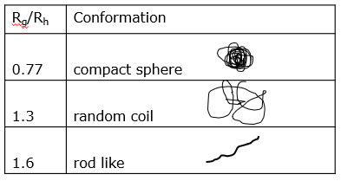

Supplementary Table S4 Determined S/N ratios and derived LODs and LOQs based on analysis of the lowest-concentrated mRNA calibration sample using SEC-UV and SEC-pcs-FLD. YOYO-1 is not included, as the calibration samples were not analyzed with this dye due to a limited number of experiments performed owing to the high associated costs; Acridine Orange is not depicted either, as no FLD signal was observed for the mRNA + Acridine Orange due to the dye in flow path causing high background fluorescence saturating the detector
 | mRNA concentration [µg/ml] (ngª) | Nucleic acid dye | S/N  ratio  (RSD) | LOD^{b} |  | LOQ^{b}
 |  |  |  | [µg/ml] | [ng]ª | [µg/ml] | [ng]ª
SEC-pcs-FLD | 1 (10) | SYBR Green I | 266.9  (-) | 0.01 | 0.1 | 0.04 | 0.4
SEC-pcs-FLD | 1 (10) | SYBR  Gold | 1063.7  (-) | 0.003 | 0.03 | 0.009 | 0.09
SEC-pcs-FLD | 1 (10) | Thiazole Orange | 87.0  (-) | 0.03 | 0.3 | 0.11 | 1.1
SEC-UV | 1 (10) | - | 6.8^{c}  (57%) | 0.44 | 4.4 | 1.48 | 14.8
ª amount on column considering 10 µl injection volume
^{b} considering S/N of 3 for LOD and S/N 10 for LOQ
^{c} averaged value based on n = 3 individual samples analyzed on three separate days

Supplementary Table S5 Linearity and precision results obtained for the individual dyes applied for post-column staining of a 1922 nt-long mRNA and subsequent fluorescence detection after size-exclusion chromatographic separation. YOYO-1 is not included, as the calibration samples were not analyzed with this dye due to a limited number of experiments performed owing to the high associated costs; Acridine Orange is not depicted either, as no FLD signal was observed for the mRNA + Acridine Orange due to the dye in flow path causing high background fluorescence saturating the detector
 | Coefficient of determination (R²) of calibration curveª | Precision^{b}
SYBR Green I | 0.9983 | 3.1
SYBR Gold | 0.9985 | 1.7
Thiazole Orange | 0.9975 | 2.0
ª covering a concentration range of 1 - 100 µg/ml based on seven calibration solutions and linear regression without any weighting
^{b} relative standard deviation of peak area based on sixfold analysis of the mRNA sample (75 µg/ml) within one day
Supplementary Table S6 Calculated FLD/UV peak area ratios for the mRNA, ssRNA ladder and dsRNA ladder to assess dye selectivity towards ssRNA and dsRNA species. Acridine Orange is not depicted, as no FLD signal was observed for the mRNA + Acridine Orange due to the dye in flow path causing high background fluorescence saturating the detector
 | mean FLD/UV  peak area ratio  mRNAª [-] (RSD) | mean FLD/UV  peak area ratio  ssRNA ladder^{b} [-] (RSD) | mean FLD/UV  peak area ratio  dsRNA ladder^{b} [-] (RSD)
SYBR Green I | 46.9 (4.0%) | 34.4 (9.2%) | 197.7 (30.1%)
SYBR Gold | 152.4 (3.8%) | 123.3 (9.6%) | 134.2 (10.1%)
Thiazole Orange | 18.8 (2.6%) | 14.4 (7.7%) | 15.3 (16.7%)
YOYO-1 iodide | 6.8 (6.5%) | -^{c} | 39.1 (27.6%)
ª mean value based on sixfold analysis of the mRNA calibration sample (75 µg/ml, n = 6) also used for assessing reproducibility of approach; regarding YOYO-1, displayed mean value is based on threefold analysis (n = 3) of the calibration sample due to a limited number of experiments performed owing to the high associated cost
^{b} corresponds to the mean FLD/UV ratio across all individual ladder fragments (n = 2 measurements, 7 fragments per ladder)
^{c} ssRNA ladder was not analyzed using YOYO-1 due to a limited number of experiments performed owing to the high associated costs
Supplementary Table S7 Calculated FLD peak area ratios regarding two different emission wavelengths for the mRNA and dsRNA ladder to assess selectivity of YOYO-1 towards ssRNA and dsRNA species.
 | mean FLD  peak area ratio  (λ_{em} = 509 nm / 600 nm)  mRNAª [-] (RSD) | mean FLD  peak area ratio  (λ_{em} = 509 nm / 600 nm)  dsRNA ladder^{b} [-] (RSD in %)
YOYO-1 iodide | 1.3 (2.9%) | 5.8 (27.8%)
ª mean value based on threefold analysis of a mRNA calibration sample (75 µg/ml, n = 3)
^{b} corresponds to the mean FLD peak ratio across all individual ladder fragments (n = 1 measurement, 7 fragments per ladder)

References
- Burchard, W. Adv. Polym. Sci. 1983,48, 1–124.

