SUPPLEMENTARY INFORMATION
Page S-5, Figure S1. Sampling sites for Lac Saint-Pierre and Yamaska River.
Page S-6, Table S1. Validation parameters of the quantitative method including method detection and quantification limits (MDL and MQL), extraction recoveries and matrix effects.
Page S-7, Figure S2. Chromatographic gradient conditions for the quantitative analysis workflow (QqQ) and the suspect screening and non-targeted analysis workflow (HRMS).
Page S-8, Table S2. Ionization and ion selection parameters for the quantitative analysis workflow (QqQ) and the suspect screening and non-targeted analysis workflow (HRMS).
Page S-9, Table S3. Selected reaction monitoring (SRM) parameters for targeted compounds quantitative analysis.
Page S-11, Table S4. Validation parameters of the quantitative method including accuracy and precision.
Page S-12, Table S5. Compound Discoverer 3.3 workflows.
Page S-13, Table S6. Calculated Log P of targeted compounds.
Page S-14, Figure S3. Chemical structures of microcystins (MC-LR), anabaenopeptins (AP-A) and other found cyanopeptides : Microginin 690, Aeruginopeptin 228A, Cyanopeptolin 1081 and Aeruginosin A.
Page S-15, Table S7. Microcystins (MCs) specific ions from MS² fragmentation.
Page S-16, Figure S4. Structure characterization of [Ser⁷]microcystin-LR. A) Extracted ion chromatogram of ion m/z 999.5503 and B) isotopic pattern of most intense precursor ion. C) Fragmentation spectrum and in-silico matching with FISh coverage.
Page S-17, SI-2. Spectral interpretation of [DMAdda⁵, GluOMe⁶]microcystin-LHty.
Page S-18, Figure S5. Structure characterization of [seco-4/5][D-Asp³]microcystin-HtyR. A) Extracted ion chromatogram of ion m/z 1063.5370 and B) isotopic pattern of most intense precursor ion. C) Extracted ion chromatogram of thiol derivative ion m/z 1141.5552 and D) isotopic pattern of thiol derivative. E) Fragmentation spectrum and in-silico matching with FISh coverage.
Page S-19, Figure S6. Structure characterization of [D-Asp³]microcystin-MR. A) Extracted ion chromatogram of ion m/z 999.4937 and B) isotopic pattern of most intense precursor ion. C) Extracted ion chromatogram of thiol derivative ion m/z 1077.5037 and D) isotopic pattern of thiol derivative. E) Fragmentation spectrum and in-silico matching with FISh coverage.
Page S-20, Figure S7. Structure characterization of [D-Asp³]microcystin-M(O)R. A) Extracted ion chromatogram of ion m/z 1015.4898 and B) isotopic pattern of most intense precursor ion. C) Extracted ion chromatogram of thiol derivative ion m/z 1093.4993 and D) isotopic pattern of thiol derivative. E) Fragmentation spectrum and in-silico matching with FISh coverage.
Page S-21, Figure S8. Structure characterization of [DMAdda⁵]microcystin-YR. A) Extracted ion chromatogram of ion m/z 1031.5168 and B) isotopic pattern of most intense precursor ion. C) Extracted ion chromatogram of thiol derivative ion m/z 1109.5294 and D) isotopic pattern of thiol derivative. E) Fragmentation spectrum and in-silico matching with FISh coverage.
Page S-22, Figure S9. Structure characterization of [D-Ser¹, D-Asp³]microcystin-HtyR. A) Extracted ion chromatogram of ion m/z 1061.5292 and B) isotopic pattern of most intense precursor ion. C) Extracted ion chromatogram of thiol derivative ion m/z 1139.5392 and D) isotopic pattern of thiol derivative. E) Fragmentation spectrum and in-silico matching with FISh coverage.
Page S-23, Figure S10. Structure characterization of [D-Ser¹, D-Asp³]microcystin-HtyR. A) Extracted ion chromatogram of ion m/z 967.5246 and B) isotopic pattern of most intense precursor ion. C) Extracted ion chromatogram of thiol derivative ion m/z 1045.5334 and D) isotopic pattern of thiol derivative. E) Fragmentation spectrum and in-silico matching with FISh coverage.
Page S-24, Figure S11. Structure characterization of [Mdha-GSH⁷]microcystin-LR. A) Extracted ion chromatogram of ion m/z 1302.6398 and B) isotopic pattern of most intense precursor ion. C) Fragmentation spectrum and in-silico matching with FISh coverage.
Page S-25, Figure S12. Structure characterization of [epoxyAdda⁵]microcystin-LR. A) Extracted ion chromatogram of ion m/z 1011.5501 and B) isotopic pattern of most intense precursor ion. C) Extracted ion chromatogram of thiol derivative ion m/z 1089.5625 and D) isotopic pattern of thiol derivative. E) Fragmentation spectrum and in-silico matching with FISh coverage.
Page S-26, Figure S13. Structure characterization of [DMAdda⁵]microcystin-LR. A) Extracted ion chromatogram of ion m/z 981.5108 and B) isotopic pattern of most intense precursor ion. C) Extracted ion chromatogram of thiol derivative ion m/z 1059.5524 and D) isotopic pattern of thiol derivative. E) Fragmentation spectrum and in-silico matching with FISh coverage.
Page S-27, Figure S14. Structure characterization of [seco-1/2]microcystin-LR. A) Extracted ion chromatogram of ion m/z 1013.5672 and B) isotopic pattern of most intense precursor ion. C) Extracted ion chromatogram of thiol derivative ion m/z 1091.5706 and D) isotopic pattern of thiol derivative. E) Fragmentation spectrum and in-silico matching with FISh coverage.
Page S-28, Table S8. Anabaenopeptins (APs) specific ions from MS² fragmentation (with associated sample).
Page S-29, Figure S15. Structure characterization of anabaenopeptin F. A) Extracted ion chromatogram of ion m/z 851.4758 and B) isotopic pattern of most intense precursor ion. E) Fragmentation spectrum and in-silico matching with FISh coverage.
Page S-30, SI-3. Spectral interpretation of anabaenopeptin F.
Page S-31, Figure S16. Structure characterization of anabaenopeptin E. A) Extracted ion chromatogram of ion m/z 851.4755 and B) isotopic pattern of most intense precursor ion. E) Fragmentation spectrum and in-silico matching with FISh coverage.
Page S-32, Figure S17. Structure characterization of anabaenopeptin H. A) Extracted ion chromatogram of ion m/z 923.5311 and B) isotopic pattern of most intense precursor ion. E) Fragmentation spectrum and in-silico matching with FISh coverage.
Page S-33, Figure S18. Structure characterization of anabaenopeptin HU892. A) Extracted ion chromatogram of ion m/z 893.5226 and B) isotopic pattern of most intense precursor ion. E) Fragmentation spectrum and in-silico matching with FISh coverage.
Page S-34, Figure S19. Structure characterization of anabaenopeptin SA3. A) Extracted ion chromatogram of ion m/z 823.4703 and B) isotopic pattern of most intense precursor ion. E) Fragmentation spectrum and in-silico matching with FISh coverage.
Page S-35, Figure S20. Structure characterization of anabaenopeptin 679. A) Extracted ion chromatogram of ion m/z 637.3700 and B) isotopic pattern of most intense precursor ion. E) Fragmentation spectrum and in-silico matching with FISh coverage.
Page S-36, Table S9. Other cyanopeptides specific ions from MS² fragmentation.
Page S-37, Figure S21. Structure characterization of microginin 690. A) Extracted ion chromatogram of ion m/z 691.3350 and B) isotopic pattern of most intense precursor ion. E) Fragmentation spectrum and in-silico matching with FISh coverage.
Page S-38, Figure S22. Structure characterization of aeruginopeptin 228A. A) Extracted ion chromatogram of ion m/z 1045.4854 and B) isotopic pattern of most intense precursor ion. E) Fragmentation spectrum and in-silico matching with FISh coverage.
Page S-39, Figure S23. Structure characterization of cyanopeptolin 1081. A) Extracted ion chromatogram of ion m/z 1082.5393 and B) isotopic pattern of most intense precursor ion. E) Fragmentation spectrum and in-silico matching with FISh coverage.
Page S-40, Figure S24. Structure characterization of aeruginosin A. A) Extracted ion chromatogram of ion m/z 617.3458 and B) isotopic pattern of most intense precursor ion. E) Fragmentation spectrum and in-silico matching with FISh coverage.
Page S-41, Figure S25. Structure characterization of transformation product 2 (TP2). A) Extracted ion chromatogram of ion m/z 680.3755, B) isotopic pattern of most intense precursor ion, C) Fragmentation spectrum and compound class coverage compared to anabaenopeptin B and D) Fragmentation spectrum and in-silico matching with FISh coverage.
Page S-42, Figure S26. Proposed transformation product 2 (TP2) formation by ketonization of anabaenopeptin B.
Page S-43, Figure S27. Structure characterization of transformation product 3 (TP3). A) Extracted ion chromatogram of ion m/z 695.3759, B) isotopic pattern of most intense precursor ion, C) Fragmentation spectrum and compound class coverage compared to oscillamide Y and D) Fragmentation spectrum and in-silico matching with FISh coverage.
Page S-44, Figure S28. Proposed transformation product 3 (TP3) formation by carbamatization of oscillamide Y.
Page S-45, Figure S29. Structure characterization of transformation product 4 (TP4). A) Extracted ion chromatogram of ion m/z 711.3710, B) isotopic pattern of most intense precursor ion, C) Fragmentation spectrum and compound class coverage compared to oscillamide Y and D) Fragmentation spectrum and in-silico matching with FISh coverage.
Page S-46, Figure S30. Proposed transformation product 4 (TP4) formation in two steps of oscillamide Y.
Page S-47, Figure S31. Structure characterization of transformation product 5 (TP5). A) Extracted ion chromatogram of ion m/z 911.5712, B) isotopic pattern of most intense precursor ion, C) Extracted ion chromatogram of thiol derivative ion m/z 989.5826 and D) isotopic pattern of thiol derivative. E) Fragmentation spectrum and compound class coverage compared to [Asp³]microcystin-LR and F) Fragmentation spectrum and in-silico matching with FISh coverage.
Page S-48, Figure S32. Proposed transformation product 5 (TP5) formation in two steps of [Asp³]microcystin-LR.
Page S-49, Figure S33. Structure characterization of transformation product 6 (TP6). A) Extracted ion chromatogram of ion m/z 999.5491, B) isotopic pattern of most intense precursor ion, C) Extracted ion chromatogram of thiol derivative ion m/z 1077.5518 and D) isotopic pattern of thiol derivative. E) Fragmentation spectrum and compound class coverage compared to [Asp³]microcystin-LR and F) Fragmentation spectrum and in-silico matching with FISh coverage.
Page S-50, Figure S34. Proposed transformation product 6 (TP6) formation by linearization of [Asp³]microcystin-LR.
Page S-51, Figure S35. Structure characterization of transformation product 7 (TP7). A) Extracted ion chromatogram of ion m/z 1061.5301, B) isotopic pattern of most intense precursor ion, C) Extracted ion chromatogram of thiol derivative ion m/z 1139.5427 and D) isotopic pattern of thiol derivative. E) Fragmentation spectrum and compound class coverage compared to microcystin-YR and F) Fragmentation spectrum and in-silico matching with FISh coverage.
Page S-52, Figure S36. Proposed transformation product 7 (TP7) formation by linearization of microcystin-YR.
Page S-53. References
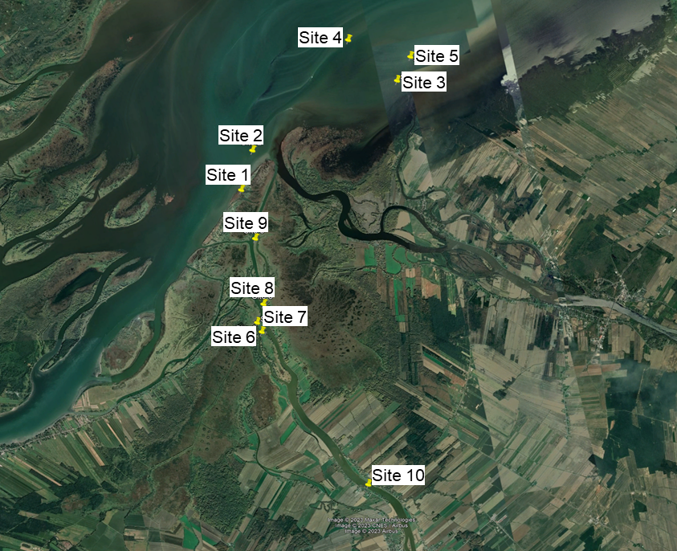
Figure S1. Sampling sites for Lac Saint-Pierre and Yamaska River

Table S1. Validation parameters of the quantitative method including method detection and quantification limits (MDL and MQL), extraction recovery and matrix effects.
Compounds | R² | MDL  (ng L⁻¹) | MQL  (ng L⁻¹) | Extraction  recoveries (%) | Matrix effects (%)
AG-98A | 0.9995 | 7 | 22 | 76 ± 3 | 88 ± 2
AG-98B | 0.9997 | 4 | 12 | 75 ± 4 | 82 ± 2
AGU-98A | 0.9986 | 11 | 35 | 89 ± 3 | 93 ± 2
AP-A | 0.9999 | 4 | 13 | 107 ± 2 | 90 ± 1
AP-B | 0.9997 | 4 | 12 | 110 ± 7 | 87 ± 5
AP-C | 0.9999 | 9 | 31 | 110 ± 4 | 90 ± 3
AP-J | 0.9999 | 10 | 33 | 108 ± 5 | 89 ± 3
AP-915 | 0.9996 | 8 | 25 | 105 ± 3 | 95 ± 7
FA-A | 0.9999 | 8 | 25 | 92 ± 4 | 86 ± 2
OC-Y | 0.9999 | 3 | 9 | 103 ± 3 | 98 ± 6
CP-1041 | 0.9961 | 8 | 26 | 54 ± 5 | 86 ± 3
[Asp³]MC-RR | 0.9999 | 3 | 9 | 81 ± 4 | 93 ± 3
MC-RR | 0.9999 | 10 | 33 | 82 ± 6 | 89 ± 4
MC-YR | 0.9998 | 8 | 26 | 104 ± 8 | 91 ± 5
MC-HtyR | 0.9996 | 7 | 23 | 95 ± 7 | 100 ± 4
[Asp³]MC-LR | 0.9999 | 5 | 16 | 110 ± 6 | 90 ± 3
MC-LR | 0.9999 | 3 | 11 | 105 ± 3 | 90 ± 3
MC-HilR | 0.9997 | 10 | 32 | 104 ± 9 | 89 ± 3
MC-WR | 0.9998 | 10 | 32 | 110 ± 9 | 93 ± 3
MC-LA | 0.9995 | 5 | 17 | 103 ± 8 | 89 ± 2
MC-LY | 0.9998 | 8 | 28 | 99 ± 7 | 93 ± 5
MC-LW | 0.9999 | 8 | 26 | 107 ± 9 | 103 ± 9
MC-LF | 0.9999 | 9 | 28 | 89 ± 5 | 101 ± 2
MG-527-ME | 0.9972 | 11 | 38 | 96 ± 3 | 92 ± 2
MG-690-ME | 0.9978 | 7 | 23 | 58 ± 3 | 105 ± 3
MG-FR1 | 0.9999 | 12 | 39 | 76 ± 3 | 91 ± 2
MG-FR2 | 0.9999 | 9 | 30 | 96 ± 5 | 103 ± 5
NOD-R | 0.9999 | 4 | 13 | 104 ± 7 | 88 ± 4
Note: The MDL and MQL were calculated by the standard deviation (SD) of five times the estimated MDL (0.5 ng L⁻¹) : SD x 3.3 (MDL) and SD x 10 (MQL).
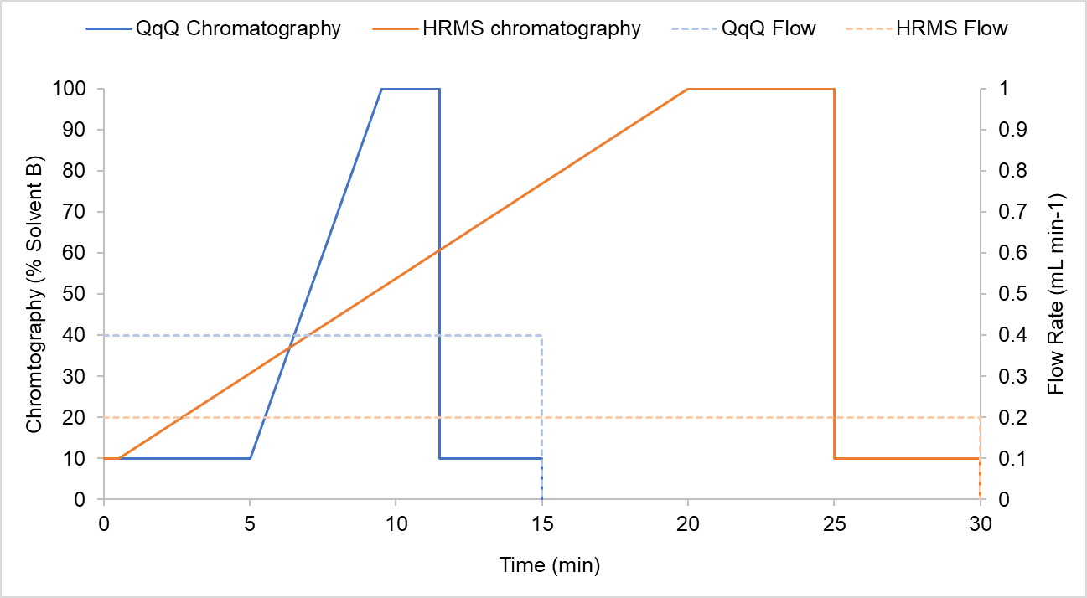
Figure S2. Chromatographic gradient conditions for the quantitative analysis workflow (QqQ) and the suspect screening and non-targeted analysis workflow (HRMS).

Table S2. Ionization and ion selection parameters for the quantitative analysis workflow (QqQ) and the suspect screening and non-targeted analysis workflow (HRMS).
QqQ |  | HRMS
Ionization parameters
Positive Ionization (V) | 3900 | 4000
Sheath Gas (Arbitrary) | 50 | 30
Auxiliary Gas (Arbitrary) | 10 | 10
Sweep Gas (Arbitrary) | 1 | 3
Ion Transfer Tube Temperature (°C) | 325 | 300
Vaporizer Temperature (°C) | 350 | 400
S-len RF level | NA | 55
SRM¹ parameters |  | DDA² parameters
Cycle Time (second) | 0.3 | FS Resolution (FWHM) | 70,000
Points Per Peak | 20 | FS AGC Target | 1e6
Q1 Resolution (FWHM) | 0.7 | FS Maximum Injection Time (ms) | 55
Q3 Resolution (FWHM) | 1.2 | FS Scan Range (m/z) | 300 to 1400
CID Gas (mTorr) | 1.5 | PRM Resolution (FWHM) | 17,500
 |  | PRM AGC Target | 1e5
 |  | PRM Maximum Injection Time (ms) | 55
 |  | TopN | 5
 |  | Isolation Window (m/z) | 3
 |  | Intensity Threshold | 1.5e5
 |  | Exclude Isotopes | On
 |  | Dynamic Exclusion (s) | 1
1. Selected reaction monitoring (SRM)
2. Data dependent acquisition (DDA)
Table S3. Selected reaction monitoring (SRM) parameters for targeted compounds quantitative analysis
Compounds | Retention Time (min) | Retention Time Window (min) | RF Lens (V) | Precursor ion (m/z) | Product ion (m/z)* | Collision Energy (V)
AG-98A | 3.52 | 0.25 | 87 | 655.3 | 281.1 | 40
 |  |  |  |  | 575.2 | 18
AG-98B | 4.07 | 0.35 | 89 | 689.2 | 281.2 | 41
 |  |  |  |  | 609.2 | 18
AP-B | 4.70 | 0.25 | 127 | 837.4 | 175.1 | 38
 |  |  |  |  | 201.1 | 42
MG-527-ME | 4.96 | 0.25 | 97 | 542.3 | 102 | 35
 |  |  |  |  | 194 | 23
[Asp³]MC-RR | 5.22 | 0.25 | 92 | 512.9 | 445.7 | 20
 |  |  |  |  | 620.2 | 27
MG-690-ME | 5.26 | 0.25 | 103 | 705.3 | 357.1 | 25
 |  |  |  |  | 510.2 | 20
AGU-98A | 5.24 | 0.25 | 94 | 982.4 | 804.4 | 27
 |  |  |  |  | 902.4 | 10
MC-RR | 5.28 | 0.25 | 99 | 519.9 | 135.1 | 31
 |  |  |  |  | 213.1 | 36
MC-RR-¹⁵N₁₃ | 5.28 | 0.25 | 99 | 526.1 | 135.1 | 31
AP-A | 5.44 | 0.25 | 121 | 844.4 | 637.2 | 26
 |  |  |  |  | 663.2 | 25
AP-915 | 5.52 | 0.25 | 131 | 916.4 | 709.4 | 29
 |  |  |  |  | 735.3 | 28
NOD-R | 5.60 | 0.25 | 128 | 825.5 | 135.1 | 59
 |  |  |  |  | 389.2 | 42
OC-Y | 5.64 | 0.25 | 145 | 858.4 | 651.3 | 23
 |  |  |  |  | 1024.5 | 15
CP-1041 | 5.66 | 0.25 | 108 | 1042.5 | 184.2 | 47
 |  |  |  |  | 681.2 | 28
MG-FR1 | 5.68 | 0.25 | 112 | 728.4 | 384.2 | 23
 |  |  |  |  | 664.2 | 32
MC-YR | 5.76 | 0.25 | 120 | 1045.5 | 135 | 71
 |  |  |  |  | 1017.2 | 45
MC-YR-¹⁵N₁₀ | 5.76 | 0.25 | 120 | 1055.6 | 215.1 | 65
MC-HtyR | 5.80 | 0.25 | 120 | 1059.5 | 107.1 | 85
 |  |  |  |  | 135.1 | 70
MG-FR2 | 5.82 | 0.25 | 123 | 742.4 | 182.1 | 43
 |  |  |  |  | 398.2 | 25
[Asp³]MC-LR | 5.87 | 0.25 | 126 | 981.5 | 135.1 | 66
 |  |  |  |  | 539.2 | 48
MC-LR | 5.87 | 0.25 | 122 | 995.5 | 135.1 | 70
 |  |  |  |  | 213.1 | 64
MC-LR-¹⁵N₁₀ | 5.87 | 0.25 | 122 | 1005.1 | 215.1 | 65
FA-A | 5.96 | 0.25 | 123 | 867.4 | 637.3 | 28
 |  |  |  |  | 686.2 | 37
MC-HilR | 6.00 | 0.25 | 101 | 1009.5 | 213.1 | 77
 |  |  |  |  | 269.1 | 57
AP-J | 6.04 | 0.25 | 107 | 794.4 | 637.2 | 24
 |  |  |  |  | 663.3 | 24
MC-WR | 6.05 | 0.25 | 116 | 1068.5 | 135.1 | 70
 |  |  |  |  | 213.1 | 64
AP-C | 6.14 | 0.25 | 117 | 808.4 | 419.2 | 37
 |  |  |  |  | 651.3 | 25
MC-LA | 6.86 | 0.25 | 113 | 910.4 | 375.2 | 32
 |  |  |  |  | 776.3 | 19
MC-LA-¹⁵N₇ | 6.86 | 0.25 | 131 | 917.5 | 215.1 | 65
MC-LY | 6.97 | 0.25 | 118 | 1002.5 | 494.2 | 26
 |  |  |  |  | 868.4 | 20
MC-LW | 7.46 | 0.25 | 140 | 1025.5 | 517.2 | 27
 |  |  |  |  | 891.4 | 21
MC-LF | 7.60 | 0.25 | 144 | 986.5 | 478.2 | 25
 |  |  |  |  | 852.4 | 20
*The first product ion is for quantification, and the second product ion is for confirmation
Table S4. Validation parameters of the quantitative method including accuracy and precision.
Compounds | Accuracy (%)¹ |  |  | Intra-day precision² (RSD, %) |  |  | Inter-day precision³ (RSD, %)
Compounds | Spike level (µg L⁻¹) |  |  | Spike level (µg L⁻¹) |  |  | Spike level (µg L⁻¹)
Compounds | 2.5 | 50 |  | 2.5 | 50 |  | 2.5 | 50
AG-98A | 94 ± 5 | 97 ± 3 |  | 2 | 2 |  | 10 | 13
AG-98B | 107 ± 6 | 105 ± 4 |  | 3 | 1 |  | 9 | 12
AGU-98A | 112 ± 10 | 90 ± 5 |  | 5 | 6 |  | 10 | 10
AP-A | 94 ± 1 | 93 ± 3 |  | 1 | 2 |  | 2 | 3
AP-B | 95 ± 2 | 107 ± 2 |  | 7 | 4 |  | 6 | 4
AP-C | 103 ± 11 | 101 ± 3 |  | 5 | 1 |  | 9 | 9
AP-J | 106 ± 3 | 95 ± 3 |  | 4 | 1 |  | 9 | 3
AP-915 | 100 ± 2 | 97 ± 5 |  | 2 | 5 |  | 5 | 7
FA-A | 104 ± 1 | 95 ± 2 |  | 2 | 2 |  | 11 | 4
OC-Y | 110 ± 2 | 103 ± 2 |  | 3 | 1 |  | 8 | 4
CP-1041 | 103 ± 2 | 93 ± 2 |  | 3 | 1 |  | 9 | 10
[Asp³]MC-RR | 89 ± 3 | 95 ± 3 |  | 6 | 4 |  | 10 | 8
MC-RR | 109 ± 2 | 94 ± 3 |  | 1 | 1 |  | 12 | 3
MC-YR | 100 ± 1 | 96 ± 3 |  | 5 | 6 |  | 7 | 8
MC-HtyR | 95 ± 4 | 96 ± 4 |  | 2 | 1 |  | 6 | 5
[Asp³]MC-LR | 110 ± 5 | 105 ± 2 |  | 8 | 2 |  | 8 | 7
MC-LR | 113 ± 6 | 102 ± 3 |  | 3 | 2 |  | 11 | 4
MC-HilR | 110 ± 3 | 101 ± 1 |  | 4 | 1 |  | 4 | 7
MC-WR | 102 ± 6 | 105 ± 3 |  | 3 | 1 |  | 8 | 5
MC-LA | 104 ± 2 | 100 ± 1 |  | 3 | 1 |  | 7 | 5
MC-LY | 108 ± 6 | 100 ± 1 |  | 8 | 4 |  | 10 | 11
MC-LW | 97 ± 3 | 90 ± 6 |  | 2 | 2 |  | 2 | 3
MC-LF | 101 ± 3 | 93 ± 5 |  | 4 | 1 |  | 3 | 7
MG-527-ME | 103 ± 6 | 91 ± 2 |  | 2 | 1 |  | 3 | 4
MG-690-ME | 107 ± 4 | 91 ± 4 |  | 2 | 1 |  | 14 | 3
MG-FR1 | 96 ± 3 | 94 ± 2 |  | 8 | 8 |  | 4 | 5
MG-FR2 | 105 ± 4 | 93 ± 7 |  | 3 | 5 |  | 5 | 7
NOD-R | 88 ± 7 | 103 ± 1 |  | 2 | 3 |  | 5 | 4
- Recovery value from spiked level.
- Intra-day precision was determined with five consecutive injections during the same day.
- Inter-day precision was determined with injections for five consecutive days.

Nodes Settings | FISh Scoring Experiment | Compound Class Experiment
Select Spectra
Lower RT Limit | 1
Uppet RT Limit | 25
Polarity Mode | Positive
Detect Compounds
Mass Tolerance (ppm) | 5
Minimum Peak Intensity | 10000
Use Most Intense Isotope | True
Chromatographic S/N Threshold | 1.5
Group Isotopes for | Br, Cl
Ions | All options available
Group Compounds
Mass Tolerance (ppm) | 5
RT Tolerance (min) | 0.1
Preferred Ions | [M + H]+1; [M+2H]+2; [M+NH4]+1; [M+Na]+1
Search Mass Lists
Mass Lists | CyanoMetDB 2023 | NA
Mass Tolerance (ppm) | 5 | NA
Predict Composition
Mass Tolerance | 5
Minimun Element Counts | C H
Maximum Elements Counts | C90 H190 Br5 Cl4 F5 I N10 O18 P3 S5 Si15
Minimun RDBE | 0
Maximum RDBE | 40
Minimun H/C | 0.1
Maximum H/C | 3.5
Maximum # Candidates | 10
Intensity Tolerance [%] | 30
Intensity Threshold [%] | 0.1
S/N Threshold | 3
Use Dynamic Recalibration | True
Use Fragments Matching | True
Apply Spectral Distance
Mass Tolerance (ppm) | 5
Intensity Tolerance [%] | 30
Intensity Threshold [%] | 0.1
S/N Threshold | 3
Use Dynamic Recalibration | True
Compound Class Scoring
Compound Classes | NA | One class per target compound
S/N Threshold | NA | 3
High Acc. Mass Tolerance | NA | 5 ppm
Low Acc. Mass Tolerance | NA | 0.5 Da
Use Full MS Tree | NA | True
Allow DIA Scoring | NA | True
Table S5. Compound Discoverer 3.3 workflows.

Table S6. Calculated Log P of targeted compounds.
Compounds | RT*  (min) | Log P
AG-98A | 7.57 | -0.62
AG-98B | 6.59 | -1.48
AGU-98A | 10.24 | -3.97
AP-A | 10.57 | 0.58
AP-B | 8.73 | -1.47
AP-C | 12.01 | -0.89
AP-J | 11.82 | 0.88
AP-915 | 10.78 | 1.90
FA-A | 11.69 | 1.21
OC-Y | 10.98 | 1.08
CP-1041 | 11.10 | 0.77
[Asp³]MC-RR | 9.74 | -4.82
MC-RR | 9.87 | -5.10
MC-YR | 10.94 | -3.96
MC-HtyR | 11.09 | -3.45
[Asp³]MC-LR | 11.11 | -2.89
MC-LR | 11.17 | -3.64
MC-HilR | 11.41 | -3.39
MC-WR | 11.54 | -3.33
MC-LA | 13.75 | -2.57
MC-LY | 14.02 | -1.58
MC-LW | 15.08 | -0.95
MC-LF | 15.38 | -1.11
MG-527-ME | 9.21 | 0.88
MG-690-ME | 9.82 | 0.76
MG-FR1 | 10.69 | 1.04
MG-FR2 | 11.10 | 1.95
NOD-R | 10.60 | -3.57
* Retention time using suspect screening method

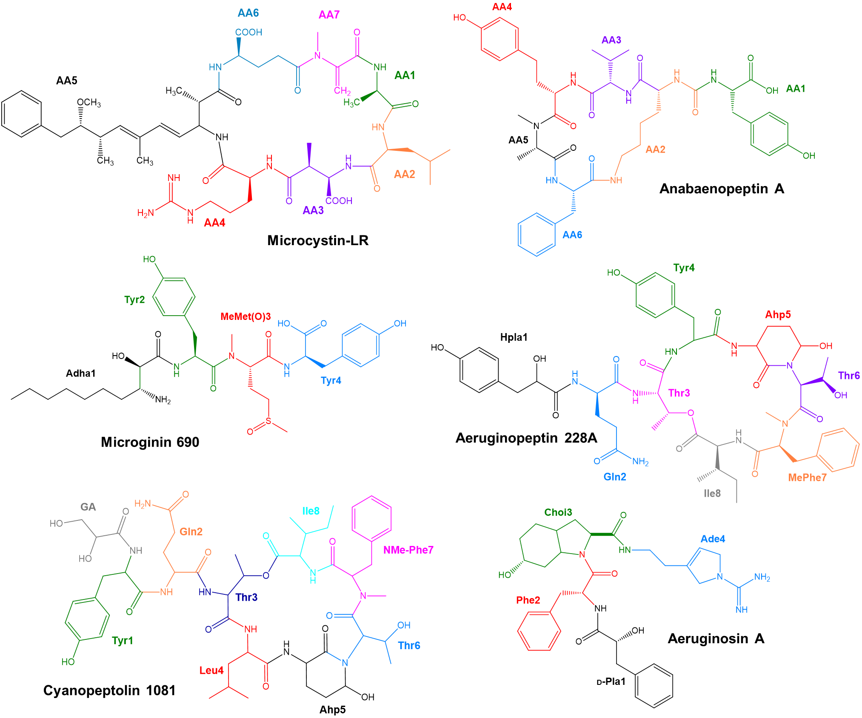
Figure S3. Chemical structures of microcystins (MC-LR), anabaenopeptins (AP-A) and other found cyanopeptides : Microginin 690, Aeruginopeptin 228A, Cyanopeptolin 1081 and Aeruginosin A.

Table S7. Microcystins (MCs) specific ions from MS² fragmentation
Fragmentation sequence | [Ser⁷]  MC-LR | [DMAdda⁵,GluOMe⁶]  MC-LHty | [seco-4/5]  [D-Asp³]  MC-HtyR | [DAsp³]  MC-MR | [DAsp³]  MC-M(O)R | [DMAdda⁵]MC-YR | [D-Ser¹,D-Asp³]MC-HtyR | [D-Asp³,  DMAdda⁵]  MC-LR | [Mdha-GSH⁷]  MC-LR | [epoxyAdda⁵]MC-LR | [DMAdda⁵]MC-LR | [seco-1/2]  MC-LR
M+H⁺ | 999.5503 | 1016.5310 | 1063.5370 | 999.4937 | 1015.4898 | 1031.5168 | 1061.5292 | 967.5260 | 1302.6398 | 1011.5501 | 981.5108 | 1013.5672
M+2H²⁺ | 500.2790 |  | 532.2754 | 500.2506 | 508.2494 | 516.2636 | 531.2687 | 484.5656 | 651.8229 | 506.2815
M+H⁺-H₂O |  | 998.5264*
M+H⁺-CO | 971.5533* | 988.5381* |  |  |  | 1003.5235* | 1033.5291* | 939.5304* |  |  | 963.5499* | 985.5735
M+H⁺-134 (Adda) |  | 882.4664 |  | 865.5233 |  |  |  |  | 1168.5671 | 877.4788
M+H⁺-134 (Adda)-NH₃ |  |  | 912.4440*
AA3+AA4+Adda+H⁺ |  |  |  |  |  | 585.3378 |  |  |  |  | 585.3401
AA3+AA4+Adda-CO+H⁺ |  |  |  |  |  |  |  |  |  |  |  | 571.3608*
AA4+Adda+AA6+H⁺ | 599.3565* | 620.3315* |  | 599.3580* | 599.3544 | 585.3378 | 599.3585* | 585.3985* | 599.3546* | 615.3487* | 585.3401 | 599.3564*
AA4+Adda+AA6-CO+H⁺ |  | 592.3373* |  |  |  |  | 571.3624* | 557.3474* | 571.3599* | 587.3580* |  | 571.3608*
AA6+AA7+AA1+AA2+AA3-NH₃+H⁺ |  | 523.2369*
AA1+AA2+AA3+AA4+H⁺ |  | 491.2527* | 520.2518* |  |  |  |  |  | 470.2716
AA1+AA2+AA3+AA4-NH₃+H⁺ |  |  |  |  |  |  | 519.2229* | 439.2038*
AA1+AA2+AA3+AA4-CO-NH₃+H⁺ |  | 446.2280* | 475.2307* |  | 445.1869*
Adda-134+AA6+AA7+AA1-NH₃+H⁺ | 450.2238* | 446.2280* |  |  | 446.2291* |  |  |  | 682.2752* |  |  | 446.2322*
AA2+AA3+AA4+H⁺ |  |  | 449.2149* |  |  |  |  |  |  |  |  | 399.2356*
Adda-134+AA6+AA7-NH₃+H⁺ | 379.1879* | 375.1910* | 375.1906* | 375.1895* | 375.1923* | 361.1742* | 375.1928* | 361.1751* |  | 391.1856* | 361.1741* | 375.1945*
Adda-134+AA6+AA7-NH₃-CO+H⁺ |  |  |  |  |  |  |  |  |  |  |  | 347.1971*
AA2+AA3+H⁺ |  |  |  |  | 263.0702*
AA6+AA7+H⁺ | 217.0822 | 227.1028 | 213.0872 | 213.0869 | 213.0885 | 213.0869 | 213.0864 | 213.0880 | 520.1696* | 213.0871 | 213.0873 | 213.0870
[AA4+NH₂+2H]⁺ | 174.1350 | 195.2800* | 174.1349* | 174.1352* | 174.1345* | 174.1347* | 174.1348* | 174.1348* | 174.1348* | 174.1349* | 174.1354* | 174.1354*
AA7+AA1+H⁺ | 159.0762* | 155.0817 | 155.0826* | 155.0815* | 155.0822 | 155.0818 | 171.0771 | 155.0801* | 462.1646* | 155.0813 | 155.0823 | 155.0821
Adda frag (Ph-CH₂-CH(O⁺Me) | 135.0806 | 135.0806 | 135.0803 | 135.0805 | 135.0805 | 135.0807 | 135.0805 | 135.0805 | 135.0804 | 135.0804 | 135.0806 | 135.0804
AA7+AA1-CO+H⁺ | 131.0820* | 127.0868 | 127.0865 | 127.0867* | 127.0870* | 127.0869 | 143.0824 | 127.0871* | 434.1701* |  | 127.0872 | 127.0869
AA7+H⁺ |  |  |  |  |  |  |  |  | 391.1294*
AA2 Immonium | 86.0971 | 86.0971 | 150.0910 | 104.0531* | 120.0459* | 136.0836* | 150.0912 | 86.0971 | 86.0969* | 86.0970 | 86.0969 | 86.0969
*Fragments in italic were not selected in the FISh scoring experiment.

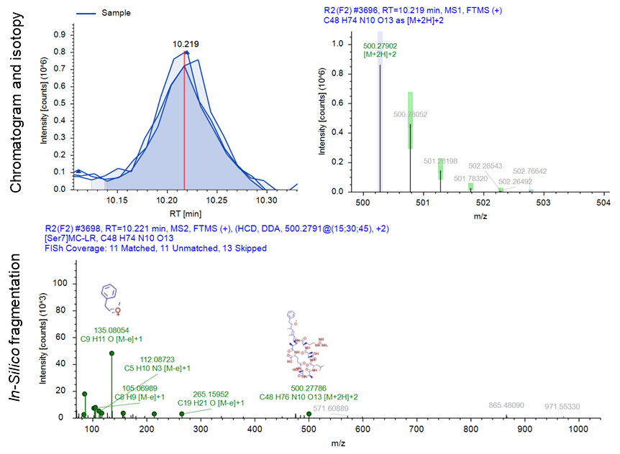
C
B
A
Figure S4. Structure characterization of [Ser⁷]microcystin-LR. A) Extracted ion chromatogram of ion m/z 999.5503 and B) isotopic pattern of most intense precursor ion. C) Fragmentation spectrum and in-silico matching with FISh coverage.
Amino acid Ser is confirmed at position 7 with ions: m/z 450.2238, 379.1879, 217.0822, 159.0762, and 131.0820. Additionally, the absence of a thiol derivative supported the absence of Mdha at position 7. The spectra also retained microcystin-LR characteristics, particularly with m/z 599.3565 confirming Arg at position 4 and m/z 86.0971 as the Leu immonium ion at position 2.
SI-2. Spectral interpretation of [DMAdda⁵, GluOMe⁶]microcystin-LHty
Spectra (Figure 3 in the main text) showed an ion at m/z 227.1028 indicating GluOMe at position 6 and Mdha at position 7, along with a thiol derivative at m/z 1094.5449. Also, the ion at m/z 195.2800 confirmed Hty at position 4 and m/z 86.0971 the Leu immonium ion at position 2. Furthermore, ions at m/z 620.3315, 592.3372, 446.2280, and 375.1910 confirmed DMAdda at position 5.

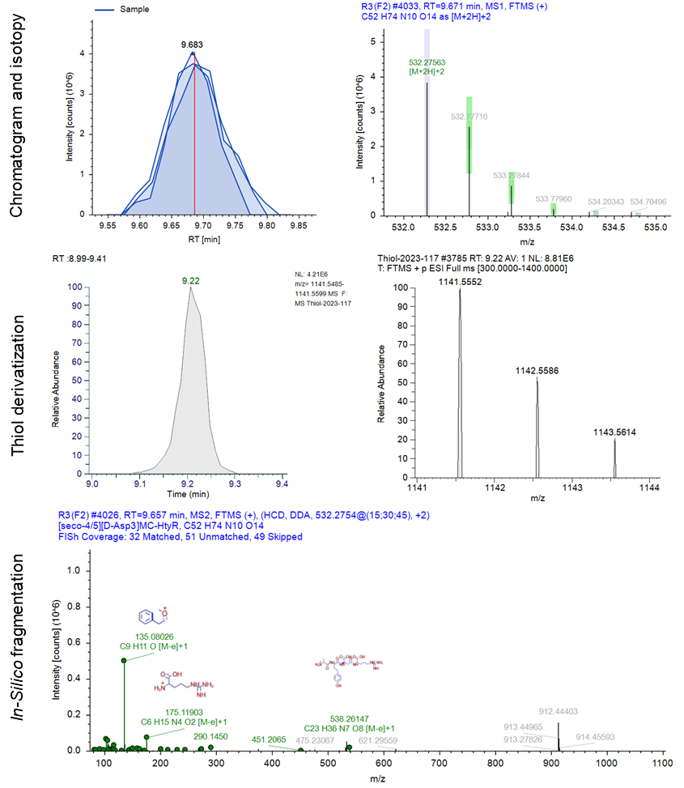
E
C
D
A
B
Figure S5. Structure characterization of [seco-4/5][D-Asp³]microcystin-HtyR. A) Extracted ion chromatogram of ion m/z 1063.5370 and B) isotopic pattern of most intense precursor ion. C) Extracted ion chromatogram of thiol derivative ion m/z 1141.5552 and D) isotopic pattern of thiol derivative. E) Fragmentation spectrum and in-silico matching with FISh coverage.
The presence of Arg at position 4 was confirmed by m/z 174.1349, Leu at position 2 by m/z 150.0910, and D-Asp at position 3 by m/z 449.2149. Positions 1, 6, and 7 were confirmed by ions m/z 375.1906, 213.0872, 155.0826, and 127.0865, along with a thiol derivative at m/z 1141.5552 confirming Mdha at position 7. Absence of ions m/z 599.3557 supports the cycle cleavage between positions 4 and 5, confirming the linear structure of this microcystin.
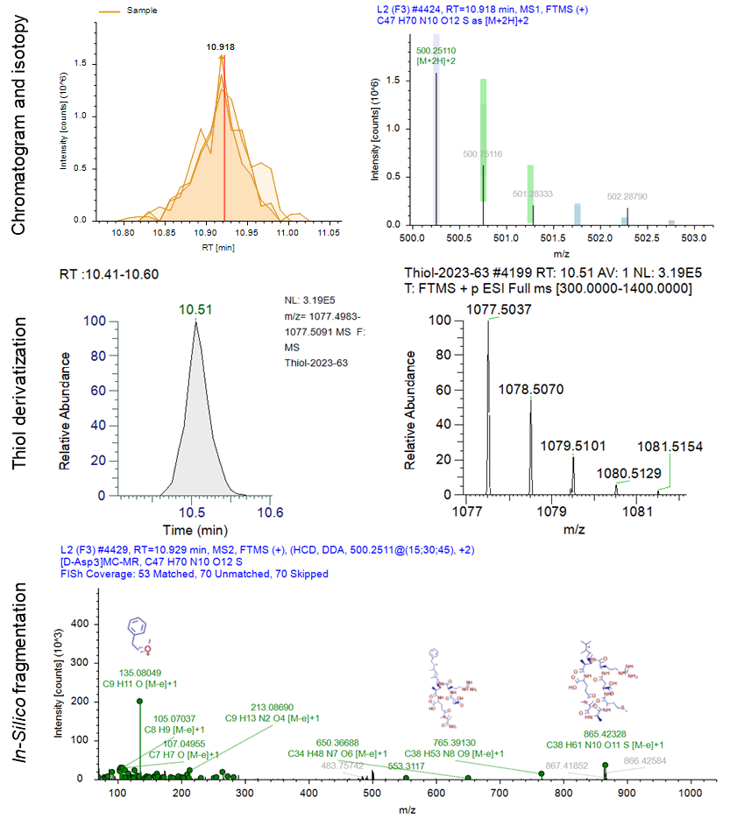
E
D
B
A
C
Figure S6. Structure characterization of [D-Asp³]microcystin-MR. A) Extracted ion chromatogram of ion m/z 999.4937 and B) isotopic pattern of most intense precursor ion. C) Extracted ion chromatogram of thiol derivative ion m/z 1077.5037 and D) isotopic pattern of thiol derivative. E) Fragmentation spectrum and in-silico matching with FISh coverage.
Ion m/z 599 confirmed the Arg⁴-Adda⁵-Glu⁶ sequence in the structure. Additionally, ions m/z 375, 213, 155, and 127 verified the presence of Ala at position 1 and Mdha at position 7. This was further validated by thiol derivatization, yielding ion m/z 1077.5037.
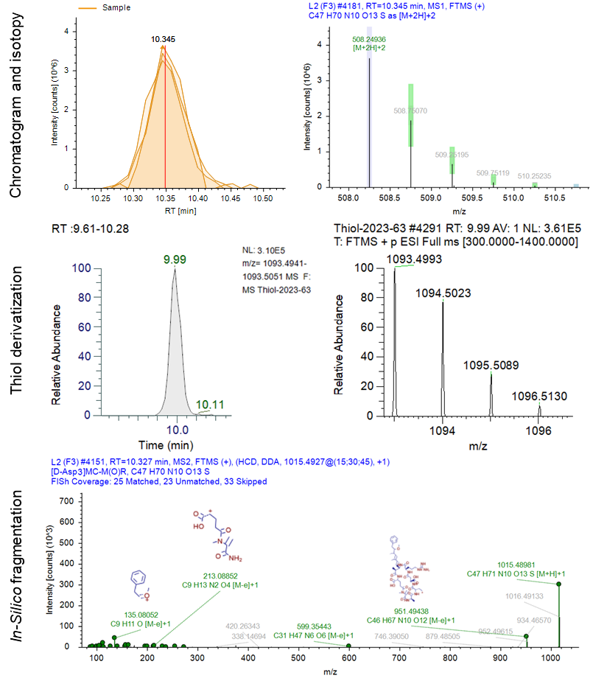
E
D
C
B
A
Figure S7. Structure characterization of [D-Asp³]microcystin-M(O)R. A) Extracted ion chromatogram of ion m/z 1015.4898 and B) isotopic pattern of most intense precursor ion. C) Extracted ion chromatogram of thiol derivative ion m/z 1093.4993 and D) isotopic pattern of thiol derivative. E) Fragmentation spectrum and in-silico matching with FISh coverage.
Ion m/z 599 confirmed the Arg⁴-Adda⁵-Glu⁶ sequence in the structure. Similar to [D-Asp³]microcystin-MR, ions m/z 375, 213, 155, and 127 confirmed Ala at position 1 and Mdha at position 7, as validated by thiol derivatization with ion m/z 1093.4993 for [D-Asp³]microcystin-M(O)R. Additional ions m/z 445.1869, 446.2291, 263.0702, and the immonium ion at m/z 120.0459 further confirmed the presence of D-Asp at position 3 and M(O) at position 2.
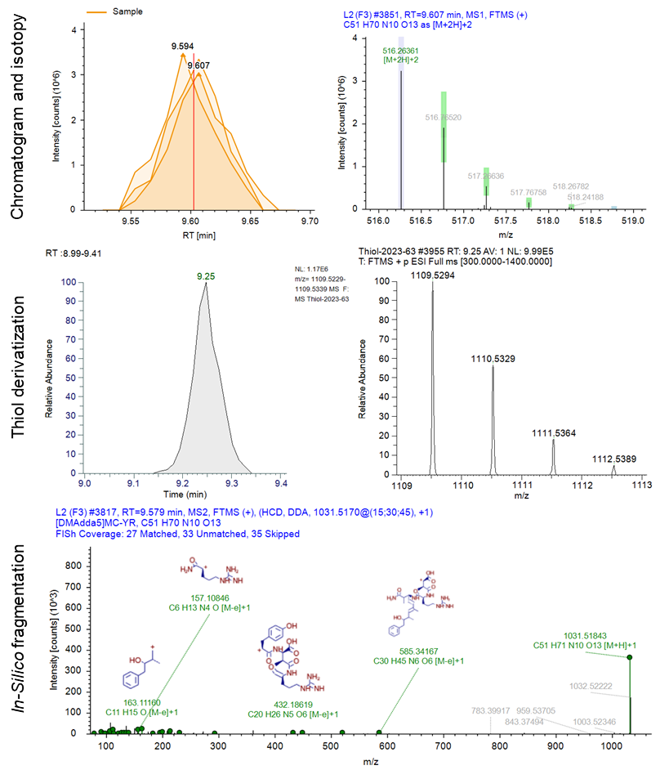
E
D
C
B
A
Figure S8. Structure characterization of [DMAdda⁵]microcystin-YR. A) Extracted ion chromatogram of ion m/z 1031.5168 and B) isotopic pattern of most intense precursor ion. C) Extracted ion chromatogram of thiol derivative ion m/z 1109.5294 and D) isotopic pattern of thiol derivative. E) Fragmentation spectrum and in-silico matching with FISh coverage.
The spectra of [DMAdda⁵]microcystin-YR are similar to microcystin-YR, except for ions m/z 585.3378 and 361.1742, demethylated forms of m/z 599 ions for Adda and Arg at position 4, and m/z 375 present in common microcystins (Adda5-Glu6-Mdha7). Finally, a thiol-derivatized ion confirmed Mdha at position 7.
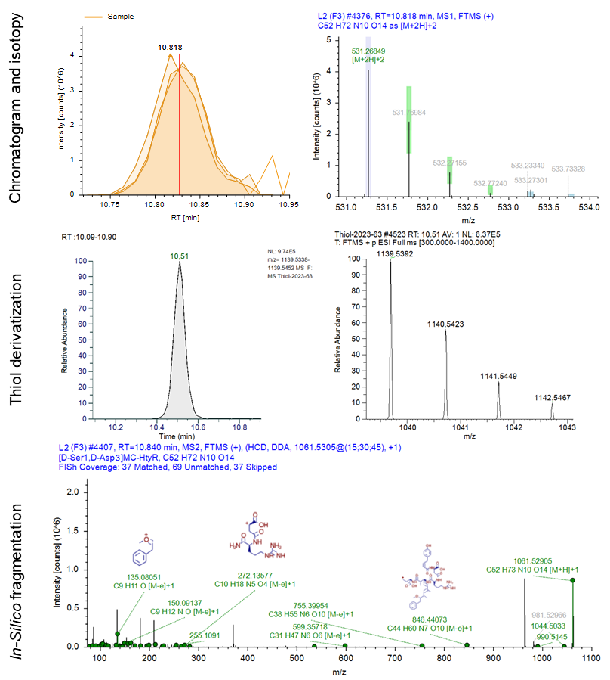
E
C
D
B
A
Figure S9. Structure characterization of [D-Ser¹, D-Asp³]microcystin-HtyR. A) Extracted ion chromatogram of ion m/z 1061.5292 and B) isotopic pattern of most intense precursor ion. C) Extracted ion chromatogram of thiol derivative ion m/z 1139.5392 and D) isotopic pattern of thiol derivative. E) Fragmentation spectrum and in-silico matching with FISh coverage.
Ser is confirmed at position 1 and D-Asp at position 3 with ions: m/z 519.2229, 171.0771, and 143.0824. A thiol derivative was found at m/z 1139.5392 confirming Mdha at position 7. The spectra retained microcystin-HtyR characteristics, particularly with m/z 599.3565 confirming Arg at 4 position and m/z 150.0912 as the Hty immonium ion at position 2.
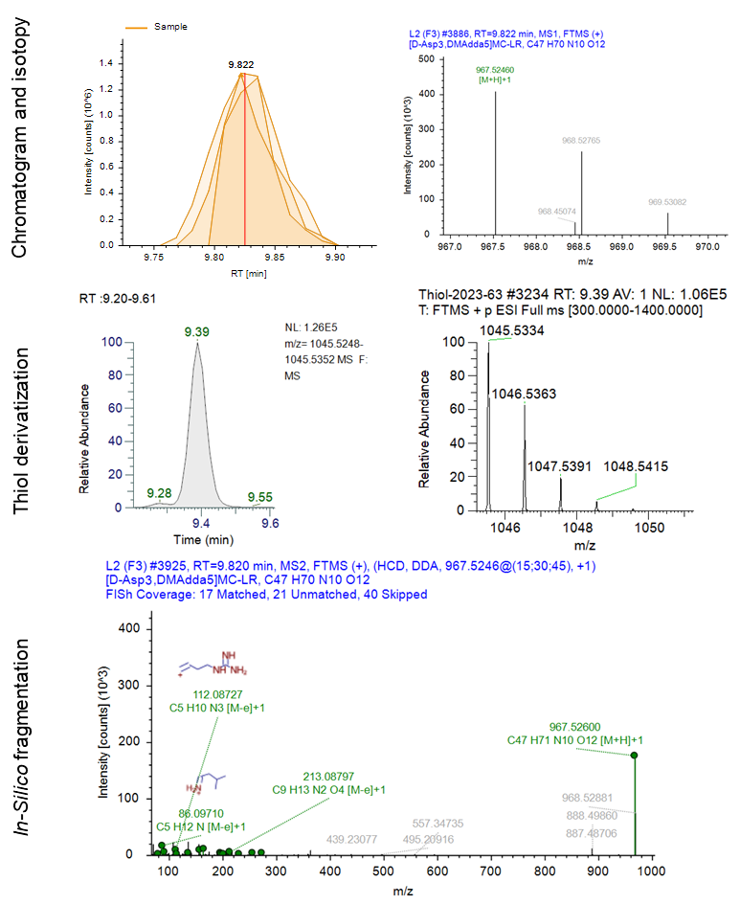
E
D
C
A
B
Figure S10. Structure characterization of [D-Asp³, DMAdda⁵]microcystin-LR. A) Extracted ion chromatogram of ion m/z 967.5246 and B) isotopic pattern of most intense precursor ion. C) Extracted ion chromatogram of thiol derivative ion m/z 1045.5334 and D) isotopic pattern of thiol derivative. E) Fragmentation spectrum and in-silico matching with FISh coverage.
D-Asp was confirmed at position 3, DMAdda at position 5, and Arg at position 4 with ions: m/z 585.3985, 439.2038, and 361.1751, and a thiol derivative at m/z 1045.5334 confirmed Mdha at position 7. Spectra matched microcystin-LR, particularly with m/z 213.0880, 174.1348, 155.0801, and 127.0871 confirming positions 1, 6, and 7, and m/z 86.0971 as the Leu immonium ion at position 2.
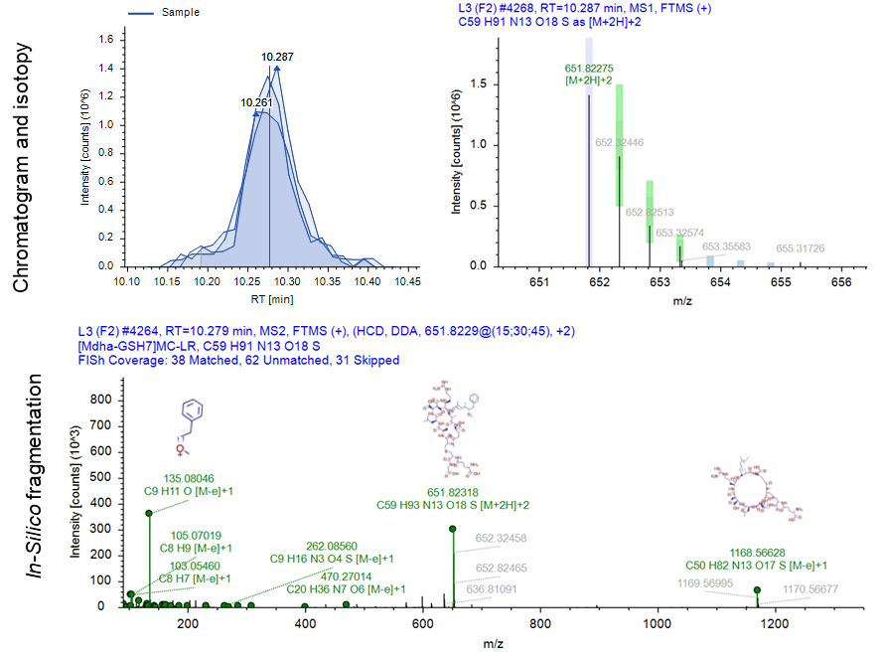
C
B
A
Figure S11. Structure characterization of [Mdha-GSH⁷]microcystin-LR. A) Extracted ion chromatogram of ion m/z 1302.6398 and B) isotopic pattern of most intense precursor ion. C) Fragmentation spectrum and in-silico matching with FISh coverage.
The addition of glutathione (GSH) is validated by observed fragments: m/z 682.2752, 520.1696, 462.1646, 434.1701, and 391.1294, also confirming positions 1, 5, and 6. Spectra characteristics also resemble microcystin-LR, particularly with m/z 599.3546 and 174.1348 confirming Arg at position 4 and m/z 86.0969 as the Leu immonium ion at position 2.
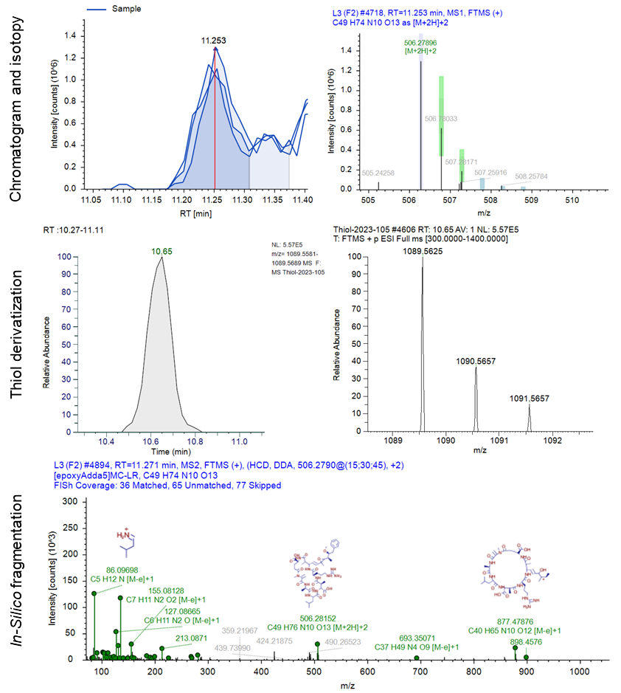
E
D
C
B
A
Figure S12. Structure characterization of [epoxyAdda⁵]microcystin-LR. A) Extracted ion chromatogram of ion m/z 1011.5501 and B) isotopic pattern of most intense precursor ion. C) Extracted ion chromatogram of thiol derivative ion m/z 1089.5625 and D) isotopic pattern of thiol derivative. E) Fragmentation spectrum and in-silico matching with FISh coverage.
Spectra showed m/z 615.3487, 391.1856, and 155.0813 confirming Ala at position 1, epoxyAdda at position 5, and Arg at position 4. Furthermore, Mdha at position 7 was validated by the thiol derivative observed at m/z 1089.5625. The spectra showed significant similarities to microcystin-LR including m/z 213.0871 and 174.1349 validating positions 4 and 6, and 86.0970 corresponding to the Leu immonium ion at position 2.
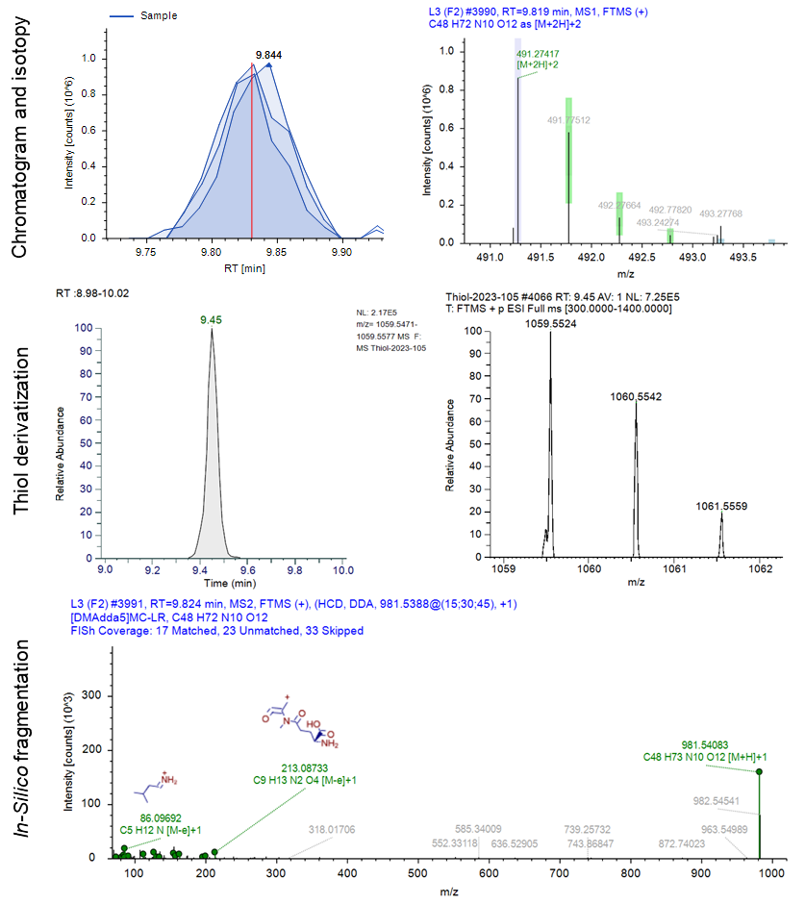
E
D
C
B
A
Figure S13. Structure characterization of [DMAdda⁵]microcystin-LR. A) Extracted ion chromatogram of ion m/z 981.5108 and B) isotopic pattern of most intense precursor ion. C) Extracted ion chromatogram of thiol derivative ion m/z 1059.5524 and D) isotopic pattern of thiol derivative. E) Fragmentation spectrum and in-silico matching with FISh coverage.
The presence of DMAdda at position 5 is showcased by m/z 585.3401 and 361.1741. A thiol derivative was detected at m/z 1059.5524, confirming Mdha at position 7. The candidate showed strong similarities to microcystin-LR, particularly with ions m/z 213.0873, 174.1354, 155.0823, and 127.0872, corroborating positions 1, 4, 6, and 7. Furthermore, Leu at position 2 was confirmed by the immonium ion m/z 86.0969.
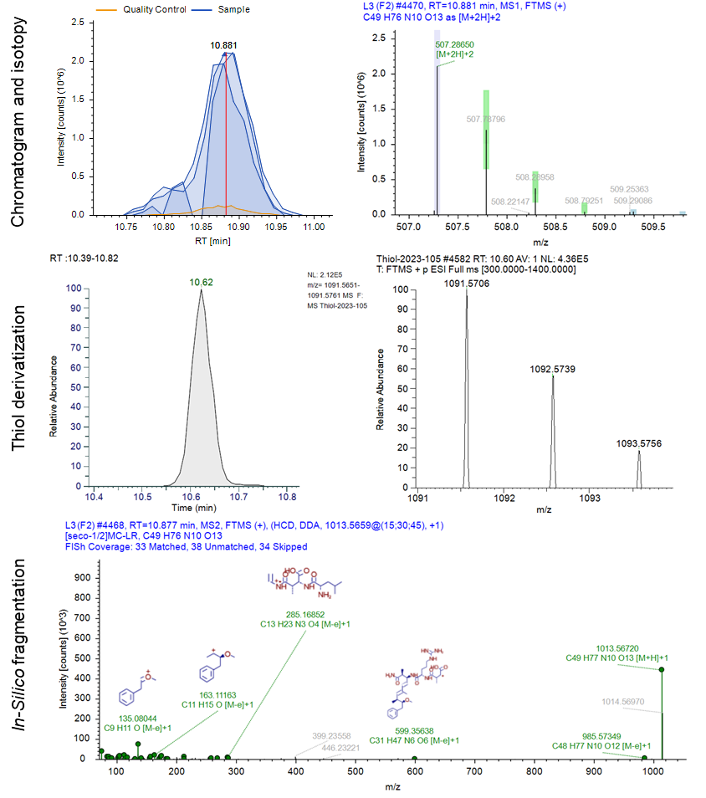
E
C
D
C
B
A
Figure S14. Structure characterization of [seco-1/2]microcystin-LR. A) Extracted ion chromatogram of ion m/z 1013.5672 and B) isotopic pattern of most intense precursor ion. C) Extracted ion chromatogram of thiol derivative ion m/z 1091.5706 and D) isotopic pattern of thiol derivative. E) Fragmentation spectrum and in-silico matching with FISh coverage.
Key fragments, such as m/z 599.3595 (Arg⁴-Adda⁵-Glu⁶), m/z 446.2322 (Adda⁵-Glu⁶-Mdha⁷-Ala¹), m/z 399.2356 (Leu²-MeAsp³-Arg⁴), and m/z 347.19708 (Adda⁵-Glu⁶-Mdha⁷), validate the connectivity of the microcystin, while the parent mass m/z 1013.5672 supports its identification as a linear form of microcystin-LR. Additionally, a thiol derivative was detected at m/z 1091.5706, confirming Mdha at position 7.
Table S8. Anabaenopeptins (APs) specific ions from MS² fragmentation (with associated sample).
Fragmentation sequence | AP-F (7) | AP-E (7) | AP-H | AP-HU892 | AP-SA3 (10) | AP-679 (10) | AP-F (11) | AP-E (11) | AP-SA3 (11) | AP-679 (11)
M+H⁺ | 851.4758 | 851.4763 | 923.5311 | 893.5226 | 823.4698 | 680.3766 | 851.4767 | 851.4768 | 823.4705 | 680.3759
M+Na⁺ |  |  |  |  |  |  |  |  |  | 702.3579
M+2H²⁺ | 426.2414 | 426.2419 | 462.2695 | 447.2647 | 412.2386 |  | 426.2421 | 426.2427 | 412.2389 | 340.6915
M+H⁺-CO-AA1-O | 651.3861* | 651.3835* | 723.4321* | 693.4332 | 651.3855* | NF | 651.3856 | 651.3870 | 651.3856* | NF
M+H⁺-AA4-AA5 |  |  |  | 541.3425*
M+H⁺-AA3-AA4-CO |  |  | 605.3735*
AA6+Lys²+CO+AA3+H⁺ |  |  |  |  | 403.2317* | 403.2357 |  |  | 403.2338 | 403.2353*
AA3+AA4+AA5+H⁺ | 376.2222 | 376.2229* |  |  | 362.2087* | 362.2072 | 376.2230* | 376.2261 | 362.2063* | 362.2067
AA4+AA5+H⁺ | 263.1393 | 277.1540 | 369.1792 | 353.1843* | 263.1386 | 263.1386 | 263.1391 | 277.1548* | 263.1391 | 263.1387
Lys+AA3+AA6+CO-NH₃+H⁺ |  |  | 366.2979*
AA5+AA6+H⁺ | 213.1292* | 233.1296* | 305.1848* | 305.1845 | 233.1280 | 233.1281 | 213.1290* | 233.1289* | 233.1278 | 233.1281
AA3+AA4+H⁺ |  |  | 291.1689* | 261.1589* |  |  |  |  |  | 277.1558
AA1 Ureido Bridge | 201.0980 | 201.0979 | 201.0977 | 201.0978 | 173.0373* | NF | 201.0981 | 201.0981 | 173.0924* | NF
AA1 Sidechain | 175.1188 | 175.1187 | 175.1187 | 175.1187 | 147.1131* | NF | 175.1189 | 175.1189 | 147.1128 | NF
AA1+H₂O-NH₃+H⁺ | 158.0922 | 158.0920 | 158.0923 | 158.0914 | 130.0861 | NF | 158.0925 | 158.0920 | 130.0868 | NF
Lys Residue Chain | 129.1020 | 129.1015 | 129.1029 | 129.1016 | 129.1012 | NF | 129.1021 | 129.1019 | 129.1019 | NF
Ph-CH₂-OH | 107.0492 | NF | 107.0493 | 107.0491 | 107.0495 | 107.0493 | 107.0495* | NF | 107.0495 | 107.0497
Lys Immonium | 84.0813 | 84.0813* | 84.0812 | 84.0811 | 84.0813* | 84.0812 | 84.0812 | 84.0813* | 84.0813 | 84.0814
*Fragments in italic were not selected in the FISh scoring experiment.
NF: Not found – Absence of a characteristic fragment confirming a congener structure compared to an analogue (AP-E and F; AP-SA3 and AP-679).

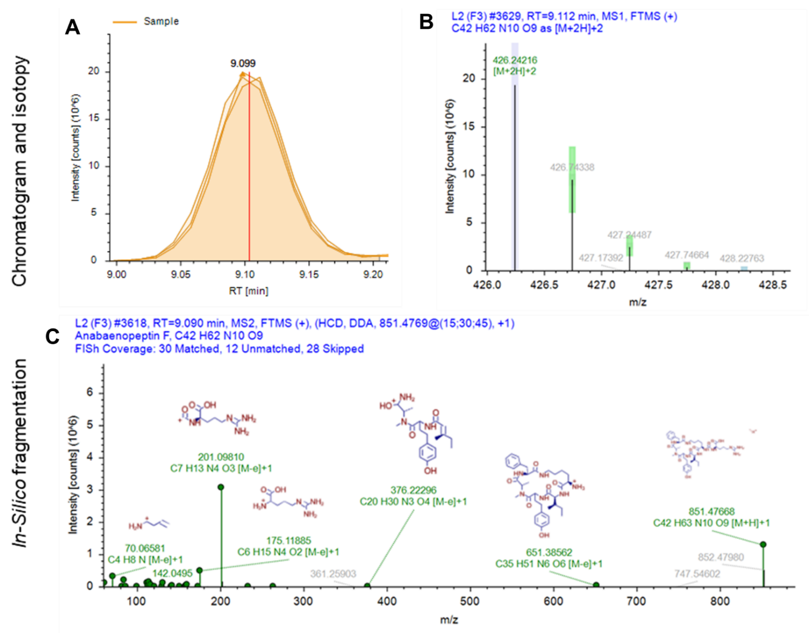
Figure S15. Structure characterization of anabaenopeptin F. A) Extracted ion chromatogram of ion m/z 851.4758 and B) isotopic pattern of most intense precursor ion. E) Fragmentation spectrum and in-silico matching with FISh coverage.

SI-3. Spectral interpretation of anabaenopeptin-F
The spectra for anabaenopeptin F (Figure 4) reveal ions at m/z 376.2230, 263.1391, and 213.1290, confirming the configuration Ile3-Hty4-MeAla5-Phe6, with the presence of m/z 201.0981 confirming the Arg-Uerido bridge at position 1.
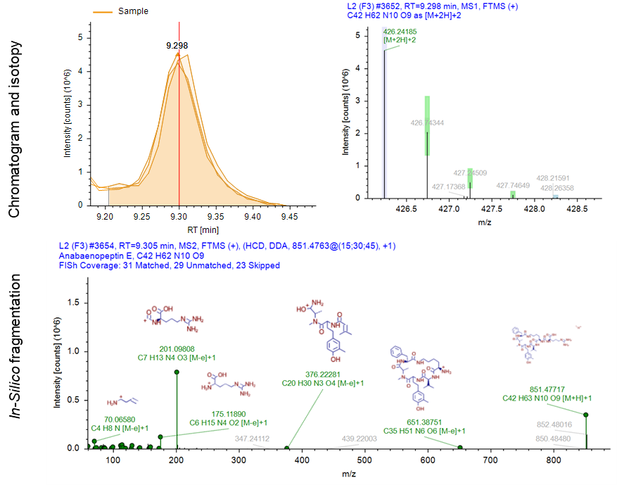
C
B
A
Figure S16. Structure characterization of anabaenopeptin E. A) Extracted ion chromatogram of ion m/z 851.4755 and B) isotopic pattern of most intense precursor ion. E) Fragmentation spectrum and in-silico matching with FISh coverage.
In contrast with anabaenopeptin F, the key fragments are m/z 277.1548 and 233.1289 indicate the configuration Val3-MeHty4-MeAla5.
B
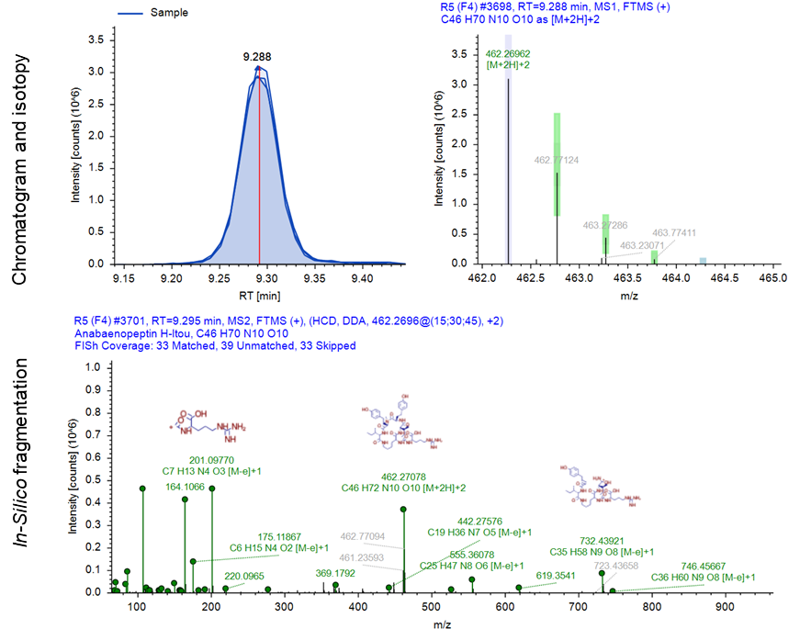
A
C
Figure S17. Structure characterization of anabaenopeptin H. A) Extracted ion chromatogram of ion m/z 923.5311 and B) isotopic pattern of most intense precursor ion. E) Fragmentation spectrum and in-silico matching with FISh coverage.
Ions at m/z 605.3735, 366.2979 and 291.1689 confirm of the presence of Ile at position 3. Additionally, m/z 369.1792 and 305.18484 confirmed Hty4-MeHty5-Ile6 in the structure and ion m/z 201.0977 validated the presence of Arg-uerido bridge at position 1.

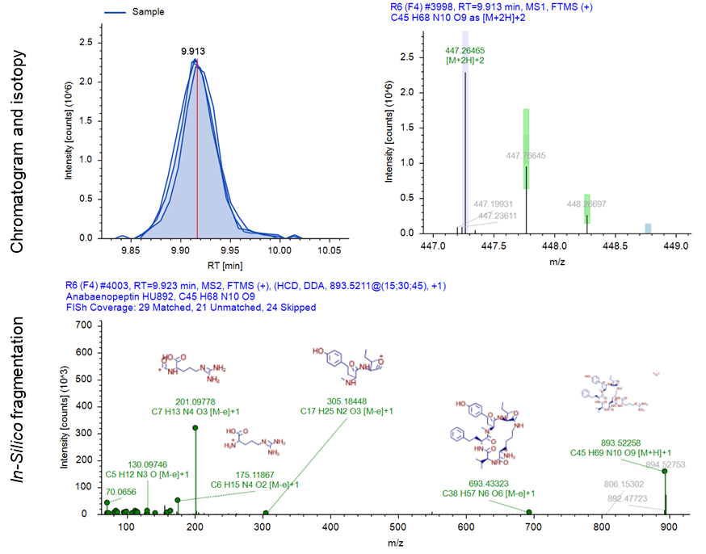
C
B
A
Figure S18. Structure characterization of anabaenopeptin HU892. A) Extracted ion chromatogram of ion m/z 893.5226 and B) isotopic pattern of most intense precursor ion. E) Fragmentation spectrum and in-silico matching with FISh coverage.
Ions at m/z 605.3735, 291.1689, 369.1792, and 305.1848 provided confirmation of the presence of positions 3 through 6 within the molecule. Furthermore, the ion at m/z 173.0373 indicated the presence of the Arg side chain at position 1.
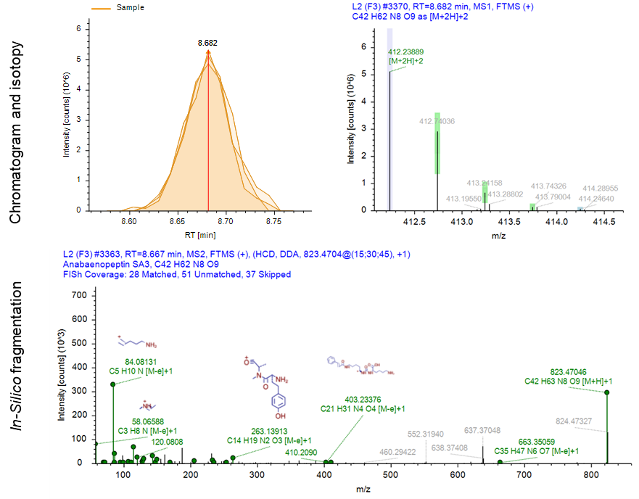
C
B
A
Figure S19. Structure characterization of anabaenopeptin SA3. A) Extracted ion chromatogram of ion m/z 823.4703 and B) isotopic pattern of most intense precursor ion. E) Fragmentation spectrum and in-silico matching with FISh coverage.
The potential structure is Lys1-CO-Lys2-Val3-Hty4-MeAla5-Phe6 with key ions at m/z 403.2338, 362.2063, 263.1391, and 233.1278 confirming positions 3 to 6 within the molecule. Additionally, and ion m/z 173.0373 is identified as the Arg-ureido bridge confirming position 1.
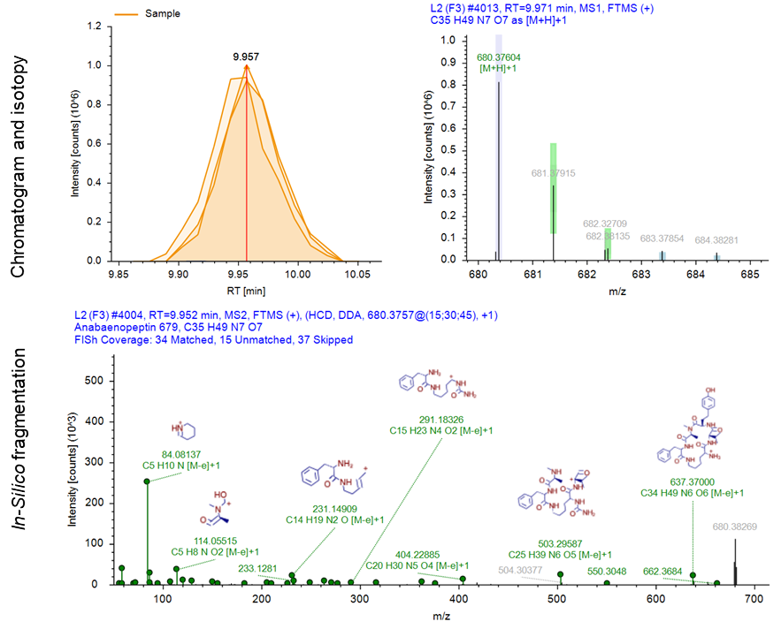
C
B
A
Figure S20. Structure characterization of anabaenopeptin 679. A) Extracted ion chromatogram of ion m/z 637.3700 and B) isotopic pattern of most intense precursor ion. E) Fragmentation spectrum and in-silico matching with FISh coverage.
Compared to anabaenopeptin SA3, the same ions were identified, including the additional m/z 277.1558 once again confirming positions 3 to 6. However, the absence of several ions such as 651, 173, 147, 130, and 129, corresponding to fragments containing the Lys-CO side chain at position 1 suggest its absence in the structure. Nonetheless, the consistent presence of the Lys immonium ion at m/z 84 in the spectra serves as an indicator of its permanent presence at position 2 in the structure.

Table S9. Other cyanopeptides specific ions from MS² fragmentation
Fragmentation sequence | Microginin 690
M+Na⁺ | 713.3183
M+H⁺ | 691.3350
M+2H⁺ | 346.1713
M+H⁺-Tyr4-H₂O | 510.2621
Adha¹+Tyr²+H₂O+C₂O | 349.2127
Tyr²+MeMet(O)³+H₂O+H⁺ and MeMet(O)³+Tyr⁴+H₂O+H⁺ | 343.1313
Tyr²+MeMet(O)³+H⁺ and MeMet(O)³-Tyr⁴+H⁺ | 325.1210
Tyr²-MeMet(O)³-CO+H+ and MeMet(O)³-Tyr⁴-CO+H⁺ | 297.1268
Tyr Immonium | 136.0762
Adha Residue | 128.1435
Fragmentation sequence | Aeruginopeptin 228A
M+H⁺ | 1045.4854
M+H⁺-H₂O | 1027.4719
M+H⁺-AA8-H₂O | 914.3898
M+H⁺-AA8-2H₂O | 896.3803
Hpla1+Gln2+Thr3+Ahp4-O+H⁺ | 511.2190
Thr³+Tyr⁴+H⁺ | 265.1175
Thr³+Tyr⁴-H₂O+H⁺ | 247.1077
Thr³+Tyr⁴-H₂O-CO+H⁺ | 219.1124*
Tyr⁴ Immonium | 136.0753
MePhe⁸ Immonium | 134.0961
Gln² Immonium | 101.0713
Ile⁹ Immonium | 86.0967
Thr³ Immonium | 74.0606*
Thr⁶ Immonium | 74.0606*
Fragmentation sequence | Cyanopeptolin 1081
M+Na⁺ | 1104.5212
M+H⁺ | 1082.5393
M+H⁺-H₂O | 1064.5288
Thr³+Leu⁴+Ahp⁵+Thr⁶+NMePhe⁷+Ile⁸-H₂O+H⁺ | 685.3914
Leu⁴+Ahp⁵+ Thr⁶+NMePhe⁷+Ile⁸+H⁺ | 602.3544
Tyr¹+GA+Gln²+Thr³+Leu⁴-H₂O+H⁺ | 576.2661
Ahp⁵+ Thr⁶+NMePhe⁷+Ile⁸-H₂O+H⁺ | 471.2606
Tyr¹+GA+Gln²+Thr³-H₂O+H⁺ | 463.1820
Tyr¹+GA+Gln²+H⁺ | 380.1450
Tyr¹ Immonium | 136.0757
Gln² Immonium | 101.0714
Leu⁴ Immonium | 86.0970
Thr³⁻⁶ Immonium | 74.0605*
Fragmentation sequence | Aeruginosin A
M+H⁺ | 617.3458
M+H⁺-CH₂N₂ | 575.3239
[M-d-Pla¹-CO+2H]⁺ | 469.2930
[Choi+Ade³-CO+2H]⁺ | 322.2237
[Choi+Ade³-CO-NH₃+2H]⁺ | 305.1972
[Choi+Ade³-CO+H-NH₂-NH-C+2H]⁺ | 280.2018
d-Pla¹+Phe²+H⁺ | 268.1342
Choi Residue | 140.1071
Phe² Residue | 120.0810
Dehydrated Choi Immonium | 122.0965

*Fragments in italic were not selected in the FISh scoring experiment.

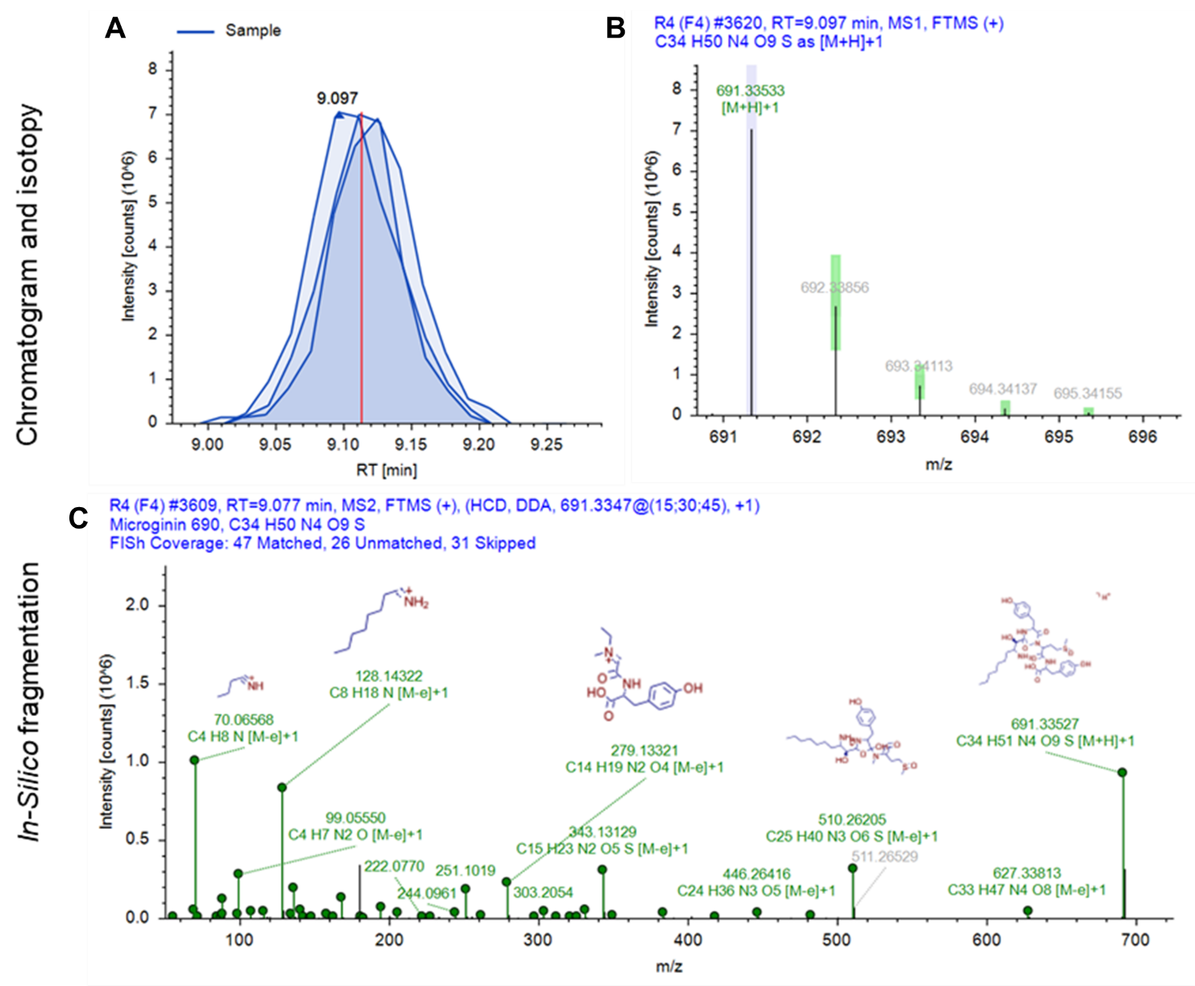
Figure S21. Structure characterization of Microginin 690. A) Extracted ion chromatogram of ion m/z 691.3350 and B) isotopic pattern of most intense precursor ion. E) Fragmentation spectrum and in-silico matching with FISh coverage.
The Adha moiety at position 1 is confirmed by ions m/z 349.2127 and the residue m/z 128.1436. Tyr at position 4 is confirmed by the ion at m/z 510.2621, and the sequence Tyr2-MeMet(O)3-Tyr4 is supported by the following ions: m/z 349.2127, 343.1313, 325.1210, and 297.1268. The presence of Tyr in the structure is further confirmed by its immonium ion at m/z 136.0755.

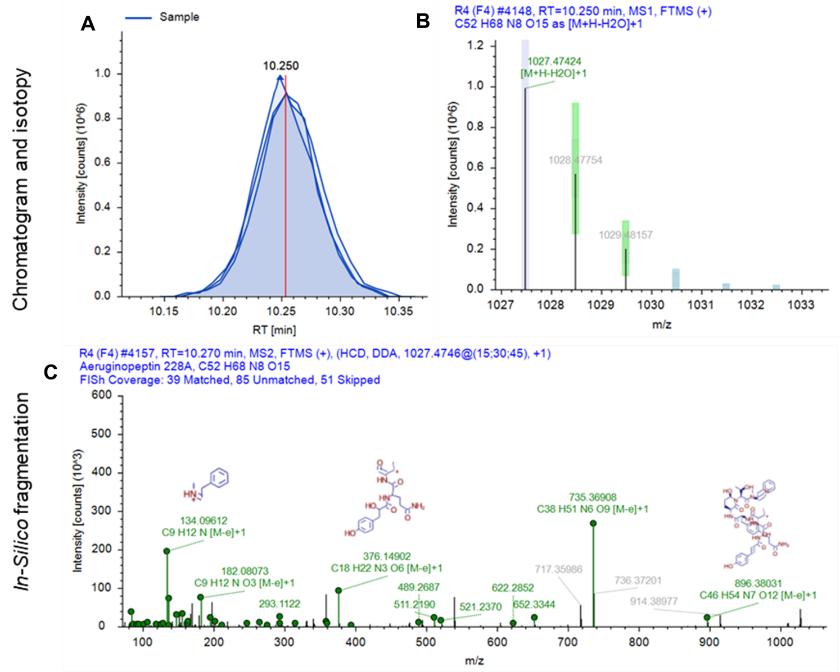
Figure S22. Structure characterization of Aeruginopeptin 228A. A) Extracted ion chromatogram of ion m/z 1045.4854 and B) isotopic pattern of most intense precursor ion. E) Fragmentation spectrum and in-silico matching with FISh coverage.
The ion at m/z 914.3898 confirms Ile at position 8, while ions m/z 511.2190, 265.1175, 247.1077, and 219.1125 confirm the structure Hpla1-Gln2-Thr3-Tyr4 (Table 6). Immonium ions for Gln, Thr, Tyr, Ahp, MePhe, and Ile have also been identified by the following ions: m/z 101.0713, 74.0606, 136.0753, 134.0961, and 86.0967. In the in-silico fragmentation depicted in E), we observe the generation of Ahp5-Thr6-MePhe7 fragments, including the prominent ion m/z 489.2689, which also include Ile at position 8.
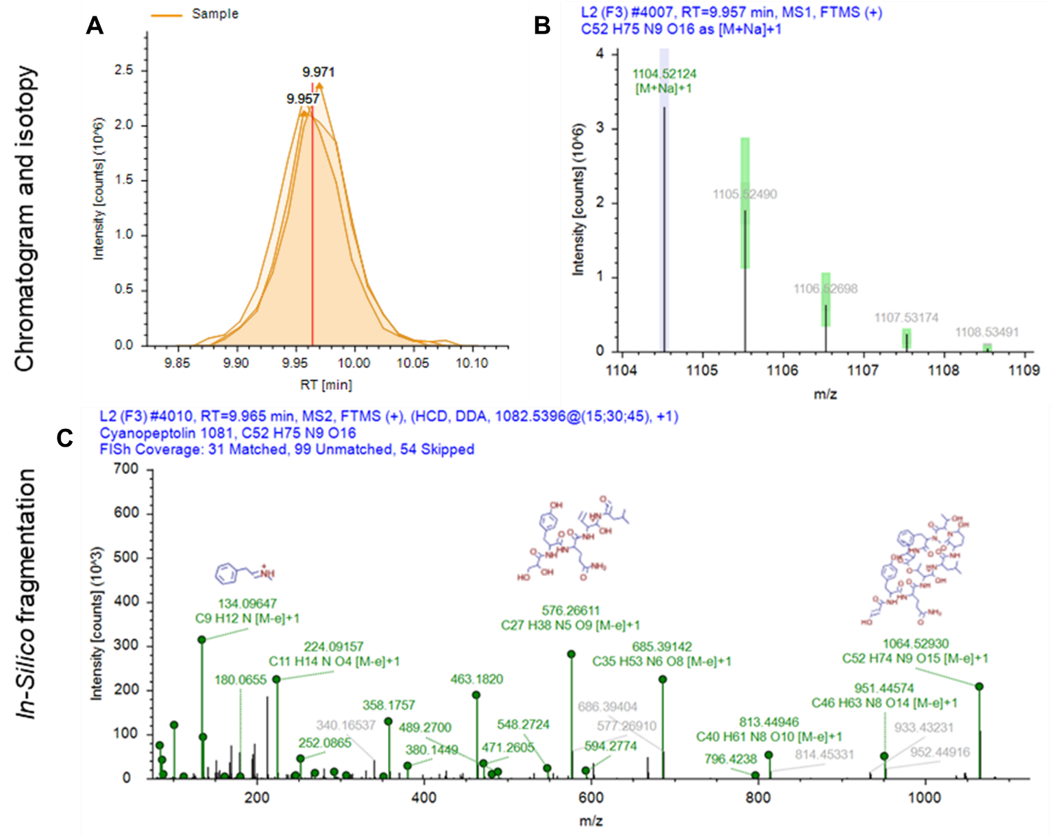
Figure S23. Structure characterization of Cyanopeptolin 1081. A) Extracted ion chromatogram of ion m/z 1082.5393 and B) isotopic pattern of most intense precursor ion. E) Fragmentation spectrum and in-silico matching with FISh coverage.
The spectra show the ion at m/z 685.3914 corresponds to positions 3 to 8 and ion at m/z 602.3544 corresponds to positions 4 to 8. Additionally, the ion at m/z 576.2661 corresponds to positions 1 to 4, m/z 471.2606 to positions 5 to 8, m/z 463.1820 to positions 1 to 3, and m/z 380.1450 to positions 1 to 2. Furthermore, immonium ions of Tyr, Gln, Leu, and Thr are present at m/z 136.0757, 101.0714, 86.0970, and 74.0605, respectively.
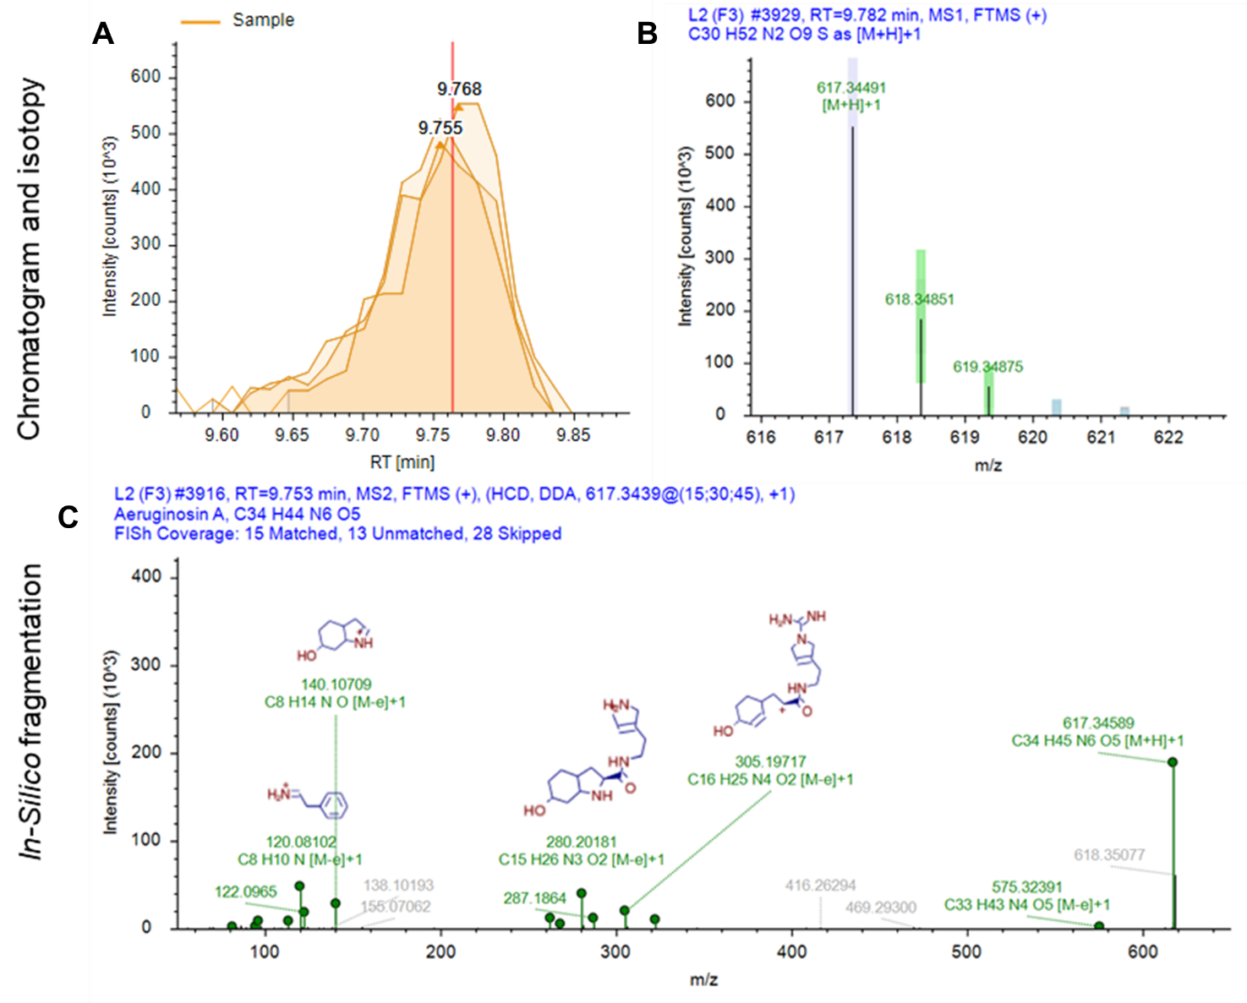
Figure S24. Structure characterization of Aeruginosin A. A) Extracted ion chromatogram of ion m/z 617.3458 and B) isotopic pattern of most intense precursor ion. E) Fragmentation spectrum and in-silico matching with FISh coverage.
The Choi moiety was characterized by m/z 140.1071, representing its residue, and m/z 122.0965 being its dehydrated immonium ion. These ions serve as indicators for the characterization of AGs. The proposed congener structure is d-Pla1-Phe2-Choi-Ade3, where ion m/z 575.3240 was identified and results from the loss of 42 u from the protonated molecule attributed to the removal of a carbodiimide (CH₂N₂) following the rearrangement and fragmentation of Ade (1). This difference in mass was also observed for fragments m/z 322.2237 and 280.2018, confirming the presence of Choi-Ade3, and the ion at 268.1342 confirms the presence of d-Pla at position 1 (1). Finally, ion m/z 120.0810 indicates the presence of Phe immonium ion.

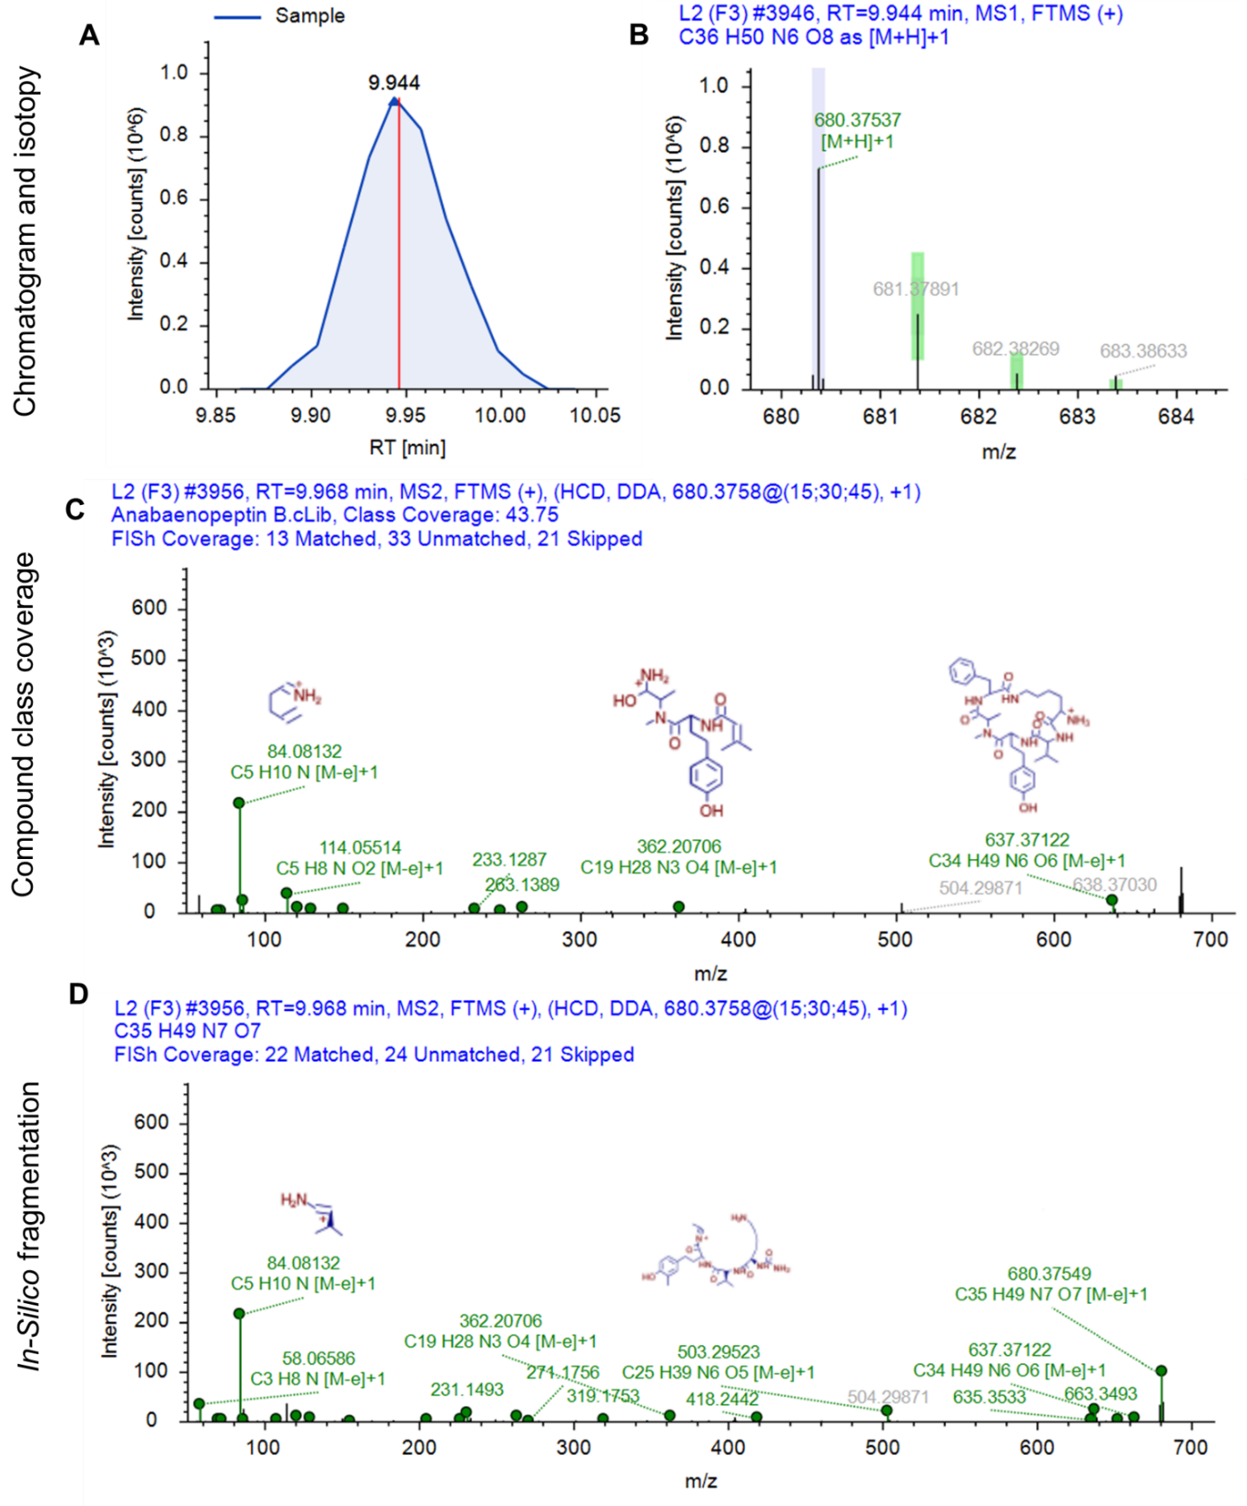
Figure S25. Structure characterization of transformation product 2 (TP2). A) Extracted ion chromatogram of ion m/z 680.3755, B) isotopic pattern of most intense precursor ion, C) Fragmentation spectrum and compound class coverage compared to Anabaenopeptin B and D) Fragmentation spectrum and in-silico matching with FISh coverage.
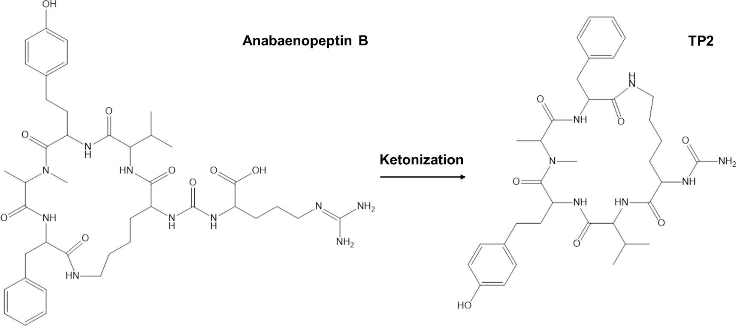
Figure S26. Proposed transformation product 2 (TP2) formation by ketonization of Anabaenopeptin B.
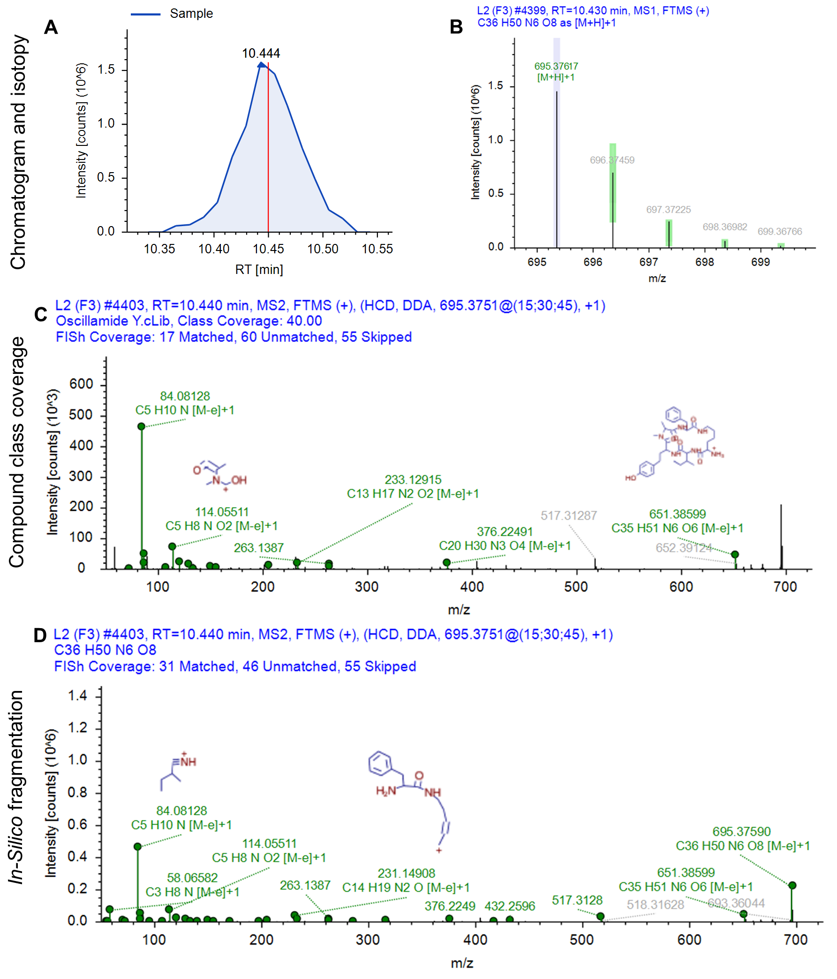
Figure S27. Structure characterization of transformation product 3 (TP3). A) Extracted ion chromatogram of ion m/z 695.3759, B) isotopic pattern of most intense precursor ion, C) Fragmentation spectrum and compound class coverage compared to Oscillamide Y and D) Fragmentation spectrum and in-silico matching with FISh coverage.
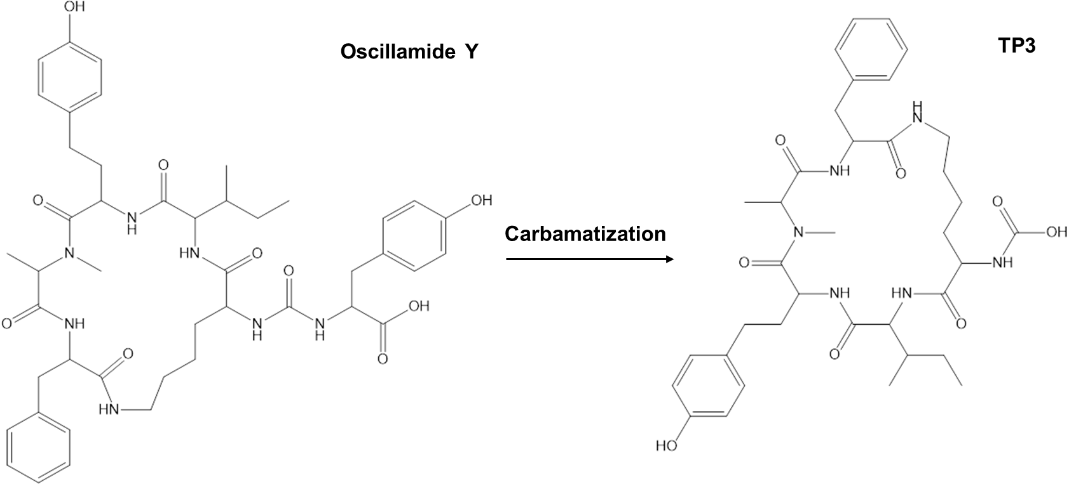
Figure S28. Proposed transformation product 3 (TP3) formation by carbamatization of Oscillamide Y.
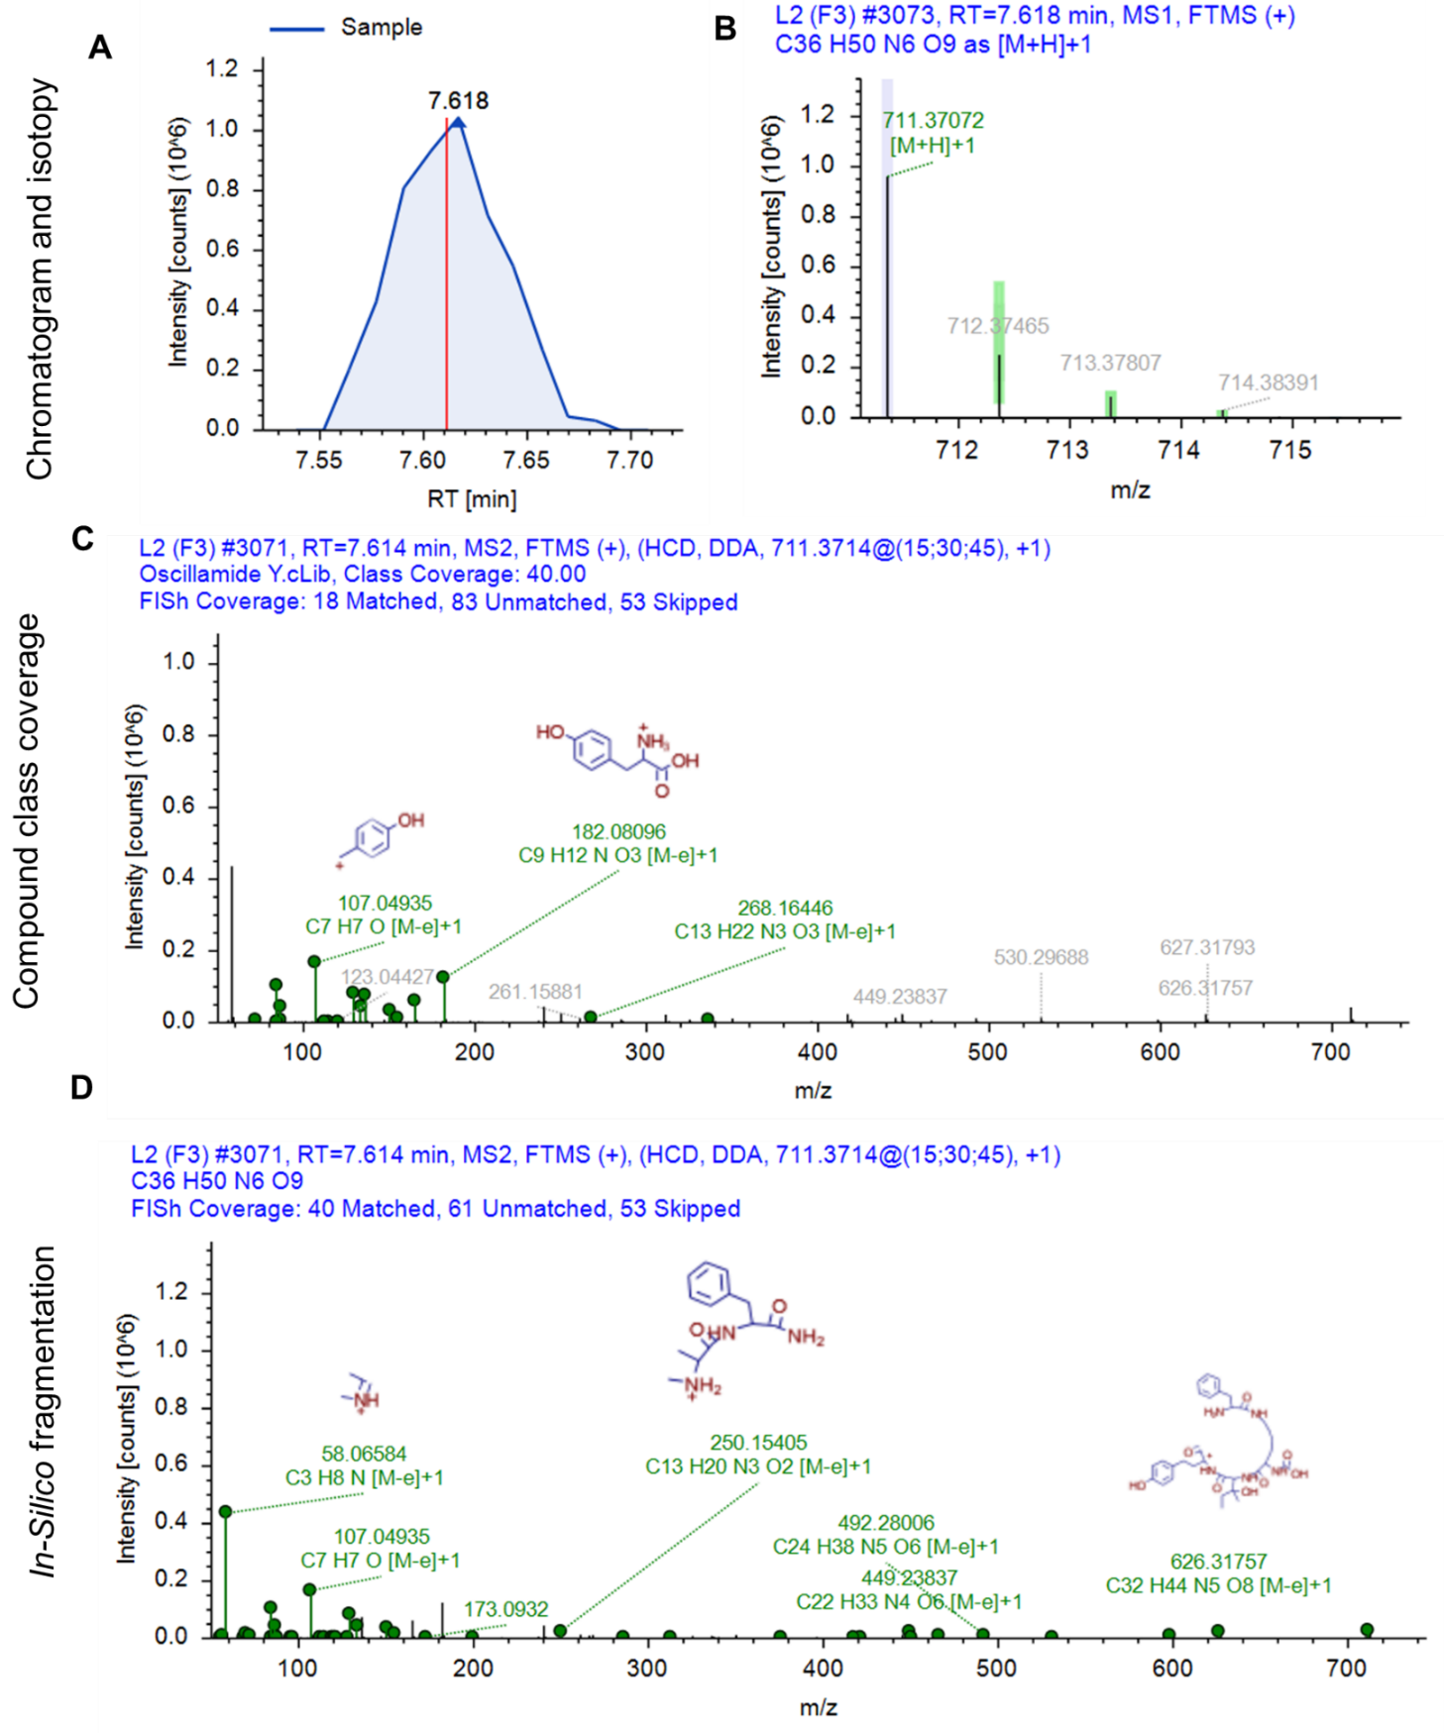
Figure S29. Structure characterization of transformation product 4 (TP4). A) Extracted ion chromatogram of ion m/z 711.3710, B) isotopic pattern of most intense precursor ion, C) Fragmentation spectrum and compound class coverage compared to Oscillamide Y and D) Fragmentation spectrum and in-silico matching with FISh coverage.
Two significant ions observed in the TP3 spectra (Figure S26) at m/z 376 (AA3+AA4+AA5+H⁺) and 417 (AA6+AA2+CO+AA3+H⁺) are absent in the TP4 spectra but are replaced by ions at m/z 392 and 433, indicating the presence of hydroxyisoleucine at position AA3.
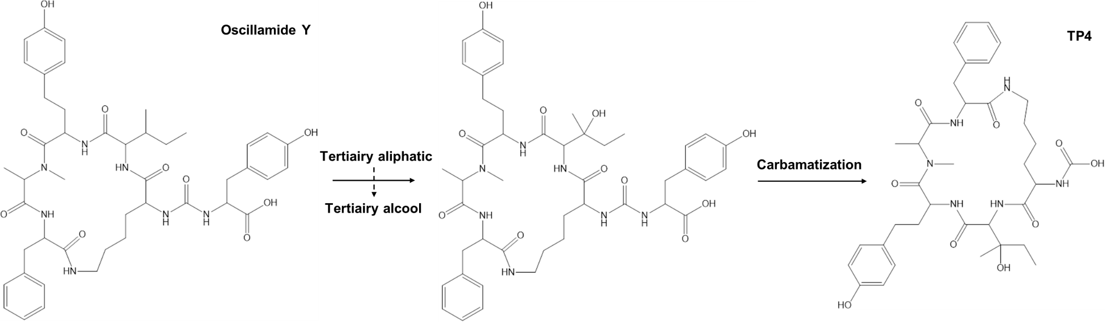

Figure S30. Proposed transformation product 4 (TP4) formation in two steps of Oscillamide Y.
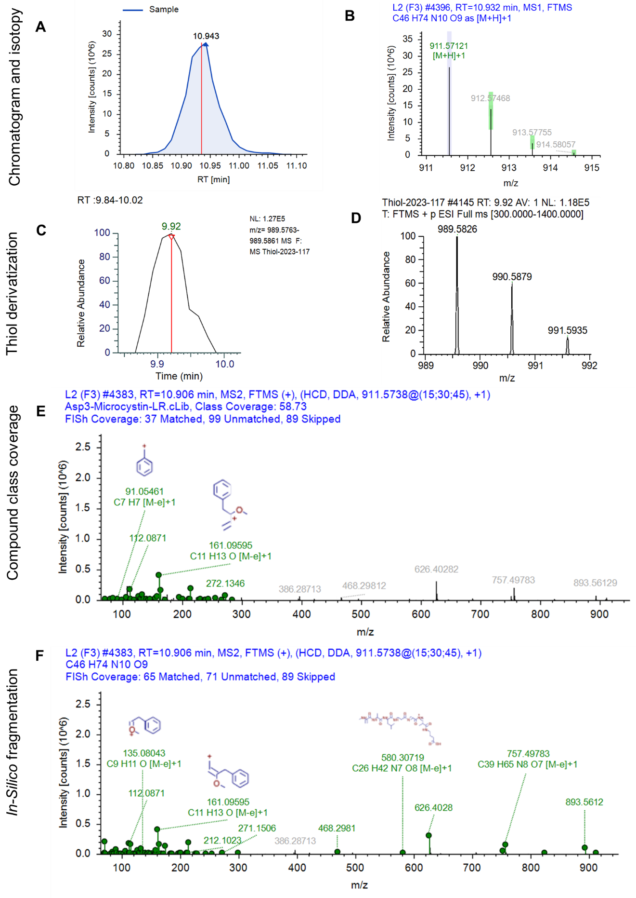
Figure S31. Structure characterization of transformation product 5 (TP5). A) Extracted ion chromatogram of ion m/z 911.5712, B) isotopic pattern of most intense precursor ion, C) Extracted ion chromatogram of thiol derivative ion m/z 989.5826 and D) isotopic pattern of thiol derivative. E) Fragmentation spectrum and compound class coverage compared to [Asp³]microcystin-LR and F) Fragmentation spectrum and in-silico matching with FISh coverage.
The presence of fragment m/z 626.4028, which includes AA3 to AA6, indicates a loss of 88, corresponding to two carboxyl groups, compared to the m/z 714 peak in the [Asp³]microcystin-LR spectra. Moreover, a thiol derivative was found at m/z 989.5826, confirming the presence of the alkene function in the Mdha group at AA7.
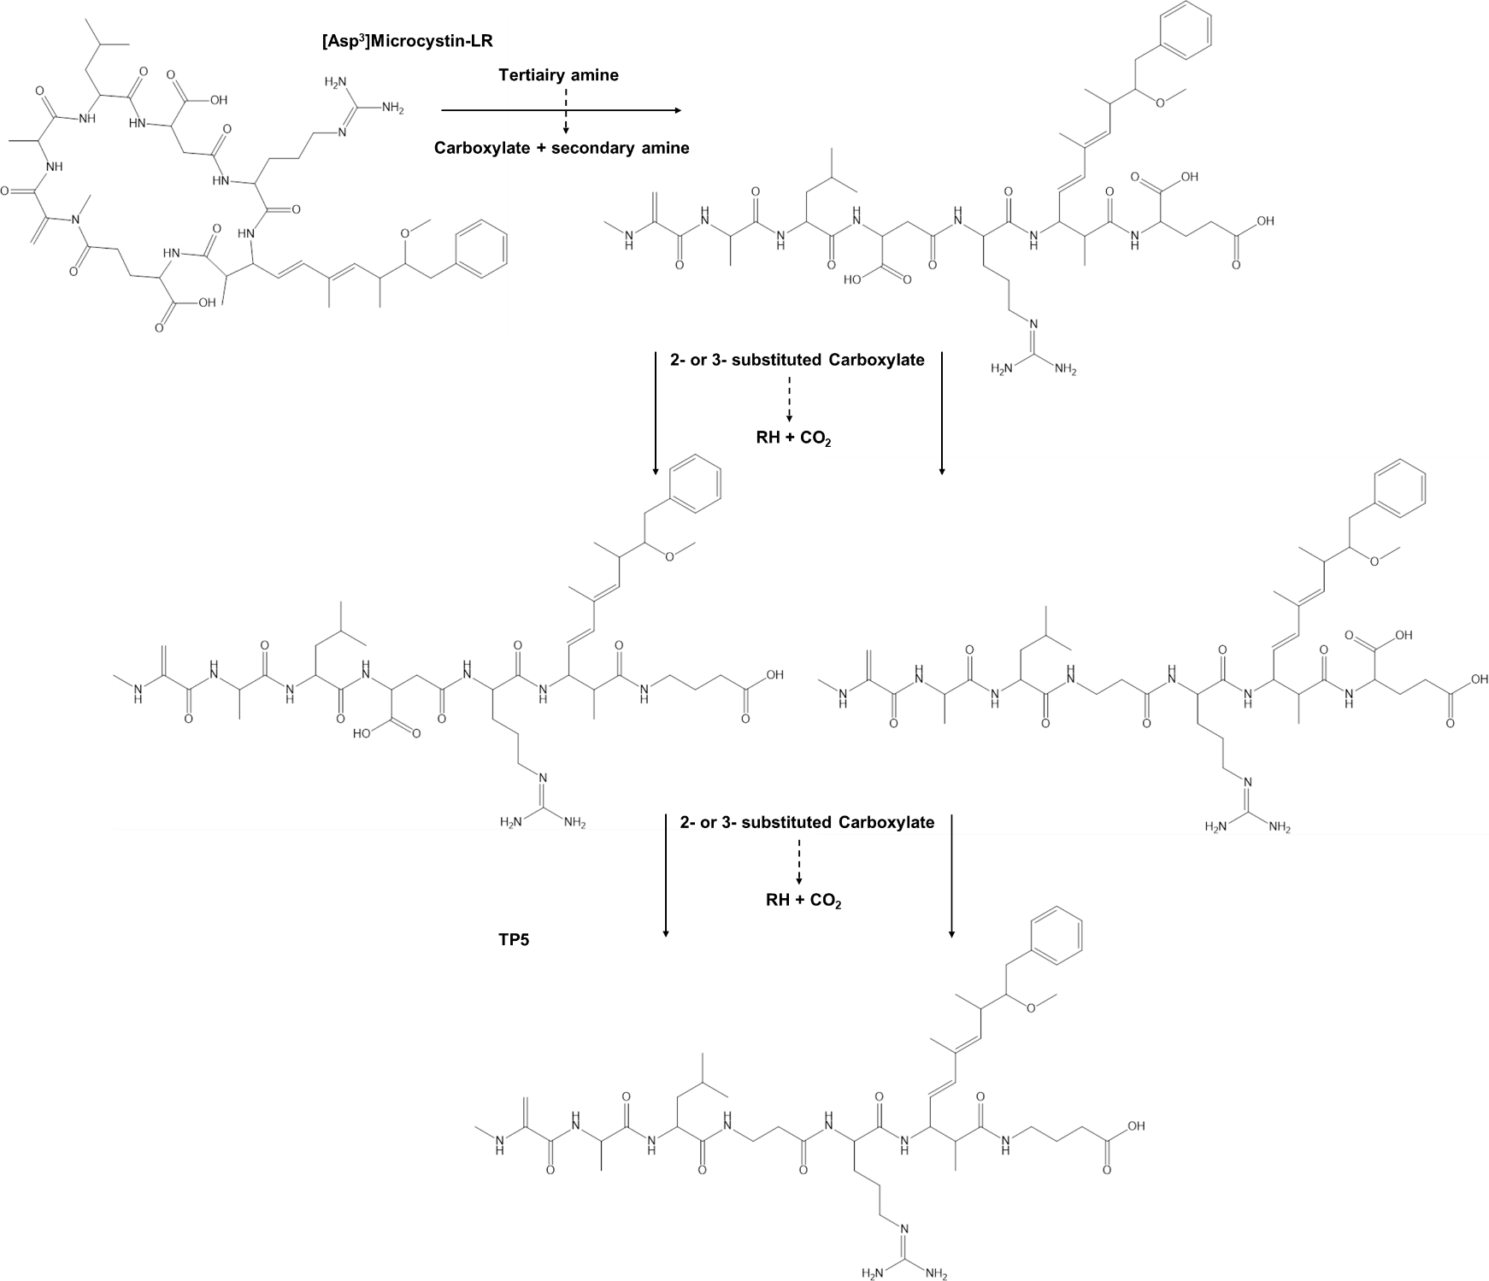
Figure S32. Proposed transformation product 5 (TP5) formation in two steps of [Asp³]microcystin-LR.

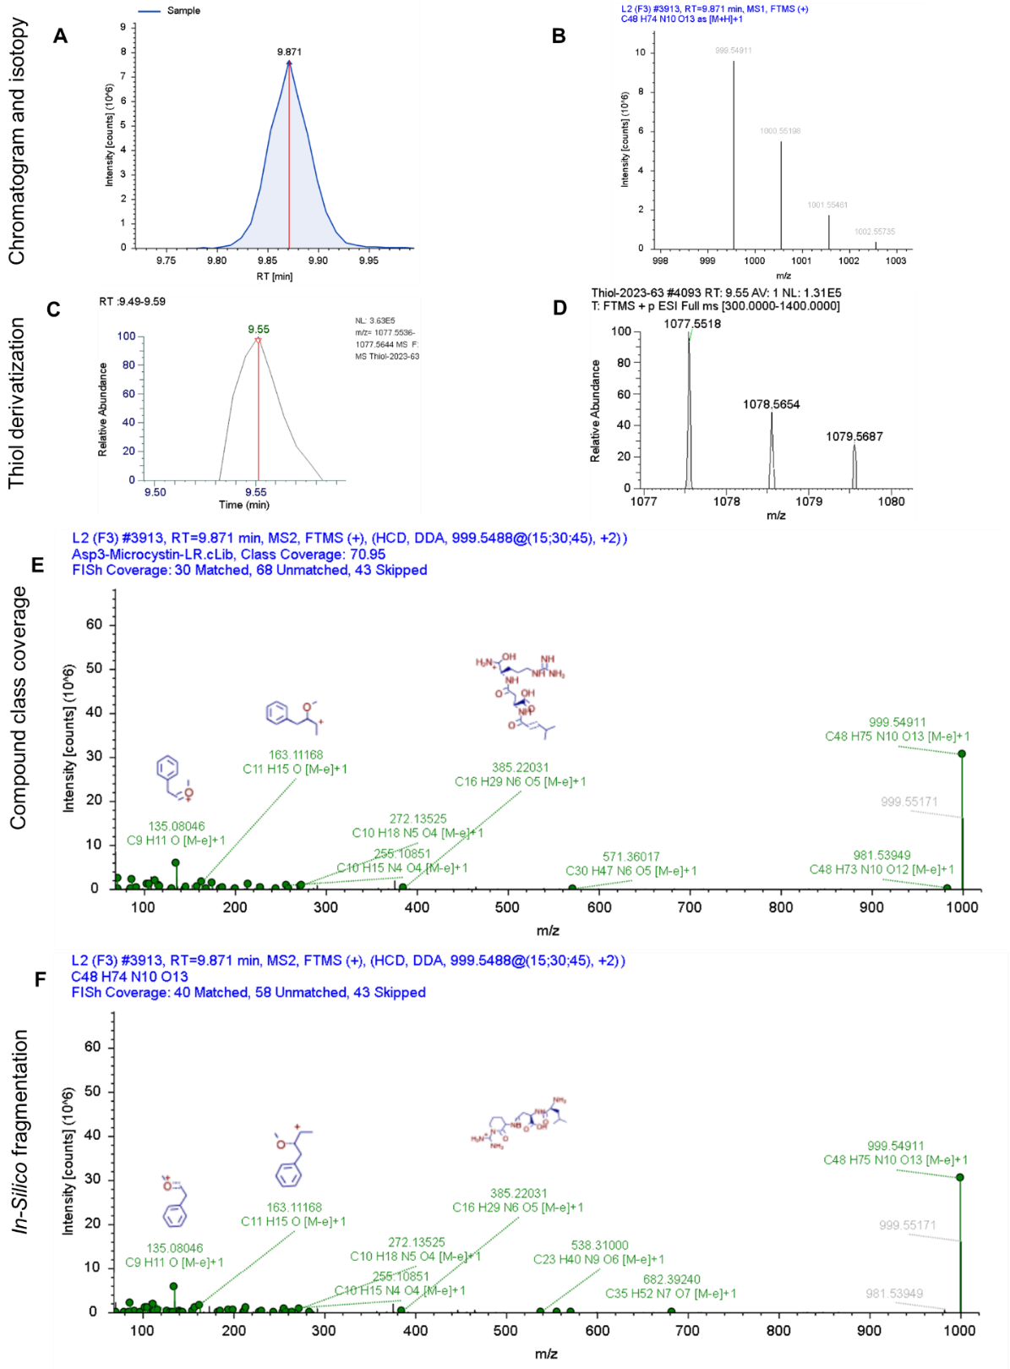
Figure S33. Structure characterization of transformation product 6 (TP6). A) Extracted ion chromatogram of ion m/z 999.5491, B) isotopic pattern of most intense precursor ion, C) Extracted ion chromatogram of thiol derivative ion m/z 1077.5518 and D) isotopic pattern of thiol derivative. E) Fragmentation spectrum and compound class coverage compared to [Asp³]microcystin-LR and F) Fragmentation spectrum and in-silico matching with FISh coverage.
The seco-1/7 form can be verified by the presence of characteristic peaks at m/z 714, 599, 571, 385, 368, and 174, among others, which are associated with the chain Tyr2-Asp3-Arg4-Adda5-Glu6-Mdha7. Besides, the characteristic peaks at 127 and 155, associated with the AA1-AA7 linkage, are absent from the spectra, indicating the ring opening at these positions. Furthermore, a thiol derivative was found at m/z 1077.5518, confirming the presence of Mdha at AA7 position.
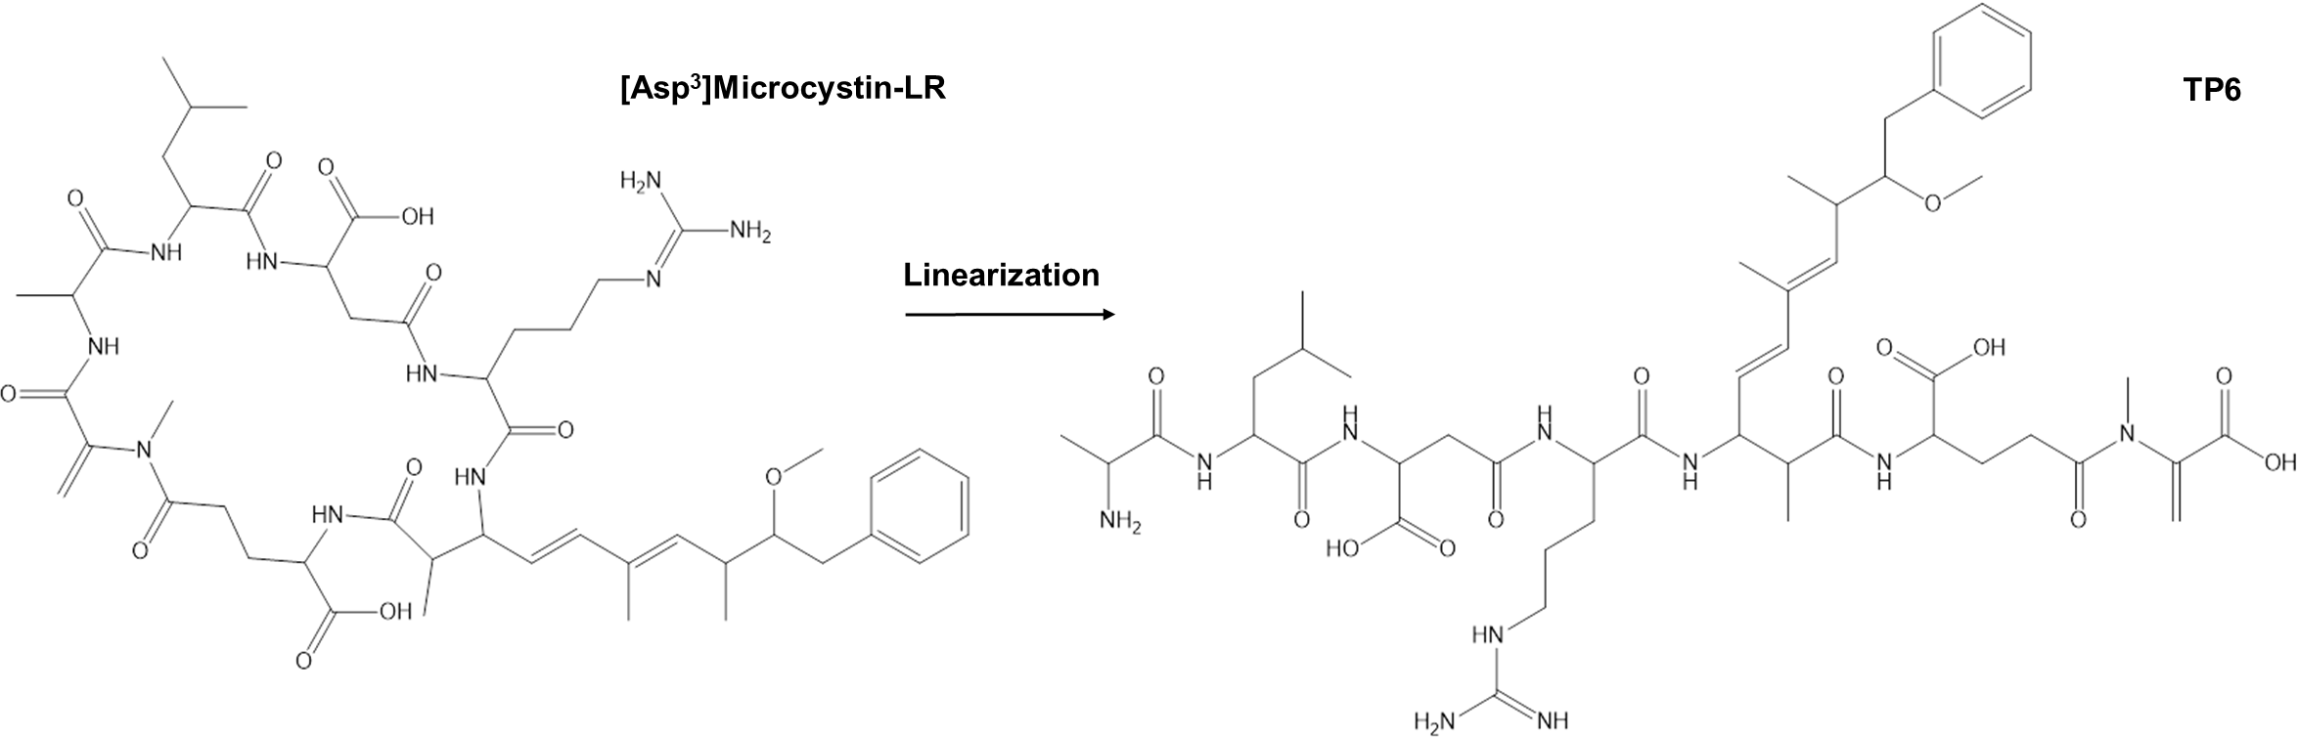
Figure S34. Proposed transformation product 6 (TP6) formation by linearization of [Asp³]microcystin-LR.
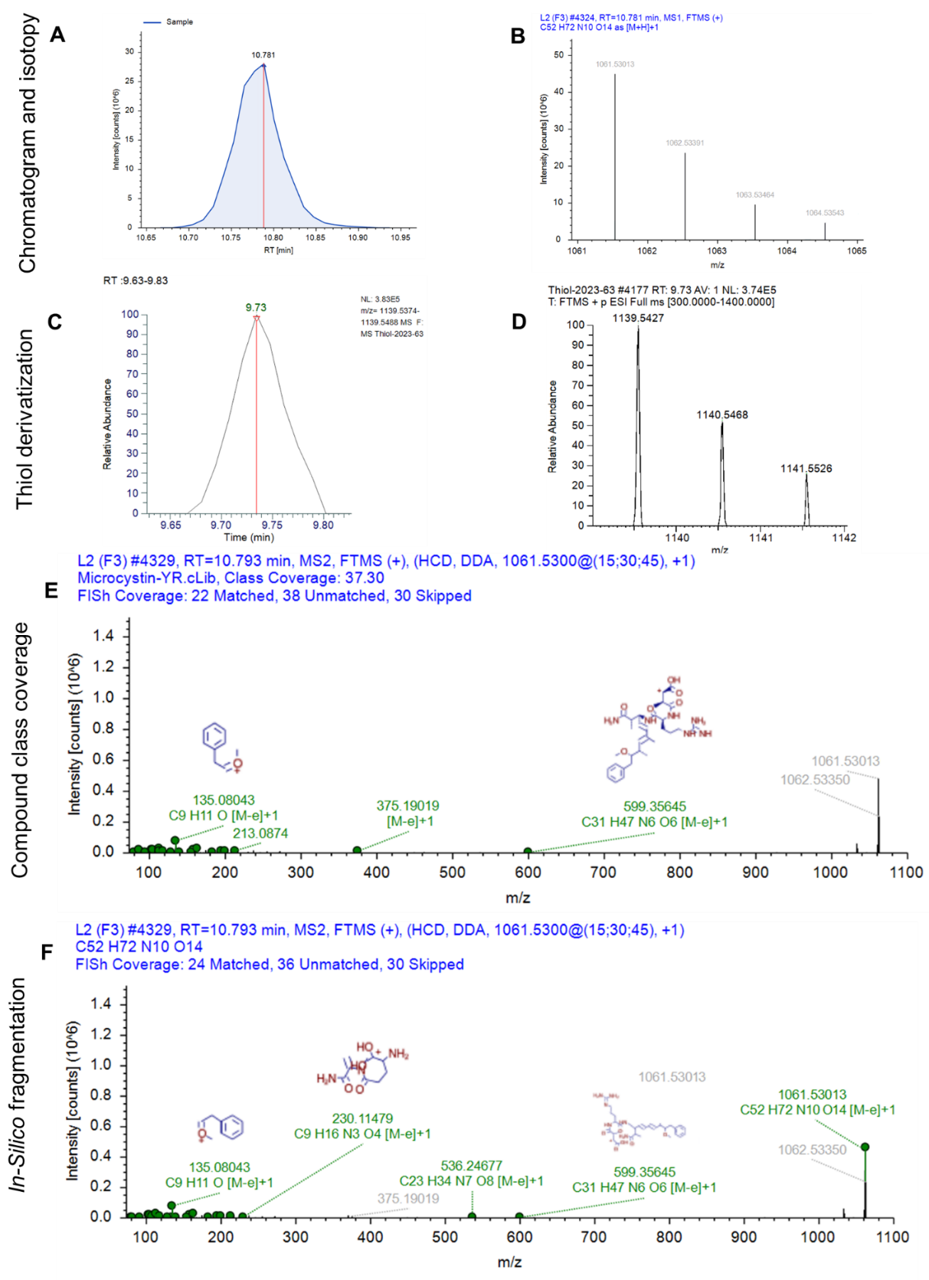
Figure S35. Structure characterization of transformation product 7 (TP7). A) Extracted ion chromatogram of ion m/z 1061.5301, B) isotopic pattern of most intense precursor ion, C) Extracted ion chromatogram of thiol derivative ion m/z 1139.5427 and D) isotopic pattern of thiol derivative. E) Fragmentation spectrum and compound class coverage compared to microcystin-YR and F) Fragmentation spectrum and in-silico matching with FISh coverage.
The main peaks associated with microcystin-YR are present in the spectra, including m/z 599, 375, 213, 155, 135, and 127. These peaks correspond to amino acids AA1, 3, 4, 6, and 7. Additionally, a peak at 536 indicates the hydroxylation of Tyr (AA2) to dopamine. A thiol derivative was found at m/z 1139.5427, confirming the presence of Mdha at AA7 position.
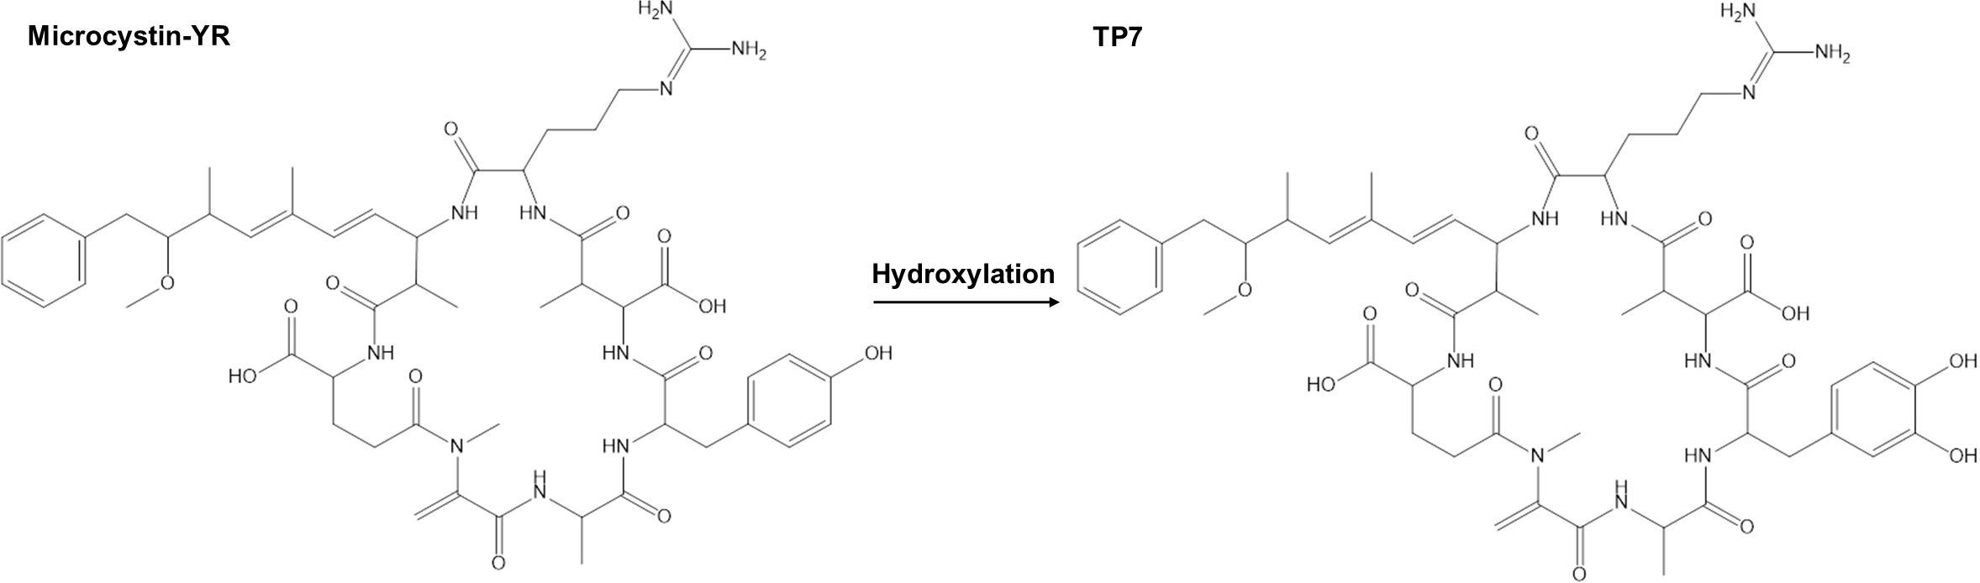

Figure S36. Proposed transformation product 7 (TP7) formation by linearization of microcystin-YR.
References

1. Otto JFM, Kiel C, Nejstgaard JC, Pohnert G, Berger SA, Ueberschaar N. Tracking a broad inventory of cyanotoxins and related secondary metabolites using UHPLC-HRMS. J Hazard Mater Adv. 2023;12:100370.

