Supplementary Material

Comprehensive profiling of sulfated phenolic compounds in edible and infesting seaweeds by a dedicated software-assisted platform

Enrico Taglioni¹, Chiara Cavaliere¹, Andrea Cerrato¹, Aldo Laganà¹, Carmela Maria Montone^{1,*}, Anna Laura Capriotti¹

¹ Department of Chemistry, Sapienza University of Rome, Piazzale Aldo Moro 5, 00185 Rome, Italy

*Corresponding author

Dr. Carmela Maria Montone
E-mail: carmelamaria.montone@uniroma1.it
tel: +39 06 4991 3945

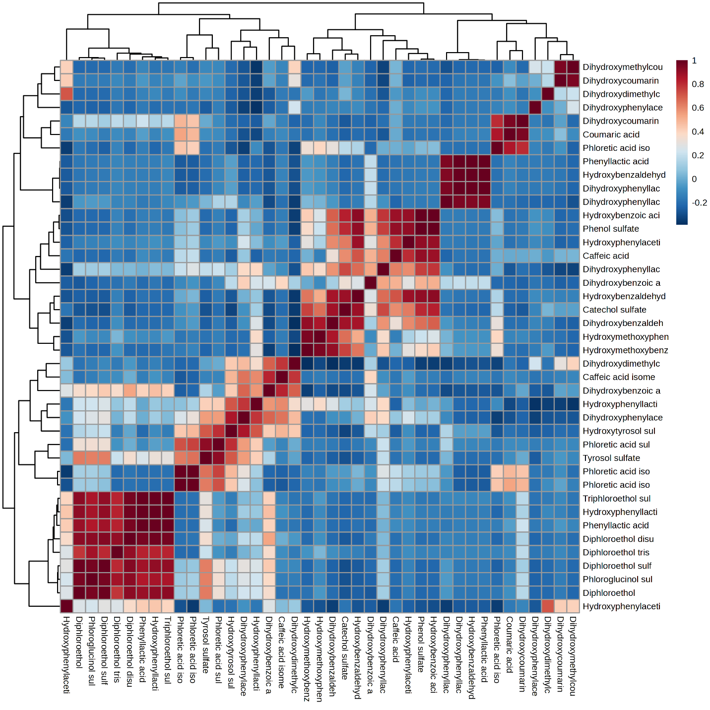
Figure S1. Correlation heatmap of the peak areas of the 44 annotated phenolic compounds in the 10 analyzed seaweed strains.

Figure S2. Box and whiskers plot of the peak areas of (a) phenol sulfate, (b) catechol sulfate, (c) phloroglucinol sulfate, (d) diphloroethol sulfate, (e) diphloroethol disulfate, and (f) triphloroethol sulfate in the ten analyzed seaweed samples.
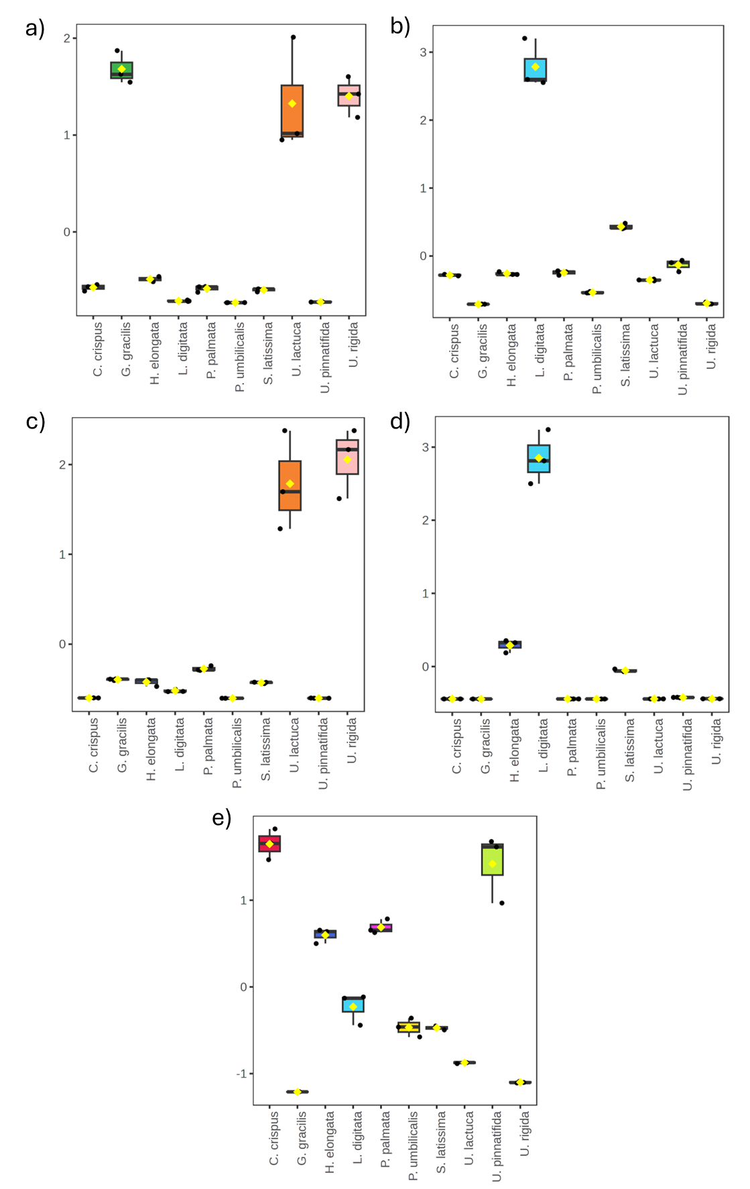
Figure S3. Box and whiskers plot of the peak areas of (a) phenol sulfates, (b) phenolic acids, (c) phenolic acid sulfates, (d) phlorotannins, and (e) coumarins in the ten analyzed seaweed samples.
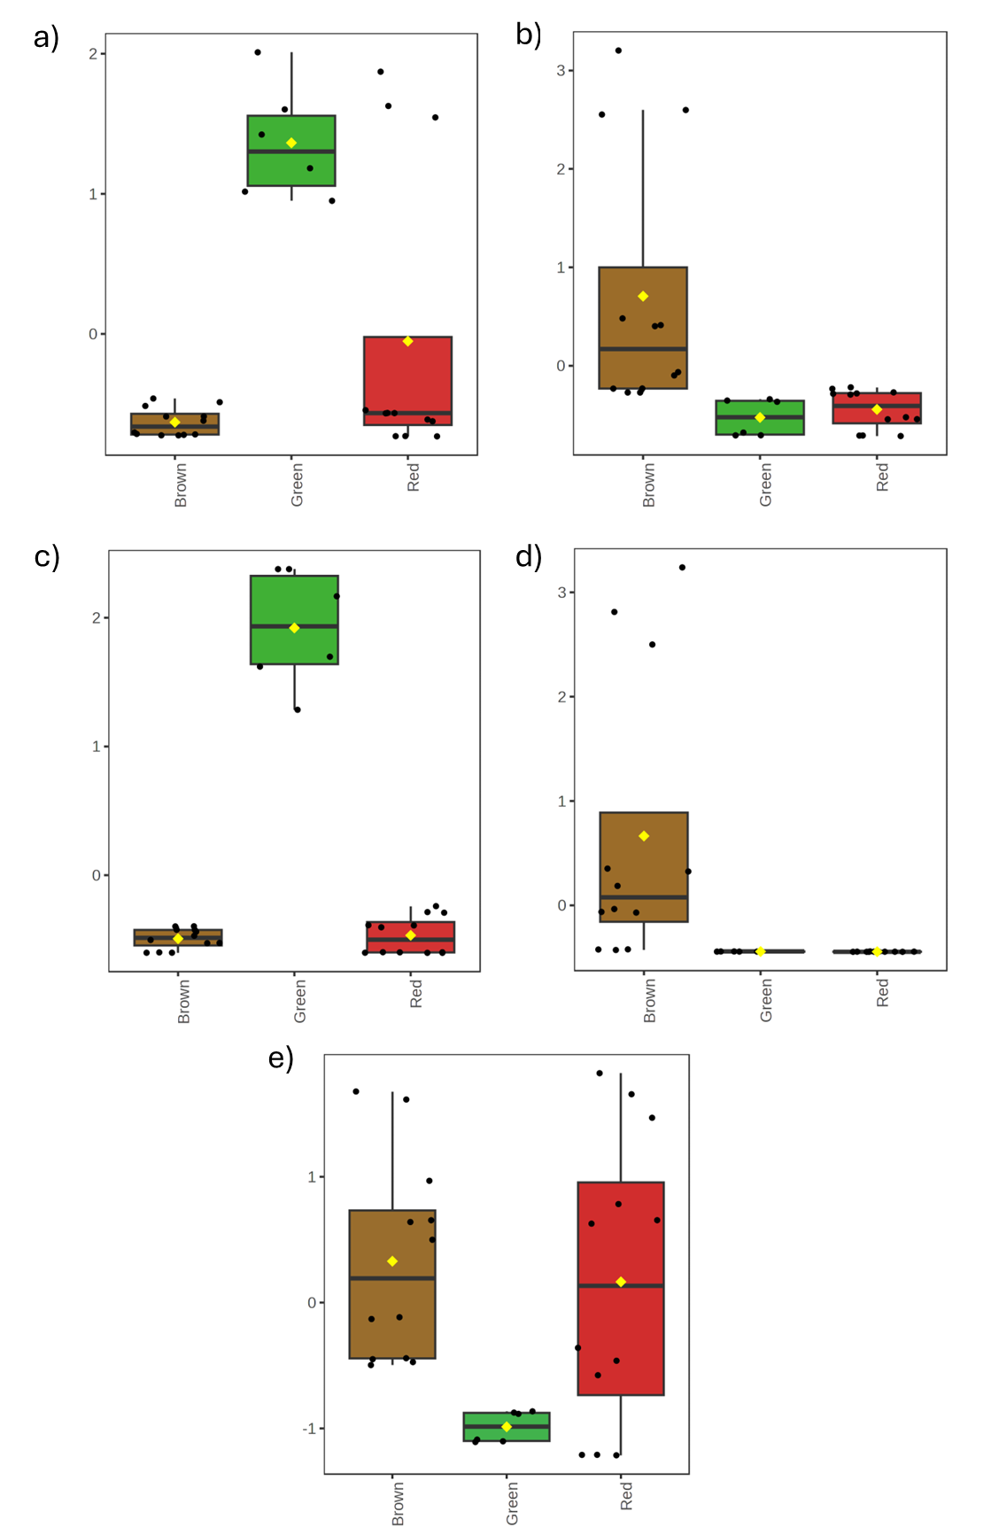
Figure S4. Box and whiskers plot of the peak areas of (a) phenol sulfates, (b) phenolic acids, (c) phenolic acid sulfates, (d) phlorotannins, and (e) coumarins in the ten analyzed seaweed samples grouped into three classes based on the taxonomy.

