Supporting Information

Limitations of boronate affinity chromatography for the specific enrichment of fructose-derived early glycation products in protein analytics
Sebastian Lux, Clara Vogt, Milena Voll, Ralf Hoffmann

Table of contents
Supplementary tables 3
Tab. S1 Parameters and settings used for RP-HPLC-ESI-QqLIT-MS. 3
Tab. S2 Parameters used for glycated peptides in scheduled MRM. 4
Tab. S3 Precursor ions of unmodified, hexose- and hexitol-modified peptides targeted by high resolution ESI-QqOrbitrap-MS (direct infusion) in PRM-mode using individually optimized normalized collision energies (NCE). 5
Tab. S4 Instrumental limits of detection (ILD), instrumental limits of quantitation (ILQ), and linearity parameters for a dilution series of seven synthetic Heyns peptides in aqueous buffer using three different MRM transitions per analyte. 6
Tab. S5 Recovery rates of glycated and reduced glycated peptide standards in affinity fractions based on their relative peak areas to reference mixtures. 7
Tab. S6 Percentage distribution of glycated and reduced glycated peptide standards in affinity fractions. 8
Supplementary figures 9
Fig. S1 Tandem mass spectra of doubly protonated precursor ions of Amadori (a, m/z 1052.5) or Heyns peptide #3 (b, m/z 1053.1) acquired on the QTRAP4000 (direct infusion) at a collision energy (CE) of 50%. 9
Fig. S2 Peak areas obtained for a dilution series of synthetic Heyns peptide #3 in aqueous buffer using the MRM transitions m/z 1053 → 1005 (a, Heyns peptide qualifier) and m/z 702 → 1007 (b, quantifier). 10
Fig. S3 RP chromatogram of the wash fraction collected in boronate affinity chromatography (BAC) for a peptide mixture containing three fructated (Hey) and three glucated (Ama, 1 nmol each) peptides. 11
Fig. S4 RP chromatograms from 20 to 34 min of an SPE-purified peptide mixture (A) containing three fructated (Hey) and three glucated peptides (Ama, 0.75 nmol each) as well as unbound (B-D) and enriched fractions (E-G) collected by BAC. 12
Fig. S5 RP chromatograms and ESI-MS (inserts) of SPE-purified peptide mixtures (n = 2) containing fructated (Hey) and glucated peptides (Ama, 0.75 nmol each) incubated in the presence (rAma/rHey, b,d) or absence (a,c) of sodium borohydride in ammonium acetate loading buffer (250 mmol/L, 50 mmol/L magnesium acetate, pH 8.1). 13
Fig. S6 Zoomed high-resolution mass spectra (m/z 900-906) of two peptide mixtures containing different fructated (Hey) and glucated peptides (Ama) incubated in ammonium acetate (c/d, 250 mmol/L, 50 mmol/L magnesium acetate, pH 8.1) or sodium phosphate loading buffer (e/f, 50 mmol/L, pH 8.5) in the absence (a/b) or presence (rAma/rHey, c-f) of sodium borohydride. 14
Fig. S7 Tandem mass spectra of doubly protonated precursor ions of the unreduced (a/b, m/z 1104.1) and reduced (c, m/z 1105.1) Amadori (red) or Heyns peptide #5 (blue) using a normalized collision energy (NCE) of 22. 15
Fig. S8 Tandem mass spectra of doubly protonated precursor ions of the reduced Amadori (red, m/z 1105.1) and the unmodified peptide #5 (gray, m/z 1023.1) at a normalized collision energy (NCE) of 30. 15
Fig. S9 Tandem mass spectra recorded for quadruply charged precursor ions detected at m/z 625.0297 (a) and m/z 666.0468 (c,e) and triply charged precursor ions detected at m/z 833.0372 (b) and m/z 887.7267 (d,f) of unmodified (a,b), reduced fructated (c,d), and reduced glucated peptide #2 (e,f). 16
Fig. S10 Annotated tandem mass spectra recorded for quadruply charged precursor ions detected at m/z 625.0297 (a) and m/z 666.0468 (c,e) and triply charged precursor ions detected at m/z 833.0372 (b) and m/z 887.7267 (d,f) of unmodified (a,b), reduced fructated (c,d), and reduced glucated peptide #2 (e,f). 17
Fig. S11 Tandem mass spectra recorded for triply charged precursor ions detected at m/z 647.9789 (a) and m/z 702.6684 (c,e) and doubly charged precursor ions detected at m/z 971.4648 (b) and m/z 1053.4990 (d,f) of unmodified (a,b), reduced fructated (c,d), and reduced glucated peptide #3 (e,f). 18
Fig. S12 Annotated tandem mass spectra recorded for triply charged precursor ions detected at m/z 647.9789 (a) and m/z 702.6684 (c,e) and doubly charged precursor ions detected at m/z 971.4648 (b) and m/z 1053.4990 (d,f) of unmodified (a,b), reduced fructated (c,d), and reduced glucated peptide #3 (e,f). 19
Fig. S13 Tandem mass spectra recorded for triply charged precursor ions detected at m/z 547.3174 (a) and m/z 602.0069 (c,e) and doubly charged precursor ions detected at m/z 820.4725 (b) and m/z 902.5067 (d,f) of unmodified (a,b), reduced fructated (c,d), and reduced glucated peptide #4 (e,f). 20
Fig. S14 Annotated tandem mass spectra recorded for triply charged precursor ions detected at m/z 547.3174 (a) and m/z 602.0069 (c,e) and doubly charged precursor ions detected at m/z 820.4725 (b) and m/z 902.5067 (d,f) of unmodified (a,b), reduced fructated (c,d), and reduced glucated peptide #4 (e,f). 21
Fig. S15 Tandem mass spectra recorded for triply charged precursor ions detected at m/z 682.3700 (a) and m/z 737.0595 (c,e) and doubly charged precursor ions detected at m/z 1023.0513 (b) and m/z 1105.0856 (d,f) of unmodified (a,b), reduced fructated (c,d), and reduced glucated peptide #5 (e,f). 22
Fig. S16 Annotated tandem mass spectra recorded for triply charged precursor ions detected at m/z 682.3700 (a) and m/z 737.0595 (c,e) and doubly charged precursor ions detected at m/z 1023.0513 (b) and m/z 1105.0856 (d,f) of unmodified (a,b), reduced fructated (c,d), and reduced glucated peptide #5 (e,f). 23
Fig. S17 Tandem mass spectra recorded for triply charged precursor ions detected at m/z 550.9698 (a) and m/z 605.6593 (c,e) and doubly charged precursor ions detected at m/z 825.9511 (b) and m/z 907.9853 (d,f) of unmodified (a,b), reduced fructated (c,d), and reduced glucated peptide #6 (e,f). 24
Fig. S18 Annotated tandem mass spectra recorded for triply charged precursor ions detected at m/z 550.9698 (a) and m/z 605.6593 (c,e) and doubly charged precursor ions detected at m/z 825.9511 (b) and m/z 907.9853 (d,f) of unmodified (a,b), reduced fructated (c,d), and reduced glucated peptide #6 (e,f). 25
Fig. S19 Tandem mass spectra recorded for triply charged precursor ions detected at m/z 614.3098 (a) and m/z 668.9993 (c,e) and doubly charged precursor ions detected at m/z 920.9611 (b) and m/z 1002.9954 (d,f) of unmodified (a,b), reduced fructated (c,d), and reduced glucated peptide #7 (e,f). 26
Fig. S20 Annotated tandem mass spectra recorded for triply charged precursor ions detected at m/z 614.3098 (a) and m/z 668.9993 (c,e) and doubly charged precursor ions detected at m/z 920.9611 (b) and m/z 1002.9954 (d,f) of unmodified (a,b), reduced fructated (c,d), and reduced glucated peptide #7 (e,f). 27
Fig. S21 RP chromatograms from 18 to 36 min of an SPE-purified peptide mixture containing three fructated (Hey) and three glucated peptides (Ama, 1 nmol each) incubated in sodium phosphate buffer (50 mmol/L, pH 8.5) in the presence (orange, rAma/rHey, a) or absence (blue, b) of sodium borohydride and the corresponding elution (c,d) and wash fractions (e,f) obtained by BAC using ammonium acetate loading buffer (250 mmol/L, 50 mmol/L magnesium acetate, pH 8.1). 28
Fig. S22 RP chromatograms from 20 to 34 min of an SPE-purified peptide mixture (A) containing three fructated (Heyns) and three glucated peptides (Amadori, n=3, 1 nmol each) reduced with sodium borohydride and the wash (B-D) and enriched fractions (E-G) collected by BAC. 29

Supplementary tables

Tab. S1 Parameters and settings used for RP-HPLC-ESI-QqLIT-MS.
Parameter | Settings
ESI-source parameters
IS [V] | 5500
TEM [°C] | 650
Nebulizer gas (Gas 1, psig) | 40
Drying gas (Gas 2, psig) | 75
Curtain gas (CUR, psig) | 35
Mass analyzer settings
Declustering potential (DP, V) | ª
Collision cell entrance potential (EP, V) | 10
Collision cell exit potential (CXP, V) | ª
Interface heating | on
Q₁ resolution | unit
Q₃ resolution | -
Collision (CAD) gas | high
Collision potential (CE, V) | ª
Cycle time [s] | 1.35
Dwell time [ms] | ^{b}
ª: Analyte and charge state dependent parameters (see Tab. S2), ^{b}: Automatically defined by the Scheduled MRM™ Algorithm.

Tab. S2 Parameters used for glycated peptides in scheduled MRM.
# | Sequence | RT  [min] | m/z [M+nH]^{n+} | n | Q₁/Q₃ masses | Fragment ion | DP  [V] | EP  [V] | CE [V] | CXP [V]
1 | AVGDK_{Hex}LPECEAVC*GKPK | 9.2 | 674.0 | 3 | 674 → 656 | [M+3H-3H₂O]³⁺ | 88 | 10 | 29 | 8
 |  |  |  |  | 674 → 642 | [M+3H-2H₂O-C₂H₄O₂]³⁺ | 88 | 10 | 30 | 10
 |  |  |  |  | 674 → 759 | y₇⁺ | 88 | 10 | 37 | 12
2 | TC*VADESAENC*DK_{Hex}SLHTLFGDK | 13.3 | 665.5 | 4 | 666 → 642 | [M+4H-2H₂O-C₂H₄O₂]⁴⁺ | 107 | 10 | 29 | 9
2 | TC*VADESAENC*DK_{Hex}SLHTLFGDK | 13.3 | 887.1 | 3 | 887 → 881 | [M+3H-H₂O]³⁺ | 107 | 10 | 33 | 12
 |  |  |  |  | 887 → 1018 | y₉⁺ | 107 | 10 | 53 | 16
3 | ADLAK_{Hex}YIC*ENQDSISSK | 13.5 | 1052.5 | 2 | 1053 → 1026 | [M+2H-3H₂O]²⁺ | 113 | 10 | 49 | 16
 |  |  |  |  | 1053 → 1005 | [M+2H-2H₂O-C₂H₄O₂]²⁺ | 113 | 10 | 50 | 15
3 | ADLAK_{Hex}YIC*ENQDSISSK | 13.5 | 702.0 | 3 | 702 → 1007 | y₉⁺ | 113 | 10 | 35 | 16
4 | K_{Hex}VPQVSTPTLVEVSR | 14.6 | 901.5 | 2 | 902 → 854 | [M+2H-2H₂O-C₂H₄O₂]²⁺ | 90 | 10 | 44 | 12
4 | K_{Hex}VPQVSTPTLVEVSR | 14.6 | 601.3 | 3 | 601 → 70 | Pro_{Im} | 90 | 10 | 109 | 2
 |  |  |  |  | 601 → 901 | y₈⁺ | 90 | 10 | 29 | 14
5 | VFDEFK_{Hex}PLVEEPQNLIK | 18.5 | 1104.1 | 2 | 1104 → 1077 | [M+2H-3H₂O]²⁺ | 141 | 10 | 51 | 16
 |  |  |  |  | 1104 → 1056 | [M+2H-2H₂O-C₂H₄O₂]²⁺ | 141 | 10 | 57 | 17
5 | VFDEFK_{Hex}PLVEEPQNLIK | 18.5 | 736.4 | 3 | 736 → 981 | y₁₅²⁺ | 141 | 10 | 29 | 14
6 | AEFAEVSK_{Hex}LVTDLTK | 18.6 | 907.0 | 2 | 907 → 880 | [M+2H-3H₂O]²⁺ | 108 | 10 | 43 | 14
 |  |  |  |  | 907 → 859 | [M+2H-2H₂O-C₂H₄O₂]²⁺ | 108 | 10 | 44 | 13
6 | AEFAEVSK_{Hex}LVTDLTK | 18.6 | 605.0 | 3 | 605 → 676 | y₆⁺ | 108 | 10 | 21 | 10
7 | EQLK_{Hex}AVMDDFAAFVEK | 18.7 | 1002.0 | 2 | 1002 → 954 | [M+2H-2H₂O-C₂H₄O₂]²⁺ | 89 | 10 | 47 | 15
7 | EQLK_{Hex}AVMDDFAAFVEK | 18.7 | 668.3 | 3 | 668 → 120 | Phe_{Im} | 89 | 10 | 89 | 6
 |  |  |  |  | 668 → 1042 | y₉⁺ | 89 | 10 | 29 | 16
C*: carbamidomethylated cysteine, K_{Hex}: hexosamine-modified lysine, red – quantifier (peptide backbone fragment), blue – qualifier (96 Da neutral loss)

Tab. S3 Precursor ions of unmodified, hexose- and hexitol-modified peptides targeted by high resolution ESI-QqOrbitrap-MS (direct infusion) in PRM-mode using individually optimized normalized collision energies (NCE).
# | Protein/Location | Sequence | m/z [M+nH]^{n+} | n | NCE [%]
2 | HSA  T₅₂ – K₆₄ – K₇₃ | TC*VADESAENC*DKSLHTLFGDK | 833.0372 | 3 | 24
2 | HSA  T₅₂ – K₆₄ – K₇₃ | TC*VADESAENC*DKSLHTLFGDK | 625.0297 | 4 | 22
2 | HSA  T₅₂ – K₆₄ – K₇₃ | TC*VADESAENC*DK_{Hexose}SLHTLFGDK | 887.0548 | 3 | 18
2 | HSA  T₅₂ – K₆₄ – K₇₃ | TC*VADESAENC*DK_{Hexose}SLHTLFGDK | 665.5429 | 4 | 18
2 | HSA  T₅₂ – K₆₄ – K₇₃ | TC*VADESAENC*DK_{Hexitol}SLHTLFGDK | 887.7267 | 3 | 24
2 | HSA  T₅₂ – K₆₄ – K₇₃ | TC*VADESAENC*DK_{Hexitol}SLHTLFGDK | 666.0468 | 4 | 22
3 | HSA  A₂₅₈ – K₂₆₂ – K₂₇₄ | ADLAKYIC*ENQDSISSK | 971.4648 | 2 | 30
3 | HSA  A₂₅₈ – K₂₆₂ – K₂₇₄ | ADLAKYIC*ENQDSISSK | 647.9789 | 3 | 20
3 | HSA  A₂₅₈ – K₂₆₂ – K₂₇₄ | ADLAK_{Hexose}YIC*ENQDSISSK | 1052.4912 | 2 | 22
3 | HSA  A₂₅₈ – K₂₆₂ – K₂₇₄ | ADLAK_{Hexose}YIC*ENQDSISSK | 701.9965 | 3 | 26
3 | HSA  A₂₅₈ – K₂₆₂ – K₂₇₄ | ADLAK_{Hexitol}YIC*ENQDSISSK | 1053.4990 | 2 | 32
3 | HSA  A₂₅₈ – K₂₆₂ – K₂₇₄ | ADLAK_{Hexitol}YIC*ENQDSISSK | 702.6684 | 3 | 20
4 | HSA  K₄₁₄ – R₄₂₈ | KVPQVSTPTLVEVSR | 820.4725 | 2 | 30
4 | HSA  K₄₁₄ – R₄₂₈ | KVPQVSTPTLVEVSR | 547.3174 | 3 | 20
4 | HSA  K₄₁₄ – R₄₂₈ | K_{Hexose}VPQVSTPTLVEVSR | 901.4989 | 2 | 20
4 | HSA  K₄₁₄ – R₄₂₈ | K_{Hexose}VPQVSTPTLVEVSR | 601.3350 | 3 | 20
4 | HSA  K₄₁₄ – R₄₂₈ | K_{Hexitol}VPQVSTPTLVEVSR | 902.5067 | 2 | 34
4 | HSA  K₄₁₄ – R₄₂₈ | K_{Hexitol}VPQVSTPTLVEVSR | 602.0069 | 3 | 20
5 | HSA  V₃₇₃ – K₃₇₈ – K₃₈₉ | VFDEFKPLVEEPQNLIK | 1023.0513 | 2 | 30
5 | HSA  V₃₇₃ – K₃₇₈ – K₃₈₉ | VFDEFKPLVEEPQNLIK | 682.3700 | 3 | 20
5 | HSA  V₃₇₃ – K₃₇₈ – K₃₈₉ | VFDEFK_{Hexose}PLVEEPQNLIK | 1104.0777 | 2 | 22
5 | HSA  V₃₇₃ – K₃₇₈ – K₃₈₉ | VFDEFK_{Hexose}PLVEEPQNLIK | 736.3876 | 3 | 20
5 | HSA  V₃₇₃ – K₃₇₈ – K₃₈₉ | VFDEFK_{Hexitol}PLVEEPQNLIK | 1105.0856 | 2 | 32
5 | HSA  V₃₇₃ – K₃₇₈ – K₃₈₉ | VFDEFK_{Hexitol}PLVEEPQNLIK | 737.0595 | 3 | 20
6 | HSA  A₂₂₆ – K₂₃₃ – K₂₄₀ | AEFAEVSKLVTDLTK | 825.9511 | 2 | 30
6 | HSA  A₂₂₆ – K₂₃₃ – K₂₄₀ | AEFAEVSKLVTDLTK | 550.9698 | 3 | 20
6 | HSA  A₂₂₆ – K₂₃₃ – K₂₄₀ | AEFAEVSK_{Hexose}LVTDLTK | 906.9775 | 2 | 22
6 | HSA  A₂₂₆ – K₂₃₃ – K₂₄₀ | AEFAEVSK_{Hexose}LVTDLTK | 604.9874 | 3 | 20
6 | HSA  A₂₂₆ – K₂₃₃ – K₂₄₀ | AEFAEVSK_{Hexitol}LVTDLTK | 907.9853 | 2 | 32
6 | HSA  A₂₂₆ – K₂₃₃ – K₂₄₀ | AEFAEVSK_{Hexitol}LVTDLTK | 605.6593 | 3 | 20
7 | HSA  E₅₄₂ – K₅₄₅ – K₅₅₇ | EQLKAVMDDFAAFVEK | 920.9611 | 2 | 30
7 | HSA  E₅₄₂ – K₅₄₅ – K₅₅₇ | EQLKAVMDDFAAFVEK | 614.3098 | 3 | 20
7 | HSA  E₅₄₂ – K₅₄₅ – K₅₅₇ | EQLK_{Hexose}AVMDDFAAFVEK | 1001.9875 | 2 | 20
7 | HSA  E₅₄₂ – K₅₄₅ – K₅₅₇ | EQLK_{Hexose}AVMDDFAAFVEK | 668.3274 | 3 | 14
7 | HSA  E₅₄₂ – K₅₄₅ – K₅₅₇ | EQLK_{Hexitol}AVMDDFAAFVEK | 1002.9954 | 2 | 32
7 | HSA  E₅₄₂ – K₅₄₅ – K₅₅₇ | EQLK_{Hexitol}AVMDDFAAFVEK | 668.9993 | 3 | 20
Hexitol-lysine: +164.0685 Da (C₆H₁₂O₅); Hexosyl-lysine: +162.0528 Da (C₆H₁₀O₅); C*: carbamidomethylated cysteine

Tab. S4 Instrumental limits of detection (ILD), instrumental limits of quantitation (ILQ), and linearity parameters for a dilution series of seven synthetic Heyns peptides in aqueous buffer using three different MRM transitions per analyte.
# | Sequence | m/z [M+nH]^{n+} | n | Q₁/Q₃ masses | ILD  [pmol] | ILQ  [pmol] | Peak Area  ILQ | Range [pmol] | LDR | R²
1 | AVGDK_{Hey}LPECEAVC*GKPK | 674 | 3 | 674 → 656 | 0.5 | 1 | 9.25E+03 | 2.5 – 100 | 40 | 0.998
 |  |  |  | 674 → 642 | 0.5 | 1 | 8.94E+03 | 2.5 – 100 | 40 | 0.998
 |  |  |  | 674 → 759 | 1 | 2.5 | 1.66E+04 | 2.5 – 100 | 40 | 0.998
2 | TC*VADESAENC*DK_{Hey}SLHTLFGDK | 665.5 | 4 | 666 → 642 | 0.25 | 1 | 9.55E+03 | 2.5 – 100 | 40 | 0.992
2 | TC*VADESAENC*DK_{Hey}SLHTLFGDK | 887 | 3 | 887 → 881 | 0.25 | 0.5 | 3.88E+03 | 5 – 50 | 10 | 0.999
 |  |  |  | 887 → 1018 | 1 | 5 | 4.96E+03 | 10 – 100 | 10 | 0.994
3 | ADLAK_{Hey}YIC*ENQDSISSK | 1052.5 | 2 | 1053 → 1026 | 2.5 | 5 | 1.86E+04 | 5 – 100 | 20 | 0.992
 |  |  |  | 1053 → 1005 | 1 | 2.5 | 6.02E+03 | 2.5 – 100 | 40 | 0.991
3 | ADLAK_{Hey}YIC*ENQDSISSK | 702 | 3 | 702 → 1007 | 0.5 | 1 | 5.52E+03 | 1 – 100 | 100 | 1.000
4 | K_{Hey}VPQVSTPTLVEVSR | 901.5 | 2 | 902 → 854 | 1 | 2.5 | 1.21E+04 | 2.5 – 100 | 40 | 0.995
4 | K_{Hey}VPQVSTPTLVEVSR | 601.3 | 3 | 601 → 70 | 0.25 | 0.5 | 3.96E+04 | 1 – 50 | 50 | 0.993
 |  |  |  | 601 → 901 | 0.25 | 0.5 | 2.57E+04 | 1 – 50 | 50 | 0.995
5 | VFDEFK_{Hey}PLVEEPQNLIK | 1104.1 | 2 | 1104 → 1077 | 2.5 | 5 | 2.13E+03 | 10 – 100 | 10 | 0.977
 |  |  |  | 1104 → 1056 | 5 | 10 | 1.01E+04 | 10 – 100 | 10 | 0.979
5 | VFDEFK_{Hey}PLVEEPQNLIK | 736.4 | 3 | 736 → 981 | 2.5 | 5 | 5.78E+03 | 5 – 100 | 20 | 0.986
6 | AEFAEVSK_{Hey}LVTDLTK | 907 | 2 | 907 → 880 | 2.5 | 5 | 1.12E+04 | 5 – 100 | 20 | 0.981
 |  |  |  | 907 → 859 | 1 | 2.5 | 2.31E+03 | 5 – 100 | 20 | 0.982
6 | AEFAEVSK_{Hey}LVTDLTK | 605 | 3 | 605 → 676 | 2.5 | 5 | 2.57E+04 | 5 – 100 | 20 | 0.991
7 | EQLK_{Hey}AVMDDFAAFVEK | 1002 | 2 | 1002 → 954 | 5 | 10 | 9.27E+03 | 10 – 100 | 10 | 0.947
7 | EQLK_{Hey}AVMDDFAAFVEK | 668.3 | 3 | 668 → 120 | 1 | 2.5 | 1.54E+04 | 2.5 – 100 | 40 | 0.975
 |  |  |  | 668 → 1042 | 2.5 | 5 | 2.05E+04 | 5 – 100 | 20 | 0.974
ILDs and ILQs were defined by signal-to-noise ratios (S/N) better than 3 and ≥ 10, respectively. C*: carbamidomethylated cysteine, K_{Hey}: gluco/mannosamine-modified lysine, LDR: linear dynamic range, R²: coefficient of determination, red – quantifier (peptide backbone fragment), blue – qualifier (96 Da neutral loss)

Tab. S5 Recovery rates of glycated and reduced glycated peptide standards in affinity fractions based on their relative peak areas to reference mixtures.
The composition of complementary peptide mixtures in each experiment is summarized by the colors orange and purple, denoting mix 1 and mix 2.
# | Mod | Exp 1  12.5 pmol  NH₄Ac  pH 8.1 | Exp 2  125 pmol  NH₄Ac  pH 8.1 | Exp 3  6 nmol  NH₄Ac  pH 8.1 |  |  | Exp 4  3 nmol  NH₄Ac  pH 8.1 |  | Exp 5  3 nmol  NH₄Ac  pH 10 |  | Exp 6  3 nmol  Na-PB  pH 8.5 |  | Exp 7  3 nmol  NH₄Ac  pH 8.1 |  | Exp 8  3 nmol  NH₄Ac  pH 8.1 |  | Exp 9  3 nmol  NH₄Ac  pH 10 |  | Exp 10  3 nmol  Na-PB  pH 8.5
# | Mod | Elu  [%] | Elu  [%] | FT [%] | Wash  [%]*³ | Elu  [%] | FT/W  [%] | Elu  [%] | FT/W [%] | Elu  [%] | FT/W [%] | Elu  [%] | FT/W [%] | Elu  [%] | FT/W [%] | Elu  [%] | FT/W [%] | Elu  [%] | FT/W [%] | Elu  [%]
1 | Ama | 75*¹ |  | - | - | 75
1 | rAma
1 | Hey | < LOQ | 0.3 | 5.6 | 87 | -
1 | rHey
2 | Ama | 72*¹ |  |  |  |  | - | 146 | - | 143 | <5*² | 146 | - | 105
2 | rAma |  |  |  |  |  |  |  |  |  |  |  | - | 93 | 6 | 134 | 3 | 137 | 112 | 24
2 | Hey | < LOQ | 1.6 |  |  |  | 132 | 8.7 | 144 | 9.0 | 133 | 6.3 | 106 | 9.2
2 | rHey |  |  |  |  |  |  |  |  |  |  |  | - | 86 | 15 | 138 | - | 135 | 155 | 9
3 | Ama | 84*¹ |  | - | - | 89 | - | 152 | - | 120 | <3*² | 154 | 5.1 | 95
3 | rAma |  |  |  |  |  |  |  |  |  |  |  | 9.1 | 93 | 8 | 143 | 4 | 131 | 67 | 48
3 | Hey | 5.3 | 4.0 | 4.6 | 69 | 5.4 | 110 | 6.5 | 112 | 5.7 | 142 | 3.6 | 83 | 1.8
3 | rHey |  |  |  |  |  |  |  |  |  |  |  | - | 77 | 21 | 134 | 4 | 123 | 110 | 38
4 | Ama | 93*¹ |  | - | - | 78 | - | 152 | - | 159 | - | 131 | 1.2 | 101
4 | rAma |  |  |  |  |  |  |  |  |  |  |  | - | 95 | 9 | 148 | 4 | 145 | 24 | 127
4 | Hey | 6.2 | 6.1 | 3.4 | 75 | 6.4 | 152 | 8.7 | 150 | 8.1 | 109 | 7.1 | 76 | 3.1
4 | rHey |  |  |  |  |  |  |  |  |  |  |  | - | 90 | 20 | 140 | 3 | 137 | 21 | 137
5 | Ama | 81*¹ |  | - | - | 58 | - | 226 | - | 187 | 51 | 134 | - | 111
5 | rAma |  |  |  |  |  |  |  |  |  |  |  | 10 | 51 | 52 | 135 | 16 | 116 | 237 | -
5 | Hey | < LOQ | 1.6 | 2.3 | 51 | 1.3 | 140 | - | 134 | 1.1 | 205 | 1.0 | 92 | -
5 | rHey |  |  |  |  |  |  |  |  |  |  |  | 19 | 58 | 51 | 110 | 19 | 135 | 171 | 3
6 | Ama | 98*¹ |  | - | - | 64 | - | 193 | - | 145 | 9 | 144 | - | 98
6 | rAma |  |  |  |  |  |  |  |  |  |  |  | 11 | 57 | 57 | 166 | 21 | 146 | 211 | 73
6 | Hey | 7.8 | 1.6 | 2.1 | 23 | <9*² | 131 | - | 138 | 2.8 | 197 | 2.7 | 101 | -
6 | rHey |  |  |  |  |  |  |  |  |  |  |  | 19 | 59 | 62 | 140 | 24 | 166 | 191 | 11
7 | Ama | 107*¹ |  | - | - | 71 | - | 251 | - | 195 | 19 | 176 | - | 118
7 | rAma |  |  |  |  |  |  |  |  |  |  |  | 3.8 | 41 | -*² | -*² | -*² | -*² | -*² | -*²
7 | Hey | 7.3 | 1.7 | 3.1 | 26 | 1.7 | 170 | - | 185 | - | 418 | 3.1 | 81 | -
7 | rHey |  |  |  |  |  |  |  |  |  |  |  | 8.4 | 56 | -*² | -*² | -*² | -*² | -*² | -*²
*¹: normalized recovery after UV/VIS adjustment to Heyns peptides; *²: overlap with other signals in UV; *³: after SPE

Tab. S6 Percentage distribution of glycated and reduced glycated peptide standards in affinity fractions.
The composition of complementary peptide mixtures in each experiment is summarized by the colors orange and purple, denoting mix 1 and mix 2.
# | Mod | Exp 3  6 nmol  NH₄Ac  pH 8.1 |  |  | Exp 4  3 nmol  NH₄Ac  pH 8.1 |  | Exp 5  3 nmol  NH₄Ac  pH 10 |  | Exp 6  3 nmol  Na-PB  pH 8.5 |  | Exp 7  3 nmol  NH₄Ac  pH 8.1 |  | Exp 8  3 nmol  NH₄Ac  pH 8.1 |  | Exp 9  3 nmol  NH₄Ac  pH 10 |  | Exp 10  3 nmol  Na-PB  pH 8.5
# | Mod | FT [%] | Wash  [%]*³ | Elu  [%] | FT/W  [%] | Elu  [%] | FT/W [%] | Elu  [%] | FT/W [%] | Elu  [%] | FT/W [%] | Elu  [%] | FT/W [%] | Elu  [%] | FT/W [%] | Elu  [%] | FT/W [%] | Elu  [%]
1 | Ama | 0 | 0 | 100
1 | rAma
1 | Hey | 6 | 94 | 0
1 | rHey
2 | Ama |  |  |  | 0 | 100 | 0 | 100 | <3 | >97 | 0 | 100
2 | rAma |  |  |  |  |  |  |  |  |  | 0 | 100 | 4 | 96 | 2 | 98 | 82 | 18
2 | Hey |  |  |  | 94 | 6 | 94 | 6 | 95 | 5 | 92 | 8
2 | rHey |  |  |  |  |  |  |  |  |  | 0 | 100 | 10 | 90 | 0 | 100 | 95 | 5
3 | Ama | 0 | 0 | 100 | 0 | 100 | 0 | 100 | <2 | >98 | 5 | 95
3 | rAma |  |  |  |  |  |  |  |  |  | 9 | 91 | 5 | 95 | 3 | 97 | 58 | 42
3 | Hey | 6 | 87 | 7 | 94 | 6 | 95 | 5 | 98 | 2 | 98 | 2
3 | rHey |  |  |  |  |  |  |  |  |  | 0 | 100 | 14 | 86 | 3 | 97 | 74 | 26
4 | Ama | 0 | 0 | 100 | 0 | 100 | 0 | 100 | 0 | 100 | 1 | 99
4 | rAma |  |  |  |  |  |  |  |  |  | 0 | 100 | 6 | 94 | 3 | 97 | 16 | 84
4 | Hey | 4 | 88 | 8 | 95 | 5 | 95 | 5 | 94 | 6 | 96 | 4
4 | rHey |  |  |  |  |  |  |  |  |  | 0 | 100 | 13 | 88 | 2 | 98 | 13 | 87
5 | Ama | 0 | 0 | 100 | 0 | 100 | 0 | 100 | 28 | 72 | 0 | 100
5 | rAma |  |  |  |  |  |  |  |  |  | 16 | 84 | 28 | 72 | 12 | 88 | 100 | 0
5 | Hey | 4 | 93 | 2 | 100 | 0 | 99 | 1 | 100 | 0 | 100 | 0
5 | rHey |  |  |  |  |  |  |  |  |  | 25 | 75 | 32 | 68 | 12 | 88 | 98 | 2
6 | Ama | 0 | 0 | 100 | 0 | 100 | 0 | 100 | 6 | 94 | 0 | 100
6 | rAma |  |  |  |  |  |  |  |  |  | 16 | 84 | 26 | 74 | 13 | 87 | 74 | 26
6 | Hey | >6 | >67 | <26 | 100 | 0 | 98 | 2 | 99 | 1 | 100 | 0
6 | rHey |  |  |  |  |  |  |  |  |  | 24 | 76 | 31 | 69 | 13 | 87 | 95 | 5
7 | Ama | 0 | 0 | 100 | 0 | 100 | 0 | 100 | 10 | 90 | 0 | 100
7 | rAma |  |  |  |  |  |  |  |  |  | 8 | 92
7 | Hey | 10 | 84 | 6 | 100 | 0 | 100 | 0 | 99 | 1 | 100 | 0
7 | rHey |  |  |  |  |  |  |  |  |  | 13 | 87
*²: overlap with other signals in UV; *³: after SPE

Supplementary figures
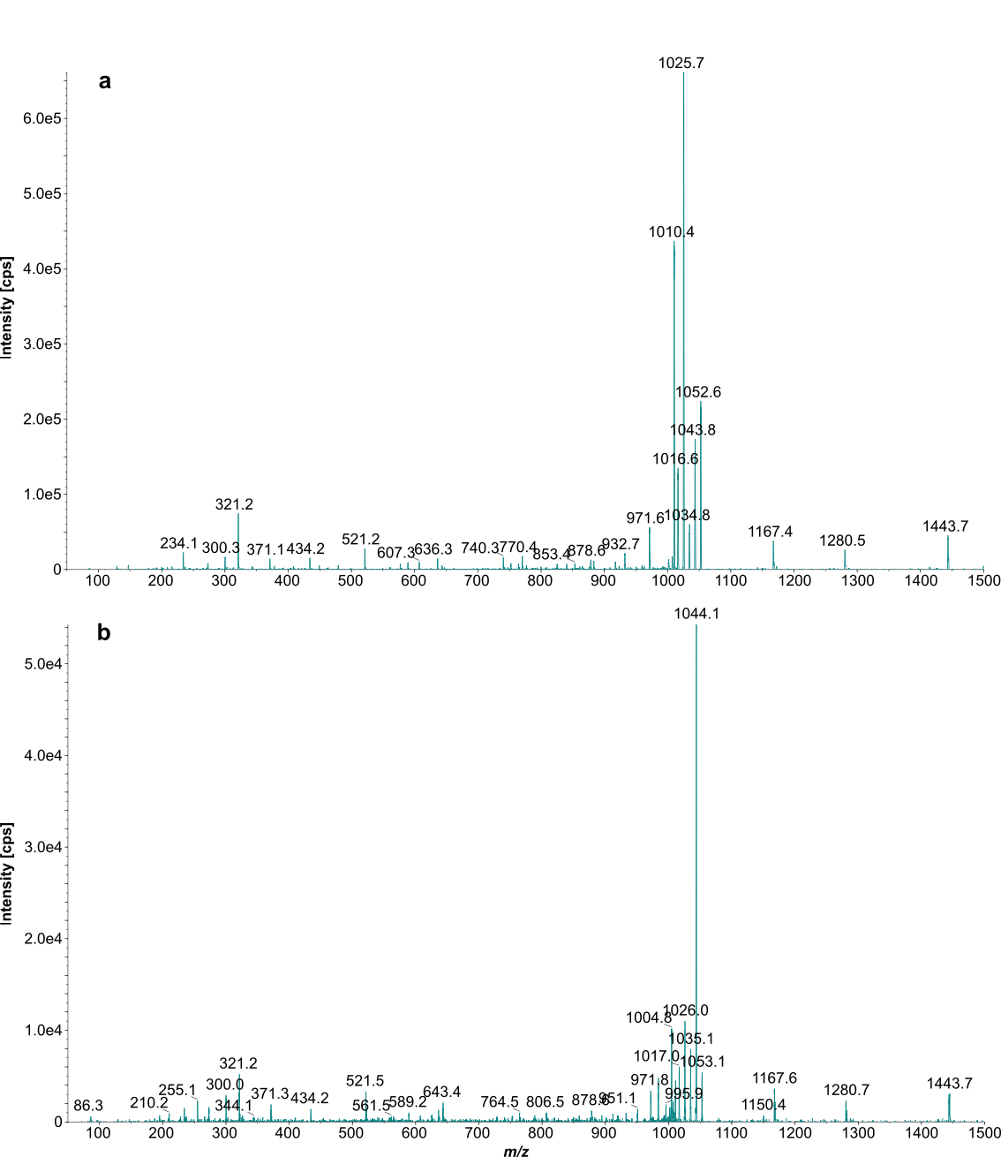

Fig. S1 Tandem mass spectra of doubly protonated precursor ions of Amadori (a, m/z 1052.5) or Heyns peptide #3 (b, m/z 1053.1) acquired on the QTRAP4000 (direct infusion) at a collision energy (CE) of 50%.

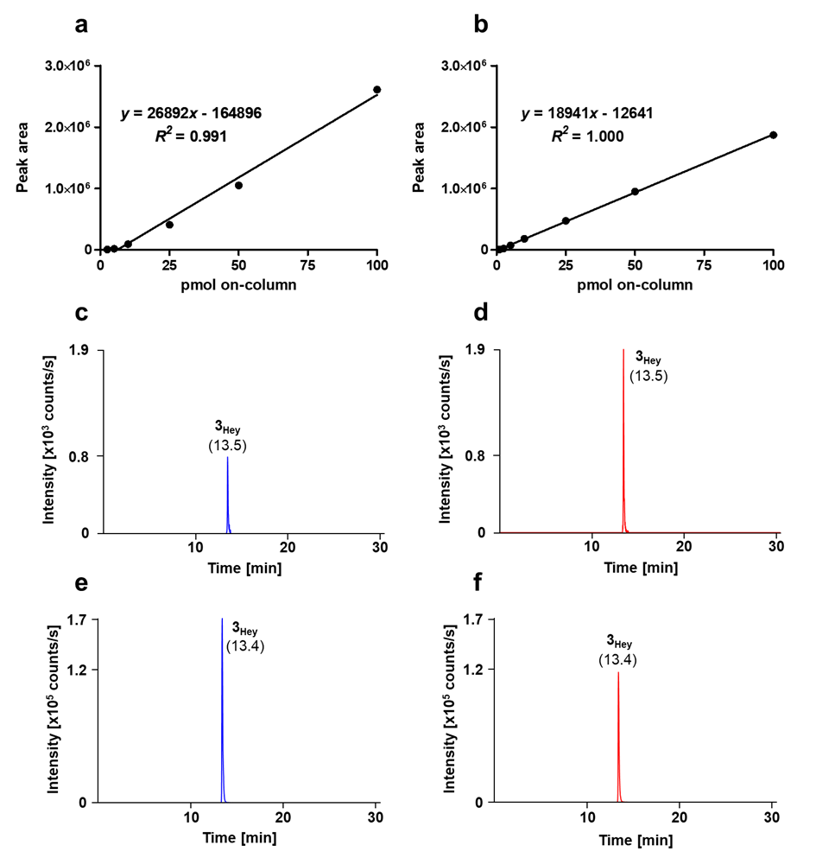

Fig. S2 Peak areas obtained for a dilution series of synthetic Heyns peptide #3 in aqueous buffer using the MRM transitions m/z 1053 → 1005 (a, Heyns peptide qualifier) and m/z 702 → 1007 (b, quantifier).
XICs of the qualifier (blue, c/e) and quantifier (red, d/f) are shown for a spiked plasma sample depleted of Amadori peptides by BAC with on-column loads of 1 pmol (c/d) and 100 pmol (e/f).

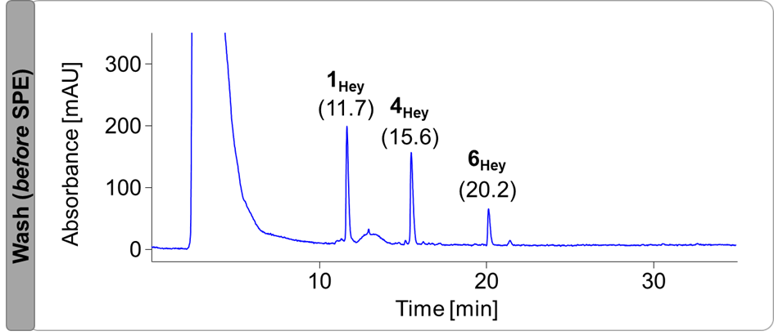

Fig. S3 RP chromatogram of the wash fraction collected in boronate affinity chromatography (BAC) for a peptide mixture containing three fructated (Hey) and three glucated (Ama, 1 nmol each) peptides.
The peptides were separated on a Jupiter C₁₈ column at 60°C using a linear gradient from 95% eluent A to 95% eluent B in 30 min. The absorbance was recorded at 214 nm. Peptide sequences and modification sites are listed in Tab. S3. Recovery rates and percentage distribution in affinity processed fractions are summarized in Tab. S5 (Exp 3).
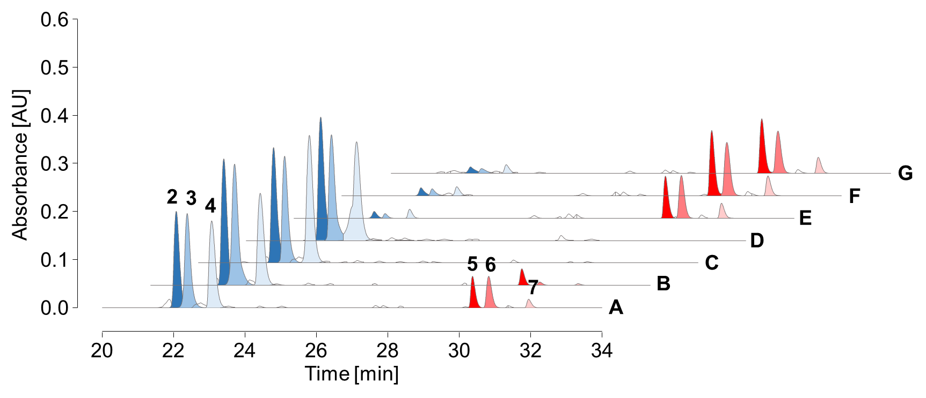

Fig. S4 RP chromatograms from 20 to 34 min of an SPE-purified peptide mixture (A) containing three fructated (Hey) and three glucated peptides (Ama, 0.75 nmol each) as well as unbound (B-D) and enriched fractions (E-G) collected by BAC.
Equilibration, sample loading, and column washing in affinity chromatography were performed using either sodium phosphate (50 mmol/L, pH 8.5, B/E) or ammonium acetate loading buffer (250 mmol/L, 50 mmol/L magnesium acetate, pH 8.1, C/F), with additional equilibration at basic pH (pH 10, D/G) tested for the latter. Peptides were separated on an Aqua C₁₈ column at 60°C using a linear gradient from 97% eluent A to 40% eluent C in 37 min. The absorbance was recorded at 214 nm. Peptide sequences and modification sites are listed in Tab. S3. Recovery rates and percentage distribution in affinity processed fractions are summarized in Tab. S5 and Tab. S6 (Exp 4/Exp 5/Exp 6).
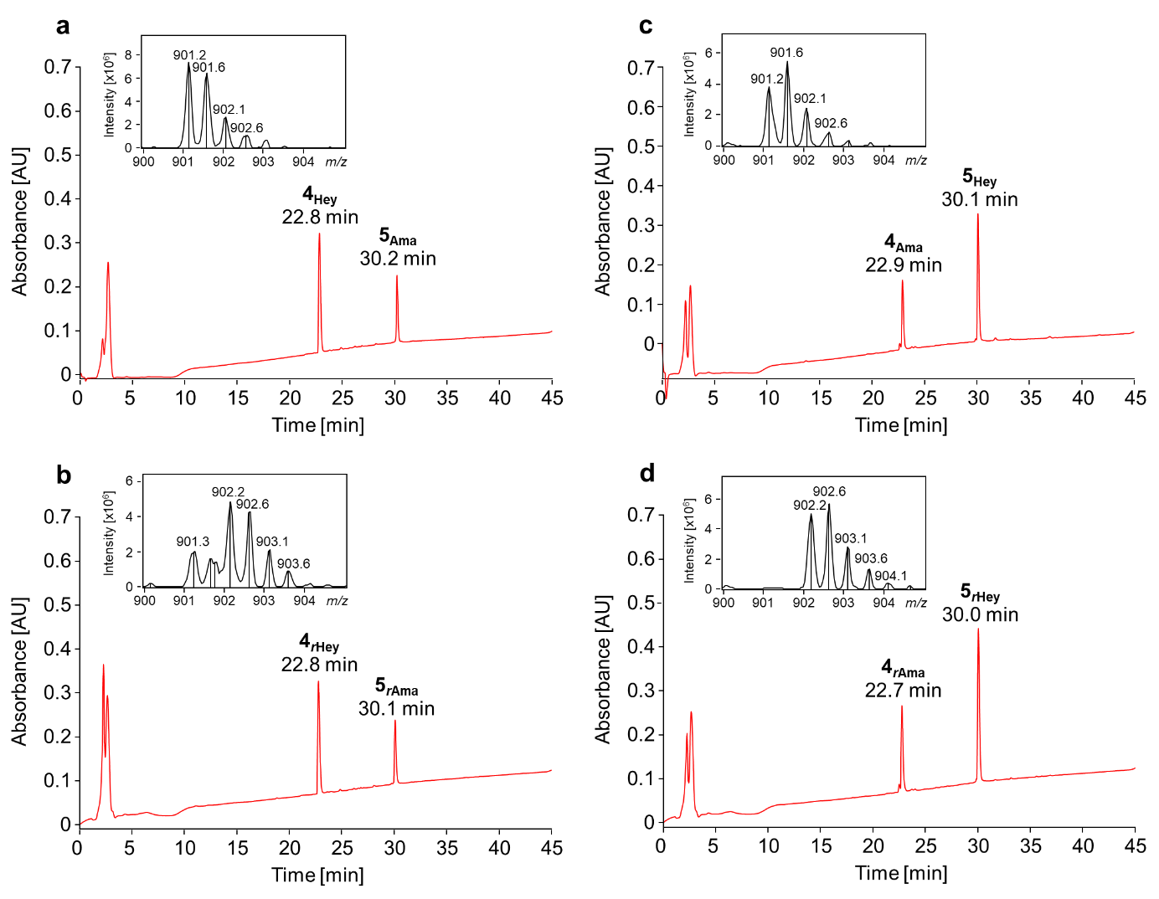

Fig. S5 RP chromatograms and ESI-MS (inserts) of SPE-purified peptide mixtures (n = 2) containing fructated (Hey) and glucated peptides (Ama, 0.75 nmol each) incubated in the presence (rAma/rHey, b,d) or absence (a,c) of sodium borohydride in ammonium acetate loading buffer (250 mmol/L, 50 mmol/L magnesium acetate, pH 8.1).
Peptides were separated on an Aqua C₁₈ column at 60°C using a linear gradient from 97% eluent A to 40% eluent C in 37 min. Absorbance was recorded at 214 nm. Mass spectra were recorded online from 22.6 min to 24.1 min (a), 22.7 min to 24.0 min (b,d) and 22.7 min to 24.1 min (c) on an ESI-ion trap-MS in positive ion mode from m/z 500 to 1200. The small insets show the isotopic patterns of the doubly protonated precursor ions of glycated peptide #4 (K_{Hex}VPQVSTPTLVEVSR, m/z 901.5) and its reduced version (m/z 902.5). Peptide sequences and modification sites are listed in Tab. S3.
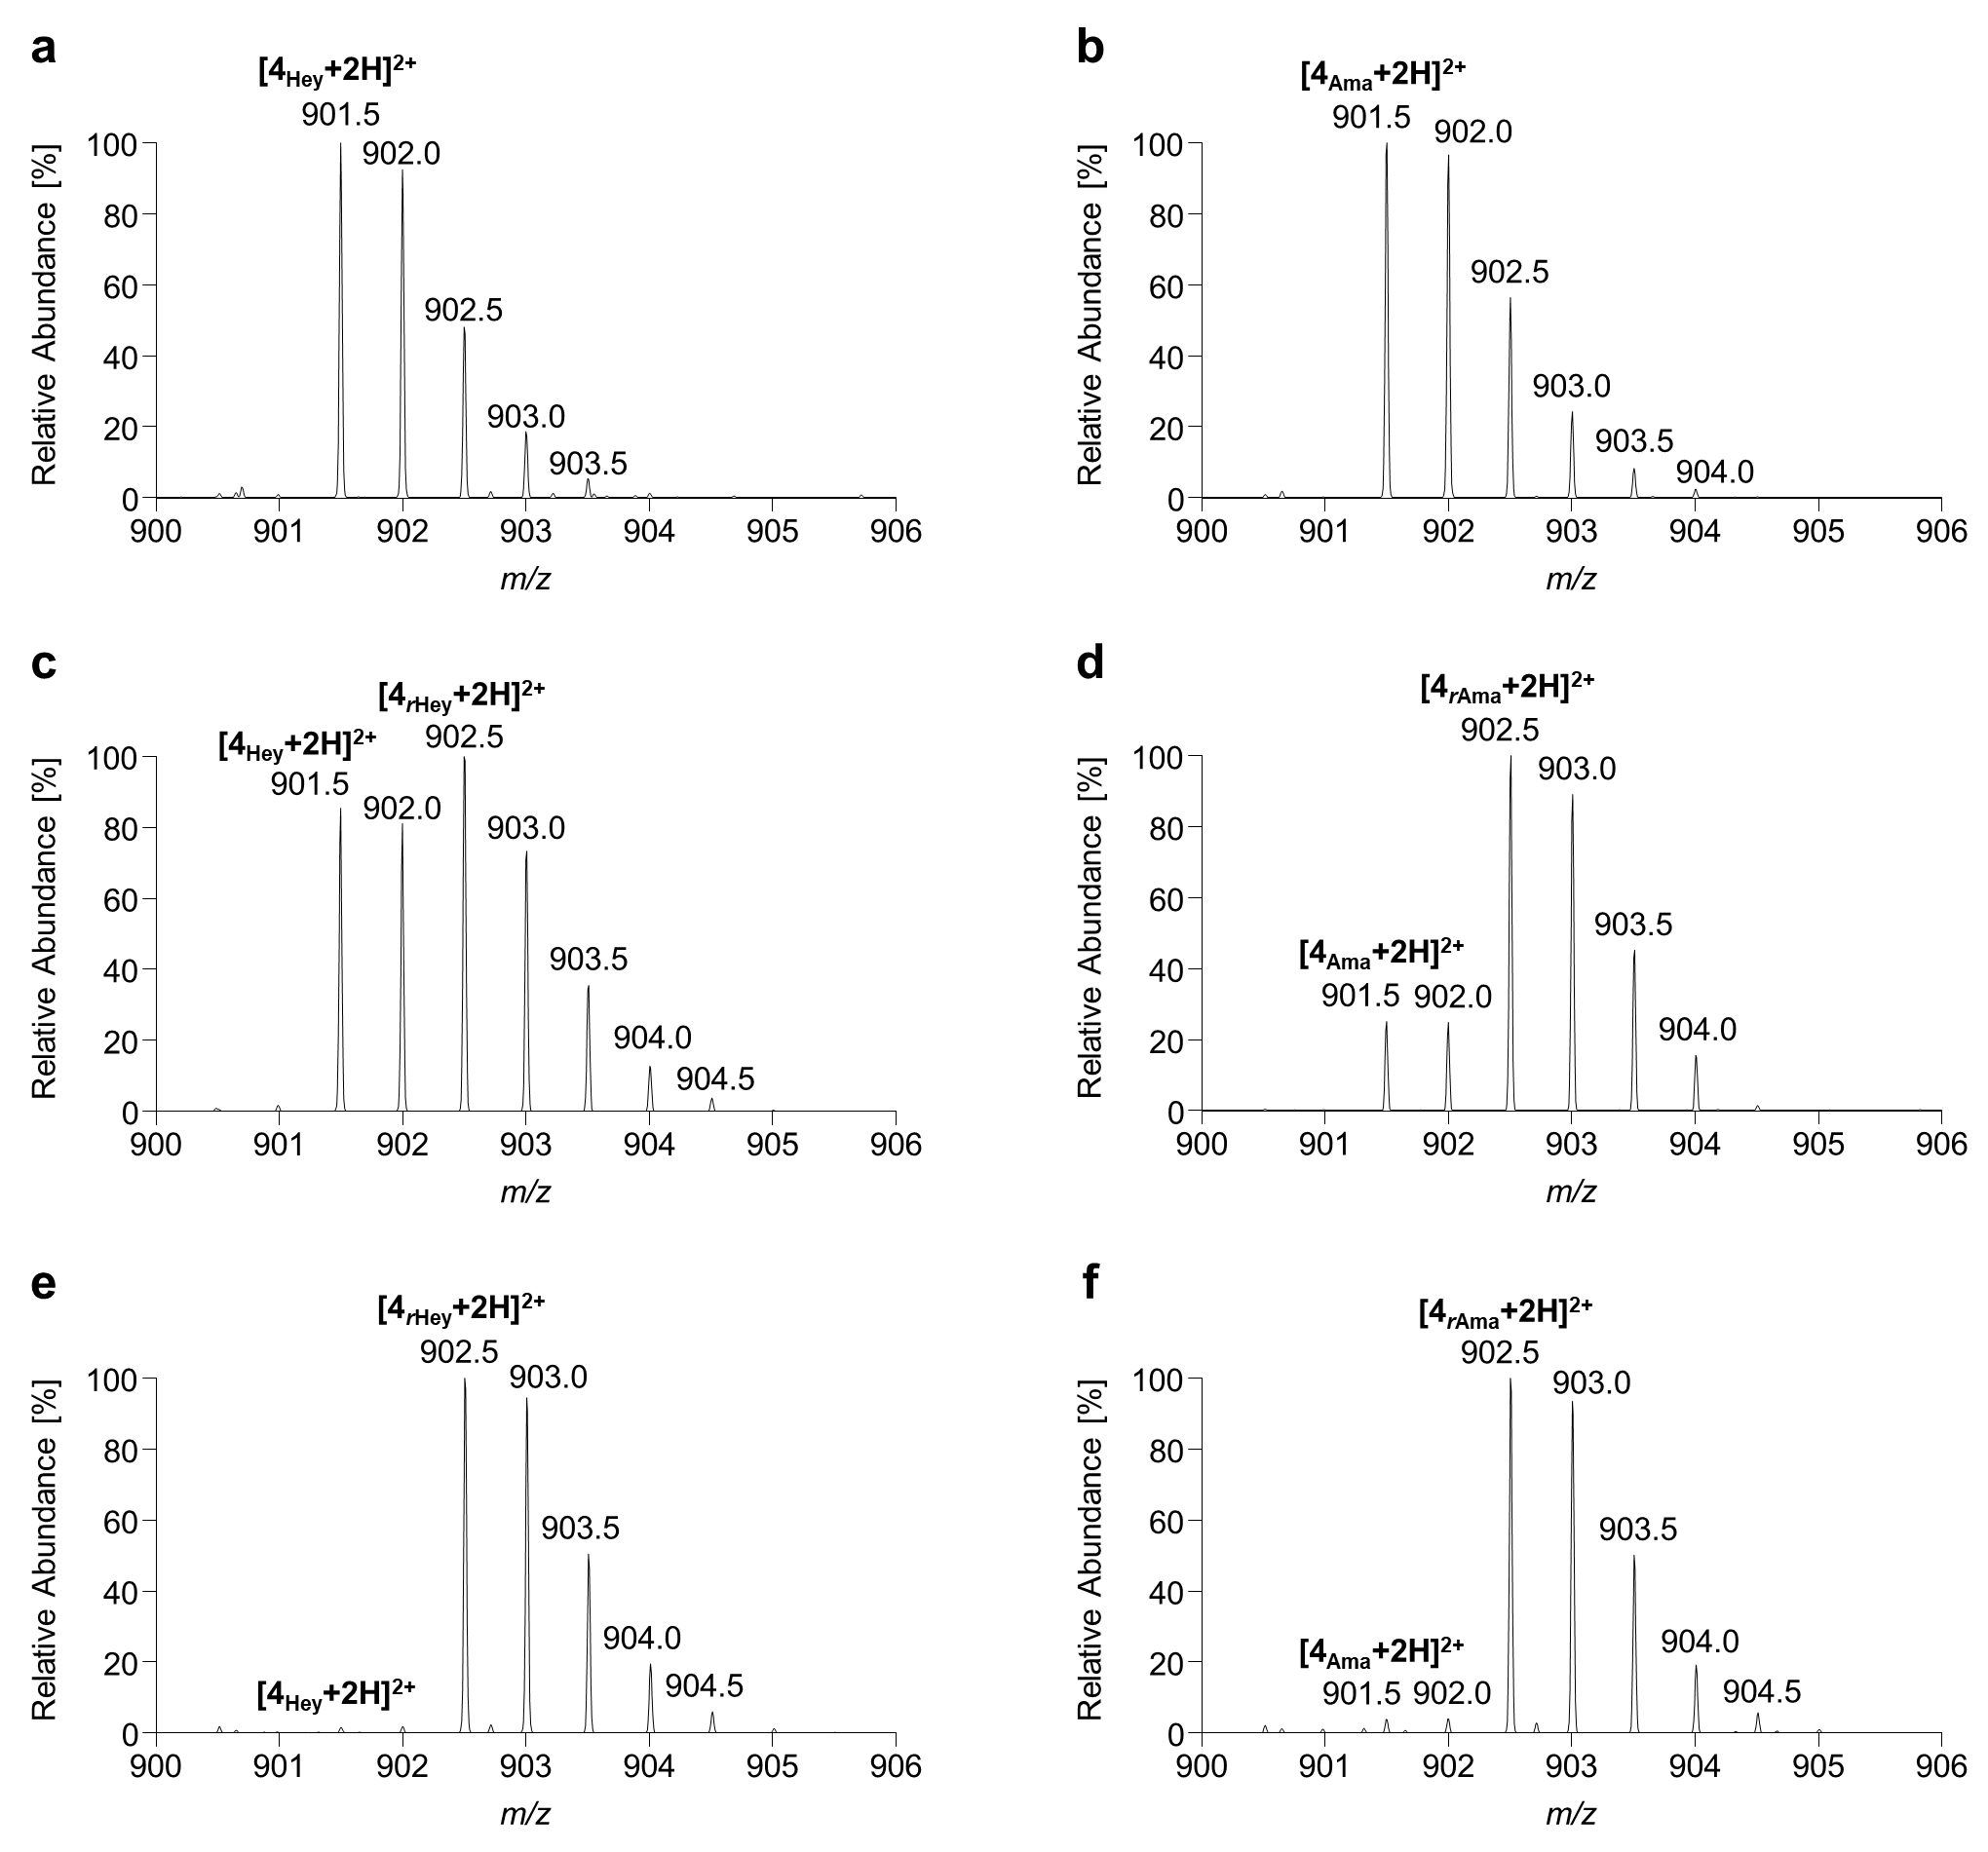

Fig. S6 Zoomed high-resolution mass spectra (m/z 900-906) of two peptide mixtures containing different fructated (Hey) and glucated peptides (Ama) incubated in ammonium acetate (c/d, 250 mmol/L, 50 mmol/L magnesium acetate, pH 8.1) or sodium phosphate loading buffer (e/f, 50 mmol/L, pH 8.5) in the absence (a/b) or presence (rAma/rHey, c-f) of sodium borohydride.
Ratios of signals corresponding to the doubly charged precursor ion of the hexose- (Hey/Ama, m/z 901.5) and hexitol-modified (rHey/rAma, m/z 902.5) peptide #4 (KVPQVSTPTLVEVSR) represent the efficiency of borohydride reduction.
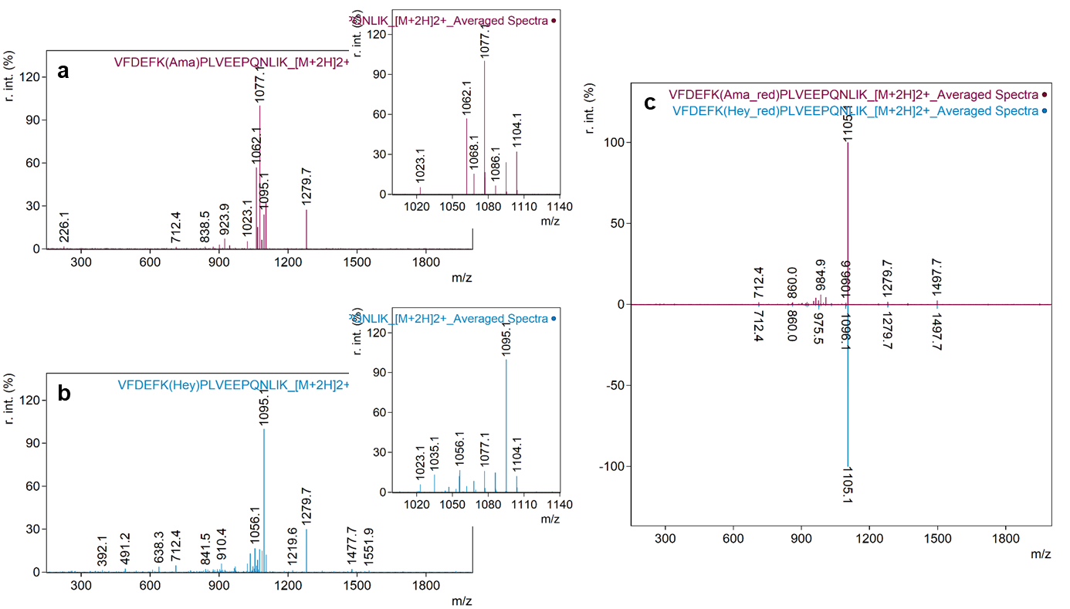

Fig. S7 Tandem mass spectra of doubly protonated precursor ions of the unreduced (a/b, m/z 1104.1) and reduced (c, m/z 1105.1) Amadori (red) or Heyns peptide #5 (blue) using a normalized collision energy (NCE) of 22.
The insets show zoomed mass ranges including the characteristic neutral loss pattern of unreduced glycated peptides.
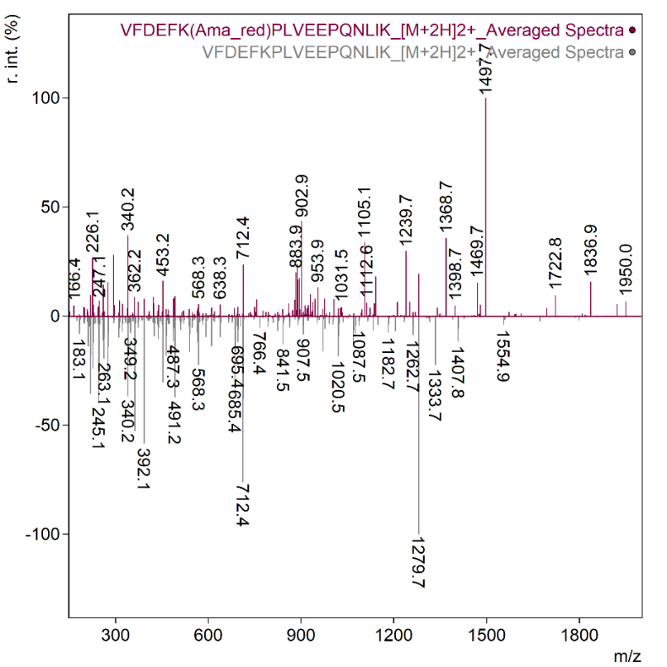

Fig. S8 Tandem mass spectra of doubly protonated precursor ions of the reduced Amadori (red, m/z 1105.1) and the unmodified peptide #5 (gray, m/z 1023.1) at a normalized collision energy (NCE) of 30.

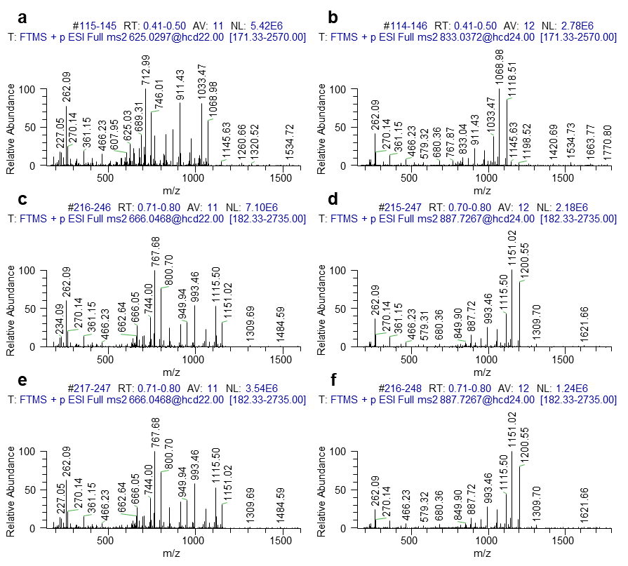

Fig. S9 Tandem mass spectra recorded for quadruply charged precursor ions detected at m/z 625.0297 (a) and m/z 666.0468 (c,e) and triply charged precursor ions detected at m/z 833.0372 (b) and m/z 887.7267 (d,f) of unmodified (a,b), reduced fructated (c,d), and reduced glucated peptide #2 (e,f).

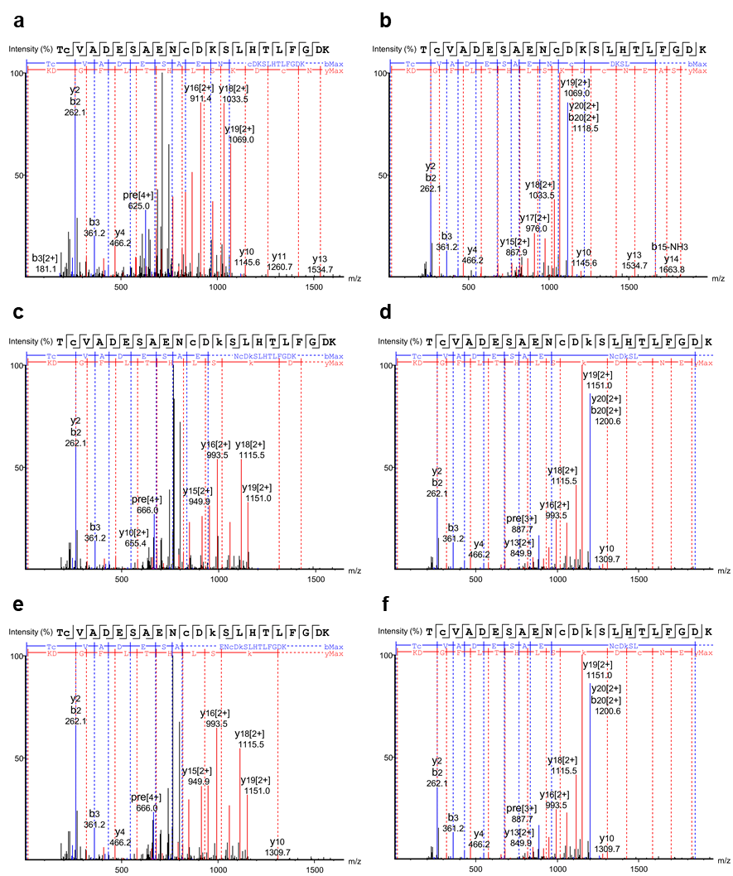

Fig. S10 Annotated tandem mass spectra recorded for quadruply charged precursor ions detected at m/z 625.0297 (a) and m/z 666.0468 (c,e) and triply charged precursor ions detected at m/z 833.0372 (b) and m/z 887.7267 (d,f) of unmodified (a,b), reduced fructated (c,d), and reduced glucated peptide #2 (e,f).

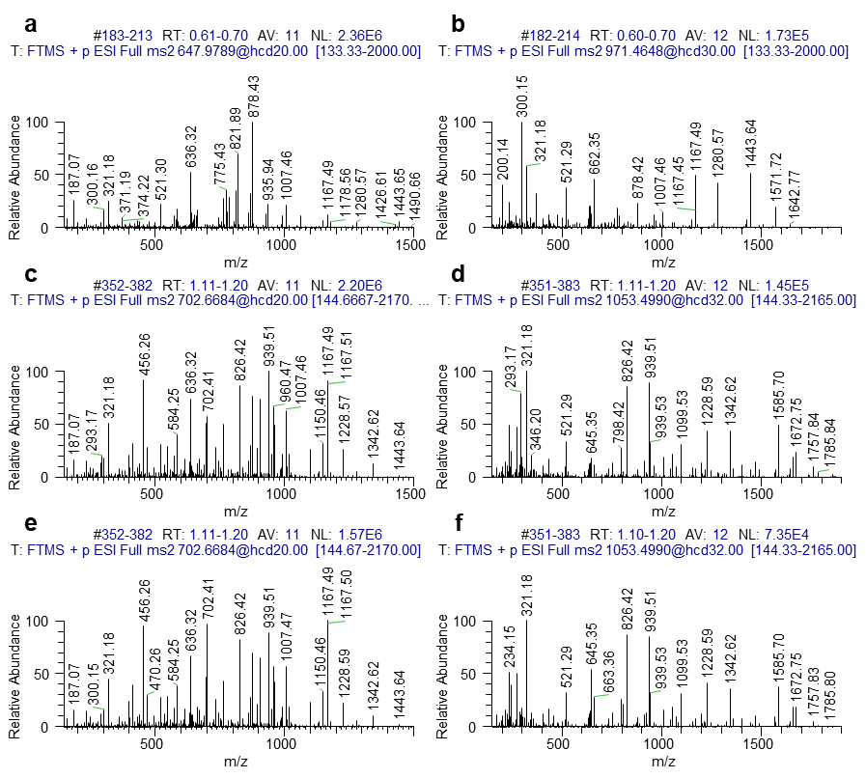

Fig. S11 Tandem mass spectra recorded for triply charged precursor ions detected at m/z 647.9789 (a) and m/z 702.6684 (c,e) and doubly charged precursor ions detected at m/z 971.4648 (b) and m/z 1053.4990 (d,f) of unmodified (a,b), reduced fructated (c,d), and reduced glucated peptide #3 (e,f).

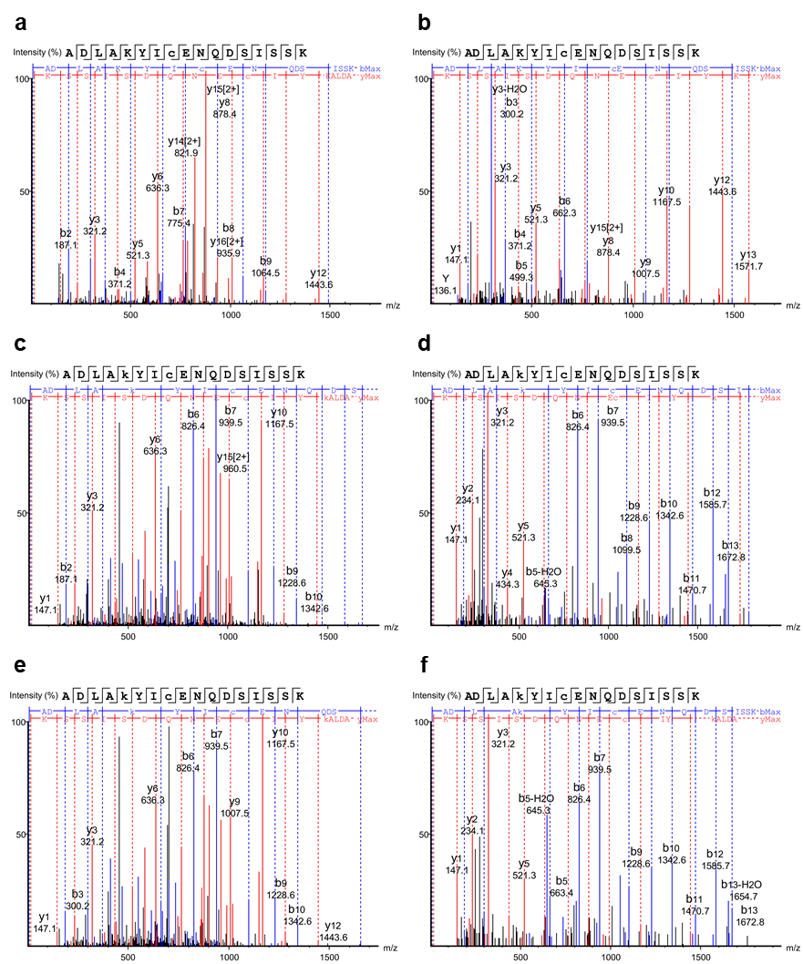

Fig. S12 Annotated tandem mass spectra recorded for triply charged precursor ions detected at m/z 647.9789 (a) and m/z 702.6684 (c,e) and doubly charged precursor ions detected at m/z 971.4648 (b) and m/z 1053.4990 (d,f) of unmodified (a,b), reduced fructated (c,d), and reduced glucated peptide #3 (e,f).

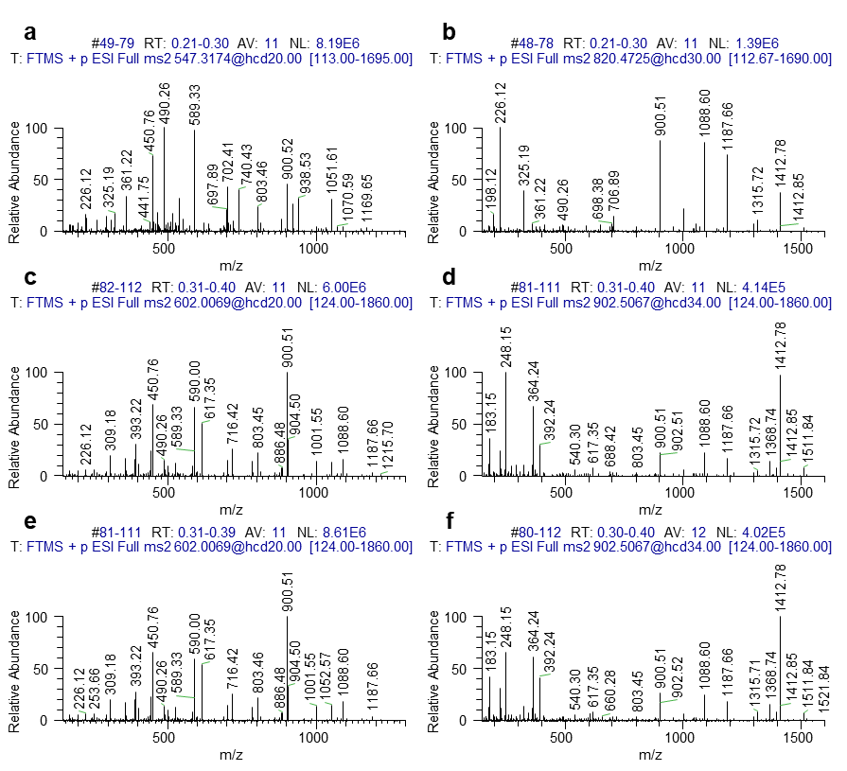

Fig. S13 Tandem mass spectra recorded for triply charged precursor ions detected at m/z 547.3174 (a) and m/z 602.0069 (c,e) and doubly charged precursor ions detected at m/z 820.4725 (b) and m/z 902.5067 (d,f) of unmodified (a,b), reduced fructated (c,d), and reduced glucated peptide #4 (e,f).

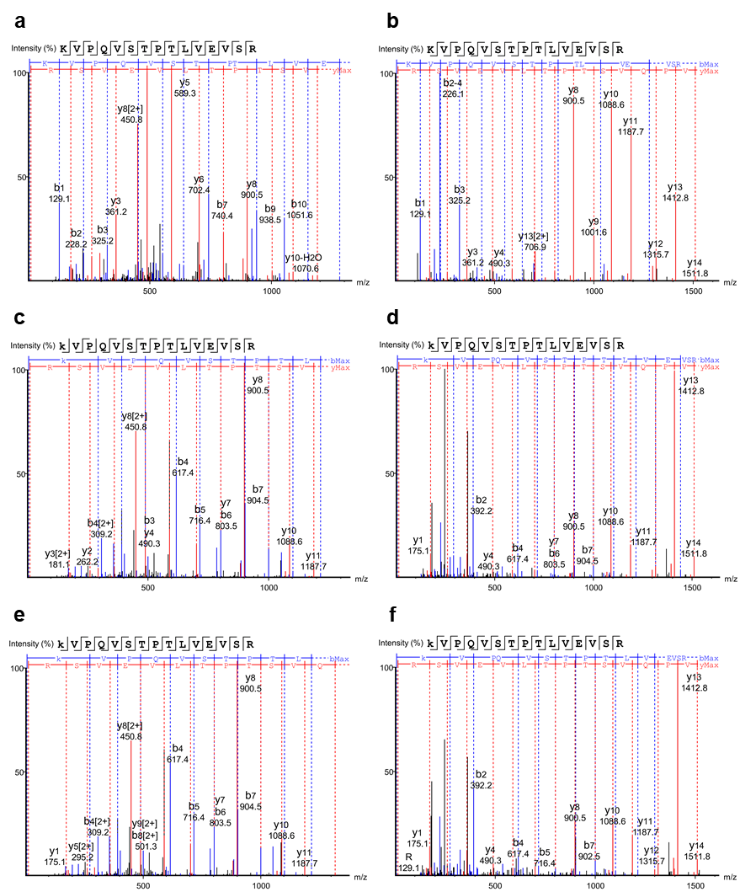

Fig. S14 Annotated tandem mass spectra recorded for triply charged precursor ions detected at m/z 547.3174 (a) and m/z 602.0069 (c,e) and doubly charged precursor ions detected at m/z 820.4725 (b) and m/z 902.5067 (d,f) of unmodified (a,b), reduced fructated (c,d), and reduced glucated peptide #4 (e,f).

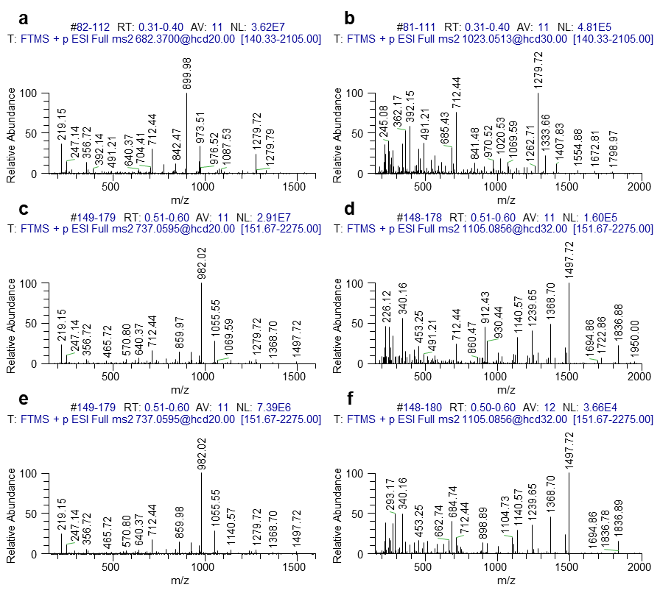

Fig. S15 Tandem mass spectra recorded for triply charged precursor ions detected at m/z 682.3700 (a) and m/z 737.0595 (c,e) and doubly charged precursor ions detected at m/z 1023.0513 (b) and m/z 1105.0856 (d,f) of unmodified (a,b), reduced fructated (c,d), and reduced glucated peptide #5 (e,f).

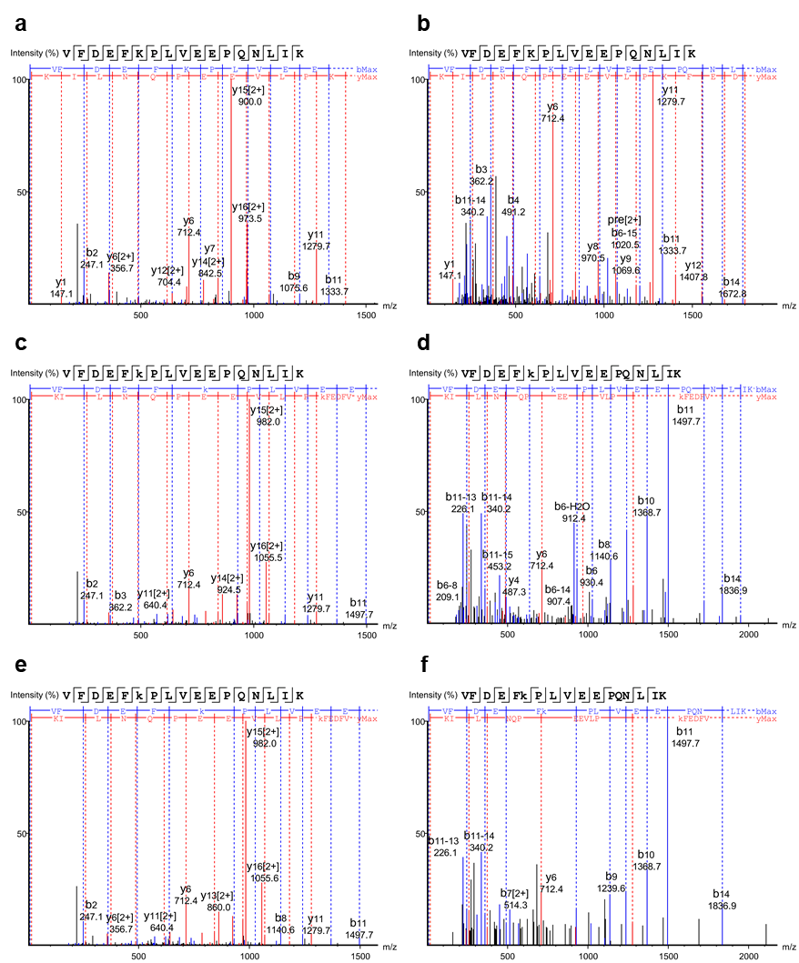

Fig. S16 Annotated tandem mass spectra recorded for triply charged precursor ions detected at m/z 682.3700 (a) and m/z 737.0595 (c,e) and doubly charged precursor ions detected at m/z 1023.0513 (b) and m/z 1105.0856 (d,f) of unmodified (a,b), reduced fructated (c,d), and reduced glucated peptide #5 (e,f).

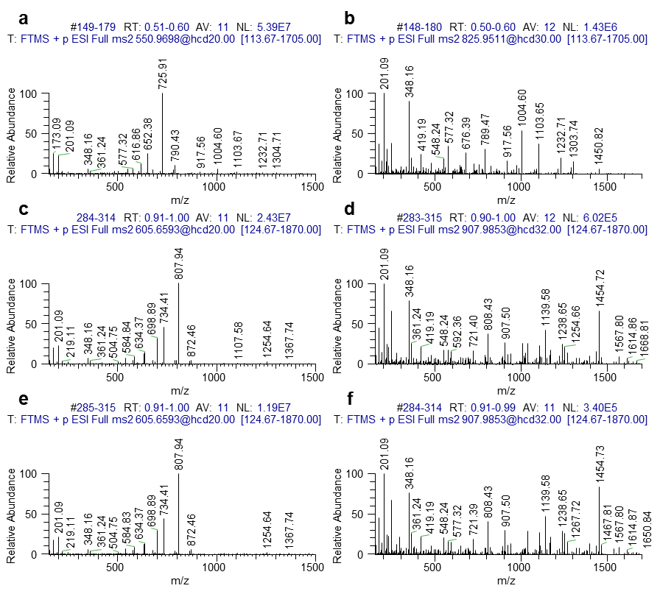

Fig. S17 Tandem mass spectra recorded for triply charged precursor ions detected at m/z 550.9698 (a) and m/z 605.6593 (c,e) and doubly charged precursor ions detected at m/z 825.9511 (b) and m/z 907.9853 (d,f) of unmodified (a,b), reduced fructated (c,d), and reduced glucated peptide #6 (e,f).

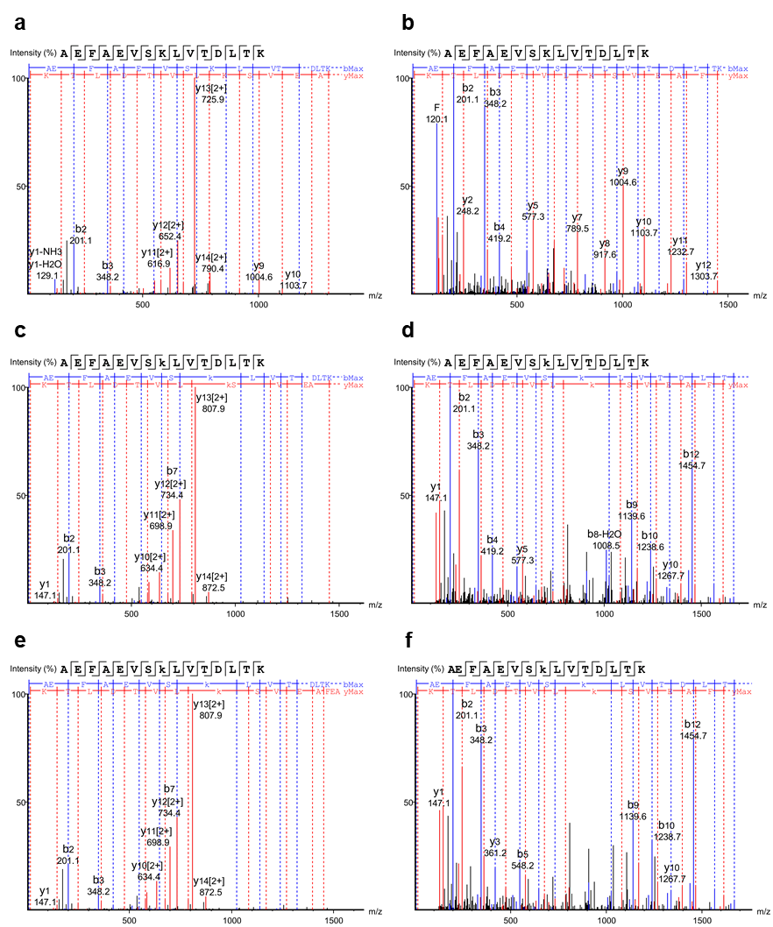

Fig. S18 Annotated tandem mass spectra recorded for triply charged precursor ions detected at m/z 550.9698 (a) and m/z 605.6593 (c,e) and doubly charged precursor ions detected at m/z 825.9511 (b) and m/z 907.9853 (d,f) of unmodified (a,b), reduced fructated (c,d), and reduced glucated peptide #6 (e,f).

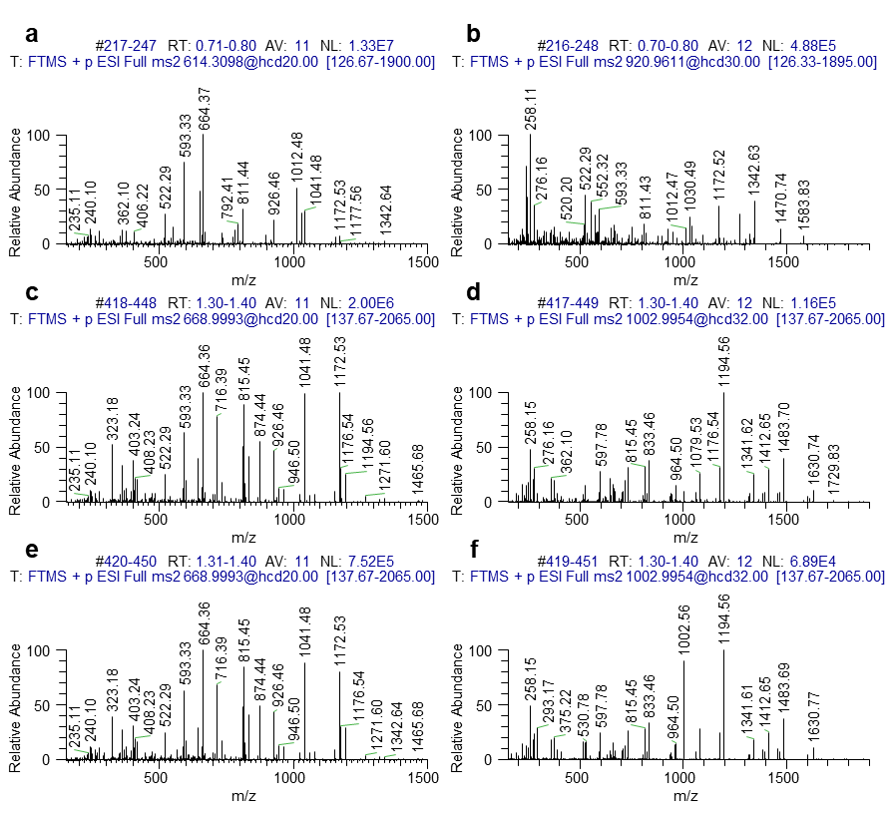

Fig. S19 Tandem mass spectra recorded for triply charged precursor ions detected at m/z 614.3098 (a) and m/z 668.9993 (c,e) and doubly charged precursor ions detected at m/z 920.9611 (b) and m/z 1002.9954 (d,f) of unmodified (a,b), reduced fructated (c,d), and reduced glucated peptide #7 (e,f).

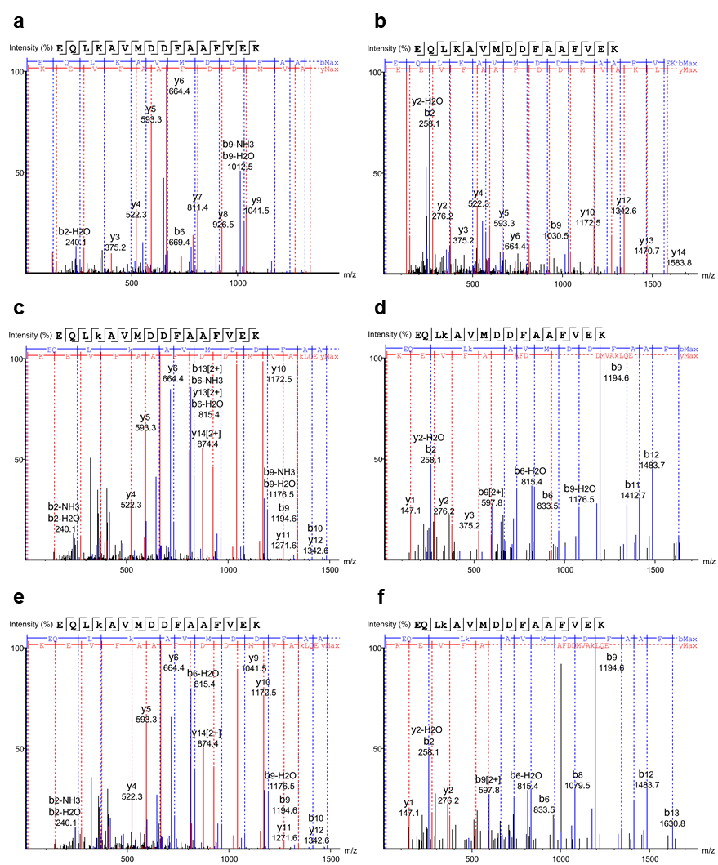

Fig. S20 Annotated tandem mass spectra recorded for triply charged precursor ions detected at m/z 614.3098 (a) and m/z 668.9993 (c,e) and doubly charged precursor ions detected at m/z 920.9611 (b) and m/z 1002.9954 (d,f) of unmodified (a,b), reduced fructated (c,d), and reduced glucated peptide #7 (e,f).

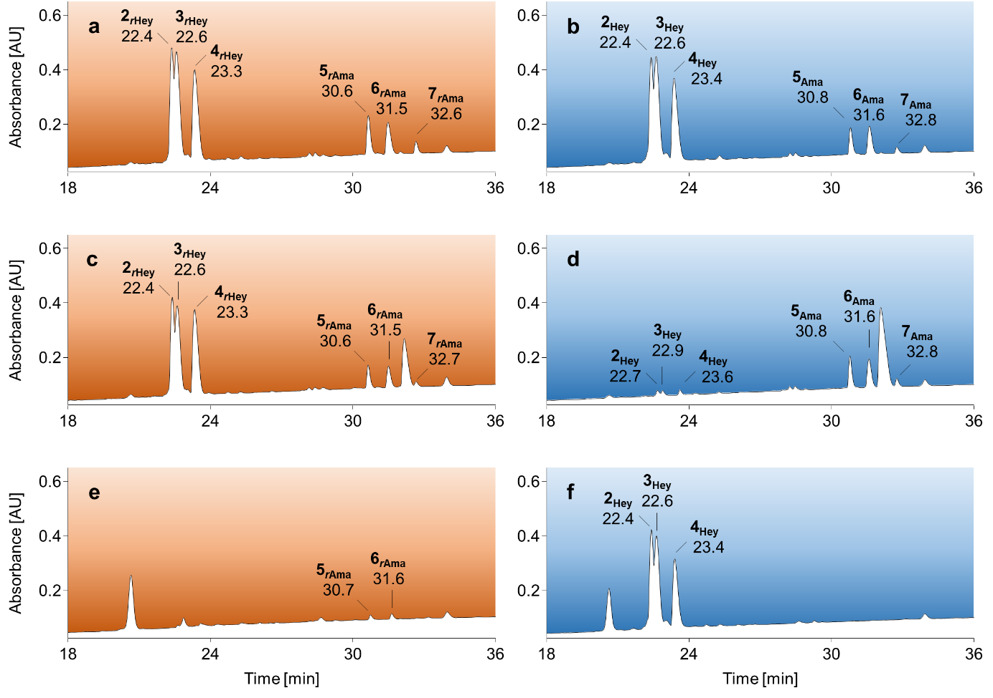

Fig. S21 RP chromatograms from 18 to 36 min of an SPE-purified peptide mixture containing three fructated (Hey) and three glucated peptides (Ama, 1 nmol each) incubated in sodium phosphate buffer (50 mmol/L, pH 8.5) in the presence (orange, rAma/rHey, a) or absence (blue, b) of sodium borohydride and the corresponding elution (c,d) and wash fractions (e,f) obtained by BAC using ammonium acetate loading buffer (250 mmol/L, 50 mmol/L magnesium acetate, pH 8.1).
Peptides were separated on an Aqua C₁₈-column at 60°C using a linear gradient from 97% eluent A to 40% eluent C in 37 min (absorbance recorded at 214 nm). Peptide sequences and modification sites are listed in Tab. S3. Results for the complementary peptide mixture are shown in Fig. S21. Recovery rates and percentage distribution in affinity processed fractions are summarized in Tab. S5 and Tab. S6 (Exp 7).
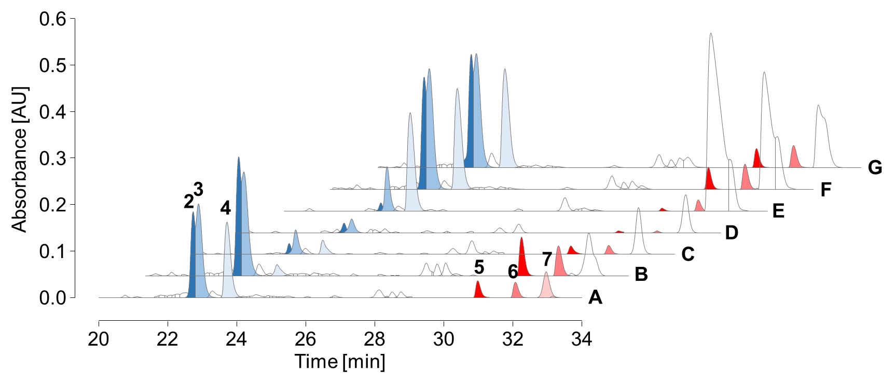

Fig. S22 RP chromatograms from 20 to 34 min of an SPE-purified peptide mixture (A) containing three fructated (Heyns) and three glucated peptides (Amadori, n=3, 1 nmol each) reduced with sodium borohydride and the wash (B-D) and enriched fractions (E-G) collected by BAC.
Equilibration, sample loading, and washing in BAC were performed using either sodium phosphate (pH 8.5, B,E) or ammonium acetate loading buffer (pH 8.1, C,F), the latter also with additional equilibration and sample loading at pH 10 (D/G). Peptides were separated on an Aqua C₁₈-column at 60°C using a linear gradient from 97% eluent A to 40% eluent C in 37 min. The absorbance was recorded at 214 nm. Peptide sequences and modification sites are listed in Tab. S3. Recovery rates and percentage distribution in affinity processed fractions are summarized in Tab. S5 and Tab. S6 (Exp 8/Exp 9/Exp 10).

