Supplementary Material for:
Development and application of a simple formate-buffered extraction method for the analysis of 104 organic pollutants in river suspended particulate matter by HPLC-ESI-MS/MS
Alexis P. Roodt^{1,2}*, Ralf Schulz^{2,1}
¹ Eußerthal Ecosystem Research Station (EERES), RPTU Kaiserslautern-Landau, Birkenthalstrasse 13, D-76857, Eußerthal, Germany
² Institute for Environmental Sciences, RPTU Kaiserslautern-Landau, Fortstrasse 7, 76829 Landau, Germany
*Corresponding author: roodt.a@rptu.de

Table of Contents
Fig. S1. Map of the study area showing sampling sites in relation to nature protected areas and land cover in the Lauter catchment S2
Fig. S2. Average percentage recoveries of 104 targeted analytes measured by HPLC-ESI-MS/MS plotted against their respective log octanol/water partition coefficients (logP) S3
Fig. S3. Comparison of percentage matrix effects (%ME) determined for 104 analytes in extracts prepared from reference SPM-sample material using four extraction methods. S4
Fig. S4. Monthly (April – October 2023) concentrations of the three most frequently quantified pharmaceuticals, namely citalopram, venlafaxine and carbamazepine in SPM samples collected at the eight study sites along the river Lauter S5
References S5

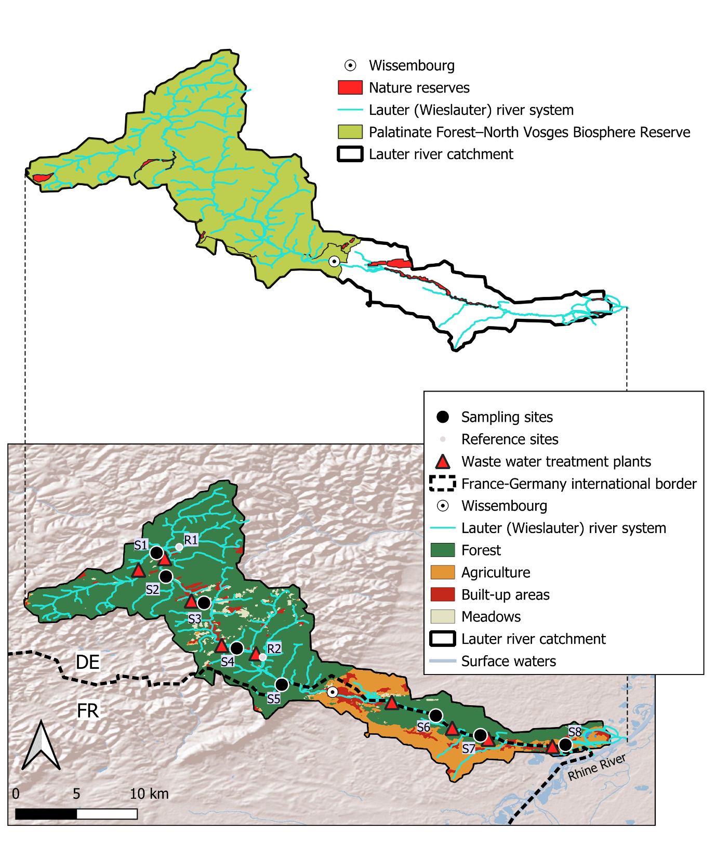
Fig. S1. Map of the study area showing sampling sites in relation to nature protected areas (above) and land cover (below) in the Lauter catchment (FR: France, DE: Germany). Land cover data for the year 2023 was obtained from the Sentinel-2 10m land use/land cover time series of the world [1].

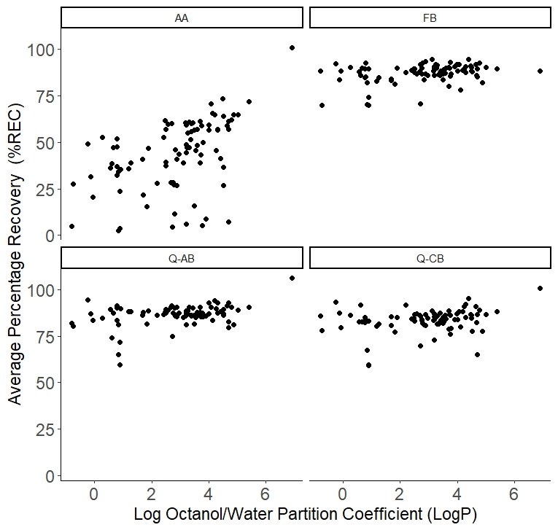
Fig. S2. Average (n = 4) percentage recoveries of 104 targeted analytes measured by HPLC-ESI-MS/MS plotted against their respective log octanol/water partition coefficients (logP). Analytes were extracted from reference SPM material fortified at a concentration of 25 ng/g (dry weight) using acidified acetonitrile extraction (AA), formate buffered (FB) extraction or modified versions of the official citrate (Q-CB) and acetate (Q-AB) buffered QuEChERS methods.

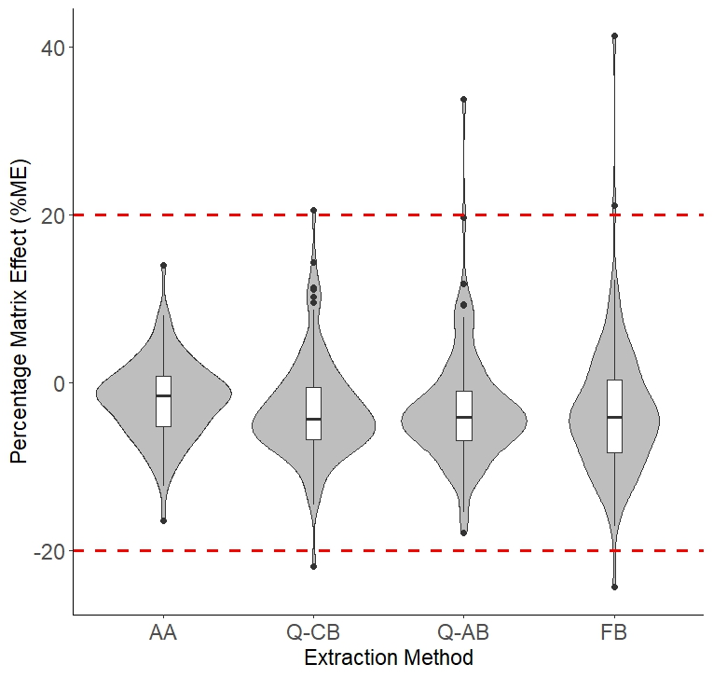
Fig. S3. Comparison of percentage matrix effects (%ME) determined for 104 analytes in extracts prepared from reference SPM-sample material using acidified acetonitrile extraction (AA), formate buffered (FB) extraction or modified versions of the official citrate (Q-CB) and acetate (Q-AB) buffered QuEChERS methods.

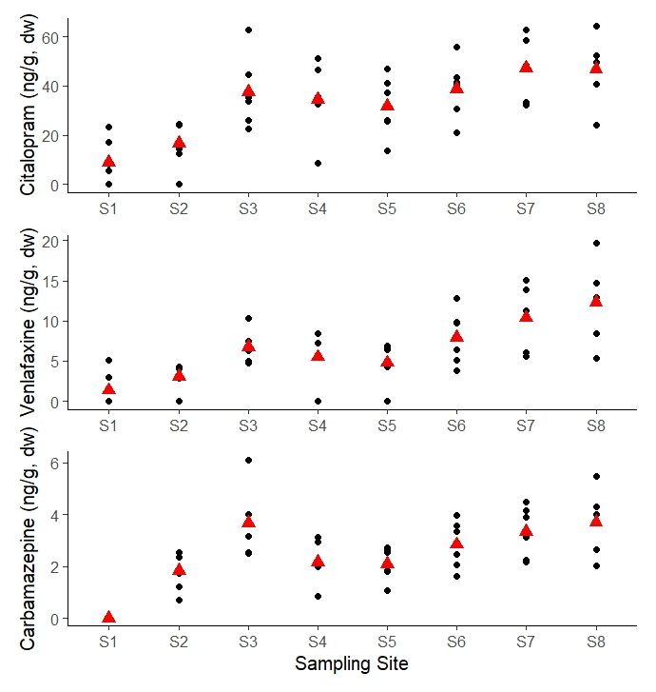
Fig. S4. Monthly (April – October 2023, n=6) concentrations (black points) of the three most frequently quantified pharmaceuticals, namely citalopram, venlafaxine and carbamazepine in SPM samples collected at the eight study sites (S1 – S8) along the river Lauter (Site numbering starts closest to the river source). Red triangles indicate the site-specific average analyte concentration.

References
[1] K. Karra, C. Kontgis, Z. Statman-Weil, J.C. Mazzariello, M. Mathis, S.P. Brumby, Global land use / land cover with Sentinel 2 and deep learning, in: 2021 IEEE Int. Geosci. Remote Sens. Symp. IGARSS, 2021: pp. 4704–4707.

