Supplementary information

Synthesis and characterization of miniaturized aptamer-based monolithic sorbent for selective extraction of β-amyloid peptides from cerebrospinal fluid

Israel Donizeti de Souza^{1,2}, Caroline Fernandes Grecco^{1,2}, Maria Eugênia Costa Queiroz², Valerie Pichon¹, and Audrey Combès^{1*}

¹ Department of Analytical, Bioanalytical Sciences and Miniaturization (LSABM), Chemistry, Biology and Innovation (CBI), UMR 8231 ESPCI Paris - CNRS, ESPCI Paris, PSL University, 10 Rue Vauquelin, 75005, Paris, France
² Departamento de Química da Faculdade de Filosofia, Ciências e Letras de Ribeirão Preto (DQ-FFCLRP), Universidade de São Paulo, Ribeirão Preto, São Paulo, Brazil.

*Corresponding author: Combès Audrey, E-mail: audrey.combes@espci.fr. Telephone number: ++33140797673

S1. Quantification by HPLC-UV of the amount of aptamers grafted on the monolithic capillary

The calculation of the amount of aptamers grafted on the monolithic capillary was performed by quantifying the remaining aptamers in the immobilization and washing solutions. Therefore, 3 solutions were collected during the immobilization steps:
Solution A: 120 µL of the grafting solution + 168 µL 100 mM phosphate buffer solution pH 8.0
Solution B: 720 µL of BB solution containing NaCNBH₃ at 5 mg.mL⁻¹ + 720 µL of BB
Solution C: 420 µL water/methanol 70:30 (v/v) solution
Solutions A, B, and C were dried in N₂ flow and the dry extract was resuspended in MilliQ water. Then, 10 µL was injected into HPLC-UV system. The chromatographic equipment consisted of an Agilent 1200 series (Agilent Technology, Massy, France) LC system equipped with a binary pump, an autosampler, and a diode array detector controlled by Chemstation software. Ion pairing chromatography was achieved using a
Zorbax Eclipse XDB-C18 column (150 × 3 mm, 5 µm). The mobile phase was composed of 50 mM TEA in water (A) and acetonitrile (B). Chromatographic separation was carried out at 0.2 mL.min-¹ as follows: 10% B (0 – 2.5 min), 10 – 35% B (2.5 – 10 min), 35% B (10 – 12 min), 35 – 40% B (12 – 13 min), 40 – 10% B (13 – 35 min). Analytes were monitored at 260 nm.
Calibration curves were plotted from 0.5 to 10 µg.mL⁻¹ individually for OS1 and OS2, Fig S1. These calibration curves were applied to measure the amount of aptamers in solutions A, B, and C. Solution A corresponds to the amount of aptamers that remain in the effluent of the capillary after the grafting step. Solutions B and C percolated through the capillary to stabilize the grafting process and washed out the aptamers that were not covalently bound to the monolith. Then, the amount of grafted aptamers (G) was calculated by the following equation:
$$G=A_{0}-(a+b+c)$$
Where A₀ and a correspond to the amount of aptamers in the Solution A before and after percolation through the capillary (grafting step), respectively. The b and c are the amount of aptamers measured in the solutions B and C, respectively

Figure S1. Calibration curves for quantification of non grafted (a) apt1 and (b) apt 2.

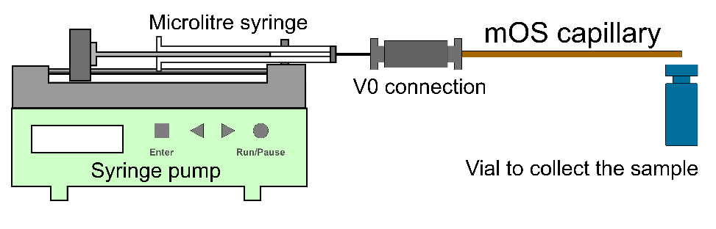
Figure S2. Experimental set-up for the capillary extraction (offline).

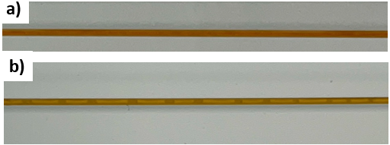
Figure S3. Optical images of CapS1 and CapS2 monolithic capillaries

Figure S4. Chromatograms of blank CSF samples monitored at m/z 1083.3 for Aβ40 (a) and m/z 1129.5 for Aβ42 (b).

