Assessment of the differentiation of Sambucus nigra plant parts using a multi-target and suspect screening by LC-HRMS and ICP-OES

M. Häßlerª, K. Wetzelª, L. Warneckeª, T. Niedenthal^{b}, L. Montero^{a,c}, J. F. Ayala-Cabrera^{a,d,e}, O. J. Schmitz^{a*}

ªApplied Analytical Chemistry, University of Duisburg-Essen, Universitätsstr. 5, 45141 Essen/Germany
^{b}Forschergruppe Klostermedizin GmbH, Annastr. 26a, 97072 Würzburg, Germany
^{c}Foodomics Laboratory, Institute of Food Science Research – CIAL (CSIC-UAM), Calle Nicolás Cabrera 9, 28049 Madrid, Spain
^{d}Department of Analytical Chemistry, University of the Basque Country (UPV/EHU), Sarriena Auzoa, 48940 Leioa, Spain
^{e}Research Centre for Experimental Marine Biology and Biotechnology, University of the Basque Country (PiE-UPV/EHU), Areatza Hiribidea 47, 48620 Plentzia, Spain

*Corresponding author mail: oliver.schmitz@uni-due.de

Supplementary information

ORCID:
M. Häßler: 0009-0003-5757-4208
K. Wetzel: 0009-0006-7572-3061
L. Montero: 0000-0003-1811-0913
J. F. Ayala-Cabrera: 0000-0002-4145-7731
O. J. Schmitz: 0000-0003-2184-1207
Sample materials
Table S1: Detailed origin of the different S. Nigra plant samples
Plant parts | Sample name | Place & Year of harvest | Provider | condition | Origin
Berries | SNB Herbathek | Poland (2021) | Herbathek | Driedª, Whole fruits | Agriculture
Flowers | SNF Herbathek | Bosnia (2021) | Herbathek | Driedª | Agriculture
Bark | SNK Herbathek | Poland (2021) | Herbathek | Driedª, precrushed | Agriculture
Bark | SNK Essen | Essen (07’2023) | Marvin Häßler | Dried^{b} | Urban Area
Root | SNR Essen | Essen (07’2023) | Marvin Häßler | Dried^{b} | Urban Area
Flowers | SNF Haltern | Haltern am See Germany (06’2023) | Lennard Warnecke | Blooming and wilted flowers, dried^{b} | Park
Flowers | SNF Marl | Marl Germany (06’2023) | Lennard Warnecke | Blooming flowers, dried^{b}. | Parking lot (near airfield)
Leaves | SNL Haltern | Haltern am See Germany (06’2023) | Lennard Warnecke | Dried^{b} | Park
Flowers | SNF Galke | Poland (2022) | Alfred Galke GmbH | Driedª | Agriculture
Berries | SNB Galke | Poland (2020) | Alfred Galke GmbH | Driedª. Whole fruits | Agriculture
ªpurchased samples were airdried
^{b}collected samples were dried in a desiccator protected from light at room temperature

All samples were first screened to select suitable wavelengths.
The following wavelengths were selected based on good peak symmetry and intensity:

Table S2: Selected wavelengths for elemental analysis using ICP-OES in S. nigra plant samples.
Element | Wavelength | Concentration Range
 | [nm] | [ppm]
Aluminum (Al) | 396.152 | 0 - 4
Calcium (Ca) | 370.602 | 0 - 100
Iron (Fe) | 238.204 | 0 - 2
Potassium (K) | 766.491 | 0 - 100
Magnesium (Mg) | 277.983 | 0 - 70
Sodium (Na) | 589.592 | 0 - 5
Phosphorus (P) | 213.618 | 0 - 60
Sulfur (S) | 180.669 | 0 - 20
Silicon (Si) | 251.611 | 0 - 10
Yttrium (Y)ª | 371.029 | 0.6
ªInternal standard

Table S3: Method validation for elements by ICP-OES analysis
Element | LOD | LOQ | Sensitivity | linearity
 | (µg·L⁻¹) | (µg·L⁻¹) | (slope) | R²
Al | 12.8 | 42.7 | 31704 | 0.9999
Ca | 79.2 | 264 | 6248 | 0.9999
Fe | 3.91 | 13.0 | 31051 | 0.9999
K | 93.4 | 311 | 1730 | 0.9941
Mg | 64.3 | 214 | 1710 | 0.9995
Na | 64.6 | 215 | 13980 | 0.9997
P | 38.7 | 129 | 933 | 0.9999
S | 129 | 431 | 173 | 0.9999
Si | 66.1 | 220 | 10978 | 0.9999
Pb | 27.5 | 91.7 | 1902 | 0.9998
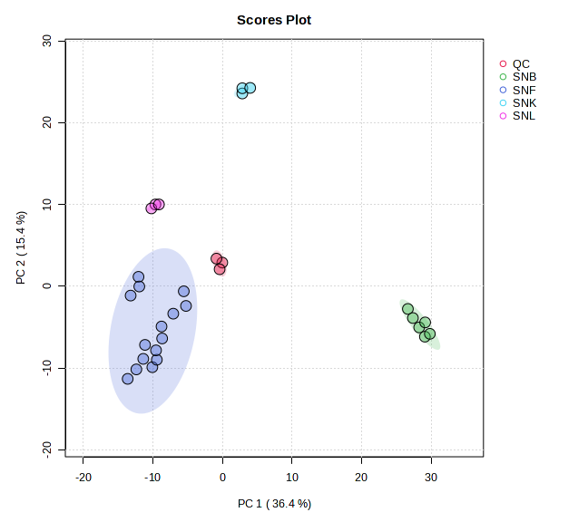
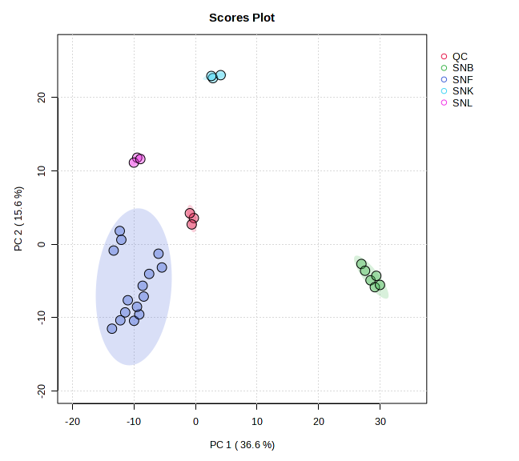
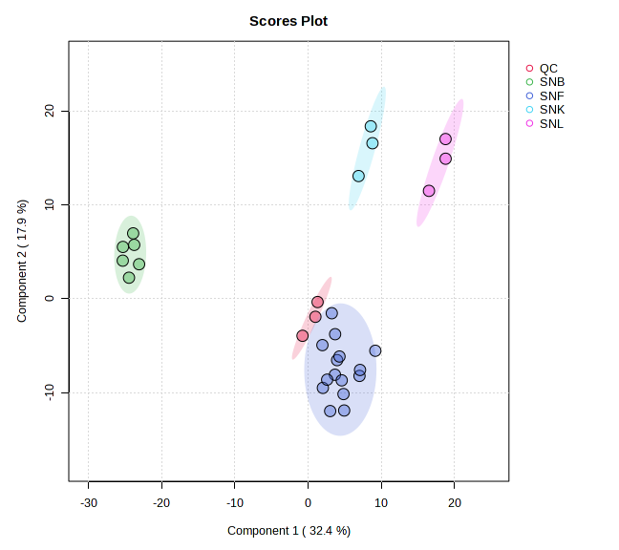
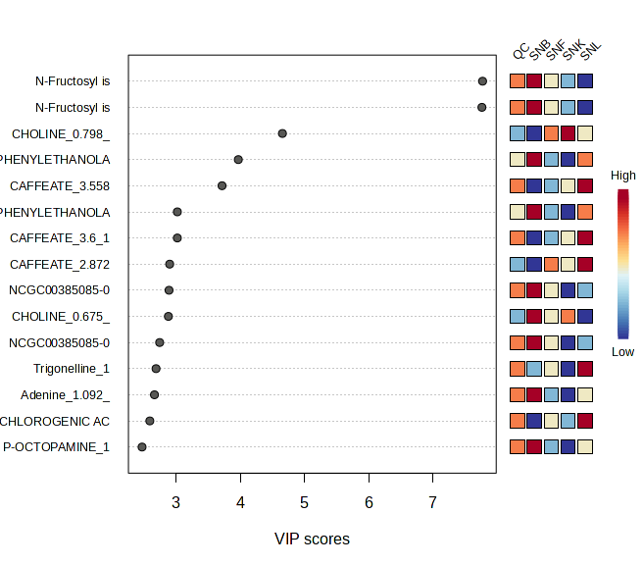
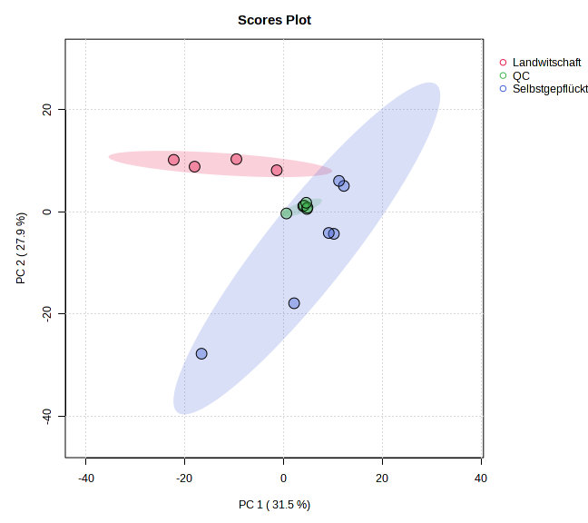
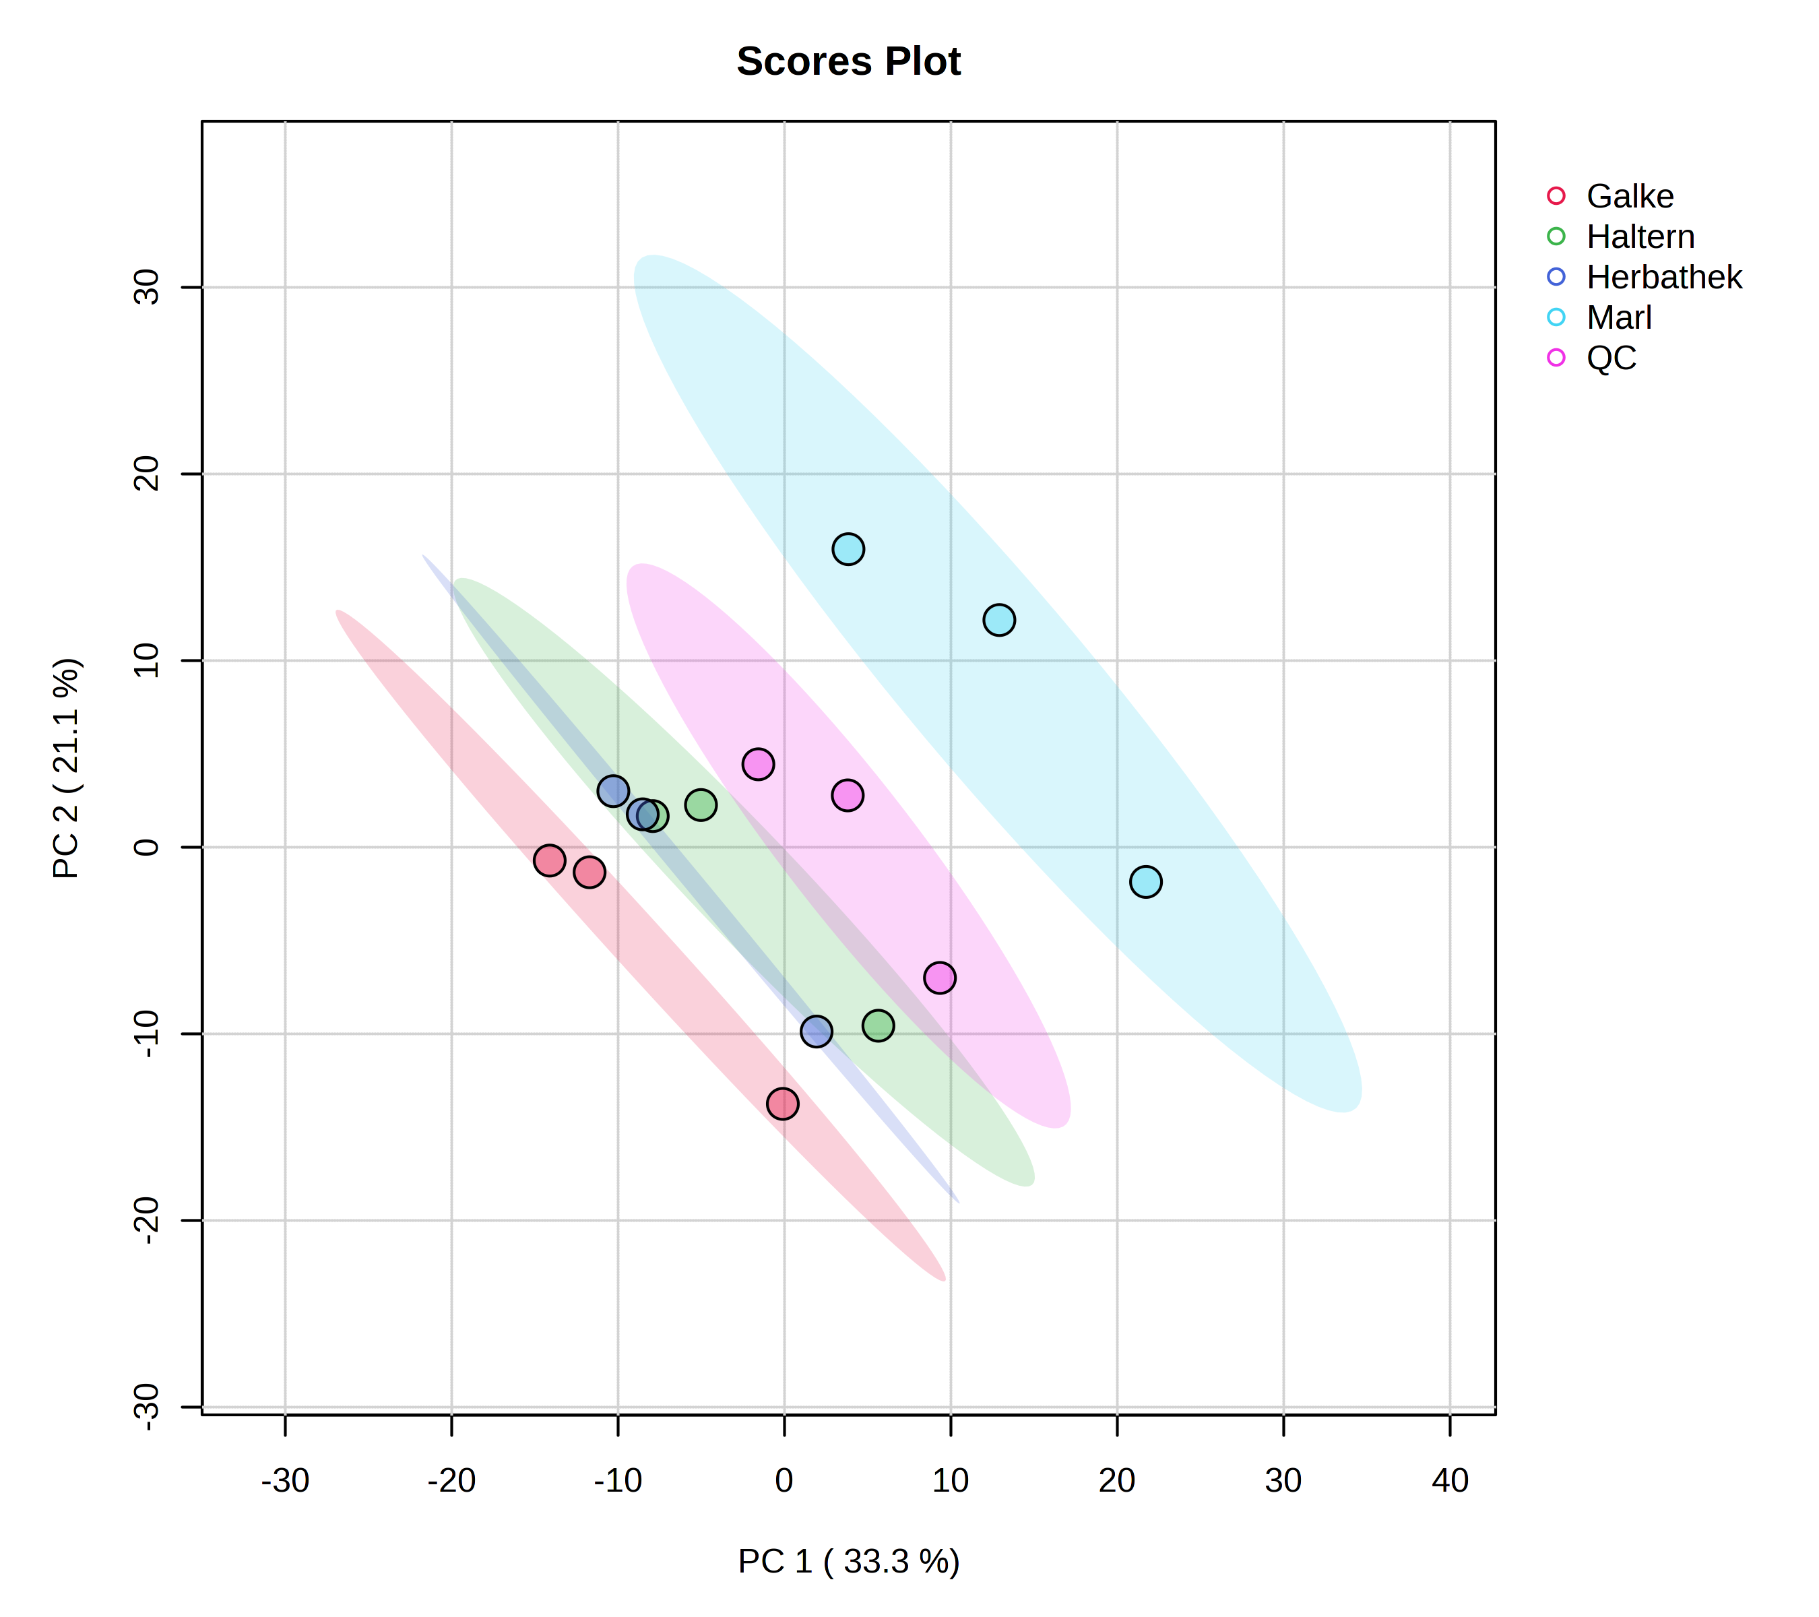
A
B
C
D
E
F
Figure S1: Comparative metabolomic profiling of S. nigra groups before (A) and after filtering (B) using PCA and PLS-DA Analyses (D) for a focus on unknown compound investigation and variable importance scores (E) for highlighting. Profiling the flowers because of the biggest sample size (C) by PCA and Nature harvested (blue) and Agricultural farmed (Red) as PCA Analysis (F) for comparison.

Table S4: Concentration of Elements within the Samples determined with Quintuplicate ICP-OES measurements
 | Flowers | Flowers | Flowers | Flowers | Roots | Bark | Bark | Berries | Berries | Leaves
Conc. in ppm | Germany (Haltern am See) | Bosnia | Germany (Marl) | Poland | Germany (Essen) | Germany (Essen) | Essen | Poland | Poland | Germany (Haltern am See)
Al | 0.17 | 0.07 | 0.13 | 0.078 | 0.10 | 0.23 | 0.075 | 0.018 | 0.039 | 0.23
Ca | 6.0 | 4.5 | 7.3 | 4.6 | 8.3 | 33 | 13 | 2.8 | 2.7 | 8.9
Fe | 0.14 | 0.12 | 0.15 | 0.13 | 0.13 | 0.38 | 0.074 | 0.047 | 0.083 | 0.25
K | 3.6 | 3.2 | 30 | 25.8 | 5.6 | 3.2 | 8.8 | 16 | 19 | 13
Mg | 4.4 | 3.5 | 3.9 | 3.0 | 4.5 | 3.8 | 3.7 | 1.8 | 1.9 | 4.2
Na | 0.06 | <0.001 | <0.001 | <0.001 | 0.004 | 0.097 | <0.001 | <0.001 | <0.001 | 0.071
P | 4.4 | 4.9 | 3.9 | 4.5 | 2.2 | 0.86 | 0.84 | 2.6 | 2.6 | 2.0
S | 0.32 | 3.6 | 3.2 | 2.8 | 1.5 | 1.7 | 1.3 | 1.3 | 1.3 | 1.9
Si | 0.29 | 0.10 | 0.24 | 0.15 | 0.16 | 0.29 | 0.13 | 0.041 | 0.076 | 0.55
Mn | <0.01 | <0.01 | <0.01 | <0.01 | <0.01 | <0.01 | <0.01 | <0.01 | <0.01 | <0.01
Pb | <0.01 | <0.01 | <0.01 | <0.01 | <0.01 | <0.01 | <0.01 | <0.01 | <0.01 | <0.01

Table S5: Detected Features listed. Sorted by level of identification.
Compound Name | RT  (min) | Sum formula | Mass (measured) | Addukt  (Pos) | monoisotopic mass | Substanceclass | Polyphenol | Level
Apigenin | 12.0 | C₁₅H₁₀O₅ | 271.0607 | [M+H]⁺ | 270.0528 | Flavonoid | Yes | 1
Bergapten | 11.8 | C₁₂H₈O₄ | 217.0506 | [M+H]⁺ | 216.0423 | Coumarin | No | 1
Caffeic acid | 3.6 | C₉H₈O₄ | 163.0352 | [M-H₂O+H]⁺ | 180.0423 | Cinnamic acid derivative | Yes | 1
Catechin | 3.3 | C₁₅H₁₄O₆ | 291.0862 | [M+H]⁺ | 290.0790 | Flavonoid | Yes | 1
Chlorogenic acid | 3.6 | C₁₆H₁₈O₉ | 355.1032 | [M+H]⁺ | 354.0951 | Cinnamic acid derivative | Yes | 1
Coumaric acid | 3.9 | C₉H₈O₃ | 147.0443 | [M-H₂O+H]⁺ | 164.0473 | Cinnamic acid derivative | Yes | 1
Coumarin | 5.9 | C₉H₇O₃- | 147.0442 | [M+H]⁺ | 146.0572 | Coumarin | No | 1
Curcumin | 3.4 | C₂₁H₂₀O₆ | 369.1331 | [M+H]⁺ | 368.1260 | Ketone derivative | No^{b} | 1
Ferulic acid | 4.7 | C₁₀H₁₀O₄ | 177.0551 | [M-H₂O+H]⁺ | 194.0579 | Cinnamic acid derivative | Yes | 1
Gallic acid | 1.4 | C₇H₆O₅ | 170.0284 | [M+H]⁺ | 170.0215 | Phenolic acid | Yes | 1
Naringenin | 11.9 | C₁₅H₁₂O₅ | 273.0771 | [M+H]⁺ | 272.0685 | Flavonoid | Yes | 1
Phenylalanine | 1.8 | C₉H₁₁NO₂ | 166.0867 | [M+H]⁺ | 165.0790 | Amine | No | 1
Quercetin | 10.3 | C₁₅H₁₀O₇ | 303.0509 | [M+H]⁺ | 302.0427 | Flavonoid | Yes | 1
Rutin | 5.4 | C₂₇H₃₀O₁₆ | 611.1629 | [M+H]⁺ | 610.1534 | Flavonoid | Yes | 1
Sucrose | 0.7 | C₁₂H₂₂O₁₁ | 365.1060 | [M+Na]⁺ | 342.1162 | Carbohydrate | No | 1
Vanillic acid | 3.6 | C₈H₈O₄ | 169.04991 | [M+H]⁺ | 168.0423 | Phenolic acid | No (Monophenol) | 1
Vanillin | 4.1 | C₈H₈O₃ | 153.0548 | [M+H]⁺ | 152.0473 | Phenol derivative | No (Monophenol) | 1
Myricetin | 7.1 | C₁₅H₁₀O₈ | 319.0437 | [M+H]⁺ | 318.0376 | Flavonoid | Yes | 1
Adenine | 1.1 | C₅H₅N₅ | 136.0759 | [M+H]⁺ | 135.0545 | Nucleobase | No | 2
Arginine | 0.6 | C₆H₁₄N₄O₂ | 175.1197 | [M+H]⁺ | 174.1117 | Amino acid | No | 2
CinnamicAcid | 1.8 | C₉H₈O₂ | 131.0493 | [M-H₂O+H]⁺ | 148.0524 | Cinnamic acid derivative | No | 2
Dopamine | 1.1 | C₈H₁₁NO₂ | 154.0866 | [M+H]⁺ | 153.0790 | Amine | No | 2
Enoxolone | 12.6 | C₃₀H₄₆O₄ | 471.3478 | [M+H]⁺ | 470.3396 | Triterpenoid | No | 2
Flavovilloside | 4.3 | C₃₃H₄₀O₂₀ | 757.2196 | [M+H]⁺ | 756.2113 | Flavonoid | Yes | 2
Glutarylcarnitine | 1.2 | C₁₂H₂₁NO₆ | 276.1449 | [M+H]⁺ | 275.1369 | Carnitine derivative | No | 2
Guanine | 1.3 | C₅H₅N₅O | 152.0569 | [M+H]⁺ | 151.0494 | Nucleobase | No | 2
Isochlorogenic acid A | 5.0 | C₂₅H₂₄O₁₂ | 499.1241 | [M-H₂O+H]⁺ | 516.1268 | Cinnamic acid derivative | Yes | 2
Kaempferol 3-O-sophoroside | 4.6 | C₂₇H₃₀O₁₆ | 611.1614 | [M+H]⁺ | 610.1534 | Flavonoid | Yes | 2
Neochlorogenic acid | 3.2 | C₁₆H₁₈O₉ | 355.1027 | [M+H]⁺ | 354.0951 | Cinnamic acid derivative | Yes | 2
N-Fructosyl isoleucine | 1.1 | C₁₂H₂₃NO₇ | 294.1561 | [M+H]⁺ | 293.1475 | Amino acid derivative | No | 2
P-Octopamine | 1.1 | C₈H₁₁NO₂ | 136.0761 | [M-H₂O+H]⁺ | 153.0790 | Amine | No | 2
Proanthocyanidin B1 | 3.4 | C₃₀H₂₆O₁₂ | 579.1507 | [M+H]⁺ | 578.1424 | Polyphenol | Yes | 2
Quercetin 3-(6''-malonyl-glucoside) | 6.1 | C₂₄H₂₂O₁₅ | 551.1047 | [M+H]⁺ | 550.0959 | Flavonoid | Yes | 2
Quercetin-3-O-hexoside | 5.4 | C₂₁H₂₀O₁₂ | 465.1035 | [M+H]⁺ | 464.0955 | Flavonoid | Yes | 2
Tryptophan | 3.5 | C₁₁H₁₂N₂O₂ | 205.0976 | [M+H]⁺ | 204.0899 | Amino acid | No | 2
Tyrosine | 1.1 | C₉H₁₁NO₃ | 182.0814 | [M+H]⁺ | 181.0739 | Amino acid | No | 2
Umbelliferone | 4.5 | C₉H₆O₃ | 163.0392 | [M+H]⁺ | 162.0317 | Coumarin | No | 2
Quercetin diglucoside | 4.2 | C₂₇H₃₀O₁₇ | 627.1565 | [M+H]⁺ | 0.0000 | Flavonoid | Yes | 2
(-)-epicatechin | 3.4 | C₁₅H₁₄O₆ | 291.0868 | [M+H]⁺ | 290.0790 | Flavonoid | Yes | 3
(22E)-3alpha,12alpha-Dihydroxy-5beta-chol-22-en-24-oic Acid | 14.5 | C₂₄H₃₈O₄ | 803.5467 | [2M+Na] | 390.2770 | Steroid acid | No | 3
(2S)-4-[(1R)-2,6,6-Trimethyl-4-oxo-2-cyclohexen-1-yl]-2-butanyl β-D-glucopyranoside | 5.6 | C₁₉H₃₂O₇ | 373.2227 | [M+H]⁺ | 372.2148 | Glycoside | No | 3
1,4-Dihydroxy-16-heptadecen-2-yl acetate | 12.7 | C₁₉H₃₆O₄ | 351.2512 | [M+Na]⁺ | 328.2614 | Polyhydroxy fatty acid ester | No | 3
10-Hydroxydecanoate | 4.4 | C₁₀H₁₉O₃ | 153.1275 | [M-2H₂O+H]⁺ | 187.1340 | Fatty acid derivative | No | 3
1-palmitoyl-2-hydroxy-sn-glycero-3-phosphoethanolamin | 13.0 | C₂₁H₄₄NO₇P | 454.2943 | [M+H]⁺ | 453.2856 | Phospholipid | No | 3
1-Stearoyl-sn-glycero-3-phosphocholine | 14.3 | C₂₆H₅₄NO₇P | 524.3724 | [M+H]⁺ | 523.3638 | Phospholipid | No | 3
2-(hydroxymethyl)-6-[4-[(2S,3S)-3-(hydroxymethyl)-5-[(E)-3-hydroxyprop-1-enyl]-7-methoxy-2,3-dihydro-1-benzofuran-2-yl]-2-methoxyphenoxy]oxane-3,4,5-triol | 4.4 | C₂₆H₃₂O₁₁ | 503.1920 | [M-H₂O+H]⁺ | 520.1945 | Glycoside | No | 3
2-Oxindole | 2.0 | C₈H₇NO | 134.0601 | [M+H]⁺ | 133.0528 | Indole derivative | No | 3
2-Phenylglycine | 3.6 | C₈H₉NO₂ | 135.0442 | [M-NH₄+2H]⁺ | 151.0633 | Amino acid derivative | No | 3
3-Hydroxy-11-ursen-28,13-olid | 12.5 | C₃₀H₄₆O₃ | 437.3428 | [M-H₂O+H]⁺ | 454.3447 | Triterpenoid | No | 3
3-Hydroxy-13,28-epoxyurs-11-en-28-one | 12.5 | C₃₀H₄₆O₃ | 437.3428 | [M-H₂O+H]⁺ | 454.3447 | Triterpenoid | No | 3
3-p-Coumaroylquinic acid | 3.9 | C₁₆H₁₈O₈ | 339.1082 | [M+H]⁺ | 338.1002 | Cinnamic acid derivative | Yes | 3
4,9-dimethoxyfuro[3,2-g]chromen-7-one | 11.7 | C₁₃H₁₀O₅ | 247.0615 | [M+H]⁺ | 246.0528 | Coumarin derivative | No | 3
4-Guanidino-butanoate | 0.8 | C₅H₁₁N₃O₂ | 146.0925 | [M+H]⁺ | 145.0851 | Amino acid derivative | No | 3
4-O-feruloyl-D-quinic acid | 4.2 | C₁₇H₂₀O₉ | 369.1184 | [M+H]⁺ | 368.1107 | Cinnamic acid derivative | Yes | 3
5-Aminopentanoate | 13.4 | C₅H₁₁NO₂ | 100.0758 | [M-H₂O+H]⁺ | 117.0790 | Amino acid derivative | No | 3
Adenosine | 1.1 | C₁₀H₁₃N₅O₄ | 268.1044 | [M+H]⁺ | 267.0968 | Nucleoside | No | 3
Alpha-Tocopherol (Vitamin E) | 15.7 | C₂₉H₅₀O₂ | 429.3744 | [M-H₂O+H]⁺ | 430.3811 | Vitamin | No | 3
Antimycin A2 | 16.3 | C₂₇H₃₈N₂O₉ | 535.2728 | [M+H]⁺ | 534.2577 | Antibiotic | No | 3
Archangelicine | 12.7 | C₂₄H₂₆O₇ | 444.2026 | [M+NH₄]⁺ | 426.1679 | Coumarin derivative | No | 3
Benzoic acid | 1.1 | C₇H₆O₂ | 123.0443 | [M+H]⁺ | 122.0368 | Phenolic acid | No | 3
Choline | 0.8 | C₅H₁₄CINO | 104.1075 | [M+H]⁺ | 104.1075 | Quaternary ammonium compound | No | 3
Citrate | 0.9 | C₆H₅O₇ | 190.0042 | [M+H]⁺ | 189.0035 | Carboxylic acid derivative | No | 3
Cynarine | 7.1 | C₂₅H₂₄O₁₂ | 517.1345 | [M+H]⁺ | 516.1268 | Cinnamic acid derivative | Yes | 3
Geranic acid | 5.1 | C₁₀H₁₆O₂ | 169.1227 | [M+H]⁺ | 168.1150 | Terpenoid | No | 3
Guanosine | 1.3 | C₁₀H₁₃N₅O₅ | 284.0994 | [M+H]⁺ | 283.0917 | Nucleoside | No | 3
imperatorin | 12.1 | C₁₆H₁₄O₄ | 271.0974 | [M+H]⁺ | 270.0892 | Coumarin derivative | No | 3
Isorhamnetin | 4.8 | C₁₆H₁₂O₇ | 317.0661 | [M+H]⁺ | 316.0583 | Flavonoid | Yes | 3
isorhamnetin-3-O-glucoside | 4.8 | C₂₂H₂₂O₁₂ | 479.1188 | [M+H]⁺ | 478.1111 | Flavonoid | Yes | 3
Kaempferol | 4.6 | C₁₅H₁₀O₆ | 287.0555 | [M+H]⁺ | 286.0477 | Flavonoid | Yes | 3
Kaempferol-3-O-rutinoside | 6.5 | C₂₇H₃₀O₁₅ | 595.1677 | [M+H]⁺ | 594.1585 | Flavonoid | Yes | 3
kaempferol-7-O-hexoside | 3.9 | C₂₁H₂₀O₁₁ | 449.1089 | [M+H]⁺ | 448.1006 | Flavonoid | Yes | 3
Loliolide | 4.7 | C₁₁H₁₆O₃ | 197.1176 | [M+H]⁺ | 196.1099 | Monoterpene lactone | No | 3
L-Valine | 0.9 | C₅H₁₁NO₂ | 118.0862 | [M+H]⁺ | 117.0790 | Amino acid | No | 3
Morin | 6.1 | C₁₅H₁₀O₇ | 303.0503 | [M+H]⁺ | 302.0427 | Flavonoid | Yes | 3
Narcissin | 6.9 | C₂₈H₃₂O₁₆ | 625.1782 | [M+H]⁺ | 624.1690 | Flavonoid | Yes | 3
Oroselol | 12.8 | C₁₄H₁₂O₄ | 227.0714 | [M-H₂O+H]⁺ | 244.0736 | Sesquiterpene lactone | No | 3
Osthol | 12.2 | C₁₅H₁₆O₃ | 245.1184 | [M+H]⁺ | 244.1099 | Coumarin derivative | No | 3
palmitic Acid | 12.9 | C₁₆H₃₂O₂ | 255.2520 | [M+H]⁺ | 256.2402 | Fatty acid | No | 3
P-Anisaldehyde | 6.0 | C₈H₈O₂ | 137.0601 | [M+H]⁺ | 136.0524 | Aromatic aldehyde | No | 3
p-Coumaraldehyde | 1.8 | C₉H₈O₂ | 149.0598 | [M+H]⁺ | 148.0524 | Phenolic aldehyde | No | 3
Pheophytin A | 18.3 | C₅₅H₇₄N₄O₅ | 871.5771 | [2M+H]⁺ | 870.5659 | Chlorophyll derivative | No | 3
Proline | 0.8 | C₅H₉NO₂ | 116.0707 | [M+H]⁺ | 115.0633 | Amino acid | No | 3
Pyridoxal | 12.4 | C₈H₉NO₃ | 150.0555 | [M-H₂O+H]⁺ | 167.0582 | Vitamin | No | 3
Pyrogallol | 1.9 | C₆H₆O₃ | 127.0390 | [M+H]⁺ | 126.0317 | Phenol | Yes | 3
Rhamnetin 3-sophoroside | 4.8 | C₂₈H₃₂O₁₇ | 641.1721 | [M+H]⁺ | 640.1639 | Flavonoid | Yes | 3
Rosmarinic acid | 7.2 | C₁₈H₁₆O₈ | 163.0393 | [M+H-C₉H₁₀O₅]⁺ | 360.0845 | Phenolic acid | Yes | 3
Thymine | 2.0 | C₅H₆N₂O₂ | 127.0502 | [M+H]⁺ | 126.0429 | Nucleobase | No | 3
Trigonelline | 1.0 | C₇H₇NO₂ | 138.0631 | [M+H]⁺ | 137.0477 | Alkaloid | No | 3

Table S6: Concentration of level 1 identified compounds within the samples calculated by triplicate external calibration.
Name | LOD | LOQ | Flower Marl | Flower Haltern | Flower Herbathek | Flower Galke | Leaves Haltern | Bark Essen | Berries Galke | Berries Herbathek | Roots Essen
 | (µM] | (µM) | (µM) | (µM) | (µM) | (µM) | (µM) | (µM) | (µM) | (µM) | (µM)
Apigenin | 0.065 | 0.218 | 0.12 | 0.32 | 0.3 | 0.27 | <LOD | <LOD | <LOD | <LOD | <LOD
Apigenin | 0.065 | 0.218 | ±0.017 | ±0.054 | ±0.071 | ±0.059
Bergapten | 0.002 | 0.007 | 0.01 | 0.04 | <LOD | <LOD | 0.02 | 0.02 | <LOD | <LOD | <LOD
Bergapten | 0.002 | 0.007 | ±0.002 | ±0.003 |  |  | ±0.002 | ±0.003
Caffeic acid | 0.095 | 0.315 | 34.03 | 20.8 | 28.05 | 31 | 31.8 | 8.56 | 2.68 | 1.24 | <LOD
Caffeic acid | 0.095 | 0.315 | ±2.64 | ±3.59 | ±1.29 | ±1.02 | ±1.15 | ±0.182 | ±0.091 | ±0.09
Catechin hydrate | 0.04 | 0.134 | 0.83 | 0.55 | 0.36 | 0.24 | <LOD | 0.41 | <LOD | <LOD | <LOD
Catechin hydrate | 0.04 | 0.134 | ±0.134 | ±0.141 | ±0.089 | ±0.085 |  | ±0.011
Chlorogenic acid | 1.178 | 3.927 | 231 | 136 | 193 | 200 | 207 | 56.4 | 19.6 | 9.65 | <LOD
Chlorogenic acid | 1.178 | 3.927 | ±25.2 | ±11.9 | ±9.74 | ±6.95 | ±19.7 | ±5.88 | ±1.12 | ±0.398
Coumaric acid | 0.261 | 0.869 | 116 | 70.1 | 71.43 | 57.8 | 27.8 | 1.08 | 2.04 | <LOD | <LOD
Coumaric acid | 0.261 | 0.869 | ±4.03 | ±6.16 | ±6.81 | ±6.82 | ±2.43 | ±1.04 | ±0.267
Coumarin | 0.036 | 0.121 | 0.08 | 0.09 | 0.27 | 0.14 | 0.06 | 0.14 | <LOD | <LOD | <LOD
Coumarin | 0.036 | 0.121 | ±0.022 | ±0.046 | ±0.06 | ±0.053 | ±0.005 | ±0.021
Curcumin | 0.01 | 0.035 | <LOD | <LOD | <LOD | <LOD | 0.09 | 0.03 | <LOD | <LOD | <LOD
Curcumin | 0.01 | 0.035 |  |  |  |  | ±0.02 | ±0.012
Ferulic acid | 0.137 | 0.457 | 0.51 | <LOD | 0.69 | 0.98 | 1.56 | 2.52 | <LOD | <LOD | <LOD
Ferulic acid | 0.137 | 0.457 | ±0.253 |  | ±0.195 | ±0.423 | ±2.22 | ±0.404
Gallic acid | 0.557 | 1.855 | <LOD | <LOD | <LOD | <LOD | <LOD | <LOD | 0.66 | 0.87 | <LOD
Gallic acid | 0.557 | 1.855 |  |  |  |  |  |  | ±0.08 | ±0.047
Naringenin | 0.004 | 0.014 | 3.52 | 3.36 | 9.45 | 7.43 | 0.35 | <LOD | <LOD | <LOD | <LOD
Naringenin | 0.004 | 0.014 | ±0.599 | ±0.38 | ±0.208 | ±0.449 | ±0.038
Phenylalanine | 0.084 | 0.279 | 27.1 | 51.2 | 43.36 | 38.6 | 37.8 | 17.93 | 31.8 | 44.9 | <LOD
Phenylalanine | 0.084 | 0.279 | ±11.9 | ±21.1 | ±16.0 | ±15.8 | ±3.58 | ±4.55 | ±1.60 | ±3.21
Rutin | 0.038 | 0.125 | 173 | 180 | 191 | 186 | 189 | 0.97 | 64.1 | 53.6 | <LOD
Rutin | 0.038 | 0.125 | ±16.3 | ±17.6 | ±19.6 | ±21.7 | ±17.1 | ±0.899 | ±6.08 | ±3.75
Tryptophan | 0.034 | 0.112 | 16.31 | 31.24 | 24.18 | 26.92 | 31.4 | 26.86 | 5.46 | 6.02 | 0.06
Tryptophan | 0.034 | 0.112 | ±3.099 | ±3.018 | ±1.575 | ±1.443 | ±1.72 | ±2.96 | ±0.362 | ±0.307 | ±0.114
Vanillic acid | 0.002 | 0.006 | 0.003 | 0.066 | 0.005 | 0.065 | 0.063 | <LOD | <LOD | <LOD | <LOD
Vanillic acid | 0.002 | 0.006 | ±0.001 | ±0.001 | ±0.001 | ±0.002 | ±0.001
Vanillin | 0.019 | 0.063 | 0.03 | 0.05 | 0.03 | 0.07 | 0.05 | 0.37 | 0.08 | 0.07 | 0.04
Vanillin | 0.019 | 0.063 | ±0.004 | ±0.003 | ±0.003 | ±0.005 | ±0.007 | ±0.054 | ±0.008 | ±0.002 | ±0.039

