Analytical and Bioanalytical Chemistry

Electronic Supplementary Material

Separation of PS Diastereomers in GalNAc-Conjugated siRNA - A Comparative Study of Chromatographic and Ion Mobility Mass Spectrometry Approaches
Mona-Katharina Bill, Micaela Graglia, Jo-Anne Riley, Mateusz Zugaj, Nadeschda Demtschenko, Jonathan Fox, Lucas Bethge, Jeske J. Smink, Christian Manz*

*E-Mail: christian.manz@astrazeneca.com
Updated address: Medicinal Chemistry, Research and Early Development, Respiratory and Immunology, BioPharmaceuticals R&D, AstraZeneca, SE-431 83, Mölndal, Sweden
Table S1 Summary of liquid chromatography equipment and conditions
Analytical Technique | HILIC | IP-RP | AEX¹
Instrument | Agilent 1290 Infinity II® UHPLC-UV/MS (OpenLab® ChemStation® software) | Agilent 1290 Infinity II® UHPLC-UV/MS (OpenLab® ChemStation® software) | Agilent 1290 Infinity II® Bio UHPLC-UV (OpenLab® ChemStation® software)
Column | ACQUITY™ Premier BEH™ Amide, 1.7 μm, 2.1 x 50 mm, 130 Å | ACQUITY™ Premier Oligonucleotide BEH™ C18, 1.7 µm, 2.1 x 100 mm, 130 Å | DNAPac™ PA200 RS, 4 µm, 4.6 x 150 mm
Column Temperature | 20 °C | 25 °C | 30 °C (50 °C)
Mobile Phase A | A: 25 mM ammonium formate in water/ACN (30:70, v/v) | A: 20 mM TEAA in water | A1 (pH 7.0 or pH 9.0): 20 mM Tris in water  A2 (pH 11.0): 20 mM Na₃PO₄ in water
Mobile Phase B | B: 25 mM ammonium formate in water/ACN (60:40, v/v) | B: 20 mM TEAA in water/ACN (2:98, v/v) | B: 1.25 M NaCl in A
Elution Gradient | 15–50% B in 30 min | 12–16% B in 20 min | Individual gradients with an increase of % B ranging from 2% to 11% over 12 min or 22 min
Flow | 0.5 mL/min | 0.3 mL/min | 0.8 mL/min
Sample Preparation² | ACN/water (80:20, v/v), 10 OD/ml | 100% water, 10 OD/mL | 100% water, 10 OD/mL
Injection volume | 2 µl | 1 µL | 1–5 µL
UV Detection | 260 nm | 260 nm | 260 nm
Single quadrupole MS settings | ESI, negative mode, 4000 V capillary voltage, 40 psig nebulizer pressure, 11.0 L/min drying gas flow at 300 °C temperature | ESI, negative mode, 3000 V capillary voltage, 40 psig nebulizer pressure, 11.0 L/min drying gas flow at 300 °C temperature | n/a
¹Individual AEX conditions/gradients are summarized in Table S2; ²sample concentration was adjusted and determined based on UV absorption at 260 nm using a NanoDrop™ Photometer (VWR, Darmstadt, Germany); n/a: not applicable

Table S2 Summary of AEX conditions
Figure | pH of mobile phase | Gradient | Injection volume | Column temperature
1 b | pH 9.0 | 48–53% B in 12 min | 1 µL | 30 °C
2 | AS: pH 9.0  S: pH 7.0 | 49–53% B in 22 min  42–46% B in 22 min | 5 µL | 30 °C
5 | PS-1+2: pH 11.0  PS-3+4: pH 7.0 | 65–75% B in 22 min  46–48% B in 22 min | 3 µL | 30 °C
S1 | pH 9.0 | 42–52% B in 12 min | 1 µL | 30 °C
S2 | AS: pH 9.0  S: pH 7.0 | 50–61% B in 22 min  55–59% B in 22 min | 2 µL  5 µL | 30 °C  50 °C

Table S3 Cyclic™ IMS settings used for separation of the ions specified
Sample and ion | Figure | Travelling wave (TW) height (V) | Pushes per bin | Separation time (ms)
siRNA#1 AS, Intact | 3 a | 15 | 2 | 2.0
siRNA#1 AS, b₅²⁻ | 3 b | 20 | 2 | 120.0
siRNA#1 AS, w₅³⁻ | 3 b | 15 | 3 | 78.0
siRNA#2, AS intact | S5 | 15 | 2 | 2.0
siRNA#2 AS, w₅³⁻ | S5 | 20 | 2 | 60.0
siRNA#2 AS, a-B₄²⁻ | S5 | 20 | 2 | 30.0
siRNA#1 AS, c₁³⁻ | 4 | 20 | 2 | 45.0
siRNA#1 AS, w₃²⁻ | 4 | 15 | 5 | 52.0
siRNA#1 AS, b₅²⁻ | 5 | 20 | 3 | 116.0
siRNA#1 AS, w₅³⁻ | 5 | 15 | 5 | 81.0
siRNA#2 S w₃²⁻ | S5 | 15 | 5 | 100
siRNA#2 S w₃²⁻ | S5 | 15 | 5 | 100

Table S4 Cyclic™ IMS settings used for the slicing experiment for the ions specified
Sample/data | Figure | Travelling wave (TW) height (V) | Pushes per bin | Slicing experiment timing details
siRNA#1 (w₃²⁻ à)y₂⁻ and siRNA#1 (w₃²⁻ à)b₂⁻ | S7 | 20 | 5 | Separate 2.0 ms, Eject 3.2 ms, Eject to Pre Store 3.8 ms, Hold and Eject 20.0, Reinject from Pre Store 10.0 ms (Activation Enabled at 65V), Separate 70 ms

Table S5 Overview of all antisense (AS) and sense (S) strand model sequences used for this study
Sample name | Sequence (5’ > 3’)
siRNA#1 4xPS (AS) | mU (ps) fU (ps) mA fU mA fG mA fG mC fA mA fG mA fA mC fA mC (ps) fU (ps) mG
siRNA#1 PS-1 (AS) | mU (ps) fU mA fU mA fG mA fG mC fA mA fG mA fA mC fA mC fU mG
siRNA#1 PS-2 (AS) | mU fU (ps) mA fU mA fG mA fG mC fA mA fG mA fA mC fA mC fU mG
siRNA#1 PS-3 (AS) | mU fU mA fU mA fG mA fG mC fA mA fG mA fA mC fA mC (ps) fU mG
siRNA#1 PS-4 (AS) | mU fU mA fU mA fG mA fG mC fA mA fG mA fA mC fA mC fU (ps) mG
siRNA#1 PS-1+2 (AS) | mU (ps) fU (ps) mA fU mA fG mA fG mC fA mA fG mA fA mC fA mC fU mG
siRNA#1 PS-3+4 (AS) | mU fU mA fU mA fG mA fG mC fA mA fG mA fA mC fA mC (ps) fU (ps) mG
siRNA#1 6xPS (S) | [GN (ps)]₃ C4XLT (ps) mC mA mG mU mG mU fU fC fU mU mG mC mU mC mU mA mU (ps) mA (ps) mA
siRNA#2 4xPS (AS) | fU (ps) mC (ps) fU mA fA mG fU mC fG mA fA mU fC mC fA mU fC (ps) mC (ps) fU
siRNA#2 PS-1 (AS) | fU (ps) mC fU mA fA mG fU mC fG mA fA mU fC mC fA mU fC mC fU
siRNA#2 PS-2 (AS) | fU mC (ps) fU mA fA mG fU mC fG mA fA mU fC mC fA mU fC mC fU
siRNA#2 PS-3 (AS) | fU mC fU mA fA mG fU mC fG mA fA mU fC mC fA mU fC (ps) mC fU
siRNA#2 PS-4 (AS) | fU mC fU mA fA mG fU mC fG mA fA mU fC mC fA mU fC mC (ps) fU
siRNA#2 PS-1+2 (AS) | fU (ps) mC (ps) fU mA fA mG fU mC fG mA fA mU fC mC fA mU fC mC fU
siRNA#2 PS-3+4 (AS) | fU mC fU mA fA mG fU mC fG mA fA mU fC mC fA mU fC (ps) mC (ps) fU
siRNA#2 6xPS (S) | [GN (ps)]₃ C4XLT (ps) mA mG mG mA mU mG fG fA fU mU mC mG mA mC mU mU mA (ps) mG (ps) mA
mX: 2ʹOMe ribonucleosides, fX: 2ʹF nucleosides, (ps): phosphorothioate linkage (otherwise: phosphodiester linkage), GN: GalNAc moiety, C4XLT: linker moiety

Short description of method development for IP-RP, AEX and HILIC and critical parameters influencing diastereomer separation
The IP‑RP method is based on conditions described by Enmark et al. [1]. The composition of the mobile phases was considered most critical with good results obtained when using TEA as ion-pair reagent, excluding HFIP but instead adding acetate as acidifier and changing from MeOH to ACN as strong organic eluent. The AEX method development led to similar conditions as published by Togawa et al. [2]. The use of NaCl as strong eluent additive as well as the specific column and its particle size seemed to be critical for optimal PS diastereomer separation, though a column length of 150 mm was sufficient to obtain good results. The pH of the mobile phases showed the greatest impact on chromatographic performance. Extending the range to pH 11.0 was beneficial for some model compounds and was facilitated by changing from Tris to Na₃PO₄ as mobile phase additive. Column temperature (20 °C–60 °C) and flow rate (0.6–0.8 mL/min) were optimized regarding peak shape and resolution. The best results were furthermore obtained by individually adapted gradient with shallow slopes that reflect the change of polarity based on the number of PS linkages present in the molecule. During the development of the HILIC method, the influence of several analytical parameters on the diastereomers separation and peak shape was evaluated. Ammonium formate or ammonium acetate are the main additives used in HILIC mobile phases for their compatibility with mass detector [3]. We opted for the addition of ammonium formate for a slightly better peak shape in comparison to ammonium acetate. Column temperature had the largest impact on peak resolution. Indeed, decreasing the temperature from 50 °C to 20 °C improved peak splitting. In in-house experiments, we already observed that 15 mM ammonium formate is the lowest concentration necessary for a proper chromatographic peak profile. Increasing the salt concentration to 25 mM improved peak shape and resolution, but higher concentrations did not result to further improvements. We also investigated the influence of four mobile phase pH in the range 5.5–8.5, with the best performance being achieved with unmodified pH (6.7).
- Enmark M, Rova M, Samuelsson J, Örnskov E, Schweikart F, Fornstedt T. Investigation of factors influencing the separation of diastereomers of phosphorothioated oligonucleotides. Anal Bioanal Chem 2019;411:3383–94. https://doi.org/10.1007/s00216-019-01813-2.
- Togawa H, Okubo T, Horiuchi K, Yamaguchi T, Tomita-Sudo E, Akita T, Kawakami J, Obika S. Separation of the diastereomers of phosphorothioated siRNAs by anion-exchange chromatography under non-denaturing conditions. J Chromatogr A 2024;1721:464847. https://doi.org/10.1016/j.chroma.2024.464847.
- McCalley DV. Understanding and manipulating the separation in hydrophilic interaction liquid chromatography. J Chromatogr A 2017;1523:49–71. https://doi.org/10.1016/j.chroma.2017.06.026.

Short description of integration
For the three LC methods, manual integration of obtained UV chromatograms was performed by applying the drop-down method. Therefore, a peak baseline according to a preceding blank injection was established to which vertical peak splitting lines from valleys between peaks were added. Minor peaks presumed to originate from impurities were excluded from integration to ensure that the main diastereomer peaks were normalized to a total of 100% area. Stated R values were calculated by chromatography software.
A similar drop-down approach was applied to the IMS mobilograms, whereby vertical lines were placed at local minima to define peak boundaries. When baseline elevation was observed preceding or following the respective diastereomeric peaks, a valley-to-valley strategy was additionally employed.
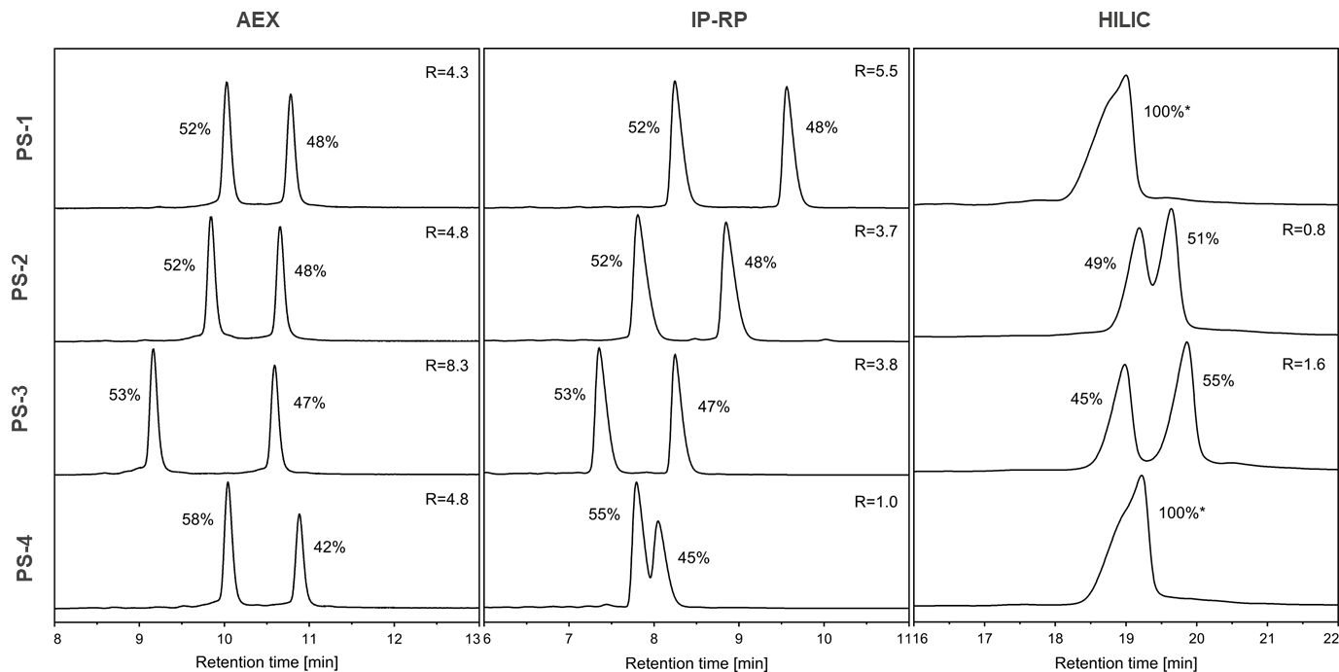
Fig. S1 LC Method development for siRNA#2 with simplified model antisense strands (only 1x PS) for AEX, IP-RP and HILIC (from left to right) ); PS-1 to PS-4 describes the position of the PS linkage for the simplified model compounds derived from the siRNA#2 antisense. The number next to the peaks represents the relative peak area in percent for the respective diastereomer signal. For separated diastereomers, the resolution (R) calculated considering the peaks width measured at half peak height, is stated. Samples for which no sufficient resolution was obtained are marked with an asterisk

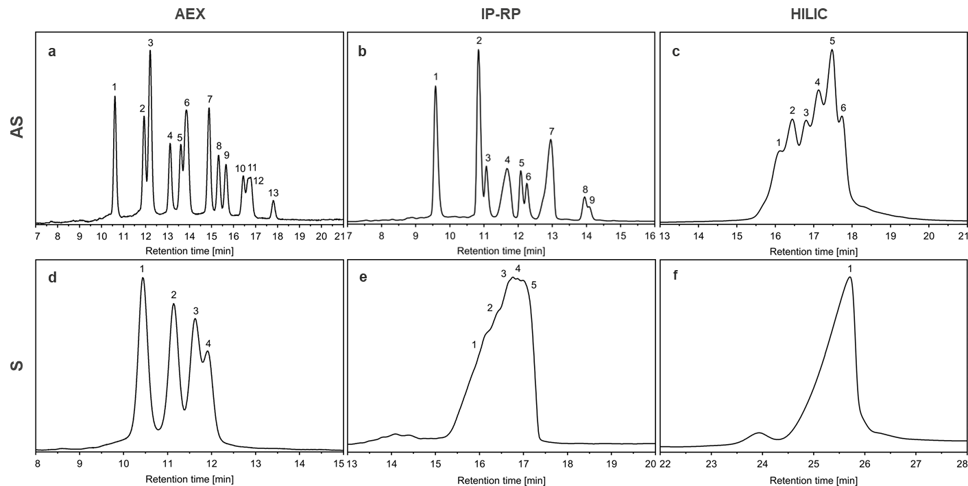
Fig. S2 LC separation of siRNA#2 antisense (top row) and sense strand (bottom row) with AEX, IP-RP and HILIC (from left to right). The numbers in the chromatograms indicate visually identified peak tops

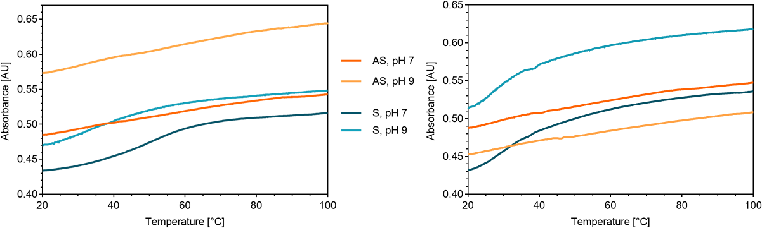
Fig. S3 Melting curves of siRNA#1 (left) and siRNA#2 (right) AS and S strands measured over a temperature range of 20–100 °C using 0.6 M NaCl, 20 mM Tris in H₂O at pH 7 and pH 9 as buffer

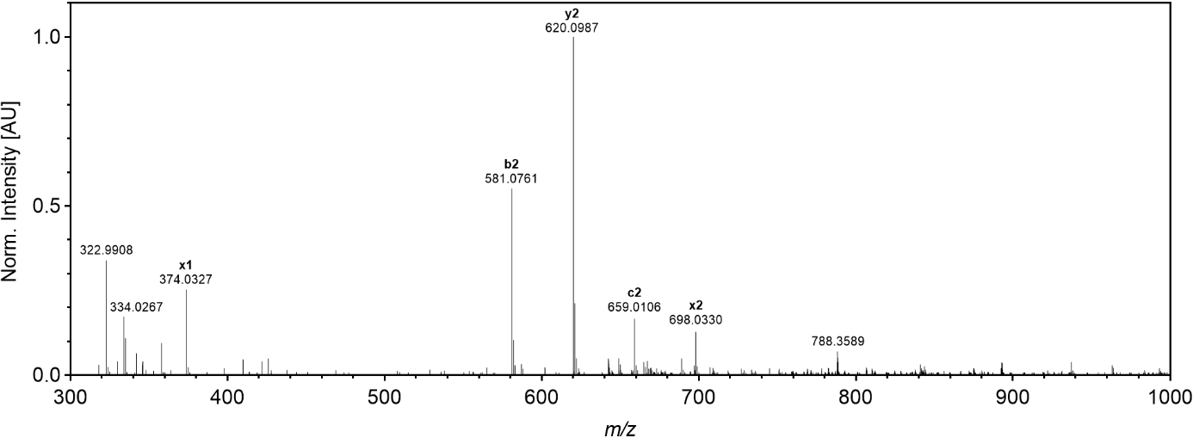
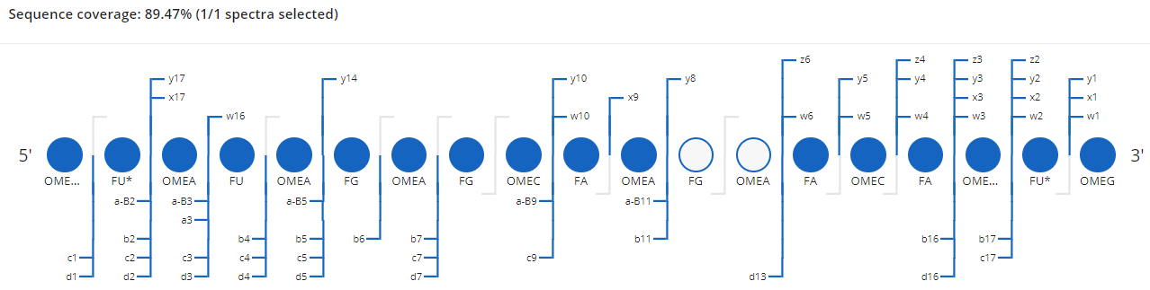
Fig. S4 Example MS/MS spectrum for siRNA#1 AS strand (obtained by isolating charge state z = −8 at m/z 788 and applying 35 V to generate ladder type fragments) and visualization of the sequence coverage

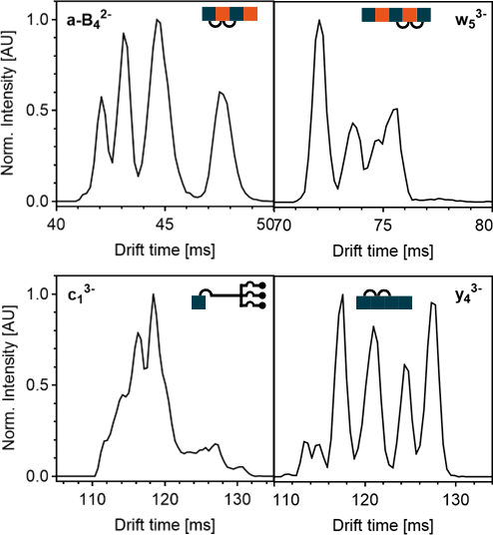
Fig. S5 Mobilograms of the siRNA#2 single strand fragments. Antisense strand (top): Mobilogram of the terminal 4-mer fragments from the 5ʹ end (a-B₄²⁻) is shown on the left and of the 5-mer fragment from the 3ʹ end (w₅³⁻) on the right side. Sense strand (bottom): Mobilogram of the terminal fragment containing the GalNAc cluster from the 5ʹ end (c₁³⁻) is shown on the left and of the 4-mer fragment from the 3ʹ end (w₃²⁻) on the right side

Table S6 Mathematical approach to back calculate intact single strand diastereomer composition from two terminal fragments using the siRNA#1 antisense strand as example based on the relative area obtained for the w₅³⁻ and b₅²⁻ fragments as shown in Fig. S6
3ʹ end / 5ʹ end  (w₅³⁻ / b₅²⁻) | PS1  (38.32%) | PS2  (23.21%) | PS3  (26.78%) | PS4  (11.69%)
PS1  (19.84%) | PS1 x PS1  (7.60%) | PS1 x PS2  (4.60%) | PS1 x PS3  (5.31%) | PS1 x PS4  (2.32%)
PS2  (21.40%) | PS2 x PS1  (8.20%) | PS2 x PS2  (4.97%) | PS2 x PS3  (5.73%) | PS2 x PS4  (2.50%)
PS3  (29.70%) | PS3 x PS1  (11.38%) | PS3 x PS2  (6.89%) | PS3 x PS3  (7.95%) | PS3 x PS4  (3.47%)
PS4  (29.07%) | PS4 x PS1  (11.14%) | PS4 x PS2  (6.75%) | PS4 x PS3  (7.78%) | PS4 x PS4  (3.40%)

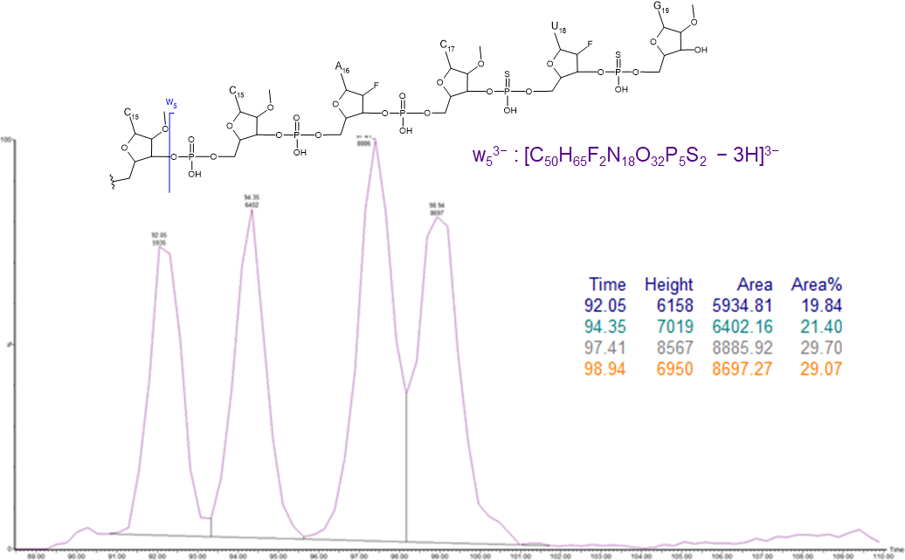
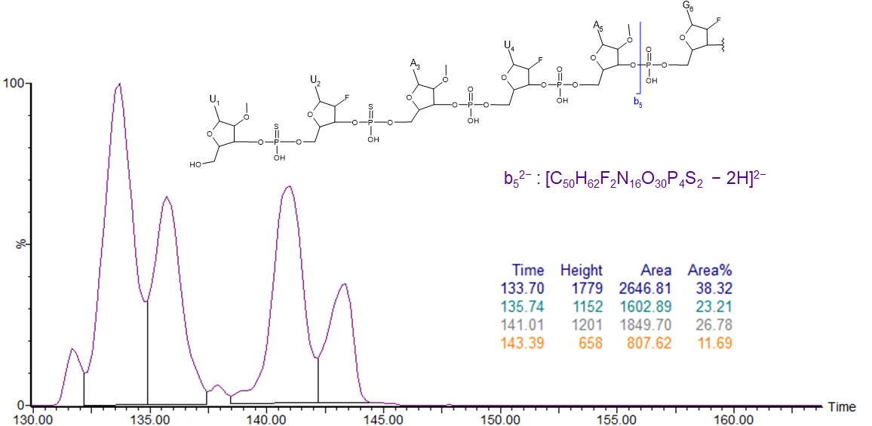
Fig. S6 Mobilograms and relative peak areas of the siRNA#1 antisense strand fragments w₅³⁻ (top) and b₅²⁻ (bottom)
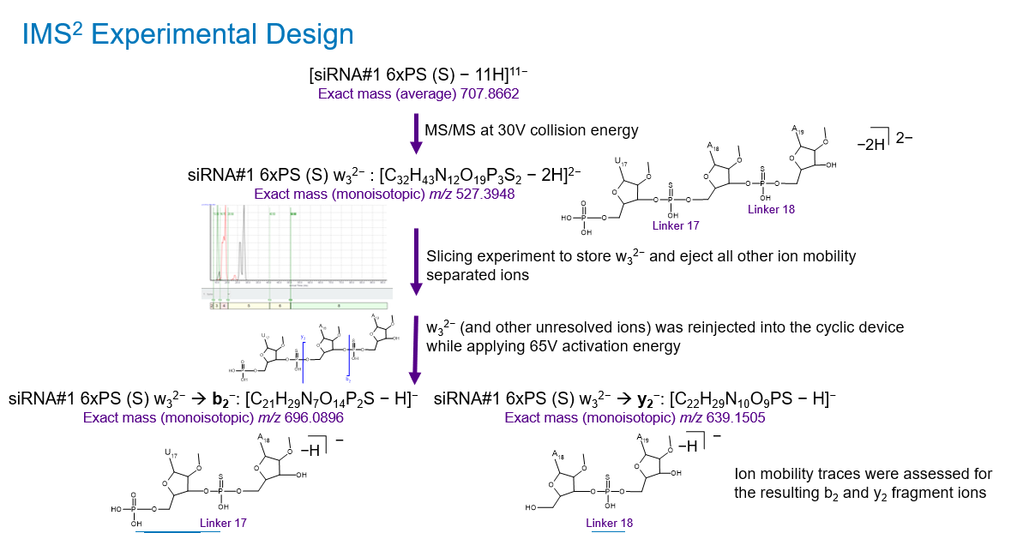
Fig. S7 Experimental IMS² design to generate terminal and internal fragments for diastereomer characterization

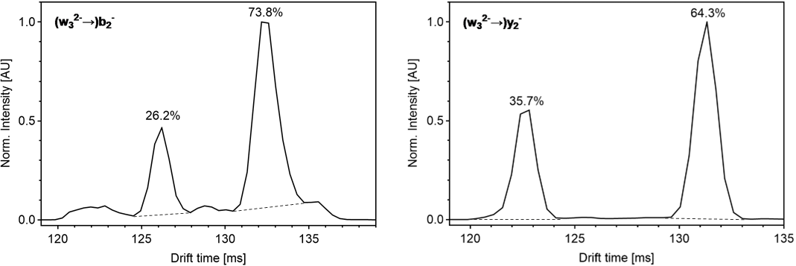
Fig. S8 Results of IMS² experiments with isolated phosphorothioate bonds for the 3ʹ end of the siRNA#1 sense strand

