Supporting Information
A new elemental analytical approach for microplastic sum parameter analysis—ETV/ICP-MS with CO₂
Vera M. Scharek¹, Thommy Kröger¹, Karin Keil², Heike Traub¹, Björn Meermann¹*
¹Federal Institute for Materials Research and Testing (BAM), Division 1.1 – Inorganic Trace Analysis (ITALab), Richard-Willstätter-Str. 11, 12489 Berlin, Germany
²Federal Institute for Materials Research and Testing (BAM), Division 1.9 – Chemical and Optical Sensing, Richard-Willstätter-Str. 11, 12489 Berlin, Germany
Corresponding author: PD Dr. habil. Björn Meermann, bjoern.meermann@bam.de

The Ar-CO₂ gas mixture $ρ_{mix}$ at room temperature was obtained on basis of the ideal gas law equation using Eq. S1. For the pressure P, the atmospheric value of 101,325 Pa was utilized. M_{mix} is the molar mass of the gas mixture calculated from the molar portions given in the certificate of the primary reference material and the molar masses of CO₂ and Ar, respectively. R represents the universal gas constant with about 8.3144 J mol⁻¹ K⁻¹ and for the temperature T in K, a value of 293.15 K was used.
$ρ_{mix}=\frac{P∙M_{mix}}{R∙T}$ Eq. S1

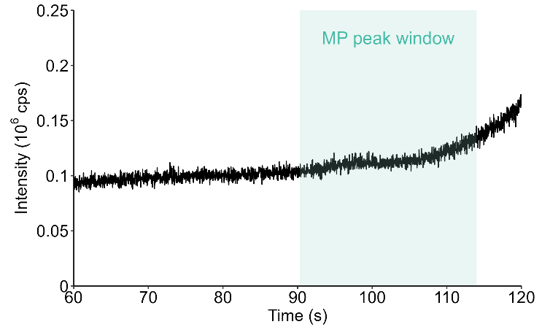
Figure S1: ¹³C⁺ time scan of the ETV/ICP-MS measurement of an empty boat.
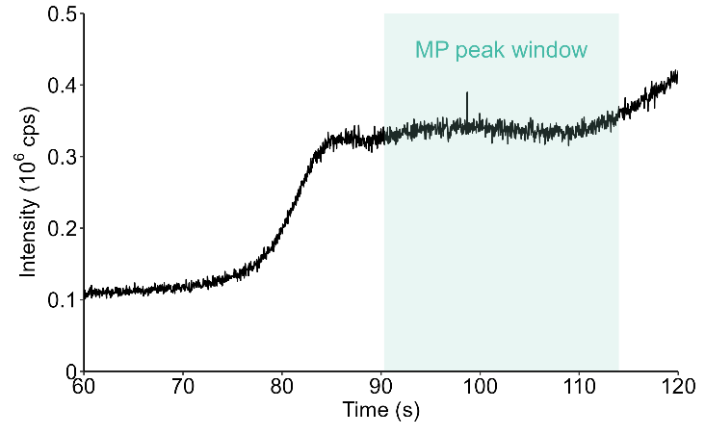
Figure S2: ¹³C⁺ time scan of the ETV/ICP-MS measurement of soil matrix without added MPs.

