Supplementary material 1

Adsorption of Serum Components on Ag Colloids: On the Biochemical Interpretation of Surface Enhanced Raman Spectra of Human Serum
Roberto Gobbatoª, Stefano Fornasaro^{b}, Valter Sergoª and Alois Bonifacio^{a,}*.
ª Raman Spectroscopy Laboratory, Department of Engineering and Architecture, University of Trieste, Via Valerio 6a, 34127, Trieste, TS, Italy
^{b} Department of Chemical and Pharmaceutical Sciences, University of Trieste, Via Licio Giorgieri 1, 34127, Trieste, TS, Italy

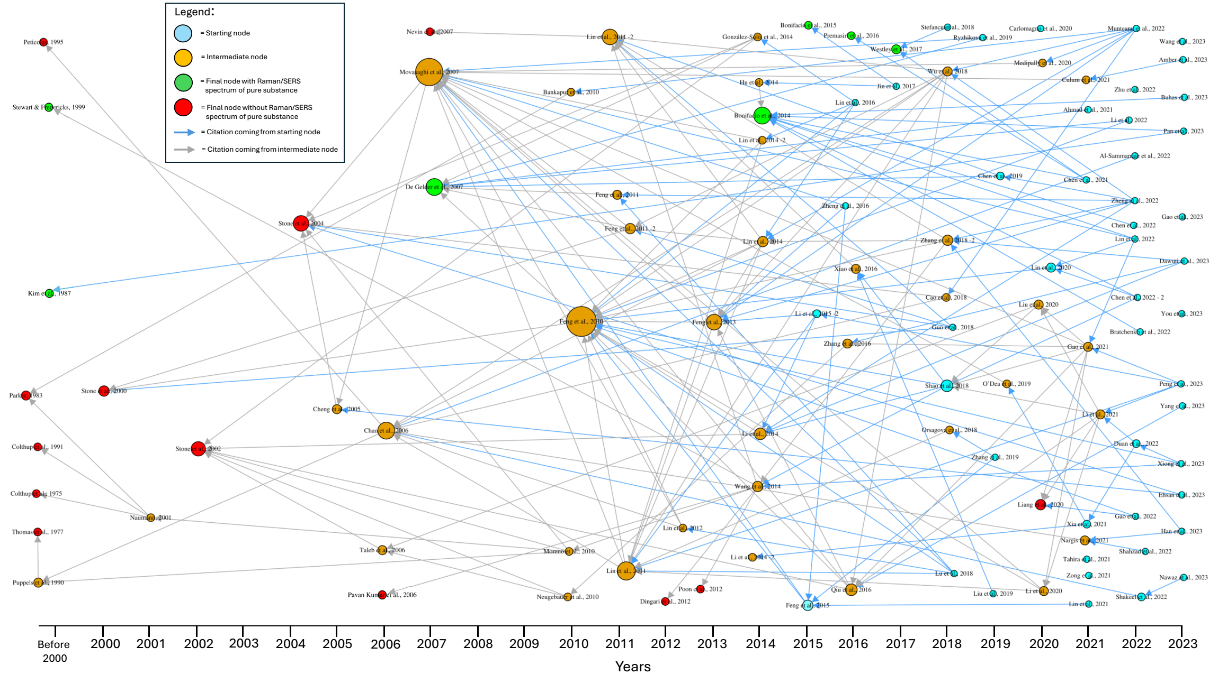
Figure S1. Citation network for the 638 cm⁻¹ band assignment (see Materials and Methods in the paper for a description of the dataset). The correspondent numerical matrix used to build the citation network is provided in Supplementary material 2 (.xlsx).
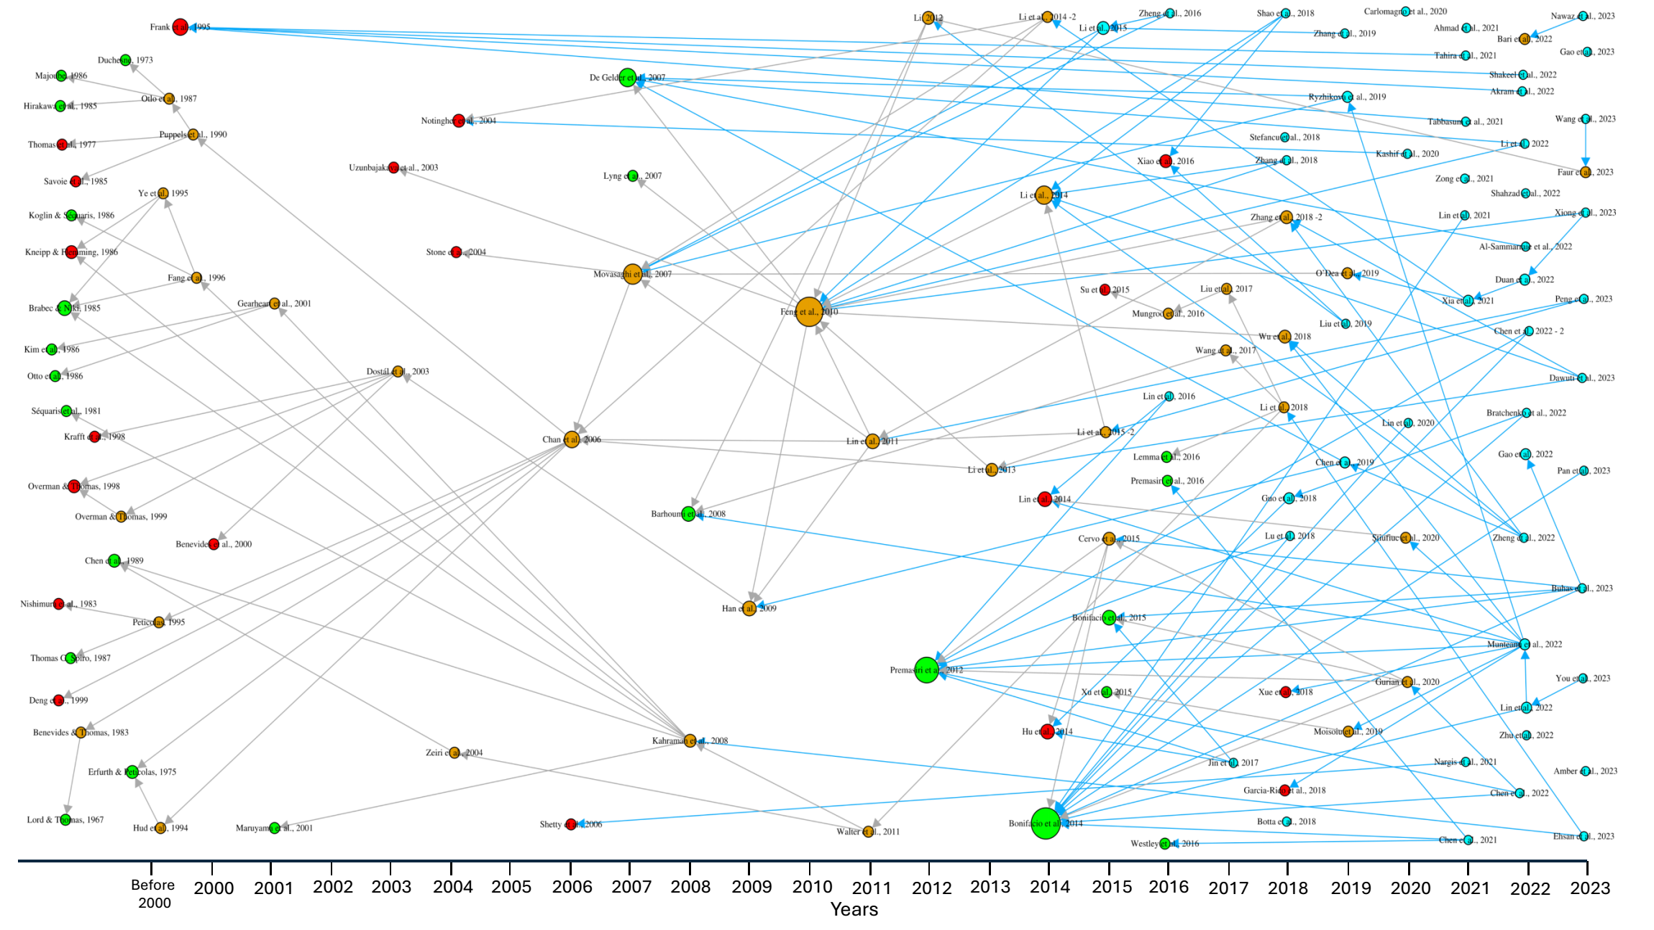
Figure S2. Citation network for the 725 cm⁻¹ band assignment (see Materials and Methods in the paper for a description of the dataset). The correspondent numerical matrix used to build the citation network is provided in Supplementary material 3 (.xlsx).

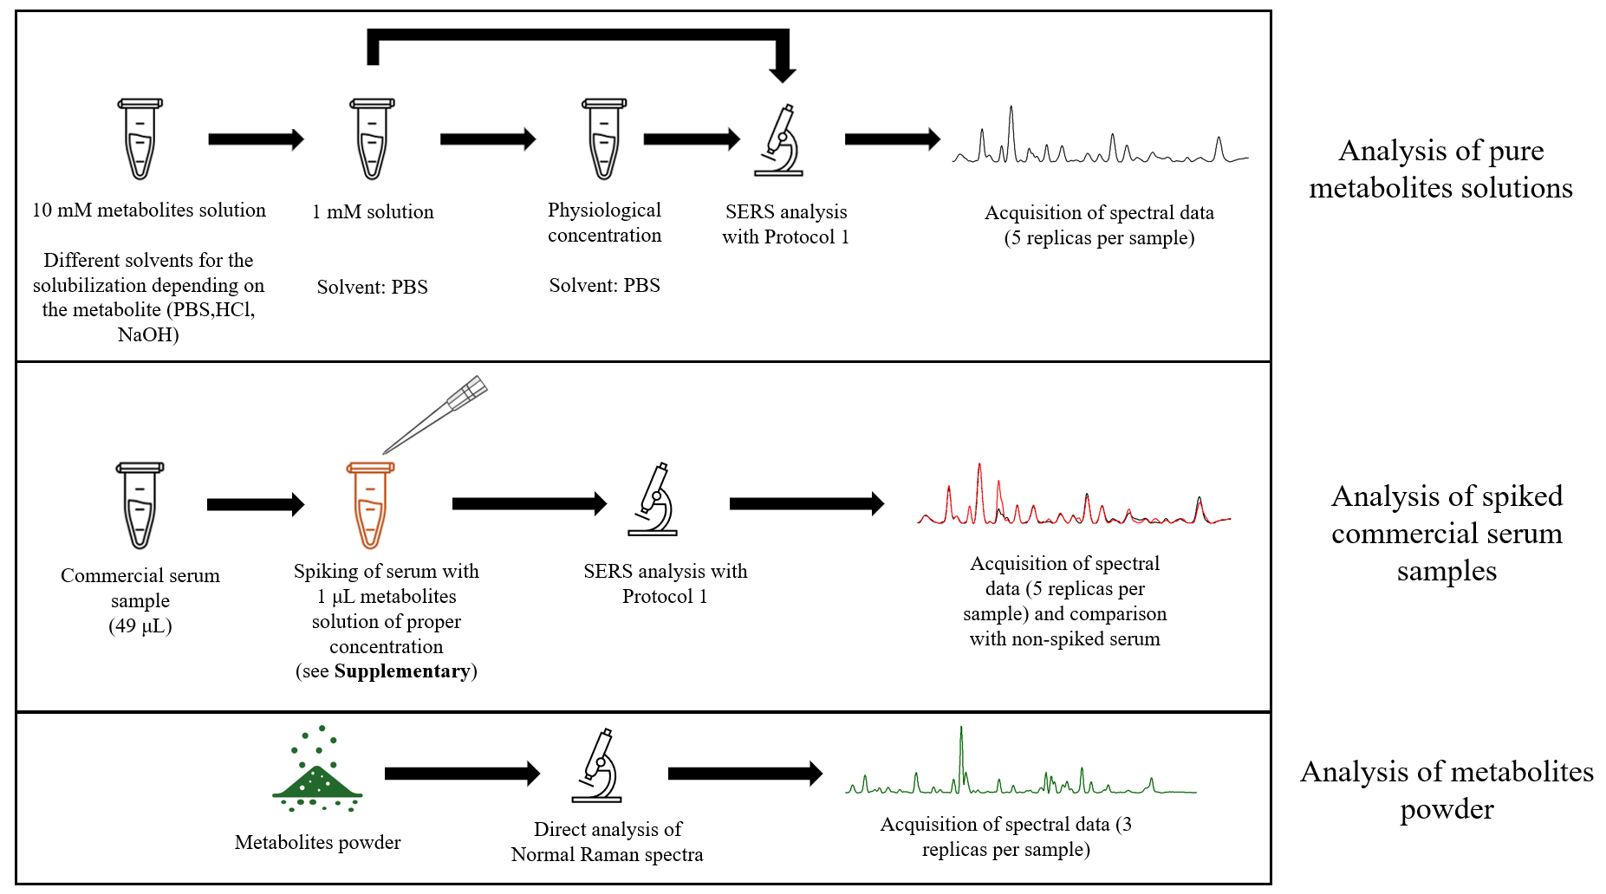
Figure S3. Procedures of used for preparation of pure biomolecules solutions at physiological concentrations (top); spiked serum samples (middle); and normal Raman spectra of metabolites powders (bottom). The list of biomolecules analyzed is provided in Supplementary Material- Table S2 (.docx).

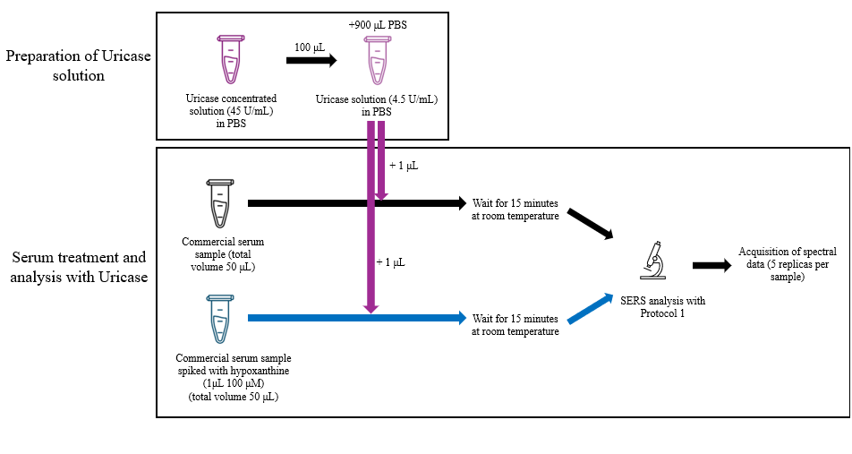
Figure S4. Protocol used for uricase experiments.
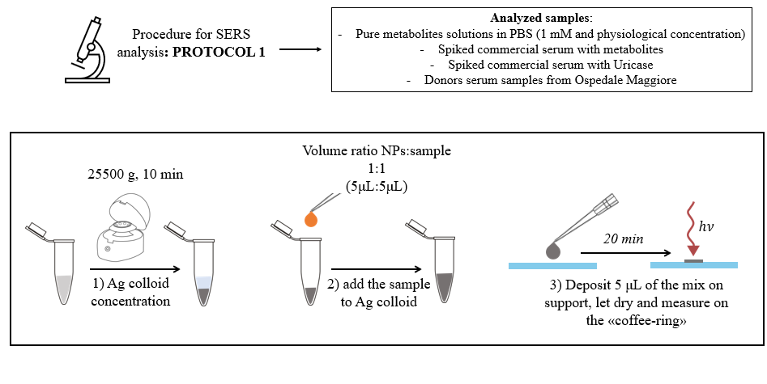
Figure S5. Details of the protocol used for SERS measurements.

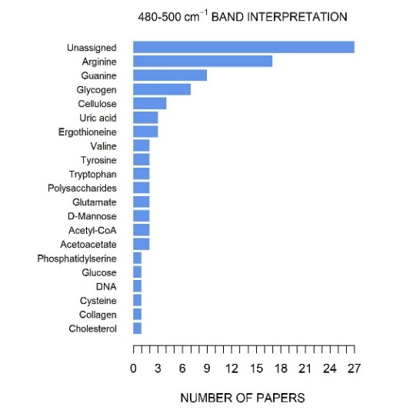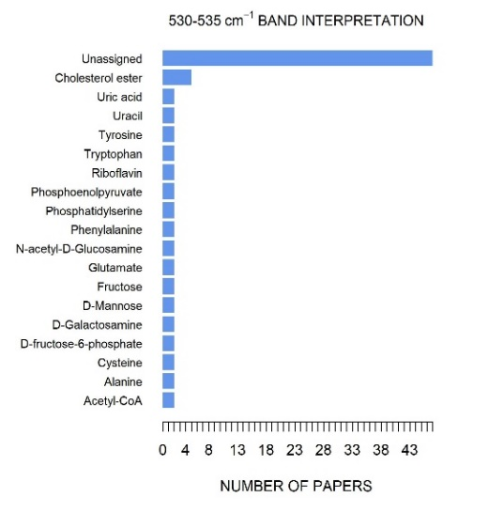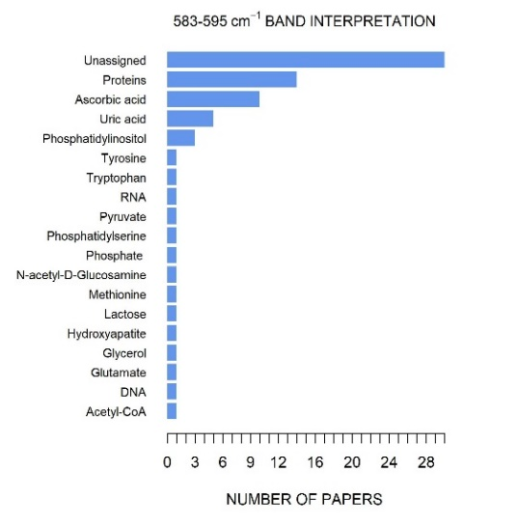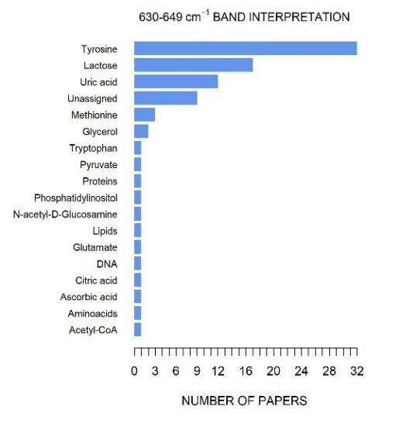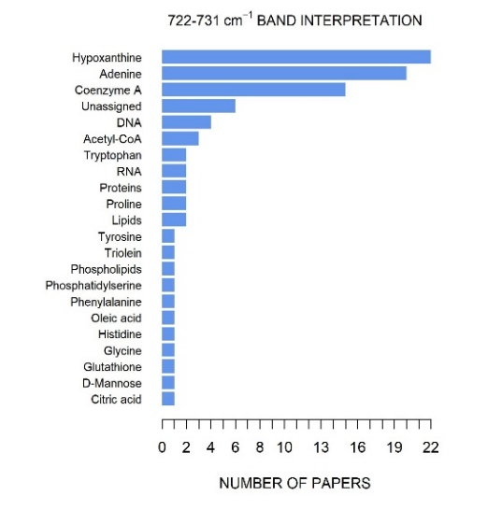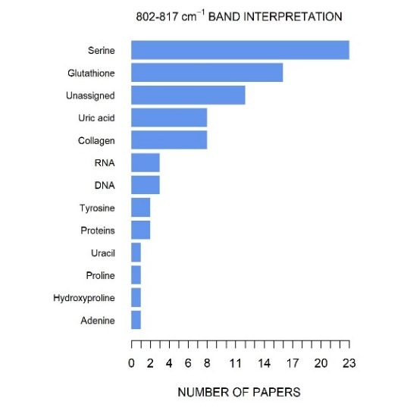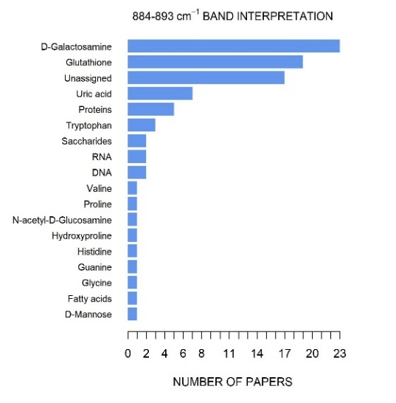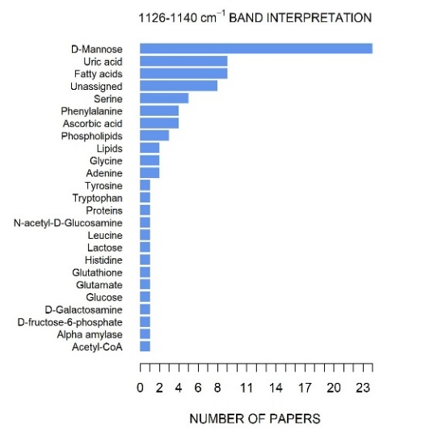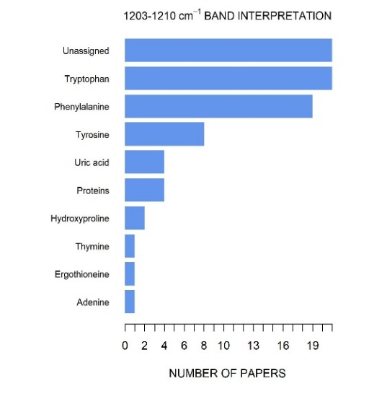
Figure S6. Bar plots showing how frequently different biomolecules have been attributed to main bands in the SERS serum of spectrum (i.e. number of papers attributing a specific biomolecule for a specific band). Information of each article are summarized in Supplementary Material - Table S1.
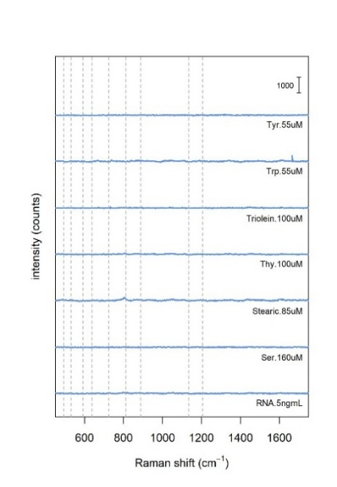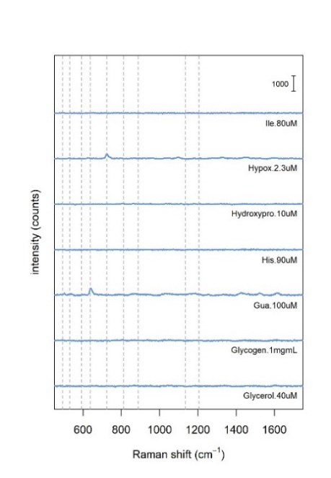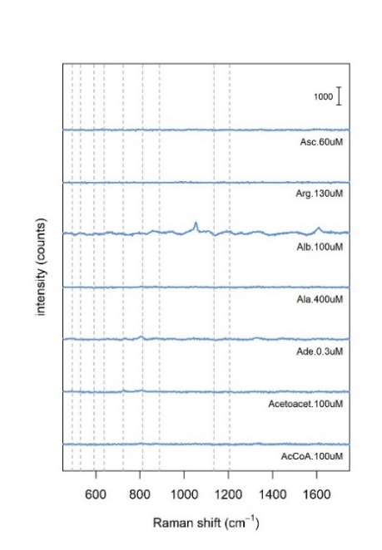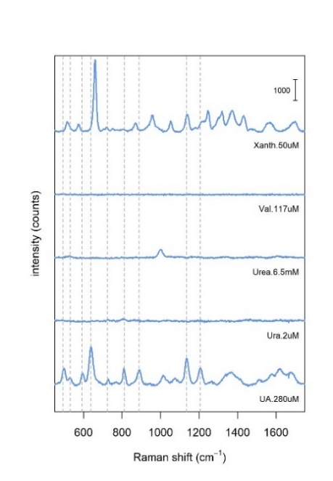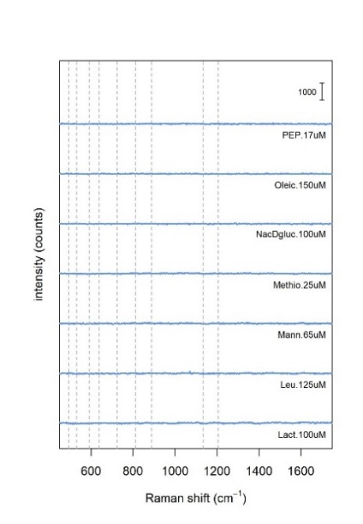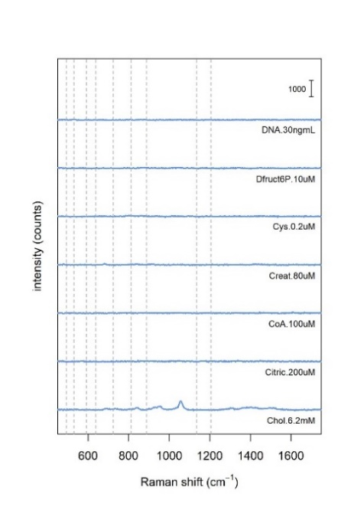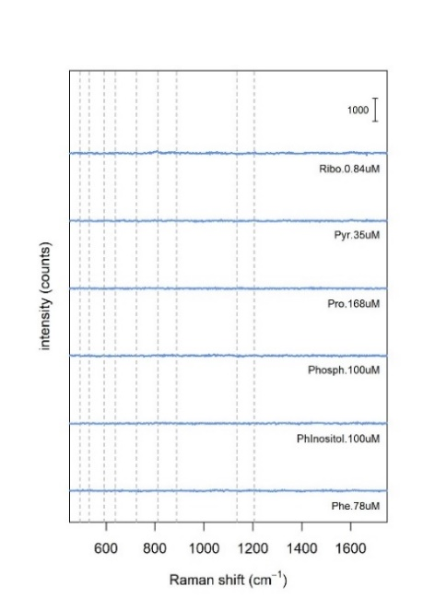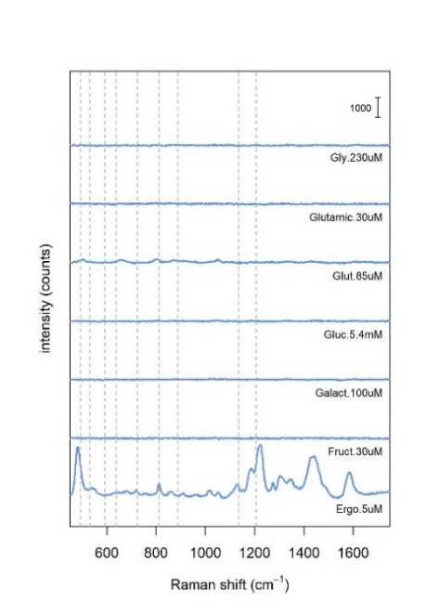
Figure S7. SERS spectra of pure biomolecules, at average physiological concentrations in PBS solution.
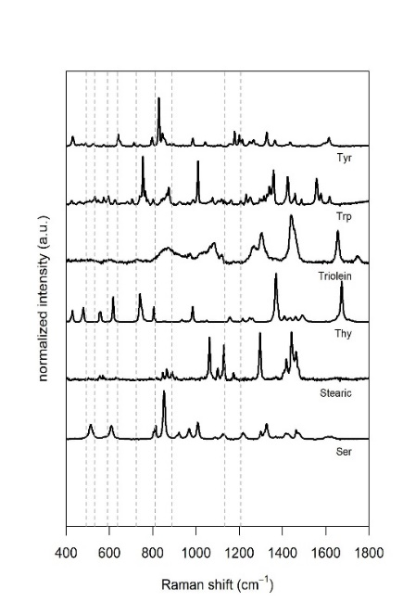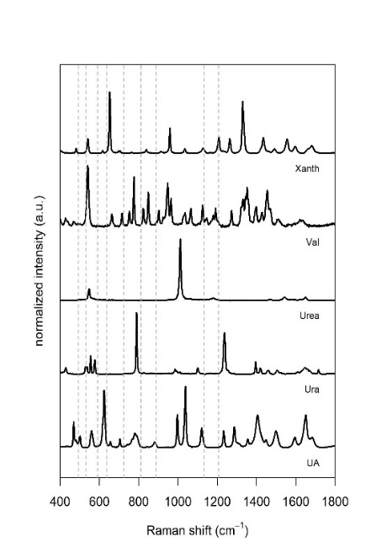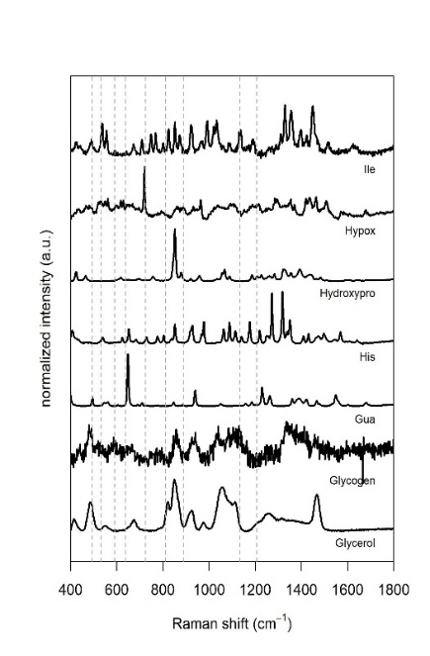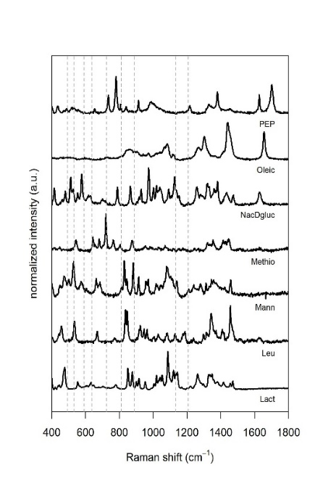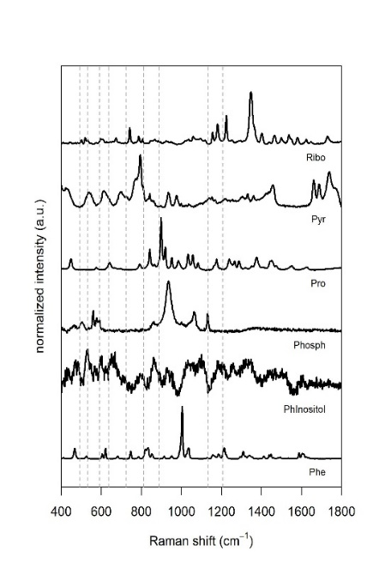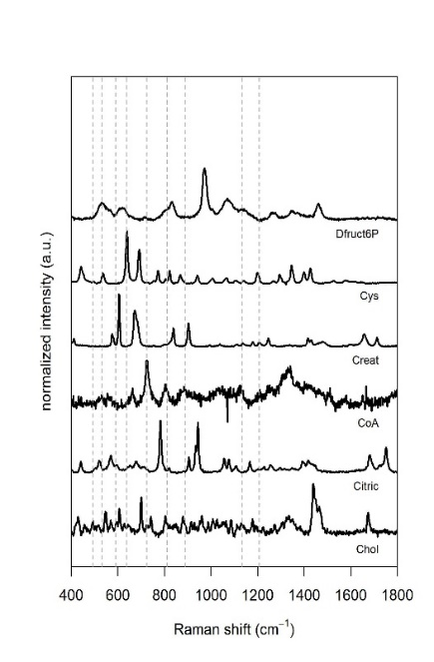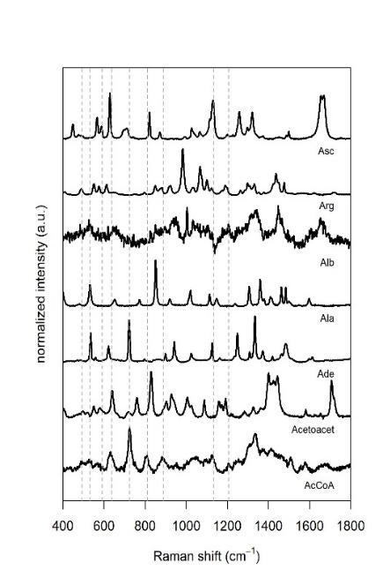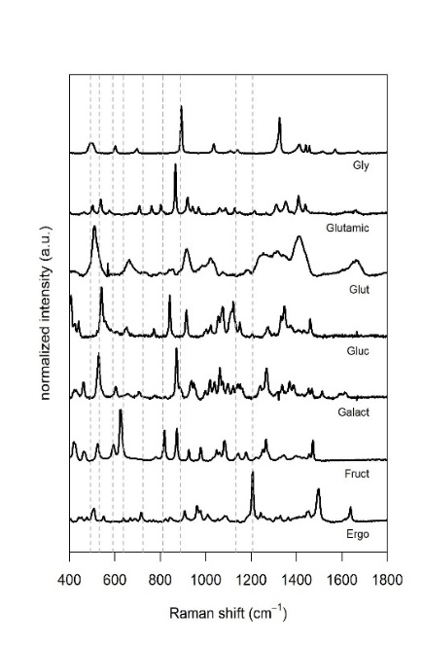
Figure S8. Normal Raman spectra of the biomolecules used in Figures S7 and S9.
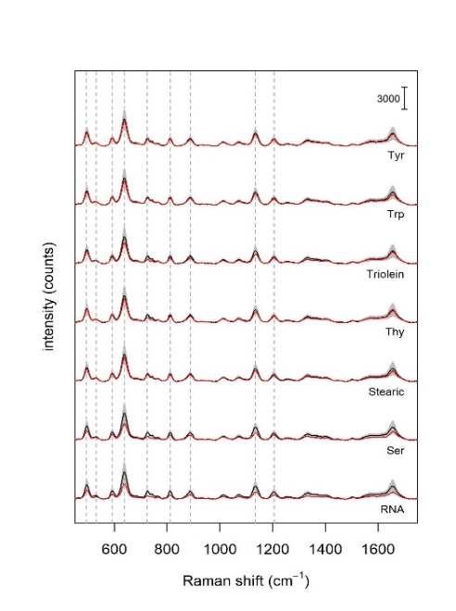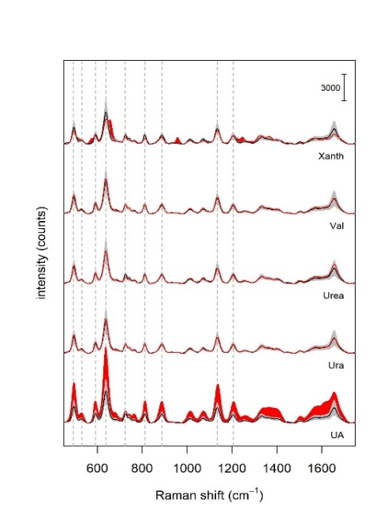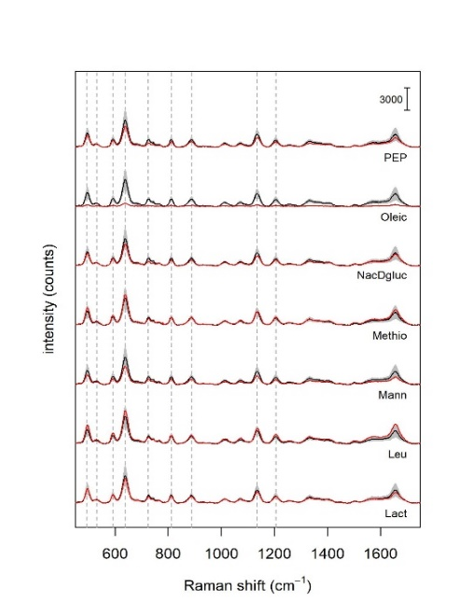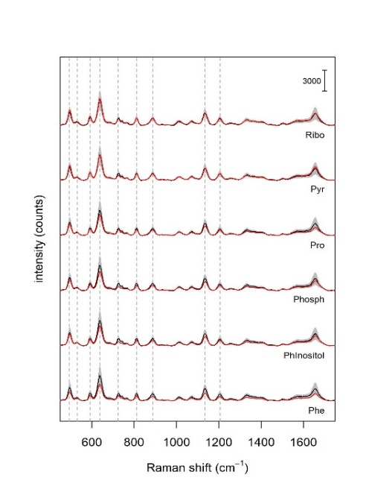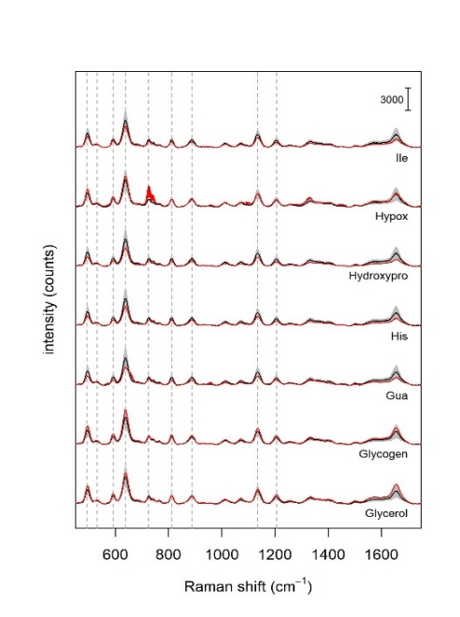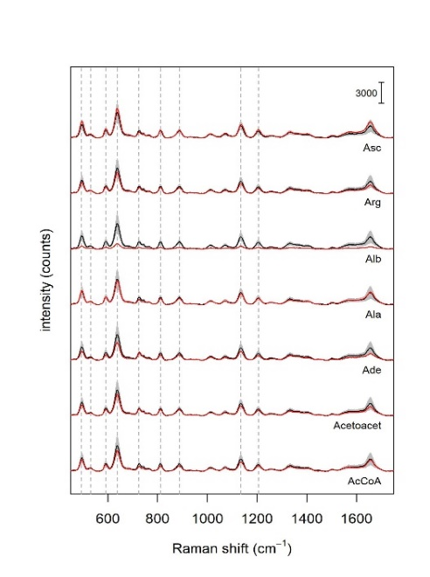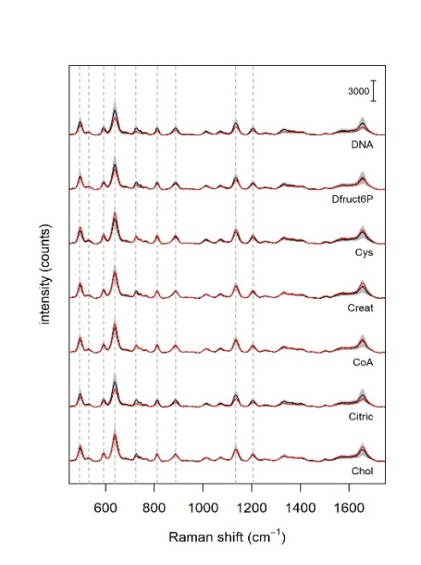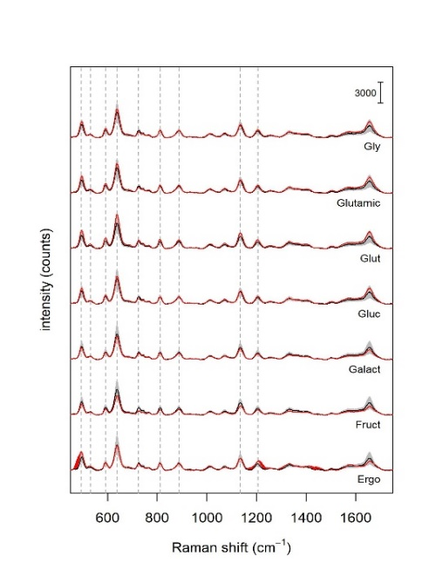
Figure S9. SERS spectra of commercial serum spiked with various biomolecules (at a final concentration in serum equal to two times the average physiological concentrations).
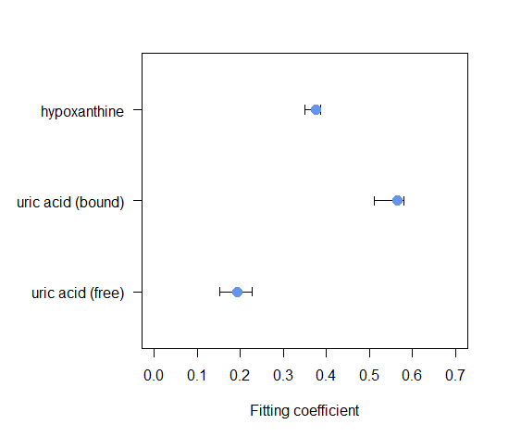
Figure S10. Statistics on the fitting coefficients for the components used to fit serum spectra of the 81 donors dataset. Whiskers represent 95% confidence intervals as derived from bootstrapping.

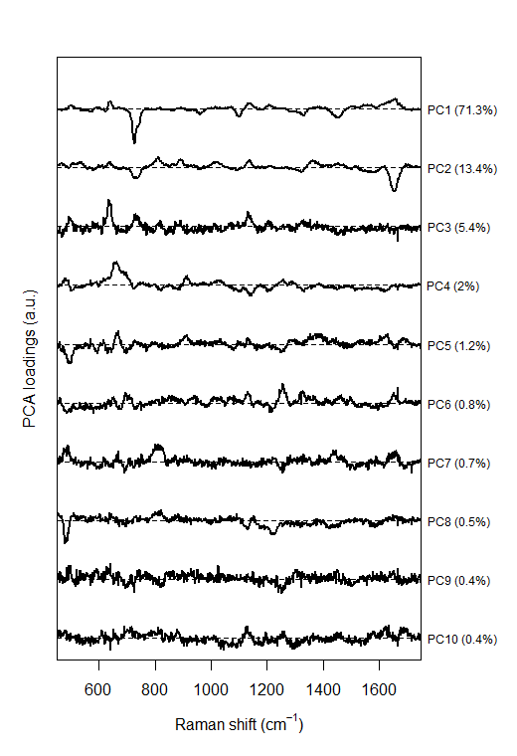
Figure S11. Loadings for the first 10 principal components of the serum donors dataset with the correspondent explained variance.

