Supplemental Information:

Structural annotation of acylcarnitines detected in SRM 1950 using Collision Induced Dissociation and Electron Induced Dissociation

Valentina Ramundi¹, Michael Witting^{1,2,}*

¹ Metabolomcis and Proteomics Core, Helmholtz Zentrum München, Ingolstädter Landstraße 1, 85764 Neuherberg, Germany
² Chair of Analytical Food Chemistry, TUM School of Life Sciences, Technical University of Munich, Maximus-von-Imhof-Forum 2, 85354 Freising-Weihenstephan, Germany

* Corresponding author: Dr. Michael Witting, michael.witting@helmholtz-munich.de

SI Table 1: MS settings for analysis of acylcarnitines at the ZenoTOF 7600 or 8600.
 | CID 7600 | CID 8600 | EAD Zeno 7600 | EAD Zeno 8600
Ion Source | TurboV | OptiFlow Pro Analytical> 200uL/Cal | TurboV | OptiFlow Pro Analytical> 200uL/Cal
Curtain gas | 40 | 40 | 40 | 40
CAD gas | 7 | 7 | 7 | 7
Ion source gas 1(psi) | 45 | 45 | 45 | 45
Ion source gas 2(psi) | 45 | 45 | 45 | 45
Temperature (°C) | 500 | 400 | 500 | 400
IDA Survey experiment
Polarity | positive | positive | positive | positive
Spray voltage (V) | 5500 | 5500 | 5500 | 5500
Mass range (Da) | 70-1500 | 70-1501 | 70-1500 | 70-1500
Accumulation time (s) | 0.1 | 0.1 | 0.1 | 0.1
Declustering potential (V) | 80 | 0 | 80 | 0
Collision energy (V) | 10 | 10 | 10 | 10
Collision energy spread (V) | 0 | 0 | 0 | 0
Time bins to sum | 6 | 6 | 6 | 6
Maximun candidates ion | 10 | 10 | 10 | 3
Intensity threshold exceeds (counts/s) | 10 | 10 | 10 | 10
IDA Dependent
Spray voltage (V) | 5500 | 5500 | 5500 | 5500
Fragmentation mode | CID | CID | EAD | EAD
Mass range (Da) | 50-1500 | 50-1500 | 50-1500 | 50-1500
Accumulation time (s) | 0.025 | 0.025 | 0.095 | 0.095
Declustering potential (V) | 80 | 0 | 80 | 0
Collision energy (V) | 35 | 35 | 12 | 12
Electron beam current (nA) | - | - | 7000 | 7000
Electron KE (eV) | - | - | 16 | 16
ETC | - | - | 100 | 100
Reaction time (ms) | - | - | 30 | 30
Zeno threshold (cps) | 80000 | 1000000 | 80000 | 1000000
Time bins to sum | 6 | 6 | 6 | 6

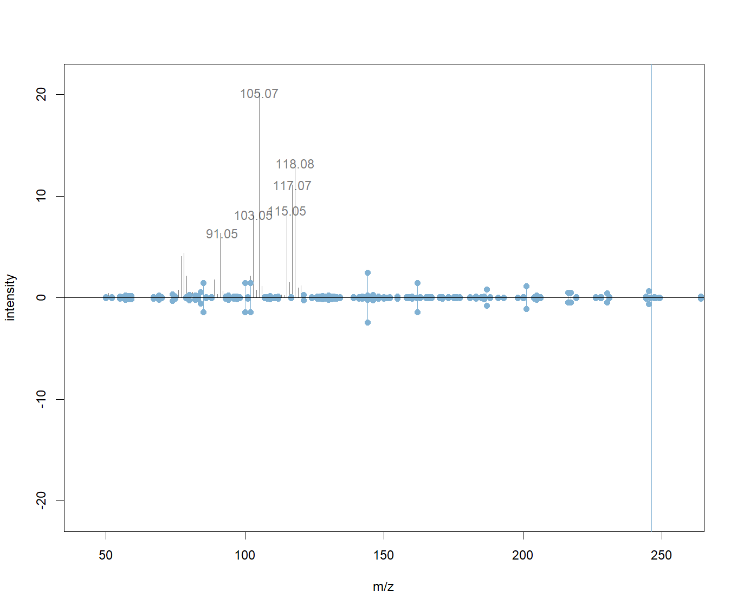
SI Figure 1: Example mirror plot of an uncleaned and cleaned spectrum. Contamination is observed in the lower mass region and is not interfering with the localization of double bonds. Peaks marked in blue are the remaining after spectra cleaning.

SI Figure 2: Extracted ion chromatograms Car 4:0 and Car 5:0 from plasma (red) and reference standards (blue). In both cases, retention times of reference standards confirm the identity suggested by EID fragmentation.

