Supplementary Material

Use of Gb₃ trisaccharides with oligo-EG linker for detection of Escherichia coli O157:H7 Shiga toxins present in a fresh vegetable salad

Hirotaka Uzawa¹ ∙ Daiki Tanaka¹ ∙ Yuki Oba¹ ∙ Yasuo Seto² ∙ Yoshihiro Nishida³

¹ Research Institute of Core Technology for Materials Innovation, National Institute of Advanced Industrial Science and Technology (AIST), 1-1-1 Higashi, Tsukuba, 305-8565, Japan
² Forensic Science Group, RIKEN SPring-8 Center, Sayo-gun 679-5148, Hyogo, Japan
³ Division of Applied Biological Chemistry, Graduate School of Environmental Horticulture, Chiba University, Matsudo 271-8510, Chiba, Japan

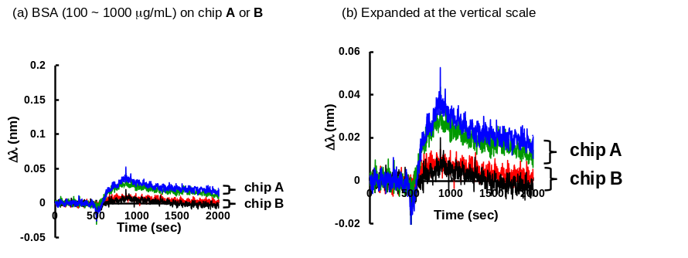

Fig. 1S Nonselective adhesion of BSA on each of chips A and B (Scheme 1) changing BSA concentrations between 100 μg/mL and 1000 μg/mL. (a) The RIfS sensorgrams holding the vertical scale as the same as Fig. 3(a) in the main text and (b) zooming in the vertical scale of Fig. 1S(a)

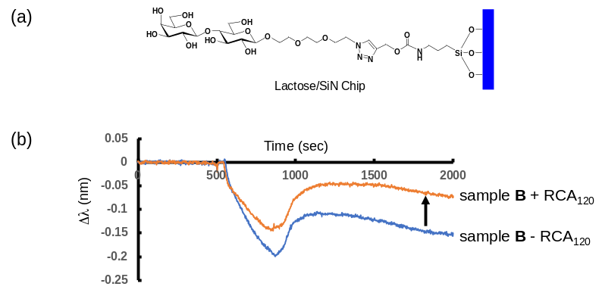

Fig. 2S (a) A lactose/EG₃ SiN chip used in the RIfS detection of RCA₁₂₀ lectin (a botanical βGal binding protein) added in sample B (filtrate fraction) from the cucumber salad. (b) Sensorgrams of two kinds of test samples: sample B containing RCA₁₂₀ at 1 μg/mL (sensorgram in orange) and sample B without RCA₁₂₀ (sensorgram in blue)

Table 1S Calculation of S/N ratios by a root square mean (RSM) method for experimental RIfS signal strengths when chip B is used for detection of Stx1 at different Stx1 concentrations
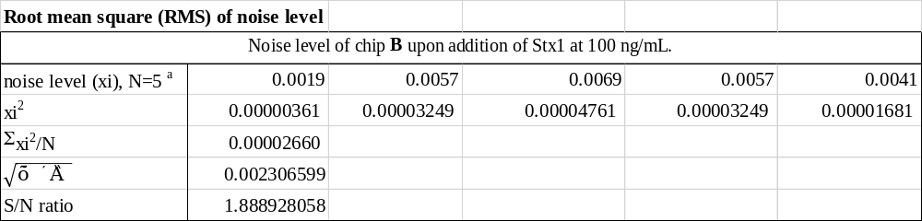

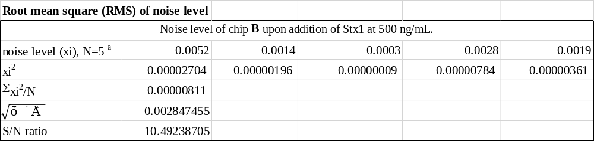
ª noise levels at each of five points on RIfS sensorgrams in Fig. 3 (a).

