Untargeted approaches based on GC-Orbitrap-HRMS and two-dimensional GC-MS for the identification of intentionally and non-intentionally added substances from bio-based food contact materials

Maurizio Piergiovanni ^{a*}, Simone Squara ^{b}, Marco Fontanarosa ª, Cristian Maffezzoni ª, Nicolò Riboni ª, Antonella Cavazza ª, Monica Mattarozzi ª, Federica Bianchi ª, Michele Suman ^{b,c*}, Maria Careri ª

ª University of Parma, Department of Chemistry, Life Sciences and Environmental Sustainability, Parco Area delle Scienze 17/A, 43124 Parma, Italy
^{b} Barilla G.R. F.lli SpA, Research, Development & Quality, Sensory and Analytical Food
Science, Via Mantova 166, 43100, Parma, Italy
^{c} University of Parma, Department of Food and Drug, Parco Area delle Scienze 27/A, 43124 Parma, Italy

* Corresponding authors: Maurizio Piergiovanni, E-mail address: maurizio.piergiovanni@unipr.it
Michele Suman, E-mail address: michele.suman@unipr.it

Supplementary information

GC-Orbitrap HRMS data filtering
Prior to multivariate statistical analysis, features were filtered based on a 5:1 sample/blank ratio and analytical quality (mass accuracy: 5 ppm, peak rating ≥ 6, and RSD% of the peak areas across the QCs after area correction ≤ 20%). The “Peak rating” parameter considers peak shape (Modality, Zig-Zag, Jaggedness, and FWHM to Base), peak area and coefficient of variation. These filters allowed the removal of low-quality peaks, improving the reliability of spectra deconvolution and enabling better annotation. The selected peak rating threshold (≥ 6) in at least 3 runs out of 3 resulted in a good compromise between the number of hits and the analytical quality. In addition, the “Max. Corrected QC Area RSD” filter applied to the QC-corrected area allowed to retain only the features showing stable signal intensity throughout the entire sample set.

Table S1. List of analysed bio-based FCM samples and details on the materials and end-use conditions reported on the label.
Code | Item | Material | End-use indication
P1 | Cutlery | no-PLA | 70°C, 2h
P2 | Cutlery | no-PLA | 70°C, 2h
P3 | Cutlery | cPLA | 70°C, 2h
P4 | Cutlery | no-PLA | 70°C, 2h
P5 | Cutlery | no-PLA | 70°C, 2h
P6 | Cutlery | no-PLA | 70°C, 2h
P7 | Cutlery | no-PLA | 70°C, 2h
P8 | Cutlery | no-PLA | 70°C, 2h
P9 | Cutlery | cPLA | 70°C, 2h
P10 | Cutlery | cPLA | 70°C, 2h
P11 | Cutlery | cPLA | 70°C, 2h
P12 | Cutlery | cPLA | 70°C, 2h
P13 | Cutlery | cPLA | 70°C, 2h
P14 | Cutlery | cPLA | 70°C, 2h
PAL1 | Coffee scoop | cPLA | 70°C, 2h
COP1 | Cup | PLA | 40°C, 2h
COP2 | Cup | PLA | 40°C, 2h
CAN1 | Straw | PLA | 40°C, 2h
CAN2 | Straw | PLA | 40°C, 2h
B1 | Glass | PLA | 40°C, 2h
B2 | Glass | PLA | 40°C, 2h
B3 | Glass | PLA | 40°C, 2h
B4 | Glass | PLA | 40°C, 2h
B5 | Glass | PLA | 40°C, 2h
B6 | Glass | PLA | 40°C, 2h

Table S2. Classification performance of PLS-DA models calculated for both maximum end-use temperature indications and material classification
Model | Class | Cross - validation |  |  | External validation
Model | Class | Sensitivity | Specificity | Precision | Sensitivity | Specificity | Precision
Indications of the maximum temperature for end-use | 40°C, 2h | 1.00 | 1.00 | 1.00 | 1.00 | 0.92 | 0.90
Indications of the maximum temperature for end-use | 70°C, 2h | 1.00 | 1.00 | 1.00 | 0.92 | 1.00 | 1.00
Material resistant to moderate temperature | no-PLA | 1.00 | 0.87 | 0.88 | 0.83 | 0.67 | 0.71
Material resistant to moderate temperature | cPLA | 0.87 | 1.00 | 1.00 | 0.67 | 0.83 | 0.80

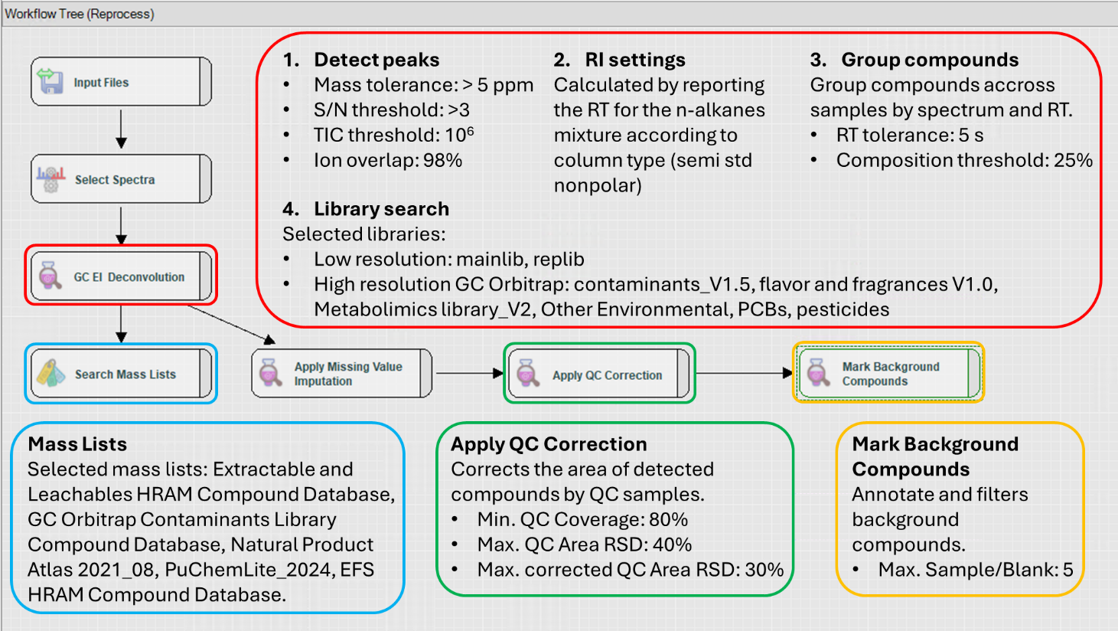
Fig. S1. Workflow Tree from the Compound Discoverer 3.0 software displaying GC-Orbitrap HRMS data processing nodes and the associated workflow connections

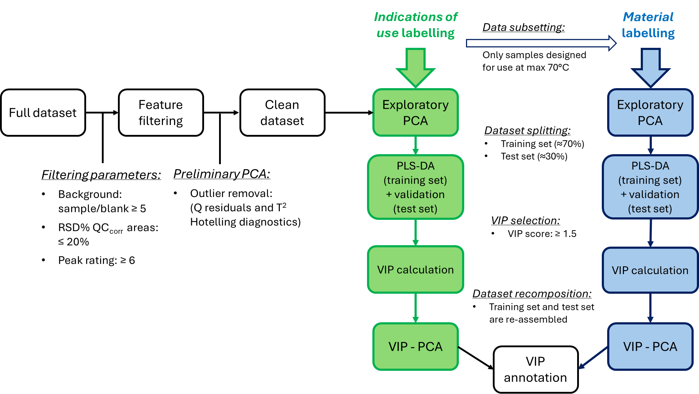
Fig. S2. Flowchart of signal processing and extraction of characteristic features for each sample class.

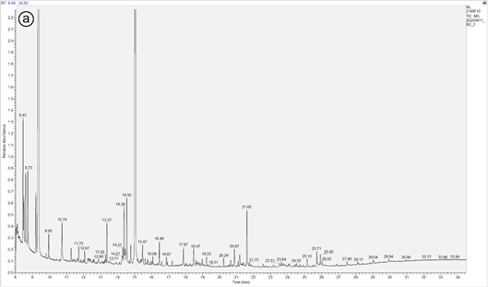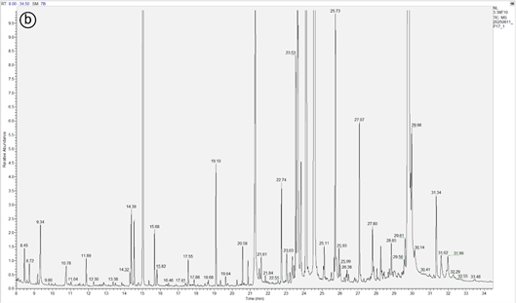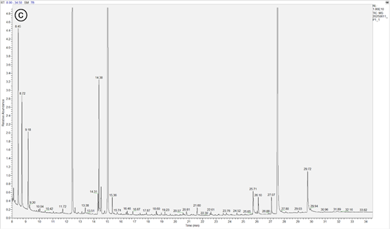
Fig. S3. GC-Orbitrap HRMS TIC chromatograms of representative samples of each category of bio-based FCM investigated; (a) B2 (PLA), (b) P14 (cPLA), and (c) P1 (no-PLA).
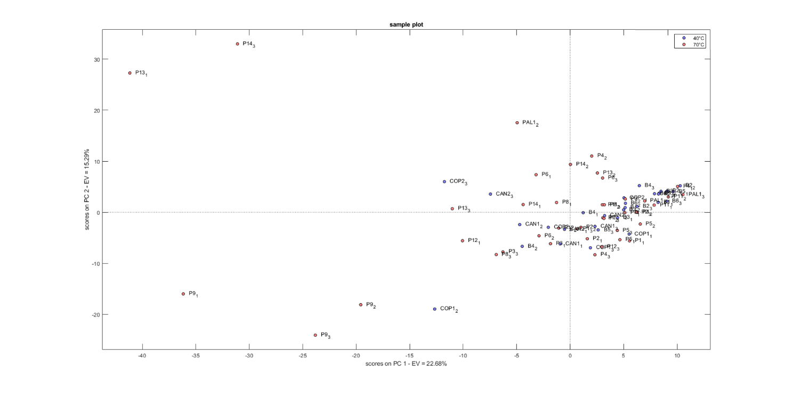
Fig. S4. Score plot of the PCA analysis of the clean dataset using all variables. Samples are labelled according to the maximum end-use temperature indications.
Fig. S5. GC-Orbitrap-HRMS EI MS hypothetic rearrangement pattern of Class A, B, C, D, E leading to the formation of the common ion.
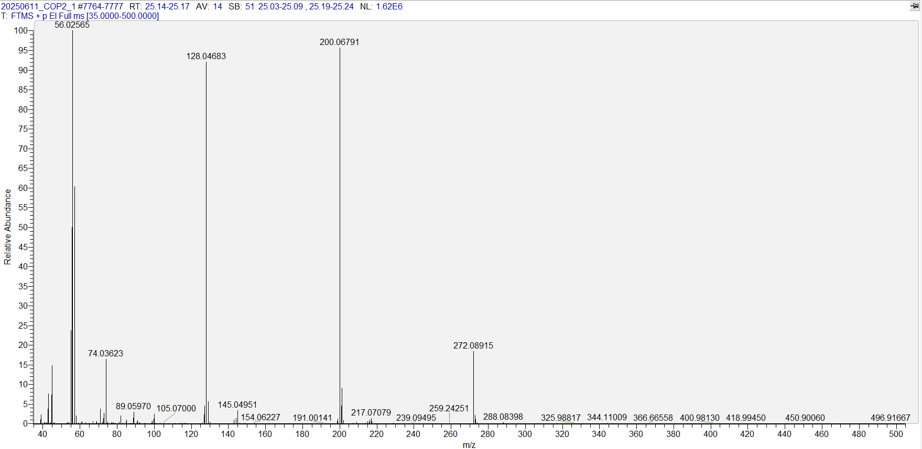
Fig. S6. GC-Orbitrap-HRMS EI spectrum of Class C features showing the characteristic m/z pattern.

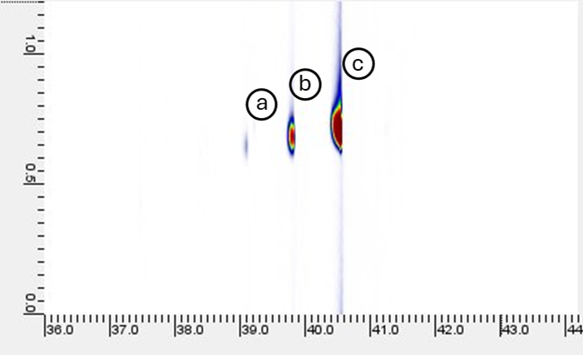
Fig. S7. GC×GC-MS extracted ion chromatogram (XIC) of m/z: 259.20 in the cPLA class image showing the butyl-citrate derivatives. Analyte (a) (tR 39.1 min, RI: 2189) was tentatively identified as Butyl Citrate, analyte (b) (tR 39.8 min, RI: 2221) was not identified, analyte (c) (tR 40.5 min, RI: 2269) was tentatively identified as Tributyl Acetylcitrate

