Supplementary Information

Evaluation of isotope-dilution mass spectrometry, internal standard, and external standard methods for PFAS quantification in tap water and soil

Eriko Yamazaki^{a*}, Nobuyasu Hanariª, Keisuke Nakamuraª

ª Research Institute for Material and Chemical Measurement, National Metrology Institute of Japan, National Institute of Advanced Industrial Science and Technology (NMIJ/AIST), 1-1-1 Umezono, Tsukuba, Ibaraki 305-8563, Japan

*Corresponding author: Eriko Yamazaki

Research Institute for Material and Chemical Measurement,
National Metrology Institute of Japan, National Institute of Advanced Industrial Science and Technology (NMIJ/AIST),
1-1-1 Umezono, Tsukuba, Ibaraki 305-8563, Japan.
Phone: +81 50 3521 3452
E-mail: eriko.yamazaki@aist.go.jp

This supplementary information contains 5 pages, 5 tables, and 1 figure.
Table of Contents

Tables
Table S1. Mass-labeled standards used for IDMS and the internal standard method………..S3
Table S2. HPLC conditions…………….………………………………………....………….S3
Table S3. Mass transitions, Q1 pre-rod bias voltage (V), collision energy (eV), and Q3 pre-rod bias voltage (V) for individual compounds……….………….………………………….S4
Table S4. p-values of homoscedasticity tests…………………………………………...…S5
Table S5. p-values of lack-of-fit (LOF) tests……………………….…………….………S5

Figures
Fig. S1. Residual plots of calibration curves for the IDMS, internal standard, and external standard methods…………………………………………………………………………….S6

Table S1. Mass-labeled standards used for IDMS and the internal standard method
Target analyte | Calibration method | Mass-labeled standard
PFHxS | IDMS | ¹³C₃-PFHxS
PFHxS | IS | ¹⁸O₂-PFHxS
PFOS | IDMS | ¹³C₄-PFOS
PFOS | IS | ¹⁸O₂-PFHxS
PFOA | IDMS | ¹³C₄-PFOA
PFOA | IS | ¹⁸O₂-PFHxS
PFNA | IDMS | ¹³C₅-PFNA
PFNA | IS | ¹⁸O₂-PFHxS

Table S2. HPLC conditions
Parameter | Conditions
Analytical column | Betasil® C18 (2.1 mm i.d. × 50 mm × 5.0 µm)
Guard column | ZORBAX Eclipse XDB-C8 (2.1 mm id. × 12.5 mm × 5 μm)
Column temperature (℃) | 30
Injection volume (µL) | 10
Mobile phase A | 10% methanol in 2 mM ammonium acetate solution
Mobile phase B | MeOH
Flow rate (mL/min) | 0.23
Gradient | Time (min) | A (%) | B (%)
 | 0 | 90 | 10
 | 2 | 50 | 50
 | 10 | 0 | 100
 | 14 | 0 | 100
 | 15 | 90 | 10
 | 20 | 90 | 10

Table S3. Mass transitions, Q1 pre-rod bias voltage (V), collision energy (eV), and Q3 pre-rod bias voltage (V) for individual compounds
Compound | Mass transitions (m/z) | Q1 pre-rod bias voltage (V) | Collision energy (eV) | Q3 pre-rod bias voltage (V)
PFHxS | 398.95 79.95* | 30 | 43 | 30
PFHxS | 398.95 98.9 | 30 | 34 | 34
PFOS | 498.95 79.95* | 34 | 55 | 30
PFOS | 498.95 98.95 | 34 | 43 | 34
PFOA | 412.95 369.00* | 30 | 10 | 40
PFOA | 412.95 169.00 | 30 | 18 | 32
PFNA | 462.95 418.95* | 30 | 11 | 30
PFNA | 462.95 219.00 | 32 | 16 | 34
¹³C₃-PFHxS | 401.95 79.95 | 44 | 38 | 30
¹³C₃-PFHxS | 401.95 98.95 | 42 | 33 | 30
¹⁸O₂-PFHxS | 402.95 83.95 | 29 | 39 | 13
¹³C₄-PFOS | 502.95 79.95 | 24 | 55 | 27
¹³C₄-PFOS | 502.95 98.95 | 24 | 45 | 27
¹³C₄-PFOA | 417.00 172.00 | 15 | 19 | 15
¹³C₅-PFNA | 468.00 423.00 | 17 | 11 | 29
d₃-N-MeFOSA | 515.00 168.90 | 36 | 25 | 30
d₃-N-MeFOSA | 515.00 219.00 | 38 | 24 | 44
* used for quantifier.
Table S4. p-values of homoscedasticity tests
 | PFHxS | PFOS | PFOA | PFNA
IDMS | 0.264 | 0.569 | 0.243 | 0.896
IS | 0.349 | 0.394 | 0.436 | 0.093
ES | 0.052 | 0.096 | 0.127 | 0.245

Table S5. p-values of lack-of-fit (LOF) tests
 | PFHxS | PFOS | PFOA | PFNA
IDMS | 0.0517 | 0.164 | 0.0821 | 0.770
IS | 0.00562 ** | 0.000414 *** | 0.00346 ** | 2.13 × 10^{–8} ***
ES | 4.12 × 10^{–13 ***} | 2.40 × 10^{–10 ***} | 3.08 × 10^{–12 ***} | 1.70 × 10^{–5 ***}
** p < 0.01 *** p < 0.001
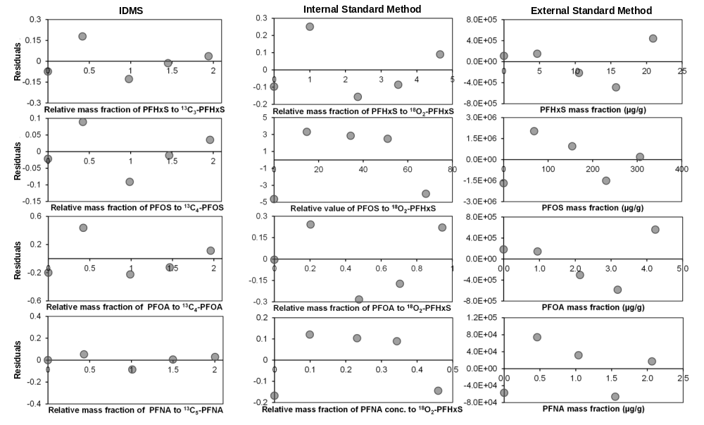
Fig. S1. Residual plots of calibration curves for the IDMS, internal standard, and external standard methods

