Supplementary Information
to the article
Development and Validation of HILIC–MS/MS Method for the Analysis of Glutathione Metabolism in Cell Cultures
Miroslav Kubátª, Erika Roušarováª, Tomáš Roušar^{b}, Petr Česla^{a,}*

ªUniversity of Pardubice, Faculty of Chemical Technology, Department of Analytical Chemistry, Studentská 573, CZ-53210 Pardubice, Czech Republic
^{b}University of Pardubice, Faculty of Chemical Technology, Department of Biological and Biochemical Sciences, Studentská 573, CZ-53210 Pardubice, Czech Republic

Table S1
Final concentrations (ng/mL) of standard additions for method validation and sample analysis
Analyte/C_{SA} (ng/mL) | SA1 low | SA1 med | SA1 high | SA2 low | SA2 med | SA2 high | SA3 low | SA3 med | SA3 high | Adj. SA1 | Adj. SA2
CG | 19.0 | 95.0 | 476 | 36.0 | 182 | 909 | 52.0 | 261 | 1300 | 95.0 | 182
CT | 19.0 | 95.0 | 476 | 36.0 | 182 | 909 | 52.0 | 261 | 1300 | 95.0 | 182
Cys | 19.0 | 95.0 | 476 | 36.0 | 182 | 909 | 52.0 | 261 | 1300 | 95.0 | 182
CysS | 19.0 | 95.0 | 476 | 36.0 | 182 | 909 | 52.0 | 261 | 1300 | 95.0 | 182
gGC | 38.0 | 190 | 952 | 73.0 | 364 | 1800 | 104 | 522 | 2600 | 952 | 1800
Gln | 190 | 952 | 4800 | 364 | 1800 | 9100 | 522 | 2600 | 13000 | 4800 | 9100
Glu | 190 | 952 | 4800 | 364 | 1800 | 9100 | 522 | 2600 | 13000 | 4800 | 9100
Gly | 95.0 | 476 | 2400 | 182 | 909 | 4500 | 261 | 1300 | 6500 | 476 | 909
GSH | 190 | 952 | 4800 | 364 | 1800 | 9100 | 522 | 2600 | 13000 | 4800 | 9100
GSSG | 38.0 | 190 | 952 | 73.0 | 364 | 1800 | 104 | 522 | 2600 | 190 | 364
HCys | 10.0 | 48.0 | 238 | 18.0 | 91.0 | 455 | 26.0 | 130 | 652 | 48.0 | 91.0
HCysS | 19.0 | 95.0 | 476 | 36.0 | 182 | 909 | 52.0 | 261 | 1300 | 95.0 | 182
Met | 38.0 | 190 | 952 | 73.0 | 364 | 1800 | 104 | 522 | 2600 | 190 | 364
MSO | 10.0 | 48.0 | 238 | 18.0 | 91.0 | 455 | 26.0 | 130 | 652 | 48.0 | 91.0
MSO2 | 10.0 | 48.0 | 238 | 18.0 | 91.0 | 455 | 26.0 | 130 | 652 | 48.0 | 91.0
NAC | 10.0 | 48.0 | 238 | 18.0 | 91.0 | 455 | 26.0 | 130 | 652 | 48.0 | 91.0
NAM | 10.0 | 48.0 | 238 | 18.0 | 91.0 | 455 | 26.0 | 130 | 652 | 48.0 | 91.0
PGlu | 95.0 | 476 | 2400 | 182 | 909 | 4500 | 261 | 1300 | 6500 | 476 | 909
SAH | 19.0 | 95.0 | 476 | 36.0 | 182 | 909 | 52.0 | 261 | 1300 | 95.0 | 182
SAM | 38.0 | 190 | 952 | 73.0 | 364 | 1800 | 104 | 522 | 2600 | 190 | 364
Tau | 190 | 952 | 4800 | 364 | 1800 | 9100 | 522 | 2600 | 13000 | 952 | 1800

Table S2
Columns used and their characteristics
Commercial name | Dimensions | Pore size | Carbon load | Manufacturer | Particle type | Stationary phase | Mode
Kinetex C18 | 150 × 3.0 mm, 2.6 µm | 100 Å | 12 % | Phenomenex, Torrance, CA, USA | superficially porous | endcapped, C18 | RP
Kinetex Polar C18 | 150 × 3.0 mm, 2.6 µm | 100 Å | 9 % | Phenomenex, Torrance, CA, USA | superficially porous | endcapped, polar modified C18 | RP
Ascentis Express RP-Amide | 150 × 3.0 mm, 2.7 µm | 90 Å | 8.3 % | Supelco, Bellefonte, PA, USA | superficially porous | endcapped, amide alkyl chain | RP
Ascentis HILIC | 150 × 3.0 mm, 2.7 µm | 90 Å | - | Supelco, Bellefonte, PA, USA | superficially porous | bare silica | HILIC
Atlantis HILIC Silica | 100 × 3.0 mm, 5 µm | 100 Å | - | Waters, Milford, MA, USA | fully porous | bare silica | HILIC
Separon SGX | 150 × 3.0 mm, 5 µm | 100 Å | - | Tessek Ltd., Prague, Czech Republic | fully porous | bare silica | HILIC
SUPELCOSIL LC-Si | 150 × 3.0 mm, 5 µm | 120 Å | - | Supelco, Bellefonte, PA, USA | fully porous | bare silica | HILIC
Chromolith Performance Si | 100 × 4.6 mm | bimodal 20/130 Å | - | Merck, Darmstadt, Germany | monolith | bare silica | HILIC
XBridge HILIC | 100 × 3.0 mm, 5 µm | 130 Å | - | Waters, Milford, MA, USA | fully porous | unbonded bridged ethyl hybrid, silica | HILIC
TSKgel Amide-80 | 150 × 2.0 mm, 3 µm | 100 Å | - | Tosoh Bioscience, Tokyo, Japan | fully porous | amide | HILIC
ZIC-HILIC | 150 × 2.1 mm, 3 µm | 100 Å | - | Merck, Darmstadt, Germany | fully porous | zwitterionic sulfobetaine | HILIC

Table S3
Physicochemical characteristics of the analytes (RT – retention time, MM – monoisotopic mass, log P – hydrophobic factor, Hy – hydrophilic factor, pKa – dissociation constant).
Analyte  (Abbreviation) | RT (min) | MM (Da) | log P | Hy | pKa_{(COOH)} | pKa_{(NH2)} | Amino group | Carboxyl group | Amide bond | Sulfur form
Cysteine  (Cys) | 7.237 | 121.02 | -2.49 | 3.5641 | 1.71 | 8.33 | 1 | 1 | 0 | -SH
Homocysteine  (HCys) | 6.474 | 135.04 | -2.34 | 3.2681 | 2.22 | 8.87 | 1 | 1 | 0 | -SH
Cysteinylglycine  (CG) | 7.839 | 178.04 | -3.32 | 3.9444 | 3.6 | 8.08 | 1 | 1 | 0 | -SH
γ-glutamylcysteine  (gGC) | 7.638 | 250.06 | -4.06 | 4.3559 | 1.91 | 9.24 | 1 | 2 | 1 | -SH
Glutathione  (GSH) | 8.38 | 307.08 | -5.44 | 5.0022 | 1.94 | 9.22 | 1 | 2 | 2 | -SH
glutathione-(Gly-¹³C₂,¹⁵N)  (GSH IS) | 8.38 | 310.08 | -5.44 | 5.5167 | 1.94 | 9.22 | 1 | 2 | 2 | -SH
N-acetyl-cysteine  (NAC) | 1.739 | 163.03 | -0.97 | 1.8825 | 3.24 | 9.52 | 0 | 1 | 1 | -SH
N-acetyl-methionine  (NAM) | 1.428 | 191.06 | -0.35 | 0.7517 | 4.02 | - | 0 | 1 | 1 | -SCH₃
Methionine  (Met) | 5.712 | 149.05 | -1.87 | 1.936 | 2.28 | 9.21 | 1 | 1 | 0 | -SCH₃
seleno-methionine  (SeMet) | 5.591 | 197.00 | -1.52 | 1.936 | 1.56 | 9.5 | 1 | 1 | 0 | -SeCH₃
methionine-sulfoxide  (MSO) | 8.967 | 165.05 | -3.09 | 1.8825 | 1.74 | 9.11 | 1 | 1 | 0 | -SOCH₃
methionine-sulfone  (MSO2) | 8.059 | 181.04 | -3.44 | 1.8368 | 1.55 | 8.69 | 1 | 1 | 0 | -SO₂CH₃
Taurine  (Tau) | 9.685 | 125.01 | -2.95 | 2.4818 | 1.05 | 9.06 | 1 | 0 | 0 | -SO₂OH
Cystine  (CysS) | 12.544 | 240.02 | -4.34 | 4.6571 | 2.1 | 8.02 | 2 | 2 | 0 | -S-S-
seleno-cystine  (SeCysS) | 12.343 | 335.91 | -3.64 | 4.6571 | 0.64 | 8.61 | 2 | 2 | 0 | -Se-Se-
Homocystine  (HCysS) | 11.205 | 268.06 | -4.04 | 4.3559 | 1.59 | 8.52 | 2 | 2 | 0 | -S-S-
Cystathionine  (CT) | 12.519 | 222.07 | -3.63 | 4.5875 | 1.79 | 9.66 | 2 | 1 | 0 | -S-
glutathione disulfide  (GSSG) | 12.173 | 612.15 | -9.24 | 8.4985 | 1.44 | 9.61 | 2 | 4 | 4 | -S-S-
S-adenosyl methionine  (SAM) | 15.434 | 398.14 | -5.48 | 4.4632 | 1.81 | 9.5 | 2 | 1 | 0 | -(S⁺)CH₃-
S-adenosyl homocysteine  (SAH) | 10.849 | 384.12 | -4.95 | 4.5365 | 1.7 | 9.41 | 2 | 1 | 0 | -S-
pyroglutamic acid  (Pglu) | 2.948 | 129.04 | -3.01 | 0.9485 | 3.61 | - | 1 | 1 | 1 | -
Glutamine  (Gln) | 8.767 | 146.07 | -3.06 | 4.0678 | 2.17 | 9.13 | 1 | 1 | 0 | -
glutamic acid  (Glu) | 8.215 | 147.05 | -3.69 | 2.9336 | 2.19 | 9.67 | 1 | 2 | 0 | -
glutamic acid-2,3,3,4,4-d₅  (Glu IS) | 8.215 | 152.05 | -3.69 | 2.9336 | 2.19 | 9.67 | 1 | 2 | 0 | -
Glycine  (Gly) | 8.22 | 75.03 | -3.21 | 2.8695 | 2.31 | 9.24 | 1 | 1 | 0 | -

Table S4
Optimized parameters of MS/MS detection in MRM mode
Analyte Abbreviation | Monoisotopic Mass (Da) | Precursor Ion (m/z) | Fragmentor (V) | Product Quantifier Ion (m/z) | Quantifier Collision (V) | Product Qualifier Ion (m/z) | Qualifier Collision (V)
CG | 178.0 | 179.0 | 80 | 75.9 | 16 | 58.9 | 40
CT | 222.1 | 223.2 | 90 | 88.0 | 30 | 134.0 | 10
Cys | 121.0 | 122.2 | 70 | 58.9 | 26 | 79.0 | 26
CysS | 240.0 | 241.0 | 100 | 73.9 | 30 | 151.9 | 10
gGC | 250.1 | 251.0 | 100 | 84.0 | 28 | 122.0 | 10
Gln | 146.1 | 147.1 | 80 | 130.0 | 6 | 130.0 | 6
Glu | 147.1 | 148.1 | 80 | 84.0 | 16 | 56.0 | 30
Glu IS | 152.1 | 153.1 | 80 | 89.0 | 16 | 89.0 | 16
Gly | 75.0 | 76.1 | 60 | 30.0 | 10 | 29.IV | 40
GSH | 307.1 | 308.0 | 110 | 179.0 | 10 | 75.9 | 26
GSH IS | 310.1 | 311.1 | 110 | 181.9 | 10 | 75.9 | 28
GSSG | 612.2 | 307.0 | 100 | 84.0 | 30 | 130.0 | 10
HCys | 135.0 | 136.0 | 80 | 90.0 | 10 | 56.0 | 20
HCysS | 268.1 | 269.2 | 90 | 136.0 | 6 | 136.0 | 6
Met | 149.1 | 150.2 | 80 | 56.0 | 16 | 61.0 | 24
MSO | 165.1 | 166.1 | 80 | 73.9 | 10 | 56.0 | 26
MSO2 | 181.0 | 182.0 | 90 | 56.0 | 16 | 136.0 | 6
NAC | 163.0 | 164.0 | 70 | 122.0 | 6 | 75.9 | 20
NAM | 191.1 | 192.1 | 80 | 144.0 | 6 | 56.0 | 26
PGlu | 129.0 | 130.0 | 100 | 84.0 | 14 | 41.0 | 24
SAH | 384.1 | 385.2 | 120 | 87.9 | 40 | 136.0 | 20
SAM | 398.1 | 399.3 | 120 | 250.0 | 12 | 136.0 | 32
SeCysS | 334.1 | 335.1 | 90 | 245.8 | 10 | 87.9 | 26
SeMet | 197.0 | 198.0 | 80 | 180.9 | 6 | 180.9 | 6
Tau | 125.0 | 126.1 | 100 | 44.0 | 20 | 84.9 | 6

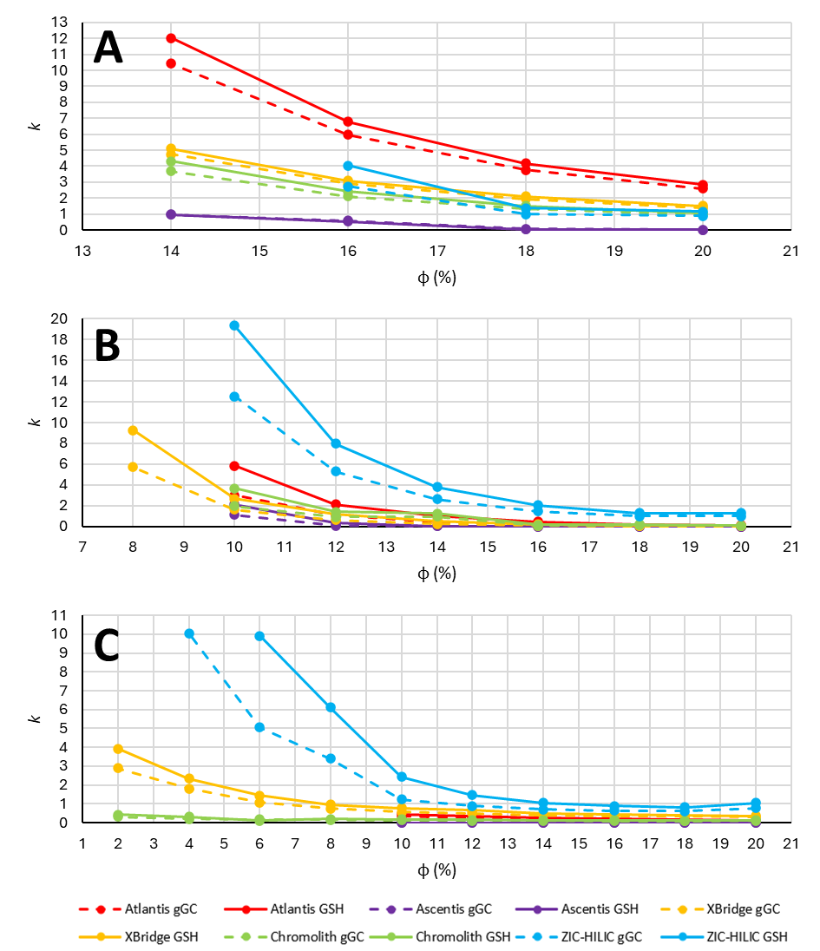
Figure S1
Dependence of the retention factor (k) on the volume fraction of the aqueous component (φ) for gGC (dashed lines) and GSH (solid lines). Isocratic analyses were performed using three different mobile phases: (A) 5 mM ammonium formate with 0.2% formic acid, (B) 5 mM ammonium bicarbonate, and (C) 0.05% trifluoroacetic acid (TFA). Color coding corresponds to the individual tested stationary phases.

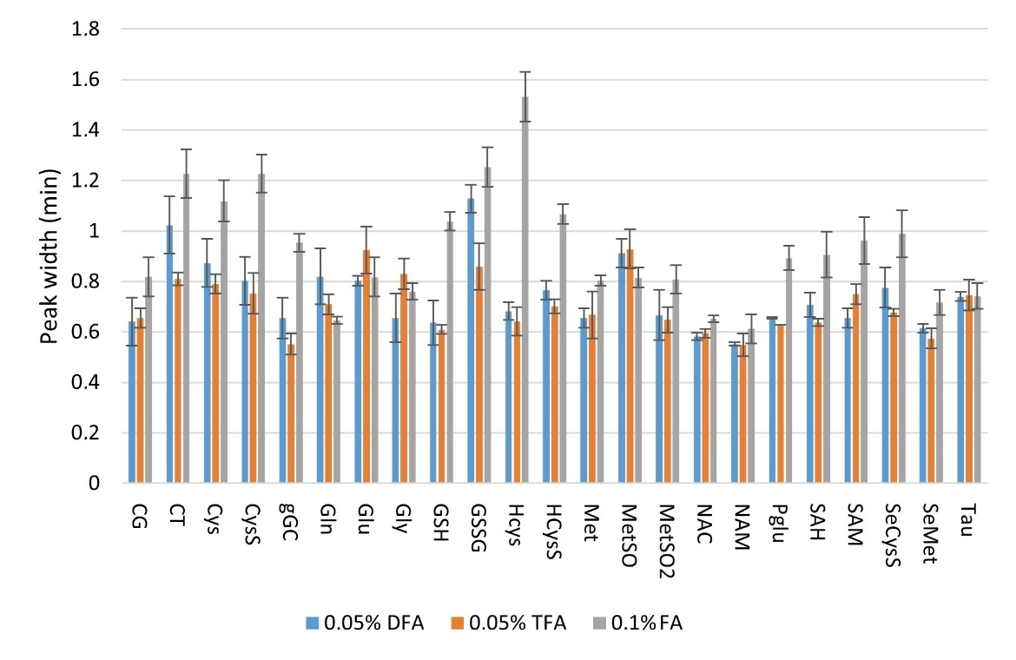
Figure S2
The effect of the acidic additive in the mobile phase on the peak width. Gradient separation performed on the ZIC HILIC column (150 × 2.1 mm, 3.5 µm, 100Å), mobile phase consisted of 0.05-0.1% (v/v) FA/DFA/TFA in water (mobile phase A) and 0.05-0.1% FA/DFA/TFA (v/v) in acetonitrile (mobile phase B); linear gradient elution (2% to 70% mobile phase A in 20 min; 8 min equilibration), flow-rate 0.4 mL/min, temperature 30 °C.

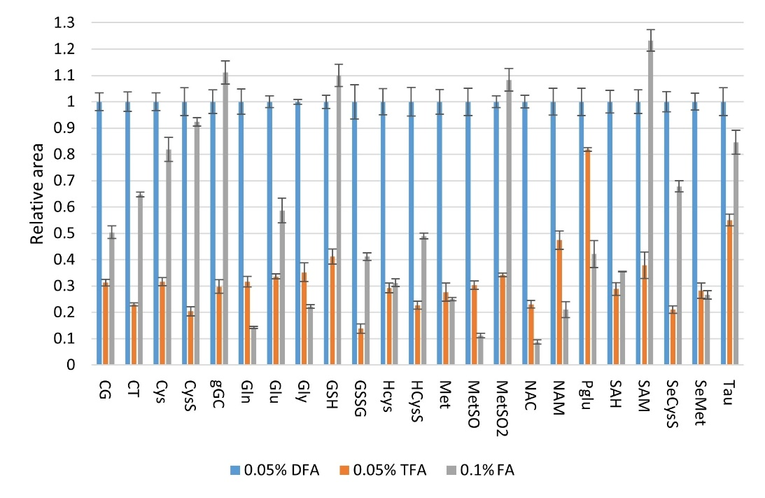
Figure S3
The relative effect of the acidic additive in the mobile phase on the detector response (peak area related to the mobile phase with DFA). Gradient separation performed on the ZIC HILIC column (150 × 2.1 mm, 3.5 µm, 100Å), mobile phase consisted of 0.05-0.1% (v/v) FA/DFA/TFA in water (mobile phase A) and 0.05-0.1% FA/DFA/TFA (v/v) in acetonitrile (mobile phase B); linear gradient elution (2% to 70% mobile phase A in 20 min; 8 min equilibration), flow-rate 0.4 mL/min, temperature 30 °C.

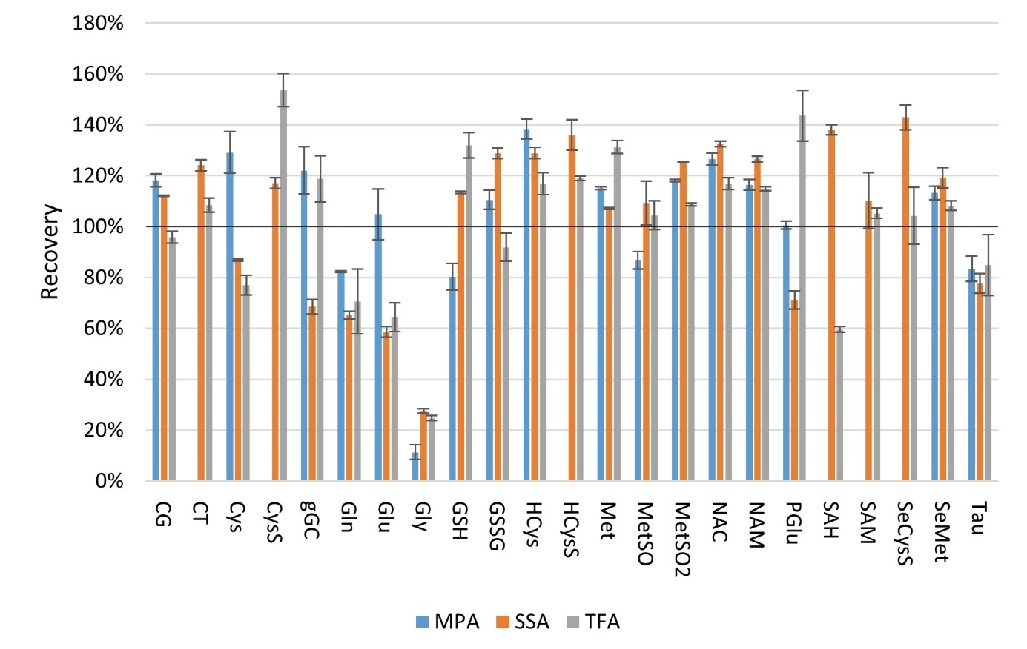
Figure S4
The matrix effects after extraction using different acid solutions.

Table S5
Linearity of three standard additions (SA) at low, medium, and high concentration (Table S2). Limits of quantification (LOQ) and limits of detection (LOD) for each analyte determined using signal-to-noise ratio 10:1, and 3:1, respectively.
Analyte | Low Mean R² | Medium Mean R² | High Mean R² | LOQ (ng/mL) | LOD (ng/mL)
CG | 0.9991 | 0.9996 | 0.9941 | 5 | 1.5
CT | 0.9917 | 0.9996 | 0.9999 | 5 | 1.5
Cys | 0.9997 | 0.9997 | 0.9991 | 5 | 1.5
CysS | 0.9957 | 0.9996 | 0.9999 | 5 | 1.5
gGC | 0.9945 | 0.9999 | 0.9999 | 5 | 1.5
Gln | 0.9996 | 0.9990 | 0.9995 | 5 | 1.5
Glu | 0.9988 | 0.9998 | 0.9994 | 5 | 1.5
Gly | 0.9985 | 0.9997 | 0.9995 | 5 | 1.5
GSH | 0.9988 | 0.9983 | 0.9998 | 5 | 1.5
GSSG | 0.9936 | 0.9983 | 0.9996 | 5 | 1.5
HCys | 0.9998 | 0.9996 | 0.9988 | 5 | 1.5
HCysS | 0.9971 | 0.9997 | 0.9999 | 1 | 0.3
Met | 0.9994 | 0.9999 | 0.9997 | 1 | 0.3
MSO | 0.9986 | 0.9997 | 0.9997 | 5 | 1.5
MSO2 | 0.9992 | 0.9999 | 0.9974 | 5 | 1.5
NAC | 0.9998 | 0.9999 | 0.9995 | 5 | 1.5
NAM | 0.9999 | 0.9998 | 0.9997 | 0.5 | 0.15
PGlu | 0.9988 | 0.9995 | 0.9965 | 5 | 1.5
SAH | 0.9976 | 0.9999 | 0.9999 | 1 | 0.3
SAM | 0.9739 | 0.9998 | 0.9992 | 5 | 1.5
Tau | 0.9995 | 0.9997 | 0.9968 | 5 | 1.5
GSH/IS | 0.9993 | 0.9976 | 0.9918 | 5 | 1.5
Glu/IS | 0.9975 | 0.9978 | 0.9997 | 5 | 1.5

Table S6
Intra-day precision (expressed as coefficient of variance, CV) and accuracy (expressed as mean recovery, RE) of three standard addition concentration levels - low (L), medium (M), and high (H) (Table S2). Number of experiments n = 3.
INTRADAY | L Mean RE (%) | L CV (%) | M Mean RE (%) | M CV (%) | H Mean RE (%) | H CV (%)
CG | 109 | 0.4 | 106 | 2.1 | 117 | 1.0
CT | 91 | 0.8 | 99 | 0.5 | 97 | 3.1
Cys | 103 | 1.9 | 109 | 1.2 | 114 | 0.9
CysS | 93 | 2.2 | 100 | 1.3 | 98 | 2.9
gGC | 102 | 4.2 | 108 | 1.9 | 100 | 1.7
Gln | 115 | 1.8 | 112 | 0.4 | 96 | 4.8
Glu | 121 | 0.5 | 115 | 0.7 | 108 | 2.2
Gly | 90 | 1.3 | 103 | 2.6 | 105 | 3.8
GSH | 125 | 0.9 | 112 | 0.8 | 98 | 4.6
GSSG | 85 | 1.5 | 88 | 2.6 | 107 | 3.0
HCys | 102 | 3.0 | 110 | 1.9 | 95 | 2.6
HCysS | 97 | 1.0 | 101 | 2.6 | 98 | 3.1
Met | 96 | 1.4 | 103 | 2.6 | 105 | 3.2
MSO | 105 | 1.4 | 100 | 2.9 | 101 | 3.3
MSO2 | 112 | 2.4 | 106 | 0.8 | 112 | 0.4
NAC | 101 | 1.9 | 105 | 1.4 | 97 | 3.4
NAM | 99 | 0.9 | 101 | 1.8 | 104 | 2.7
PGlu | 87 | 3.1 | 108 | 2.7 | 115 | 1.2
SAH | 98 | 1.9 | 99 | 1.5 | 98 | 3.2
SAM | 86 | 1.9 | 95 | 0.9 | 96 | 1.6
Tau | 116 | 2.2 | 109 | 1.7 | 115 | 0.4
GSH/IS | 99 | 3.5 | 104 | 1.2 | 107 | 1.8
Glu/IS | 95 | 4.4 | 92 | 0.5 | 92 | 1.9

Table S7
Inter-day precision (expressed as coefficient of variance, CV) and accuracy (expressed as mean recovery, RE) of three standard addition concentration levels - low (L), medium (M), and high (H) (Table S2). Number of experiments n = 9.
INTRADAY | L Mean RE (%) | L CV (%) | M Mean RE (%) | M CV (%) | H Mean RE (%) | H CV (%)
CG | 106 | 5.5 | 106 | 2.0 | 114 | 3.7
CT | 93 | 4.6 | 99 | 1.9 | 98 | 3.2
Cys | 107 | 5.6 | 109 | 2.9 | 111 | 3.8
CysS | 94 | 2.6 | 99 | 2.8 | 99 | 3.1
gGC | 106 | 4.2 | 107 | 2.7 | 101 | 4.3
Gln | 119 | 3.7 | 108 | 3.1 | 97 | 4.7
Glu | 120 | 2.4 | 109 | 4.5 | 108 | 4.0
Gly | 101 | 11.4 | 104 | 6.8 | 104 | 5.3
GSH | 120 | 3.3 | 112 | 0.9 | 97 | 3.5
GSSG | 89 | 4.4 | 88 | 2.5 | 104 | 3.6
HCys | 104 | 2.7 | 110 | 1.8 | 96 | 3.2
HCysS | 97 | 3.5 | 100 | 2.5 | 100 | 3.7
Met | 103 | 5.2 | 103 | 2.7 | 105 | 3.6
MSO | 105 | 4.4 | 102 | 2.6 | 102 | 4.4
MSO2 | 110 | 2.2 | 107 | 1.6 | 112 | 1.0
NAC | 106 | 4.6 | 105 | 2.1 | 98 | 3.9
NAM | 99 | 2.0 | 101 | 2.3 | 103 | 3.7
PGlu | 90 | 4.1 | 103 | 4.2 | 112 | 2.7
SAH | 99 | 1.9 | 99 | 2.0 | 98 | 3.5
SAM | 97 | 9.1 | 96 | 2.5 | 95 | 3.5
Tau | 109 | 5.6 | 108 | 2.0 | 114 | 1.2
GSH/IS | 100 | 3.6 | 103 | 3.1 | 109 | 2.0
Glu/IS | 104 | 8.9 | 93 | 2.8 | 93 | 1.8

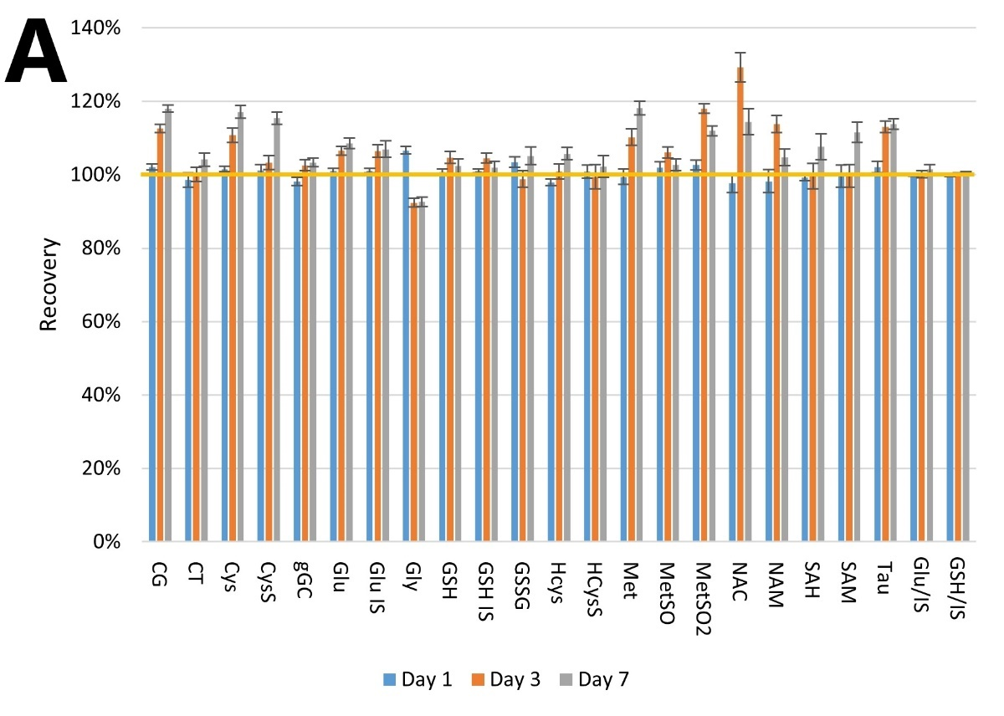
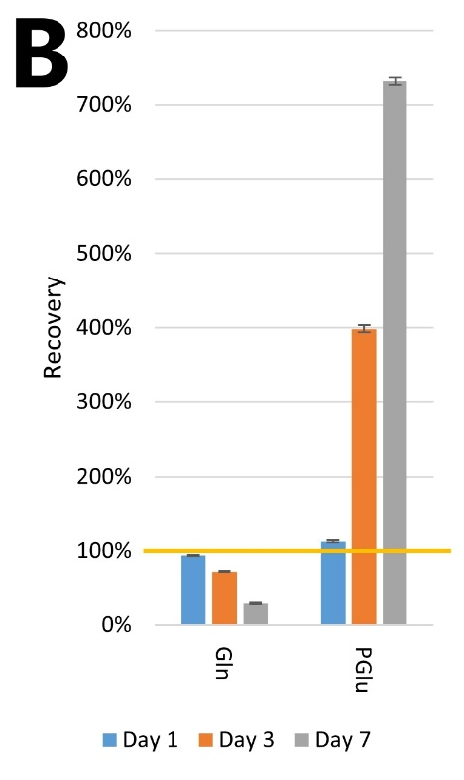
Figure S5
A: The stability of the analytes in the autosampler conditions (10 °C). B: The stability of Gln and PGlu in the autosampler conditions (10 °C).

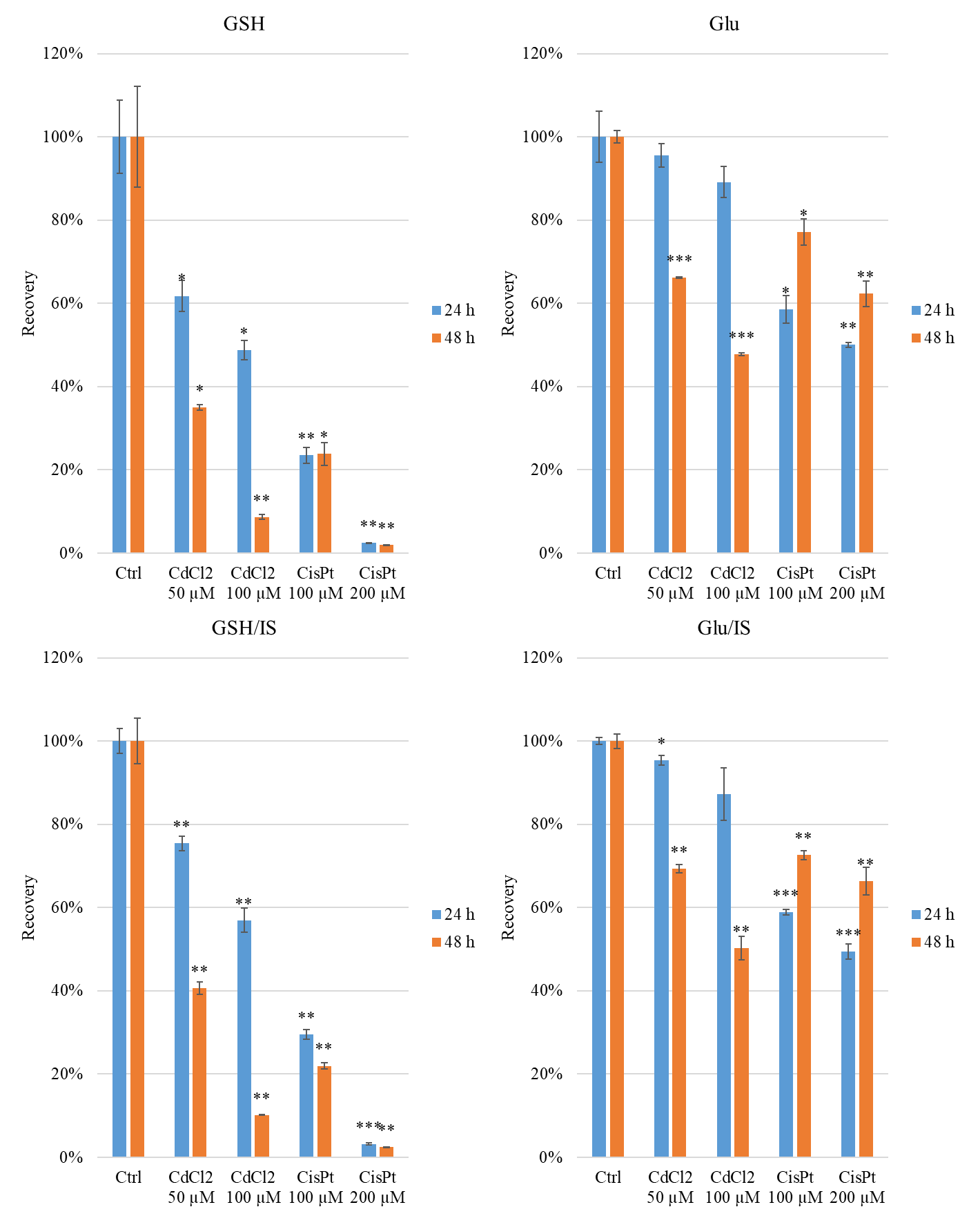
Figure S6
The relative content of GSH, Glu, and GSH/IS, Glu/IS in A549 human lung adenocarcinoma cancer cells after incubation with 50-100 µmol/L CdCl₂ and 100-200 µmol/L cisPt for 24 and 48 hours. The significand differences between incubated samples and control samples (Ctrl) described as ns: not significant; * for p < 0.05; ** for p < 0.01; *** for p < 0.001.

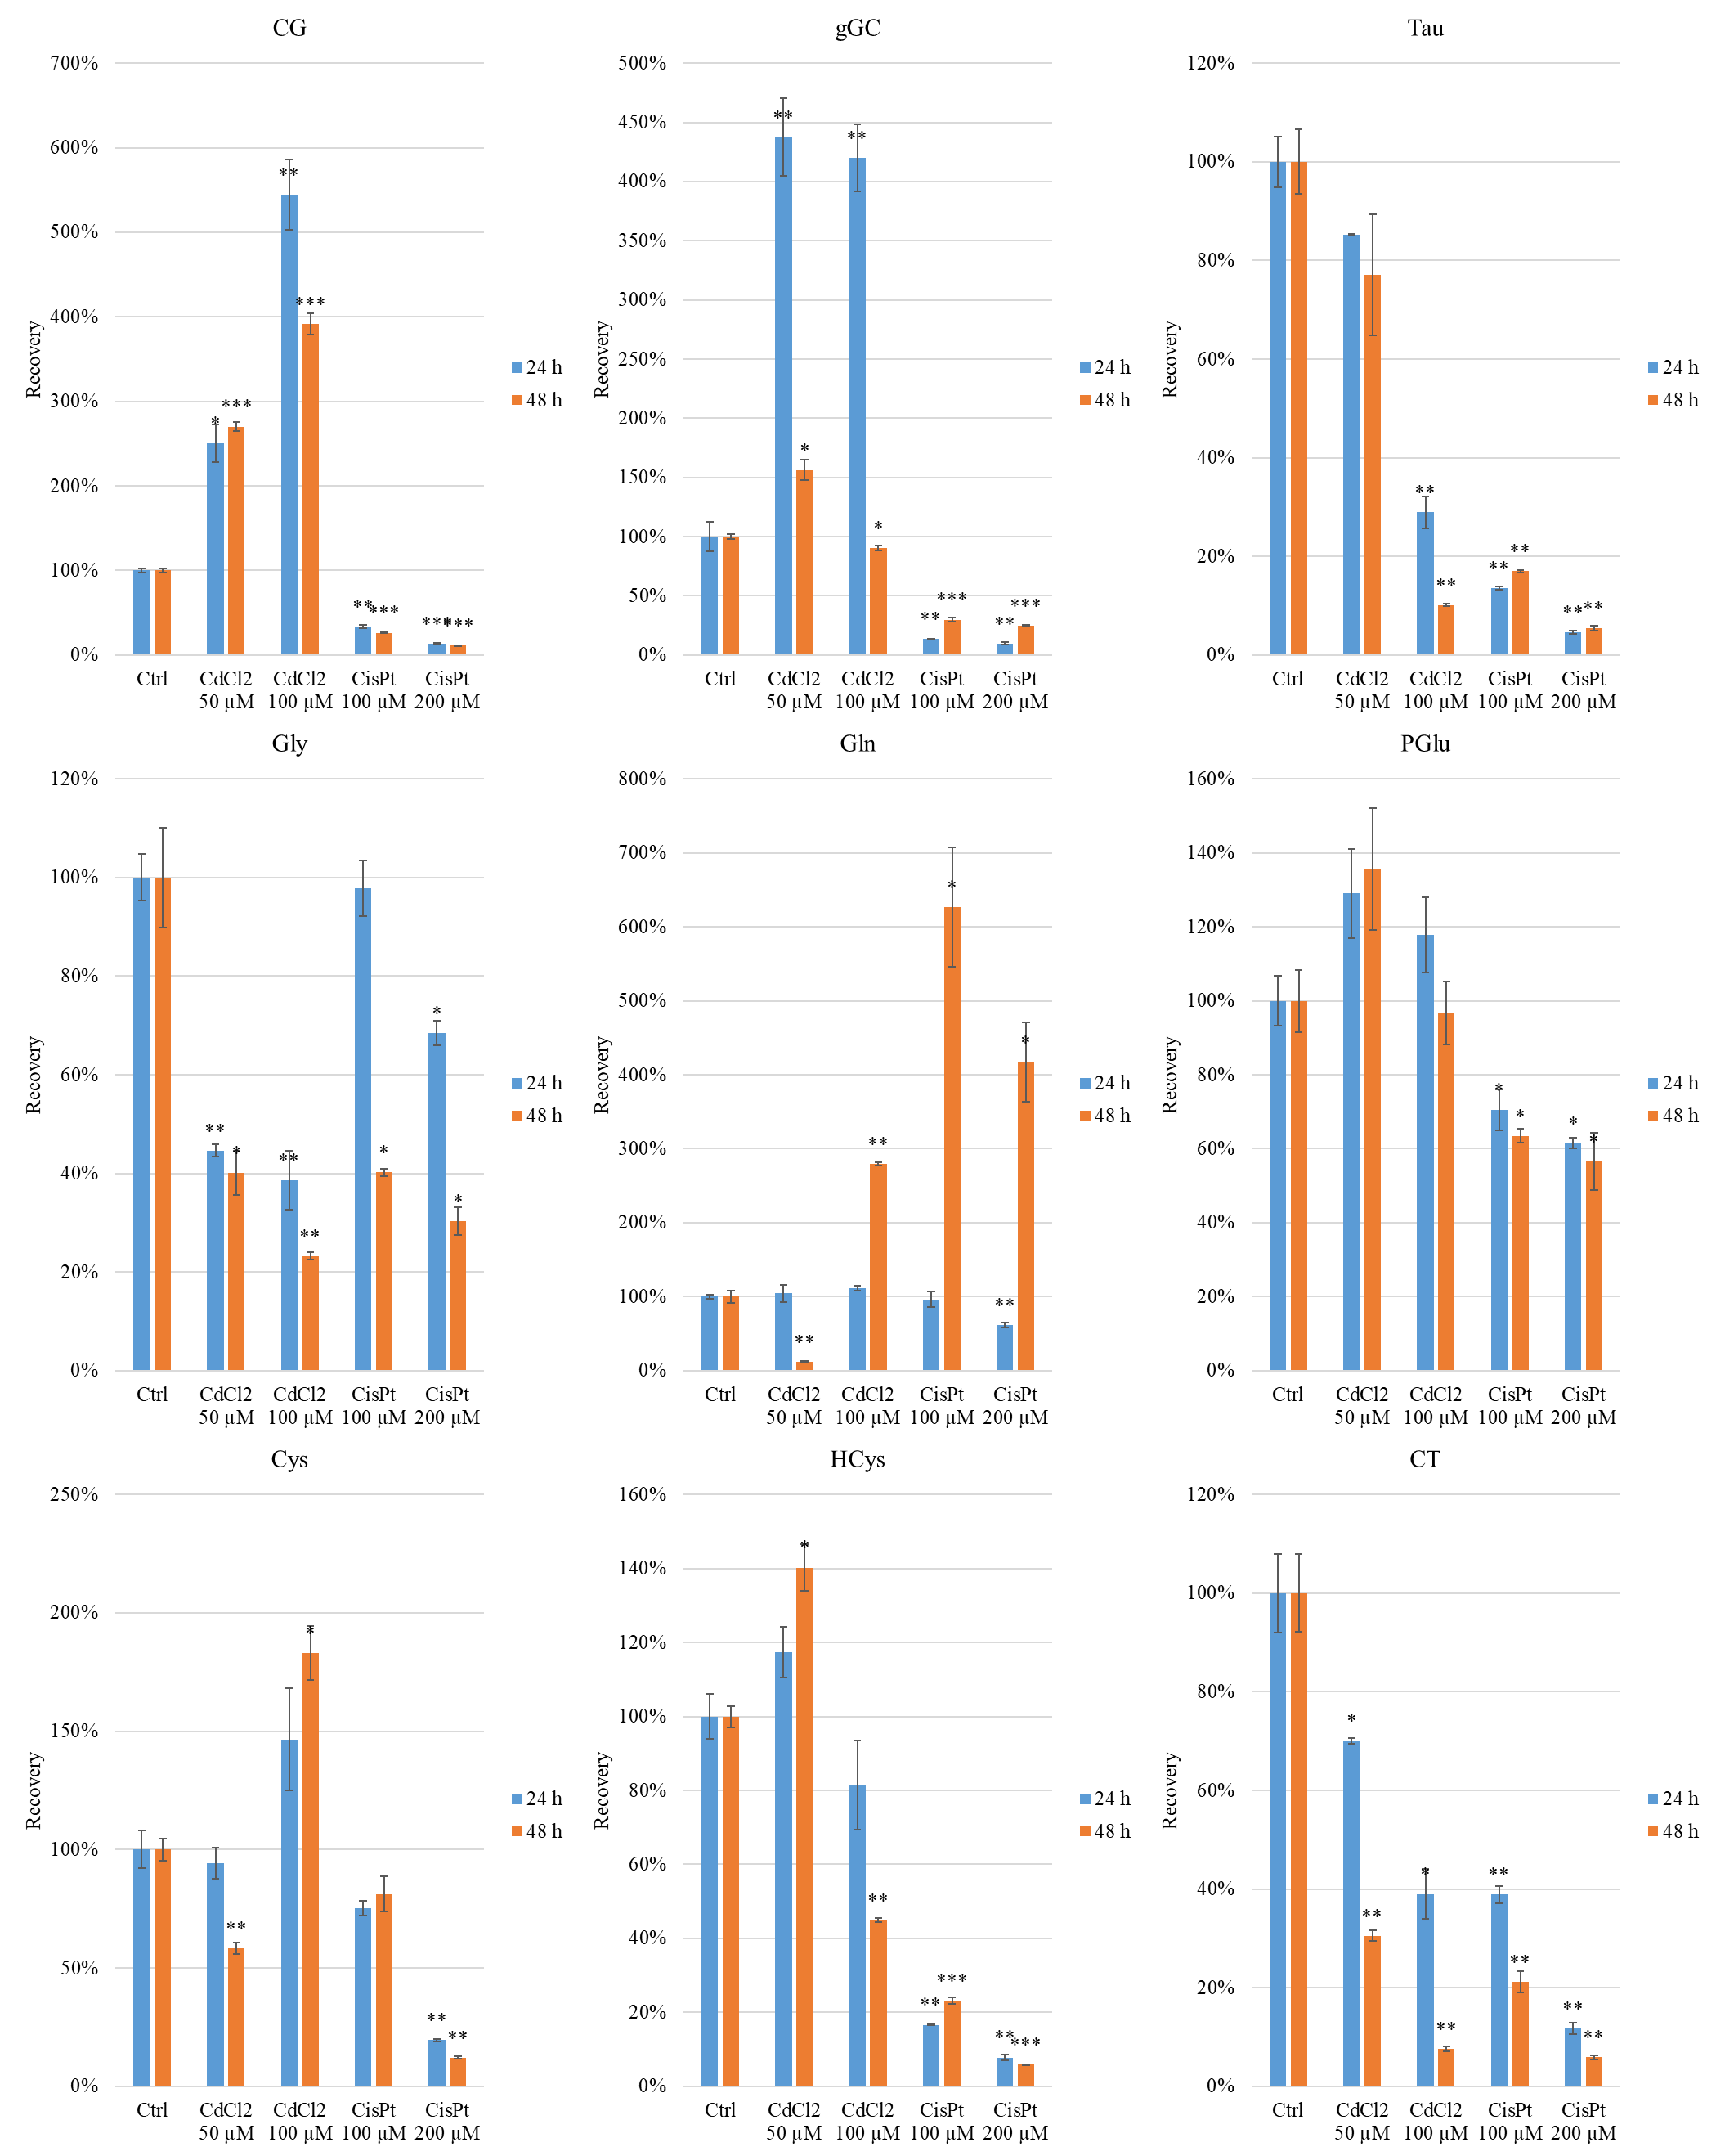
Figure S7
The relative content of CG, gGC, Tau, Gly, Gln, PGlu, Cys, HCys, and CT in A549 human lung adenocarcinoma cancer cells after incubation with 50-100 µmol/L CdCl₂ and 100-200 µmol/L cisPt for 24 and 48 hours. The significand differences between incubated samples and control samples (Ctrl) described as ns: not significant; * for p < 0.05; ** for p < 0.01; *** for p < 0.001.

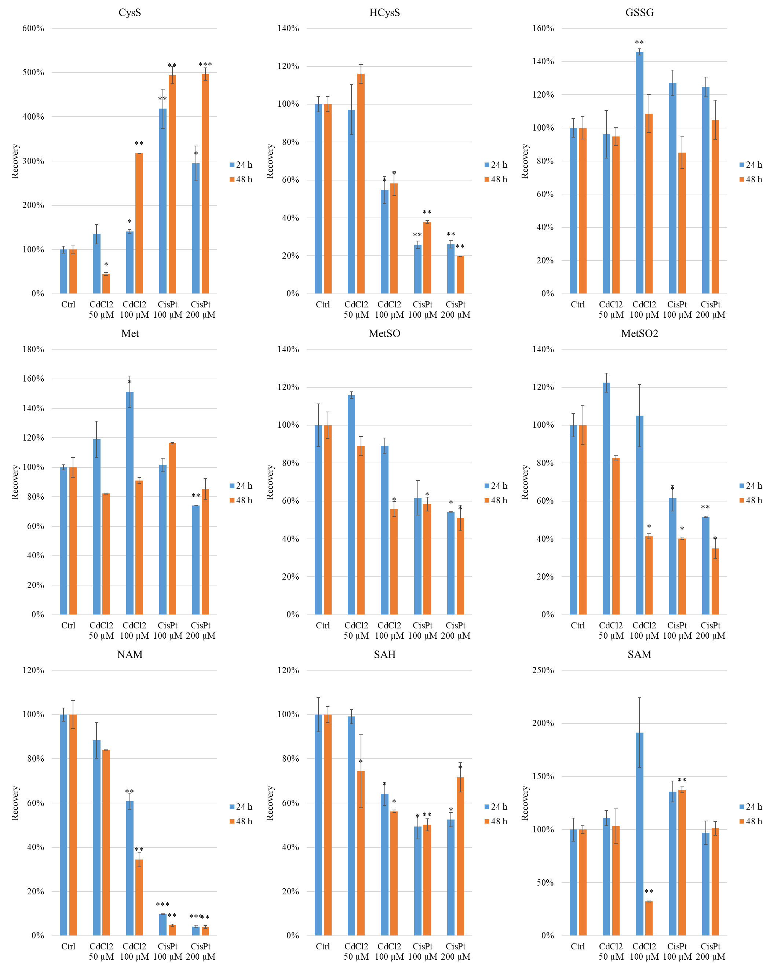
Figure S8
The relative content of CysS, HCysS, GSSG, Met, MetSO, MetSO2, NAC, SAH, and SAM in A549 human lung adenocarcinoma cancer cells after incubation with 50-100 µmol/L CdCl₂ and 100-200 µmol/L cisPt for 24 and 48 hours. The significand differences between incubated samples and control samples (Ctrl) described as ns: not significant; * for p < 0.05; ** for p < 0.01; *** for p < 0.001.

Table S8
The absolute concentrations of affected A549 samples and controls after 24 and 48 h
C (ng/mL) | CTRL  24 h | CdCl₂  50 µM 24 h | CdCl₂  100 µM 24 h | cisPt  100 µM 24 h | cisPt  200 µM 24 h | CTRL  48 h | CdCl₂  50 µM 48 h | CdCl₂  100 µM 48 h | cisPt  100 µM 48 h | cisPt  200 µM 48 h
CG | 53.37 | 133.59 | 290.38 | 17.91 | 7.11 | 34.64 | 93.57 | 135.59 | 9.10 | 3.81
CT | 96.90 | 67.86 | 37.78 | 37.68 | 11.39 | 312.49 | 95.32 | 23.59 | 66.02 | 18.42
Cys | 37.46 | 35.34 | 54.89 | 28.23 | 7.30 | 33.32 | 19.42 | 61.02 | 27.06 | 4.03
CysS | 8.47 | 11.42 | 11.89 | 35.43 | 24.98 | 13.21 | 5.88 | 41.88 | 65.29 | 65.61
gGC | 337.54 | 1476.79 | 1417.37 | 44.90 | 32.95 | 104.64 | 163.49 | 94.60 | 31.22 | 26.06
Gln | 6439.56 | 6737.16 | 7171.61 | 6189.90 | 3949.89 | 647.61 | 77.63 | 1809.07 | 4057.96 | 2699.63
Gly | 404.72 | 180.60 | 156.43 | 396.20 | 276.96 | 1180.31 | 473.83 | 274.27 | 474.45 | 356.88
GSSG | 19.19 | 18.45 | 27.97 | 24.41 | 23.93 | 29.96 | 28.40 | 32.53 | 25.48 | 31.42
HCys | 17.47 | 20.50 | 14.24 | 2.91 | 1.36 | 13.69 | 19.20 | 6.14 | 3.17 | 0.80
HCysS | 5.92 | 5.75 | 3.24 | 1.53 | 1.55 | 12.30 | 14.27 | 7.17 | 4.66 | 2.45
Met | 321.80 | 382.97 | 486.88 | 326.90 | 238.55 | 285.30 | 234.45 | 259.75 | 332.20 | 243.40
MetSO | 52.43 | 60.73 | 46.71 | 32.34 | 28.41 | 56.42 | 50.18 | 31.44 | 32.97 | 28.79
MetSO2 | 8.26 | 10.12 | 8.68 | 5.07 | 4.27 | 12.14 | 10.05 | 5.01 | 4.88 | 4.24
NAM | 5.68 | 5.01 | 3.46 | 0.56 | 0.24 | 4.77 | 4.01 | 1.65 | 0.23 | 0.19
PGlu | 605.32 | 780.87 | 713.22 | 426.95 | 372.20 | 727.07 | 986.67 | 702.57 | 461.40 | 411.35
SAH | 5.08 | 5.04 | 3.26 | 2.51 | 2.67 | 6.28 | 4.67 | 3.53 | 3.15 | 4.50
SAM | 365.61 | 405.44 | 699.73 | 496.71 | 354.61 | 362.06 | 373.16 | 116.91 | 497.67 | 365.98
Tau | 3737.32 | 3186.04 | 1081.99 | 506.73 | 170.62 | 2750.10 | 2119.09 | 278.31 | 466.50 | 150.34
GSH/IS | 13518.21 | 10191.80 | 7698.29 | 3997.88 | 431.41 | 12962.91 | 5266.62 | 1319.22 | 2848.55 | 318.14
Glu/IS | 6440.81 | 6141.99 | 5620.84 | 3793.12 | 3179.52 | 5364.64 | 3718.23 | 2693.63 | 3893.49 | 3559.21
GSH | 14416.91 | 8901.94 | 7030.51 | 3388.93 | 358.26 | 12326.89 | 4312.36 | 1065.82 | 2934.09 | 243.83
Glu | 6807.43 | 6502.53 | 6065.64 | 3985.51 | 3408.84 | 5264.85 | 3486.68 | 2515.34 | 4061.97 | 3280.96

Table S9
The two-sample t-test p-values of affected A549 samples after 24 and 48 h compared with control (ns not significant; * p-value < 0.05; ** p-value < 0.01; *** p-value < 0.001)
p-value | CdCl₂  50 µM 24 h | CdCl₂  100 µM 24 h | cisPt  100 µM 24 h | cisPt  200 µM 24 h | CdCl₂  50 µM 48 h | CdCl₂  100 µM 48 h | cisPt  100 µM 48 h | cisPt  200 µM 48 h
CG | * | ** | ** | *** | *** | *** | *** | ***
CT | * | * | ** | ** | ** | ** | ** | **
Cys | ns | ns | ns | ** | ** | * | ns | **
CysS | ns | * | ** | * | * | ** | ** | ***
gGC | ** | ** | ** | ** | * | * | *** | ***
Gln | ns | ns | ns | ** | ** | ** | * | *
Gly | ** | ** | ns | * | * | ** | * | *
GSSG | ns | ** | ns | ns | ns | ns | ns | ns
HCys | ns | ns | ** | ** | * | ** | *** | ***
HCysS | ns | * | ** | ** | ns | * | ** | **
Met | ns | * | ns | ** | ns | ns | ns | ns
MetSO | ns | ns | ns | * | ns | * | * | *
MetSO2 | ns | ns | * | ** | ns | * | * | *
NAM | ns | ** | *** | *** | ns | ** | ** | **
PGlu | ns | ns | * | * | ns | ns | * | *
SAH | ns | * | * | * | * | * | ** | *
SAM | ns | ns | ns | ns | ns | ** | ** | ns
Tau | ns | ** | ** | ** | ns | ** | ** | **
GSH/IS | ** | ** | ** | *** | ** | ** | ** | **
Glu/IS | * | ns | *** | *** | ** | ** | ** | **
GSH | * | * | ** | ** | * | ** | * | **
Glu | ns | ns | * | ** | *** | *** | * | **

* Corresponding author, e-mail: Petr.Cesla@upce.cz

