Supplementary information

Assessing PFAS Total in landfill leachate through multiple extraction methods and fluorine mass balance

Sofia Levalier¹, Viktor Sjöberg¹, Leo Yeung¹, Anna Kärrman^{1*}
¹ Man-Technology-Environment (MTM) Research Centre, School of Science and Technology, Örebro University, Sweden, SE-701 82
* Corresponding author: Anna Kärrman, E-mail: anna.karrman@oru.se

Materials and methods:

The extraction procedure was adapted from previously published methods with modifications. For WAX, the extraction was adapted from ISO 21675:2019 [1] and the pH 2 condition was selected as a method-specific modification based on internal laboratory optimization, which showed improved recoveries of ultra-short chain PFAS under acidic loading conditions. For HLB, the extraction procedure was adapted from a previously published method using Oasis HLB cartridges, with near neutral loading conditions [2,3]. For WCX, the extraction protocol was adapted from a previously published method [4]pH 9 was applied during loading to evaluate the sorbent under alkaline conditions.

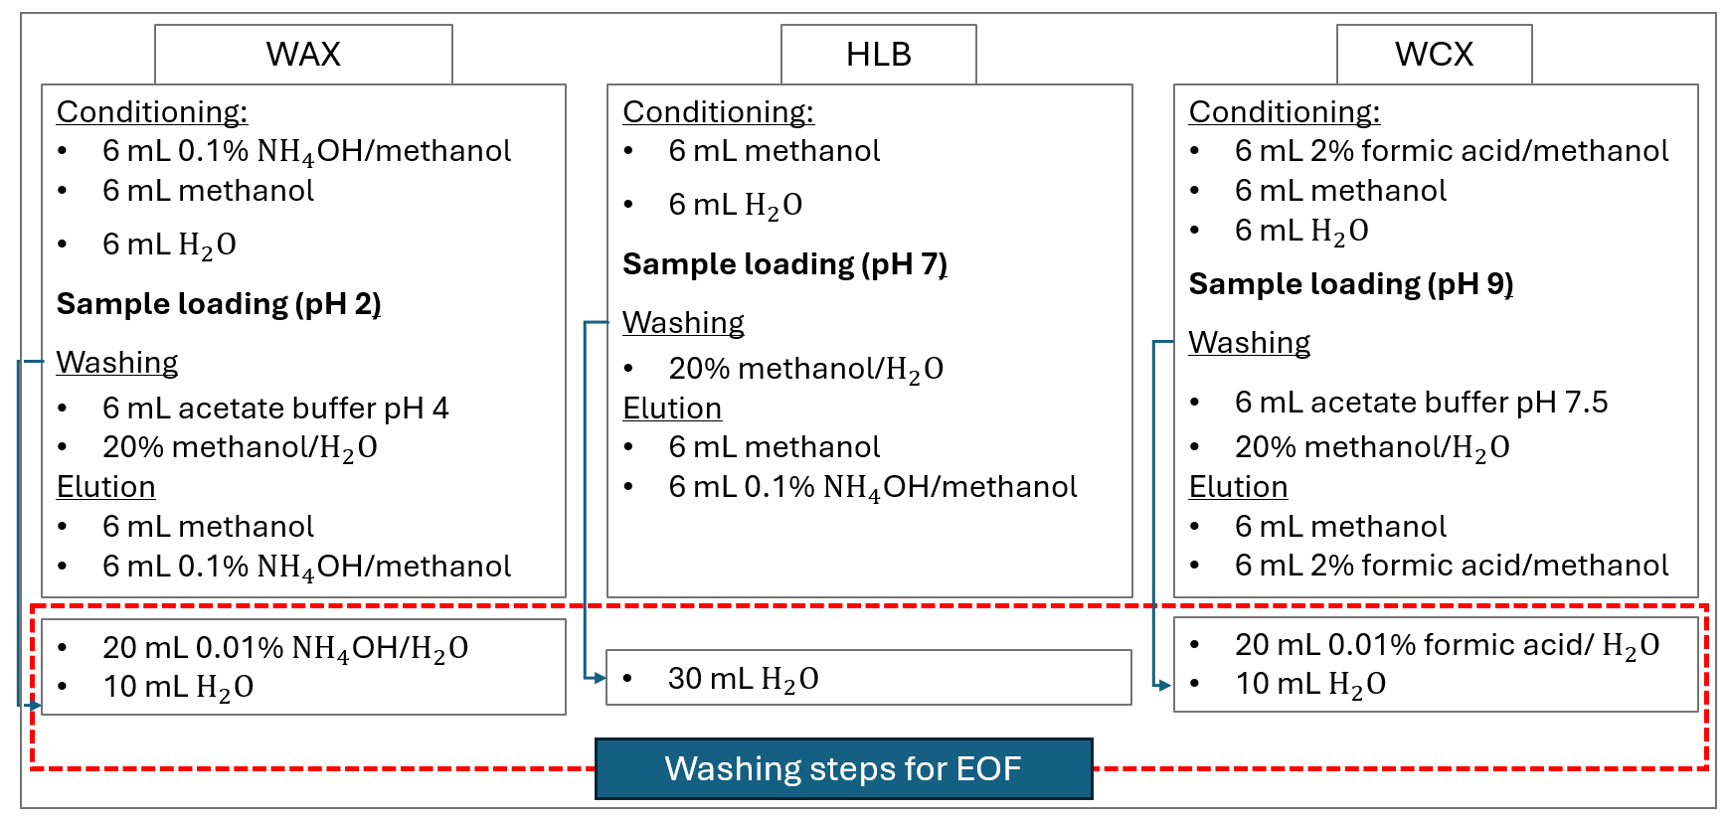
Figure S1: SPE-extraction scheme

Table S1: List of native standards
Group | Acronym | Name
PFCA | TFA | Trifluoroacetic acid
PFCA | PFPrA | Perfluoropropionic acid
PFCA | PFBA | Perfluorobutanoic acid
PFCA | PFPeA | Perfluoropentanoic acid
PFCA | PFHxA | Perfluorohexanoic acid
PFCA | PFHpA | Perfluoroheptanoic acid
PFCA | PFOA | Perfluorooctanoic acid
PFCA | PFNA | Perfluorononanoic acid
PFCA | PFDA | Perfluorodecanoic acid
PFCA | PFUnDA | Perfluoroundecanoic acid
PFCA | PFDoDA | Perfluorododecanoic acid
PFCA | PFTrDA | Perfluorotridecanoic acid
PFCA | PFTDA | Perfluorotetradecanoic acid
PFCA | PFHxDA | Perfluorohexadecanoic acid
PFCA | PFODA | Perfluorooctadecanoic acid
PFSA | TFMS | Trifluoromethanesulfonic acid
PFSA | PFEtS | Perfluoroethane sulfonic acid
PFSA | PFPrS | Perfluoropropane sulfonic acid
PFSA | PFBS | Perfluorobutane sulfonic acid
PFSA | PFPeS | Perfluoropentane sulfonic acid
PFSA | PFHxS | Perflurohexane sulfonic acid
PFSA | PFHpS | Perfluoroheptane sulfonic acid
PFSA | PFOS | Perfluorooctane sulfonic acid
PFSA | PFNS | Perfluorononane sulfonic acid
PFSA | PFDS | Perfluorodecane sulfonic acid
PFSA | PFDoDS | Perfluorododecane sulfonic acid
FTSA | 4:2 FTSA | 4:2 Fluorotelomer sulfonic acid
FTSA | 6:2 FTSA | 6:2 Fluorotelomer sulfonic acid
FTSA | 8:2 FTSA | 8:2 Fluorotelomer sulfonic acid
FTSA | 10:2 FTSA | 10:2 Fluorotelomer sulfonic acid
FTCA | 3:3 FTCA | 3:3 Fluorotelomer carboxylic acid
FTCA | 5:3 FTCA | 5:3 Fluorotelomer carboxylic acid
FTCA | 7:3 FTCA | 7:3 Fluorotelomer carboxylic acid
FTUCA | 6:2 FTUCA | 6:2 Fluorotelomer unsaturated carboxylic acid
FTUCA | 8:2 FTUCA | 8:2 Fluorotelomer unsaturated carboxylic acid
FTUCA | 10:2 FTUCA | 10:2 Fluorotelomer unsaturated carboxylic acid
PFPiA | C6/C6 PFPiA | Bis (perfluorohexyl) phosphinic acid
PFPiA | C8/C8 PFPiA | Bis (perfluorooctyl) phosphinic acid
FASA | FBSA | Perfluorobutane sulfonamide
FASA | Me-FBSA | Methyl perfluorobutane sulfonamide
FASA | FHxSA | Perfluorohexane sulfonamide
FASA | Me-FHxSA | Methyl perfluorohexane sulfonamide
PFECA | HFPO-DA | Hexafluoropropylene oxide dimer acid
PFECHS | PFECHS | Perfluoroethylcyclohexane sulfonic acid
PFESA | 6:2 Cl-PFESA | 6:2 chlorinated polyfluorinated ether sulfonate
PFESA | 8:2 Cl-PFESA | 8:2 chlorinated polyfluorinated ether sulfonate
Zwitterionic PFAS | N-AP-FBSA | N-[3-(dimethylamino)propyl]-(perfluorobutane-1-sulfonamide)
Zwitterionic PFAS | N-AP-PFeSA | Perfluoropentane sulfonamido amine
Zwitterionic PFAS | N-AP-FHxSA | Perfluorohexane sulfonamido amine
Zwitterionic PFAS | 5:3 FTB | 5:3 Fluorotelomer betaine
Zwitterionic PFAS | TAmP-FHxSA | N-[3-(Trimethylammonium)propyl]perfluoro-1-hexanesulfonamidate
Zwitterionic PFAS | N-AP-6:2 FOSA | 6:2 Fluorotelomer sulfonamide amine
Zwitterionic PFAS | OXAmP-6:2 FOSA | 6:2 Fluorotelomer sulfonamide amine oxide
Zwitterionic PFAS | N-AP-FOSA | 6:2 Fluorotelomer sulfonamide alkylbetaine
Zwitterionic PFAS | CMAmP-6:2 FOSA | 6:2 Fluorotelomer sulfonamide alkylbetaine
Bis-FASI | FMeSI | Bis[(trifluoromethylsulfonyl)imide
Bis-FASI | PFEtSI | Bis(perfluoroethylsulfonyl)imide
Bis-FASI | PFBSI | Bis(perfluorobutylsulfonyl)amide
Inorganic anions | BF₄⁻ | Tetrafluoroborate
Inorganic anions | PF₆⁻ | Hexafluorophosphate

Table S2: List of isotopically labeled standards: extraction standards were spiked prior extraction and injection standards were spiked prior analysis.
Acronym | Name | Type of standard
¹³C₂ TFA | Trifluoro-[1,2-¹³C₂]acetic acid | Extraction standard
¹³C₃ PFPrA | Perfluoro-[2,2,3,3,3-¹³C₃]propanoic acid | Extraction standard
¹³C₄ PFBA | Perfluoro-n-[2,3,4-¹³C₄]butanoic acid | Extraction standard
¹³C₅ PFPeA | Perfluoro-n-[3,4,5-¹³C₅]pentanoic acid | Extraction standard
¹³C₅ PFHxA | Perfluoro-n-[1,2-¹³C₅]hexanoic acid | Extraction standard
¹³C₄ PFHpA | Perfluoro-n-[1,2,3,4-¹³C₄]heptanoic acid | Extraction standard
¹³C₈ PFOA | Perfluoro-n-[¹³C₈]octanoic acid | Extraction standard
¹³C₉ PFNA | Perfluoro-n-[¹³C₉]nonanoic acid | Extraction standard
¹³C₆-PFDA | Perfluoro-n-[¹³C₆]decanoic acid | Extraction standard
¹³C₇ PFUnDA | Perfluoro-n-[1,2,3,4,5,6,7-¹³C₇]undecanoic acid | Extraction standard
¹³C₂ PFDoDA | Perfluoro-n-[1,2-¹³C₂]dodecanoic acid | Extraction standard
¹³C₂ PFTDA | Perfluoro-n-[1,2-¹³C₂]tetradecanoic acid | Extraction standard
¹³C₂ PFHxDA | Perfluoro-n-[1,2-13C2]hexadecanoic acid | Extraction standard
¹³C₃-PFBS | Sodium perfluoro-1-[2,3,4-¹³C₃]butanesulfonate | Extraction standard
¹³C₃-PFHxS | Sodium perfluoro-1-[¹³C₃]hexanesulfonate | Extraction standard
¹³C₈-PFOS | Sodium perfluoro-1-[¹³C₈]octanesulfonate | Extraction standard
¹³C₂-4:2 FTSA | Sodium 1H,1H,2H,2H-perfluoro-1-[1,2-¹³C₂]hexane sulfonate | Extraction standard
¹³C₂-6:2 FTSA | Sodium 1H,1H,2H,2H-perfluoro-1-[1,2-¹³C₂]octane sulfonate | Extraction standard
¹³C₂-8:2 FTSA | Sodium 1H,1H,2H,2H-perfluoro-1-[1,2-¹³C₂]decane sulfonate | Extraction standard
¹³C₂ 6:2 FTUCA | 2H-perfluoro-[1,2-13C2]-2-decenoic acid | Extraction standard
¹³C₂ 8:2 FTUCA | 2H-perfluoro-[1,2-¹³C₂]2-octenoic acid | Extraction standard
²H₃ N-MeFOSA | N-methyl-²H₃-perfluoro-1-octanesulfonamide | Extraction standard
¹³C₃ CMAmP-6:2 FOSA | ¹³C₃-6:2 fluorotelomer sulfonamide alkylbetaine | Extraction standard
¹³C₃ PFBA | Perfluoro-n-[2,3,4-¹³C₃]butanoic acid | Injection standard
¹³C₃ PFPeA | Perfluoro-n-[3,4,5-¹³C₃]pentanoic acid | Injection standard
¹³C₂ PFHxA | Perfluoro-n-[1,2-¹³C₂]hexanoic acid | Injection standard
¹³C₂ PFOA | Perfluoro-n-[¹³C₂]octanoic acid | Injection standard
¹³C₅ PFNA | Perfluoro-n-[¹³C₅]nonanoic acid | Injection standard
¹³C₂-PFDA | Perfluoro-n-[¹³C₂]decanoic acid | Injection standard
¹³C2 PFUnDA | Perfluoro-n-[1,2,3,4,5,6,7-¹³C₂]undecanoic acid | Injection standard
¹⁸O₂-PFHxS | Sodium perfluoro-1-[¹⁸O₂]hexanesulfonate | Injection standard
¹³C₄-PFOS | Sodium perfluoro-1-[¹³C₄]octanesulfonate | Injection standard

Table S3: Target compounds, the MRM transitions and SRM, and corresponding surrogate standard used for quantification.
Compound | Quantifier m/z | Surrogate standard
TFA | 113 > 69 | ¹³C₂ TFA
PFPrA | 163 > 119 | ¹³C₃ PFPrA
PFBA | 213 > 169 | ¹³C₄ PFBA
PFPeA | 263 > 219 | ¹³C₅ PFPeA
PFHxA | 313 > 269 | ¹³C₅ PFHxA
PFHpA | 363 > 319 | ¹³C₄ PFHpA
PFOA | 413 > 369 | ¹³C₈ PFOA
PFNA | 463 > 419 | ¹³C₉ PFNA
PFDA | 513 > 469 | ¹³C₆-PFDA
PFUnDA | 563 > 519 | ¹³C₇ PFUnDA
PFDoDA | 613 > 569 | ¹³C₂ PFDoDA
PFTrDA | 663 > 619 | ¹³C₂ PFDoDA
PFTDA | 713 > 669 | ¹³C₂ PFTDA
PFHxDA | 813 > 769 | ¹³C₂ PFHxDA
PFODA | 913 > 869 | ¹³C₂ PFHxDA
TFMS | 149 > 80 | ¹³C₃-PFBS
PFEtS | 199 > 80 | ¹³C₃-PFBS
PFPrS | 249 > 80 | ¹³C₃-PFBS
PFBS | 299 > 99 | ¹³C₃-PFBS
PFPeS | 349 > 99 | ¹³C₃-PFHxS
PFHxS | 399 > 99 | ¹³C₃-PFHxS
PFHpS | 449 > 99 | ¹³C₈-PFOS
PFOS | 499 > 99 | ¹³C₈-PFOS
PFNS | 549 > 99 | ¹³C₈-PFOS
PFDS | 599 > 99 | ¹³C₈-PFOS
PFDoDS | 699 > 99 | ¹³C₈-PFOS
4:2 FTSA | 327 > 307 | ¹³C₂-4:2 FTSA
6:2 FTSA | 427 > 407 | ¹³C₂-6:2 FTSA
8:2 FTSA | 527 > 507 | ¹³C₂-8:2 FTSA
10:2 FTSA | 627 > 607 | ¹³C₂-8:2 FTSA
3:3 FTCA | 241 >117 | ¹³C₂ 6:2 FTCA
5:3 FTCA | 341 > 237 | ¹³C₂ 6:2 FTUCA
7:3 FTCA | 441 > 337 | ¹³C₂ 8:2 FTUCA
6:2 FTUCA | 357 > 293 | ¹³C₂ 6:2 FTUCA
8:2 FTUCA | 457 > 393 | ¹³C₂ 8:2 FTUCA
10:2 FTUCA | 557 > 493 | ¹³C₂ 8:2 FTUCA
C6/C6 PFPiA | 701 > 401 | ¹³C₂ PFDoDA
C8/C8 PFPiA | 901 > 401 | ¹³C₂ PFTDA
FBSA | 298> 78 | ¹³C₄ PFBA
Me-FBSA | 312 > 112 | ¹³C₄ PFBA
FHxSA | 398 > 78 | ¹³C₃-PFHxS
Me-FHxSA | 412 > 169 | ²H₃-N-MeFOSA
HFPO-DA | 285 > 169 | ¹³C₅ PFHxA
PFECHS | 461 > 381 | ¹³C₈ PFOA
6:2 Cl-PFESA | 531 > 351 | ¹³C₈-PFOS
8:2 Cl-PFESA | 631>451 | ¹³C₈-PFOS
N-AP-FBSA | 385 > 85 | ¹³C₃ CMAmP-6:2 FOSA
N-AP-PFeSA | 435 > 85 | ¹³C₃ CMAmP-6:2 FOSA
N-AP-FHxSA | 485 > 85 | ¹³C₃ CMAmP-6:2 FOSA
5:3 FTB | 414> 58 | ¹³C₃ CMAmP-6:2 FOSA
TAmP-FHxSA | 499> 60 | ¹³C₃ CMAmP-6:2 FOSA
N-AP-6:2 FOSA | 513 > 58 | ¹³C₃ CMAmP-6:2 FOSA
OXAmP-6:2 FOSA | 529 > 440 | ¹³C₃ CMAmP-6:2 FOSA
N-AP-FOSA | 585 > 85 | ¹³C₃ CMAmP-6:2 FOSA
CMAmP-6:2 FOSA | 571> 104 | ¹³C₃ CMAmP-6:2 FOSA
FMeSI | 280>147 | ¹³C₃-PFBS
PFEtSI | 380>197 | ¹³C₃-PFHxS
PFBSI | 580>297 | ¹³C₈-PFOS
BF₄⁻ | 87* | ¹³C₂ TFA
PF₆⁻ | 145* | ¹³C₂ TFA
*BF₄⁻ and PF₆⁻ were acquired in selected reaction monitoring mode.

Table S4: Instrumental parameters for UPLC-MS/MS analysis of PFAS in landfill leachate
UPLC
Column temperature | 50 ℃
Flow rate | 0.3 mL/min
Injection volume | 10 µL
Gradient
Time | %A : %B
0.00 | 99:1
13.3 | 0:100
14.0 | 0:100
14.2 | 99:1
17.0 | 99:1
MS
Capillary voltage (kV) | 0.8
Cone voltage (V) | 30
Source temperature (℃) | 150
Desolvation temperature (℃) | 400
Cone Gas Flow (L/Hr) | 150
Desolvation Gas Flow (L/Hr) | 800

Table S5: Instrumental parameters for SFC-MS/MS analysis of PFAS in landfill leachate
SFC
Column temperature | 50 ℃
Flow rate | 1.2 mL/min
Injection volume | 2 µL
Gradient
Time | %A : %B
0.00 | 85:15
5.00 | 65:35
6.00 | 65:35
6.01 | 85:15
8.00 | 85:15
MS
Capillary (kV) | 2.5
Cone (V) | 27
Source Temperature (°C) | 150
Desolvation Temperature (°C) | 350
Cone Gas Flow (L/Hr) | 50
Desolvation Gas Flow (L/Hr) | 650

Results
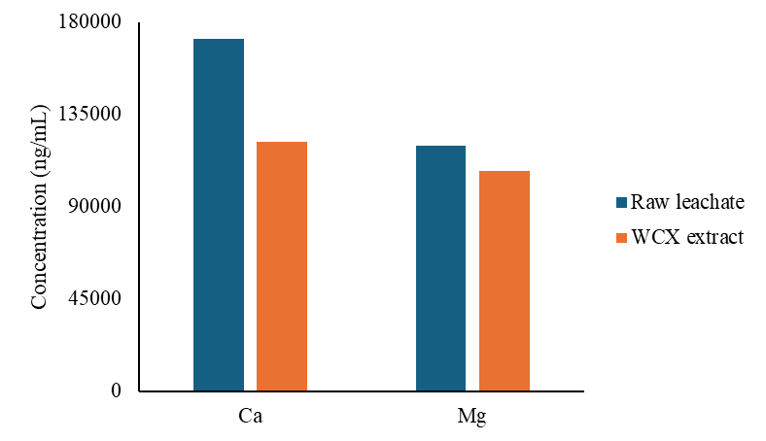
Figure S2: The concentration of magnesium and calcium in raw landfill leachate and leachate after extraction with WCX (n=3).

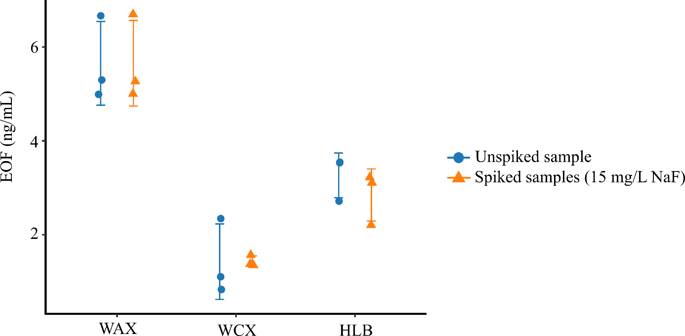
Figure S3: EOF concentrations measured in landfill leachate samples, comparing unspiked samples and samples spiked with NaF prior extraction. Error bars represent the standard deviation of triplicate extractions.

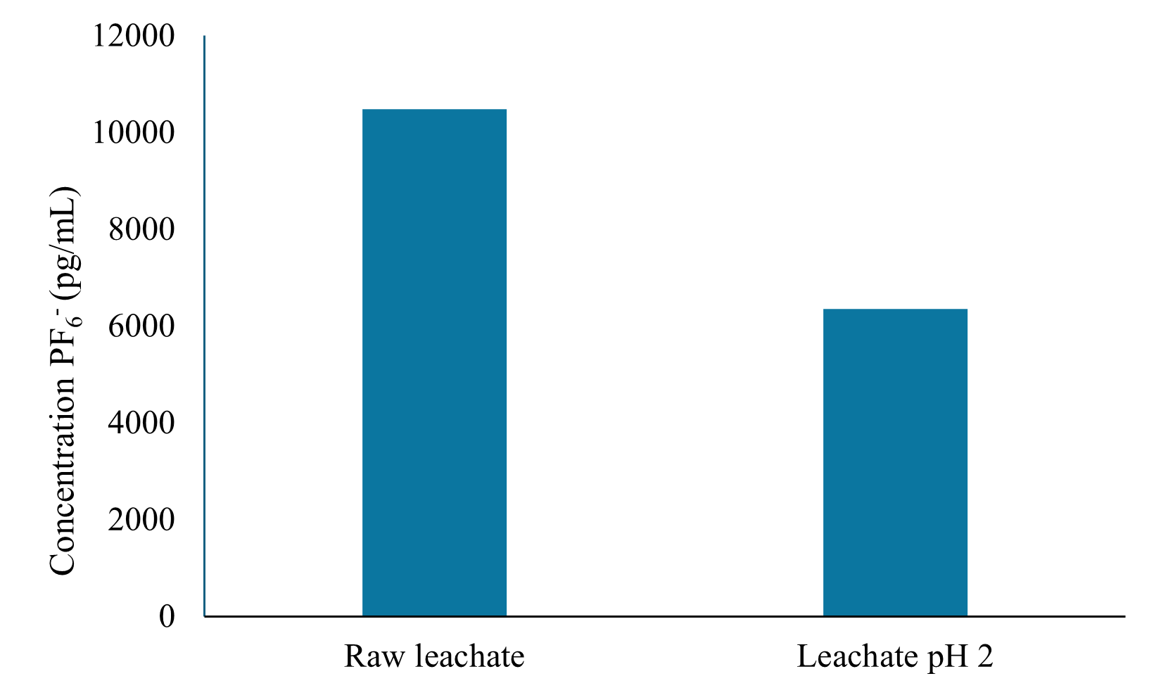
Figure S4: Direct injection of landfill leachate and landfill leachate adjusted to pH 2 with nitric acid

Table S6: Recovery of native standards (n=2) added to landfill leachate
Class | acronym | SPE-WAX | SPE-WCX | SPE-HLB
PFCA & PFSA | PFPrA | 61% | 0% | 0%
PFCA & PFSA | TFMS | 59% | 0 | 0%
PFCA & PFSA | PFEtS | 50% | 0% | 0%
PFCA & PFSA | PFPrS | 76% | 0% | 0%
PFCA & PFSA | PFPeS | 94% | 22% | 96%
PFCA & PFSA | PFHpS | 87% | 97% | 97%
PFCA & PFSA | PFNS | 62% | 87% | 69%
PFCA & PFSA | PFDS | 65% | 78% | 65%
PFCA & PFSA | PFDoDS | 35% | 10% | 73%
FASA | FBSA | 80% | 31% | 79%
FASA | MeFBSA | 34% | 31% | 2%
FASA | PFHxSA | 17% | 39% | 65%
FASA | MePFHxSA | 1% | 0% | 2%
PFPA & PFPiA | PFHxPA | 153% | 152% | 91%
PFPA & PFPiA | PFOPA | 42% | 69% | 55%
PFPA & PFPiA | 6:6 PFPiA | 35% | 44% | 37%
PFPA & PFPiA | 8:8 PFPiA | 50% | 16% | 23%
FTCA & FTUCA | 3:3 FTCA | 32% | 0% | 92%
FTCA & FTUCA | 5:3 FTCA | 24% | 55% | 70%
FTCA & FTUCA | 7:3 FTCA | 8% | 22% | 65%
Zwitterionic PFAS | N-AP-FBSA | 73% | 104% | 156%
Zwitterionic PFAS | N-AP-PFeSA | 101% | 101% | 173%
Zwitterionic PFAS | N-AP-FHxSA | 101% | 115% | 174%
Zwitterionic PFAS | 5:3 FTB | 73% | 85% | 96%
Zwitterionic PFAS | TAmP-FHxSA | 74% | 97% | 100%
Zwitterionic PFAS | N-AP-6:2 FOSA | 117% | 104% | 271%
Zwitterionic PFAS | OXAmP-6:2 FOSA | 50% | 84% | 54%
Zwitterionic PFAS | N-AP-FOSA | 128% | 116% | 50%
Zwitterionic PFAS | CMAmP-6:2 FOSA | 57% | 90% | 99%
Bis-FASI | FMeSI | 17% | 50% | 95%
Bis-FASI | PFEtSI | 86% | 94% | 99%
Bis-FASI | PFBSI | 57% | 84% | 64%
Others | 6:2 Cl-PFESA | 75% | 94% | 84%
Others | 8:2 Cl-PFESA | 50% | 66% | 59%
Others | PFECHS | 80% | 92% | 100%
Others | 6:6 PFPiA | 35% | 44% | 37%
Others | 8:8 PFPiA | 50% | 16% | 23%
Others | 10:2 FTSA | 43% | 52% | 64%
Others | BF₄⁻ | 37% | 0% | 0%
Others | PF₆⁻ | 1% | 5% | 6%
References
[1] Water quality-Determination of perfluoroalkyl and polyfluoroalkyl substances (PFAS) in water-Method using solid phase extraction and liquid chromatography-tandem mass spectrometry (LC-MS/MS). 2019.
[2] Gallen C, Eaglesham G, Drage D, Nguyen TH, Mueller JF. A mass estimate of perfluoroalkyl substance (PFAS) release from Australian wastewater treatment plants. Chemosphere 2018;208:975–83. https://doi.org/10.1016/j.chemosphere.2018.06.024.
[3] Brumovský M, Bečanová J, Karásková P, Nizzetto L. Retention performance of three widely used SPE sorbents for the extraction of perfluoroalkyl substances from seawater. Chemosphere 2018;193:259–69. https://doi.org/10.1016/J.CHEMOSPHERE.2017.10.174.
[4] D’Agostino LA, Mabury SA. Identification of novel fluorinated surfactants in aqueous film forming foams and commercial surfactant concentrates. Environ Sci Technol 2014;48:121–9. https://doi.org/10.1021/es403729e.

