Supplementary Information

Reusable 3D-Printed microfluidic-on-Fabric with Modular Electrodes for Point-of-Care Na⁺ and K⁺ Detection in Various Biofluids

Tao Zhang^{1,2}, Grayson Ruffner¹, Sarah Varney², Inchan Baek³, Bella Fong², Hui Chen^{2,}* and Chengpeng Chen^{1,}*
- Department of Chemistry and Biochemistry,
University of Maryland Baltimore County,
MD, USA, 21250
- Department of Chemistry and Biochemistry,
James Madison University,
VA, USA, 22801
- Phillips Academy,
MA, USA, 01810

*Corresponding to: Dr. Chengpeng Chen
1000 Hilltop Circle, Baltimore, MD, USA
Chemistry and Biochemistry
University of Maryland Baltimore County
+1-4104553053
cpchen@umbc.edu

*Co-corresponding to: Dr. Hui Chen
901 Carrier Drive
Chemistry and Biochemistry
James Madison University
+1-6319949866
chen22hx@jmu.edu

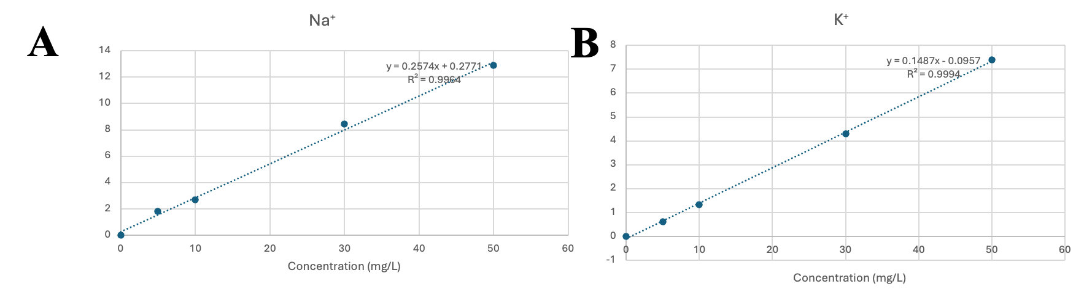
Figure S1. (A) An example calibration curve for Na⁺ obtained using ion chromatography. (B) An example calibration curve for K⁺ obtained using ion chromatography. Y-axis was normalized peak area.

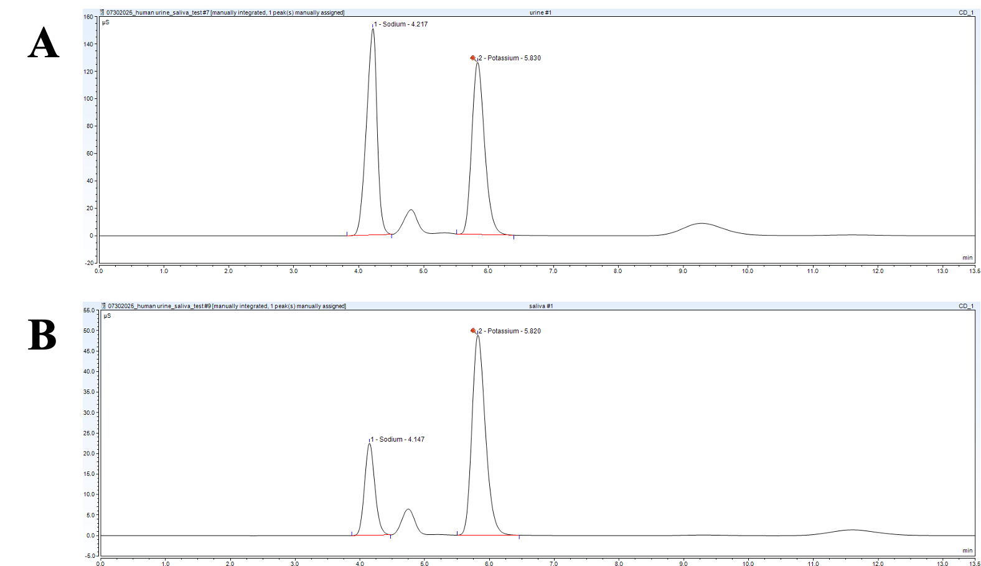
Figure S2. (A) An example chromatogram of a urine sample obtained using ion chromatography. (B) An example chromatogram of a saliva sample obtained using ion chromatography.

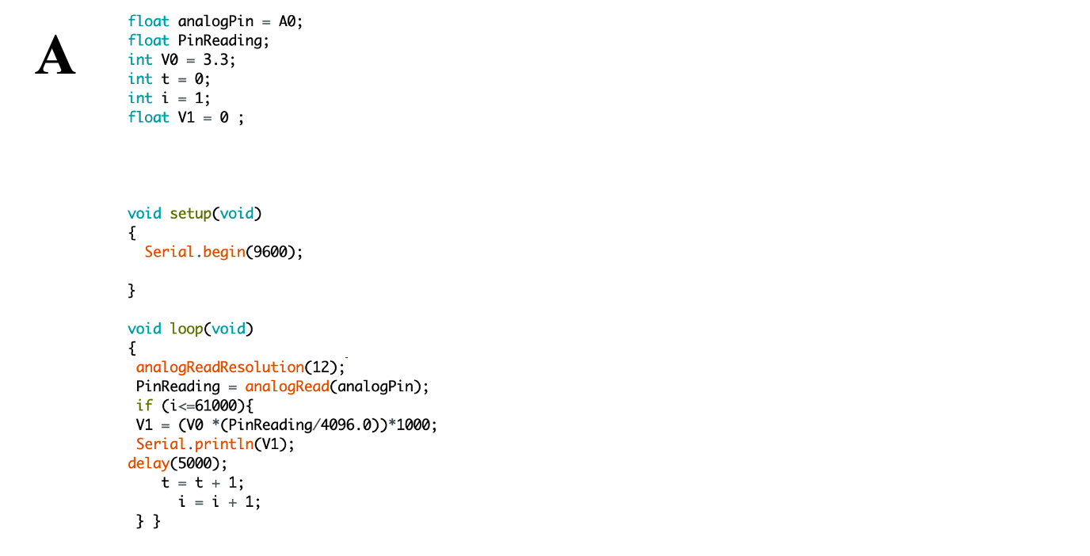
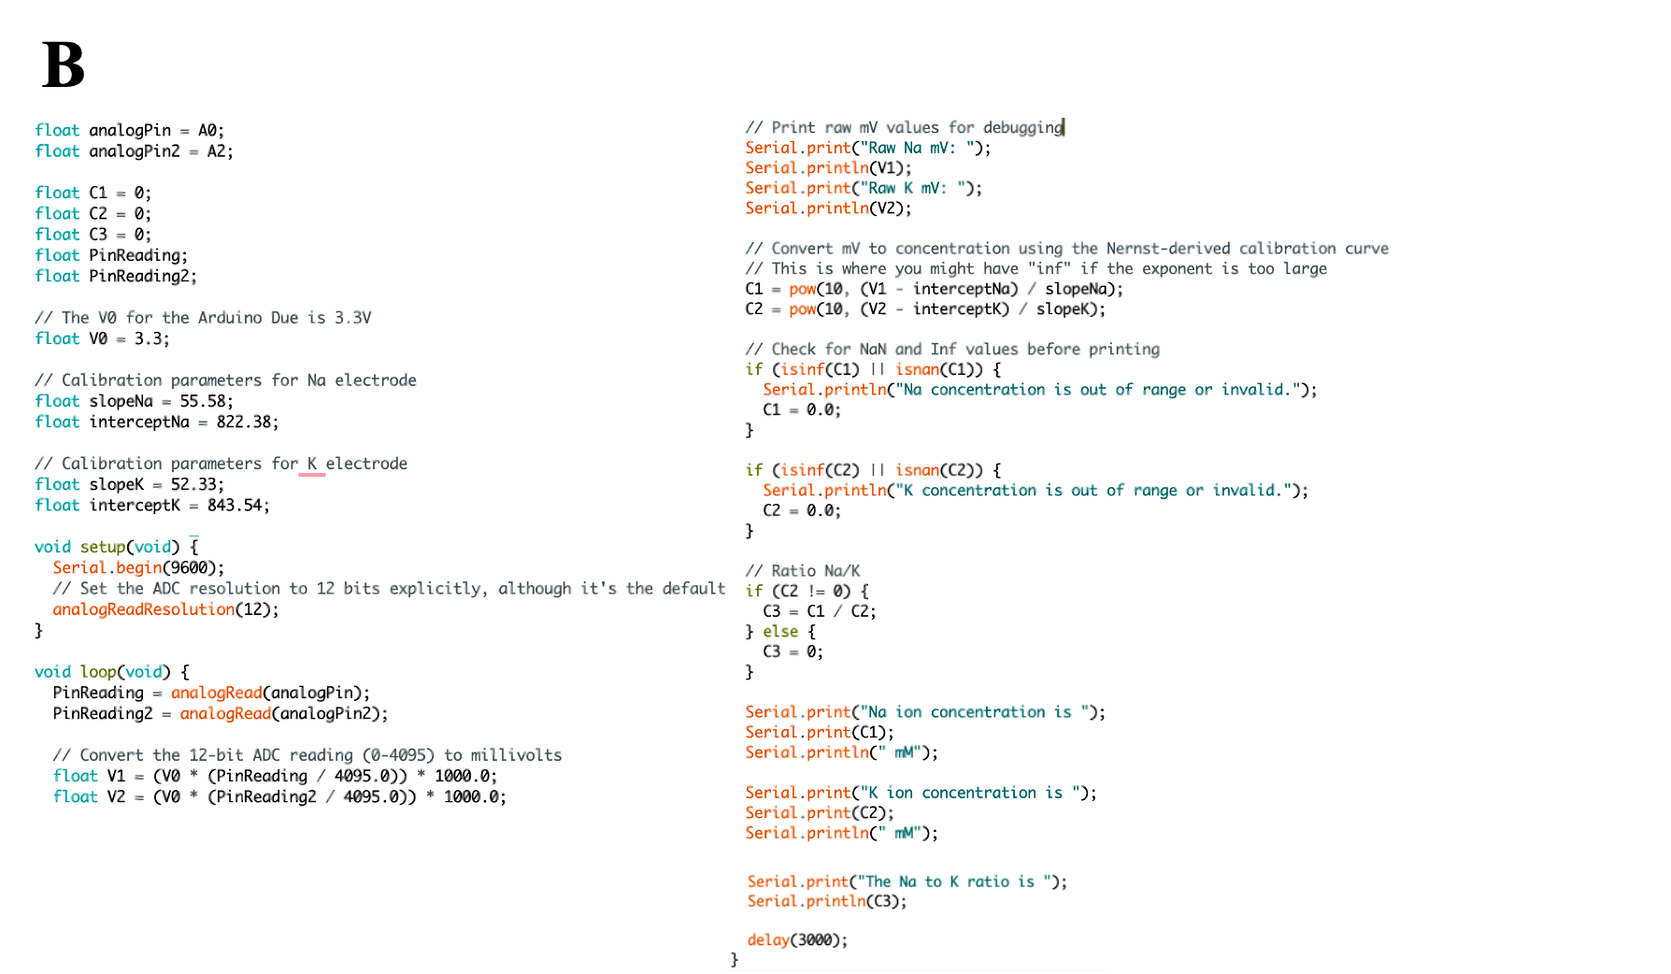
Figure S3. (A) The Arduino code for voltage reading. (B) The Arduino code for Na⁺ and K⁺ transducing.
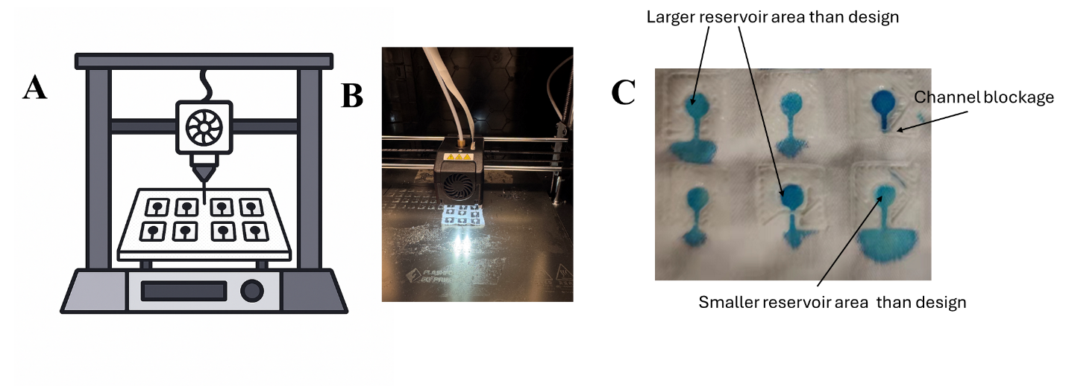

Figure S4. (A) Cartoon illustration showing the microfluidic printing process. (B) Photograph of direct printing onto a fabric substrate. (C) Image of the directly 3D-printed microfluidics-on-fabric with a blue dye solution flowing from the reservoir into the channel.

