Supplementary Information
Analytical and Bioanalytical Chemistry

Supporting molecular detection of A(H5N1) through development and characterization of RNA reference materials

Eileen A. Moran^{1*}, Monique E. Hunter², Jason G. Kralj², Kristine Gierz³, Julia C. Frederick⁴, Jimma Liddell⁴, Lisa M. Keong⁴, Bo Shu⁴, John R. Barnes⁵, Jasmine Chaitram⁶, Marie K. Kirby⁴, C. Todd Davis⁴, Stephanie L. Servetas², Scott Jackson², Peter M. Vallone¹, Megan H. Cleveland¹

¹Biomolecular Measurement Division, National Institute of Standards and Technology, Gaithersburg, MD, USA
²Biosystems and Biomaterials Division, National Institute of Standards and Technology, Gaithersburg, MD, USA
³Statistical Engineering Division, National Institute of Standards and Technology, Gaithersburg, MD, USA
⁴Influenza Division, Centers for Disease Control and Prevention, Atlanta, GA, USA
⁵Division of Infectious Disease Readiness and Innovation, Centers for Disease Control and Prevention, Atlanta, GA, USA
⁶Office of Readiness and Response, Centers for Disease Control and Prevention, Atlanta, GA, USA
*Corresponding author: Eileen A. Moran, eileen.moran@nist.gov

$$\begin{matrix}y_{ijkl}∣γ_{ijk}, σ_{rep}∼N\left(γ_{ijk}, σ_{rep}^{2}\right), & i \text{denotes targets} (i=1, …, 3) \\ & j \text{denotes amplicon} (j=1,2) \\ & k \text{denotes box} (k=1,…, 8) \\ & l \text{denotes replicates,} \\ γ_{ijk}∣α_{ij}, σ_{ij}∼N\left(α_{ij}, σ_{ij}^{2}\right), & γ_{ijk}\text{ is the mean }λ\text{ for target }i\text{, amplicon }j, \text{unit }k, \\ α_{ij}∣μ_{i}, τ_{i}∼N\left(μ_{i}, τ_{i}^{2}\right), & α_{ij}\text{is the consensus amplicon mean }λ \text{for target }i\text{ at amplicon }j, \\ μ_{i}, & μ_{i} \text{is the target mean, }μ_{i}>0, \\ V∼N\left(0.7663, {0.0088}^{2}\right), & V \text{is the droplet volume used for the droplet-volume adjustment,} \\ μ_{i}^{(adj)}= \frac{11 ×200 ×μ_{i}}{V/1000}, & μ_{i}^{\left(adj\right)} \text{is the mean copies/}μ\text{L for target }i.\end{matrix}$$
Fig. S1 A hierarchical Bayesian mixed-effects model was used to assign concentration values and associated uncertainties for RM 8038. The models accounted for variability due to box differences, amplicon differences, droplet volume, and repeatability

$$\begin{matrix}y_{ij}∣μ, b_{j}, σ∼N\left(μ+b_{j}, σ^{2}\right), & i \text{indexes replicates within box }j, j=1,…, J, \\ b_{j}∣τ∼N\left(0, τ^{2}\right), & b_{j} \text{is the deviation for box }j\text{,} \\ μ∼N\left(\overline{y}, s_{y}^{2}\right), & \overline{y}= \text{mean of }y_{ij}, s_{y}= \text{standard deviation of }y_{ij}, \\ V∼N\left(0.7663, {0.0088}^{2}\right), & V \text{is the droplet volume used for the droplet-volume adjustement.}\end{matrix}$$
Fig. S2 A hierarchical Bayesian mixed-effects model was used to assess homogeneity for RM 8038. The models accounted for variability due to box differences, amplicon differences, droplet volume, and repeatability

$${\overline{y}}_{ij}= β_{0i}+ β_{1i}×{\text{Date}}_{j}+ ϵ_{ij}, ϵ_{ij}∼N\left(0, \frac{σ_{i}^{2}}{w_{ij}}\right) \\ \text{where }w_{ij}= 1/{\text{SE}{\left({\overline{y}}_{ij}\right)}^{2}}$$
Fig. S3 RM 8038 stability was characterized by using a weighted linear regression model of the RT-ddPCR concentration measurements. The data consist of replicate observations indexed by target i, date j, and replicate k. A weighted linear regression is then fit for each target i

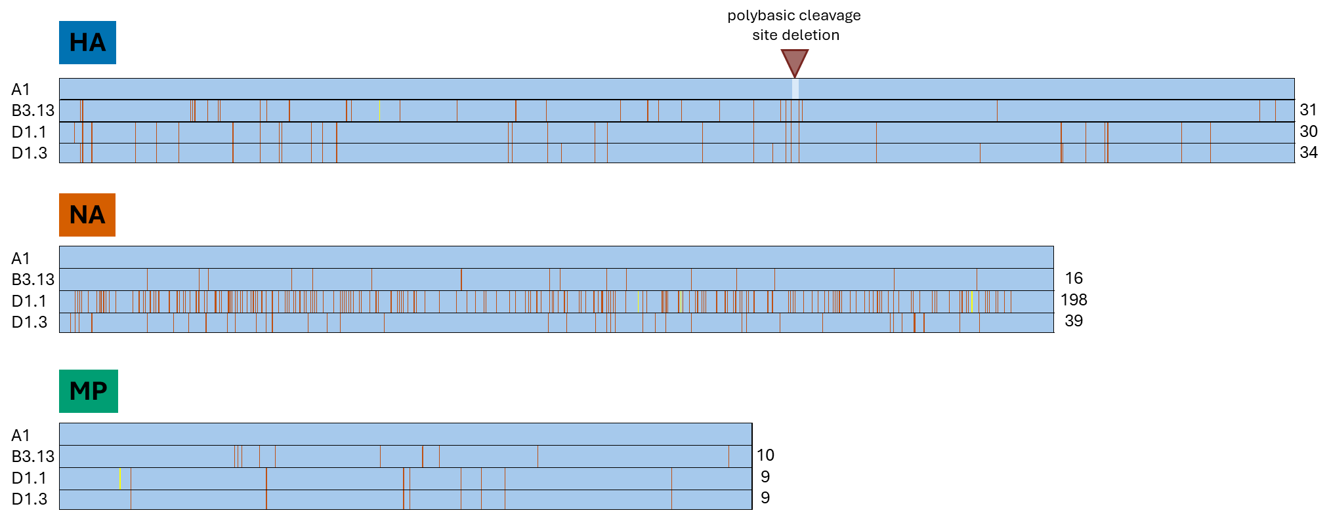
Fig. S4 The RGTM/RM sequences are similar to those of clinical isolates. Nucleotide consensus sequences generated from alignments of 22 B3.13 and 8 D1.1 human isolate sequences were aligned with a single D1.3 isolate sequence and the sequences of HA, NA, and MP RGTM/RM components. Sequences are labeled by genotype to the left of each row outlined in black. Blue shading indicates matching nucleotides across all three sequences. Vertical orange lines within each sequence indicate a mismatch with the RGTM/RM (A1) sequence at that position. The number of mismatches with the RGTM/RM sequence is indicated to the right of each row. Scaling across HA, NA, and MP alignments is equivalent to represent actual sequence length differences between HA, NA, and MP segments. Bright yellow vertical lines within each sequence represent ambiguous base calls because of an even number of sequences with conflicting nucleotides used to generate the consensus sequence. Light blue shading in the HA RGTM/RM (A1) sequence indicates the sequence gaps due to the polybasic cleavage site deletion in the RGTM/RM. Ambiguous base calls and the sequence gaps were not included in the mismatch counts

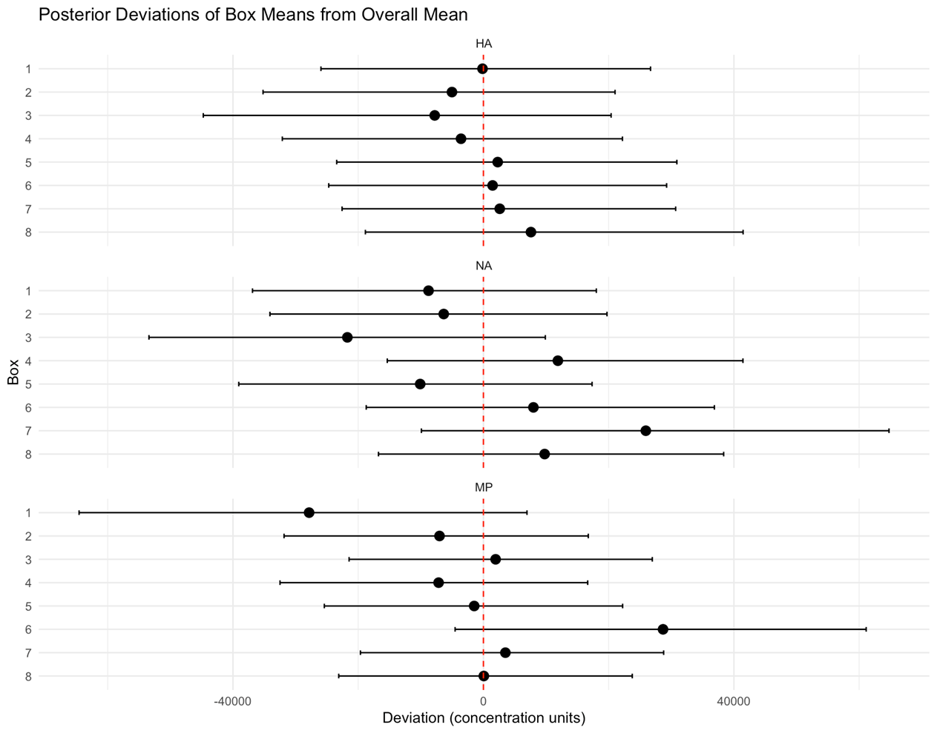
Fig. S5 The RM 8038 RNA components are sufficiently homogeneous. Concentration measurements from each HA, NA, and MP box do not differ from the overall mean of their respective box measurements (hierarchical Bayesian mixed-effects model, not significant at 95 % confidence level). Box level means (black points) are displayed along with deviations from the overall mean with bars representing the 95 % credible intervals. All credible intervals include 0 (red dashed line), indicating the boxes do not differ significantly from the overall mean for each RM 8038 RNA component

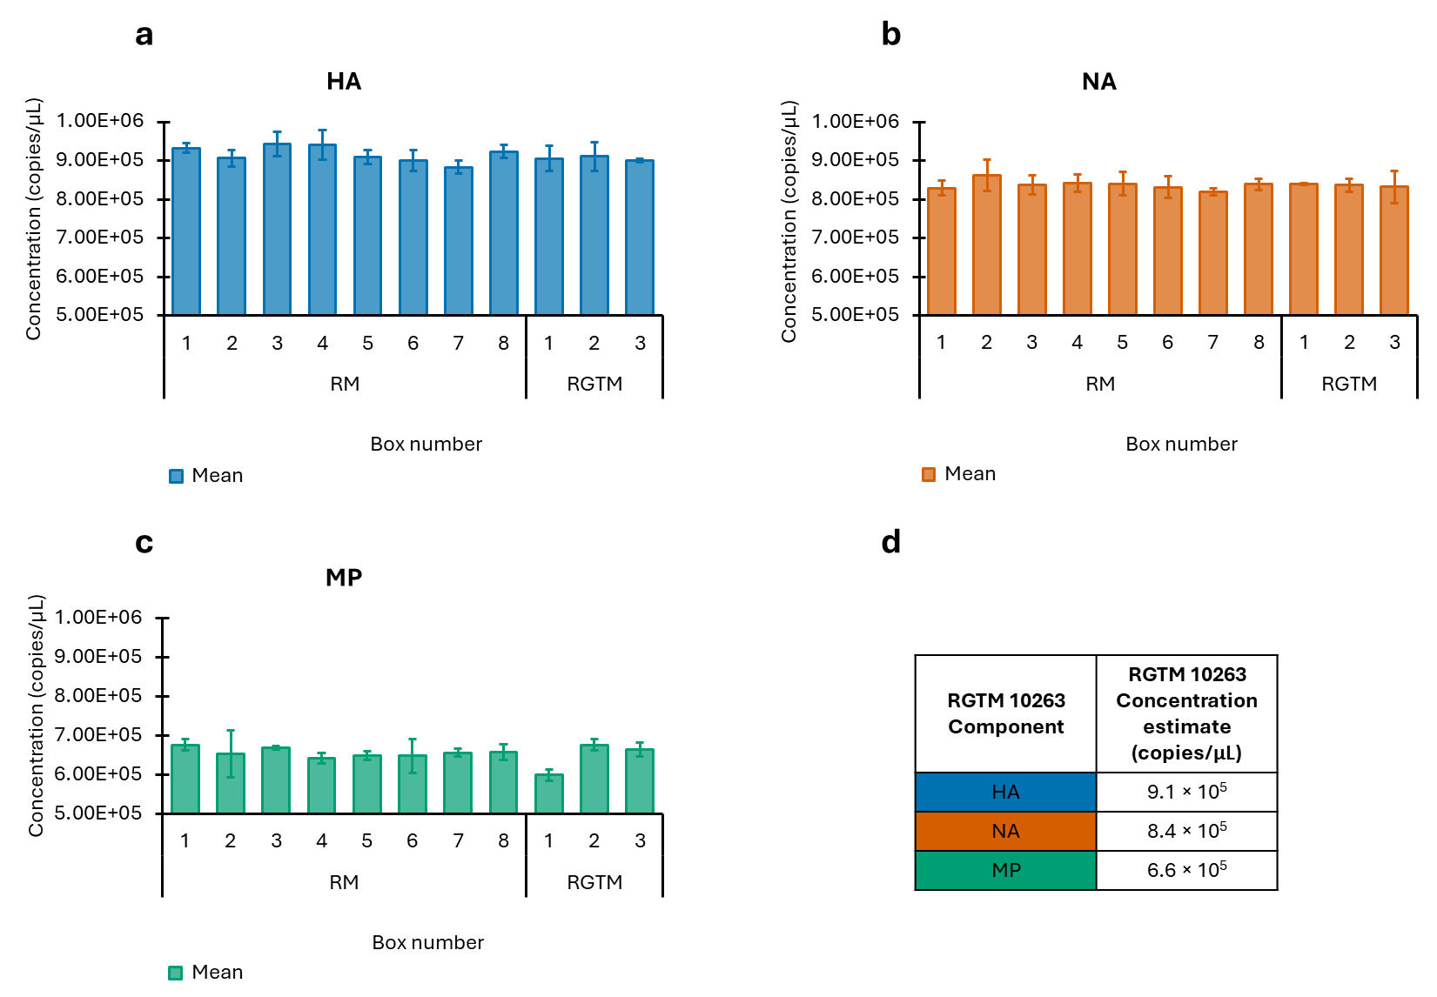
Fig. S6 The RGTM 10263 RNA components are sufficiently homogeneous. Initial homogeneity testing for the entire lot of RGTM/RM was performed before RGTM 10263 was released to the public. Concentration measurements on a sample from each of the 8 RM and 3 RGTM freezer storage boxes were made for a HA, b NA, and c MP RNA. Shown are the means of technical triplicate RT-ddPCR measurements for each sample with error bars indicating ± one standard deviation. The d mean of all RM and RGTM homogeneity measurements for each RNA component was taken as an initial quantitative estimate of the concentration of each RGTM 10263 component and provided in a guidance document for RGTM customers
Table S1: RNase P rRT-PCR results (C_{T} values) for HA, NA, and MP RNA
Sample (Neat) | RNase P
HA Sample 1 | 20.95
HA Sample 2 | 20.94
NA Sample 1 | 20.99
NA Sample 2 | 20.78
MP Sample 1 | 20.72
MP Sample 2 | 20.81

