Supporting information
Spruce galactoglucomannans stabilized emulsions as essential fatty acid delivery systems for functionalized drinkable yoghurt and oat-based beverage

Fabio Valoppi^{a,b}, Ndegwa Mainaª, Marja Allénª, Roberta Miglioli^{a,c}, Petri O. Kilpeläinen^{d}, Kirsi S. Mikkonen^{a,b,*}

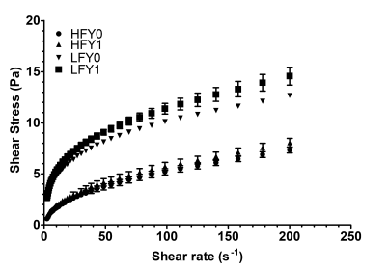
Fig. S1. Flow curves of HFY0, HFY1, LFY0, LFY1 after 15 days of storage at 4 °C. Analysis carried out at 10 °C. Bars represents standard error

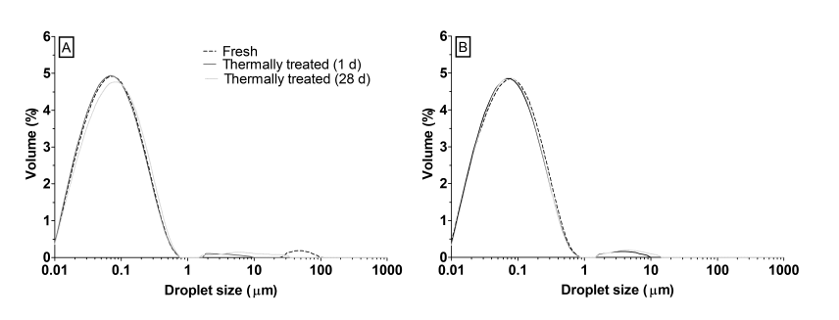
Fig. S2. Droplet size distribution of OOE_{0.8/1.5} (a) and OOE_{0.5/1} (b) before and after pasteurization (80 °C for 10 min) during storage at 22 °C
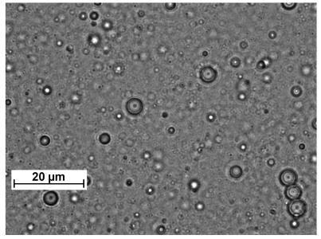
Fig. S3. Optical microscope image of freshly prepared OOE_{0.5/2}

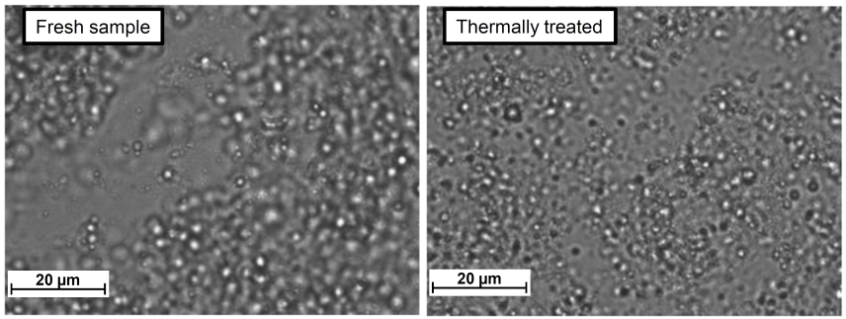
Fig. S4. Optical microscopy images of OBB_{0.2/1.5} before (left) and after (right) thermal treatment at 80 °C for 10 min

