Supplementary Material

A new phytoecdysteroid from the stem bark of Vitex cienkowskii
Timo D. Starkª*, Julius Ramiª, Sonja Fröhlichª, Patrick Weissª, Wolfgang Vierling,^{b} Alain B. Dongmo^{c} and Thomas Hofmannª

ªLehrstuhl für Lebensmittelchemie und Molekulare Sensorik, Technische Universität München, Lise-Meitner-Str. 34, 85354 Freising, Germany
^{b} Institut für Pharmakologie und Toxikologie, Technische Universität München, Biedersteiner Str. 29, 80802 München, Germany
^{c}Department of Animal Biology, Faculty of Science, University of Douala, P.O. Box 24157, Douala, Cameroon

* To whom correspondence should be addressed

PHONE +49-8161-71-2911

FAX +49-8161-71-2949

E-MAIL timo.stark@tum.de

Figure S1. Chemical structure of compound 1.

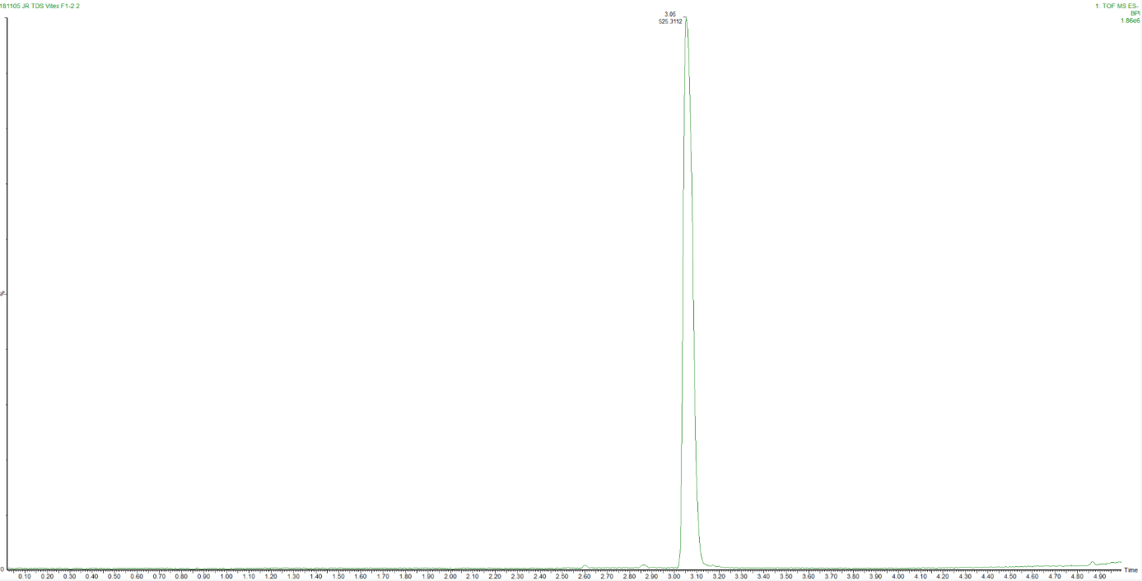
Figure S2. UPLC-HRESI-TOF MS analysis of 1.

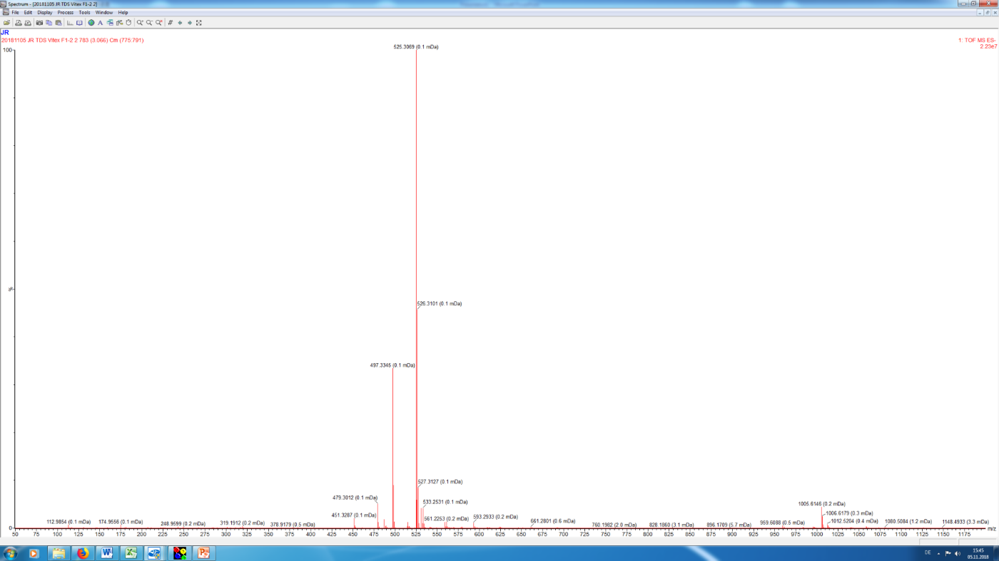
Figure S3. HRESIMS (neg.) spectrum of 1
Elemental Composition Report
Mass Calc. Mass mDa PPM DBE Formula
525.3069 525.3064 +0.5 +1.0 6.5 C28 H45 O9
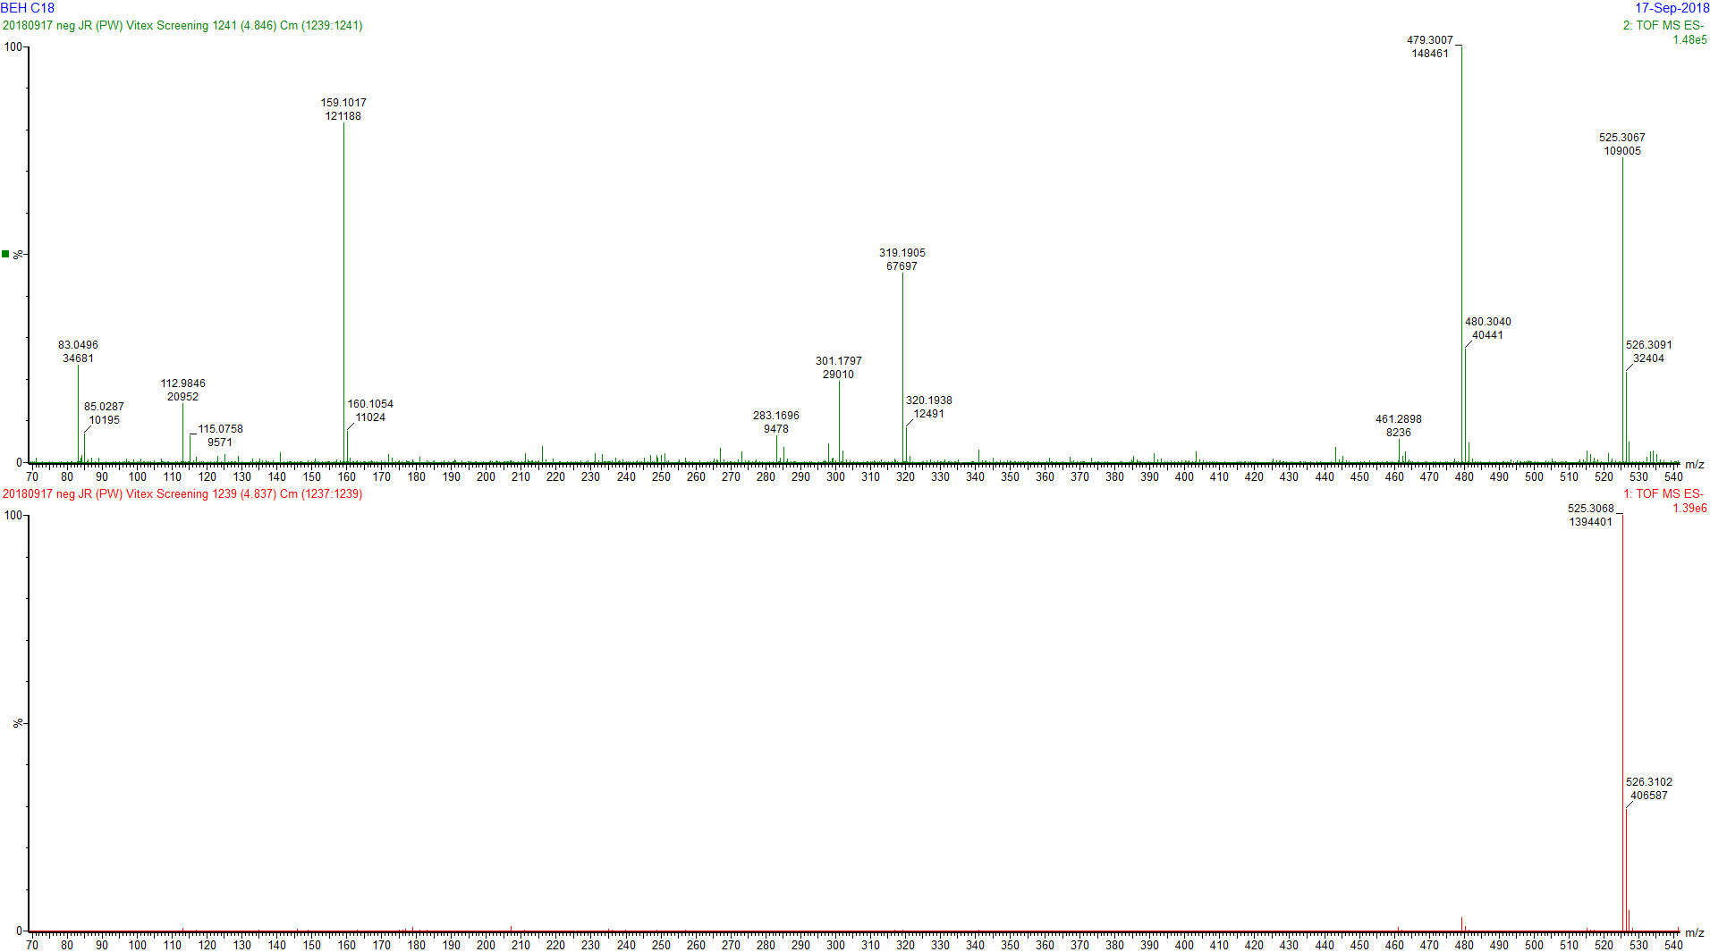
Figure S4. HRESIMS^{e} (neg.) spectrum of 1

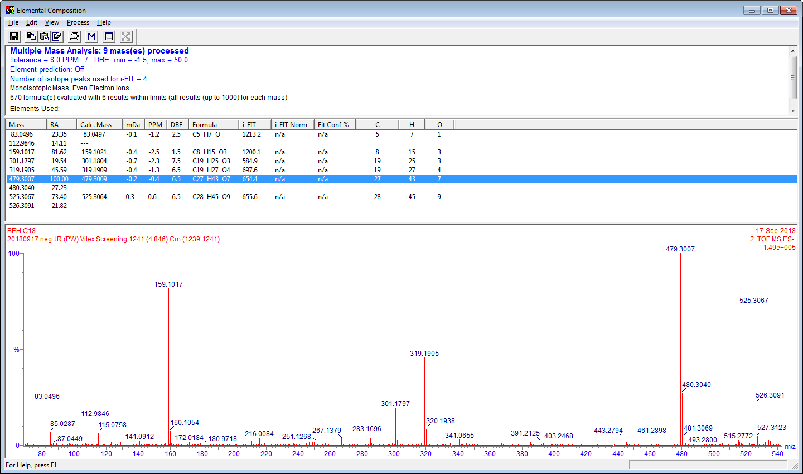
Figure S5. Elemental Composition Report of the HRESIMS^{e} (neg.) spectrum of 1

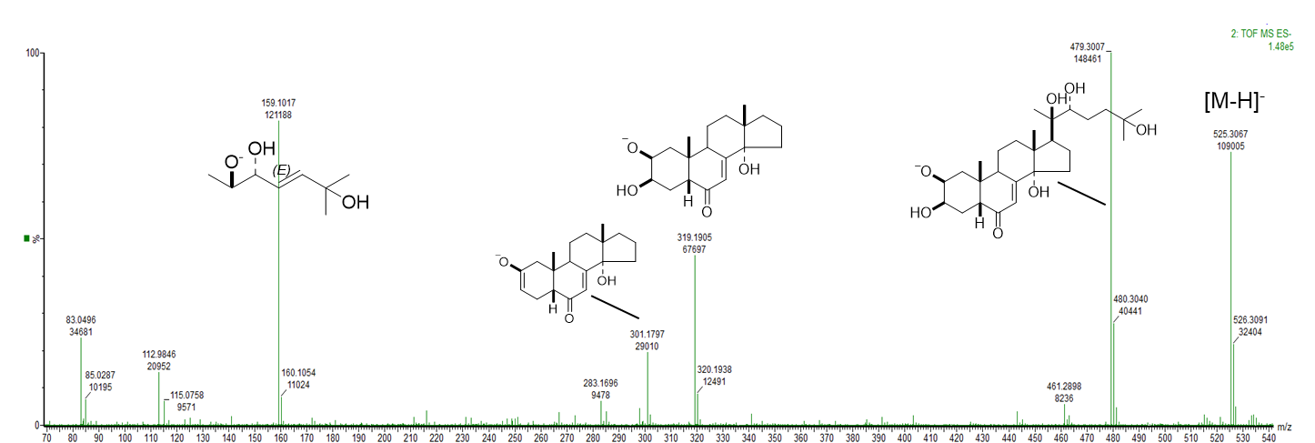
Figure S6. HRESIMS^{e} (neg.) spectrum of 1 with proposed fragments. The negative charge could be located at one of the hydroxyl functions, one representative structure is shown. The double bond in the fragment m/z 159.1017 could be also Z configured and at another position.

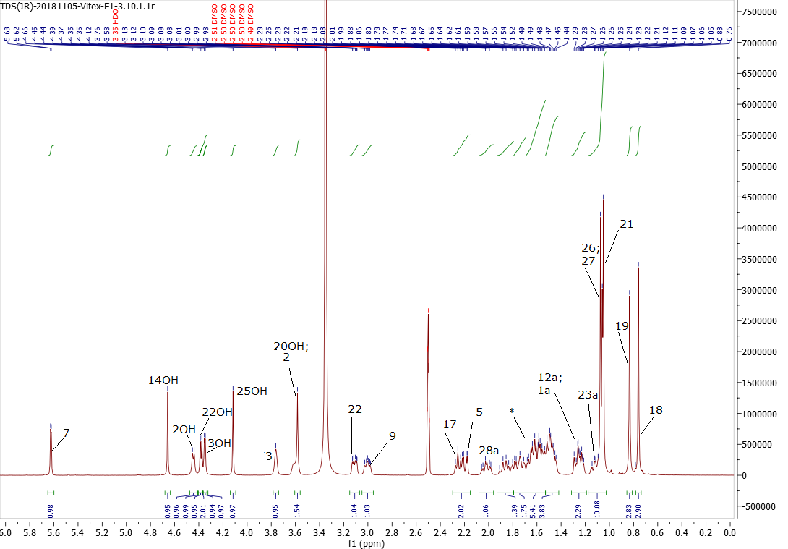
Figure S7. ¹H NMR spectrum (DMSO-d6, 400 MHZ, 27 °C) of 1

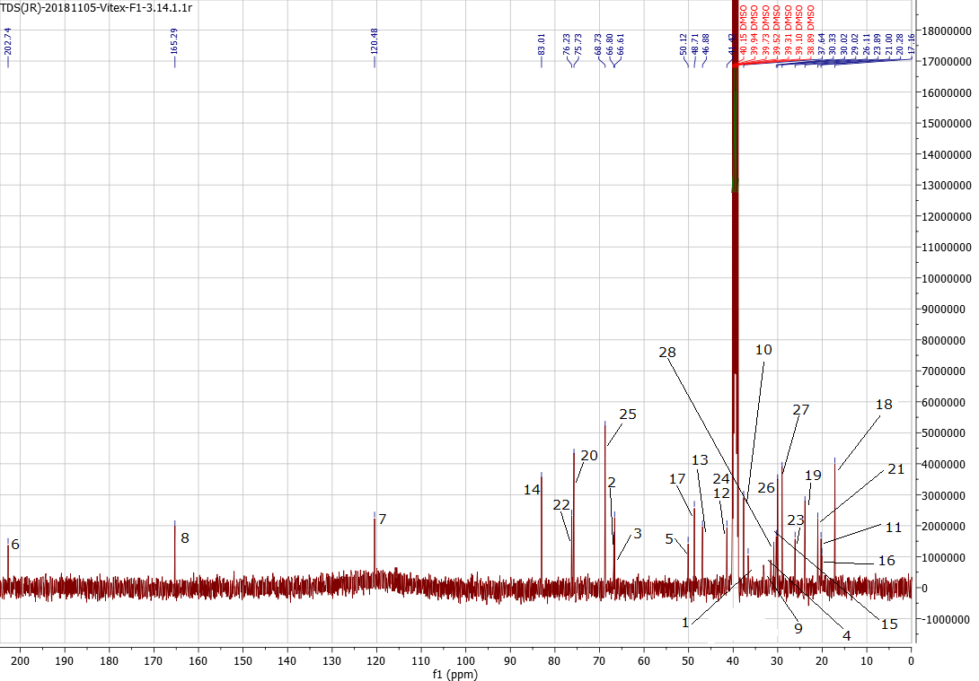
Figure S8. ¹³C NMR spectrum (DMSO-d6, 100 MHZ, 27 °C) of 1

Figure S9. COSY NMR spectrum (DMSO-d6, 400 MHZ, 27 °C) of 1

Figure S10. HSQC NMR spectrum (DMSO-d6, 400 MHZ, 100 MHZ, 27 °C) of 1

Figure S11. HMBC NMR spectrum (DMSO-d6, 400 MHZ, 100 MHZ, 27 °C) of 1

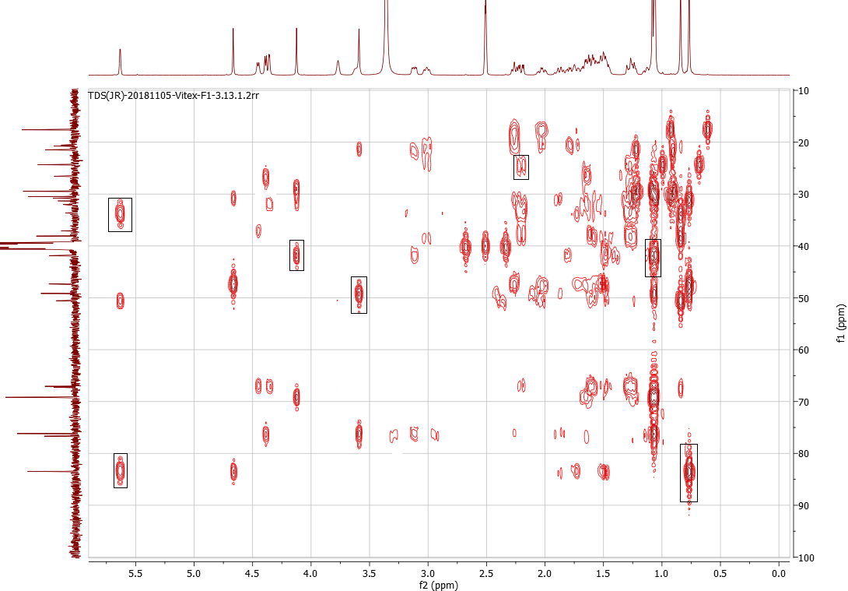
Figure S12. Excerpt of HMBC NMR spectrum (DMSO-d6, 400 MHZ, 100 MHZ, 27 °C) of 1

Table S1. Assignment of ¹H-NMR signals (400 MHz, DMSO-d₆, 27 °C) of 1

H an C-Atom (H-C)ª | δ [ppm]^{b} | I^{c} | M^{c} | J [Hz]^{c} | homonuclear ¹H, ¹H connectivity^{d}
1a | 1.25 | 1 | m | - | 1b, 2
1b | 1.60 | 1 | m | - | 1a, 2
2 | 3.58 | 1 | s | - | 1a, 1b, 2-OH
3 | 3.76 | 1 | s | - | 4a, 3-OH
4a | 1.50 | 1 | m | - | 5, 4b
4b | 1.59 | 1 | m | - | 3, 4a
9 | 3.00 | 1 | t | 8.0, 6.9, 4.0 | 11a ,11b, 7
7 | 5.62 | 1 | d | 2.4 | 9
5 | 2.20 | 1 | m | - | 4a, 4b
17 | 2.27 | 1 | m | - | 16a, 16b
22 | 3.11 | 1 | m | - | 23a, 22-OH
11a | 1.60 | 1 | m | - | 12a, 9, 11b
11b | 1.85 | 1 | m | - | 11a
16a | 1.60 | 1 | m | - | 17, 16b
16b | 1.85 | 1 | m | - | 17, 16a
12a | 1.27 | 1 | m | - | 11a, 12b
12b | 1.68 | 1 | m | - | 12a
15a | 1.76 | 1 | m | - | 16a, 15b
15b | 1.50 | 1 | m | - | 16b, 115a
28a | 2.02 | 1 | m | - | 28b
28b | 1.60 | 1 | m | - | 28a
23a | 1.10 | 1 | m | - | 22, 23b
23b | 1.48 | 1 | m | - | 23a
18 | 0.76 | 3 | s | - | -
19 | 0.78 | 3 | s | - | -
21 | 1.07 | 3 | s | - | -
26 | 1.06 | 3 | s | - | -
27 | 1.07 | 3 | s | - | -
14-OH | 4.68 | 1 | s | - | -
2-OH | 4.46 | 1 | d | 5.8 | 2
22-OH | 4.39 | 1 | d | 5.1 | 22
3-OH | 4.35 | 1 | d | 3.0 | 3
25-OH | 4.14 | 1 | s | - | -
20-OH | 3.59 | 1 | s | - | -
ªArbitrary numbering of carbon atoms refers to structure in Figure 1. ^{b}The ¹H chemical shifts are given in relation to DMSO-d₆. ^{c}Determined from 1D-spectrum. ^{d}Homonuclear ¹H,¹H connectivities obeserved by g-COSY experiment.

Table S2. Assignment of ¹³C-NMR signals (100 MHz, DMSO-d₆, 27 °C) of 1
 |  |  | heteronucleare 1H-13C connectivity^{c}
C-Atomª | δ [ppm]^{b} | HSQC+1H | via ¹J(C,H) | via ^{2,3}J(C,H)
1 | 36.64 | CH₂ | 1a,1b | 19, 2-OH, 5, 3
2 | 66.80 | CH | 2 | 1a, 1b, 4a, 19, 2-OH, 3-OH
3 | 66.61 | CH | 3 | 1a, 1b, 4a, 19, 2-OH, 3-OH
4 | 31.56 | CH₂ | 4a, 4b | 5
5 | 50.12 | CH | 5 | 7, 19
6 | 202.74 | C | - | 5, 4a, 4b
7 | 120.48 | CH | 7 | 9,5
8 | 165.29 | C | - | 9,1a, 14-OH, 12b, 11a
9 | 33.16 | CH | 9 | 19, 1a, 5, 7
10 | 37.64 | C | - | 1a, 1b, 19, 9
11 | 20.28 | CH₂ | 11a, 11b | 12a, 9
12 | 41.42 | CH₂ | 12a, 12b | 11b
13 | 46.88 | C | - | 15b, 17, 18, 14-OH
14 | 83.01 | C | - | 7, 15a, 16b, 18, 11b, 15b, 14-OH
15 | 30.33 | CH₂ | 15a, 15b | 14-OH, 17, 16b
16 | 20.09 | CH₂ | 16a, 16b | 17, 15b
17 | 48.71 | CH | 17 | 18, 20-OH, 21, 22, 15b
18 | 17.16 | CH₃ | 18 | 17
19 | 23.89 | CH₃ | 19 | 5,1b, 9
20 | 75.73 | C | - | 22,21, 17, 20-OH, 22-OH
21 | 21.00 | CH₃ | 21 | 20-OH, 22
22 | 76.73 | CH | 22 | 21, 16a
23 | 26.11 | CH₂ | 23a, 23b | 22-OH, 28b
24 | 41.42 | C | - | 22, 25-OH, 26, 27
25 | 68.73 | C | - | 28b,26,27, 25-OH
26 | 30.02 | CH₃ | 26 | 27, 25-OH
27 | 29.02 | CH₃ | 27 | 26, 25-OH
28 | 30.88 | CH₂ | 28a, 28b | 23b
ªArbitrary numbering of carbon atoms refers to structure in Figure 1. ^{b}The ¹³C chemical shifts are given in relation to DMSO-d₆. ^{c} Assignments based on HSQC (¹J) und HMBC (^{2,3}J) experiments.

Table S3. Instrument parameters of the Vion IMS qTOF and processing options.
2D Peak detection limit
Max. allowed number of peaks per chromatogram | 10000
4D peak detection
High Energy Intensity threshold [counts] | 20
Low Energy Intensity threshold [counts] | 20
Noise
Max. number of peaks to keep per channel | 200000
Target by RT
Identify target peak using rule | Largest in the RT window
RT identification tolerance [min] | 0.12
Target by mass
Target match tolerance [ppm] | 10.0
Fragment identification
Fragment match tolerance [mDa] | 10.0
Allow scores below | 8
Ion ratio tolerance [%] | 10.0
Drift specific mass chromatogram
Tolerance [mDa] | 10.0
Observed targets with no expected retention time
Max. number of targets with the same m/z to keep | 10
Min. rel. intensity threshold for targets at the same m/z | 0.01
Max. candidates per sample to use | 4000
Max. candidates per sample to keep | 500
Target by CCS
CCS tolerance [%] | 1.2
General parameters
Analyzer Mode |  | Sensitivity
ESI LockSpray |  | Set
Capillary [kV] |  | 2.30
Sampling Cone [V] |  | 40
Source Offset [V] |  | 80
Source Temperature [°C] |  | 120
Desolvation Temperature [°C] |  | 550
Cone Gas [L/hour] |  | 50
Desolvation Gas [L/hour] |  | 900
Reference Capillary [kV] |  | 2.30
Instrument
Collision Energy [V] |  | 6
Ion Guide Gradient [V] |  | 0.5
Aperture 2 [V] |  | 0.0
LM Resolution (low) |  | 4.7
HM Resolution (high) |  | 15.00
Pre-filter [V] |  | 10
Ion Energy [V] |  | 1.2
Detector Voltage [V] |  | 2075
Average Single Ion Intensity |  | 6.2
Gate Delay [ms] |  | 0
StepWave
SW 1 Offset [V] |  | 20
SW 2 Offset [V] |  | 30
SW 1 Velocity [m/s] |  | 300
SW 1 Pulse Height [V] |  | 15.0
SW 2 Velocity [m/s] |  | 300
SW 2 Pulse Height [V] |  | 15.0
System2
pDRE Attenuate |  | Off
pDRE Transmission [%] |  | 1.0
pDRE HD Attenuate |  | Off
pDRE HD Transmission [%] |  | 10.0
MS Profile
Quadrupole Options |  | Automatic Profile
MS/MSMS |  | MS
Set Mass |  | 0.00
m/z |  | 1.25 Ma
 |  | 0.17Mb
Dwell Time [%Scan Time] |  | 25
Ramp Time [%Scan Time] |  | 75
RF
StepWave RF [V] |  | 250
Trap/IMS RF [V] |  | 250
Ion Guide RF Offset [V] |  | 200
Ion Guide RF Gain |  | 5
Cell 1 RF [V] |  | 300
Cell2 RF Offset [V] |  | 150
Cell2 RF Gain |  | 2
MS/MS Ramp Mode |  | Automatic
MS/MS Ramp Initial |  | 50
MS/MS Ramp Final |  | 275
MSe Experiment
Mode |  | High Definition MSe
Scan Settings
Low Mass [m/z] |  | 50
High mass [m/z] |  | 1000
Scan Time [s] |  | 1.000
Collision energy
Low Energy [eV] |  | 6.00
High Energy Ramp [eV] |  | 20.00
to [eV] |  | 30.00
Lock Correction
Automatic Lock Correction Interval [min] |  | 0.5
Binary Solvent Manager
Solvents: A1 |  | H₂O + 0.1% FA
Solvents: B1 |  | ACN + 0.1% FA
Gradient Start |  | At injection
Seal wash |  | Enable seal wash
Interval [min] |  | 5.0
Sample Manager FTN
Solvents
Wash Solvent |  | ACN + 0.1% FA
Pre-inject [s] |  | 0
Post-inject [s] |  | 5
Purge Solvent |  | H₂O
Temperatures
Sample Temperature [°C] |  | 10.0
Column Temperature [°C] |  | 45.0

