SUPPORTING INFORMATION FOR

Characterization of various isomeric photoproducts of ergosterol and vitamin D₂ generated by UV irradiation

Katrin Sommer, Marissa Hillinger, Andrea Eigenmann and Walter Vetter*

University of Hohenheim, Institute of Food Chemistry, Department of Food Chemistry (170b), D-70593 Stuttgart, Germany

* Corresponding author
Walter Vetter
Email: walter.vetter@uni-hohenheim.de
Content:
Figure S1 shows HPLC-UV and HPLC-CD chromatograms of vitamin D₂ and vitamin D₃ standard mix.
Figure S2 shows HPLC-UV spectra of reference standards.
Figure S3 shows HPLC-UV peak purity analysis and HPLC-UV spectra of photoproducts co-eluting as peak cluster #3 after UV irradiation of ergosterol and vitamin D₂.
Figure S4 shows ¹H NMR spectra of suprasterol₂ isomers in CDCl₃ after isolation by preparative HPLC.
Figure S5 shows UHPLC-HRMS chromatograms and mass spectra of ergosterol, vitamin D₂, and photoproducts generated by UV irradiation of vitamin D₂
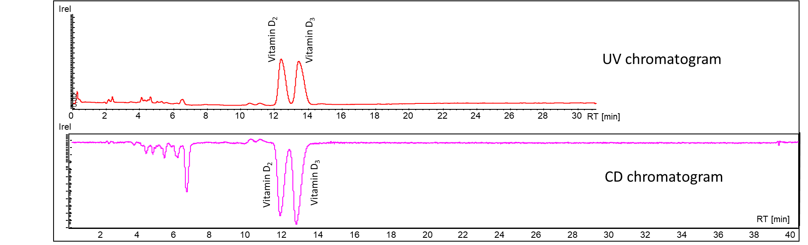
Figure S1: HPLC-UV and HPLC-CD chromatograms of vitamin D₂ and vitamin D₃ standard mix.

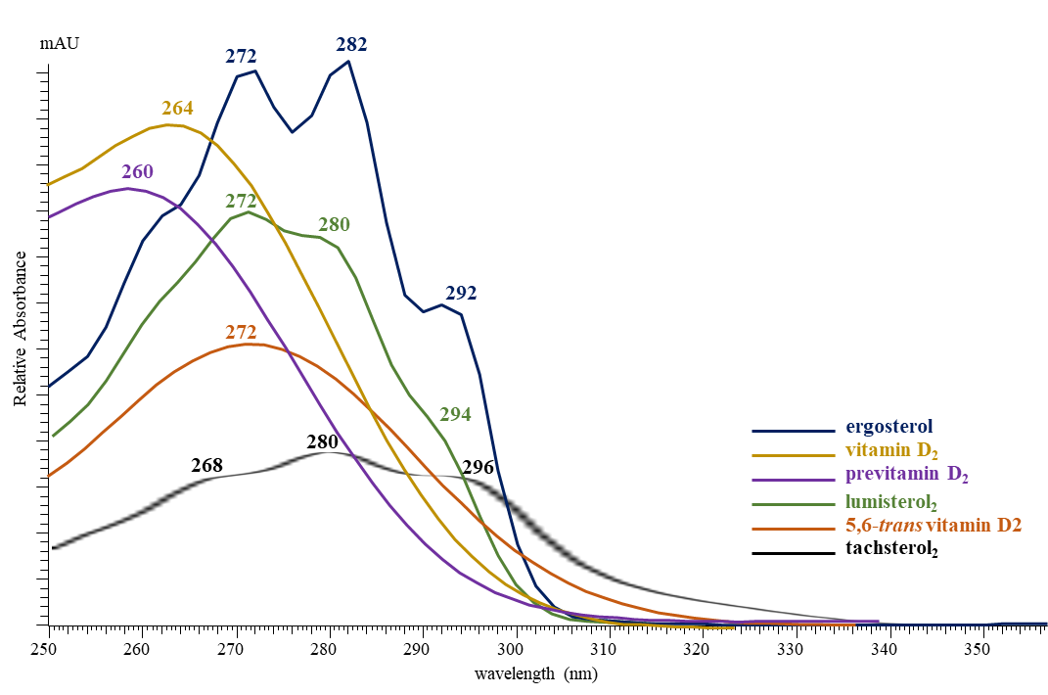

Figure S2. HPLC-UV spectra of reference standards ergosterol (blue), vitamin D₂ (yellow), previtamin D₂ (purple), lumisterol₂ (green), 5,6-trans vitamin D₂ (orange) and tachysterol₂ (black).

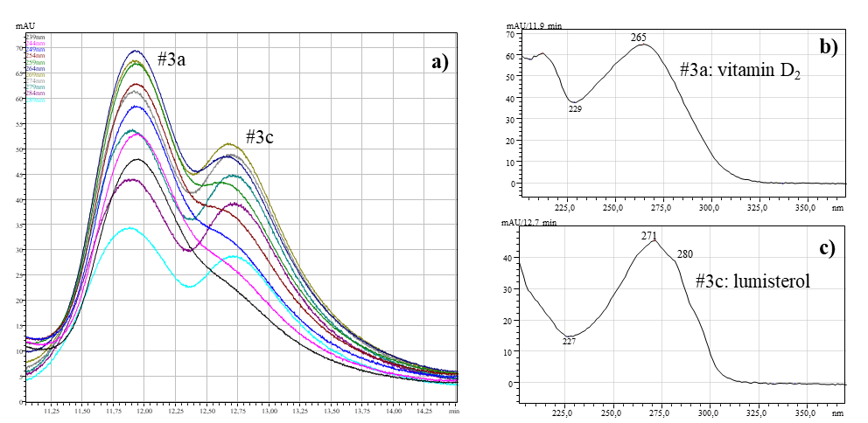

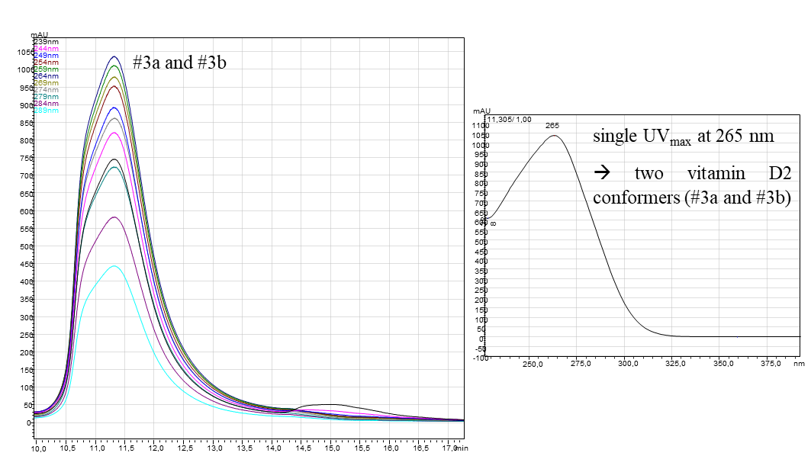
e)
d)

Figure S3. Peak purity analysis and UV spectra of HPLC-UV peak #3 after UV irradiation of (a-c) ergosterol and (d,e) vitamin D₂ standard solutions in ethanol for 60 min.
(a) Peak purity analysis of peak #3 (generated after ergosterol UV irradiation) indicated two compounds that could be identified by their characteristic UV spectra as (b) vitamin D₂ (#3a, UV_{max} at 265 nm) and (c) lumisterol₂ (#3c, λ_{max} at 271 nm and 280 nm) and comparison with reference standards (see Fig. S1). (d) Peak purity analysis of peak #3 (generated after vitamin D₂ UV irradiation) indicated two photoproducts (#3a and #3b), which was supported by reversed orientation in the circular dichroism detector, which could not be differentiated in HPLC-UV due to their (e) identical UV spectra with λ_{max} at 265 nm. Thus, #3a and #3b were characterized as cis/trans-conformers, respectively, which was further verified by HPLC fractionation and subsequent GC/MS analysis.

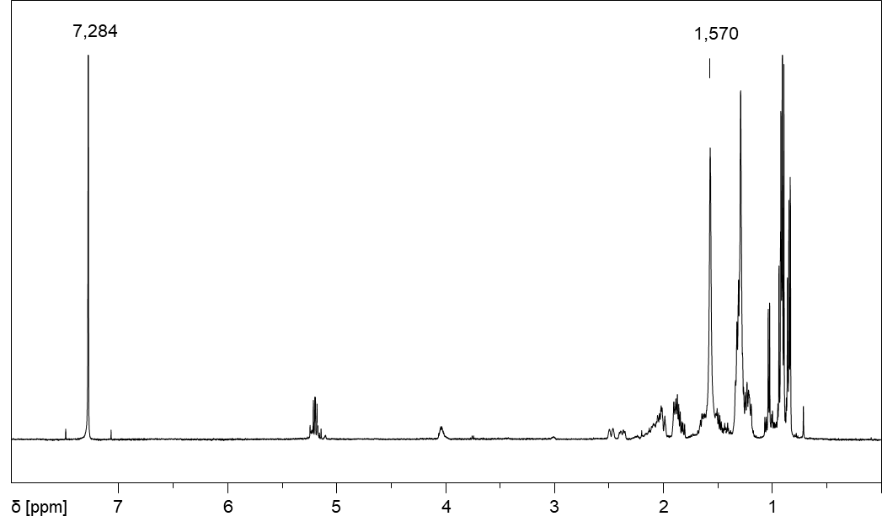
a)

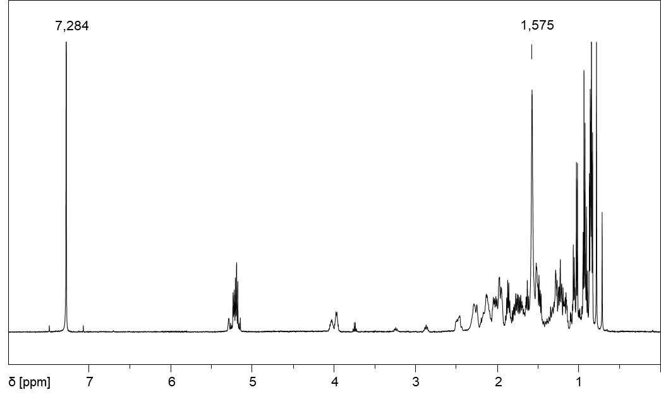
b)

Figure S4: ¹H NMR spectra (500 MHz, CDCl₃) of isolated (a) suprasterol₂ II and (b) suprasterol₂ I.

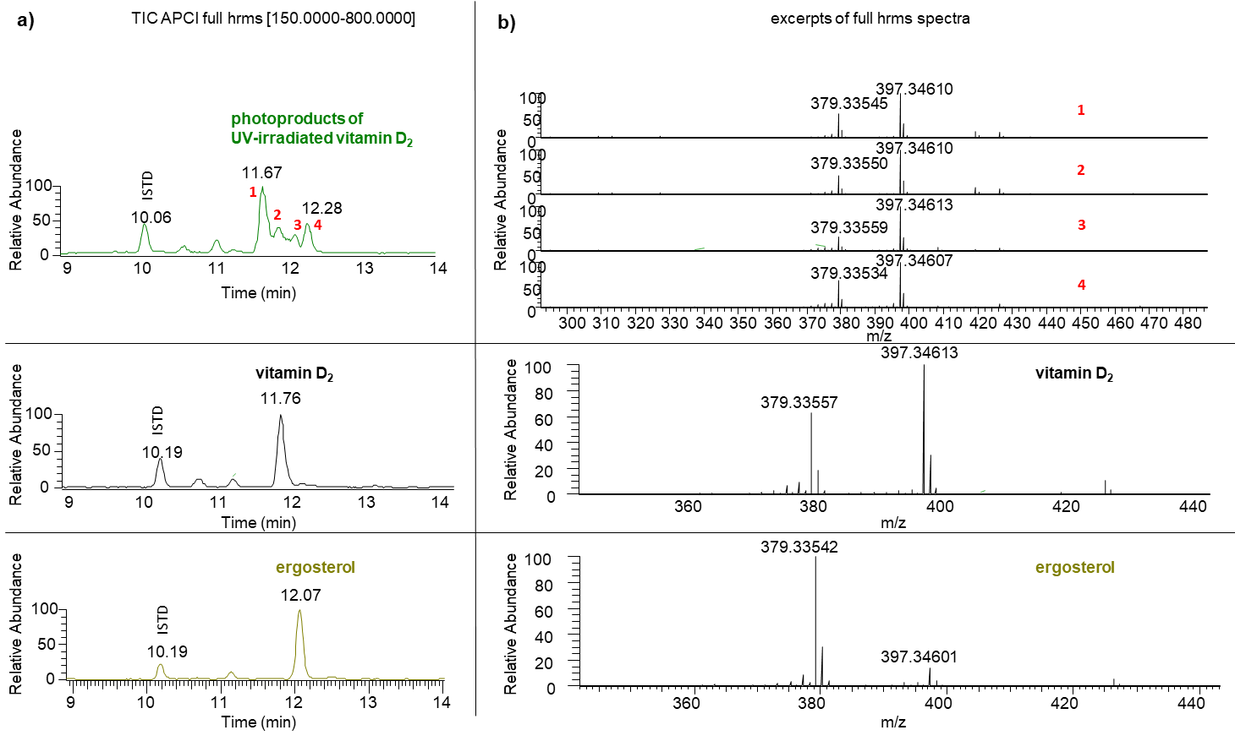
Figure S5: UHPLC-HRMS analysis of ergosterol, vitamin D₂, and UV-irradiated vitamin D₂ (Agilent Zorbax Eclipse C18, 1.8 um, 2 x 50mm, 10 µL/injection, 40 °C, solvent: MeOH/ H₂O, 0.2% formic acid) detected 4 isobaric photoproducts (1 – 4). (a) Total ion chromatograms (TIC) and (b) high resolution mass spectra of standards and photoproducts shows that a mass-to-charge based differentiation of photoproducts were not possible.

