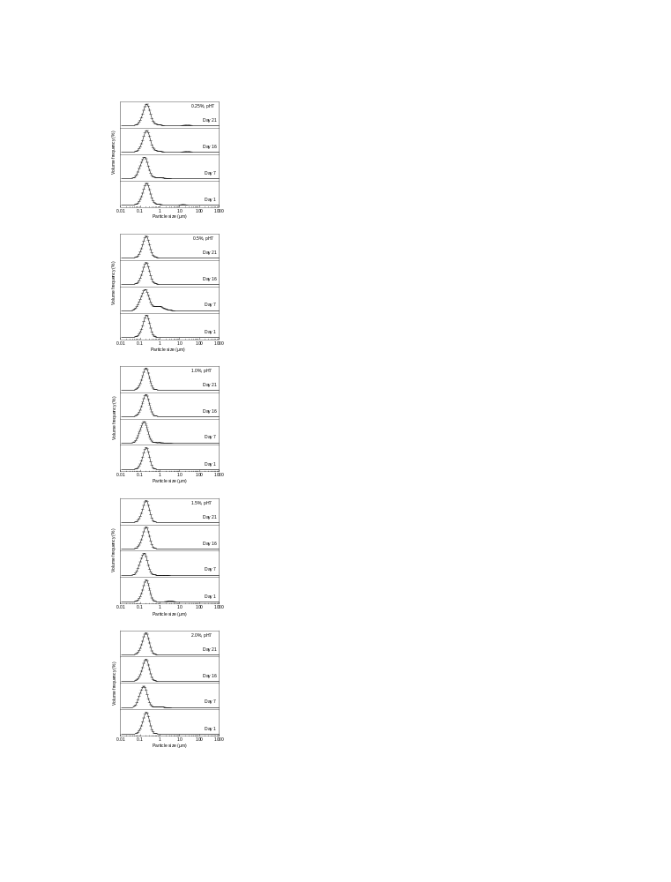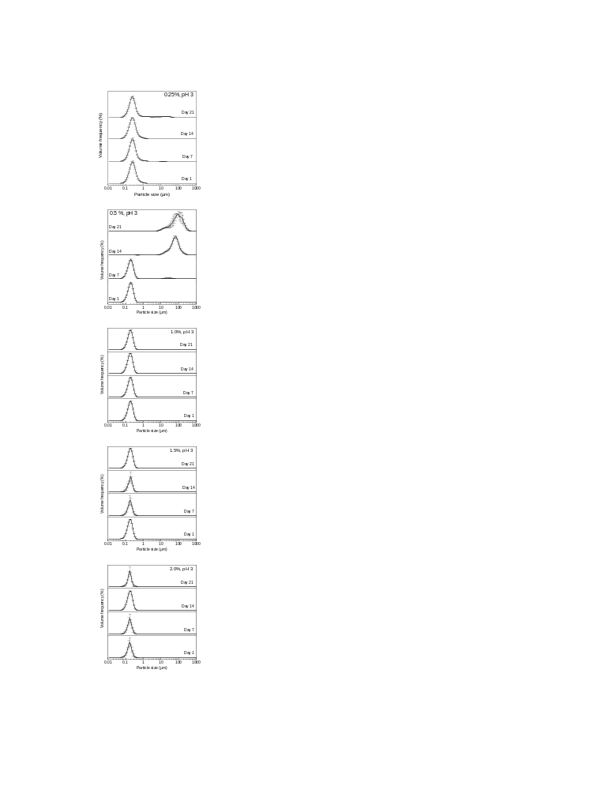
Fig. S1. Particle size (d₄₃) distributions of tristearin (10% w/w/) solid lipid nanoparticles stabilized with glycyrrhizin (0.25-2.0%) at pH 3 and 7 during storage at 20°C.

