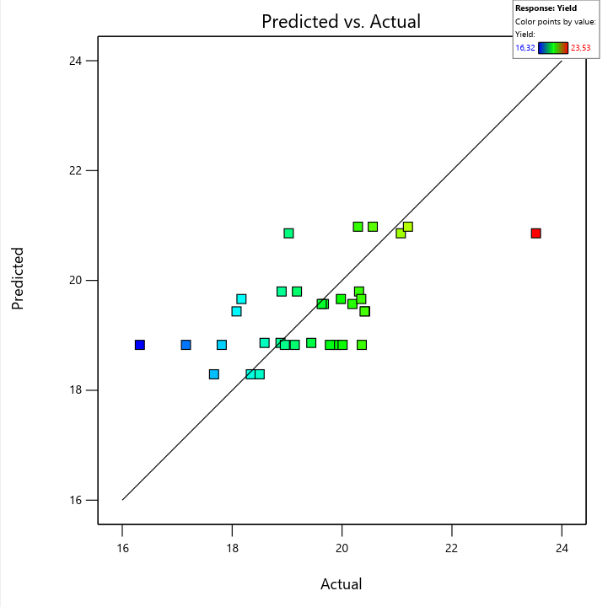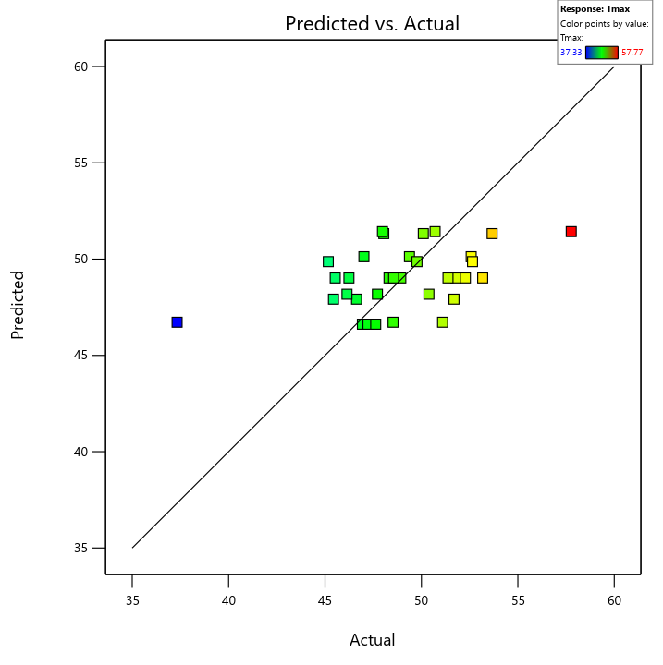
Fig 1 Plots of predicted by the model vs. actual response values of yield [%] and Tmax [min] of cranberry seed oil extracted in UAE process.

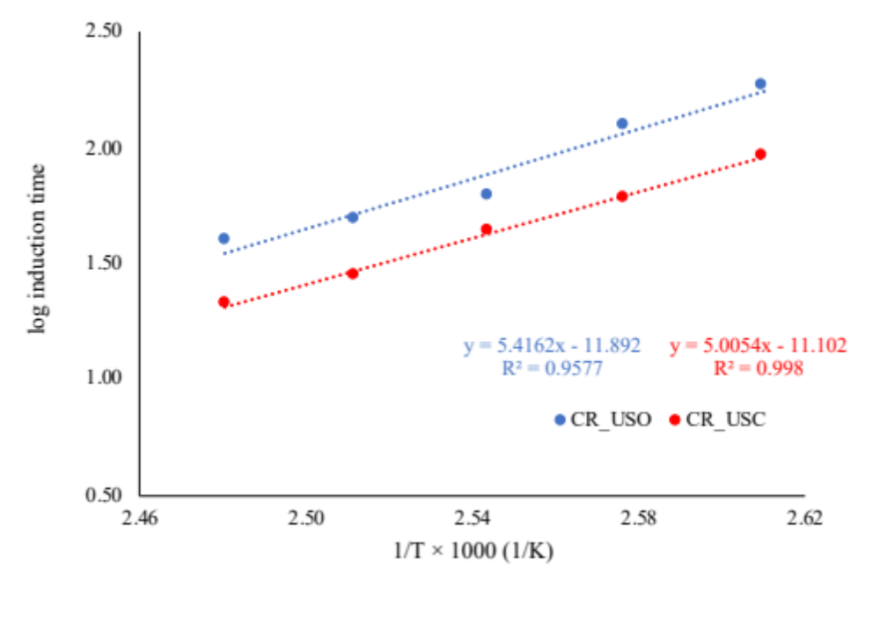
Fig 2 The plot of logarithm of maximum induction time versus inversed temperature; CR_USC- control oil sample, CR_USO- sample of oil extracted using ultrasound in the most efficient conditions

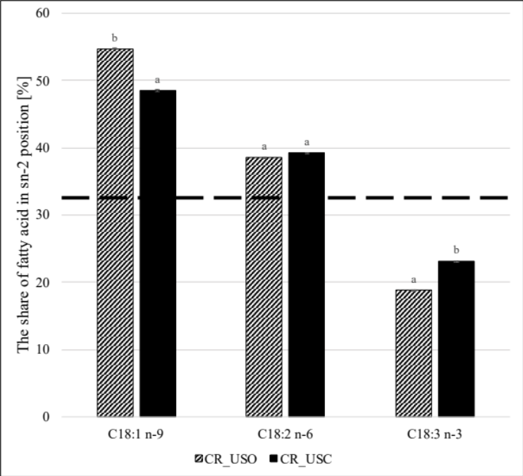
Fig 3 Percentage share of fatty acids in sn-2 position in the tested oils (CR_USC- control oil sample, CR_USO- sample of oil extracted using ultrasound in the most efficient conditions). The dotted line indicates the constant share of fatty acid occupying sn-2 position assuming the equilibrium of all positions in the triacylglycerol molecule; C18:1- oleic acid, C18:2- linoleic fatty acid, C18:3- α-linolenic acid; different letters ^{a-b} indicate significant differences at p < 0.05

