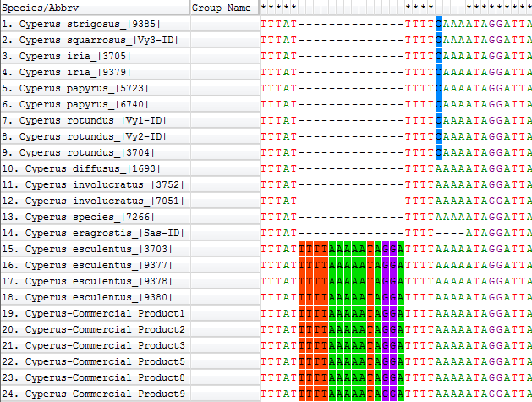
Suppl. Figure 1: Tandem repeat motif of 14 base pairs in the psbA-trnH igs sequences of Cyperus esculentus (black box), contrasting with a single copy of this motif in all other Cyperus accessions investigated in this study.
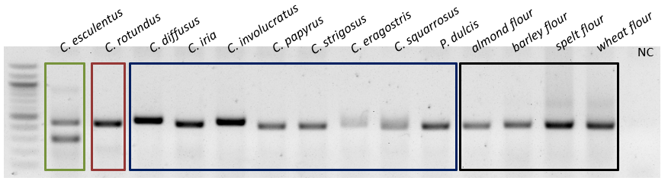
Suppl. Figure 2: ITS2-based agarose electrophoresis of ARMS (using the CE3 diagnostic primer, species-specific for C. esculentus) amplicons from C. esculentus (green) and C. rotundus (red) reference plants as well as all other Cyperus species used in this study (blue). An individual of almond (Prunus dulcis) (that has a similar vernacular name) was also included (blue). The test was extended to flours of other commonly used products, namely almond, barley, spelt and wheat flour. A unique signal for C. esculentus that is absent in all other species can be observed.

