Supplementary Information

Characterization of chemical compounds of fractions from four different bee pollens with chemometric classification

Gülsen Tel-Çayan¹* · Fatih Çayan¹ · Ebru Deveci² · Şükrü Karataş³ · Mehmet Emin Duru⁴

¹Department of Chemistry and Chemical Processing Technologies, Muğla Vocational School, Muğla Sıtkı Koçman University, Muğla, Türkiye
²Chemistry and Chemical Processing Technology Department, Technical Sciences Vocational School, Konya Technical University, Konya, Türkiye
³Mugla Sıtkı Kocman University, Köyceğiz Vocational School, Department of Herbal and Animal Production, Medicinal and Aromatic Plants Program, Mugla, Türkiye
⁴Department of Chemistry, Faculty of Science, Muğla Sıtkı Koçman University, Muğla, Türkiye

Palynological analysis
Preparations of bee pollens were prepared by modifying Barth [1] method. For the preparations to be permanent, glycerin-gelatin colored with basic fuchsin was used as in Sorkun [2] method. 10 g of bee pollen sample was weighed and taken into a centrifuge tube. 65 mL of 70% ethanol was added and kept for 30 min, and kept in an ultrasonic water bath for 5 min for homogeneous distribution of pollen grains. These tubes were centrifuged at 3500 rpm for 20 min to ensure that the pollen grains settled to the bottom. After centrifugation, the supernatant was poured off, a 1:1 glycerin-water solution was added to the remaining sediment, and the pollen grains were vortexed until they were homogeneously distributed, and then centrifuged again for 20 min. The supernatant was poured again, and the tubes were turned upside down on a blotting paper to dry the pollen remaining at the bottom. The glycerin-gelatin matrix taken to the tip of the needle with the help of a dissection needle was spread to the pollen at the bottom of the tube. The glycerin-gelatin was taken on a slide and melted on a 40-45°C heating table. A 18×18 mm² cover slide was placed and turned into a fixed preparation. The prepared preparations were turned upside down and kept for 12 h so that the melted glycerin-gelatin could freeze and the pollen could be stained and approach the cover slide surface, and they were ready for light microscopic analysis. All bee pollens were observed under a light microscope (Olympus CX-31, Olympus, Japan). At least 500 pollen grains were counted in each microscopic slide.
While producing the bee pollen used in this study, the shape and color of the relevant bee pollen were examined under a microscope and other bee pollen mixed with very small amounts of other plants were separated and after this separation, experimental studies were started. The four bee pollens analyzed were found to contain 100% of that pollen.
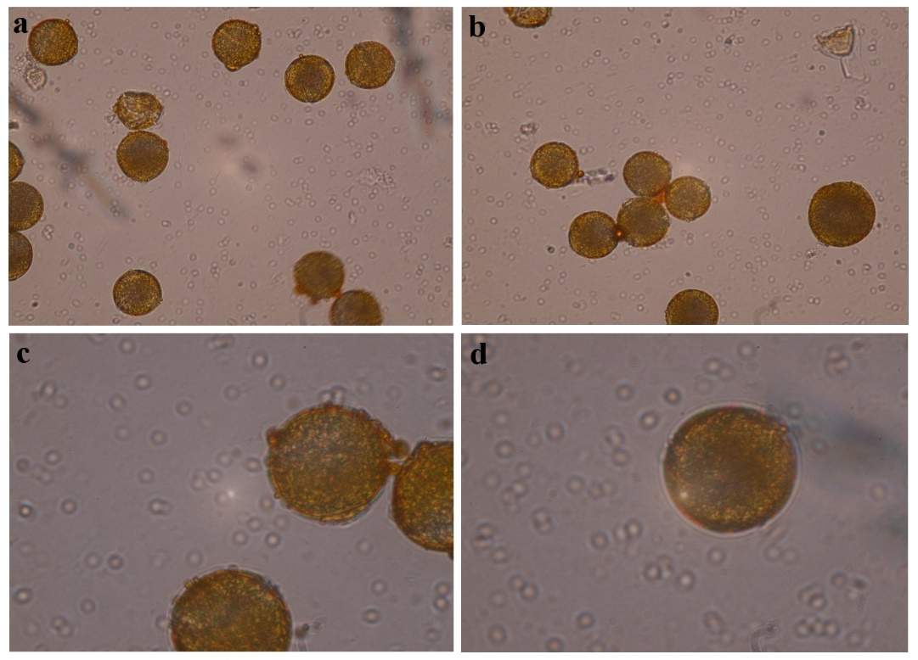
Fig. S1 Microscope images of C. creticus bee pollen were observed by light microscope (Olympus CX-31 microscope) a-b) 40x c-d) 100x
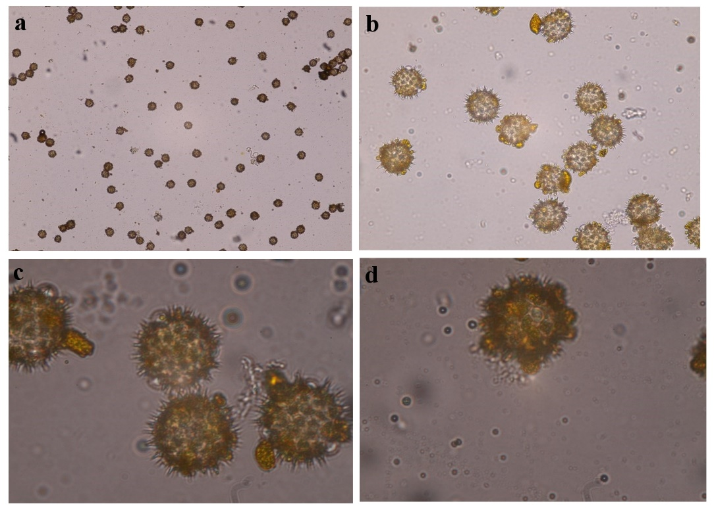

Fig. S2 Microscope images of H. annuus bee pollen were observed by light microscope (Olympus CX-31 microscope) a) 4x b) 40x c-d) 100x
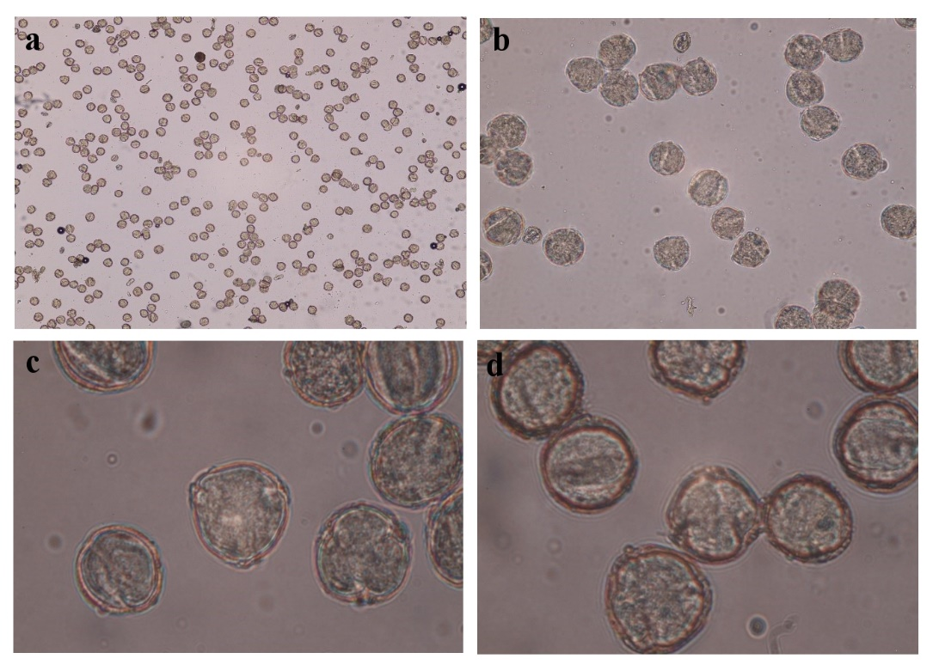
Fig. S3 Microscope images of P. somniferum bee pollen were observed by light microscope (Olympus CX-31 microscope) a) 4x b) 40x c-d) 100x
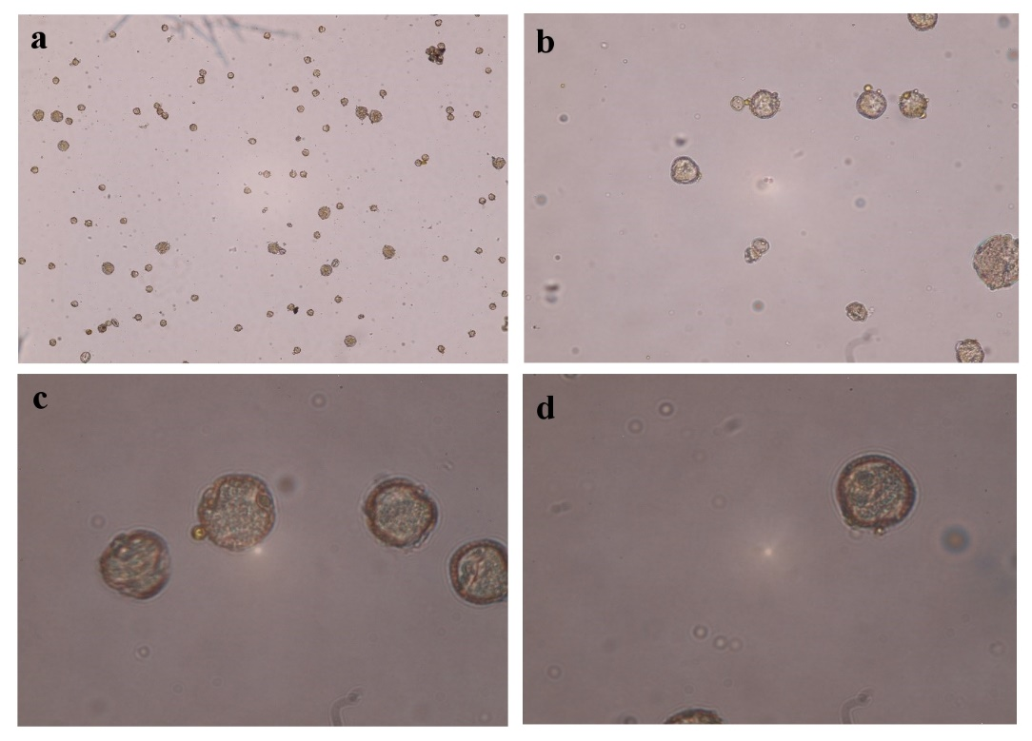
Fig. S4 Microscope images of Salix sp. bee pollen were observed by light microscope (Olympus CX-31 microscope) a) 4x b) 40x c-d) 100x
Table S1 The analytical parameters of chemical compounds for HPLC-DAD analysis [3]
Peak number | Compounds | Retention time (min) | Calibration equation | R² | LOD (μg/L) | LOQ (μg/L)
1 | Fumaric acid | 3.061 | y = 7536.59x – 42682.3 | 0.9941 | 0.836 | 1.240
2 | trans-Aconitic acid | 3.303 | y = 1748.3x | 0.9737 | 0.177 | 0.318
3 | Gallic acid | 3.585 | y = 42016x – 318333 | 0.9998 | 0.021 | 0.063
4 | Levulinic acid | 3.809 | y = 145020x – 702450 | 0.9981 | 0.017 | 0.085
5 | Protocatechuic acid | 5.345 | y = 33240.3x + 77523 | 0.9996 | 0.247 | 0.632
6 | p-Hydroxy phenyl acetic acid | 6.326 | y = 1988.98x – 8881.95 | 0.9950 | 0.023 | 0.096
7 | Catechin | 6.402 | y = 11220.2x + 9048.92 | 0.9990 | 0.086 | 0.176
8 | Chlorogenic acid | 7.749 | y = 2355.2x – 142500 | 0.9995 | 1.120 | 2.652
9 | p-Hydroxy benzoic acid | 7.950 | y = 33763.8x + 112.809 | 0.9998 | 0.110 | 0.216
10 | 6,7-Dihydroxy coumarin | 8.921 | y = 24832.9x – 63553.9 | 0.9997 | 0.013 | 0.058
11 | Vanillic acid | 9.635 | y = 41742.6x – 226.431 | 0.9947 | 0.195 | 0.782
12 | Caffeic acid | 9.722 | y = 49477x – 110000 | 0.9990 | 0.002 | 0.018
13 | 3-Hydroxy benzoic acid | 10.214 | y = 13353.8x – 47673.3 | 0.9972 | 0.114 | 0.187
14 | Vanillin | 11.714 | y = 82270.1x + 6509.90 | 0.9991 | 0.023 | 0.056
15 | p-Coumaric acid | 14.556 | y = 106128x + 386852 | 0.9999 | 0.037 | 0.048
16 | Guaiacol | 14.822 | y = 18959.3x + 16959.3 | 0.9999 | 0.001 | 0.024
17 | Ferulic acid | 16.642 | y = 68078x – 396175 | 0.9942 | 0.163 | 0.357
18 | Coumarin | 18.701 | y = 114406x – 670907 | 0.9961 | 0.002 | 0.001
19 | Rutin | 20.459 | y = 12669x – 43580.3 | 0.9980 | 0.035 | 0.052
20 | 2-Hydroxy cinnamic acid | 20.509 | y = 132353x – 599487 | 0.9968 | 0.018 | 0.055
21 | Rosmarinic acid | 21.095 | y = 30134.4x – 410728 | 0.9891 | 0.060 | 0.181
22 | Myricetin | 21.517 | y = 13815.9x – 108764 | 0.9974 | 0.001 | 0.003
23 | Quercetin | 23.351 | y=38195.9x – 306791 | 0.9958 | 0.014 | 0.018
24 | trans-Cinnamic acid | 23.443 | y = 203428x – 470060 | 0.9998 | 0.163 | 0.608
25 | Naringenin | 23.568 | y = 37019x + 14167 | 0.9999 | 0.001 | 0.004
26 | Luteolin | 23.900 | y = 41238.6x – 140598 | 0.9990 | 0.002 | 0.035
27 | Kaempferol | 24.765 | y = 28107.6x + 26189.6 | 0.9998 | 0.008 | 0.026
28 | Apigenin | 25.015 | y = 26564x – 39821 | 0.9999 | 0.005 | 0.019
29 | Chrysin | 27.172 | y = 76131.8x + 128150 | 0.9999 | 0.042 | 0.118
R²: Coefficient of determination, LOD: Limit of detection, LOQ: Limit of quantification
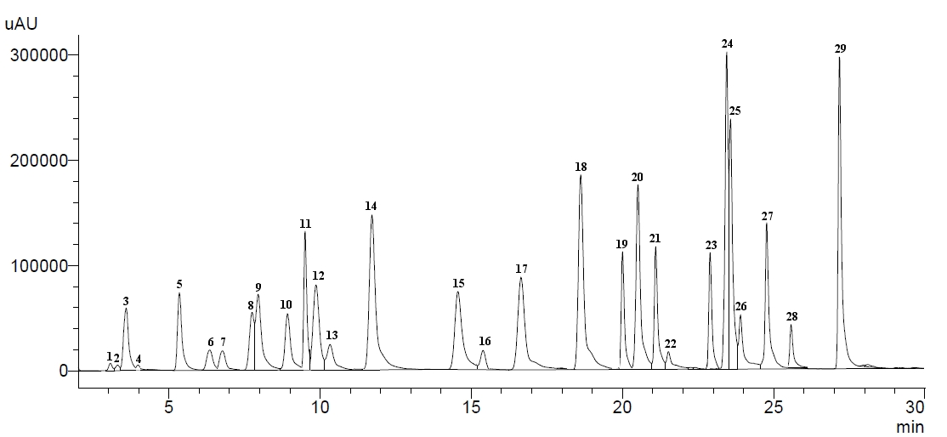
Fig. S5 HPLC chromatogram of the standards

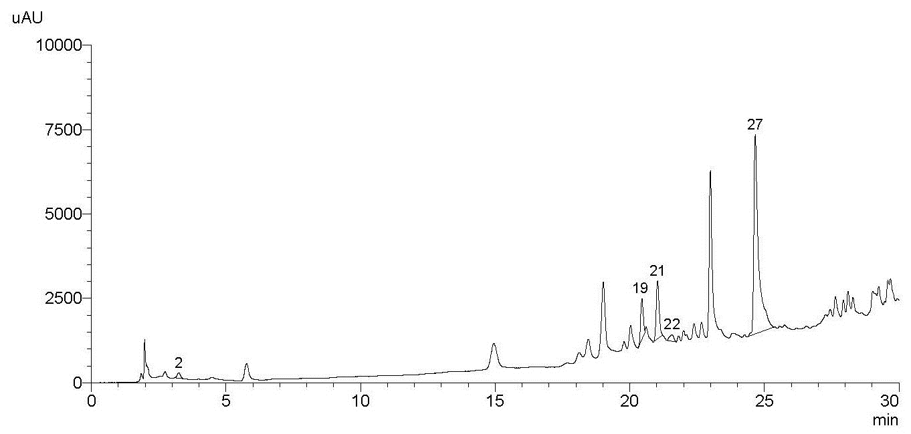
Fig. S6 HPLC chromatogram of C. creticus bee pollen (C)

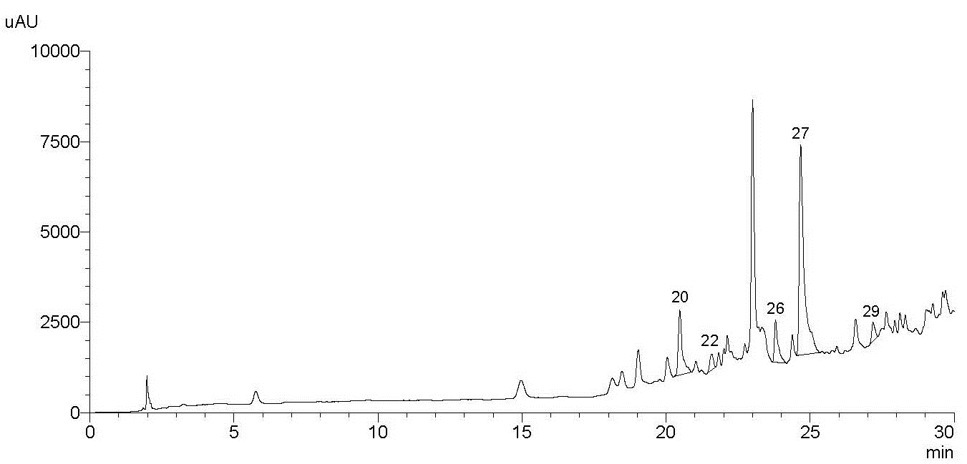
Fig. S7 HPLC chromatogram of the hexane fraction of C. creticus bee pollen (CH)

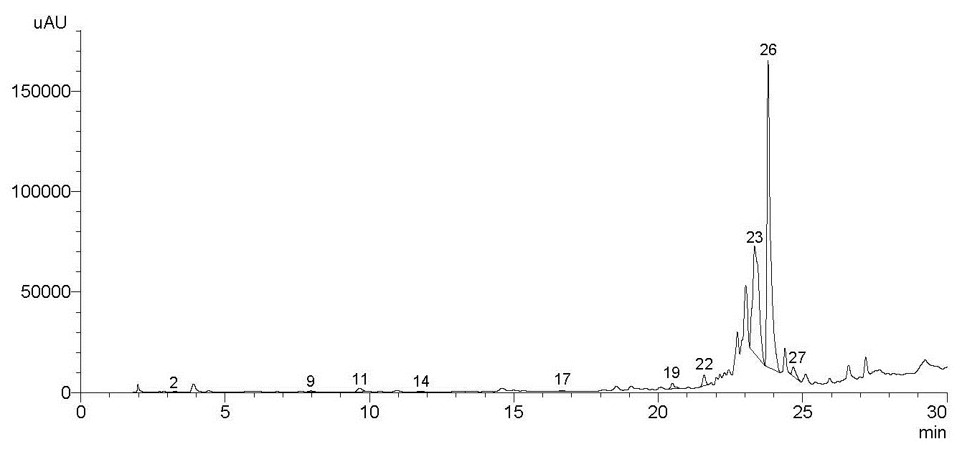
Fig. S8 HPLC chromatogram of the dichloromethane fraction of C. creticus bee pollen (CD)

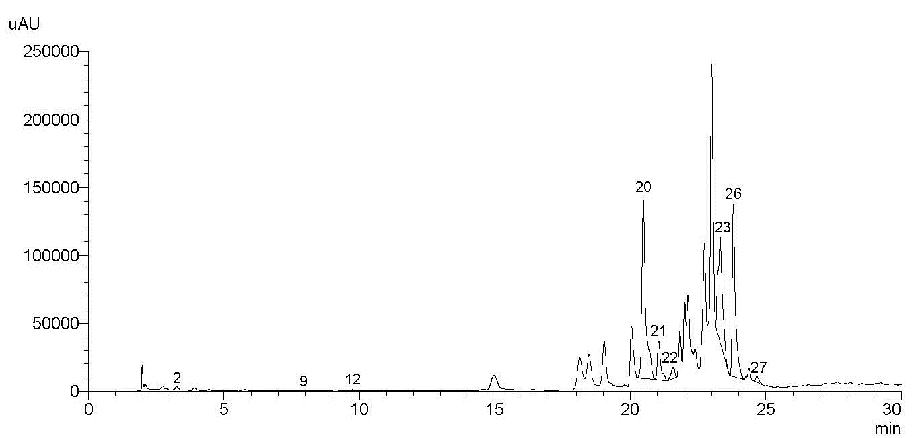
Fig. S9 HPLC chromatogram of the ethyl acetate fraction of C. creticus bee pollen (CEA)

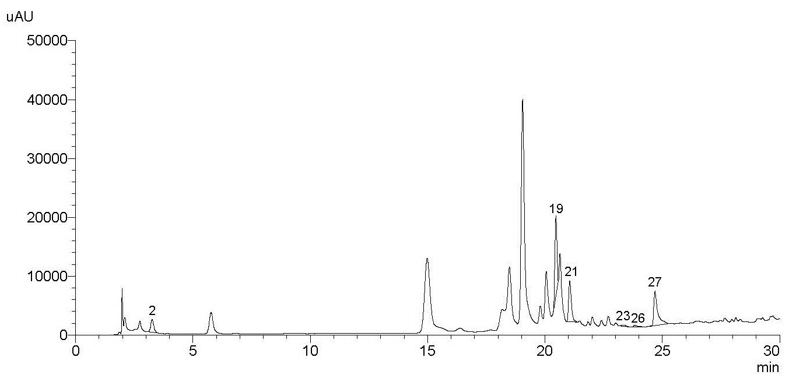
Fig. S10 HPLC chromatogram of the butanol fraction of C. creticus bee pollen (CB)

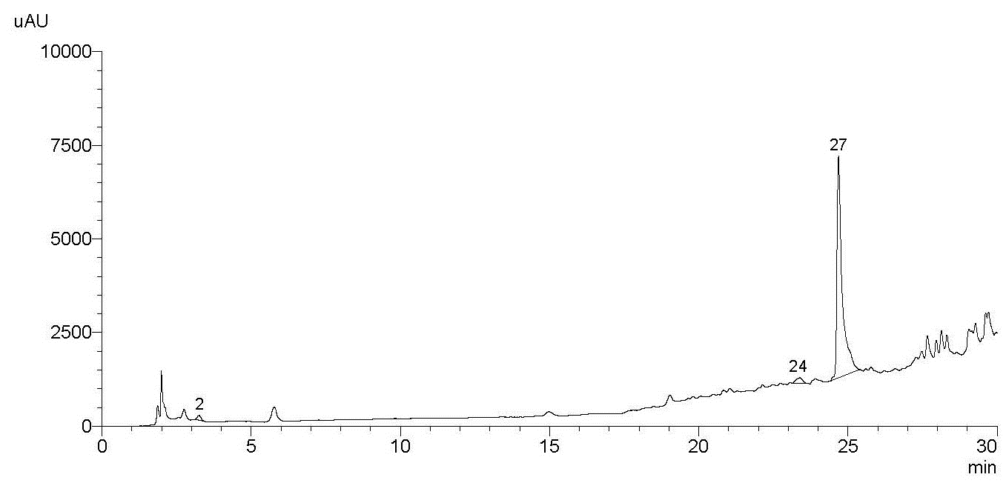
Fig. S11 HPLC chromatogram of the water fraction of C. creticus bee pollen (CW1)

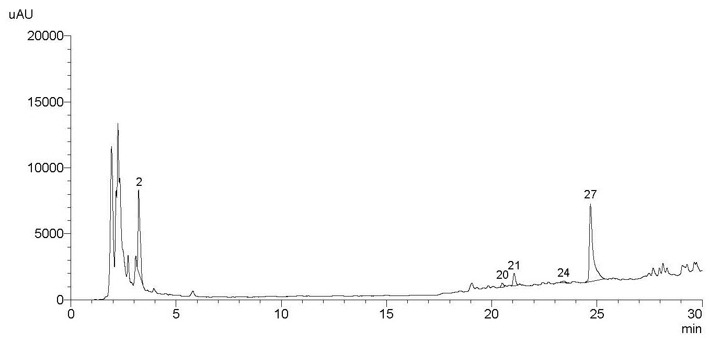
Fig. S12 HPLC chromatogram of the water extract of C. creticus bee pollen (CW2)

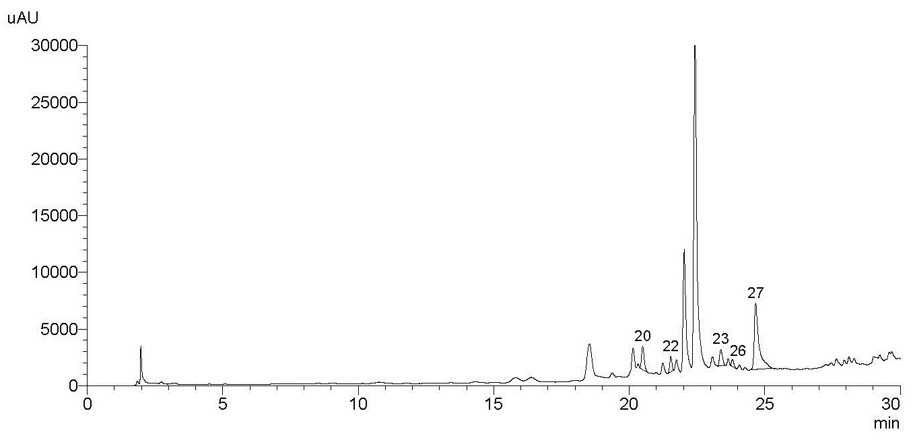
Fig. S13 HPLC chromatogram of H. annuus bee pollen (H)

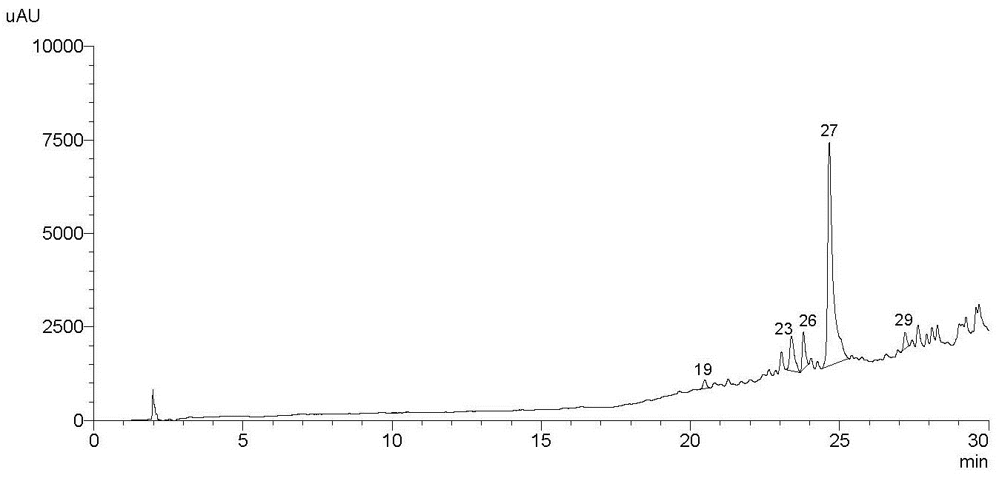
Fig. S14 HPLC chromatogram of the hexane fraction of H. annuus bee pollen (HH)

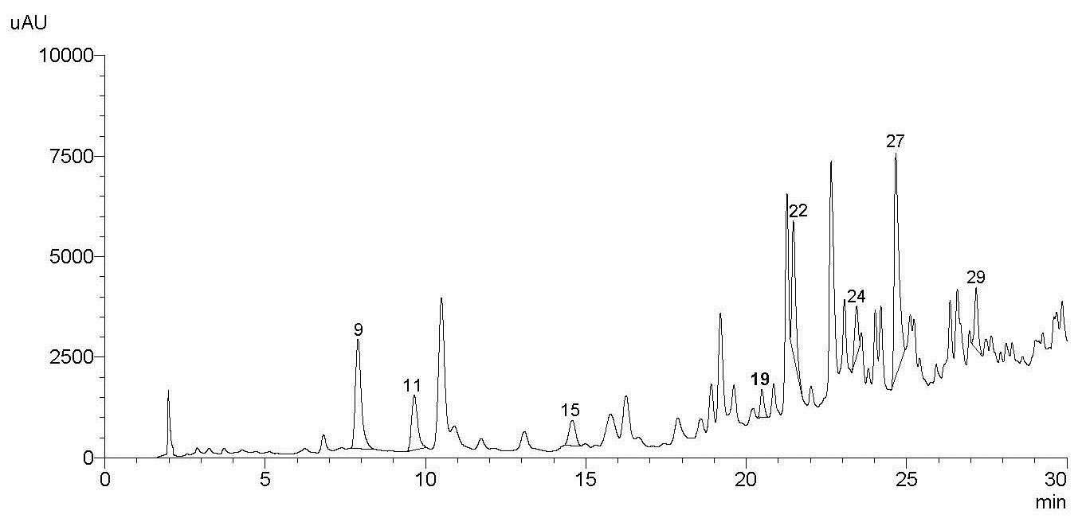
Fig. S15 HPLC chromatogram of the dichloromethane fraction of H. annuus bee pollen (HD)

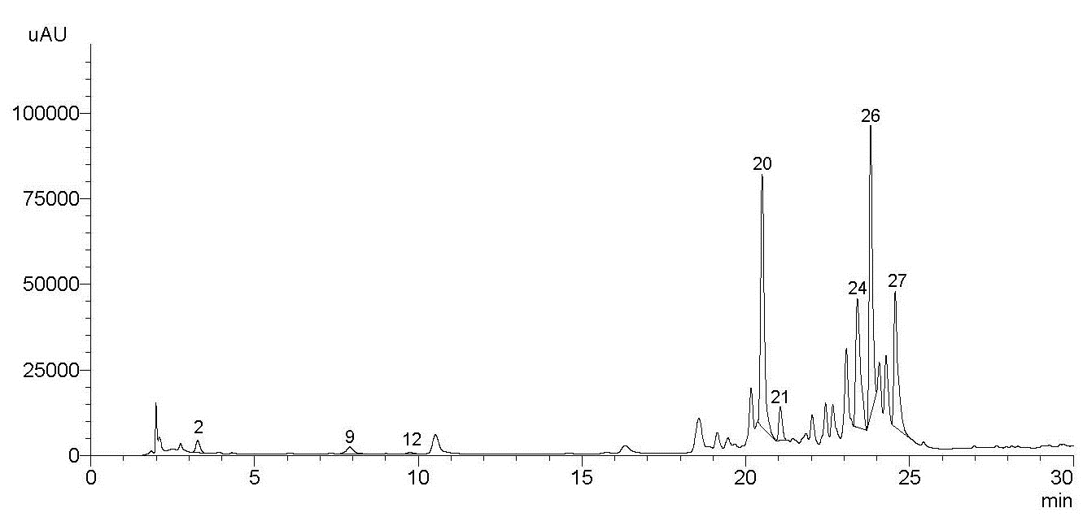
Fig. S16 HPLC chromatogram of the ethyl acetate fraction of H. annuus bee pollen (HEA)

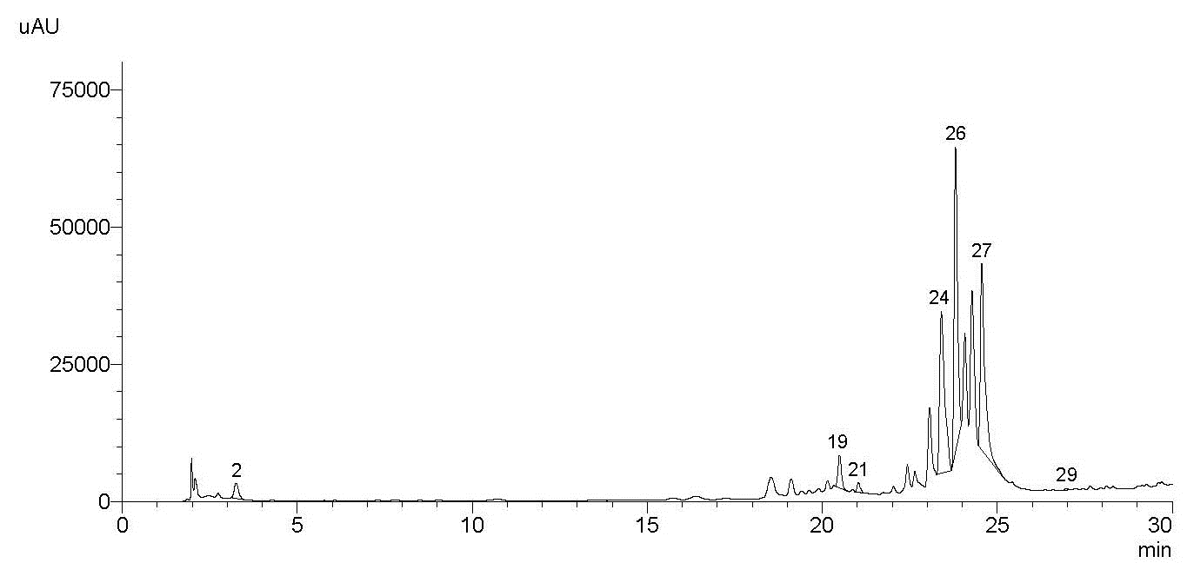
Fig. S17 HPLC chromatogram of the butanol fraction of H. annuus bee pollen (HB)

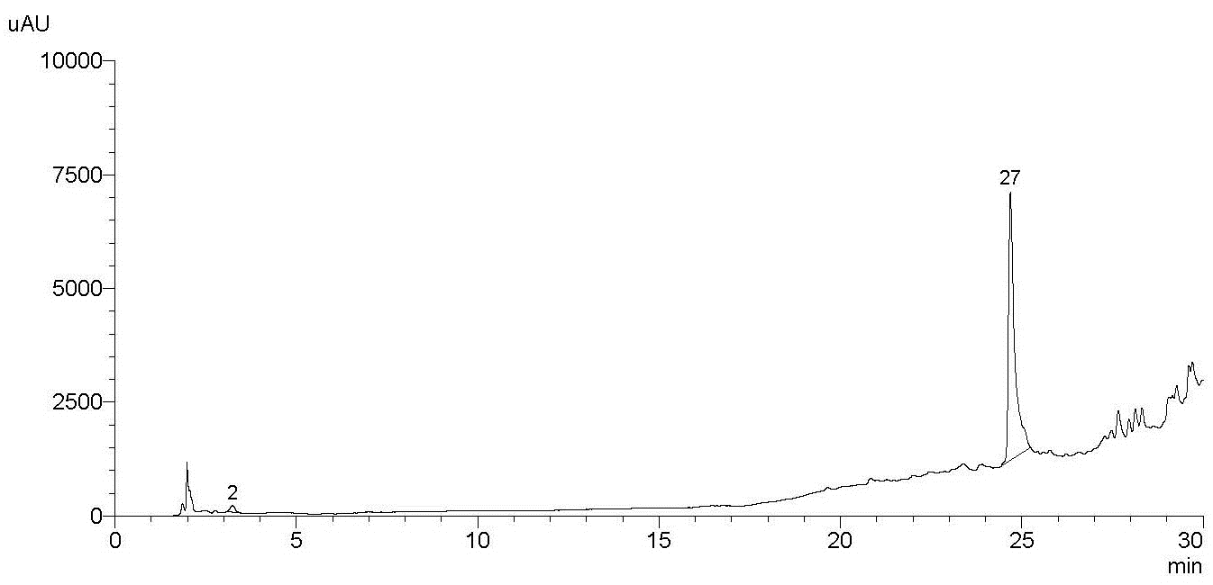
Fig. S18 HPLC chromatogram of the water fraction of H. annuus bee pollen (HW1)

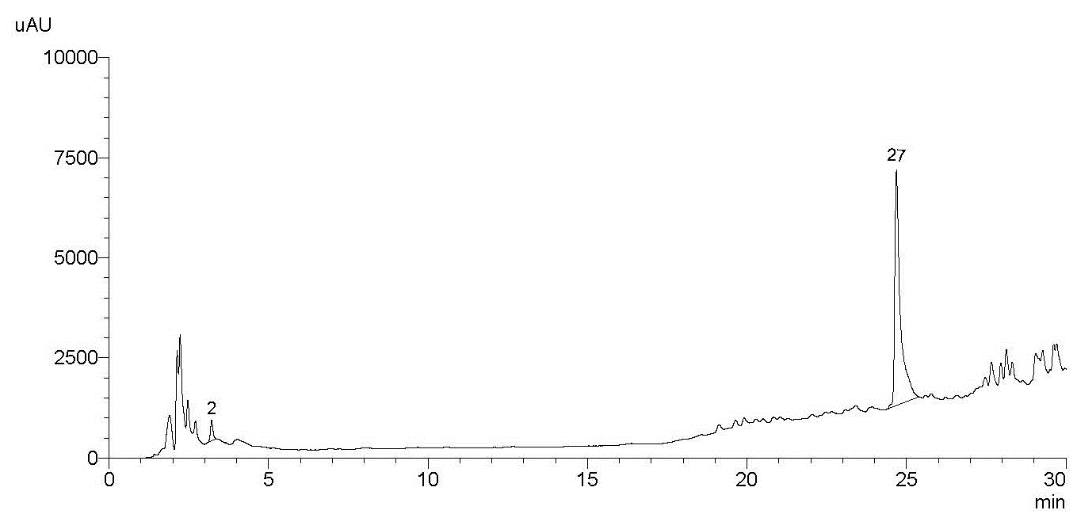
Fig. S19 HPLC chromatogram of the water extract of H. annuus bee pollen (HW2)

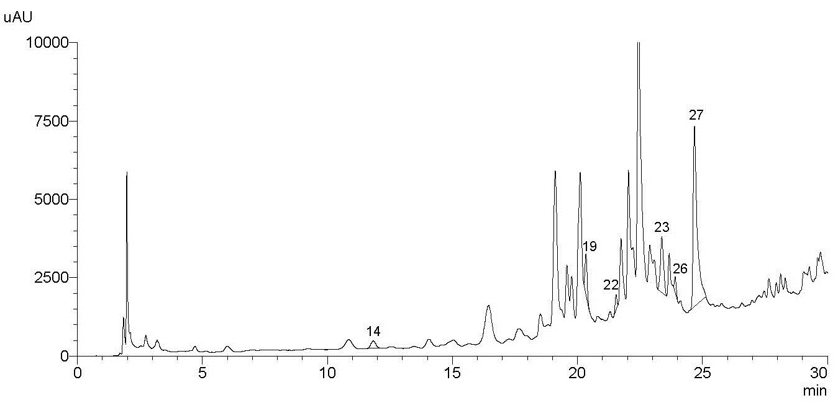
Fig. S20 HPLC chromatogram of P. somniferum bee pollen (P)

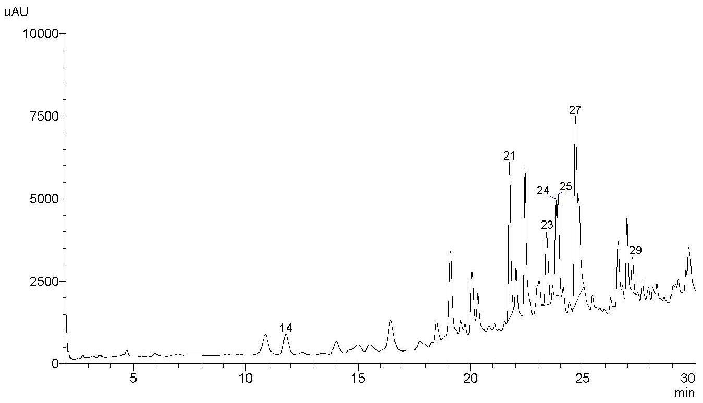
Fig. S21 HPLC chromatogram of the hexane fraction of P. somniferum bee pollen (PH)

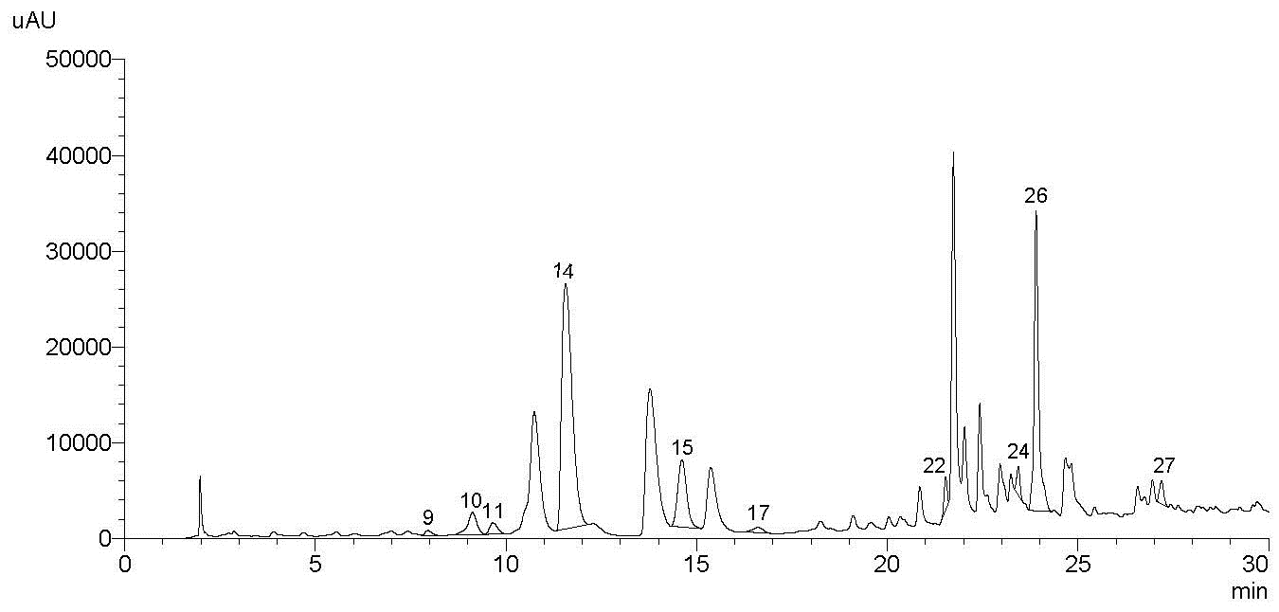
Fig. S22 HPLC chromatogram of the dichloromethane fraction of P. somniferum bee pollen (PD)

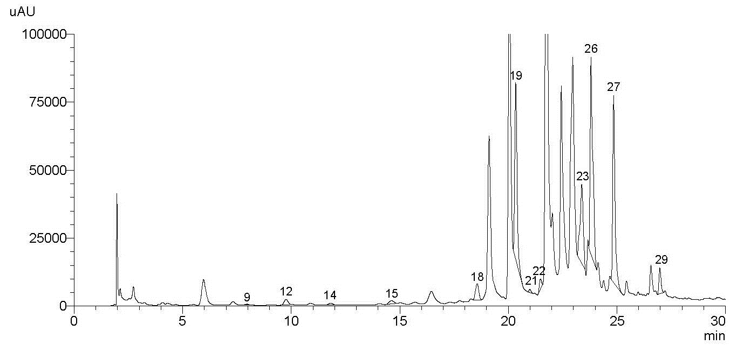
Fig. S23 HPLC chromatogram of the ethyl acetate fraction of P. somniferum bee pollen (PEA)

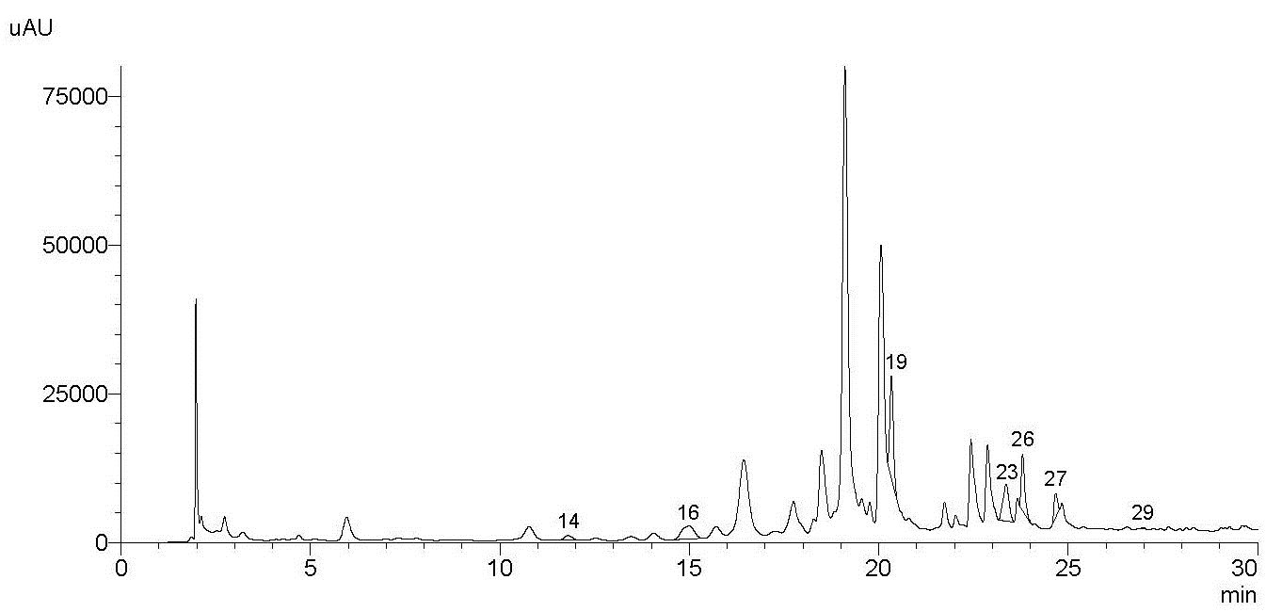
Fig. S24 HPLC chromatogram of the butanol fraction of P. somniferum bee pollen (PB)

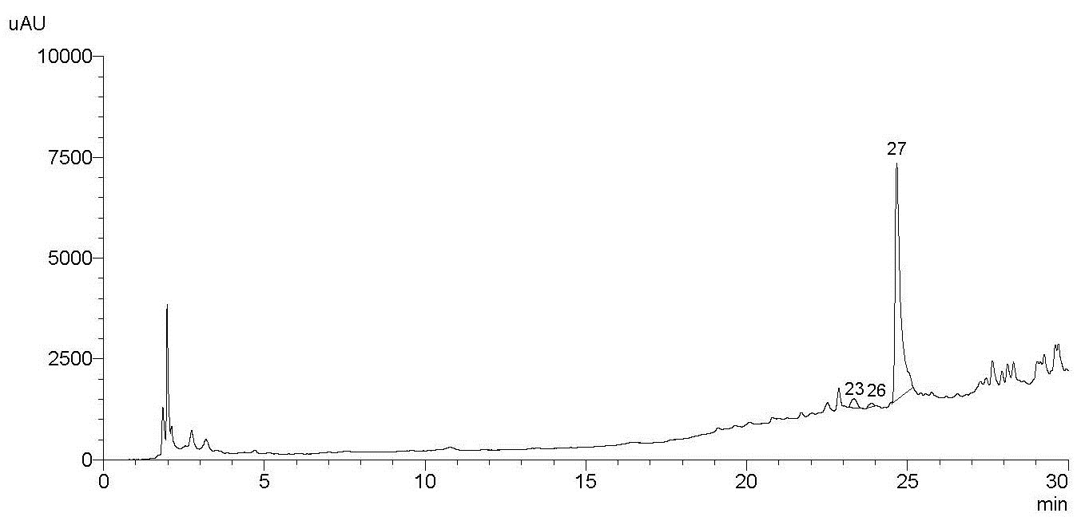
Fig. S25 HPLC chromatogram of the water fraction of P. somniferum bee pollen (PW1)

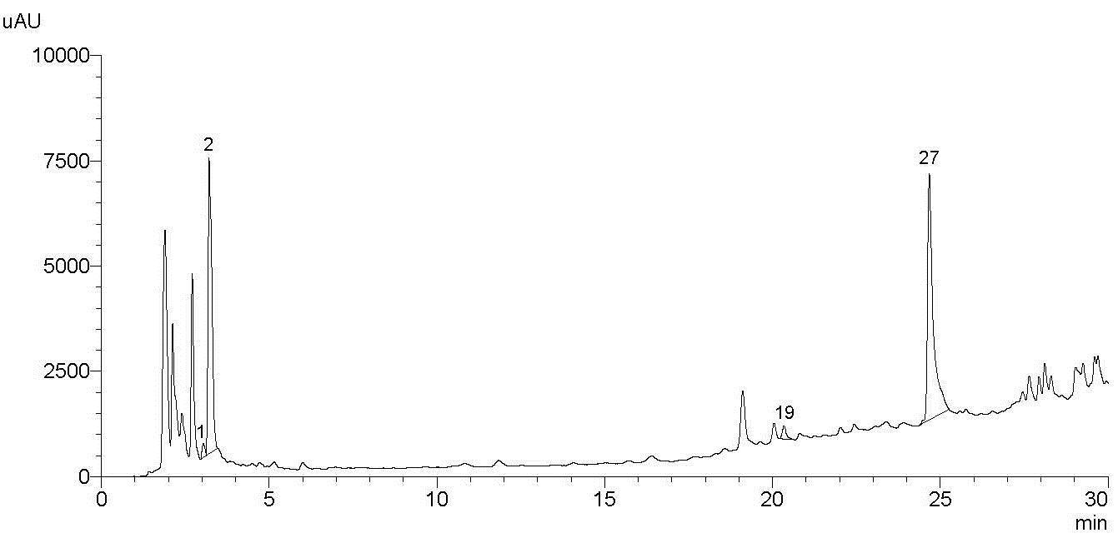
Fig. S26 HPLC chromatogram of the water extract of P. somniferum bee pollen (PW2)

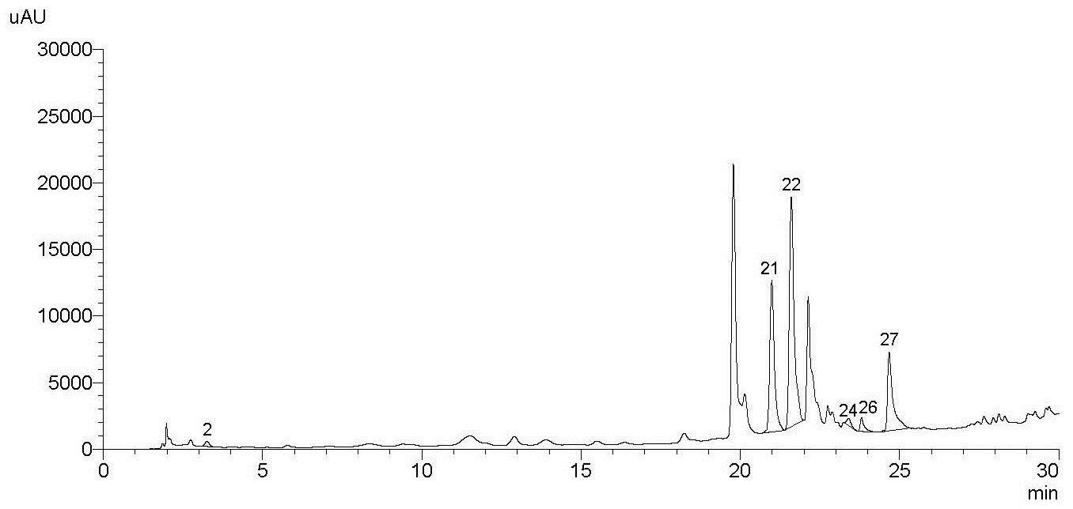
Fig. S27 HPLC chromatogram of Salix sp. bee pollen (S)

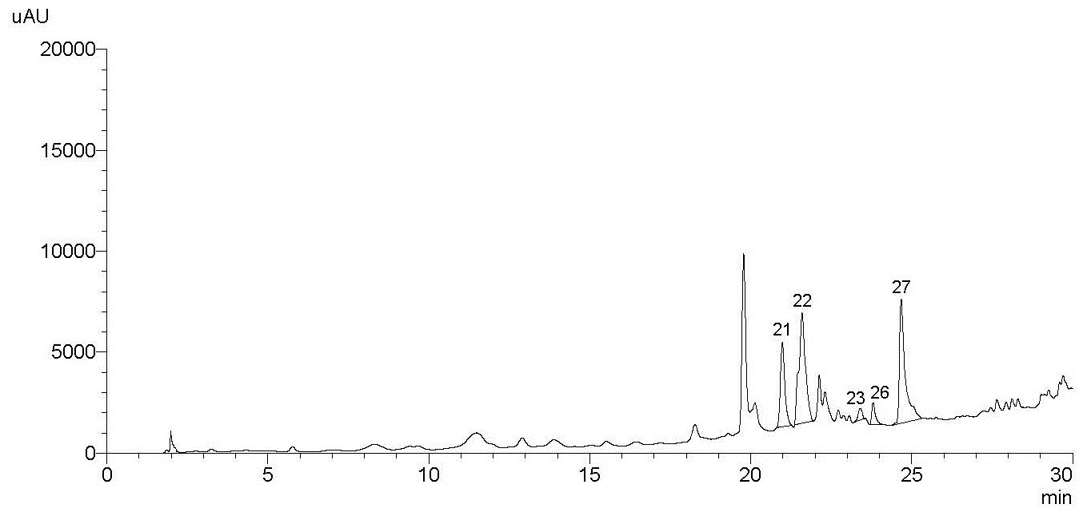
Fig. S28 HPLC chromatogram of the hexane fraction of Salix sp. bee pollen (SH)

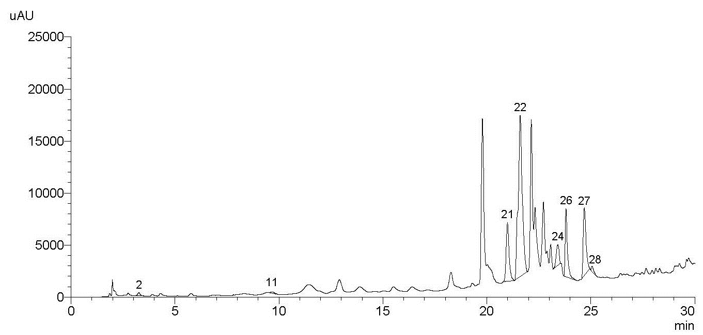
Fig. S29 HPLC chromatogram of the dichloromethane fraction of Salix sp. bee pollen (SD)

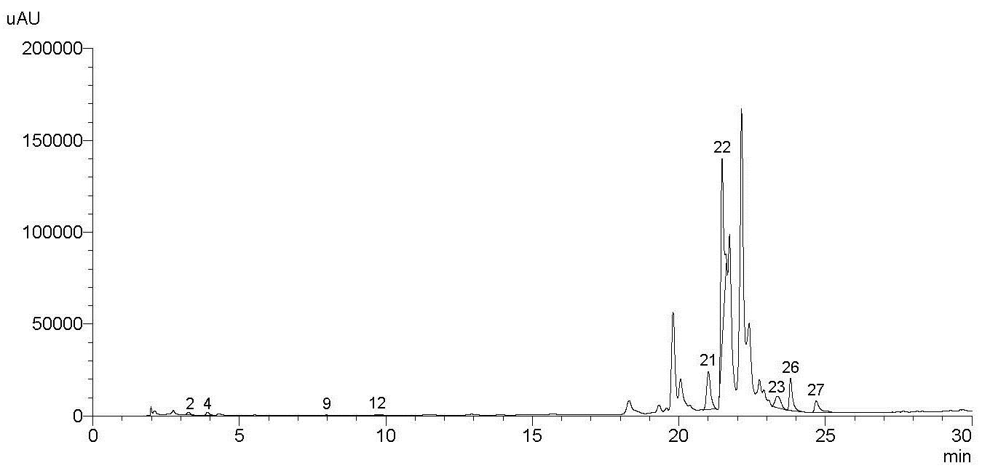
Fig. S30 HPLC chromatogram of the ethyl acetate fraction of Salix sp. bee pollen (SEA)

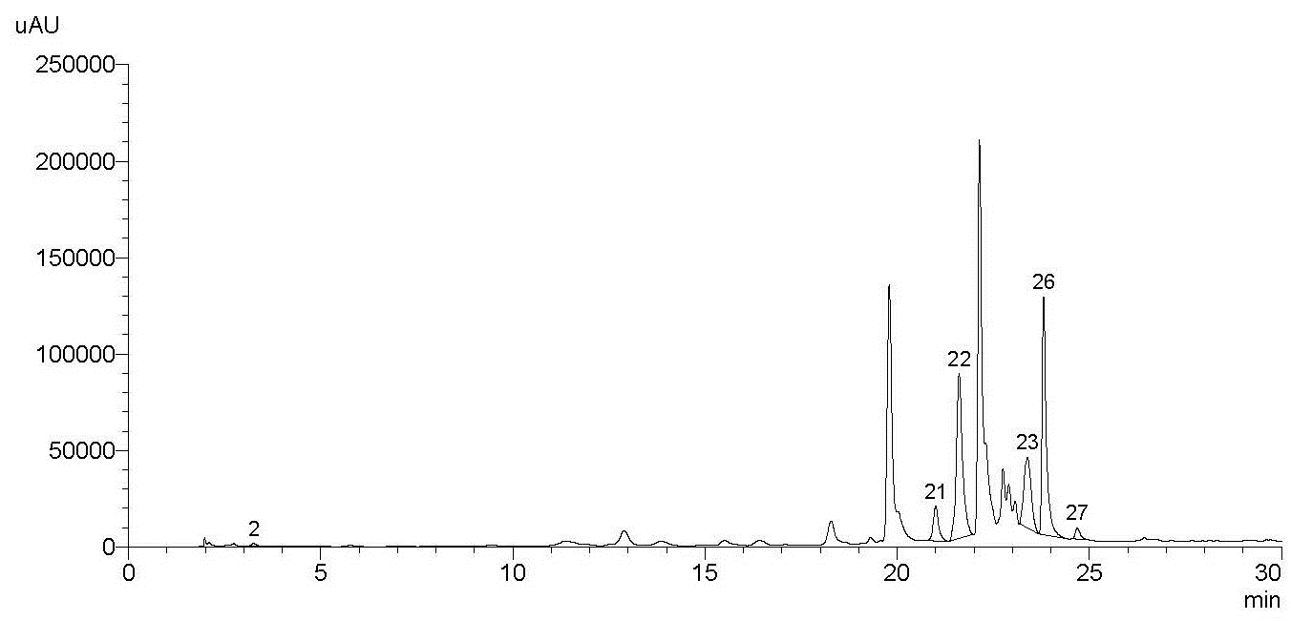
Fig. S31 HPLC chromatogram of the butanol fraction of Salix sp. bee pollen (SB)

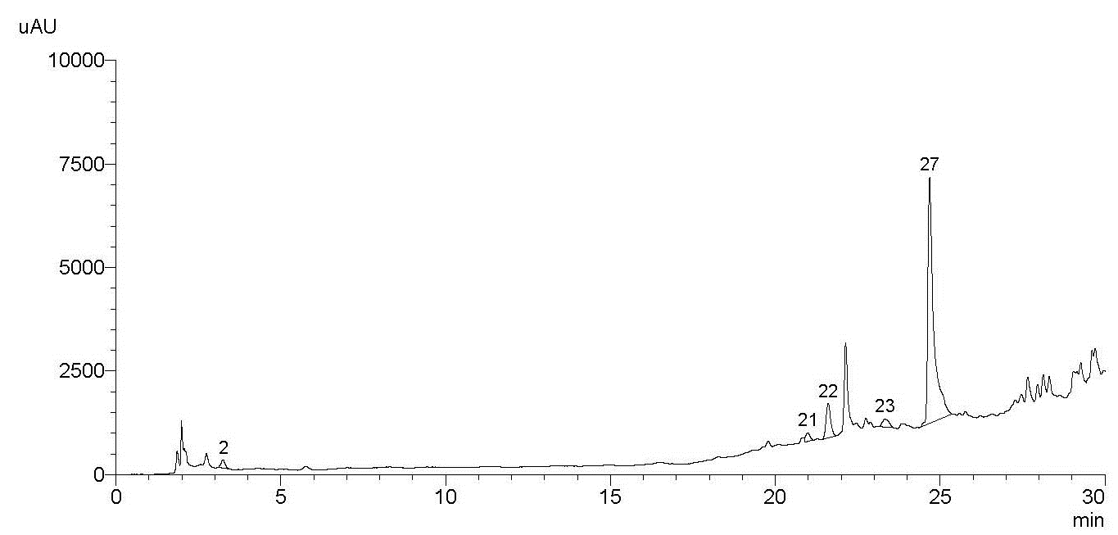
Fig. S32 HPLC chromatogram of the water fraction of Salix sp. bee pollen (SW1)

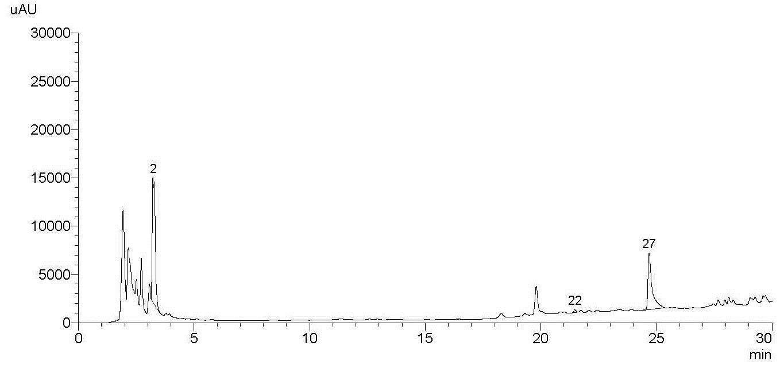
Fig. S33 HPLC chromatogram of the water extract of Salix sp. bee pollen (SW2)

References
- Barth OM, Freitas AS, Oliveira ES, Silva RA, Maester FM, Andrella RR, Cardozo GM (2010) Evaluation of the botanical origin of commercial dry bee pollen load batches using pollen analysis: A proposal for technical standardization. An Acad Bras Cienc 82(4):893-902. https://doi.org/10.1590/s0001-37652010000400011
- Sorkun K (2008) Turkey’s nectar plants, pollens and honey. Ankara: Palme Publishing.
- Tel-Çayan G, Çayan F, Deveci E, Duru ME (2021) Phenolic profile, antioxidant and cholinesterase inhibitory activities of four Trametes species: T. bicolor, T. pubescens, T. suaveolens, and T. versicolor. J Food Meas Charact 15:4608-4616. https://doi.org/10.1007/s11694-021-01034-1

* Gülsen Tel-Çayan gulsentelcayan@gmail.com.tr, gulsentel@mu.edu.tr

