Modelling and optimisation of pea protein hydrolysis: linking process parameters to technological functionality
European Food Research and Technology
Sofia Melchior ^{a,b}, Giulia Di Filippo ^{a*}, Marco Lopriore ª, Sonia Calligaris ª, Nadia Innocente ª, Maria Cristina Nicoliª

ª Department of Agricultural, Food, Environmental and Animal Sciences, University of Udine, Udine, Italy
^{b} Department of Human Sciences and Promotion of the Quality of Life, San Raffaele University, Rome, Italy

* Corresponding author:
Giulia Di Filippo, giulia.difilippo@uniud.it, Department of Agricultural, Food, Environmental and Animal Sciences, University of Udine, Udine, 33100, Italy

Sofia Melchior: 0000-0001-8404-637X
Giulia Di Filippo: 0000-0002-0579-6947
Marco Lopriore: 0009-0000-6586-0173
Sonia Calligaris: 0000-0001-5823-9688
Nadia Innocente: 0000-0003-2021-4463
Maria Cristina Nicoli: 0000-0001-8413-8549
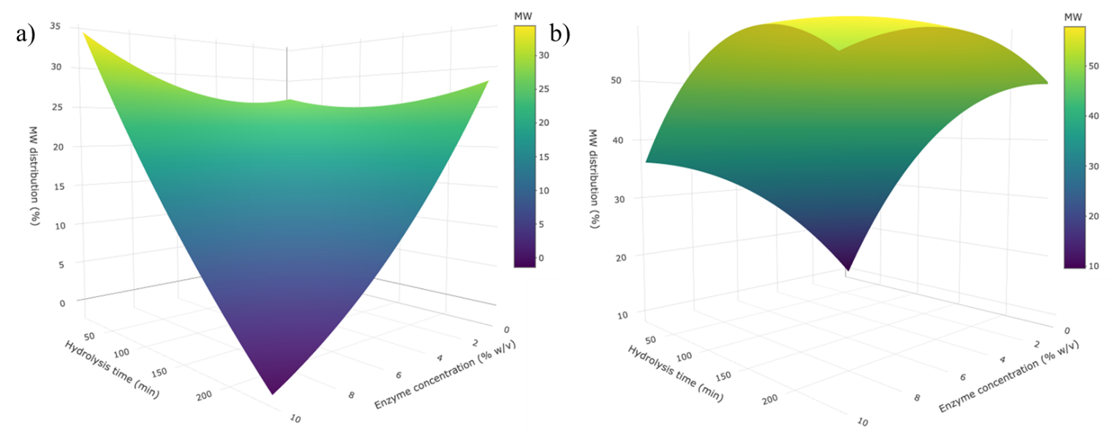
Fig. S1 3D response surface analysis plot showing the effect of enzyme concentration and time of hydrolysis on the molecular weight distribution (MW) in the range 6 – 3 kDa (a) and 3-0.6 kDa (b) of pea protein hydrolysates (PPHs). A constant value (central point) was imposed on the third independent variable of the BBD.

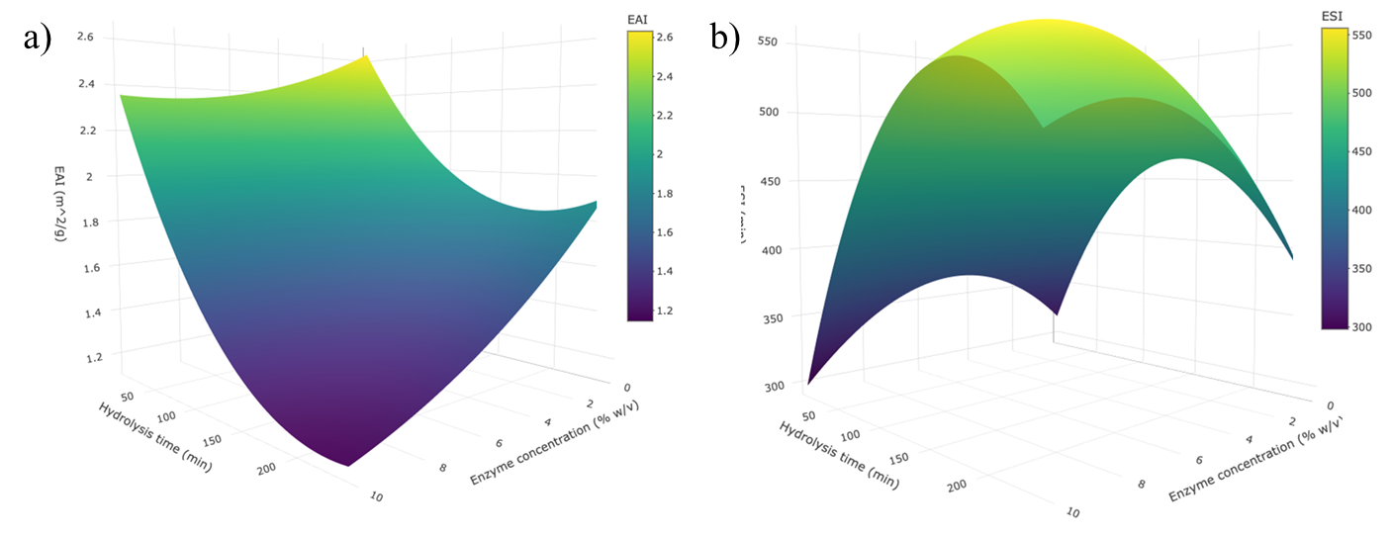
Fig. S2 3D response surface analysis plot showing the effect of enzyme concentration and time of hydrolysis on emulsion ability index (EAI) and emulsion stability index (ESI) of pea protein hydrolysates (PPHs). A constant value (central point) was imposed on the third independent variable of the BBD.

Number | [S] | [E] | t_{i} | DH  (%) | free -SH (µmol/g) | H₀  (-) | Solubility  (%) | WHC  (g_{water}/g_{sample}) | OHC  (g_{oil}/g_{sample} ) | EAI  (m²/g) | ESI  (min) | FAI  (%) | FSI  (%)
PPC | - | - | - | - | 1.53 ± 0.09 | 3348.4 ± 12.3 | 21.9 ± 0.2 | 3.51 ± 0.23 | 0.91 ± 0.03 | 2.3 ± 0.2 | 267.1 ± 24.2 | 77.1 ± 8.8 | 43.8 ± 3.0
1 | -1 | -1 | 0 | 7.4 ± 0.5 | 4.66 ± 0.44 | 877.1 ± 6.0 | 68.7 ± 0.0 | 1.28 ± 0.04 | 1.78 ± 0.02 | 2.26 ± 0.02 | 359.3 ± 89.1 | 166.7 ± 0.0 | 79.2 ± 4.2
2 | +1 | -1 | 0 | 7.1 ± 0.2 | 3.70 ± 0.16 | 1155.3 ± 6.4 | 42.7 ± 0.2 | 1.62 ± 0.09 | 1.60 ± 0.09 | 2.42 ± 0.01 | 372.4 ± 25.2 | 189.1 ± 3.1 | 65.2 ± 0.0
3 | -1 | +1 | 0 | 21.1 ± 0.4 | 5.74 ± 0.18 | 358.0 ± 3.5 | 69.4 ± 1.0 | 0.35 ± 0.02 | 1.08 ± 0.03 | 1.35 ± 0.10 | 492.6 ± 119.2 | 66.7 ± 5.9 | 29.2 ± 0.0
4 | +1 | +1 | 0 | 22.8 ± 1.6 | 5.06 ± 0.01 | 352.2 ± 4.6 | 62.8 ± 0.7 | 0.63 ± 0.03 | 1.15 ± 0.02 | 1.46 ± 0.08 | 437.6 ± 36.4 | 129.2 ± 5.9 | 27.8 ± 2.4
5 | -1 | 0 | -1 | 11.9 ± 0.5 | 4.52 ± 0.29 | 1053.4 ± 2.0 | 55.0 ± 0.0 | 1.06 ± 0.07 | 1.50 ± 0.06 | 2.01 ± 0.13 | 477.4 ± 18.5 | 187.0 ± 6.1 | 69.6 ± 6.1
6 | +1 | 0 | -1 | 13.4 ± 0.4 | 3.34 ± 0.14 | 1314.6 ± 1.6 | 52.5 ± 0.6 | 1.10 ± 0.02 | 1.47 ± 0.02 | 1.73 ± 0.10 | 444.4 ± 66.6 | 87.5 ± 5.9 | 37.5 ± 0.0
7 | -1 | 0 | +1 | 23.6 ± 1.7 | 3.80 ± 0.11 | 416.4 ± 5.6 | 67.7 ± 1.2 | 0.32 ± 0.07 | 1.14 ± 0.02 | 1.40 ± 0.02 | 596.5 ± 30.1 | 125.0 ± 0.0 | 21.8 ± 1.3
8 | +1 | 0 | +1 | 18.9 ± 0.4 | 5.27 ± 0.37 | 543.1 ± 1.4 | 63.7 ± 0.9 | 0.76 ± 0.04 | 1.44 ± 0.03 | 1.37 ± 0.09 | 373.6 ± 89.6 | 191.3 ± 6.1 | 31.3 ± 2.9
9 | 0 | -1 | -1 | 5.7 ± 0.8 | 3.53 ± 0.11 | 1551.6 ± 12.7 | 45.3 ± 0.5 | 1.42 ± 0.08 | 2.63 ± 0.07 | 2.66 ± 0.22 | 297.6 ± 18. 9 | 185.7 ± 6.7 | 100.0 ± 6.1
10 | 0 | +1 | -1 | 13.9 ± 0.5 | 5.19 ± 0.08 | 457.7 ± 3.5 | 58.7 ± 0.7 | 0.88 ± 0.27 | 1.39 ± 0.09 | 1.91 ± 0.14 | 382.4 ± 77.8 | 89.6 ± 8.8 | 71.4 ± 0.0
11 | 0 | -1 | +1 | 7.2 ± 0.2 | 4.65 ± 0.14 | 1437.7 ± 7.4 | 48.4 ± 2.1 | 1.82 ± 0.10 | 1.95 ± 0.03 | 2.35 ± 0.04 | 295.1 ± 24.5 | 170.8 ± 5.9 | 62.5 ± 0.0
12 | 0 | +1 | +1 | 30.2 ± 1.1 | 3.83 ± 0.12 | 331.5 ± 1.0 | 64.7 ± 1.3 | 1.12 ± 0.06 | 1.12 ± 0.03 | 1.12 ± 0.04 | 499.8 ± 130.0 | 108.7 ± 0.0 | 28.3 ± 3.1
13 | 0 | 0 | 0 | 20.2 ± 1.1 | 5.33 ± 0.16 | 461.1 ± 4.4 | 61.6 ± 0.3 | 1.02 ± 0.12 | 1.44 ± 0.03 | 1.66 ± 0.08 | 570.5 ± 36.3 | 144.3 ± 2.1 | 48.8 ± 1.7
14 | 0 | 0 | 0 | 20.3 ± 0.1 | 5.30 ± 0.08 | 474.3 ± 4.2 | 61.1 ± 0.3 | 1.02 ± 0.09 | 1.52 ± 0.03 | 1.71 ± 0.05 | 532.8 ± 51.1 | 122.9 ± 2.9 | 43.8 ± 2.9
15 | 0 | 0 | 0 | 18.8 ± 0.1 | 5.87 ± 0.31 | 563.9 ± 3.8 | 58.0 ± 0.9 | 0.90 ± 0.13 | 1.92 ± 0.12 | 1.71 ± 0.08 | 561.9 ± 51.2 | 102.2 ± 3.1 | 31.9 ± 2.5
16 | 0 | 0 | 0 | 19.4 ± 0.9 | 5.34 ± 0.52 | 432.5 ± 2.8 | 61.6 ± 1.0 | 0.85 ± 0.08 | 1.57 ± 0.04 | 1.43 ±0.12 | 522.8 ± 50.0 | 102.1 ± 2.9 | 36.5 ± 5.2
17 | 0 | 0 | 0 | 19.7 ± 0.0 | 5.35 ± 0.78 | 411.8 ± 1.4 | 59.2 ± 1.5 | 0.89 ± 0.04 | 1.56 ± 0.13 | 1.36 ±0.09 | 532.7 ± 115.7 | 106.4 ± 3.2 | 36.2 ± 4.1
Table S1 Degree of hydrolysis (%), free -SH groups, surface hydrophobicity (%), solubility (%), WHC (%), OHC (%), EAI (m²/g), ESI (min), FAI (%) and FSI (%) of pea protein hydrolysates samples.

